Within-vineyard temperature variability in the Jazbina hills of Croatia

Marko Karoglan¹, Maja Telišman Prtenjak², Silvio Šimon³, Mirela Osrečak¹, Jasminka Karoglan Kontić¹, Željko Andabaka¹, Ivana Tomaz¹, Branko Grisogono², Andreina Belušić², Antun Marki², Željka Prša², Branimir Omazić², Damjan Jelić², Željko Večenaj², Ivana Vladimira Petric³, Renata Leder³, Ivan Prša³, Višnjica Vučetić⁴, Damir Počakal⁴, Marina Anić¹

¹Faculty of Agriculture, University of Zagreb, Svetošimunska cesta 25, Zagreb, Croatia (mseparovic@agr.hr)
² Department of Geophysics, Faculty of Science, University of Zagreb, Horvatovac 95, Zagreb, Croatia
³ Centre for Agriculture, Food and Rural Affairs of Croatia, Jadrićeva 42, Zagreb, Croatia
⁴Meteorological and Hydrological Service of Croatia, Grič 3, Zagreb, Croatia

Abstract
Monitoring the temperature within the vineyard during the season is important for controling the maturation and planing various production activities in the vineyard. The study displays a description of the spatial variability of the temperature within the vineyard, since it has a strong effect on grape ripening and quality of the grapes. The goal of this study was to collect detailed temperature measurements at the two locations within the vineyard and to estimate temperature sensitivity at the vineyard scale. The results show that there is a great temperature variability within the vineyard and thus the need for system of zonal vineyard management. Rather than being managed uniformly, individual block can be split into zones in which management can be applied differentely.
Key words: viticulture, spatial variability, within-vineyard temperature

Introduction
Temperature is one of the most important climatic factors that affects the rate of development or loss of various biochemical compounds in grapes, including the accumulation of sugar, the loss of acidity through respiration and accumulation and maintenance of polyphenolic and aroma compounds, which ultimately affect on the quality of the grapes (Greer and Weedon 2013., Rienth et al. 2016.). Temperature is a crucial aspect of the site assessment and temperature measurements within the vineyard represent a significant advantage in capturing temperature variability versus using sometimes distant public weather station. Too much detail site assessment is expensive, wasteful and can be confusing, but too little detail may miss out on significant vineyard scale variations, including small areas with excellent potential (Smith 2002.).
Vineyards are heterogeneous because of soil, morphology and microclimate variability, but majority of vineyards have been managed on the assumption that they are homogeneous. Precision Agriculture (Cook and Bramley 1998.) involves in collecting the data relating to crop performance (vine vigor, yield and grape quality) and the attributes of individual production areas (temperature, relative humidity, solar radiation) at the high spatial resolution. By defining different sub-blocks within the vineyard and managing it differently, rather than entire vineyard the same, winemakers achieve greater control of the product. Many authors report spatial variability at macro (Tonietto and Carbonneau 2004.) and meso scale (Nicholas et al.2011.), but do not explicitly measure temperature within the vineyard and in most cases use data from public weather station, often located several kilometers away from the site to represent a vineyard.
These kind of measurements fail to present within-vineyard spatial variability, due to soil characteristics, slope and elevation (Mates et al. 2014.). There were some observation regarding variability of some parameters on the vineyard-scale, such as differences in vegetative expression and yield (King et al. 2014., Tisseyre et al. 2008.), phenological stages and maturation (Verdugo-Vasquez et al. 2016.), grape quality components (Bramley 2005., Tisseyre et al. 2008., Baluja et al. 2013.), chemical and sensory attributes of wines (Bramley et al. 2011.) and are linked it to differences in the soil. The aim of this work was to compare temperature measurements within the vineyard in one year (2017.) in order to estimate spatial variability of the temperature within the vineyard.

Materials and methods
The experiment was conducted at Jazbina experimental station, Faculty of Agriculture, University of Zagreb, located on the south and southwest facing slopes of mountain Medvednica, in year 2017. Climate analysis of the growing season was conducted for the period between fruit set and complete ripeness (July-September). Temperature observation data was collected from two meteorological station within the vineyard. Site locations were chose based on their topographic differences. First position is on top of the hill, on 252 meters altitude. Second position is on 239 meters altitude and in the center of the hill, northeast-southwest orientation. Distance between two positions is 230 meters.
Comercial temperature sensor was provided by Pinova d.o.o. and was located in the center of the hill. Scientific temperature sensor was provided by Department of Geophysics Faculty of Science, University of Zagreb, as a part of VITICLIC project and was located in the top of the hill. Calibration of two temperature measurements was made by locating both sensors at the same place for 48 hours and detecting the difference in temperature measurements between them. Differences in two temperature measurements was ± 0,3 ºC, which can be attributed to the measurement error. One temperature sensor per location was installed inside the solar shield at 2 m high, outside the vineyard canopy, at the beginning of the vineyard row. Measurements of temperature were logged once every 10 seconds for the sensor on the top of the hill or once every 10 minutes, for the sensor on the center of the hill. Data from both sensors was averaged to obtain mean hourly temperatures, from which daily measurements of minimum, mean and maximum temperature were calculated.

Results and discussion
Results from seasonal study in 2017., in the period from 4th of July to 29th of September on temperature variation within the vineyard, are showed in Table 1 and Figure 1.
Temperature varied within the vineyard significantely in terms of seasonal mean of mean daily temperatures and it was higher on the top of the hill by 1,89 ± 0,3 ºC compare to the center of the hill. Similar differences were found when comparing the sesonal mean of maxiumum and minimum daily temperatures, with position on the top of the hill having higher seasonal mean of maximum and minimum daily temperature by 1,70 ± 0,3 ºC and 1,68 ± 0,3 ºC than te position on the center of the hill, respectfully.

Table 1. Seasonal mean of mean, maximum, minimum daily temperature. Measurement error between two sensor is ± 0,3 ºC
 | Mean |  | Difference* | Range
 | Top of the hill | Center of the hill |  | Top of the hill | Center of the hill
Mean | 23,30 | 21,40 | 1,89 | 13,32 - 32,50 | 11,50 - 30,50
Max | 29,07 | 27,37 | 1,70 | 15,10 - 39,80 | 13,20 - 37,50
Min | 17,73 | 16,05 | 1,68 | 11,80 - 26,24 | 9,30 - 23,80
*Difference between the temperature on the top of the hill and on the center of the hill
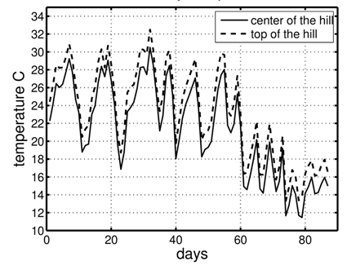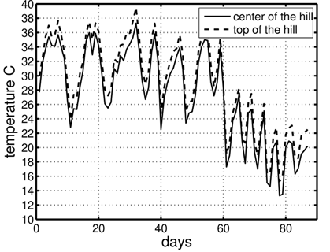
(b)
(a)
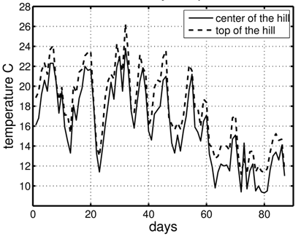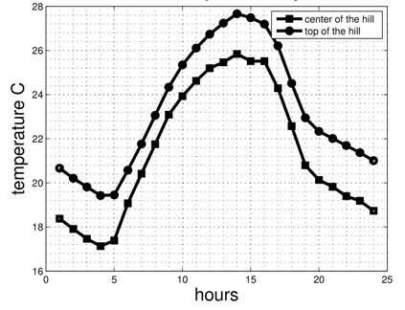
(c)
(d)

Fig.1 Daily mean (a), maximum (b), minumum (c) temperature and diurnal temperature cycle (d) for each position (top of the hill and center of the hill). Day counting starts from 4th of July and ends on 29th of September

The maximum temperature on both positions exceeded the threshold of 35 ºC, which in some cases can cause damage on grapes, decrease in tannins and anthocyanins accumulation (Rienth et al. 2016.) and block the sugar accumulation (Greer and Weedon 2013.). Differences in the temperature measurements between two positions within the vineyard can be explained by diurnal mountain winds, which occur over complex topography of all scales, from small hill to large mountain massif, and are characterized by reversal of wind direction twice per day. As a rule, up-slope flows of warm air occurs during the day and downslope flows of cold air occurs during the night, consequently leaving the top of the hill warmer during the day and during the night, when compared to the air of the center of the hill. Diurnal wind systems are usually better developed in summer than in winter, because of the strong day-night heating contrast, and in anticyclonic synoptic weather conditions where background winds are weak and the sky is clear (Zardi and Whiteman 2012.).
Our results are in accordance to the research of Bonnefoy et al. (2013.), who monitored within the vineyard temperature, with 21 temperature data loggers set up in the vineyard rows. They observed the lowest mean minimum temperature of the season at the sensor located at the bottom of the slope, and sensor located on the top of the slope recorded the highest mean minimum temperature. The mean seasonal maximum temperature was higher at the lowest point, what was not in agreement with our research. The spatial variability of temperature was marked due to the contrasted topography, different aspects of the plots and characteristics of the soil. Verdugo-Vasceze et al. (2016.) obtained similar results, with 0,4 ºC difference in temperature between two locations within the vineyard. The spatial variability of stable environmental factors (soil characteristics, slope, soil texture, presence of ground water) produced differences in the microclimate of each zone, which affected the phenology and maturity of the grapevine. According to the study of Mates et al. (2014.), there is a significant difference in temperature measurements between two locations within the vineyard by 0,6-1 ºC, confirming that different meteorological stations placed on different positions in the same vineyard can not be considered replicates. Significant variations in temperature within the vineyard can influence vine water status, as well as affect the grape composition (sugar, total acidity, pH, phenolic composition) (Baluja et al. 2013.). The productivity of the vineyard is spatially variable, whether assessed in terms of grape yield, vine vigor or grape quality, with this variation associated with variation in attributes of the land (soil and topography) underlying the vineyard (Bramley et al. 2011.).

Conclusion
Jazbina is highly complex terrain, located on the slopes of Medvednica mountain, with a unique conditions for grape growing. Regional scale analysis give us the general climatic context but it is insufficient for this study. It was possible to identify two well contrasted temperature zones within the vineyard. Differences in temperature may explain the spatial variability observed in other variables such as yield, disease development, grape ripening and quality. Spatial variability can sometimes be as significant at fine scale as at larger scales (Bonnefoy et al. 2013.).
Our results have important implication for adoption of Precision Viticulture. These results can be coupled with other climatic parameters (relative humidity, solar radiation) and crop parameters (grape quality, vine vigor and yield) as an aid to seasonal decision making and program of zone-based sampling, when being mapped for many years. Rather than being managed uniformly, individual blocks can be split into zones of characteristic performance and managed differently. Different zones within single block might be pruned to different bud numbers, fertilized or pesticide treated at different rates and harvested at different time.
Acknowledgments This study is supported by the HrZZ project (VITICLIC) (PKP-2016-06-2975) which is funded by the Environmental protection and energy efficiency fund under the Government program (Ministry of Environment and Energy & Ministry of Science nad Education) for the Promotion of research and development activities in the field of climate changes for the period 2015-2016.

References
Baluja J., Tardaguila J., Ayestaran B., Diago M.P. (2013) Spatial variability of grape composition in a Tempranillo (Vitis vinifera L.) vineyard over a 3-year survey. Precision Agriculture. 14:40-58.
Bonnefoy C., Quenol H., Barbeau G., Madelin M., Planchon O., Neethling E. (2013) Temporal and spatial analyses of temperature in a French wine-producing area: the Loire Valley. International Journal of Climatology. 33:1849-1862.
Bramley R.G.V.(2005) Understanding variability in winegrape production systems 2.Within vineyard variation in quality over several vintages.Australian Journal of Grape and Wine Research 10:32-45
Bramley R.G.V., Hamilton R.P. (2004) Understanding variability in winegrape production systems 1. Within vineyard variation in yield over several vintages. Australian Journal of Grape and Wine Research. 11:33-42.
Bramley R.G.V., Ouzman J., Boss P.K. (2011) Variation in vine vigour, grape yield and vineyard soil and topography as indicators of variation in the chemical composition of grapes, wine and wine sensory attributes. Australian Journal of Experimental Agriculture.17:217-229.
Cook S.E., Bramley R.G.V. (1998) Precision Agriculture- Opportunities, Benefits and Pitfalls. Australian Journal of Experimental Agriculture. 38:753-763.
Greer D.H., Weedon M.M. (2013) The impact of high temperatures on Vitis vinifera cv. Semillon grapevine performance and berry ripening. Frontiers in Plant Science. 4: 491.
King P.D., Smart R.E., McClellan D.J. (2014) Within-vineyard variability in vine vegetative growth, yield, and fruit and wine composition of Cabernet Sauvignon in Hawke's Bay, New Zeland. Australian Journal of Grape and Wine Research. 20:234-246.
Matese A., Crisci A., Di Gennaro S.F., Primicerio J., Tomasi D., Marcuzzo P., Guidoni S. (2014) Spatial variability of meteorological conditions at different scales in viticulture. Agricultural and Forest Meteorology. 189:159-67.
Nicholas K.A., Matthews M.A., Lobell D.B., Willits N.H., Field C.B. (2011) Effect of vineyard-scale climate variability on Pinot noir phenolic composition. Agricultural and Forest Meteorology. 151(12):1556-67.
Rienth M., Torregrosa L., Sarah G., Ardisson M., Brillouet J.M., Romieu C. (2016) Temperature desynchronizes sugar and organic acid metabolism in ripening grapevine fruits and remodels their transcriptome. BMC Plant Biology. 16:164.
Smith L. (2002). Site selection for establishment and management of vineyards. The 14th annual colloquium of spatial information research centre; University of Otago, New Zeland.
Tisseyre B., Mazzoni C., Fonta H. (2008) Within-field temporal stability of some parameters in viticulture: potential toward a site specific management. Journal International des Sciences de la Vigne et du Vin. 42:27-39.
Tonietto J., Carbonneau. A. (2004) A multicriteria climatic classification system for grape-growing regions worldwide. Agricultural and Forest Meteorology. 124:81-97.

Verdugo-Vasquez N., Acevedo-Opazo C., Valdes-Gomez H., Araya-Alman M., Ingram B., Garcia de Corazar-Atauri I., Tisseyre B. (2016) Spatial variability of phenology in two irrigated grapevine cultivar growing under semi-arid conditions. Precision Agriculture. 17:218-245.
Zardi D., Whiteman C.D. (2012) Diurnal mountain wind system. In: Mountain weather research and forecasting (Chow, F. K., S. F. J. DeWekker, B. Snyder) Springer, Berlin.

Varijabilnost temperaturnih uvjeta unutar vinogradarskog položaja Jazbina

Sažetak
Praćenje temperature u vinogradu tijekom sezone važno je za kontrolu dozrijevanja grožđa i planiranja tehnoloških zahvata u vinogradu. Istraživanje prikazuje varijabilnost temperaturnih uvjeta unutar vinograda, koje imaju snažan utjecaj na dozrijevanje grožđa i njegovu kvalitetu. Cilj ovog istraživanja bio je prikupiti detaljna mjerenja temperature na dva mjesta unutar vinograda i procijeniti osjetljivost temperature ovisno o prostoru. Rezultati pokazuju da postoji velika varijabilnost temperature unutar vinograda, a time i potreba za sustavom upravljanja vinogradom po zonama, umjesto da se cijelim vinogradom upravlja jednako.
Ključne riječi: vinogradarstvo, prostorna varijabilnost, temperatura unutar vinograda

