MULTIMODAL JOURNeY ROUTE SELECTION AS decision-making process

Bia Mandžuka¹, Marinko Jurčević², Krešimir Vidović³, Miroslav Vujić⁴
¹Faculty of Traffic and Transport Sciences, Vukelićeva 4, HR-10000 Zagreb,
bia.mandzuka@fpz.unizg.hr
²Faculty of Traffic and Transport Sciences, Vukelićeva 4, HR-10000 Zagreb,
marinko.jurcevic@fpz.unizg.hr
³Faculty of Traffic and Transport Sciences, Vukelićeva 4, HR-10000 Zagreb, kresimir.vidovic@fpz.unizg.hr
³Faculty of Traffic and Transport Sciences, Vukelićeva 4, HR-10000 Zagreb, miroslav.vujic@fpz.unizg.hr

-----------------------------------------------------------------------------------------------------------
ABSTRACT:

In recent years, special attention has been paid to the area of travel behavior, perceptions, and preferences for multimodal mobility, but also to the comprehensive facts about what multimodal mobility means for people, for their activities and their daily routines. Travel planning behaviour (choice of travel mode) can be understood as a decision-making process based on accumulated experience as well as developed behavioural patterns during the journey, etc. The paper describes a decision support system for multimodal travel planners based on a behavioural decision-making model.

Keywords: multimodal travel; user preferences; decision theory, decision support system
-----------------------------------------------------------------------------------------------------------------------

1. INTRODUCTION

In recent times, advancing eco-friendly transportation has been a top priority for the European Commission. Through various EU policies and initiatives [1, 2], the goal is to ensure smooth mobility and accessibility to essential locations and services for all citizens, enhance transportation safety, decrease negative environmental impacts such as emissions and noise, and boost the overall efficiency and affordability of the transport system. The European Union (EU) target for the transport sector is to reduce greenhouse gas (GHG) emissions by at least 60% by 2050 [3]. The EU and its Member States have set a sustainable, energy-efficient approach to mobility as their mobility target. In recent years, driven by the promotion of EU transport policy, multimodal passenger transport systems have become one of the most important tasks in addressing urban mobility [4]. The European Commission has declared 2018 the "Year of Multimodality" and has developed a number of legislative and policy initiatives for better, adequate infrastructure and digital solutions to promote an integrated, multimodal and ultimately sustainable transport system [5].
Establishing sustainable urban mobility is a complex task because sustainable urban mobility should primarily be considered at the individual level, i.e. at the level of the user. The transition from cars to sustainable modes of transport remains a complex behavioral process at the personal level and a societal challenge in general. As passengers need to get from one place to another smoothly, quickly and easily, it is necessary to offer a solution that can compete with the car, which is still the predominant choice.
According to the ISO taxonomy, Traveler Information is one of the 11 functional areas of ITS. This area includes static and dynamic information about the transport network, pre-trip and on-road information services, and support services that collect, store and manage information for planning transport activities. Pre-trip information services are of great importance to users as they allow to plan a trip from home or from any other location where internet access is available or where information on public transport, time or travel costs is available. In addition to pre-trip information, access to information during the trip is very important [6].
The paper consists of five chapters. A basic description of multimodal travel is given in the second chapter. The third chapter presents the importance and role of multimodal travel planners. The fourth chapter describes the decision-making model, focusing on a behavioral approach. The conclusion presents the main features of this approach and guidelines for further improvements.

2. MULTIMODAL TRAVEL

The concept of multimodal "door-to-door" transport is one of the priority measures in EU transport policy and can solve the transport problems of urban areas. The European Commission, which has declared 2018 as the "Year of Multimodality", has designed a series of legislative and policy initiatives for better, adequate infrastructure and digital solutions to promote an integrated, multimodal, and ultimately sustainable transport system [5].
The multimodal passenger system is the answer that leads to sustainable urban mobility. It includes end-to-end connectivity throughout the journey (service "from anywhere to anywhere"), time-saving (easy change of transport mode) and maximum flexibility in combining transport modes. Such a travel concept includes a combination of available public transport modes from origin to destination (Fig. 1). Urban integration and time-saving are the advantages of developing and introducing such a concept.
Travel planners offer the possibility of unimodal and multimodal travel planning. There are several route options with unimodal travel, but only one mode of public transport. There are several route options with multimodal trips, with each route containing a combination of transport modes according to selected criteria. In certain scenarios of multimodal travel, there are some obstacles such as lack of information for certain modes of transport (transfers, waiting times), lack of personalization of the journey, etc. To achieve such systems' quality and efficient functioning, it is necessary to implement modern technology [7].

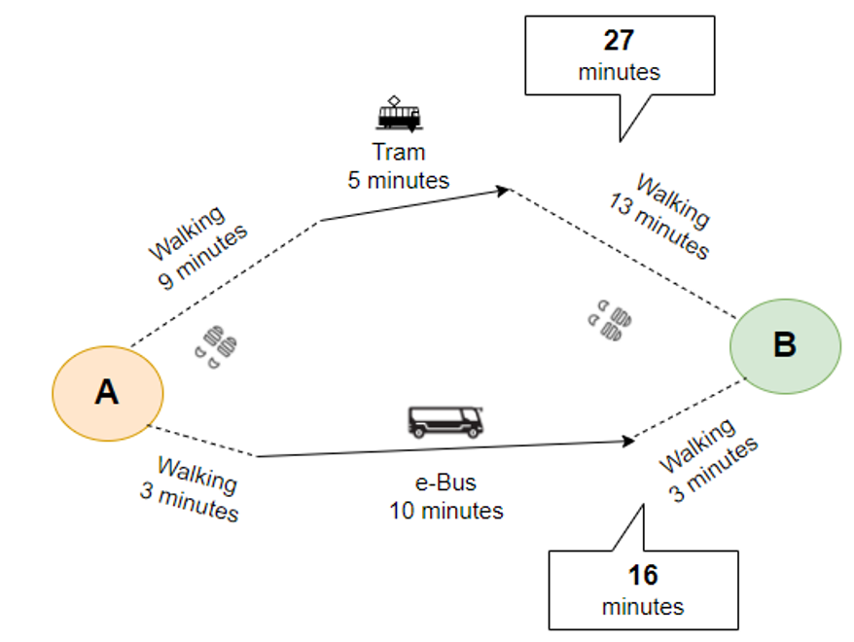

Figure 1. Multimodal travel options, [7]

The multimodal passenger information system combines a number of different data on which the system is based. These are data on users' destinations, cities, regions, information on the topography of the country and its relation to the transport system, timetables for different modes of transport, schematic maps of transport hubs, schematic maps of transport networks, information on objects of interest (points of interest - POI), information on tariffs and fare zones and, more recently, information on the pollutant emissions of certain modes of transport [6, 8-10].

3. MULTIMODAL TRAVEL PLANNERS

An appropriate definition of multimodal travel planners was provided by Gentile and Nökel [11]: “These systems are front-end-back-end computer systems, which provide a traveler the best itinerary according to several parameters characterizing an intermodal passenger transport journey. Multimodal travel planners provide better modal integration and more sustainability by enabling travellers to select the most suitable combination of transport modes for the journey and could lead to an increased use of public transport, cycling or walking in urban environment.”
Multimodal journey planners are part of urban ITS, which offers a range of passenger transport services. The basic task of the system is to answer the user's question: "How do I get from place A to place B at a certain departure/arrival time and under which conditions? " The system usually contains travel and traffic information such as locations of stops, departure and arrival times of means of transport (which are integrated into the system, e.g. tram, metro, bus, etc.), possibilities to buy tickets, possible incidents, general traffic situation, etc. In contrast to static information systems, dynamic systems enable timely decision-making when choosing means of transport and travel routes [8-10, 12,13].
Nowadays, multimodal travel planners are mainly based on algorithms that determine the shortest route / shortest travel time. The complexity in building the model that generates options tailored to passengers is reflected in the diversity of their preferences. For this reason, the choice of the most appropriate route can be considered as a multi-criteria problem. An example of the diversity of preferences can be seen in a number of travel scenarios in urban areas. In the case of congestion, passengers can be provided with information and options for other routes, making better use of the available transport infrastructure. It is important to note that the country's economy also benefits from multimodal travel information and planning services, as they provide new business opportunities for service providers and create new jobs in a very dynamic sector. Introducing new transport information and charging systems is an important step towards a better transport system.
Multimodal travel information provides dynamic real-time information integrating several accessible modes of public transport (tram, metro, bus, train, walking, etc.). In this respect, the user creates a customized journey. Previous research has defined multimodal information in three phases: Pre-trip information, on-trip information and post-trip information [6, 8, 9]. Thus, there are different physical locations where a person can be when making a travel decision, and the use of a multimodal information system can change the decision or behaviour pattern during the trip (depending on the information).
In urban areas, multimodal information is of great importance as it increases the share of public transport and other “healthy” ways such as walking and cycling [8, 11]. Multimodal travel information promotes mobility for all user groups, especially for users with disabilities or reduced mobility, by providing information about facilities and assistance at transport hubs. A particular type of user of multimodal travel planners is tourists. They may be guided by additional criteria when selecting a travel route, e.g. choosing a route that includes different attractions (POIs, etc.). The above points to a wide range of criteria and their personalized nature [8].

4. DECISION-MAKING PROCESS

Classical decision theory assumes complete and perfect rationality, whereby rational decision-makers strive to make optimal decisions. In economic theory, the so-called "economic man" (lat. Homo economicus) is an approximation of homo sapiens, who acts and exists in the best way for him and given the possibilities and limits of the environment. He or she knows the relevant aspects of the environment, but even if he or she is not familiar with all aspects, his knowledge of them is pure and coherent. Moreover, he or she is always able to choose the version of the decision that maximizes his or her personal preferences and self-interest (utility). Such an approach has met with numerous criticisms [14, 15]. The homo economicus model is often criticized because there is no perfect knowledge, stability, consistency, or rationality in decision-making.
In this case, the focus is on the user (human) who is faced with the problem of choosing a multimodal travel route. He is not an ideal rational being, but is shaped by his feelings, past travel experiences, emotions, etc. Based on his "travel genome" [16], which is an experienced record of all this, he makes a decision, i.e. the choice of a multimodal travel route. According to [17], the choice of alternative, i.e., decision-making, is an act of compromise between different "I's" within the decision-maker.
The Rational Choice Theory is limited in the human component and does not accurately picture the decision-making process. On the other hand, behavioral decision theory is driven by the decision-maker's cognitive, psychological, and emotional constraints but provides a much more comprehensive picture of the decision-making process. Nobel Prize winner Herbert A. Simon was among the first to recognize the inadequacies of the standard (classical) economic model of decision-making. As a critique and response to the previous classical approach to decision-making, Simon emphasized that decision-making is a complex, dynamic and sequential process that leads to adaptive decision-making. Simon introduced the term "bounded rationality", proving that individuals make rational decisions based on all possible information is not true [18].
People strive for a satisficing, good-enough decision in the decision-making phase, not the "best decision". Satisficing is determined by the level of aspiration of the decision-maker, i.e., the set of minimum requirements that the decision-maker sets. In contrast to the classical "rational" models of decision-making, which do not take into account the deeper psychology or influence on preferences, behavioural economics has offered a solution that considers human decision-making under realistic conditions; where preferences are not stable and are based on the rule of intransitivity [19]. Fig. 2 shows the proposal for a multimodal travel route assistance system based on elements of behavioural decision theory.

Figure 2. Multimodal travel route assistance system based behavioural decision theory

5. CONCLUSION

As a result, planners equip travelers with improved information to aid in selecting a transportation mode, empowering them to opt for the most suitable choice based on their requirements (for instance, considering factors like the mode of transport, route, cost, duration, and even an environmentally friendlier alternative), ultimately facilitating a successful journey completion. The open behavioural model is presented as a sequential, iterative process. In the open behavioral model, the key role is played by aspiration, i.e., the desire and effort to achieve something, and the use of heuristics, which are characteristic of human problem solving and decision making [20].
The system described above can be significantly improved by using real-time information on traffic conditions, possible traffic incidents, congestion, etc. This is made possible using cooperative transport systems [21]. In this case, the system becomes significantly more efficient and practical for the end-user - passenger.

AcknowledgeMENTs

The research has been supported by the Twinning Open Data Operational project that has
received funding from the European Union’s Horizon 2020 research and innovation programme under grant agreement No. 857592. In addition, part of the research activities is related to the OJP4Danube project (Coordination mechanisms for multimodal cross-border traveller information network based on OJP for Danube Region) within the Danube
Transnational Program.

6. REFERENCES

- European Commission: Sustainable Urban Mobility: European Policy, Practice and Solutions. Brussels, European Commission (2017)
- Rupprecht Consult - Forschung & Beratung GmbH (ed.): Guidelines for Developing and Implementing a Sustainable Urban Mobility Plan. European Commission (2019)
- Danish Energy Agency: Energy and Climate Policies beyond 2020 in Europe (Overall and selected countries). Copenhagen: Danish Energy Agency; (2015) Available on: https://ens.dk/sites/ens.dk/files/Globalcooperation/eu_energy_and_climate_policy_overview.pdf [Accessed: 20th December 2021]
- Stefan Klug (ed.): Multimodal Personal Mobility. Brussels: European Commission (2013). Available on: https://eusmartcities.eu/sites/default/files/201710/Multimodal%20personal%20mobility%20january.pdf [Accessed: 2nd January 2022]
- Civitas: EU Commission declares 2018 the ''Year of Multimodality''. Available on: https://civitas.eu/news/eu-commission-declares-2018-year-multimodality [Accessed: 2nd January 2022]
- Bošnjak, I.: Intelligent Transport Systems I - ITS I, Faculty of Transport and Traffic Sciences, University of Zagreb, Zagreb (2006) (in Croatian)
- Mandžuka, B.: Personalized services in multimodal journey planners (Doctoral Qualifying Exam). Faculty of Transport and Traffic Sciences, University of Zagreb, Zagreb (2021)
- Mandžuka, B., Brčić, D. and Škorput, P.: Application of multimodal travel guides for urban and suburban travel. In: Proceedings of the 34th Conference on Transportation Systems with International Participation, Automation in Transportation, pp 92 – 95. Croatia, Dubrovnik (2014) (in Croatian)
- Mandžuka, B., Brčić, D. and Škorput, P.: Application of pre-trip and on-trip information in urban areas. In: Proceedings of the 6th Croatian Road Congress - Via Vita, Croatia, Opatija (2015) (in Croatian)
- Škorput, P., Mandžuka, B. and Vujić, M.: The development of cooperative multimodal travel guide. In: Proceedings of 22nd Telecommunications Forum Telfor (TELFOR), pp 1110 – 1113. Serbia. Belgrade (2014)
- Gentile, G., Nökel, K. (ed.): Modelling Public ransport Passenger Flows in the Era of Intelligent Transport Systems. Springer International Publishing Switzerland, London (2016)
- Vujić, M., Skorput, P. and Mandžuka, B.: Multimodal route planners in maritime environment. Pomorstvo, 29 (1), pp 1-7. (2015)
- Vujic, M., Mandzuka, B., Skorput, P. (2016). Multimodal traveler information systems in maritime environment. In: Proceedings of 58th International Symposium ELMAR, pp 89-92. Croatia, Zadar (2016)
- Saad, G.: Behavioral decision theory, Wiley Encyclopedia of Management, New Jersey, United States, pp 1–3. (2015)
- Menger, M.: Teorija odlučivanja Herberta Simona: Decizionistički pristup organizaciji. In: Politička Misao (2019) Vol. 56 pp. 66–86. https://doi.org/10.20901/pm.56.2.03.
- Goulias, K. G., Davis, A.W. and McBride, E.C.: Introduction and the genome of travel behavior. In: Mapping the Travel Behavior Genome. Elsevier, pp 1–14 (2020)
- Connolly, T.: Decision making: Descriptive, normative and prescriptive interactions, In: Bell, D. E., Raiffa, H. and Tversky, A. (eds.), New York: Cambridge University press, 1988, J Behaviour Decision Making. Vol. 3. pp. 142–3. https://doi.org/10.1002/bdm.3960030208.
- Redlawsk, D.P., Lau, R.R.: Behavioral decision-making. Oxford University Press (2013)
- Brown, R.: Consideration of the origin of Herbert Simon’s theory of “satisficing” (1933‐1947). Manag Decis (2004) vol.42 pp.1240–56. https://doi.org/10.1108/00251740410568944.
- Gigerenzer, G., Gaissmaier, W.: Heuristic decision making. Annu Rev Psychol (2011) Vol.62 pp. 451–82. https://doi.org/10.1146/annurev-psych-120709-145346
- Mandzuka, S., Skorput, P. and Vujic, M.: Architecture of cooperative systems in traffic and transportation. In: Proceedings of 23rd Telecommunications Forum Telfor (TELFOR). Serbia, Belgrade (2015)

CORRESPONDANCE:
Bia Mandžuka, mag. ing. traff.
Faculty of Traffic and Transport Sciences Vukeliceva 4
10000 Zagreb, Croatia
E-mail: bmandzuka@fpz.unizg.hr
Krešimir Vidović, Ass.Prof. PhD
Faculty of Traffic and Transport Sciences Vukeliceva 4
10000 Zagreb, Croatia
E-mail: kvidovic@fpz.unizg.hr
Marinko Jurčrvić, Prof. Ph.D.
Faculty of Traffic and Transport Sciences Vukeliceva 4
10000 Zagreb, Croatia
E-mail: mjurcevic@fpz.unizg.hr
Miroslav Vujić, Ass.Prof. PhD
Faculty of Traffic and Transport Sciences Vukeliceva 4
10000 Zagreb, Croatia
E-mail: mvujic@fpz.unizg.hr

