6th International Research/Expert Conference
”Trends in the Development of Machinery and Associated Technology”

TMT 2002, Neum, B&H, 18-22 September, 2002

PROCESS PLANNING BETWEEN

LOGICAL APPROACH AND CAPP

Predrag Cosic
University of Zagreb, Faculty of Mechanical Engineering and Naval Architecture
Zagreb
Croatia

ABSTRACT
This work is a part of the project creating the technological database necessary for improvement of process planning and connection database through SQL server by Internet environment. Developed web site for Database System and Process Planning is useful especially during development student's project's of technological process inside fields Process Planning, Production and Operations Management. Here we have elaborated the first phase of selecting tool machines, tools and initial material on the basis of the chosen criteria. We have indicated the problems of selection and the possibility of working out a solution..
Keywords: process planning, CAPP, logical approach

- INTRODUCTION
A huge amount of preparation work has to be carried out before final decisions about a manufacturing plan are taken. The modern approach of CAPP tries to offload some of the manual work of the process planner by using information databanks and computerized algorithms to select proper manufacturing conditions. However, a completely automated process planning system still seems to be a not-very-near ideal, except for special applicatios with well-defined conditions.

Today, two methods are used to try to overcome this dilemma and to shorten the process generation time. One is to use a computer, i.e. CAPP. Hovewer, although research and development efforts in the field of CAPP over the past two decades have resulted in numerous experimental CAPP systems, they have had no significant effect in manufacturing planning practice. Another method (logical approach) is to improve the process planner's intuition, knowledge and expertise. This work try to improve concept of CAPP by systematic approach of organization database knowledge and the solving methods.

- SOME ASPECTS OF CAPP DEVELOPMENT AND IMPLEMENTATION
The traditional approach to process planning is based on the process planner studying the part drawing and manufacturing specifications, identifying similar parts or features and recalling past processes in making decisions and producing drawings, the process planner uses standard data and auxiliary books such as tolerance standards, material code names of different standards, surface roughness standards, machine specifications and capabilities. tool data, cutting condition data, etc. The main disadvantages of traditional process planning are: a) manufacturing logic is individual, b) it is laborious process which must often be shortened, c) results are often incomplete, d) pre-production lead times are extended, e) process information is often out of date.

The crucial idea is to divide the work between the process planner and the computer. This can reduce the pre-production lead times and increase process planner productivity by 600%, allowing more time to be spent on the planner evaluating alternatives. CAPP [1, 2] concept can include few steps like a) development od technological database, b) systematized approach of process planning, c) implementation of AI methods, d) connection CAD/CAM modules with technological database e) development distributed technological database via Internet.

This work is a part of the project creating the technological database [3, 4] necessary for improvement of process planning, implementation of AI methods and connection database by Internet environment. The main steps of this project are to define selection criteria [5] of the initial materials and primary production processes, tool machines, tools, simultanuously selection tools and machine tools, removal operations, sequencing of operations, mathematical terms for calculating cutting data, machining time, downtime/operation and the HELP with multimedia opportunities.

2.1 Simultaneously selection of machine tools and tools
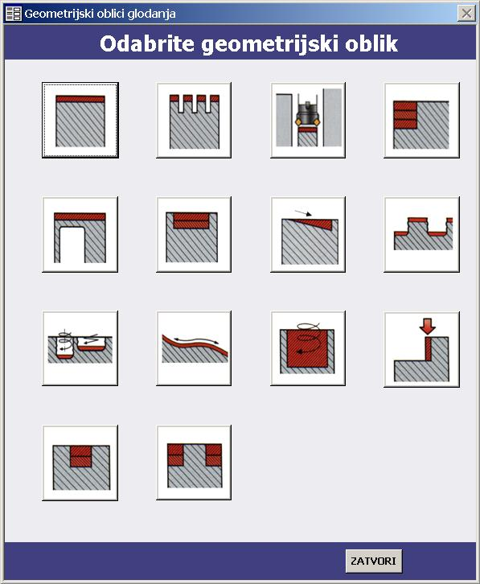
As the first phase of machine tools selection with already selected tool, the user must define inside database geometrical workpiece shape, way of tightening and workpiece size. During selection, it must be emphasized that geometrical workpiece shape for tools (Figure 1) and machine tools must be same [6]. Obtained result can be group of machine tools with weighted values of tightening and quality of machining milling. As result of the second phase user can obtain group of machines which simultaneously satisfy all demands of tools and machine tools (machining data criteria, geometrical workpiece shape, influence of tool diameter, workpiece material, machining conditions, accuracy in machining) with the next data: producer, cutting data (max cutting speed, feed, RPM, depth of cutting, power, etc (Figure 2). As the possible third phase of the selection machine tools, user can obtain machines with additional criterions for searching like machine price, machining price per hour, number of tools, exchange time of tools, etc. [6].

- SYSTEMATIZED APPROACH OF PROCESS PLANNING - LOGICAL APPROACH
The experienced process planner usually makes decisions based on comprehensive data without breaking it down to individual parameters. There is no time to analyse the problem. Understanding and a methodical thinking flow will improve the performance of the process planner.
Logical approach of a process planning, as the very complicated, multilevel and comprehensive approach of generating alternative process plans would be discussed, in this work, through few topics: a) selection of primary processes, b) selection of machine tools and tools.
Figure 1. Procedure for selection of workpiece shape of geometry – case of milling

3.1 Selection of primary process
The choice of process should be made initially with economic factors. The differences in direct manufacturing time can be quite significant. The required quantity will be a major determining factor of process selection. Manufacturing processes may be ranked in order of economic consideration as follows:

- Code A – forming from liquid (casting, moulding),
- Code B – forming from solid by deformation,
- Code C – forming from solid by material removal,
- Code D – forming by joining parts,
- Code E – forming by assembly,
- Code F – forming by material increase.
Figure 2. Simultaneously selection of tools and machine tools – case of milling

The other criteria for selection of initial material [4, 5] like grain size and orientation, ratios of material portion to the price of the blank, residual stress in the blank, scheme of stress state, machinability, anisotropy of material, geometrical similarity between initial form and workpiece,
heat treatment of product, etc. are too complicated and not enough general as the
Shape complexity
Mono  Quantity  < 180 > 1000 |  | Open  Quantity  < 150 > 2000 |  | Complex |  | Very complex  Quantity  < 100 > 1000
Quantity
< 50 > 1500
D | B | C | B | C | A | E | B
E | E | D | A | D | B | D | D
B | D | B | D | B | C | C | E
C | C | E | C | E | D | A | C
A | A | F | E | F | E | B | A
- | - | A | - | A | - | F | F
Table 1. Selection basic forming techniques

basis for the decision support. For their
implementation in decision support we have to create rules of implementation, for specific cases/fields of implementation.
The process of the general model creation would be more complicated by reason of: 1) necessity for quantity the whole’ history and sequencing the operations of metal forming processes’’ (metal forming and material removal, heat treatment, etc.), 2) necessity for continuously precision monitoring (data acquisition), 3) ’’rule creation’’ (implementation of AI techniques) as the basis in the process decision support. The end user can use the result of selection basic forming techniques as a good guide (Table 1).

Initial material selection (technological criteria) can be used only as suggestions for planning a variant of technological process [5].

5. CONCLUSION
The considered work presents the development of the variants of the technological process through the criteria of selection, the mechanism of processing, logical approach and database. The accent is placed on the simultaneously selection of the tool machines and tools with the use of the ponderable criteria of selection (selection of the primary process, the way of tightening and processing, the quality of the treated surface, depth of cutting, conditioned by the geometry of the workpiece, the dimensions of the part, the cutting data, the times of the operations processing).
The other criteria for selection of initial material like grain size and orientation, ratios of material portion to the price of the blank, residual stress in the blank, scheme of stress state, machinability, etc. are too complicated and not enough general as the basis for the decision support. For their implementation in decision support and ponderable multiple solutions of process plans variants we have to create rules of implementation, for specific cases/fields of implementation.

- REFERENCES
[1] Weill, R, Spur, G, Eversheim, W : Survey of Computer-Aided Process Planning Systems’’, Anals of the CIRP, Vol. 31/2, pp 539-551, 1982.,
[2] Juck ,H. : A Boolean Algebra Approach to High-Level Process Planning, Doctoral Thesis, The University of Western Ontario Faculty of Graduate Studies, London, 1994.,
[3] Weill, R., Lemaitre, F., Agaise, C. : The Development of Technological Data Banks for Small Manufacturing Systems, Proc. of the CIRP Seminar on Manufacturing Systems, 7, 1, pp. 15-26, 1978.
[4] Cosic P., Milinovic, S., Sever D.: Report of project named ‘’Modeling of the technological database’’, IP-171 financial support of the Ministry of Science and Technology of the Republic of Croatia, 2000/2001, some aspects of database : web site http://ptp.fsb.hr.,
[5] P.Cosic, D. Sever, S. Milinovic, Process Planning Application and Internet Connection, Proceedings of 6th International Conference AMST 2002, Udine, Italy, ed. E. Kuljanic, Springer Verlag, NewYorkBerlin, (accepted full paper, in process printing),
[6] Cosic, P., Sever, D., Milinovic, S. : Contribution to Systematized Approach of Process Planning, 8th International Conference CIM 2002, Brijuni, 2002, pp III-013 III-023.

