Comparison of time-domain thin-wire array current distribution calculation using GB-BIEM and NEC
S.Antonijević, J.Radić, V.Dorić, D.Poljak, V.Roje
University of Split
Split, Croatia

Abstract: Transient analysis of thin-wire antenna arrays is performed using two fundamentally different approaches. First set of results is obtained directly in time domain using Galerkin-Bubnov Boundary Integral Equation Method (GB-BIEM). The same configuration is then analyzed indirectly in frequency domain, using Numerical Electromagnetic Code (NEC) and applying Inverse Fast Fourier Transform (IFFT) to obtain transient response. Results of comparison between two different approaches are presented for several thin-wire configurations.

- INTRODUCTION

Transient analysis of thin-wire structures is usually performed indirectly, via inverse Fourier transform of results obtained in the frequency domain [1], [2]. Direct time domain techniques are significantly less used, primarily because of the relatively higher complexity involved in solving a space-time integro-differential equations, compared to that of solving comparable problem in the frequency domain. However, frequency-domain calculation must be repeated sufficient number of times to acquire transfer function of observed system, and inverse Fourier transform has to be applied to obtain its transient response. This makes frequency-domain based techniques somewhat inconvenient, compared to the direct-time domain techniques. In addition, if shorter time intervals are of interest, computational cost of direct-time techniques decreases, when compared to frequency-domain techniques [6-8].

Nonetheless, published time-domain results for arbitrary thin-wire configurations are relatively scarce, irrelevant of the method used. This is especially true if one is looking for the results obtained in the direct time domain techniques or measurements of the thin-wire structure transient response. The main objective of the work presented in this paper was to develop software that could be used as a reliable reference in development of the new direct time-domain methods. One of the most well-tested and understood numerical methods for thin-wire analysis today is Numerical Electromagnetic Code (NEC). This makes NEC a very good benchmark for any new numerical method, and a reference method of choice in this paper. However, NEC is a frequency-domain technique, so Inverse Fast Fourier Transform (IFFT) is necessary if time-domain results are required.
The purpose of software developed in this work is to serve as an interface to already existing commercial application that uses NEC core module, and to apply IFFT on obtained results, yielding a transient response of the thin-wire structure. Results obtained this way are compared to the results calculated using GB-BIEM direct time domain method.

- PROBLEM DESCRIPTION

The main objective of transient analysis of thin-wire structures involves calculation of space-time dependant current distribution along observed wires. Once current distribution is known, calculation of other parameters, such as electric field, power flow etc. is relatively straightforward.

The problem that is solved in this work concerns obtaining space-time current distribution on the arbitrary set of parallel wires. Geometry that is observed can consist of any number of wires in a free space or half-space.

Figure 1 – geometry of the analyzed structure

In addition to the well-known restrictions of the thin-wire approximation, geometry must consist of wires that are mutually in parallel and parallel to the ground (unless free space scenario is analyzed, of course). All other geometry parameters can be arbitrary chosen. These restrictions are due to the presently developed GB-BIEM method, not NEC. In the future work, GB-BIEM is to be further expanded so a more general thin-wire configuration case could be solved.

- GALERKIN-BUBNOV BOUNDARY INTEGRAL EQUATION METHOD (GB-BIEM)

GB-BIEM, originally developed for a single wire [3], is expanded to accommodate a case of multiple wire antenna arrays. Detailed explanation of the method is presented in [4], [5] and only the basic outline of the method will be provided here.

The mathematical model is based on a set of the coupled space-time integral equations of the Hallen type:

where v, s=1, 2,… ,M denote the index of the observed and source wire, respectively. I_{s} denotes space-time current distribution on sth source wire. r_{vs}(θ,t) is reflection coefficient pertaining to the effect of the ground, and is the excitation electric field. Coordinates on the source antenna s and on the observed antenna v are denoted by x', x, respectively. F_{0v}(t) and F_{Lv}(t) are time dependent functions describing multiple reflections of transient currents at the free wire ends.

Numerical solution of (1) comprises of three stages. First, space discretisation is applied using standard finite element space discretisation procedure. Then, time discretisation is performed using weighted residual approach. Obtained global matrix system can be written in generalized form as:

(2)

Finally, using time-marching technique, current at any given time instant is expressed using current values at previous time instants and transient response of all wires is obtained via recurrence formula:

(3)

Expression (3) is the current value on v-th wire at j-th space node and k-th time interval.

- NUMERICAL ELECTROMAGNETIC CODE (NEC)

NEC has been originally developed by J. Burke and A. Poggio in 1981 at Lawrence Livermore Laboratory under the contract for the US navy. Today it is one of the most widely used numerical tools for the analysis of antennas and scatterers in the frequency domain.
It uses method of moments to numerically solve integrodifferential equation of either electric or magnetic field in frequency domain. In the case of thin-wire structure analysis, the Pocklington integrodifferential equation for electric field at the observed frequency is used.

NEC can be acquired in several flavors for different OS platforms. For the purpose of this work, NEC-Win Pro v.1.6 from Nittany Scientific Inc. was used. NEC-Win Pro is a Windows32 compatible application package containing several executable modules for frequency-domain modeling.

Module executable name | Module description
Nec32.exe | NEC implementation
Necwinp.exe | Main application
Necvu…exe | Geometry display
PolrPlot.exe | Power gain and electric field polar diagram
Rectplt.exe | Rectangular plot of miscellaneous parameters
Smith.exe | Smith chart
Surface.exe | 3-D surface plot

Table 1 – NEC-Win Pro executable modules

However, since time-domain modeling is required, separate application had to be developed that interfaces with NEC32.EXE, module containing numerical core of the package. The rest of the executables in NEC-Win Pro package are essentially intended for entering input parameters and inspecting the calculated results - i.e. graphic user interface (GUI), and thus were redundant for the purpose of using NEC-Win Pro for the time-domain analysis.

The main principle of using frequency-domain solver to acquire time-domain results is based on the Fourier transform. For efficiency both forward and inverse Fourier transform are implemented as FFT.
The procedure of calculating time-domain results can be divided in several steps. First, the transfer function of the analyzed geometry H(f) is obtained by executing NEC sufficient number of times so that H(f) curve remains smooth enough. This can be done efficiently via FR card in NEC input file. Then, time-dependant voltage source V(t) is sampled and FFT is performed, resulting in a frequency spectrum of the excitation V(f). Next, excitation frequency spectrum and structure transfer function are multiplied in the frequency domain thus obtaining frequency-domain current distribution on analyzed structure I(f). Finally, I(t) is calculated from I(f) via FFT. The procedure is depicted in Fig.2.

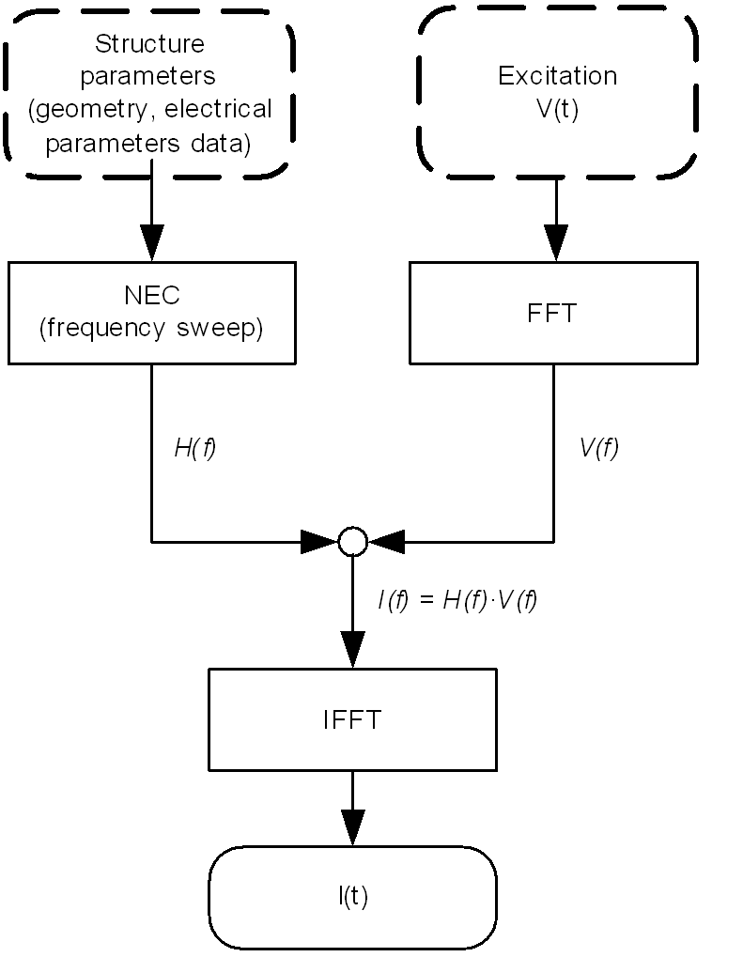

Figure 2 – using NEC to obtain current distribution in the time domain

It is important to keep frequency step small enough so that the H(f) is satisfactorily approximated. In addition, the frequency spectrum should span as large as possible. The limitations in determining lowest and highest frequencies in a frequency sweep, besides computational cost of course, are due to the NEC limitations. According to the Win-NEC Pro User Guide recommended segment length should be kept less then 0.1λ, and radius a should satisfy condition (2πa)/λ<<1. The segment length should also be at least 2 times greater then the wire radius.
Although these are only rough recommendations, they do impose a practical limit on choosing cut-off frequencies in H(f) frequency spectrum.
- NUMERICAL RESULTS

Illustrative results for two configurations are presented. In both cases antennas are fed by the voltage generator connected at the wire center. The voltage generator waveform is a Gaussian pulse:

$V_{g}(t)=V_{0}e^{−g^{2}(t−t_{0})^{2}}$ (4)

where V_{o}=1V, g=2⋅10⁹ s⁻¹, t_{o}=2 ⋅10⁻⁹ s.

First configuration consists of single wire with length 1m, radius 2 mm, placed 0.25 m above infinite dielectric plane at z=0, with ε_{r}=9. The time dependent current waveforms for center wire point are shown in Fig. 3.

Figure 3 – current distribution at the centre of the wire for the single wire configuration

Second configuration consists of three identical wires with the length 1 m, radius 2 mm, 0.4 m apart, placed in a free space. The middle wire is fed by a voltage source (4) connected in the wire center. The time dependent current waveforms on the center wire point for the fed wire are shown in Fig. 4, and on the adjacent wires in Fig. 5.
As can be clearly seen from the comparison, in both cases nearly perfect agreement between results obtained via NEC and GB-BIEM is achieved.

Figure 4 – current distribution at the center of the active wire for the three wires configuration

Figure 5 – current distribution at the center of the passive wires for the three wires configuration
- CONCLUSION

In this work the software to indirectly obtain time-domain results via interface with already existing NEC core executable is developed. The results calculated this way are compared with already existing direct time-domain method GB-BIEM results. Since the two approaches are fundamentally different, both from the numerical point of view and in the mathematical formulation, certain differences in results are expected. However, the results are in the surprisingly good agreement, making this work an important keystone as a reliable reference in developing future direct time-domain methods for more complex thin-wire geometries.
The software presented in this paper is a first version that adopts simplified approach to obtain time-domain results using the combination of NEC and FFT. Future work will include optimizing the method to reduce computational cost of the current version.

REFERENCES

- P. Parhami and R. Mittra: 'Wire antennas over a lossy half-space', IEE Trans. 1980, AP-28, (5), pp. 397-403
- S. Vitebskiy and L. Carin: 'Moment method modeling of short-pulse scattering from and the resonances of a wire buried inside a lossy, dispersive half-space', IEE Trans. 1995, AP-43, (11), pp. 1303-1312
- D. Poljak and V. Roje: 'Time domain calculation of the parameters of thin wire antennas and scatterers in a half-space configuration', IEE Proc. Microw. Antennas Propag., Feb.1998, 145 (1), pp. 57-63
- S.Antonijević, D.Poljak, C.Y.Tham and V.Roje: ' Time domain calculation of the transient current distribution along a thin wire antenna array', International Series on Advances in Boundary Elements, Vol 18, 2003, pp 229-240
- S.Antonijević, D.Poljak and V.Roje: ' Time domain calculation of the scattering on a thin wire antenna array', SoftCOM 2003, Conference proceedings, Softcom library , pp. 812-816
- T.K. Liu and K.K.Mei: 'A time domain integral equation solution for linear antennas and scatterers', Radio Sci., 1973, 8, pp.797-804
- A.G. Tijhuis, Z.Q.Peng, and A.R. Bretones: 'Transient excitation of a straight thin-wire segment: a new look at an old problem', IEE Trans. 1992, AP-40, (10), pp. 1132-1146
- S.M. Rao, T.K. Sarkar, and S.A. Dianat: 'A novel technique to the solution of transient electromagnetic scattering from thin wires', IEE Trans,. May 1980, AP-34, (5), pp. 630-634

