IMPROVING PROCESS PLANNING

THROUGH PRODUCTION COSTS

Predrag Cosic, University of Zagreb, Faculty of Mechanical Engineering and Naval Architecture, Ivana Lucica 5, 10 000 Zagreb, Croatia, tel. 385 1 61 68 340, fax 385 1 385 61 57 123, e-mail: predrag.cosic@fsb.hr; http://ptp.fsb.hr
Andrija Levanic, University of Zagreb, Faculty of Mechanical Engineering and Naval Architecture, Ivana Lucica 5, 10 000 Zagreb, Croatia,
tel. 385 1 66 24 482, andrija.levanic@fsb.hr ; http://ptp.fsb.hr

Abstract
This work is a part of the project creating the WEB application necessary for improvement of process planning through connection database (MySQL) with PhP in Internet environment. Here we have elaborated few problems of variants of machining in process plans, selecting tool machines and manufacturing processes on the basis of the chosen criterions. We have indicated the problems of selection and the possibility of working out a solution. We have especially emphasized interactions between machine tools, cutting conditions of tools, part, chucking type, batch of size, time, and production costs through process of machine tools selection.

Keywords: process planning, WEB, production costs

- INTRODUCTION

In the process production, the most important step is making a process plan. Process plan can be taken as input for many functions, for example: production planning, scheduling, part programming, etc. In spite of the importance of process planning in the manufacturing cycle, there is no formal methodology, which can be used, or can help to train personnel for this job. As different process planners have different experience, it is not wonder that for the same product, different process planners will create different processes. In the past humans operated the majority of manufacturing systems. Today, the production method is gradually moving toward automation.

- IMPROVEMENT OF PROCESS PLANNING

Variability among the planner’s judgement and experience can lead to differences in the perception of what is the best method of production. Development of the procedure for selection the best variant of process plan would lead through primary process selection (metal forming, casting etc), sequencing processes and phases, machine tools selection (by help workpiece shape, surface finish, chucking type, cutting parameters), etc. Improvement of process planning at this project stage means fast, unambiguous, higher level of automation process planning. The possible criterions for evaluation of process planning plans are calculation of times (machining, setup, preparatory), production costs, achievement realization of requested criterions, TQM etc. The most important problems at this stage of process planning improvement are:
- Determination of the best primary process [1],
- Determination of type and sequence operations,
- Credibility of setup times for chucking type (jig, vise etc),
- Credibility of preparatory times for machine tools,
- Credibility of times for tools setting,
- Credibility through selection and conformity of part shape, machine tools, tools and cutting parameters.

- PROCESS PLANNING AND COSTS PRODUCTION

Cost estimation is an essential part in the design, development and use of products. In the development and design of a manufactured product, phases include concept assessment, demonstrations of key features, and detailed design and production. The next phase is the operation and maintenance of the product, and finally, its disposal. The focus is on products defined by dimensions and tolerances, made from solid materials and, fabricated by some manufacturing process.
As more details of the product are specified, the cost estimates should become more accurate. There are few general concepts in field of the manufacturing cost estimating:
- Domain Limitation
The basis for a cost estimate must be specific to the manufacturing process, the materials used etc. Cost estimates only apply within specific domains.
- Database Commonality
Estimating the costs of a complex product through various phases of development and production requires organization of large amounts of data. If the data for design, manufacturing, and cost are linked, there is database commonality.
- Cost Allocation
Cost allocations refer to the process by which the components of a design are assigned target costs.
- Elements of Cost
There are many elements of cost. (For example, cost of material, tooling and fixture, direct labour, machining costs. We use some elements of this concept in our investigation. There are three methods of cost estimation:
- Parametric cost estimation
- Empirically based method
- Complexity theory.

In our work, we would use empirically based method of cost estimating. Our manufacturing cost estimation is based on machining time t_{t}, preparatory time t_{pzs}/n, auxiliary time t_{p} (setup, tooling time) and estimated costs of machine tools per hour.
Costs production and the quality are strongly influenced by the process plan. Creation and analysis of different process plans can improve process planning by fast and simple calculation of machining time, overall times and costs.

4. STEPS IN DEVELOPMENT OF WEB APPLICATION

For the criteria of selection machine tools, for example, turning, we have chosen: the way of tightening and processing, the required quality of the treated surface, the dimensions of the workpiece and the technological data, including performance (n, s, P) which together form the basis for further elaboration in the following phases of the database development. All selected machine tools have possible intervals of cutting condition values (feeds, cutting speeds, revolutions per minute) [2, 3].
This application displays the descriptive and the pictorial illustration of the processing so that the user decides what the union of the shapes best corresponding to his own product (Figure 1). As the second (left window side), we choose between the basic turning (longitudinal and transversal turning, conical turning, sphere turning, etc.) and additional turning (groove turning, cutting screw threads on the lathe, cutting off, etc.) on the basis of the geometrical shape of the product. By choosing a way of turning (internal or external) the window based on the multiple-choice questions opens (Figure 2).
The outcome of this phase is the display of the resulting groups of the machines with the ponderated values of the criteria (excellent - 5, very good - 4, good - 3, accepted - 2). We usually select the maximum sum of the mentioned criteria. From the tool machine displayed in the Figure 2, which is the machine identification map, we can see, one layer deeper (right upper corner), the data about the manufacturer, the type of the machine, the number of revolutions and feed, and other data necessary for the formation of the technological process together with its pictorial and schematic representation.
It is important to stress that it is possible to choose only one from the given options about the way of tightening (tightening 3 or 4-jaw universal chuck with hard or soft jaws, segmented head, etc.) [2]. As the third, after shape selection for this phase, definition type and number of operation, cutting parameters (left side of window), we would obtain all necessary dates for survey of all operations, phases, and machining, setup times (Figure 3, 4).

Size of the batch influences very critically the choice of machine tools and associated equipment. So, we come to the final choice of the machine through economic analysis, which consists of the synthesis of the price of the machining work (price of machine tool, profit rate during a given period of time, the price of the human resource, indirect expenses), price of material and the price of the tools. Furthermore, geometrical properties of the machine tools would be next step in the selection process (max. radius of turning, max. length of turning, etc).

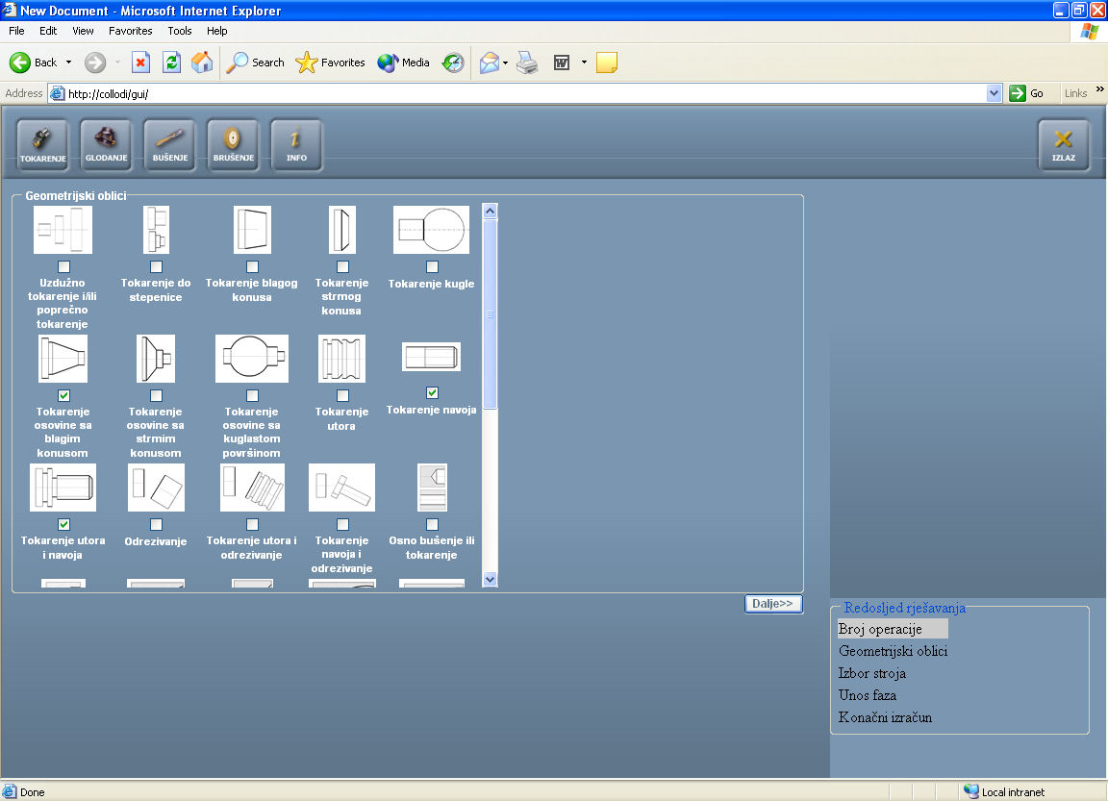
Figure 1 Selection of the part shape for machine tool selection

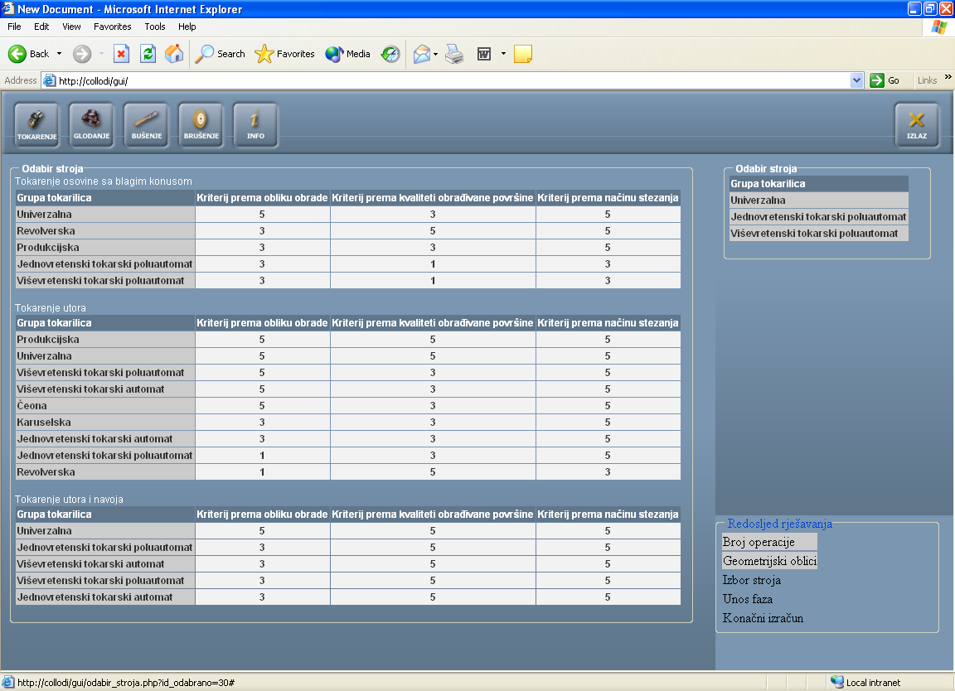

Figure 2 Process of ranking selected machine tools in view of part shape,

surface finish and chucking type

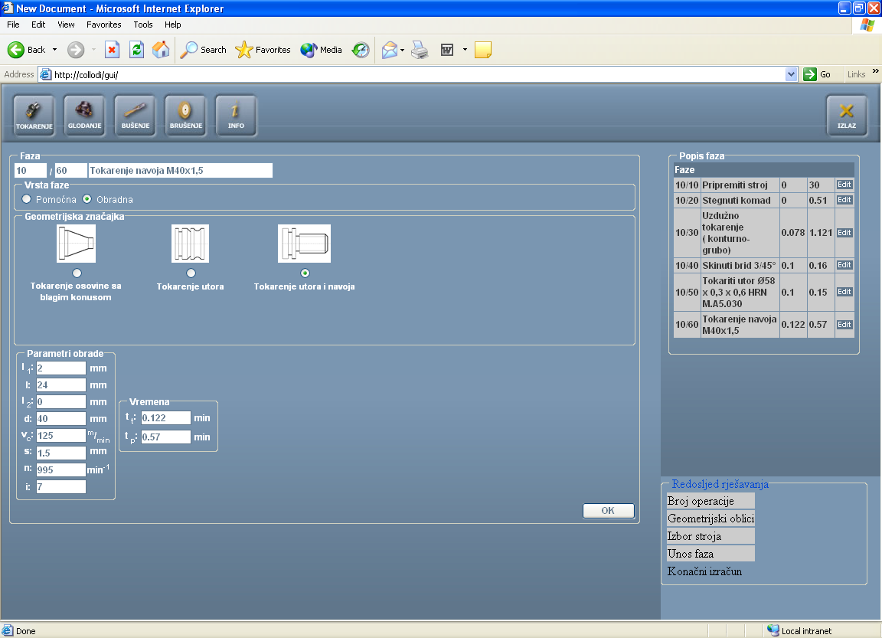

Figure 3 Phase - turning of threads with selection shape part,

cutting parameters and on-line

5. CASES OF PROCESS PLANNING APPLICATION

With applied WEB application for two selected cases, we show some of the application possibilities. We select these two cases: selection primary process (raw a material between forged and rolled workpiece) Figure 5 and selection machine tools with different number of operations (Figure 6), therefore

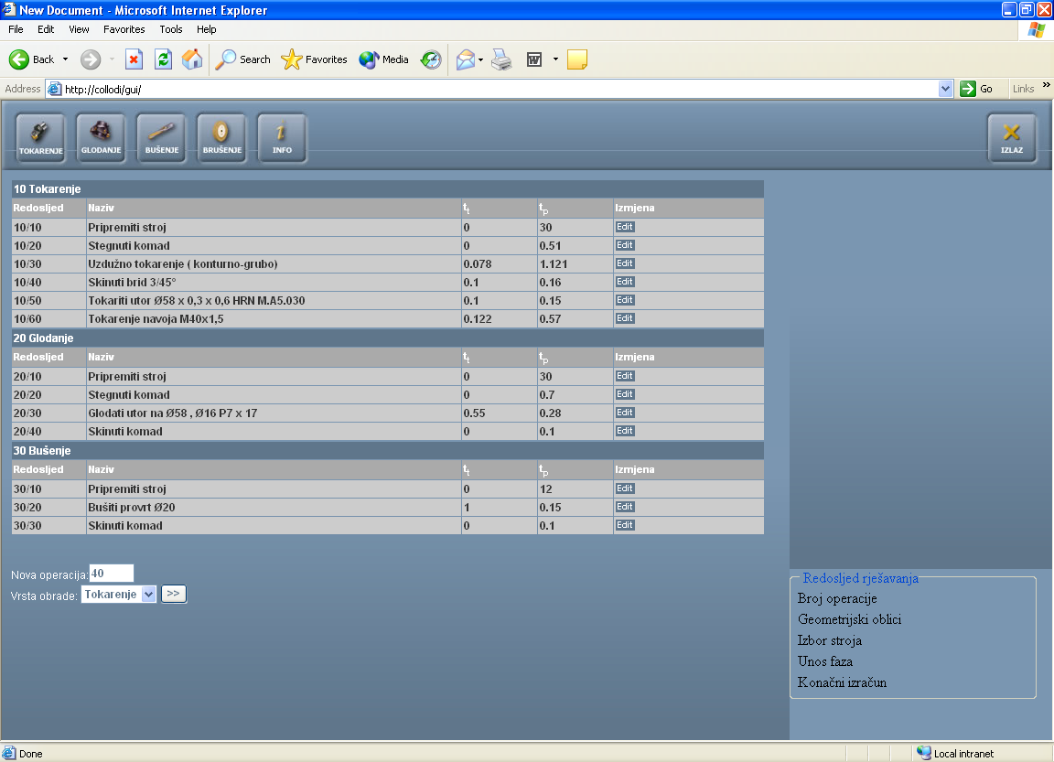

Figure 4 Sequencing operations with description of the phases, machining times, setup times and possibility of phases/operations correction

they have strong significance.

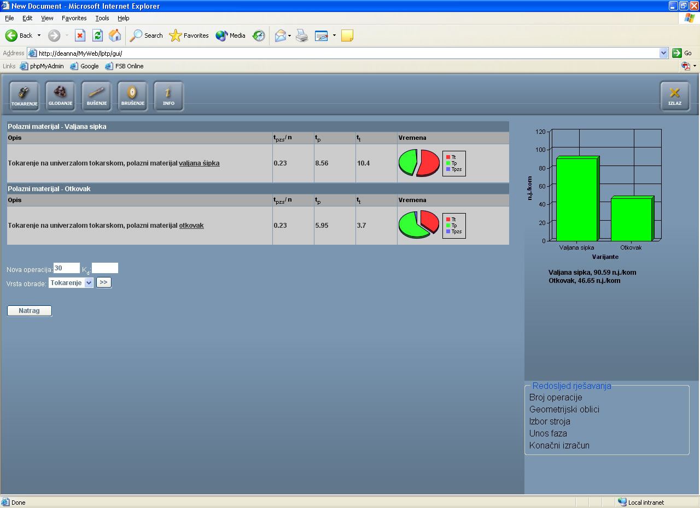

Figure 5 Manufacturing cost estimation for forged and rolled raw material

As we can see on Figure 5, the best solution of the possible process plans from forged part. Estimated manufacturing costs ratio between rolled and forged part are 90.59/46, 65 currencies per unit what was expected (pie and histogram description, left side of the window). The best solution of the possible process plans among possible machine tools and number of operations, in view of estimated manufacturing costs ratio, is turning on NC machining tool in one operation with estimated machining cost (variant III) 68,07 currency per unit what was expected (pie and histogram description, left side of the window, Figure 6).

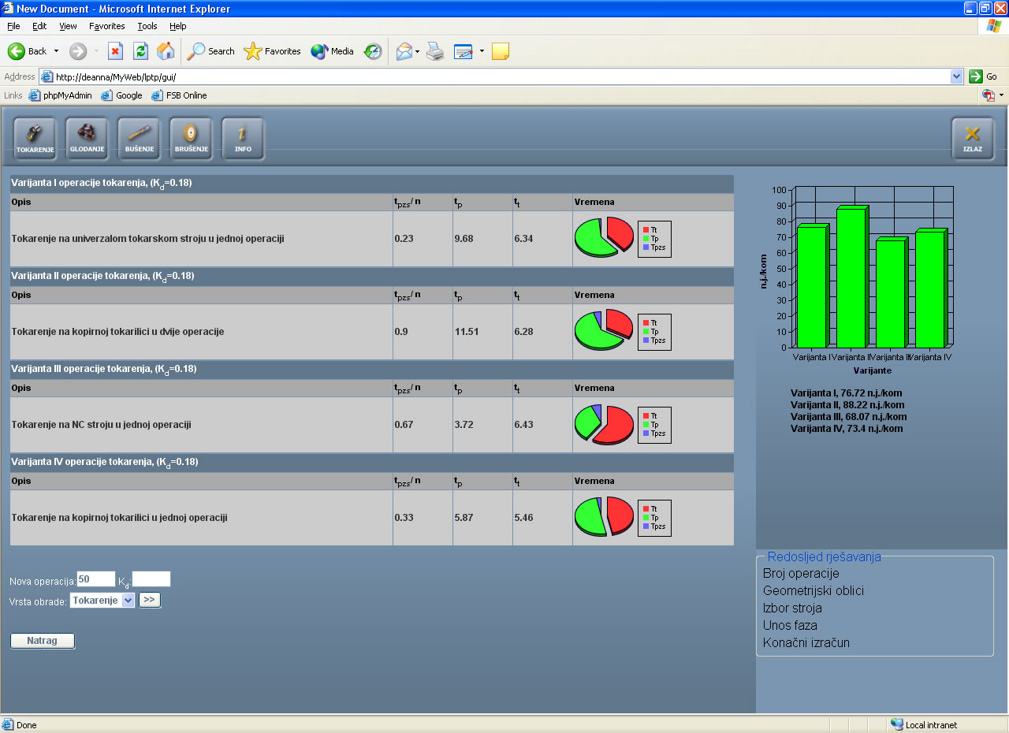

Figure 6 Manufacturing cost estimation for different machine tools

and number of operations

6. CONCLUSION

The considered work presents the development of the variants of the technological process through the criteria of selection, the mechanism of processing, logical approach and database. The accent is placed on the selection of the tool machines with the use of the ranked criteria of selection (shape of the workpiece, selection of the primary manufacturing process, the cutting data, the times and costs of the operations processing). The next phases of the project would lead toward higher level of process planning automatization [4, 5], determination the level of the significance observed variables and determination possible relationship between variables and integration with production management concept [3, 5].

Acknowledgement
This project is a part of the scientific project titled Intelligent Process Planning and Reengineering 0120-029 financed by the Ministry of Science and Technology of the Republic of Croatia in the period from 2002 to 2005. We express gratitude for the financial support of the project.

Literature

[1] Filetin, T.,: Izbor materijala pri razvoju proizvoda, FSB, Zagreb, 2000.
[2] Buchmeister, B; Polajnar, A.: Priprava proizvodnje (za delo v praksi), Fakulteta za strojništvo, Maribor, 2000.
[3] Halevi, G.: Process and Operation Planning, Kluwer Academic Publishers, Dordrecht, 2003.
[4] Chang, Tien-Chien: Expert Process Planning for Manufacturing, Addison-Wesley Publishing Company, New York, 1990.
[5] Halevi, G., Weill, D., R.: Principles of Process Planning, Chapman & Hall, London, 1995.

