The influence of surface domains on magnetization of very soft magnetic ribbons
S. Sabolek, E. Babić, D. Posedel, and M. Šušak
Department of Physics, Faculty of Science, University of Zagreb, Bijenička 32, 10000 Zagreb, Croatia
Received zzz, revised zzz, accepted zzz
Published online zzz
PACS 75.50.Kj; 75.60.-d; 81.07.Bc
The influence of surface fields H_{p} (generated by core currents) on the parameters of M-H loops (the coercive field H_{c}, the maximum magnetization M_{m}, etc.) of amorphous and nanocrystalline Fe_{73.5}Cu₁Nb₃Si_{15.5}B₇ ribbon and amorphous VITROVAC 6025Z ribbon has been investigated. In amorphous Fe_{73.5}Cu₁Nb₃Si_{15.5}B₇ ribbon H_{c} decreases with H_{p} with unchanged M_{m}, whereas in nanocrystalline Fe_{73.5}Cu₁Nb₃Si_{15.5}B₇ and VITROVAC 6025Z ribbons H_{c} increases with H_{p} and M_{m} decreases with H_{p}. This unusual increase of H_{c} with H_{p} is ascribed to the influence of H_{p} on the surface domain structure (SDS) and strong interaction between SDS and inner (main) domain structure (MDS) in these materials.
© 2003 WILEY-VCH Verlag GmbH & Co. KGaA, Weinheim
1 Introduction
The motion of domain walls (DW) of the main domain structure (MDS) usually dominates the magnetization along the axis of very soft magnetic ribbons in moderate magnetizing fields H [1]. This magnetization mechanism prevails due to a small average angle <δ> between the magnetizations of MDS domains and ribbon axis (also, direction of H) [2]. In these samples the strongest DW pinning centres are usually located near the surfaces of the ribbon. They originate from the surface inhomogeneities, stresses and irregularities (intrinsic pinning [3]) but also from some domains of SDS with magnetizations forming large angles with ribbon axis (SDS pinning, [4]). Since these materials provide numerous opportunities for applications [5], the investigation of the surface pinning of DWs is of considerable interest.
The influence of surface pinning on magnetization processes shows up best upon the application of an oblique surface field H_{p} [6]. Detailed investigation of the influence of H_{p}, generated by core currents, on the M-H loops of soft amorphous ferromagnetic ribbons showes that H_{p} usually reduces H_{c}, shifts the M-H loop, and may change the maximum (M_{m}) and remanent (M_{r}) magnetization [7]. These effects have been explained in terms of a simple model which takes into account the intrinsic pinning of DWs only and predicts a linear decrease of H_{c} with H_{p} [8].
However, recent measurements on optimally annealed (nanocrystalline) Fe_{73.5}Cu₁Nb₃Si_{15.5}B₇ ribbon (thereafter FeCuNbSiB) and amorphous VITROVAC 6025Z ribbon have shown that H_{c} in these very soft magnetic materials increases with H_{p} [9].Here we show that the variations of H_{c} with H_{p} in these materials can be quantitatively explained with an improved model for the influence of H_{p} on the magnetization processes in soft magnetic ribbons.

2 Experimental procedure
The dimensions of the samples were 200×2×0.025 mm³ and 200×2×0.020 mm³ for the optimally annealed FeCuNbSiB and VITROVAC 6025Z ribbon, respectively. The M-H loops were measured with an
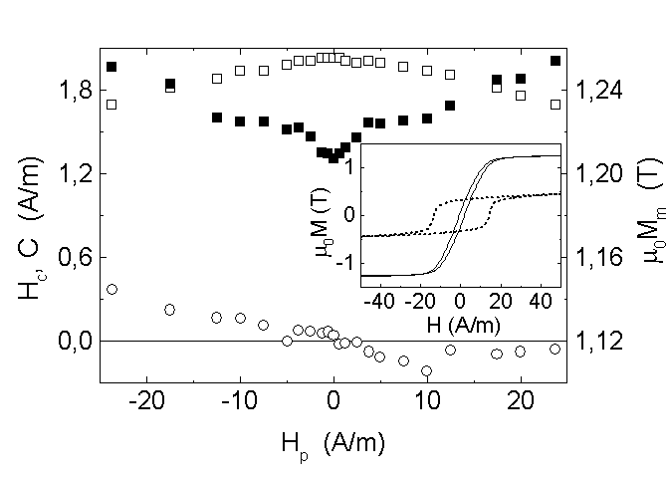
Fig. 1 Variations of the coercive field H_{c} (), maximum magnetization M_{m} () and the position of the center of the M-H loop C (), for the nanocrystalline Fe_{73.5}Cu₁Nb₃Si_{15.5}B₇ sample, with the static surface field H_{p}. The inset: M-H loops for the same sample in the amorphous (dashed) and nanocrystalline (solid) state. The measurements were performed with a triangular drive field with amplitude H₀ = 100 A/m and the frequency f = 5.5 Hz.

induction technique at room temperature [10]. A triangular magnetizing field H with the amplitude H₀ = 100 A/m and frequency f = 5.5 Hz was used. During the magnetization process, direct (J_{D}) core current (static H_{p}) was passed along the ribbon. For FeCuNbSiB sample M-H loops and the corresponding dM/dt vs. H curves were measured both in the amorphous state and after anneal at 540°C for one hour in pure Ar gas atmosphere.

3 Results and discussion
The amorphous FeCuNbSiB samples show poor soft magnetic properties consistent with a strong local magnetic anisotropy which develops during the their fabrication [11]. Therefore (inset to Fig. 1), for H₀ = 100 A/m, the coercive field is large (H_{c0} = 13.5 A/m) and M_{m} quite low. Static H_{p} causes a weak linear decrease of H_{c} and does not change M_{m} and the position of the center (C) of the M-H loop [9]. These effects are consistent with strong volume pinning of DWs [11], hence the surface pinning and H_{p} have slight influence on the magnetization processes.
The optimally annealed FeCuNbSiB sample shows excellent soft magnetic properties (Fig. 1) [12]. Accordingly, for H₀ = 100 A/m and H_{p} = 0 H_{c} is low (H_{c0} = 1.3 A/m) and M_{m} large (M_{m} ≈ M_{s} with M_{s} the saturation magnetization). However, its H_{c} increases rapidly with static H_{p} (ΔH_{c}/ΔH_{p} ≈ 0.067) for ⎢H_{p}⎢≤ 5 A/m, but the rate of the increase of H_{c} with H_{p} slows down (ΔH_{c}/ΔH_{p} ≈ 0.023) for ⎢H_{p}⎢> 5 A/m (Fig. 1). Simultaneously, M_{m} decreases a little with H_{p}, whereas center C of the M-H loop shifts linearly with H_{p} for ⎢H_{p}⎢≤ 5 A/m and shows little change for ⎢H_{p}⎢> 5 A/m.
The nonmagnetostrictive VITROVAC 6025Z ribbon (Fig. 2) shows a similar deterioration of soft magnetic properties due to H_{p}. Here, H_{c} initially increases with static H_{p} (ΔH_{c}/ΔH_{p} ≈ 0.05) for ⎢H_{p}⎢≤ 6 A/m whereas for ⎢H_{p}⎢> 6 A/m H_{c} remains constant.
These results can be explained by means of a model for the influence of H_{p} on magnetization of soft magnetic ribbons which takes into account the influence of H_{p} on intrinsic pinning of DWs and the novel effect: the H_{p}-enhanced SDS pinning of DWs [13]. This model is obtained by a simple modification of the previous model [7, 8] for the influence of H_{p} on parameters of the M-H loops of amorphous ferromagnetic ribbons. It is known that the strengths of DW pinning at the opposite surfaces of the ribbon are usually not the same [13]. Therefore, we denote the magnitudes of H necessary for depinning of DWs from the upper and lower surface of the sample in the absence of H_{p} with H_{su0} and H_{sl0} respectively, and
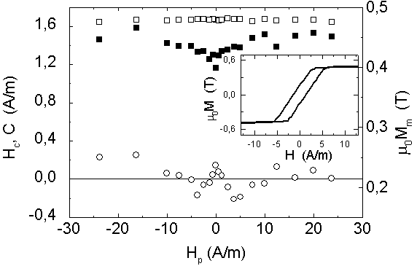
Fig. 2 Variations of the coercive field H_{c} (), maximum magnetization M_{m} () and the position of the center of the M-H loop C (), for the amorphous VITROVAC 6025Z sample with the static surface field H_{p}. The inset: M-H loop for the same sample in the absence of H_{p}. The amplitude and the frequency of the magnetizing field were the same as in Fig. 1.

assume H_{su0} < H_{sl0} [8]. According to the previous model (which takes into account only intrinsic pinning of DWs of MDS) the projection of H_{p} on the magnetization I of MDS domain (P = H_{p}sin<δ>) may influence the intrinsic pinning by either increasing or decreasing the pressure on the DW (depending on the direction of H_{p}). In particular, due to the difference between H_{su0} and H_{sl0} the effects of static H_{p} on H_{c} show two regimes. For lower magnitudes of H_{p} (H_{p} ≤ (H_{sl0} - H_{su0})/2tan<δ>) the model predicts a constant H_{c} and linear shift of the center C of the M-H loop [8]:

H_{c} = H_{su0} (1)

C = ± H_{p} tan<δ> . (2)

For larger H_{p} (H_{p} > (H_{sl0} - H_{su0})/2tan<δ>) H_{c} decrease with H_{p}, whereas C remains constant [8]:

H_{c} = (H_{su0} + H_{sl0})/2 – H_{p} tan<δ> (3)

C = ± (H_{sl0} - H_{su0})/2 = const. (4)

Since this model cannot explain the observed increase of H_{c} with H_{p}, it could be improved by taking into account that H_{p} simultaneously tends to fix the directions of I of the SDS domains forming large angles with the ribbon axis which enhances the DW pinning (SDS pinning) [4]. For simplicity, we assume that SDS pinning increases linearly with H_{p} i.e. that this enhancement is kH_{p}, where k is the coefficient which shows the rate of the increase of SDS pinning due to H_{p} (for simplicity we assumed that k is the same for both surfaces of the ribbon). The addition of this enhancement of SDS pinning in the calculation of H_{c} and C converts the equations (1) and (3) into:

H_{c} = H_{su0} + kH_{p} (5)

H_{c} = (H_{su0} + H_{sl0})/2 + kH_{p} – H_{p} tan<δ> . (6)

Simultaneously, C remains independent of SDS pinning, hence his variation with H_{p} is still described with equations (2) and (4).
Accordingly, for H_{p} ≤ (H_{sl0} - H_{su0})/2tan<δ> H_{c} increases with H_{p} if SDS pinning is present i.e. if k ≠ 0 (eq. (5)). For larger H_{p} (H_{p} > (H_{sl0} - H_{su0})/2tan<δ>) H_{c} may increase or decrease with H_{p} depending on whether the influence of H_{p} on intrinsic pinning of DWs is larger or smaller than that on SDS pinning (eq. (6)). Now, we apply this model to the results for H_{c} shown in Figs. 1 and 2.
The annealing of FeCuNbSiB sample at 540 °C leads to the formation of fine Fe₃Si nanocrystalls, the local anisotropy vanishes and the sample becomes nonmagnetostrictive [12]. The excellent soft magnetic properties of the annealed sample (Fig. 1) show the absence of strong volume pinning of DWs and practically all domains (M_{m} ≈ M_{s}) participate in the magnetization processes. Therefore, the motion of MDS DWs is determined by the surface pinning centres and Fig. 1 shows the pronounced influence of SDS pinning. In particular, H_{c} increases linearly with H_{p} for ⎢H_{p}⎢≤ 5 A/m according to eq. (5) due to enhancement of SDS pinning by H_{p} which tends to fix and/or rotate the magnetizations of the SDS domains perpendicular to the ribbon axis, i.e. parallel to H_{p} [2]. This explanation is supported by simultaneous weak decrease of M_{m} with H_{p} (Fig. 1). According to eq. (5) we find k ≈ 0.067. For ⎢H_{p}⎢> 5 A/m H_{c} increases less rapidly with H_{p} due to the influence of H_{p} on intrinsic pinning of DWs (eq. (6)). However, the enhancement of SDS pinning with H_{p} overcomes that of H_{p} (i.e. P = H_{p}sin<δ>) on depinning of DWs due to the smallness of angle<δ>. Indeed from the slopes of H_{c} vs H_{p} for ⎢H_{p}⎢>/< 5 A/m by the use of eqs. (5) and (6) we find a rather small angle <δ> = 2.4°. This result confirms that the main mechanism of the magnetization is the movement of 180°-DWs of MDS [2].
The nonmagnetostrictive VITROVAC 6025Z ribbon has also very good soft magnetic properties (H_{c} = 1.4 A/m and M_{m} ≈ M_{s} at H₀ = 100 A/m) but H_{p} causes deteriorate them H_{c} (Fig. 2). The increase of H_{c} with H_{p} for H_{p} ≤ 6 A/m, shows a strong influence of SDS pinning on the dynamics of DWs. By using eq. (5) we can estimate k ≈ 0.05 for this sample. However, for H_{p} > 6 A/m H_{c} is practically independent of H_{p}, which means that the enhancement of SDS pinning with H_{p} is approximately the same as the influence of H_{p} (P) on the depinning of DWs of MDS. According to eq. (6) H_{c} is constant if k = tan<δ> which yields <δ> ≈ 2.8°.

4 Conclusion
Due to small angles <δ> between the magnetizations Of MDS domains and ribbon axis (<δ> < 3° for both samples) the dominant magnetization mechanism in nanocrystalline FeCuNbSiB and amorphous VITROVAC 6025Z ribbons is the motion of 180°-DWs of MDS. However, a static surface field H_{p} enhances the SDS pinning of DWs [4] in these samples. This effect may ruin their soft magnetic properties when exposed to oblique external fields [6]. On the basis of an extended model for the influence of H_{p} on the parameters of the M-H loops, we find that the negative effects of oblique fields on H_{c} can be attenuated for instance by the introduction of an uniaxial anisotropy, which would increase somewhat the angle <δ> and hence enhance the direct influence of H_{p} (or similar oblique field) on the intrinsic pinning of DWs. Alternatively, one can use some surface treatment [14] in order to modify the surface domain structure of very soft magnetic ribbons.
Acknowledgements We wish to thank Dr. G. Herzer for giving us FeCuNbSiB samples.
References
[1] P. Schönhuber, H. Pfützner, G. Harasko, T. Klinger, and K. Futschik, J. Magn. Magn. Mater. 112, 349 (1992).
[2] P. T. Squire, J. Magn. Magn. Mater. 87, 299 (1990).
[3] T. Sato, and T. Yamada, IEEE Trans. Magnetic 28, 2775 (1992).
[4] K. H. Stewart, Ferromagnetic Domains (Cambridge University Press, Cambridge, 1954) p. 165.
[5] A. Hernando, M. Vazquez, and J. Barandiaran, Journal of Physics E 21, 1129 (1998).
[6] P. Tiberto, F. Vinai, O Rampado, H. Chiriac, and T. A. Ovari, , J. Magn. Magn. Mater. 196-197, 388 (1999).
[7] J. Horvat, phys. stat . sol. (a) 134, 521 (1992).
[8] S. Sabolek, Lj. Erceg, and E. Babić, phys. stat . sol. (a) 148, 283 (1995).
[9] S. Sabolek, E. Babić, D. Posedel, and M. Šušak, Sensors and Actuators A 106, 65 (2003).
[10] J. Horvat, Ž. Marohnić, and E. Babić, J. Magn. Magn. Mater. 82, 5 (1989).
[11] H. Kronmüller, J. Magn. Magn. Mater. 24, 159 (1981).
[12] G. Herzer, Physica Scripta T 49, 307 (1993).
[13] J. J. Becker, J. Appl. Phys. 52, 1905 (1981).
[14] S. Sabolek, E. Babić, S. Popović, and Ž. Marohnić, J. Magn. Magn. Mater. 261, 269 (2003).

