The influence of surface domains on magnetization of very soft magnetic ribbons
Journal of Magnetism and Magnetic Materials 00 (2004) 000--000
www.elsevier.com/locate/jmmm

S. Sabolek∗, E. Babić, D. Posedel and M. Šušak
Department of Physics, Faculty of Science, University of Zagreb, Bijenička 32, 10000 Zagreb, Croatia
Elsevier use only: Received date here; revised date here; accepted date here
Abstract
The influence of surface fields H_{p} (generated by core currents) on the parameters of M-H loops (the coercive field H_{c}, the maximum magnetization M_{m}, etc.) of amorphous and nanocrystalline Fe_{73.5}Cu₁Nb₃Si_{15.5}B₇ ribbon and amorphous VITROVAC 6025Z ribbon has been investigated. In amorphous Fe_{73.5}Cu₁Nb₃Si_{15.5}B₇ ribbon H_{c} decreases with H_{p} with unchanged M_{m}, whereas in nanocrystalline Fe_{73.5}Cu₁Nb₃Si_{15.5}B₇ and VITROVAC 6025Z ribbons H_{c} increases with H_{p} and M_{m} decreases with H_{p}. This unusual increase of H_{c} with H_{p} is ascribed to the influence of H_{p} on the surface domain structure (SDS) and strong interaction between SDS and inner (main) domain structure (MDS) in these materials.
© 2026 Elsevier B.V. All rights reserved
PACS: 75.50.Kj; 75.60.Ch; 81.65.Cf
Keywords: Coercive field; Core current; Domain wall pinning; Nanocrystalline materials

- Introduction
The motion of domain walls (DW) of the main domain structure (MDS) usually dominates the magnetization along the axis of very soft magnetic ribbons in moderate magnetizing fields H [1]. This magnetization mechanism prevails due to small average angle <δ> between the magnetizations of MDS domains and ribbon axis (also, direction of H) [2]. In these samples the strongest DW pinning centres are usually located near the surfaces of the ribbon. They originate from the surface inhomogeneities, stresses and irregularities (intrinsic pinning [3]) but also from some domains of SDS with magnetizations forming large angles with ribbon axis (SDS pinning, [4]). Since these

materials provide numerous opportunities for applications [5], the investigation of the surface pinning of DWs is of considerable interests.
The influence of surface pinning on magnetization processes shows up the best upon the application of an oblique surface field H_{p} [6]. Detailed investigation of the influence of H_{p}, generated by core currents, on the M-H loops of soft amorphous ferromagnetic ribbons showed that H_{p} usually reduces H_{c}, shifts the M-H loop, and may change the maximum (M_{m}) and remanent (M_{r}) magnetization [7]. These effects were explained in terms of a simple model which takes into account the intrinsic pinning of DWs only and predicts a linear decrease of H_{c} with H_{p} [7].
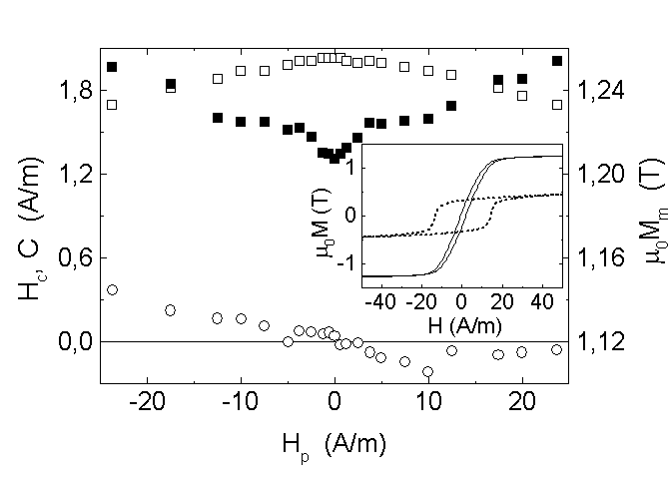
However, recent measurements on optimally annealed (nanocrystalline) Fe_{73.5}Cu₁Nb₃Si_{15.5}B₇ ribbon (thereafter FeCuNbSiB) and amorphous VITROVAC 6025Z ribbon showed that H_{c} in the very soft magnetic materials increases with H_{p} [8].Here we show that the variations of H_{c} with H_{p} in these materials can be quantitatively explained with an improved model for the influence of H_{p} on the magnetization processes in soft magnetic ribbons.
Fig. 1. Variations of the coercive field H_{c} (), maximum magnetization M_{m} () and the position of the center of the M-H loop C (), for the nanocrystalline Fe_{73.5}Cu₁Nb₃Si_{15.5}B₇ sample, with the static surface field H_{p}. The inset: M-H loops for the same sample in the amorphous (dashed) and nanocrystalline (solid) state. The measurements were performed with a triangular drive field with amplitude H₀ = 100 A/m and the frequency f = 5.5 Hz.
2. Experimental procedure
The dimensions of the samples were 200×2×0.025 mm³ and 200×2×0.020 mm³ for the optimally annealed FeCuNbSiB and VITROVAC 6025Z ribbon, respectively. The M-H loops were measured with an induction technique at room temperature [9]. The triangular magnetizing field H with the amplitude H₀ = 100 A/m and frequency f = 5.5 Hz was used. During the magnetization process, direct (J_{D}) core current (static H_{p}) was passed along the ribbon. For FeCuNbSiB sample M-H loops and the corresponding dM/dt vs. H curves were measured both in the amorphous state and after anneal at 540°C for one hour in pure Ar gas atmosphere.
3. Results and discussion
The amorphous FeCuNbSiB samples show poor soft magnetic properties consistent with strong local magnetic anisotropy which develops during the fabrication of these ribbons [10]. Therefore (inset to Fig. 1), for H₀ = 100 A/m, the coercive field is large (H_{c0} = 13.5 A/m) and M_{m} quite low.
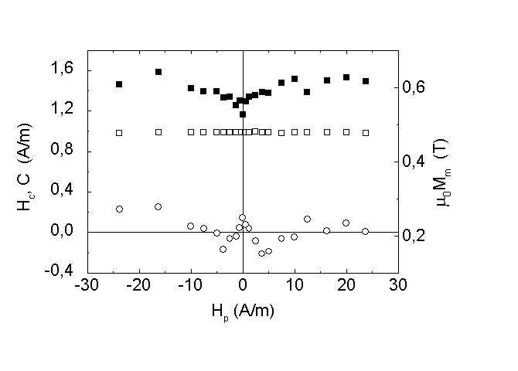
Static H_{p} causes weak linear decrease of H_{c} and does not change M_{m} and the position of the center (C) of the M-H loop [8]. These effects are consistent with strong volume pinning of DWs [10], hence the surface pinning and H_{p} have slight influence on the magnetization processes.
Fig. 2. Variations of the coercive field H_{c} (), maximum magnetization M_{m} () and the position of the center of the M-H loop C (), for the amorphous VITROVAC 6025Z sample with the static surface field H_{p}. The amplitude and the frequency of the magnetizing field were the same as in Fig. 1.
The optimally annealed FeCuNbSiB sample shows excellent soft magnetic properties (Fig. 1) [11]. Accordingly, for H₀ = 100 A/m and H_{p} = 0 H_{c} is low (H_{c0} = 1.3 A/m) and M_{m} large (M_{m} ≈ M_{s} with M_{s} the saturation magnetization). However, its H_{c} increases rapidly with static H_{p} (ΔH_{c}/ΔH_{p} ≈ 0.067) for ⎢H_{p}⎢≤ 5 A/m, but the rate of the increase of H_{c} with H_{p} slows down (ΔH_{c}/ΔH_{p} ≈ 0.023) for ⎢H_{p}⎢> 5 A/m (Fig. 1). Simultaneously, M_{m} decreases a little with H_{p}, whereas center C of the M-H loop shifts linearly with H_{p} for ⎢H_{p}⎢≤ 5 A/m and shows little change for ⎢H_{p}⎢> 5 A/m.
The nonmagnetostrictive VITROVAC 6025Z ribbon (Fig. 2) shows similar deterioration of soft magnetic properties due to H_{p}. Here, H_{c} initially increases with static H_{p} (ΔH_{c}/ΔH_{p} ≈ 0.05) for ⎢H_{p}⎢≤ 6 A/m whereas for ⎢H_{p}⎢> 6 A/m H_{c} remains constant.
These results can be explained by means of a model for the influence of H_{p} on magnetization of soft magnetic ribbons which takes into account the influence of H_{p} on intrinsic pinning of DWs and the novel effect: the H_{p}-enhanced SDS pinning of DWs [12]. The strengths of DW pinning at the opposite surfaces of the ribbon are usually not the same [13]. Therefore, we denote the magnitudes of H necessary for depinning of DWs from the upper and lower surface of the sample in the absence of H_{p} with H_{su0} and H_{sl0} respectively, and assume H_{su0} < H_{sl0}. H_{p} has two effects on H_{c}: its projection on the magnetization I of MDS domain (P = H_{p}sin<δ>) may influence the intrinsic pinning by increasing or decreasing pressure on the DW (depending on the direction of H_{p}) and simultaneously H_{p} tends to fix the directions of I of the SDS domains forming large angles with the ribbon axis which increases the DW pinning [4]. Due to difference between H_{su0} and H_{sl0} the effects of static H_{p} on H_{c} show two regimes. For lower magnitudes of H_{p} (H_{p} ≤ (H_{sl0} - H_{su0})/2tan<δ>) one obtains for H_{c} and the shift of the center C of the M-H loop [12]:

H_{c} = H_{su0} + kH_{p} (1)

C = ± H_{p} tan<δ> (2)

where k is the coefficient which shows the rate of the increase of SDS pinning due to H_{p} (for simplicity we assumed that k is the same for both surfaces of the ribbon). Therefore, H_{c} increases with H_{p} if SDS pinning is present (k ≠ 0), whereas SDS pinning has no influence on C. For larger H_{p} (H_{p} > (H_{sl0} - H_{su0})/2tan<δ>) H_{c} may increase or decrease with H_{p} depending on whether the influence of H_{p} on intrinsic pinning of DWs is larger or smaller than that on SDS pinning [12]:

H_{c} = (H_{su0} + H_{sl0})/2 + kH_{p} – H_{p} tan<δ> (3)

C = ± (H_{sl0} - H_{su0})/2 = const. (4)

whereas C is not influenced by SDS pinning.
The annealing of FeCuNbSiB sample at 540 °C leads to formation of fine Fe₃Si nanocrystalls, the local anisotropy vanishes and the sample becomes nonmagnetostrictive [11]. The excellent soft magnetic properties of the annealed sample (Fig. 1) show the absence of strong volume pinning of DWs and practically all domains (M_{m} ≈ M_{s}) participate in the magnetization processes. Therefore, the motion of MDS DWs is determined by the surface pinning centres and Fig. 1 shows the pronounced influence of SDS pinning. In particular, H_{c} increases linearly with H_{p} for ⎢H_{p}⎢≤ 5 A/m according to eq. (1) due to enhancement of SDS pinning by H_{p} which tends to fix and/or rotate the magnetizations of the SDS domains perpendicular to the ribbon axis, i.e. parallel to H_{p} [2]. This explanation is supported by simultaneous weak decrease of M_{m} with H_{p} (Fig. 1). According to eq. (1) we find k ≈ 0.067. For ⎢H_{p}⎢> 5 A/m H_{c} increases less rapidly with H_{p} due to the influence of H_{p} on intrinsic pinning of DWs (eq. (3)). However, the enhancement of SDS pinning with H_{p} overcomes that of H_{p} (i.e. P = H_{p}sin<δ>) on depinning of DWs due to smallness of angle<δ>. Indeed from the slopes of H_{c} vs H_{p} for ⎢H_{p}⎢>/< 5 A/m by the use of eqs. (1) and (3) we find rather small angle <δ> = 2.4°. This result confirms that the main mechanism of the magnetization is the movement of 180°-DWs of MDS [2].
The nonmagnetostrictive VITROVAC 6025Z ribbon has also very good soft magnetic properties (H_{c} = 1.4 A/m and M_{m} ≈ M_{s} at H₀ = 100 A/m) but H_{p} deteriorates its soft magnetic properties (Fig. 2). The increase of H_{c} with H_{p} for H_{p} ≤ 6 A/m, shows strong influence of SDS pinning on the dynamics of DWs. By using eq. (1) we can estimate k ≈ 0.05 for this sample. However, for H_{p} > 6 A/m H_{c} is practically independent of H_{p}, which means that the enhancement of SDS pinning with H_{p} is approximately the same as the influence of H_{p} (P) on the depinning of DWs of MDS. According to eq. (3) H_{c} is constant if k = tan<δ> which yields <δ> ≈ 2.8°.

4. Conclusion

Due to small angles <δ> between the magnetizations Of MDS domains and ribbon axis (<δ> < 3° for both samples) the dominant magnetization mechanism in nanocrystalline FeCuNbSiB and amorphous VITROVAC 6025Z ribbons is the motion of 180°/DWs of MDS. However, a static surface field H_{p} enhances the SDS pinning of DWs in these samples. This effect may ruin their soft magnetic properties when exposed to oblique external fields [6]. On the basis of an extended model for the influence of H_{p} on the parameters of the M-H loops, we find that the negative effects of oblique fields on H_{c} can be attenuated for instance by the introduction of uniaxial anisotropy, which would increase somewhat the angle <δ> and hence enhance the direct influence of H_{p} (or similar oblique field) on the intrinsic pinning of DWs.

References

[1] P. Schönhuber, H. Pfützner, G. Harasko, T. Klinger, K. Futschik, J. Magn. Magn. Mater. 112 (1992) 349.
[2] P. T. Squire, J. Magn. Magn. Mater. 87 (1990) 299.
[3] T. Sato and T. Yamada, IEEE Trans. Magnetic 28 (1992) 2775.
[4] K. H. Stewart, Ferromagnetic Domains (Cambridge University Press, Cambridge, 1954) p. 165.
[5] A. Hernando, M. Vazquez and J. Barandiaran, Journal of Physics E 21 (1998) 1129.
[6] P. Tiberto, F. Vinai, O Rampado, H. Chiriac and T. A. Ovari, , J. Magn. Magn. Mater. 196-197 (1999) 388.
[7] S. Sabolek, E. Babić and M. Šušak, J. Magn. Magn. Mater. 149 (1995) 331.
[8] S. Sabolek, E. Babić, D. Posedel and M. Šušak, Sensors and Actuators A 106 (2003) 65.
[9] J. Horvat, Ž. Marohnić and E. Babić, J. Magn. Magn. Mater. 82 (1989) 5.
[10] H. Kronmüller, J. Magn. Magn. Mater. 24 (1981) 159.
[11] G. Herzer, Physica Scripta T 49 (1993) 307.
[12] S. Sabolek, E. Babić, D. Posedel and M. Šušak, IEEE Trans. Magn., submitted.
[13] J. J. Becker, J. Appl. Phys. 52 (1981) 1905.

  ∗Corresponding author. Tel. : +385-1-460-5555: fax: +385-1-468-0336. E-mail address; sabolek@phy.hr (S. Sabolek)

