KATABATIC FLOW WITH CORIOLIS EFFECT

Ivana Stiperski¹, Iva Kavčič², Branko Grisogono²

¹Croatian Meteorological and Hydrological Service, Grič 3, 10000 Zagreb
²Department of Geophysics, Faculty of Science, University of Zagreb, Horvatovac bb, 10000 Zagreb
E-mail: stiperski@cirus.dhz.hr

Abstract Katabatic flows on long glaciers in high latitudes experience the Coriolis effect deflecting the flow thus affecting turbulent transports in the boundary layer. Analytically katabatic flows have been best represented by Prandtl model. However, the classic Prandtl model does not take into account the effect of the Coriolis force. It is found that after a straightforward inclusion of this effect, the solution to the model is correct only up to a constant, and does not simultaneously satisfy all boundary conditions. Therefore, a modified analytic Prandtl model is examined. The modified approximate solution agrees with a numerical solution, and qualitatively, with the results of other related studies. Besides a theoretical significance, our approximate analytic solution can be useful for developing a better parameterization in climate models having a poor vertical resolution for such shallow but persistent flows.

Keywords Katabatic flow, Coriolis force, Prandtl model

1. INTRODUCTION

Katabatic flow is a prominent feature of stable atmospheric boundary layers on inclined radiatively cooled surfaces, especially glaciers. Due to its intensity and persistence it is a major factor in determining the climate of Antarctic and Greenland, and microclimate of other relatively smaller cool surfaces. It is characterized by a pronounced low level jet and sharp near surface temperature gradient.
The simplest model of the katabatic flow represents a balance between negative buoyancy due to the surface potential temperature deficit, as the driving force, and turbulent drag that dampens the flow (e.g. Egger 1990). On longer glaciers and higher latitudes the Coriolis effect also becomes important for the katabatic flow balance leading to the occurrence of a cross-slope wind component. Cross-slope wind is balanced by the Coriolis force and turbulent dissipation. Its vertical scale is larger than the characteristic hight of the low-level jet of the down-slope component. Measurements indicate its considerable strength (van den Broeke et al. 2002). An association with the circum-polar vortex on Antarctica has also been suggested (van den Broeke and van Lipzig 2003). We tackle the problem analytically by extending and modifying Prandtl model. A new approximate solution will be offered and discussed.

2. ANALYTIC MODEL

Probably the best model for pure katabatic flow is Prandtl model (Egger 1990, Parmhed et al. 2004). Its simplicity, analytic solution while still retaining all the essentials of the katabatic flow, makes it a suitable tool for studying the influence of different factors on katabatic flows as well as for parameterizations of these flows. Inclusion of Coriolis effects into this linear model has as far as we know not been done analytically yet. An attempt to do a simple linear superposition fails; also the resultant cross-slope solution does not satisfy the upper boundary condition (B.C.) dictating a decaying solution.

2.1 Prandtl Model with f ≠ 0

The set of equations forming Prandtl model is extended to include the Coriolis force. Because of this inclusion another equation (eqn) is added to the system, as in Denby (1999); hence:
$0=\frac{g}{θ0}\text{sinα θ}+\text{fcosα V}+\text{KPr}\frac{d^{2}U}{{dz}^{2}}$ (1)

$0=−\text{fU}+\text{KPr}\frac{d^{2}V}{{dz}^{2}}$
(2)

$0=−Uγ\text{ sinα }+K\frac{d^{2}θ}{{dz}^{2}}$
. (3)

Here x is down the slope, z is perpendicular to the slope, α is the constant slope angle (positive counterclockwise, here negative), U is the down- and V is the cross-slope component respectively, θ is the potential temperature deficit (total minus the background prescribed potential temperature), K is constant eddy conductivity, f is Coriolis parameter, γ is constant lapse rate, Pr is constant Prandtl number, g is acceleration due to gravity and θ₀ is a reference temperature. We already have the solution with variable K using WKB method (e.g. Grisogono and Oerlemans 2002), but this in now skipped for simplicity. The system transforms into a single 4th order governing eqn, as in Prandtl or Ekman model:
$\frac{d^{4}θ}{{dz}^{4}}+κ^{4}θ=0$
(4)

$κ^{4}=\frac{N^{2}{\text{Prsin}}^{2}α+f^{2}\text{cos}α}{K^{2}{\text{Pr}}^{2}}$
(5)

Note that κ⁴ contains the f-term, which is a novelty here. If C is the surface potential temperature deficit, negative and constant (since 1D steady solution is sought), then the B.C. are

θ(z=0)=C, θ(z→∞)=0, U(z=0)=V(z=0)=U(z→∞)=V(z→∞)=0. (6)

The straightforward solutions to (1) through (3) are:
$θ={\text{Ce}}^{\frac{−κz}{\sqrt{2}}}\text{cos}(\frac{κz}{\sqrt{2}})$$U=\frac{\text{CK}κ^{2}}{γ\text{sin}α}e^{\frac{−κz}{\sqrt{2}}}\text{sin}(\frac{κz}{\sqrt{2}})$

, (7)
$\text{ V}=−\frac{\text{fC}}{\text{Pr}γ\text{sin}α}(1−e^{\frac{−κz}{\sqrt{2}}}\text{cos}(\frac{κz}{\sqrt{2}}))$

(8)

where Prandtl layer height is h_{p}=2^{1/2}/κ . Obviously, U and θ retain their previous forms given by Prandtl model, e.g. Egger (1990). The V solution satisfies (1) to (3) only up to a constant while not fulfilling the physically meaningful upper B.C. Namely, V in (9) goes to a nonzero constant instead of 0 as z→∞. It is physically meaningless that a boundary layer flow forces the whole atmosphere, though they may interact. Thus, we conclude that the system as it is now, is not a suitable representation of katabatic flow if f ≠ 0, i.e. (1), (2), (3) and (6) do not form a well posed mathematical problem. The reason lies in the degeneracy of the system from the 6th to the 4th order while there are the six B.C. This system degeneracy stems from the simplifications involved (linearization, no advection, no other forces but buoyancy, turbulent friction and Coriolis), not from the coordinate transformation as such. The latter was done in a tensor form as in e.g. Denby (1999). Because (1) through (3) still reveals much of the underlying physics, a modification to the model solution is sought.

2.2. Modified System and Results

Numerical solution of (1) to (3) is obtained (e.g. Grisogono and Oerlemans 2001) and displayed in an example in Fig.1 for the B.C. in (6). It suggests that the cross-slope component (V) decays with height, unlike (8), thus our trial approximate solution is:

$\text{ V}=−\frac{\text{fC}}{\text{Pr}γ\text{sin}α}e^{\frac{−z}{\text{he}}}(1−e^{\frac{−κz}{\sqrt{2}}}\text{cos}(\frac{κz}{\sqrt{2}}))$
(9)

where h_{e} = (2KPr/f)^{1/2} is Ekman layer height. Figure 1 compares the numerical solution with (7) and (9) for (α,γ,K,Pr,C)=(-4°,4∙10⁻³Km⁻¹,1m²s⁻¹,1.1,-8°C). Our guess for (9) follows from Mahrt and Schwardtfeger (1970) who used a vertically decaying V modeling the thermal wind over the Antarctic boundary layer. Moreover, data and numerical simulations by Denby (1999) seem to imply (9). Finally, f- and K-terms enter (1) and (2) in a similar way as in Ekman layer dynamics. Hence, it is reasonable to expect the wind perturbations decaying as exp(-z/h_{e}) - if not faster - due to negative buoyancy and static stability. Observations on a few glaciers on Island and Antarctica (van den Broeke et al. 2002, van den Broeke and van Lipzig 2003, Denby 1999) are not inconsistent with (9). Other two examples in Fig. 2 vary α and γ. The respective numerical solutions behave in a similar way to that in Fig. 1 (not shown). Our proposed solution in Fig. 2 is in accord with physical intuition: for the steeper slopes and more stratified atmospheres the katabatic flows are thinner, V is weaker than U extending over a thicker layer.

We believe that (9) satisfying the B.C. in (6) is an improvement to (8). Although (9), at its best, satisfies (1) through (3) only approximately, it is physically appealing because it senses both Prandtl and Ekman layer, where roughly h_{e} ~ 4 h_{p} depending on the input parameters.
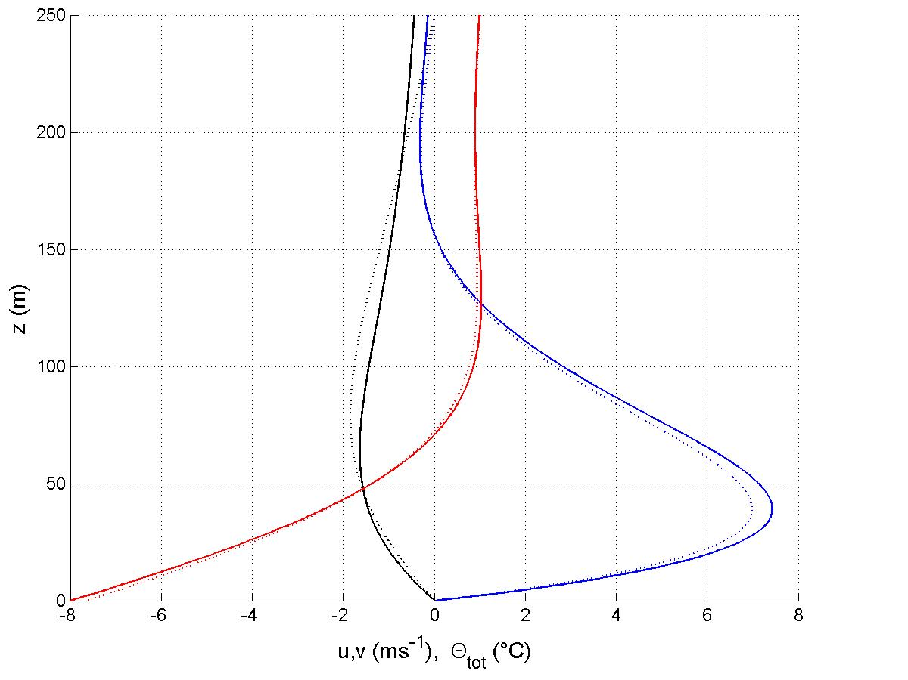

Figure 1. Numerical (dotted) vs. analytic (solid) solution for Prandtl model with f=1.1∙10⁻⁴ s⁻¹, other parameters are (-α,γ,K,Pr,C) = (-4°,4∙10⁻³Km⁻¹,1m²s⁻¹,1.1,-8°C). Here U in blue, V in black and θ_{tot} = θ + γz in red are shown.

3. CONCLUSION

Probably the best model for studying katabatic flows is that of Prandtl. It is shown that Prandtl model including the Coriolis effect, f ≠ 0, is mathematically not well defined. However, because much of the underlying physics is contained in this model, (1) through (3), we here enforce an approximate analytic solution, (7) and especially (9), all for the B.C. (6). The trial solution (9) is based on: the numerical solution shown in Fig. 1, other studies, and a physical reasoning that both Prandtl and Ekman layer dynamics should be involved. The solution can be used for studying katabatic flows, surface flux parameterizations, etc.
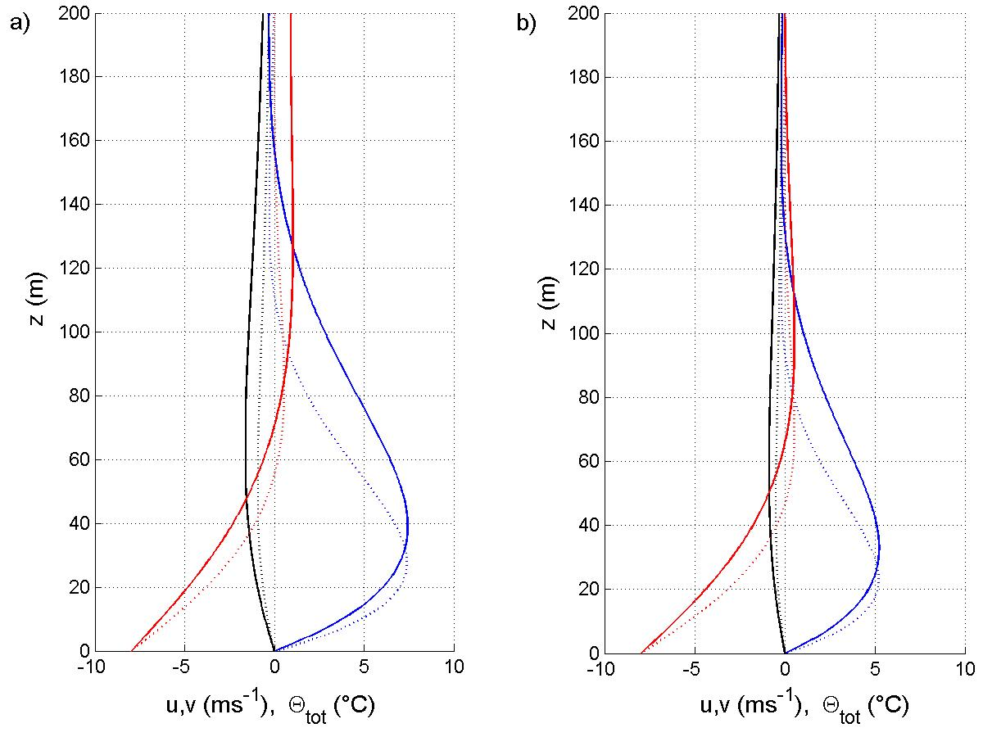

Figure 2. Analytic solution as in Fig. 1 but for a) α = -4° (solid) and α = -8° (dotted), and b) as in a) but for γ = 8 ∙10⁻³Km⁻¹. The respective numerical solutions behave like that in Fig. 1 (not shown).

References

Denby, B., 1999: Second-Order Modelling of Turbulence in Katabatic Flows. Bound.-Layer Meteorol., 92, 65-98.

Egger, J., 1990: Thermally Forced Flows: Theory. Atmospheric Processes over Complex Terrain, Meteor. Monogr., No. 45. Amer. Meteorol. Soc., 43-57.

Grisogono, B. and J. Oerlemans, 2001: A Theory for the Estimation of Surface Fluxes in Simple Katabatic Flows. Q.J.R. Meteorol. Soc., 127, 2725-2739.

Grisogono, B. and J. Oerlemans, 2002: Justifying the WKB Approximation in the Pure Katabatic Flows. Tellus, 54A, 453-462.

Mahrt, L. and W. Schwardtfeger, 1970: Ekman Spirals for Exponential Thermal Wind. Bound.-Layer Meteorol., 1,137-145.

Parmhed, O, J. Oerlemans and B. Grisogono, 2004: Describing the Surface Fluxes in the Katabatic Flow on Breidamerkurjokull, Iceland. Q.J.R. Meteorolol. Soc., 130, 1137-1151.

Van den Broeke, M.R., N.P.M. van Lipzig and E. van Meijgaard, 2002: Momentum Budget of the East Antarctic Atmospheric Boundary Layer: Results of a Regional Climate Model. J.Atmos.Sci., 59, 3117-3129.

Van den Broeke, M.R. and N.P.M. van Lipzig, 2003: Factors Controlling the Near-Surface Wind Field in Antarctica. Mon. Wea. Rev., 131, 733-743.

