Dielectric spectroscopy of genomic DNA solutions

T.Vuletić^{1,*}, S.Tomić¹, S.Dolanski Babić², S.Krča³, D.Ivanković³, L.Griparić⁴

¹Institut za fiziku, Zagreb, Croatia
² School of Medicine, University of Zagreb, Croatia
³ Institut Rudjer Bošković, Zagreb, Croatia
⁴Dept. of Biological Chemistry, UCLA School of Medicine, Los Angeles, USA
*tel:+38514698836, mob:+38598517235, fax:+38514698889, tvuletic@ifs.hr

Background/aim: The transport of electrical signals in bio-materials, and in particular in the key biological molecule Deoxyribonucleic acid (DNA), on a molecular scale is of fundamental interest in the life sciences. The highly anisotropic structure of DNA implies that the conduction process should be extremely sensitive to the internal structure and to the local environment of the DNA double helix. The aim of this research is to contribute in revealing the dynamical properties of native DNA as a function of its aqueous environment, like electrolyte concentration, counter-ion and pH.
Methods: We employed low frequency dielectric spectroscopy in the frequency range of 100 Hz to 100 MHz (LFDS) in conjunction with home-made chamber for samples in solution. LFDS is a non-destructive tool, which can be used for detecting and quantifying the polarization response of DNA in liquid environment. Because DNA is a highly charged molecule, in an applied low-frequency ac electric field, its polarization response, in combination with the motion of the surrounding ions, can be substantial.
Results: The home-made chamber is designed for measurement of liquid samples of small volume, 50-200 μL, having conductivity in the range of 2- 2000 μS/cm. Temperature stabilization is ±10 mK in the range of -20 - +60 ºC. Reproducibility is 1.5% and the measured sample stability is achieved on the time scale of 2 hours. We will show results obtained
on (1) a wide concentration range of salmon sperm Na-DNA solutions in pure water, and on (2) a wide concentration range of pure lyophilized (no buffer) calf thymus DNA solutions in pure water and in NaCl electrolyte.
Conclusions: We discuss the possible assignments of observed relaxation modes taking into account the value and the concentration dependence of the dielectric relaxation parameters obtained from fits to the generalized Debye function (the dielectric strength, the central relaxation time and the distribution of relaxation times).

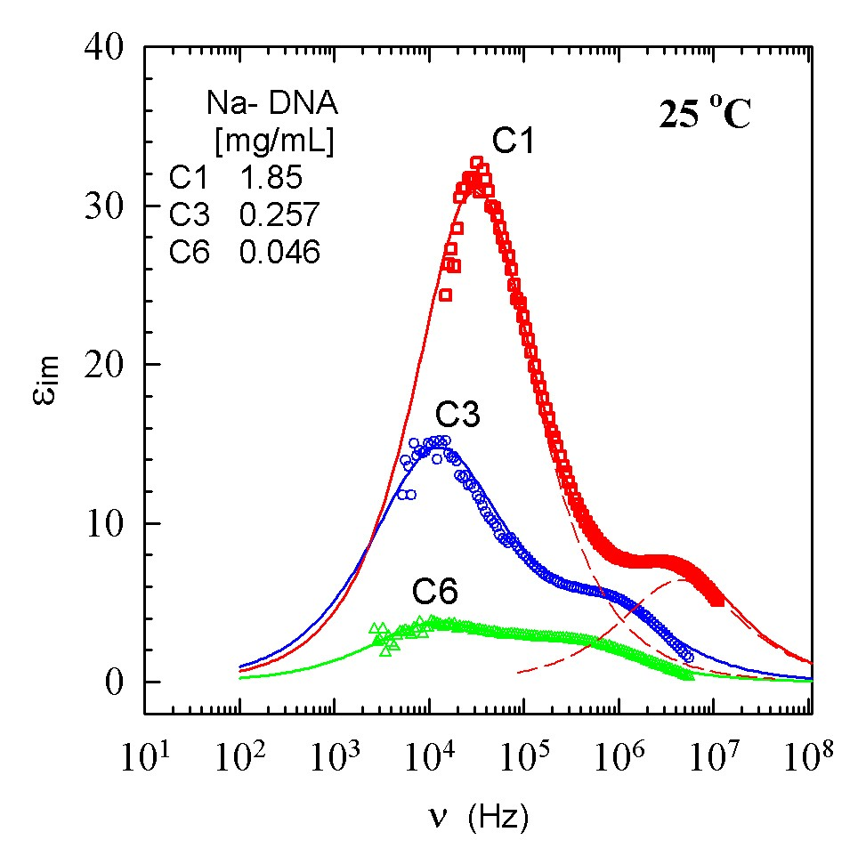

Fig. 1. Frequency dependence of the real part of the dielectric function for three selected Na-DNA concentrations. Two relaxation modes in the range 10kHz-10MHz are found. Full lines are from fit to the sum of two generalized Debye functions. Each of these is represented by dashed lines for solution C1 as an example.

