MATHEMATICAL MODELLING OF CUTTING FORCES IN THE LONGITUDINAL TURNING PROCESS
Roko Cebalo
Dražen Bajić
Boženko Bilić
Prof. dr. sc. R. Cebalo, University of Zagreb, FSB, I. Lučića 1, 10000 Zagreb
Prof. dr. sc. D. Bajić, University of Split, FESB, R. Boškovića bb, 21000 Split
Prof. dr. sc. B. Bilić, University of Split, FESB, R. Boškovića bb, 21000 Split
Key words: cutting parameters, longitudinal turning, cutting forces

ABSTRACT
Cutting forces are one of the most basic productivity features and as such represent important criteria in the optimization and control of a cutting process. This paper deals with the influence analysis of cutting parameters (cutting speed, depth and feed) on the cutting forces for the case of longitudinal turning. Second order central composite experimental design was used for the analysis and mathematical modeling. The outputs from the mathematical model were compared with the outputs resulting from the use of Kienzl’s tangential cutting force equation.
1. INTRODUCTION
Obstacle that is significant for successful exploitation of modern machine tool systems is the absence of reliable technology data needed for their programming. Illusion exist that in this computer age there is no need for in depth knowledge of machining. On a contrary in these novel market conditions there is a need for developing new laws of: machining, cutting abilities of highly productive tools, materials, etc. Modern machine tool systems are required to function with high reliability and effectiveness which depend on the quality of the inputs: machinability of a material, stiffness of a machine tool system, optimal cutting parameters, surface roughness, tool wear law, etc. Data related to machinability of a material are hard to find and they lack on reliability. The main reason for this is long and expensive experiments needed to determine machinability of a material. Machinability of a material cannot be easily and unambiguously determined and quantified. It is more a process that is largely influenced by many physical phenomena that are related to the: tool, energy transformation, etc. There is more complexity in this and it results from the influence of many effects and interactions. It is hard of even impossible to bring all of the effects to positive influence. It could be said that machinability is higher if larger number of effects achieved more positive influence. Few significant effects could be researched with the use of factorial experiments while the influence of other effects must be researched partially. The important criteria for evaluating the machinability of a material are cutting forces developed during the machining process. Machining process is highly influenced by the cutting forces. Knowledge of the forces and power involved in cutting operations is important for the following reasons :
– power requirements have to be determined so that a motor of suitable capacity can be installed in the machine tool,
– data on forces are necessary for the proper design of machine tools for cutting operations that avoid excessive distortion of the machine elements and maintain desired tolerances for the machined parts,
– whether the workpiece can withstand the cutting forces without excessive distortion has to be determined in advance.
By knowing the function of the cutting forces the following is assured: the rational design and economic exploitation of production resources, optimal machining process and development of adaptable machine tool control systems.
2. IMPACT FACTORS ON CUTTING FORCES
A general discussion of the forces acting in metal cutting is presented by using the example of a typical turning operations. When a solid bar is turned, there are three forces acting on the cutting tool, Figure 1:
– tangential force, F_{c},
- longitudinal force, F_{f},
- radial force, F_{p}.
Tangential force acts in a direction to the revolving workpiece and represents the resistance to the rotation of the workpiece. In a normal operation, tangential force is the highest of the three forces and accounts for 99% of the total power required by the operation. Longitudinal force acts in the direction parallel to the axis of the work and represents the resistance to the longitudinal feed of the tool. Longitudinal force is usually about 50% as great as tangential force. Since feed speed is usually very low in relation to the speed of the rotating workpiece, longitudinal force accounts for only about 1% of total power required. Radial force acts in a radial direction from the centerline to the workpiece. The radial force is generally the smallest of the three, often about 50% as large as longitudinal force. Its effects on power requirements is very small because speed in the radial direction is negligible.
Impact factors on cutting forces are:
- hardness and toughness of workpiece material,
- cutting tool geometry (angles α, γ, λ, κ, nose radius r_{ε}),
- size and type of chip,
- cutting speed v_{c} and
- cooling and lubrication.
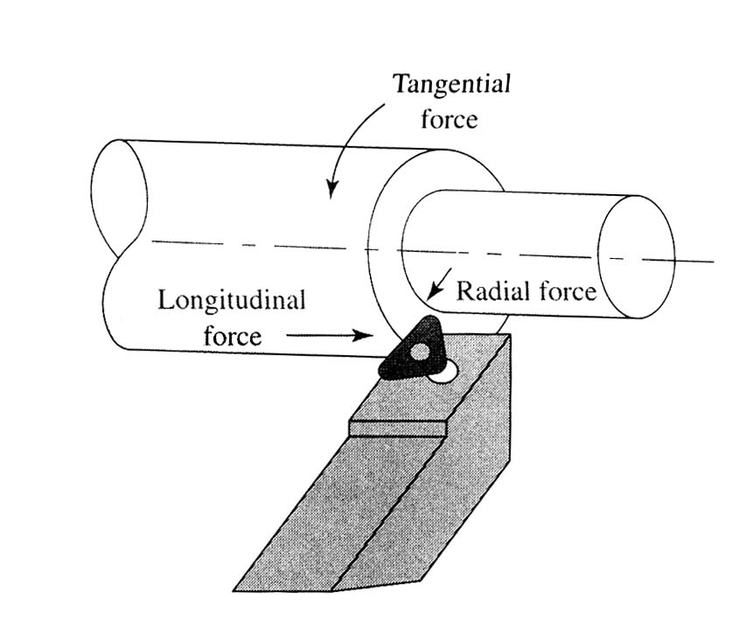
Figure 1. – Typical turning operation showing the forces acting on the cutting tool
Almost in every case it could be found that cutting forces are larger for stronger materials but this increment in cutting forces is not proportional to a material strength. The cause for this comes from the fact that when a material hardness is increased its plasticity is decreased which results with a lower compression ability of a material. It could be stated that during the machining of a material that has a doubled strength with unchanged conditions the cutting forces do not double. A material strength and also the cutting forces with it are changed with a heat treatment.
Cutting force components are decreased when rake angle γ is increased. Beside the rake angle, significant influence also has cutting speed v_{c}. Influence of a rake angle is decreased when cutting speed is increased. The influence of the relief angle α on the cutting forces is minimal only if the angle α is not small enough to cause friction between the back surface of the tool and the work piece. Large relief angle decreases the strength of the cutting wedge. The influence of the back rake angle λ on the cutting forces could only be seen for larger values and it has no influence on the cutting forces when λ = –10° ÷ +10°. When angle λ has large negative value the cutting force component F_{p} is significantly increased that is undesirable when half stabile work pieces are being machined. When lead angle κ increases the tangential and radial forces decrease while the longitudinal force increases also. The influence of the chip breaker is such that results in the increase of the cutting force by 10÷20 %. The reason for this is because of the compression of a chip against the step. Influence of the nose radius r_{ε} on the cutting forces is such that by increasing this radius the tangential force is decreased while the longitudinal and radial cutting forces are increased.
Larger cutting forces are encountered for larger intersection areas of a removed chip. Research results show that cutting forces do not increase proportional with the increase in the intersection area of a removed chip. The reason for this could be found in a smaller compression of a removed chip when intersection area is increased. Large influence on the cutting forces, beside the intersection area, has the depth/feed proportion. If the intersection area is constant the case with the larger depth/feed proportion results with the larger main cutting force component than the case with the smaller depth/feed proportion.
In a case of steel turning it could be seen that small increase of the cutting forces follows the increase of the cutting speed when the latter approaches the value of 0,83 [m/s]. When the value is reached the cutting forces start to decrease. This effect depends upon the value of the rake γ and also on the value of the cutting speed. If the cutting speed is further increased the tangential force decreases until the value of 3,3 m/s, but the tangential cutting force is different for different values of the angle γ. It is explained with a fact that material becomes stronger if the removed chip is heated on temperatures in a range of 450÷850 K. Further increase in the cutting speed from 3,3 m/s to 8,3 m/s has no what so ever effect on the cutting forces. Depending on the physical and chemical composition of the used coolants and lubricants they further decrease the cutting forces.
- THE AIM, METHODOLOGY AND CONDITIONS OF EXPERIMENT
Experiment aim is to define adequate mathematical model that is used to determine the influence of independent factors and cutting data, at cutting force, tangential, longitudinal and radial component. The following independent factors are selected: cutting speed (v_{c}), depth of cut (a_{p}), and feed (f), as it is shown in Figure 2. For a concrete case, that means determination of criteria:
– tangential force: F_{c} = f(v_{c}, a_{p}, f),
– longitudinal force: F_{f} = f(v_{c}, a_{p}, f),
– radial force: F_{p} = f(v_{c}, a_{p}, f).
Figure 2. – Scheme for cutting forces modeling
Experiments are performed in laboratory for machine tools of Faculty of electrical engineering, mechanical engineering and naval architecture, University of Split, at universal lathe machine “PRVOMAJSKA” D-420/1500. For test piece material, a steel 34CrNiMo6 was selected. The experiments are carried out by the tool for external machining that consists of: toolholder mark PTGNR 2020K 16 and insert mark TNMG 16 04 08 - PF 4015. The measurement of cutting forces was made by three component measuring gauge manufactured by “Kistler” (Type 9257 A, S:160279). The multifactor design of the second degree has been used to carry out this experiment. Actually, in order to learn more about the maximum or minimum of the process or its function it is necessary to approximate it by the polynomial of the second rather than the polynomial of the first degree.
The selected values of the cutting parameters are the following:
– cutting speed: v_{c,max} = 2,0525 (m/s)
v_{c,min} = 0,821 (m/s)
– depth of cutt: a_{p,max} = 1,2 (mm)
a_{p,min} = 0,6 (mm)
– feed: f_{max} = 0,28 (mm/r)
f_{min} = 0,16 (mm/r).
Central composite design with empiric polynomial model of the second degree is taken:
$y=b_{0}+\sum_{i=0}^{k}{b_{i}⋅x_{i}}+\sum_{1≤i⊲j}^{k}{b_{\text{ij}}}⋅x_{i}⋅x_{j}+\sum_{i=1}^{k}{b_{\text{ii}}}⋅x_{i}^{2}$ (1)
–- b₀, b_{i}, b_{ij}, b_{ii} – regression coefficient,
– x – coded values of input parameters.
In order to get regression equation determined by polynomial of the second degree using the statistics analysis, it is necessary to expand the design matrix with some other physic factor values or rather to increase the number of experimental points which is to get by rotatability character. Rotatability can be selected by an appropriate choice of coefficient, marked by α_{α} value of which depends upon the number of the points of factorial design. For k = 3 the given value of α_{α} = 1,682. The needed experimental points number, as far as the design of the second degree is concerned, figure out the following:
$N=2^{k}+n_{0}+n_{α}=\text{20}$ (2)
2^{k} – the design number within the basic points
n₀ – the repeated design number of the average level, n₀ = 6
n_{α} – the design number on the central axes, n_{α} = 6
Adding the points to the central axes where x_{i} = ± α_{α}, and α_{α} = 1,682, the 3-factorial design can be presented in Table 1.
Table 1. – Physic values and coded indexes of input factors
Input factors | Coded values of input factors
Input factors | x_{-iα} | x_{-i,min} | x_{-i0} | x_{i,max} | x_{+iα}
Input factors | -1,682 | -1 | 0 | +1 | +1,682
x₁ = v_{c} [m/s] | 0,401 | 0,821 | 1,4367 | 2,0525 | 2,4724
x₂ = a_{p} [mm] | 0,4 | 0,6 | 0,9 | 1,2 | 1,4
x₃ = f [mm/o] | 0,12 | 0,16 | 0,22 | 0,28 | 0,32
- EXPERIMENTAL RESULTS AND STATISTICS ANALYSIS
Measured values of tangential, longitudinal, and radial cutting forces, as the results of testing twenty experimental points defined by experiment plan matrix, are shown in Table 2. The mentioned values of cutting force are input data for mathematical modeling of results, which was made by multiple regression analysis and by using program package “Design Expert 6”.

Table 2. – Plan matrix and results of testing cutting forces

 | v_{c} | a_{p} | f | F_{c} [N] |  |  | F_{f} [N] |  | F_{p} [N]
 | [m/s] | [mm] | [mm/o] | Meas. | Calcul. | Kienzle | Meas. | Calcul. | Meas. | Calcul.
1. | 0,821 | 0,6 | 0,16 | 360 | 347,28 | 315,97 | 195 | 168,25 | 237 | 213,54
2. | 2,053 | 0,6 | 0,16 | 220 | 209,17 | 315,97 | 185 | 167,35 | 231 | 213,59
3. | 0,821 | 1,2 | 0,16 | 610 | 583,25 | 631,95 | 410 | 417,25 | 298 | 230,12
4. | 2,053 | 1,2 | 0,16 | 584 | 570,15 | 631,95 | 388 | 415,23 | 283 | 275,19
5. | 0,821 | 0,6 | 0,28 | 490 | 430,70 | 491,64 | 256 | 265,09 | 399 | 363,91
6. | 2,053 | 0,6 | 0,28 | 495 | 485,45 | 491,64 | 192 | 144,71 | 340 | 335,28
7. | 0,821 | 1,2 | 0,28 | 1080 | 1073,7 | 983,29 | 583 | 515,60 | 422 | 399,20
8. | 2,053 | 1,2 | 0,28 | 905 | 939,20 | 983,29 | 498 | 392,03 | 408 | 395,63
9. | 1,437 | 0,9 | 0,22 | 645 | 637,15 | 609,54 | 327 | 328,12 | 315 | 308,22
10 | 1,437 | 0,9 | 0,22 | 650 | 637,15 | 609,54 | 337 | 328,12 | 316 | 308,22
11 | 1,437 | 0,9 | 0,22 | 640 | 637,15 | 609,54 | 340 | 328,12 | 320 | 308,22
12 | 1,437 | 0,9 | 0,22 | 640 | 637,15 | 609,54 | 337 | 328,12 | 318 | 308,22
13 | 1,437 | 0,9 | 0,22 | 650 | 637,15 | 609,54 | 335 | 328,12 | 318 | 308,22
14 | 1,437 | 0,9 | 0,22 | 650 | 637,15 | 609,54 | 340 | 328,12 | 322 | 308,22
15 | 0,401 | 0,9 | 0,22 | 730 | 737,54 | 609,54 | 425 | 384,70 | 405 | 437,20
16 | 2,472 | 0,9 | 0,22 | 610 | 637,20 | 609,54 | 328 | 282,75 | 360 | 358,40
17 | 1,437 | 0,4 | 0,22 | 320 | 318,92 | 270,90 | 172 | 114,49 | 258 | 238,96
18 | 1,437 | 1,4 | 0,22 | 895 | 888,75 | 948,17 | 545 | 507,39 | 349 | 334,76
19 | 1,437 | 0,9 | 0,12 | 410 | 349,62 | 377,61 | 325 | 246,92 | 240 | 269,85
20 | 1,437 | 0,9 | 0,32 | 770 | 793,15 | 819,51 | 381 | 321,81 | 382 | 369,17
In this way, regression coefficients (parameters of mathematical model) were obtained and shown in Table 3, 4 and 5.
Table 3. – Results of regression analysis for tangential force F_{c}
 | VALUE | STANDARD ERROR | t-VALUE | SIGNIFICANT LEVEL
CONST. | -409,23 | 198,941691 | -4,703 | 0,0004
a_{p} | 408,85 | 142,820865 | 3,2029 | 0,0064
f | 3537,41 | 1282,066083 | 5,1982 | 0,0002
v_{c} | -56,76 | 69,572874 | 2,2197 | 0,0448
a_{p} ∙f | 3479,16 | 635,38983 | 1,3225 | 0,2088
a_{p} ∙v_{c} | -42,63 | 90,5913 | -0,4706 | 0,0487
f² | -9686,60 | 309,568736 | -3,0275 | 0,0097
v_{c}² | 16,80 | 2380,852547 | -3,4138 | 0,0046
a_{p}² | -257,46 | 140,465 | -1,8329 | 0,0940
Final mathematical model of tangential force F_{c} is obtained:
$\begin{aligned}F_{c}=−\text{409},\text{23}+\text{408},\text{85}⋅a_{p}+\text{3537},\text{41}⋅f−\text{56},\text{76}⋅v_{c}+\text{3479},\text{16}⋅a_{p}⋅f−\text{42},\text{63}⋅a_{p}⋅v_{c} \\ −\text{9686},6⋅f^{2}+\text{16},8⋅v_{c}^{2}−\text{257},\text{46}⋅a_{p}^{2}\end{aligned}$ (3)
with regression coefficient: r² = 0,98.
Table 4. – Results of regression analysis for longitudinal force F_{f}
 | VALUE | STANDARD ERROR | t-VALUE | SIGNIFICANT LEVEL
CONST. | 171,46 | 14,481441 | 12,2634 | 0,001
a_{p} | 88,83 | 12,099327 | 6,7796 | 0,001
f | -431,19 | 62,614817 | -6,8864 | 0,001
v_{c} | -65,51 | 8,007784 | -8,7137 | 0
a_{p} ∙f | 1437,5 | 53,828193 | 26,7053 | 0
a_{p} ∙v_{c} | -4,73 | 5,2852 | 0,8962 | 0,387
f ∙v_{c} | -179,32 | 26,225673 | -6,8376 | 0,001
v_{c}² | 26,92 | 1,886512 | 14,2728 | 0,001
Final mathematical model of longitudinal force F_{f} is obtained:
$\begin{aligned}F_{f}=−\text{171},\text{46}+\text{88},\text{83}⋅a_{p}−\text{431},\text{19}⋅f−\text{65},\text{51}⋅v_{c}+\text{1437},5⋅a_{p}⋅f−4,\text{73}⋅a_{p}⋅v_{c} \\ −\text{179},\text{32}⋅f⋅v_{c}+\text{26},\text{92}⋅v_{c}^{2}\end{aligned}$ (4)
with regression coefficient: r² = 0,91.
Table 5. – Results of regression analysis for radial force F_{p}
 | VALUE | STANDARD ERROR | t-VALUE | SIGNIFICANT LEVEL
CONST. | 60,13 | 30,426316 | 3,4397 | 0,0049
a_{p} | 96,63 | 21,186765 | 0,7783 | 0,4515
f | 1679,43 | 190,67102 | 8,6069 | 0
v_{c} | 150,25 | 14,046636 | -11,3898 | 0
a_{p} ∙f | 291,66 | 94,256923 | 3,0944 | 0,0093
f ∙v_{c} | -108,26 | 45,922983 | -2,3576 | 0,0362
a_{p}∙ v_{c} | -8,12 | 5,867 | -1,384 | 0,196
f² | -1951,15 | 354,52993 | -5,2572 | 0,0002
v_{c}² | 59,18 | 3,315968 | 18,1038 | 0
Final mathematical model of radial force F_{p} is obtained:
$\begin{aligned}F_{p}=\text{60},\text{13}+\text{96},\text{63}⋅a_{p}+\text{1679},\text{43}⋅f+\text{150},\text{25}⋅v_{c}+\text{291},\text{66}⋅a_{p}⋅f−\text{108},\text{26}⋅f⋅v_{c} \\ −8,\text{12}⋅a_{p}⋅v_{c}−\text{1951},\text{15}⋅f^{2}+\text{59},\text{18}⋅v_{c}^{2}\end{aligned}$ (5)
with regression coefficient: r² = 0,9931.
Measured and calculated results are compared with a Kienzle equation (6) results and also shown in Table 1 and figure 3.
$F_{c}=k_{c1\text{.}1}⋅b⋅h^{(1−m_{c})}$ (6)
$b=\frac{a_{p}}{\text{sin}κ}$ (7)
$h=f⋅\text{sin}κ$ (8)
where:
k_{c1.1},– specific tangential cutting force (for material 34CrNiMo6 k_{c1.1}=2240 N/mm²),
b – chip width,
h – chip thickness,
1-m_{c},– superscript values of tangential cutting force (for material 34CrNiMo6 m_{c}=0,21).
Figure 3. – Comparision of measured and Kienzle equation results
The analysis of obtained mathematical models and cutting data influence at cutting forces has been made using diagrams shown in Figures 4, 5, 6.
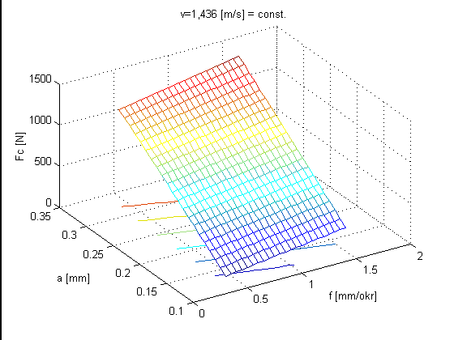 | 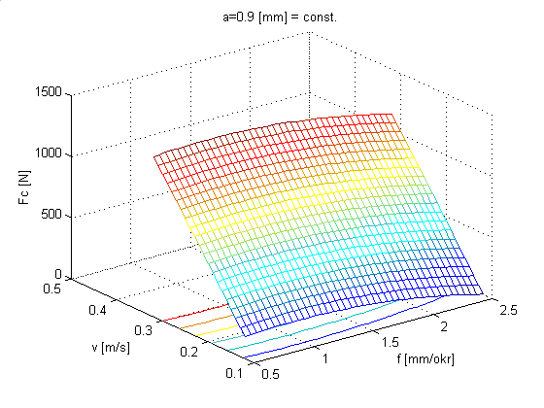
Figure 4. – Dependence of tangential force F_{c} upon impact factors
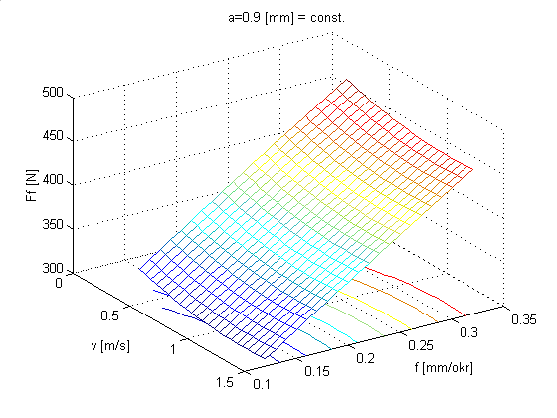 | 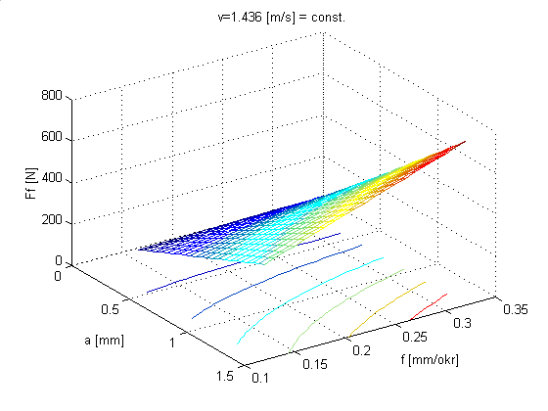
Figure 5. – Dependence of longitudinal force F_{f} upon impact factors
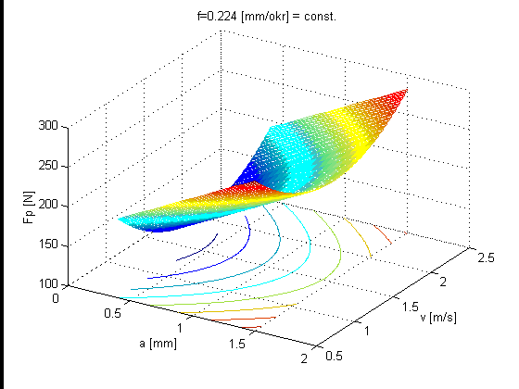 | 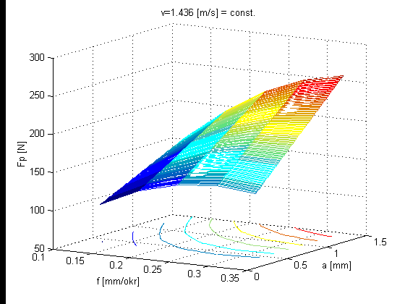
Figure 6. – Dependence of radial force F_{p} upon impact factors

4. CONCLUSION
After the experiments were conducted and statistically analyzed the mathematical model had been derived which satisfactorily fits the cutting forces. The cutting forces were also evaluated with the use of Kienzl’s tangential cutting force equation and calculation. Based on the outputs from the fitted model derived from the designed experiments conducted on a material 34CrNiMo6, calculations and Kienzl’s equation following can be stated:
– When observing the tangential force F_{c} no significant deviations could be found in the outputs from he fitted model, calculations and Kienzel’s equation.
– Increase in the radial force F_{p} is proportional to the feed f and reciprocal to the cutting speed v_{c}.
– The values of the longitudinal force F_{f} increase when the depth a_{p} is increased and on a contrary when the values of a_{p} decrease the force F_{f} also decreases. The longitudinal F_{f} is also reciprocal to the cutting speed v_{c}.
– The tangential force F_{c} is directly proportional to the parameters a_{p} and f while the effect of the cutting speed v_{c} is less influential.

5. LITERATURE
|1| D. H. Nelson, G. Schneider: Applied Manufacturing Process Planning, With Emphasis on Metal Forming and Machining, Prentice Hall Inc, Upper Saddle River, New Yersey, Ohio, 2001.
|2| D. Bajić: Doprinos poboljšanju obradivosti kod kratkohodnog honovanja, Ph.D. Thesis, University of Zagreb, FSB, Zagreb 2000.
|3| R. Cebalo: Ovisnost dubine hrapavosti o srednjoj aritmetičkoj hrapavosti brušene površine kod različitih postupaka brušenja, Strojarstvo 35(5,6) 231-235 (1993).
|4| D.C. Montgomery: Design and Analysis of Experiments, John Wiley & Sons, Inc., New York, 1997.
|5| R. Cebalo: Prepoznavanje materijala i automatsko određivanje elemenata rezanja kod tokarenja, Zbornik II, Suvremeni trendovi proizvodnog strojarstva, Zagreb, 1992.

