9th International Research/Expert Conference
”Trends in the Development of Machinery and Associated Technology”

TMT 2005, Antalya, Turkey, 26-30 September, 2005

MONITORING OF MAIN WELDING PARAMETERS AT STT WELDING PROCESS

Dr.sc. Marko Dunđer
S. Radića 16/4 Novi Travnik
Bosnia i Herzegovina

Prof.dr.sc. Ivan Samardžić
Mr.sc. Štefanija Klarić
Mechanical engineering faculty in Slavonski Brod
Croatia

ABSTRACT
The paper presents basic information of new, modern and high efficiency welding process; STT process (Surface Tension Transfer). This welding process is successfully used for performing of root passes at thick steamboilers pipes and chambers. An example of welding parameters recorded by own on-line monitoring system during performing a root pass at steamboiler chamber was explained. The sampling frequency for welding current and voltage was 2 kHz. The specific of STT welding process is application of impulse technique but with short arc metal transfer in electric arc. That is something new in relationship to other arc welding processes. The STT welding process is suitable for welding of thin plates, also. It has very low heat input what is interesting from residual stresses and deformations reduction point of view.
Key words: welding parameters, STT welding process, steamboilers, on-line monitoring system

1. INTRODUCTION
STT (Surface Tension Transfer) welding process is modern, high efficient and high quality welding process for thin wall materials joining and joining at root passes of thick materials. STT welding power source provide stabile main welding parameters during welding process which enable welding by “short circuit arc”. The material transfer in electric arc is founded on surface tension force between weld pool and melted bead in electric arc. STT unit frequently and precisely controls welding current during welding. It sets an optimal welding parameters (which are stabile) by significant changing of arc length and “stick out”. Principally, it is welding unit with possibility of welding parameters changing in milliseconds in order to obtain an optimal quality of welded joint. It is designed as a semiautomatic welding process for application where welding speed and “stick out” are variable. At STT welding process it is possible to use different shielding gases and gases mixtures (CO₂, Ar-82%+CO₂-18%, Ar-98%+CO₂-2 %,...), depending on application in praxis. Welding processes suitable for individual pipes joining and pipes joining in pipes systems (membrane wall, membrane panel) are interesting in steamboiler production which is a specific type of production due to different material types, thickness, diameters, weld joint shapes, … Conventional approach for pipes joining in steamboiler industry up to ø 88 mm is manual or automatic TIG welding process (Tungsten Inert Gas) as a single bead or multy bead process. For joining higher diameter pipes in steamboiler industry, combination of welding processes TIG + SMAW (Shielding Metal Arc Welding) or TIG + SMAW + SAW (Submerged Arc Welding) is usually used, depending on available equipment.
Manual TIG welding process is used for root passes which are the most important and the most complex from the standpoint of weldability (welding in non accessible areas, denivelation in that joint area is the most evident, gap in weld joint root must be in rigid tolerance, preheating and gas shielding from root joint pipe side aggravate welding, ...). According to some welding experts’ opinions [1], STT welding process is process which will replace manual TIG welding process in described situation.

2. MAIN CHARACTERISTICS OF STT WELDING PROCESS
STT welding proces has some differences regarding to other fusion arc welding processes: performing of welding process is in cycles, valid welding parameters seted up on power source display assure stability of electric arc and the whole welding process as a repeatibility of welding process and welding current is changinig in miliseconds, depending of process arc voltage sensing. Distribution of welding current and voltage in electric arc during the STT welding process is shown at figure 1.

Figure 1. Distribution of welding parameters in electric arc during STT welding process. [2,5]

Main advantages of STT welding process application are:
- high welding speed and higher productivity in relationship to other fusion welding processes,
- especially regarding to TIG welding process,
- lower heat input (J/mm²) in relationship to TIG welding process,
- possibility of dissimilar materials joining,
- decreasing of cold taps possibilities,
- lower number of weld stops and due to this lower possibilities of failures,
- satisfactory welding pool control during the welding,
- lower spattering and shorter cleaning of welding joint,
- possibility of different shielding gases and gases mixture application (CO₂, Ar-82%+CO₂-18%, Ar-98%+CO₂-2%, …),
- satisfactory corrosion resistance,
- lower heat and light emission,
- acceptable welding conditions for welders, etc.

3. APPLICATION OF STT WELDING PROCESS AND PROCESS DATA MONITORING
During steamboiler chamber production, main welding parameters (welding current and voltage) of semiautomatic STT welding process are recorded by On-line monitoring system. Welding process is applied during steamboiler rooth pass welding. Weld joint preparation is shown at fig. 2. Steamboiler chamber base material was 15Mo3 steel and dimensions of pipe were D × S = 244,5 x 16 mm. Affilations of chamber parts (two pipes) are made by short weld on three places (on each 120 ° of pipe circumference). Filler material was wire DMO-IG ø 1 mm and shielding gas KRYSAL 18 (Ar-82%+CO₂-18%). Welding power source was LINCOLN STT II with wire feeder LF 30. Welding parametrs setted up on STT display were:
I_{PC} = 265 A, (peak current),
I_{BC} = 65 A, (background current),
v_{z} = 3 m/min., (wire feed rate),
v = 150 mm/min (welding speed) and
Q_{gas} = 15 l/min (shielding gas flow).
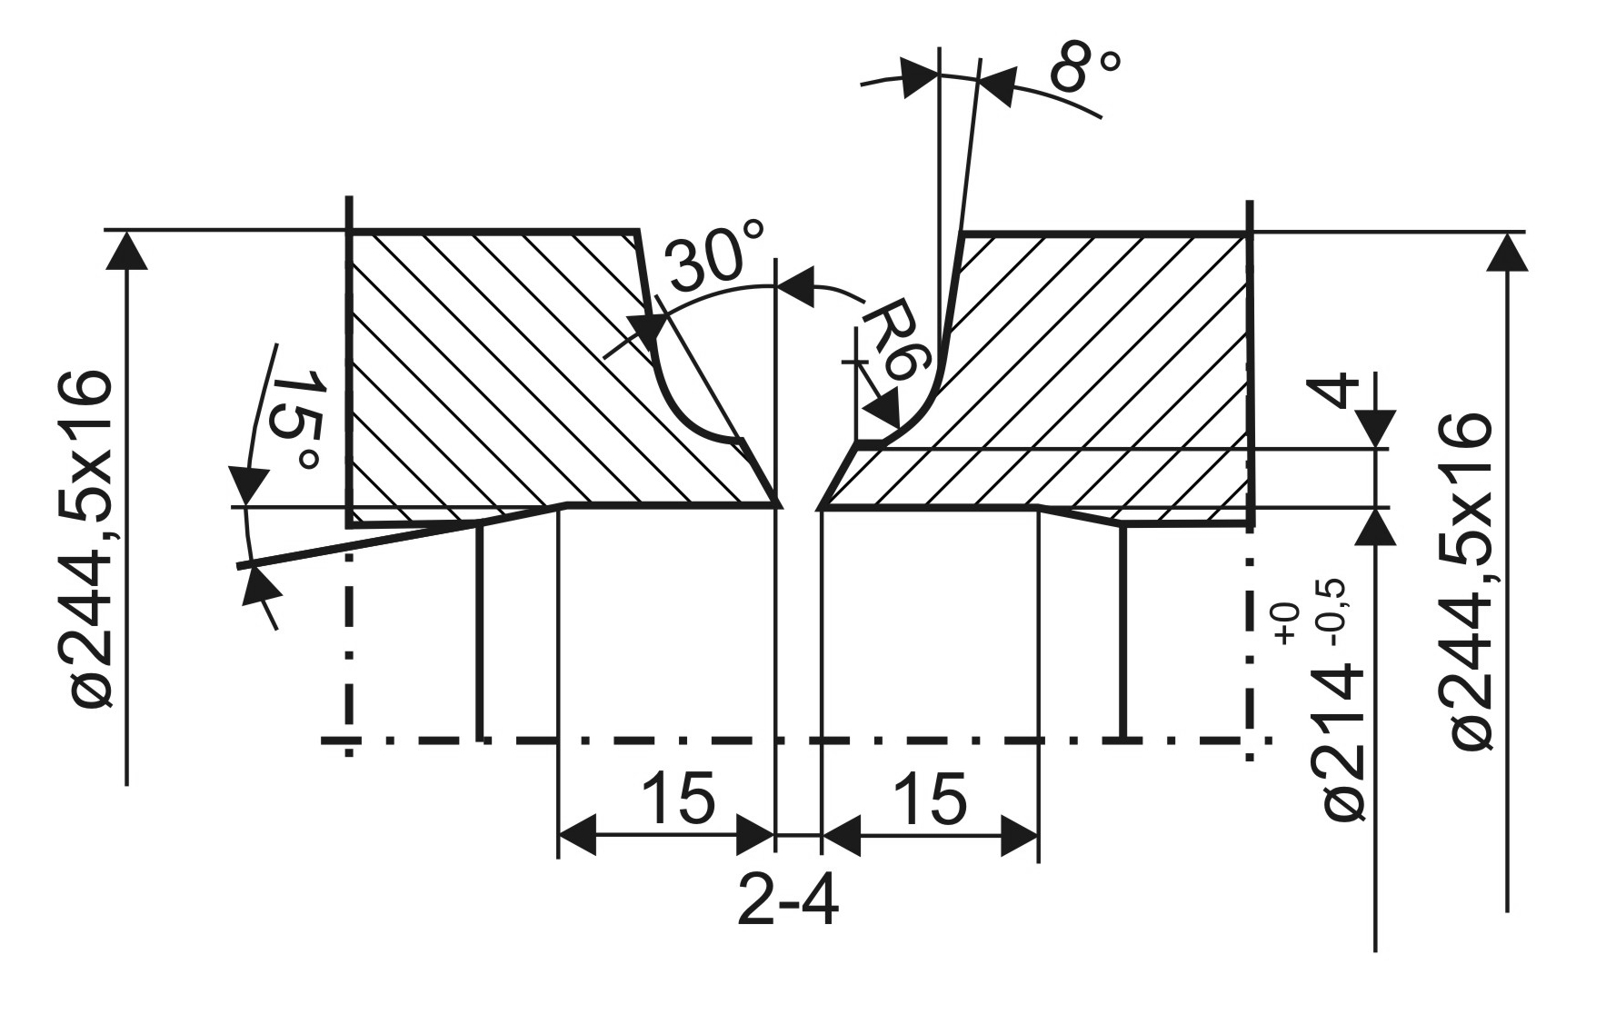

Figure 2. Shape and dimensions of pipe butt weld joint on steamboiler chamber

Welding parameters recorded by On-line monitoring system are shown at figure 4. Sampling rate during data aquisition was 20 kHz per each chanell. Based on recorded and processed data (figure 4) it is possible to conclude about weldning process stability. Based on that and output weld joint quality (figure 3) it is possible to conclude that weldability of used material and STT welding process is satisfactory.

Figure 3. In side chamber view to weld joint rooth performed by STT welding process. The weld joint quality is on high level. | 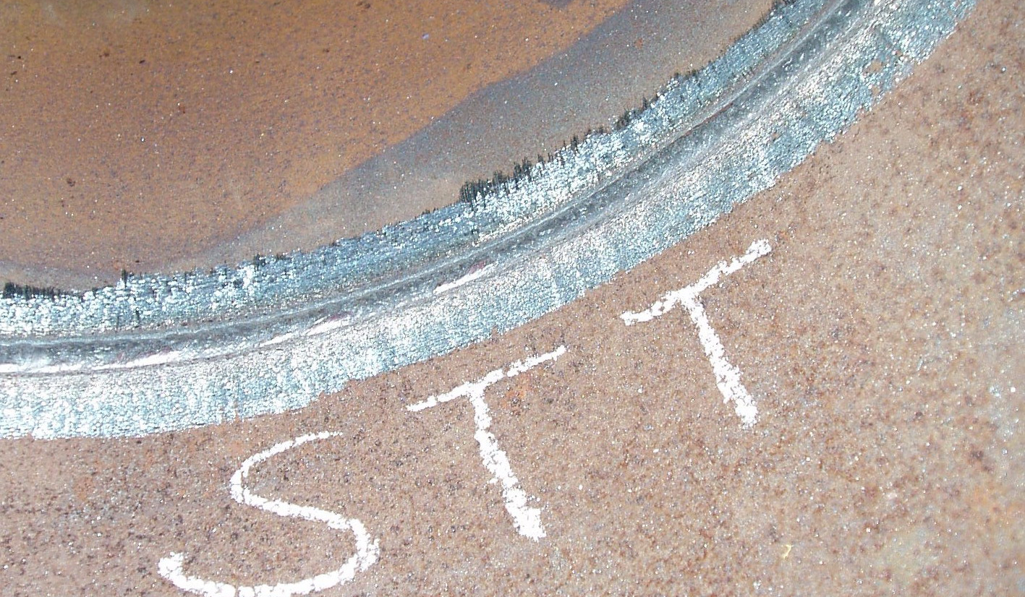

4. CONCLUSION
STT welding process was succesfuly applied in steamboiler production. The stability of welding process and weld joint output quality is acceptable, but efficiency is higher according to conventional welding technology for rooth passes performing in steamboiler production of higher diameter pipes.Authors expect wider application of this welding process for mentioned application and in other cases where advantages of STT proces are evident.

REFERENCES
1. | B. Despotović, I. Samardžić, T. Marsenić, B. Brechelmacher: Some aspects of STT welding process application in steam boiler manufacturing, 3rd International conference Mechanization, automation and robotization in welding and allied processes, Zadar, Croatia, 2005.
2. | F. Neessen, F. Naber. The GMAW – STT process – An advance welding process. Lincoln Smitweld B.V, Lincoln Electric Europe B.V. The Niederland, 2003.
3. | http://www.magnatech-lp.com/Articles/NewTechText.htm  By Elliot K. Stava & Peter Nicholson, The Lincoln Electric Co., Cleveland, OH. New Technology Speeds Oil Sands Pipe Welding, 2005.
4. | http://www.magnatech-lp.com/Articles/NewTechText.htm  D. Bruc DeRuntz Assessing the Benefits of Surface Tension Transfer® Welding to Industry, 2005.
5. | http://www.lincolnelectric.cz/oc_stt_e.htm  J. Hetych. Stt – First Source With Controlled Short – Circuitting Transfer, 2005.

a)  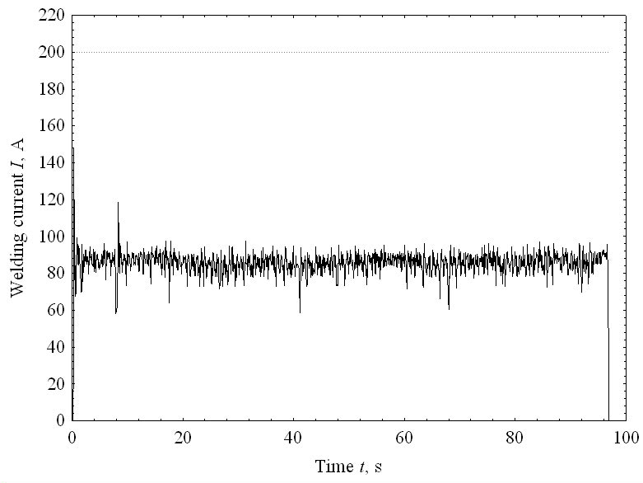 | b)  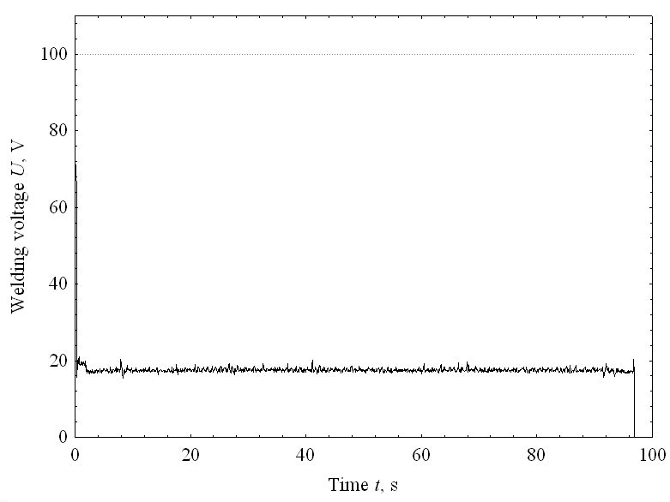
c)  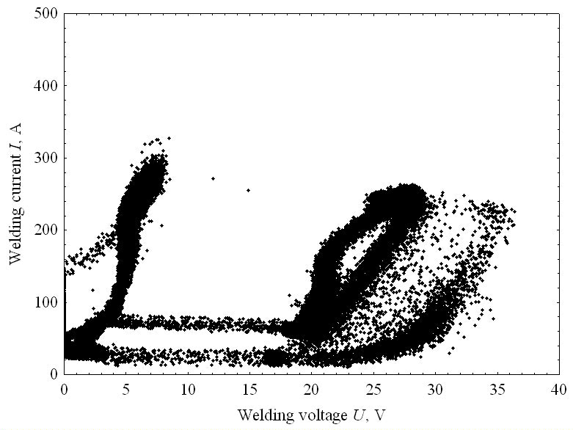 | d)  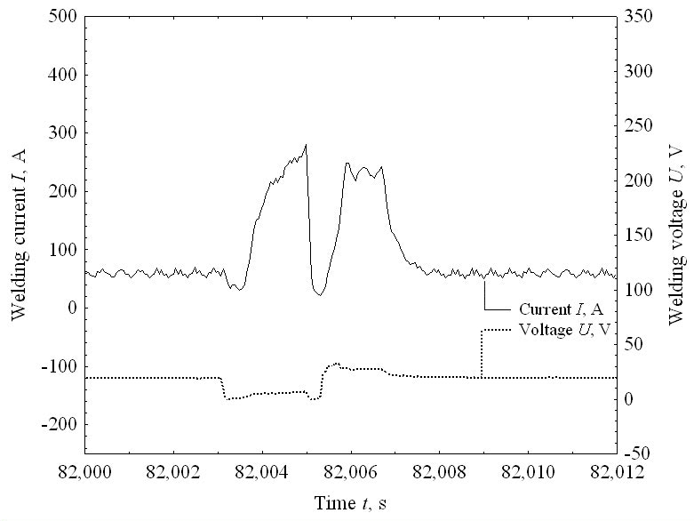
e)  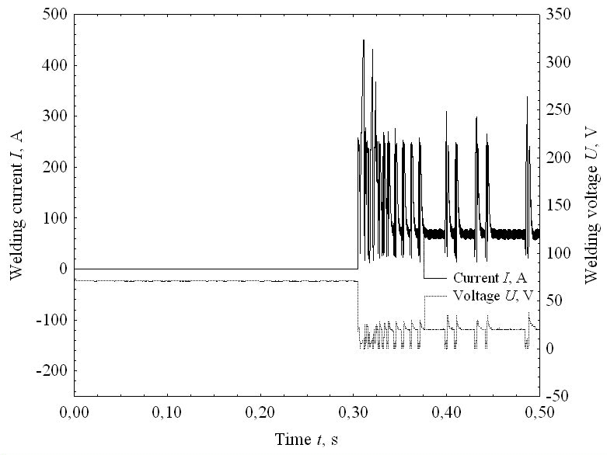 | f)  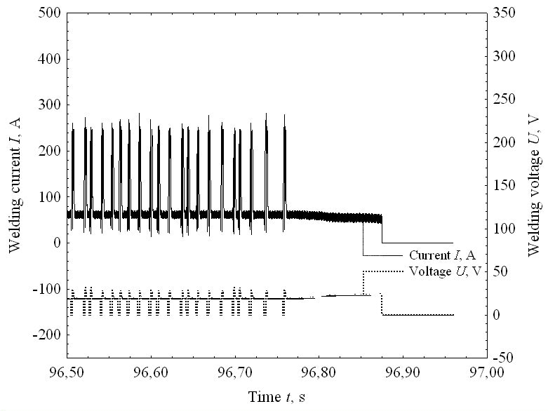

Figure 4. Fig. a and b: welding current and welding moving average distribution during STT process. Fig. c: welding current and voltage relationship (time interval of 80,00 – 90,02 s). Fig. d: distribution of welding parameters (time interval of 82,000 – 82,012 s). Fig. e and f: details of welding current and voltage distribution from the beginning and the end of the process. (Sampling frequency was 20 kHz per channel.)

