STRUCTURAL RELIABILITY OF THE STEEL BEAMS AND PLATE GIRDERS

Prof. dr. sc. Marta Sulyok, University of Zagreb, Faculty of Architecture, Zagreb, Croatia.
I.T. Specialist, Alen Selimbegović, American Express, Zagreb, Croatia

ABSTRACT
The beam design requirements for limit state lateral torsion buckling are analyzed and criteria for two codes (AISC and ECCS) are compared. As the differences in the design requirements are substantial, the comparison of the achieved reliability indices is made in order to find out the model which is closer to the target reliability level. For this purpose the four example is done concerning with the various observation data of snow loads on four locations in Croatia. The statistical parameters of the experimental results are evaluated and FOSM method is used for the procedure of the calibration. As the results varies with the applied snow loads and the slenderness ratios, for two examined models of the designed rolled beams, which are compared, it is necessary to achieve target values of reliability by correction of the model and resistance factors. The parameters of imperfection were derived from the equation for buckling of compression members, by means of nonlinear regression analysis using results from experimental research. New values α for parameters of imperfection have been obtained so that α amounts to 0.077 for the mean value, while α=0.247 for the 95% fractile value. Out of the total of 318 rolled beams tested, 17 samples are below the proposed model by α=0.247.

Keywords: reliability, rolled beams, welded beams, specifications, FOSM theory, snow loads, distribution density functions

1. INTRODUCTION
The laterally unsupported beams, which are examined in the examples of calibration, are subjected to the snow loads with secondary members dividing the main beams on the three equal not braced lengths and with the central critical segment under uniform moment. As the ultimate capacity for lateral torsion buckling varies with the theoretical models, used for design of these beams, the statistical parameters of the experimental results are the same for the certain groups of rolled beams in the same slenderness range, but the distances of the beams as well the sections are different in the conjunction with applied loads and the evaluation models.
It is evident that the differences in the design requirements for various specification, gives the different reliability index for the same applied loads calculated by the same global factors, which provides the theoretical models to be compared. The results of calibrations are compared and shows which model are on the conservative side for the certain slenderness range.

2. THEORETICAL MODELS FOR LATERAL TORSIONAL BUCKLING
The differences and similarities are compared for two code-rules which are based on the essentially the same theoretical background and the purpose of this section is to compare these methods and to draw the conclusions about the impact of the differences between them. These divergences are due to the different perceptions of the effects of initial imperfections. For specifications ECCS and AISC many variability arise especially in the inelastic range and for the beams under moment gradient.The following general treatments are used for beam design rules:
Use of the columns formula with the “equivalent” slenderness parameter: ${\bar{λ}}_{M}=\sqrt{{}_{M_{p}}M_{E}}$, here M_{p} is the plastic moment of the cross section and M_{E} is the elastic lateral torsion buckling moment of the beam with the coefficient $k_{M}=f\left({\bar{λ}}_{M}\right)$ of initial imperfection coefficients α for rolled (0.21) and welled (0.49) beams, such as specified in EC3.
Use of the analytically exact lateral-torsion buckling solutions for the cross section, loading and end condition, empirically modified to account for bucking in the inelastic range, such as in AISC Specification, with the linear interaction in the inelastic range, which can accommodate idealized conservative simplifications.
The most general equation is the one adopted in Western Europe: $M_{u}=M_{p}{\left(\frac{1}{1+{\bar{λ}}_{M^{2n}}}\right)}^{1n}$, with the exponent which takes on values 2.5 for rolled and 2.0 for welded beams. The variation of the buckling strength with ${\bar{λ}}_{M}$ for the various values of “n” and “α“is shown in Fig. 1. The advantage of this method is its simplicity and generality. Its disadvantage is that the implied reduction in flexural and torsion stiffness due to the partial plastification of the cross section is the same regardless of the magnitude of the compressive residual stress, and it does not differentiate between cases where all or most of the not braced segment is yielded and where only a small part of the length is plastificed. This equation is conservative for beams with low residual stress and steep moment gradient.
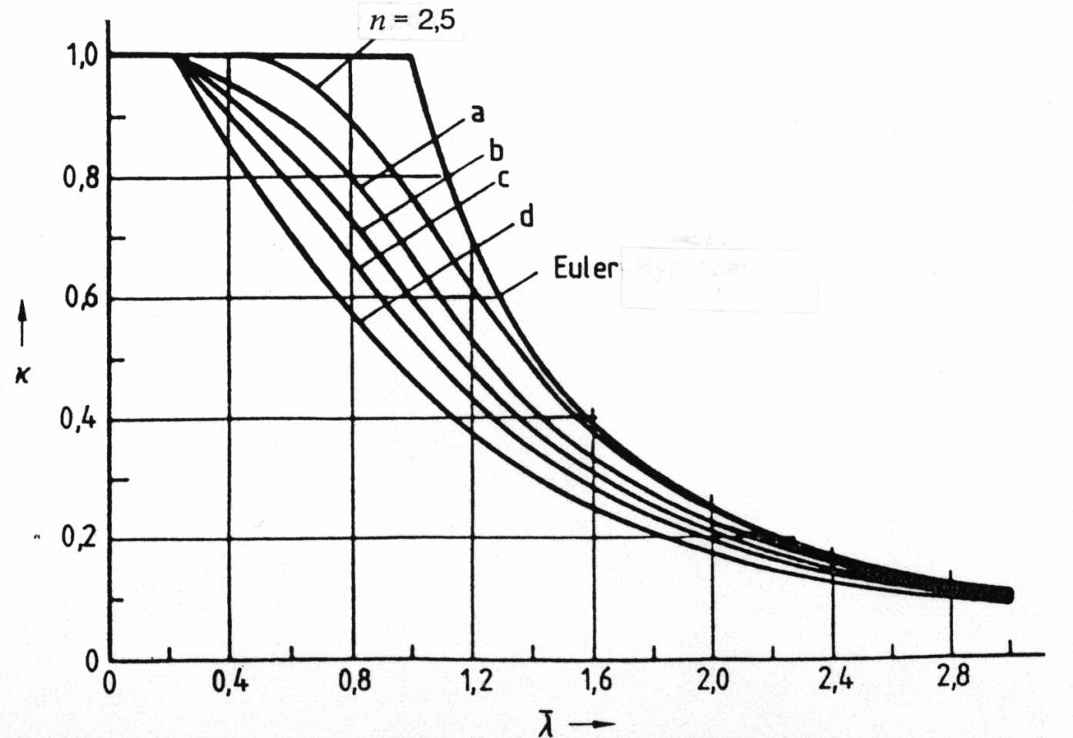
Figure 1. Buckling curves by ECCS with imperfection coefficients α and system factor n=2.5

The selected model is based on the buckling curves of the compression members with five different parameters of the initial imperfections which are now in the use of Eurocode-3 (Rondal&Maquoi) as follows:
$$\begin{aligned}\frac{σ_{\text{cr}}}{σ_{y}}=\frac{1}{2{\bar{λ}}^{2}}\left\{1+α\left(\bar{λ}−0\text{.}2\right)+{\bar{λ}}^{2}−\sqrt{{\left[1+α\left(\bar{λ}−0\text{.}2\right)+{\bar{λ}}^{2}\right]}^{2}−4{\bar{λ}}^{2}}\right\} \\ \text{where}\frac{σ_{\text{cr}}}{σ_{y}}=χ \text{for}\text{five}\text{groups}\text{of}\text{sec}\text{tions}\end{aligned}$$
Generality of the LRFD criteria of the AISC is comprised in the elastic solution which is expressed in the form: M_{E}= C_{b}M_{r} , where M_{r} is the buckling solution for the case of uniform bending and C_{b} is the coefficient which accounts for the effect of loading. The inelastic buckling solution is approximated by a straight line (Fig. 2). The ultimate moment is determined as follows:
$\begin{aligned}M_{u}=M_{p}\text{for}L≤L_{p} \\ M_{u}=C_{b}\left[M_{p}−\left(M_{p}−M_{r}\right)\frac{\left(L−L_{p}\right)}{\left(L_{r}−L_{p}\right)}\right]≤M_{p}\text{for}L_{p}≤L≤L_{r} \\ M_{u}=M_{E}\text{for}L³L_{r}\text{where}L_{p}=1\text{.}\text{76}\sqrt{EF_{y}}\end{aligned}$ (1)
E = modulus of elasticity
F_{y} = yield stress
M_{r} = S(F_{y} - F_{r} ), yield moment
M_{p} = maximum moment capacity
S = elastic section modulus
F_{r} = maximum compressive residual stress
L_{r} = unbraced length corresponding to M_{r}
L_{p} = spacing of the braces necessary to reach M_{p} without rotation capacity

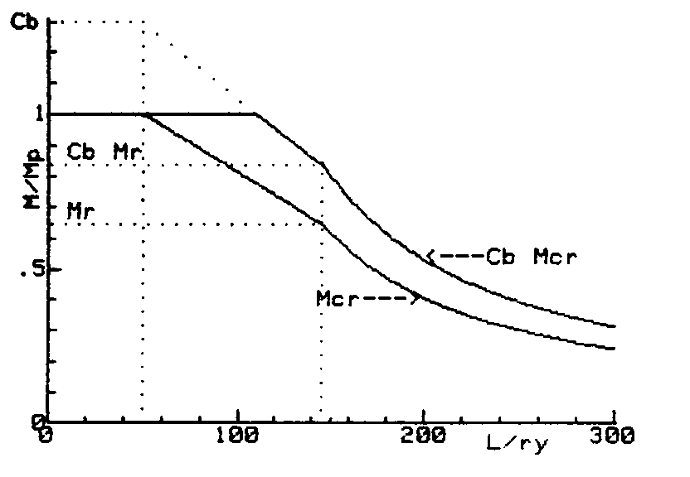

Figure 2. Variation of M_{u} with slenderness parameters by AISC Specification

Since for beams where plastic moments are assumed to develop, the distances between lateral support points will be relatively short (L_{p}), with extreme fiber strain approaching into the strain hardening range. Studies of inelastic lateral buckling have made by Galambos, Lay, Massey and Pittman, Bansal and Hartmann. The unbraced length corresponding to the elastic limit, L_{r}, can be obtained by setting M_{E}=M_{r}, where corresponding buckling moment M_{r}, is determined including residual stresses.

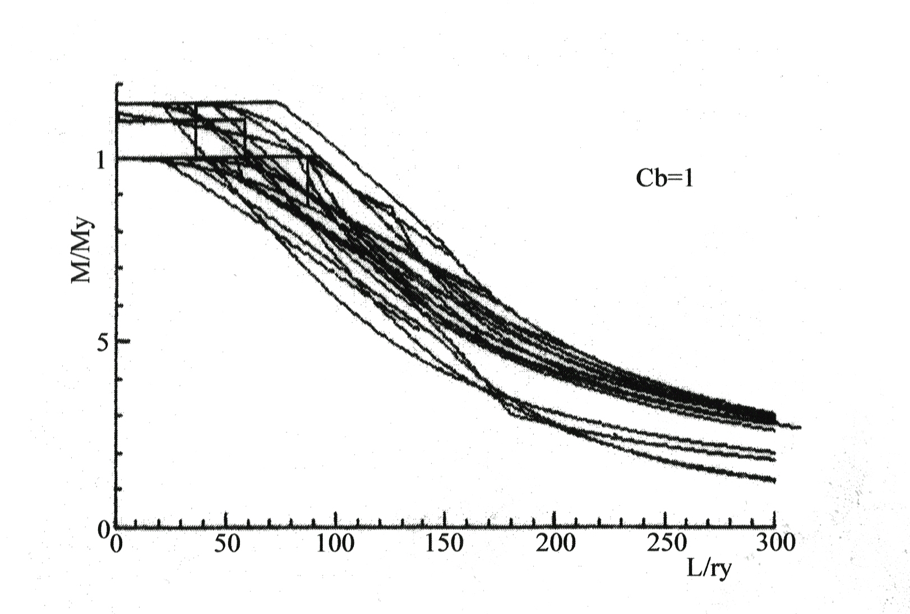
Figure 3: Models of buckling curves for steel beams gather from various standards for C_{b} =1

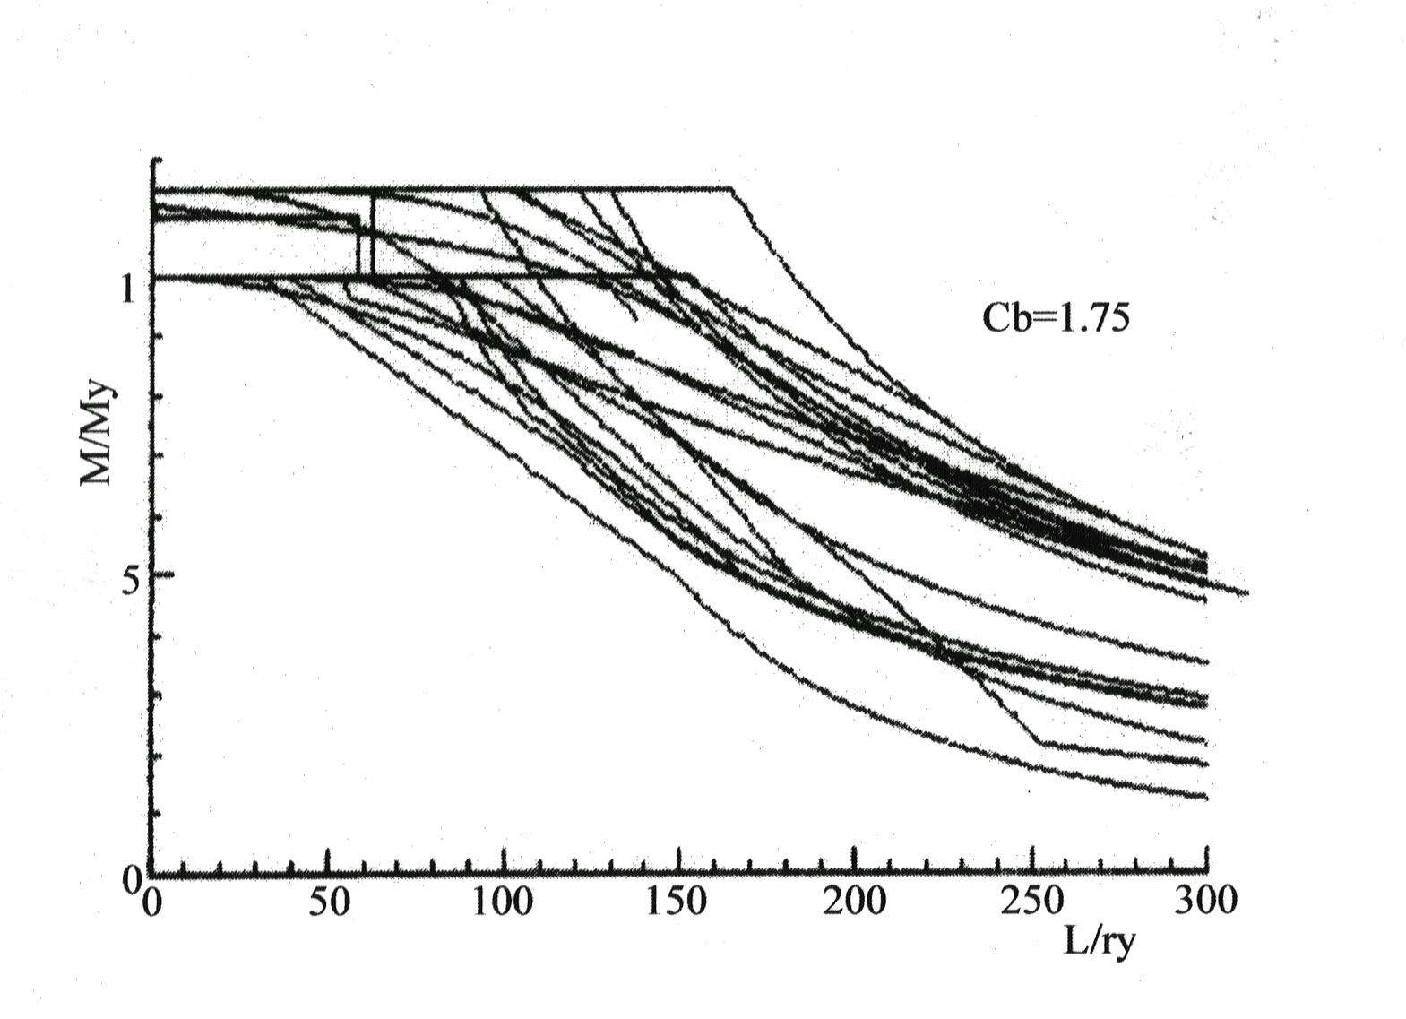
Figure 4: Models of buckling curves for steel beams for C_{b}=1.75, where C_{b} is the coefficient which accounts for the effect of loadings
$$C_{b}=1\text{.}\text{75}−1\text{.}\text{05}\frac{M_{1}}{M_{2}}+0\text{.}3{\left(\frac{M_{1}}{M_{2}}\right)}^{2}$$
As ECCS curve for n=2.50 provides a reasonable mean strength over short and medium slenderness range for rolled beams, the curve for n=1.50 forms a lower bound for the test points with the (m-2s) strength curve shown on Fig. 5. On Fig. 6. same is valid for the welded beams with different system factors “n”, which are 2.0 and 1.50 respectively. In order to determine the best fit of the assumed implicit function to the experimental data, such as selected 324 rolled beams and 132 welded beams, the mean values of no dimensional strength coefficients (δ_{i}), as well as 5% fractiles (m-1.64s) is evaluated by the method of least squares (Eq. 2) in the nonlinear regression analysis. In this problem, as no linearity is encountered, the higher-order equations with one independent variable should be tried to fit data with the correlation coefficient near 1.
$\text{min}\sum_{i=1}^{N}{{\left[{\left(\frac{1}{1+{\bar{λ}}^{2n}}\right)}^{1n}−d_{i}\right]}^{2}},\text{where}d_{i}=\frac{M_{u}}{M_{p}}\text{and \{}\bar{λ}=\sqrt{\frac{M_{p}}{M}}$ (2)
The results for the rolled beams from the selected tests data are n=2.64, which is concerning mean values, and n=1.425 for 5% fractiles. For the welded beams, on which the same evaluation is done, the results for mean value is n=2.44 and 5% fractiles n=1.095 .In order to derive the probabilistic evaluation of lateral-torsion buckling strength of ECCS and AISC design formula comparing them with test results, the realized indices of reliability is performed on the following examples.

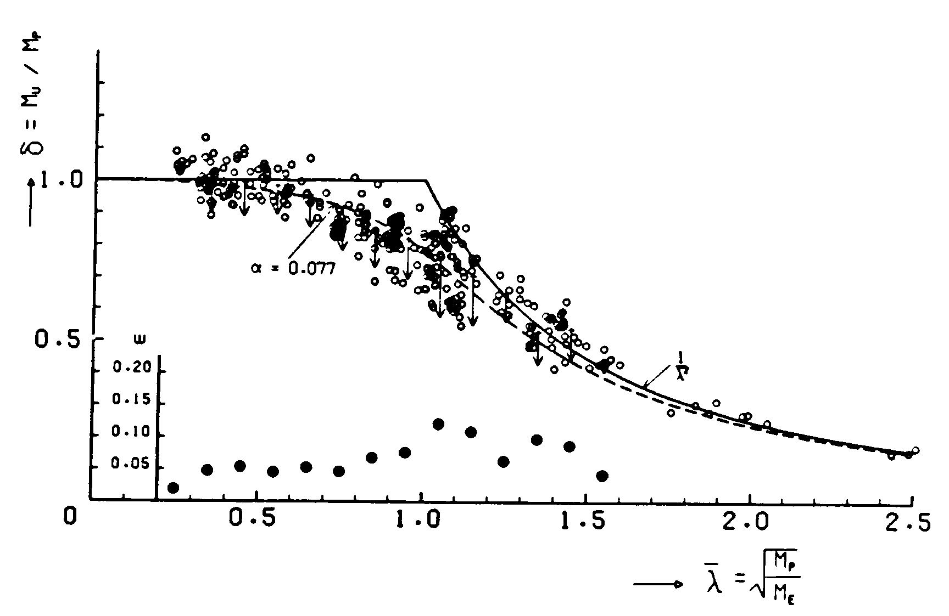

Figure 5. Experimental results and lateral-torsion buckling curves for rolled beams
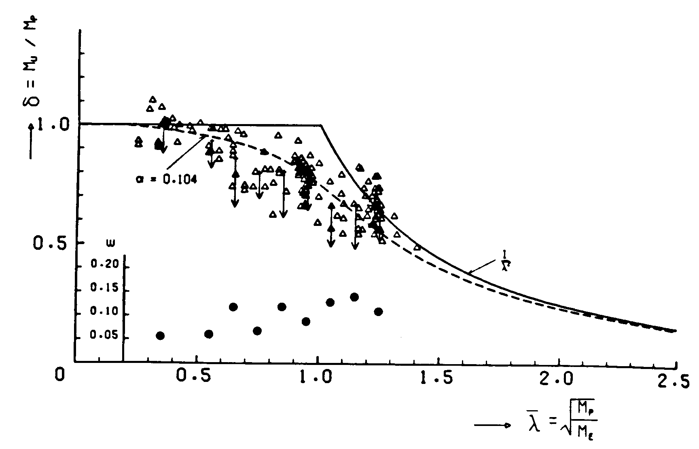
Figure 6. Experimental results and lateral-torsional buckling curves for welded beams

- THE EVALUATION OF THE RELIABILITY INDECES FOR THE ROLLED BEAMS UNDER SNOW LOADS

In this example the calibrations of the main roof beams, which are laterally unsupported on the distances between secondary beams are performed on the four different locations for the snow loads in continental part of Croatia. The snow load is taken as dominant load during 30 years of measurements of meteorological data with the characteristic values as 95% fractile with the return period of 30 years. The experimental results are selected for the needed slenderness ratios of the rolled beams designed by the theoretical models of ECCS and AISC Specifications, and the proposed fractile curve with system factor n=1.425 .

3.1 The statistical evaluation of the snow loads data
The snow measurements, which are converted to the snow loads on the flat roofs, are analyzed and compared with extreme probability distribution function type I of Gumbel as it is shown on Fig. 5 and with equation:
$F_{0}\left(x\right)=\text{exp}\left[−\text{exp}\left(−a\left(x−\overset{\text{.}}{x}\right)\right)\right]$ (3)
mod is: $\overset{\text{.}}{x}=\bar{x}−ca$
mean value of the distribution: $\bar{x}$
standard deviation of the distribution: $a=\frac{p}{s_{0}\sqrt{6}}$
Function of the extreme probability distribution during the period of n years:
$F_{n}\left(x\right)=F_{0}{\left(x\right)}^{n}=\text{exp}\left[−\text{exp}\left(−a\left(x−\overset{\text{.}}{\overset{\text{.}}{x}−\frac{1}{a}\text{ln}n}\right)\right)\right]$ (4)
where the mean value for return period of n years is:
${\bar{x}}_{n}={\bar{x}}_{0}\left(1+\frac{\sqrt{6}}{p}V_{0}\text{ln}n\right)$ (5)
The characteristic value for the load during the period of n years x _{k,n} , with the probability p that it will not be exceeded is:
$x_{k,n}=\overset{\text{.}}{x}+\frac{1}{a}\left[\text{ln}n−\text{ln}\left(−\text{ln}p\right)\right]$ (6)
$x_{k,n}={\bar{x}}_{0}\left\{1−0\text{.}\text{4501}V_{0}+0\text{.}\text{7801}V_{0}\left[\text{ln}n−\text{ln}\left(−\text{ln}p\right)\right]\right\}$ (7)
The general expression for the snow loads on the flat roofs with the reduction factor 0.8, concerning the thermal characteristics of the building and the exposure, and with probability density function of Gumbel, is defined as:
$s_{0n}=0\text{.}8\left\{\left({\bar{x}}_{0}−\frac{{\bar{y}}_{N}}{s_{N}}s_{0}\right)+\frac{s_{0}}{s_{N}}\left[\text{ln}n−\text{ln}\left(−\text{ln}p\right)\right]\right\}$ (8)

${\bar{y}}_{N}{is}_{N}$ are mean value and standard deviation of the calculated snow loads.
On Fig.7 the histograms and extreme type I distribution function is shown for the measure data of snow loads in continental parts of Croatia, which are compared with theoretical frequencies on Fig.8 and 9.

Figure 7. Histogram and distribution function for snow load

3.2 The statistical parameters for the load and the resistance variable
The examples are derived for the ultimate lateral-torsional buckling resistances of the rolled beams with sections I 200x100x8x5.5, which are designed by the above stated models, under the characteristic values of snow loads with the different length of lateral supports and distances between the beams.
The first example is on the location in Zagreb with the statistical parameter for the snow loads:
${\bar{q}}_{0}=0\text{.}\text{35}\text{kN}$/m² ; $s$₀=0.21 kN/m² ; V₀=0.60
$q_{p,n}={\bar{q}}_{0}(1+4\text{.}\text{52}V_{0})=1\text{.}\text{30}{\text{kN}}/{m^{2}}$ ............. characteristic values of the loads
${\bar{q}}_{n}={\bar{q}}_{0}(1+2\text{.}\text{652}V_{0})=0\text{.}\text{907}{\text{kN}}/{m^{2}}$............. mean values for n years
The evaluated girder is from the group of the tested beams with the variable strength shown on Fig. 5, designed by the values of the loads q_{p,n} , the distances between lateral supports l_{y} , and with ultimate strength M_{u} .
The second example is on the location in Varaždin with the statistical parameters for the snow loads:
$$\begin{aligned} \\ q_{0}=0\text{.}\text{51}{\text{kN}}/{m^{2}};s_{0}=0\text{.}\text{28}{\text{kN}}/{m^{2}};V_{0}=0\text{.}\text{55} \\ q_{\text{np}}=0\text{.}\text{51}(1+4\text{.}\text{52}V_{0})=1\text{.}\text{78}{\text{kN}}/{m^{2}} \\ {\bar{q}}_{n}=0\text{.}\text{51}(1+2\text{.}\text{652}V_{0})=1\text{.}\text{254}{\text{kN}}/{m^{2}};V_{n}=0\text{.}\text{223}\end{aligned}$$
The calculated values of the ultimate strength M_{u} and the distances between the girders are specificed in the tables 1 to 4.
Figure 8. Comparison of measured data for snow in Ogulin on probability paper with Henry-diagram

The third example is for location in Ogulin with the parameters of the snow loads:
$${\bar{q}}_{0}=0\text{.}\text{929}\text{kN}/m^{2}$$
The fourth example is for location in Slavonski Brod with the characteristics of snow load:
$$\begin{aligned}{\bar{q}}_{0}=0\text{.}\text{490}\text{kN}/m^{2}s_{0}=0\text{.}\text{244}\text{kN}/m^{2}V_{0}=0\text{.}\text{490} \\ q_{\text{np}}=2\text{.}\text{960}\text{kN}/m^{2}{\bar{q}}_{n}2\text{.}\text{120}\text{kN}/m^{2}V_{n}=0\text{.}\text{113}\end{aligned}$$
Figure 9. Comparison of measured data for snow in Varaždin on probability paper with Henry-diagram

3.3 The evaluation of the reliability indices for the calibration of the rolled beams
The reliability index is derived from the equation of the ultimate limit state with two basic variables, which are statistically independent, g(x) =R-Q, with the probability of the failure is:
$p_{f}=P(R<Q)=\int{F_{R}(x)f_{Q}(x)\text{dx}}$ (9)
where is:
F_{R} - cumulative distribution function of resistance R
f_{Q} - probability density function of load Q
The basic variable is not distributive by normal probability distribution function, so FOSM method is not applicable and Rackwitz & Fiessler-method is used with the transformation of the basic variable into the equivalent of normal distribution and the parameters ${\bar{x}}^{N},s_{x,}^{N}$ under the circumstances, that the cumulative distribution and probability density functions are the same, as for basic and approximated variables, in the reper points on the ultimate limit state plane: $g(x_{1}^{},x_{2}^{},\text{.}\text{.}\text{.}\text{.}\text{.},x_{n}^{})=0$.
The equivalent mean value and standard deviation of basic variable is:
$\begin{aligned}{\bar{x}}^{N}=x_{i}^{}−F^{−1}\left[F_{i}\left(x_{i}^{}\right)\right]s_{x_{i}}^{N} \\ s_{x_{i}}^{N}=\frac{f\left\{F^{−1}\left[F_{i}\left(x_{i}^{}\right)\right]\right\}}{f_{i}\left(x_{i}^{}\right)}\end{aligned}$ (10)
F,f - distribution and density function of basic variable x_{i}
Φ, φ - cumulative distribution and density function of standard normal variable
The iterative procedure for approaching to minimum value of β, is obtained by the equation system:
$α_{i}=\frac{\left(¶g¶x_{i}\right)s_{x_{i}}^{N}}{\sqrt{\sum_{i=1}^{m}{\left(\frac{¶g}{¶x_{i}}\right)s_{x_{i}}^{N^{2}}}}}$ (11)
$\begin{aligned}x_{i}^{}={\bar{x}}_{i}−α_{i}{\text{βs}}_{x_{i}}^{N} \\ g\left(x_{1}^{},x_{2}^{},\text{.}\text{.}\text{.}\text{.}\text{.},x_{n}^{}\right)=0\end{aligned}$ (12)
The partial derivations $¶g¶x_{i}$are evaluated for $x_{i}^{}$, and α_{i} of the basic variables x_{i} . After the convergation of this algorithm, reliability index $β^{}$is evaluated, and approximate value of the probability of failure $p_{f}@1−F\left(β^{}\right)$.

- THE RESULTS OF THE CALIBRATION FOR THE ROLLED BEAMS
From the statistical parameters of the buckling test results for rolled beams and the predicted model values, the evaluation of the reliability indices is performed and tabulated (Table 1 to 4) for stated slenderness ratios and snow loads on four locations.
Table 1. Ultimate strength and calibration for the snow load data in Zagreb
 | Theoretical results M_{teo} [kNm] for models:
$$\bar{l}=0\text{.}\text{1 }$$ | ECCS | AISC | (m-2s) curve | M_{exp} [kNm]
$${\bar{M}}_{\text{max}}$$ | 21.63 | 21.22 | 19.22 | 57.45
σ_{Mmax} | 5.01 | 4.91 | 4.45 | 1.58
β | 3.8 | 3.9 | 4.20

Table 2. Ultimate strength and calibration for the snow load data in Varaždin
 | Theoretical results M_{teo} [kNm] for models:
$\bar{l}=0\text{.}\text{605 }$ 0.77 | ECCS | AISC | (m-2s) curve | M_{exp} [kNm]
$${\bar{M}}_{\text{max}}$$ | 20.51 | 19.75 | 17.17 | 46.30
σ_{Mmax} | 4.51 | 4.40 | 3.83 | 2.77
β | 3.20 | 3.50 | 4.20

Table 3. Ultimate strength and calibration for the snow load data in Ogulin
 | Theoretical results M_{teo} [kNm] for models:
$\bar{l}=$ 0.918 | ECCS | AISC | (m-2s) curve | M_{exp} [kNm]
$${\bar{M}}_{\text{max}}$$ | 18.40 | 18.10 | 15.07 | 47.27
σ_{Mmax} | 4.14 | 4.07 | 3.40 | 5.69
β | 3.21 | 3.10 | 3.81

Table 4. Ultimate strength and calibration for the snow load data in Slavonski Brod
 | Theoretical results M_{teo} [kNm] for models:
$\bar{l}=$ 1.17 | ECCS | AISC | (m-2s) curve | M_{exp} [kNm]
$${\bar{M}}_{\text{max}}$$ | 14.51 | 14.88 | 11.93 | 40.53
σ_{Mmax} | 1.64 | 1.69 | 1.35 | 3.40
β | 5.18 | 4.80 | 6.20

The results of the calibration vary for the design models, which are examined and from criteria of European Committee for Safety of Structures, when full-safety is ensure by reliability index β=3.80, only the proposed buckling curve with new imperfection parameter α=0.247 satisfies this aim (Fig. 10.).
In order to ensure uniform reliability, it is necessary to use new model factor with the target reliability level near to β_{T} =3.80.
$$χ=\frac{M_{u}}{M_{p}}$$
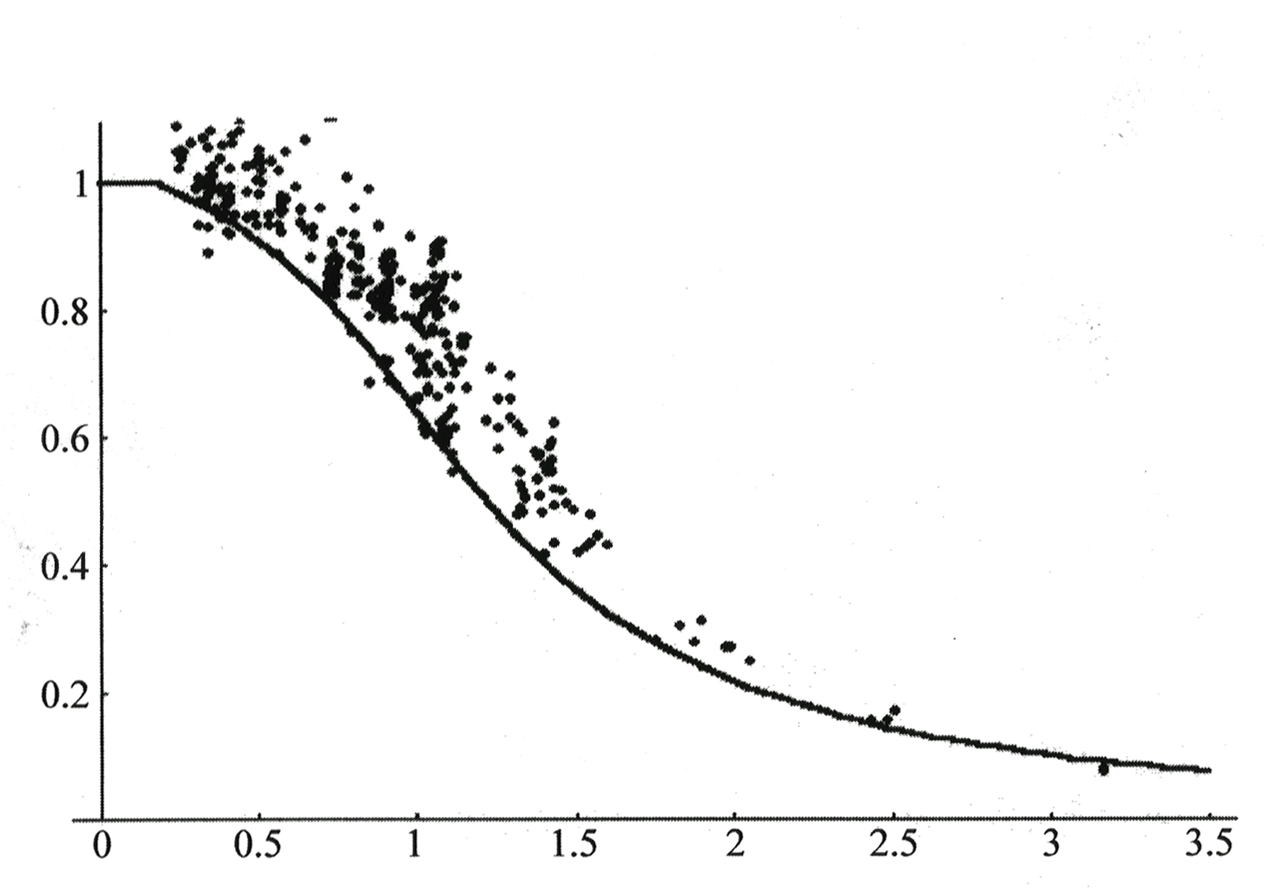
$$\bar{λ}=\sqrt{\frac{M_{p}}{M_{E}}}$$
Figure 10: Proposed buckling curve for rolled steel beams with new parameter α=0.247

5. CONCLUSION
The analysis of laterally unsupported steel beams for various design models is obtained, by which the ultimate limit state of the lateral torsion buckling strength is evaluated for the purpose of the calibration of the rolled beams under the snow loads from the measured data in Croatia. The results of the calibration varies with applied snow loads and slenderness ratio for three examined designed models, and for ECCS criteria they are in the range from realized reliability indices β= 3.20 to 5.19, for AISC Specifications indices are lower, such as β=3.10 to 4.80, and for the model of proposed system factor “n” is quite on the target safety side with β=4.20 and 6.20 . As the calibration is performed with the designed model by global and constant safety factor, the differences are the result of the basic formulations of the buckling curves. It is evident that there is no necessity to change the system factor “n” of buckling curves, but to correct the evaluation model by model and resistance factors with the target reliability level in order to achieve uniform reliability with the proposed loads factors, concerning the applied loads in certain cases.

REFERENCES
- American Institute of Steel Construction, Load and Resistance Factor Design, AISC, 1986
- Eurocode 3. Design of Steel Structures-Part 1-1: General rules and rules for buildings, 1987
- Melchers, R. E.: Structural Reliability - Analysis and Prediction, John Wiley&Sons, 1987
- Sulyok-Selimbegović, M. and Galambos, T.V.: The Evaluation of the Resistance Factors for the Laterally Unsupported Rolled and Welded Beams and Plate Girders Designed by LRFD of the AISC, Steel Structures: Advances Design and Construction, Elsevier Applied Science, London and New York, 1987, ISBN 1-85166-120-4
- Guide to Stability Design Criteria for Metal Structures, 4th edition by Galambos, T.V. John Wiley&Sons, 1988
- Lindner, J. : Design Applications for Beams restrained by adjacent members in Doweling, P.J., Harding, J.E., Bjorhovde, R., and Martinez-Romero, E.: Constructional Steel Design, Elsevier Applied Sc., London/New York, 1992

7th International Conference on Steel and Space Structures

THE CALIBRATION OF THE STEEL BEAMS UNDER SNOW LOADS IN CROATIA

Marta Sulyok-Selimbegović, University of Zagreb, Faculty of Architecture, Zagreb, Croatia.

U radu se analiziraju zahtjevi za projektiranje nosača kod graničnog stanja bočnog torzijskog izvijanja za različite podatke promatranja opterećenja snijegom na četiri različita mjesta u Hrvatskoj. Usporoređuju se kriteriji za dva propisa (AISC I ECCS), te postoje znatne razlike u projektiranju i uspoređuju se dobiveni indeksi pouzdanosti kako bi se pronašao model koji je bliži zahtjevanoj razini pouzdanosti.
Izvode se karakteristične vrijednosti stvarnih opterećenja snijegom na krovnim konstrukcijama i projektiraju se bočno nepridržani nosači od valjanog čelika različitih dužina bočnih pridržanja i kapaciteta nosivosti na momente savijanja. Za postupak kalibracije nosača koristi se viša metoda drugog reda sa statističkim parametrima u probabilističkoj analizi sa različitim funkcijama distribucije vjerojatnosti za opterećenja i otpornosti.
Budući da rezultati variraju ovisno o promjenljivom opterećenju snijegom i o omjerima vitkosti kod dva analizirana modela projektiranih nosača, koji se uspoređuju, potrebno je postići zahtjevane vrijednosti pouzdanosti, korigirajući faktore modela I otpornosti.

Rad je bio dobro primljen u sekciji “Beams and Columns”, te je tiskan u “ “Proceedings of 7th International Conference on Steel and Space Structures”, pp 289-296.
Prezentiran je auditorijumu učesnika konferencije 2.10.02. od 16-16:30 sati.
Organizator konferencije bio je CI-Premier, Singapore, a sponzor Singapore Structural Steel Society, čija gradilišta smo obišli I snimila najnoviju čeličnu konstrukciju u izvedbi za naše studente.

