Primary healthcare information system – development and deployment issues

Ranko STEVANOVIC, Vinko KOJUNDZIC,
Galibedin GALIJASEVIC
1 Croatian National Institute of Public Health, Croatia
2 Matičnjak d.o.o, 3 ABA informatika d.o.o

Abstract. Croatian national primary healthcare ICT Implementation strategy is determined by Croatian national health strategy and plan, Croatian ICT development strategy for 21st century, and requirements specifications for the heath information system. National primary healthcare ICT implementation strategy components are accented: purpose of the ICT implementation strategy, information principles, need and ICT enablement in domains of patients, healthcare professionals, policy-makers and managers and public. Based on the determinants, three organizational levels have been established – government, ministerial and project levels. General architecture of Croatian primary healthcare information system and its implementation as well as national ICT environmental accelerations for national primary healthcare ICT environmental accelerators for health ICT implementations are presented.

Keywords. health ICT implementation strategy, healthcare functional requirements, healthcare standards, integrated healthcare, communication network, healthcare implementation

Conceptual design of national healthcare information system has been based on international documents: eEurope Action Plans: 2000, 2002, 2005, EU eHealth Strategy, The eEurope Smart Card (eESC) initiative, Selected National eHealth Strategies (GB, USA).

Project organization and management
At the preparatory stage of the project, in the process of procurement and in the pilot stage of the primary health information system (PHIS):
Government level:
Government Steering Committee for Internet Infrastructure Development – responsible for strategic ICT policy and infrastructure decision making;
Health Information System Expert Group – Advisory group of experts in the fields of medicine and health as well as ICT.
Ministerial Level
Advisory teams to Minister of health (representatives from Hospitals, Institute for public health, Institute for health insurance, Faculty of Medicine, Chambers of Health). Regulatory bodies for public procurement for the health ICT projects.
Pilot project Levels
Primary healthcare team and selected implementation team representatives in Pilot project.

The Requirements and Functional Specifications

National Requirements
The strategic national requirement for the NHIS is to enable necessary data for preparing reform of health system.
The strategic information system requirements are:
- to ensure patients can be confident that professionals in the national health system caring for them have reliable and rapid access, 24 hours a day, to the relevant personal, medical and health information necessary to support their care
- to eliminate unnecessary travel and delay for patients by providing remote on-line access to services, specialists and care, wherever practicable
- to provide access for patients to accredited, independent, multimedia background information and advice about their condition and to provide every health care professional with on-line access to the latest local guidance and national evidence on treatment, and the information they need to evaluate the effectiveness of their work and to support their professional development
- to ensure the availability of accurate information for managers and planners to support local Health Improvement Programs and the National Framework for Assessing Performance
- to provide fast, convenient access for the public to accredited multimedia advice on lifestyle and health, and information to support public involvement in, and understanding of, local and national health service policy development.

The specific targets are:
- reaching agreement with the professions on the security of electronic systems and networks carrying patient-identifiable clinical information
- developing and implementing a first generation of person-based Electronic Health Records, providing the basis of lifelong core clinical information with electronic transfer of patient records between GPs
- connecting all GP practices to NHS Virtual Private Network (NHS VPN)
- providing 24 hour emergency care access to relevant information from patient records
- using NHS VPN for appointment booking, referrals, discharge information, radiology and laboratory requests and results in all parts of the country
- community prescribing with electronic links to GPs and the Prescription Pricing Authority
- routinely considering telemedicine and telecare options in all Health Improvement Programs
- offering NHS Direct services to the whole population establishing local Health Informatics Services and producing costed local implementation strategies
- completing essential national infrastructure projects including the networking infrastructure, national applications etc
- opening a National Electronic Library for Health with accredited clinical reference material on NHS VPN accessible by all authorized NHS organizations
- planning and delivering education and training in informatics for clinicians and managers

International Requirements
Functional and technological regional and international interoperability of National Health Systems, focused to meet EU eHealth goals by the end of 2005. Functionally and technologically, smoothly and cooperatively, serve any requirement for primary healthcare of non-resident during his/her stay in Croatia.

Functional Specifications
PHIS is logically divided into two parts: Central Information System to which all GP practices are connected and Client Information Systems at GPs [1].

Primary Healthcare Information System - High Level Functional Specifications – Central Information System
The Central Information System contains [2], [3]:
Primary healthcare information system management: health insurance management, patient management, electronic health documentation management, extended communications management, health information system reporting management.
Clinical Information System Management: service management, data access and protection management, clinical documentation management, health related registers management (state, local), HL/7 communication system, clinical data management, “virtual” electronic health and electronic medical record management.
Administrative and business support: Global registration management, health insurance database management, personal ID-management, national MKB-10 classification system, ICPC-2 classification system, drug, pills, orthopedic supplement list management, list of services and procedures.
Privacy and security management: Smart card technology driven privacy and security for patients and healthcare professionals, PKI infrastructure, role based data access control.
Additional functionalities:, secure e-mail services for health professionals.
Technical and technological integration with the: Hospital information systems and information systems of Croatian National Institute of Public Health, Croatian Institute for Health Insurance and Ministry of Health and Social Welfare.

Primary Healthcare Information System - High Level Functional Specifications – Client Information System
The Client Information System contains:
Health Professional: Role based Health Profession Identification, Authentication and administration services, Patient care service workflow, Diagnostics, Referrals, Prescriptions, Medical Services, patient health and medical document generation, Professional navigation services, Visit Management, Laboratory services, Calendar and administrative Management, Comprehensive Reporting System.
Health and Medical Supporting services: Health documentation management, Clinical documentation management, Decease Related Drugs Recommendations, Drug Retrieval
Patient oriented services: Visit registration and waiting room management, Patient identification, Authentication and administration services, Patient related medical documentation (laboratory, images, other), task list, procedures and memos, Patient Relationship Management,
Patient Management: General Patient Data, Health insurance related data, Patient Health Data (Anamnesis, Risk factors, Allergies, Medical treatments, Health Problems, Chronic deceases,), Patient Medical Data, Vaccinations, Administrative document issued, Illnesses.
Interoperability with Central Information System: XML/HL7 Client Agent communications services.

General Architecture of Croatian Primary Healthcare Information System
General architecture of NHIS consists of central components - The NHIS infrastructure, and contextual portals:
Components of Central Information System: Core Networked Healthcare Repositories (Population, Health Insurance, Public Health, Health Financials) along with acting Application Service Providers - ASPs (Primary Healthcare, Public Health, Health Insurance, Health Professional Associations).
Contextual Portals: Ministry of Health, Public Health, Health Insurance, Primary Healthcare, Hospital, Pharmacy, Health Professional Associations, Professional and Public education, General Health Communications, Other health related portals, as presented in Figure 1.
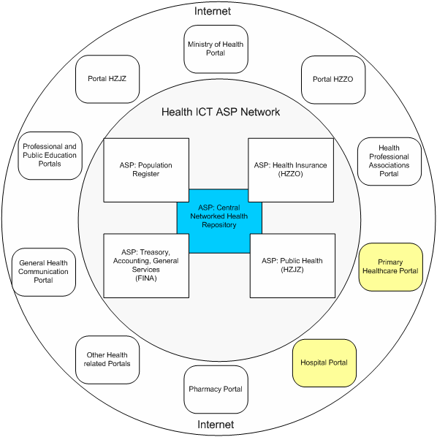

Figure 1: General Architecture of Healthcare Information System

Portal implementations provide autonomy of professional functionalities and contextually “glue” all stakeholders in their mutual interactions.

Project implementation

Primary Healthcare Information System (PHIS)
After the pilot phase, the procurement part of the process has successfully end with one signed contract for PHIS Central Information System and five contracts with five different vendors for PHIS Client Information Systems.

G1 – PHIS Central Information System
The focus of the implementation was according to the contract with supplier and specification from pilot phase on building Central Information System ready to accept connections from around 2300 different GPs locations.

G2 – PHIS Client Information System
Implementation of the Client Information Systems have been according to the specification of the Client Information System in the pilot phase.

Technical and Institutional Interoperability

Technical Interoperability
Technical interoperability is provided by implementation of technical standards and standardized hardware instances. Standardized middleware software components enabling networked interoperability.
Software Agent Technology –asynchronous cooperative message processing is enabled by implementations message exchange management system on central site: and XML/HL/7 agent as client site implementations

Institutional Interoperability
Institutional interoperability, due to requirements of interrelated national public development projects (health and social welfare system reform, reform of the government is and public services), requirements of common ICT infrastructure (government computer and communication network), related cooperative IT projects (healthcare, healthy food, healthy environment – water, land, air, new personal identity card and personal identity management, national emergency system, to mention some of them), is implemented by the coordination committee for institutional interoperability appointed by the government.
Main institutional stakeholders are: The Government – Office for e-Croatia; Ministries: Ministry of Health, Ministry of interior, Ministry of finance; Institutes and associations: Institute of Public Health, Health Insurance Institutes, Health Professional Associations; FINA- National Financial Agency in the role of Government ICT outsourcing institute.

Conclusion
¸ Design of the complex national primary healthcare information system is based on corresponding national and international strategic documents, precise definitions of functional requirements and the results of started pilot project implementation (trial run). The implementation phase brings reality checks of the accepted design and necessary fine tuning in order to achieve implementation goals. The most common cases of the fine-tuning in this case were: less than expected capability of other government bodies to support project and less than expected GPs level of sensibility to the importance of this project.
Hierarchical and functional project management showed good results since it enabled fast decisions supported by the sponsors of the projects, as well as to building capacities for accelerated implementations of the project extensions in the years to come.
Aligned with international standards and implementation policies for information societies, healthcare information system provides the drivers for national, regional and international interoperability.

References
[1] A. Pavelin, I. Klapan, M. Kovač, M. Katić, R.Stevanović, M. Rakić, N. Klapan, A Functional Telemedicine Environment in the Framework of the Croatian, Healthcare Information System // Remote Cardiology Consultations Using Advanced Medical Technology (Applications for NATO Operations) / I. Klapan,, R. Poropatich (ed.).Amsterdam, Netherlands, IOS Press, Inc., 2006.
[2] R. Stevanovic, I. Klapan, . Establishment and Development of health information system in transitional countries (Croatian experience). Telemedicine. I. Klapan, I. Cikes (ed.). Zagreb: Telemedicine Association Zagreb, 2005, 84-91
[3] Stevanovic, R. Pristas, I. et all. Development and deployment of a health information system in transitional countries (Croatian experience) // Medical and Care Compunetics 2 / Bos, Lodewijk ; Lexminarayan, Swami ; March, Andy (ed.).Amsterdam : IOS Press, 2005, 82-87

1 Corresponding Author: Ranko Stevanovic, Croatian National Institute of Public Health, Rockefellerova 7, 10000 Zagreb, Croatia

