OPTIMAL WALL-THICKNESS OF THE SPHERICAL PRESSURE VESSEL WITH RESPECT TO CRITERION ABOUT MINIMAL MASS AND EQUIVALENT STRESS

¹ Dražan Kozak

² Josip Sertić

Abstract:
Stress distribution in the spherical vessel shell is calculated according to membrane shell theory. By using of the Mises strength theory, the functional relations of both equivalent stress and pressure vessel mass with wall thickness were defined. These two curves were presented graphically and their intersection point has been considered as an optimum point where both shell mass and equivalent stress are minimal. Demonstrated principle could be applied by optimization over the zones at huge spherical vessels design.

Keywords:
spherical pressure vessel, optimal wall thickness, equivalent stress distribution

1. INTRODUCTION

It is known that a greater wall thickness of the spherical pressure vessel causes decreasing of the equivalent stresses. That can be concluded without knowing basic laws of strength of material. A designer always find of great importance to make construction with minimum material cost satisfying exploitation requirements thereat. Since the material and energy–generating product prices are ever growing, as well as market demands, the great designers' task is to optimize design computing within the meaning of strength of material and material expenditure with technological approach to structure design. Therefore constructions are, according to technical norms, arranged into more groups in respect of which according to different exploitation conditions matching different factors of safety [1-4]. More about norms for pressure vessels can be found in reference [5].
Here, we can always discuss about magnitude of factors of safety. Using of norms which were made a few decades ago provides range for new explorations and corrections. Advanced computational technology enables today almost really simulations of construction exploitation conditions. Results, given by finite element method as well as ideal analytical calculations, confirm very huge pressure vessel safety zone. Part of safety is reserved for material inhomogeneity, construction deflection from ideally form, corrosion and other concentrated stress in construction [6]. These factors significantly affect on structural stress distribution and magnitude, but they are not analyzed in this paper. Fracture mechanics and micromechanics are dealing more with that area [7].

2. OPTIMAL WALL TICKNESS MODEL

Change of mass in correlation to pressure vessel wall-thickness can be defined as:

$m_{S}=\frac{π}{6}\left[{\left(D_{i}+2h\right)}^{3}−D_{i}^{3}\right]ρ$, (1)

where are: D_{i} - internal vessel diameter, mm
h – wall thickness, mm
ρ - vessel shell material density, kg/m³.

According to HMH strength of material theory for plane stress state in spherical vessel shell, it is possible to make a mathematical relation between equivalent stress and wall-thickness. Since the membrane condition of stress rule in vessel wall, arises:

$σ_{\text{eq}}=\sqrt{σ_{Θ}^{2}+σ_{Φ}^{2}−σ_{Θ}σ_{Φ}}$, (2)

where are: σ_{eq} - equivalent stress, MPa
$σ_{Φ}=\frac{N_{Φ}}{h}$ - maximal circular direction stress, MPa
$σ_{Θ}=\frac{N_{Θ}}{h}$- maximal meridian direction stress, MPa
$N_{Φ}$ - maximal circular force, N/mm
$N_{Θ}$ - maximal meridian force, N/mm.

Thereof continues equivalent stress correlation to spherical vessel wall-thickness:

$σ_{\text{eq}}=\frac{1}{h}\sqrt{N_{Θ}^{2}+N_{Φ}^{2}−N_{Θ}N_{Φ}}$ , (3)

which is, with the constant loading, described by first degree hyperbole law. According to expression (1) and (3) it is possible to accomplish spherical vessel wall-thickness optimization.

3. IMPLEMENTATION OF OPTIMIZATION MODEL ON A REAL PRESSURE VESSEL

3.1 Spherical pressure vessel characteristics

As representative pressure vessel a spherical pressure vessel for the storage of liquid propylene with 1,7 MPa of internal pressure and 3 MPa of hydro-test pressure has been considered (Figure 1). Maximal operation temperature is 40⁰C. The vessel body is built from micro alloyed steel, commercial name NIOVAL 47. Volume of the vessel is 1200 m³ with outer diameter of 13322 mm. Body wall-thickness has been calculated as 30 mm.
Pressure vessel is filled with liquid propylene (density ρ=512,9 kg/m³) up to 80% of total volume. Mechanical properties of the vessel body are: E=210 GPa and R_{e}=450 MPa. The pressure vessel is supported by 10 legs, which are welded directly on the vessel body. Central carrying point of the joint between vessel body and leg lies exactly on the equator line.

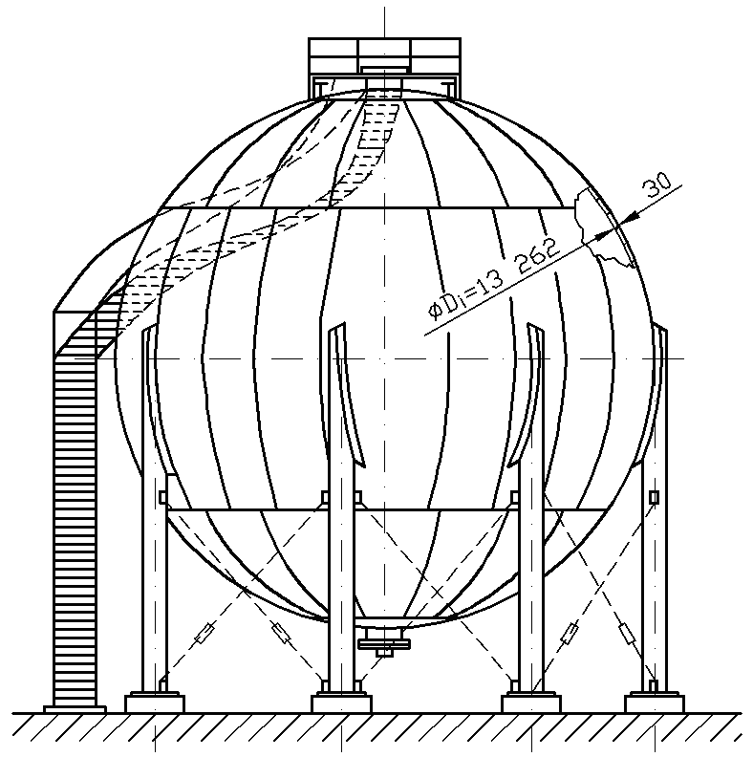
Figure1. SPHERICAL PRESSURE VESSEL FOR STORAGE OF LIQUID PROPYLENE WITH VOLUME OF V=1200 m³

The wall-thickness value has been calculated by designer by using of simple formulae (4), in which is inserted that the vessel is filled to maximum of 80% of volume (calculated height of free level is 3809 mm measured from the vessel top). For the hydro-test pressure of 3 MPa, minimal thickness on the vessel bottom can be calculated as:

$h_{i}=\frac{Dp}{4\frac{σ_{C}}{s_{i}}ν+p}+c_{1}+c_{2}=\frac{\text{13322}⋅3,\text{048}}{4⋅\frac{\text{450}}{1,1}⋅0,\text{85}+3,\text{048}}+0,3+1=\text{29},\text{65}\text{ mm}$, (4)
p=p_{i}+p_{h}=3+0,048=3,048 MPa
where are: D - outer diameter of the vessel, mm
p - total value of internal test and hydrostatic pressure
σ_{C} - characteristic stress value, MPa
s_{i} - safety factor, -
v - coefficient of weld joint weakness, -
c₁ - addition due to sheet thickness tolerance, mm and
c₂ - addition due to corrosion, mm [8].

It confirms that the wall-thickness calculation performed in the design phases has been done correctly.

3.2 Analytical stress calculation in the spherical vessel shell

Analytical stress calculation in the spherical vessel shell according to membrane theory shows the greatest stress in the bottom of spherical vessel (9). By the analyzing equilibrium of the bottom spherical vessel part (Figure 2) it is possible to set equations for circular and meridian force calculation:

$N_{Θ}=\frac{γ⋅R}{1−\text{cos}Θ}\left[\frac{1}{2}\left(R−k_{p}−\frac{h}{2}\right)\left(1−\text{cos}Θ\right)+\frac{R}{3}\left(1+{\text{cos}}^{2}Θ−\text{cos}Θ\right)\right]$ (5)

$N_{Φ}=Rγ\left[R\left(1−\text{cos}Θ\right)−k_{p}−\frac{h}{2}\right]−\frac{γR}{1−\text{cos}Θ}\left[\frac{1}{2}\left(R−k_{p}−\frac{h}{2}\right)\left(1−\text{cos}Θ\right)+\frac{R}{3}\left(1+{\text{cos}}^{2}Θ−\text{cos}Θ\right)\right]$ (6)
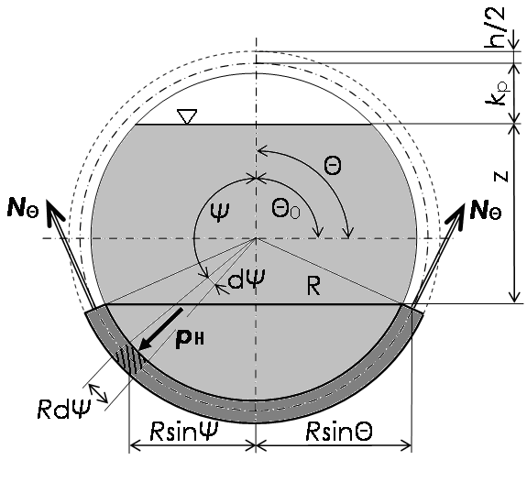
Figure2. SPHERICAL VESSEL BOTTOM PART EQUILIBRIUM
(UNDER THE SUPPORT RING) [9]

Equivalent stress distribution in a spherical vessel shell thickness of h=30 mm can be calculated by expressions (3), (5) and (6) (Figure 3).

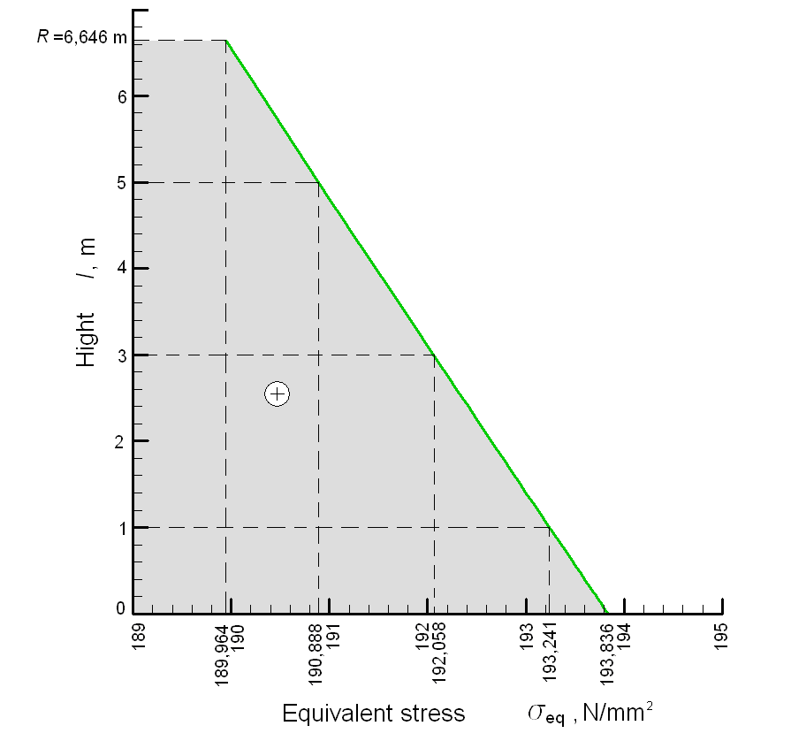

FIGURE3. DISTRIBUTION OF EQUIVALENT STRESS IN THE VESSEL MATERIAL UNDER THE EQUATOR LINE [9]

Diagram presented on the Figure 3. shows that the maximal stress on the bottom of the vessel amounts σ_{eq}=193,836 N/mm².

  - Optimal spherical vessel wall thickness

If the equations (5) and (6) are introduced into (3) the expression for equivalent stress calculation in a bottom half of vessel shell in correlation to wall thickness and observed position on vessel shell will be obtained. By means of this expression and similar ones which are able to set for upper pressure vessel shell part [9] it is possible to optimize wall thickness over spherical vessels zones. In such a manner, significantly savings can be accomplished, if we do observe the problem from the constructional aspect.
In this paper it is just shown the wall thickness optimization in according to maximal stress which is appearing on the bottom of vessel and which has a position =180°. Functional expressions (1) and (3) in which we first inserted (5) and (6) can be graphically shown as in Figure 4.

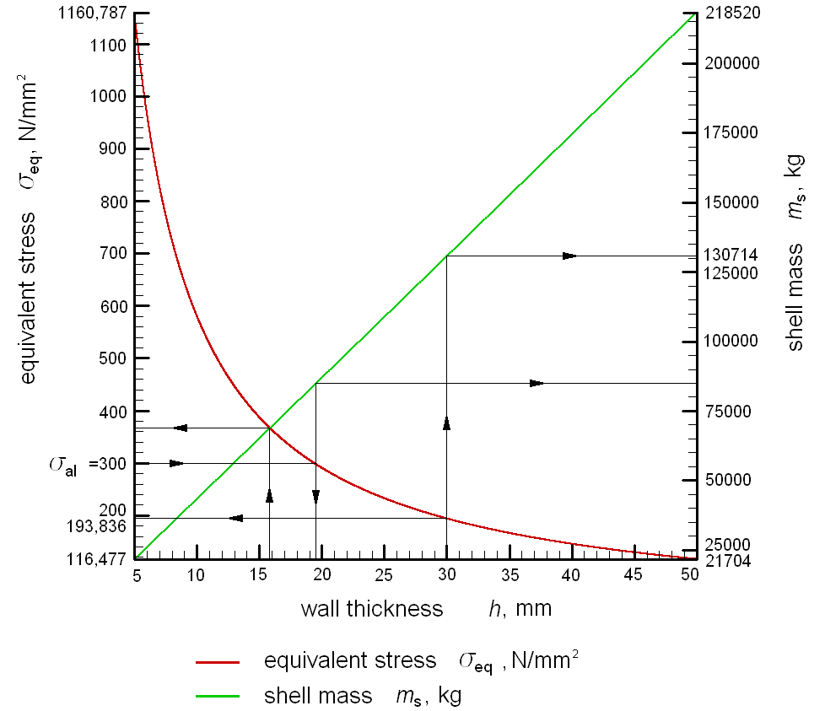

FIGURE4. DEFINING OF THE OPTIMAL WALL TICKNESS OF SPHERICAL VESSEL SHELL BASED ON EQUIVALENT STRESS AND SHELL MASS CORRELATION TO WALL THICKNESS

Intersection of two curves (Figure 4) represents optimum point which belong optimal shell wall thickness with satisfying thereat criterion about minimal overall mass and minimal equivalent stresses in vessel shell. We can read from that diagram that the optimal shell wall thickness is about 16 mm. To that wall thickness belongs maximal equivalent stress which is higher then allowed stress (σ_{al}) whit the safety factor of 1.5, but considerably less then yield point for NIOVAL 47 material. If the satisfied safety factor is desired, but the optimal wall-thickness too, then it is needed to build a shell from the material with higher yield strength. We could further talk then about financial justifiability of that kind of material implementation.

4. CONCLUSIONS

This paper gives a preposition for spherical pressure vessel wall thickness optimizing approach. It has been shown that the principles of minimal shell mass and minimal equivalent stress determined analytically by membrane stress theory could be the base for the structural optimization. Great development of welding technology and good quality of weld joints provide pressure vessels designing with different wall thickness over particular zones. It is possible to apply proposed procedure to optimize wall-thickness over different zones of huge spherical pressure vessels.

REFERENCES / BIBLIOGRAPHY

- BPVC-VIII-2004 BPVC Section VIII-Rules for Construction of Pressure Vessels Division 1
- AD-Merkbläter/Reihe B1/AD 2000
- BS 5500 Unfired Fusion Welded Pressure Vessels, 1997
- SNCT (Syndicat National de la Chaudronnerie, de la Tolerie et de la Tuyauterie Industrielle)
- R.W. Nichols: Pressure vessel codes and standards, Elsevier applied science publishers Ltd, London and New York 1987.
- Kozak, Dražan: Contribution to the numerical and experimental analysis of fracture behaviour of hetereogeneous structures (in Croatian), Dissertation, University of Zagreb, Zagreb, 2001.
- Lukačević, Zvonimir; Jovanović, Aleksandar; Kozak, Dražan: Inservice Inspection of HSS Storage Tanks, Annals of Mechanical Engineering Faculty in Slavonski Brod, Slavonski Brod, 1991, pp 369-374
- HRN M.E2.253/91
- Sertić Josip; Kozak, Dražan: Stress and Strain Analysis of the Spherical Pressure Vessel: Analytical and Numerical Approach, 5th DAAAM International Conference on Advanced Technologies for Developing Countries, 2006, Rijeka, pp 31-36

Author’s data:
¹ Dr. Dražan Kozak, Assoc. Prof.
² Josip Sertic, BSc in MechEng
Josip Juraj Strossmayer University of Osijek, Mechanical Engineering Faculty in Slavonski Brod, Trg Ivane Brlic-Mazuranic 2, HR-35000 Slavonski Brod, Croatia, Tel. +385 35 446 188, Fax: +385 35 446 446, e-mails: dkozak@sfsb.hr and jsertic@sfsb.hr

