TUMOUR-INDUCED AZOOSPERMIA

D. Ježek; University of Zagreb, School of Medicine, Dept. Histology and Embryology, Croatia

Introduction. Testicular cancer is the most common malignancy in young men, associated with a significantly lower sperm count or, in more severe cases, azoospermia. The exact mechanism responsible for this decreased sperm concentration and quality is unknown. Pre-existing defect in germ cells, leading to both cancer and defective spermatogenesis, genetic abnormalities or exposure to abnormal hormonal levels in utero, paracrine action of tumour cells could be the possible causes. Cancer might also alter the process of spermatogenesis through a hormonal imbalance. Thus, the tumour might secrete its own hormones affecting spermatogenesis or pituitary.
Presentation and history. A 34-years old patient presented andrologist complaining on infertility problems. He was married for 3 years and the couple was not able to conceive, despite normal sexual life. The patient had usual diseases in the childhood, including parotits without any sequelae. His brother had 2 children; there was no history of infertility in the family. The female partner was in good health, also without any history of infertility in her family.

Examination. The patient had normal osteomuscular status (without a female type pelvic girdle), no signs for gynaecomastia; normal distribution of the hair; unaffected quality of voice; body weight was 84 kg and height 181 cm. His cardiopulmonary and neurological status was normal. Blood pressure was 135/85 mmHg. Careful examination of the testes revealed that the both gonads were as twice as abnormal in size, reaching approximately 40 cm³ each. The patient was not sensitive on their palpation. Augmented gonads have had solid consistence. Examination by means of lamp confirmed that a solid tissue mass occupied scrotum bilaterally. The palpation of d. deferens showed no discontinuity or aplasia. However, the spermatic cord area was thickened on both sides. Liver and spleen were within normal range. No enlarged inguinal or other lymph nodes could be noted.

Preliminary diagnosis and differential diagnosis. Macrorchia. Expansive process in both testes (?). Bilateral primary tumour of the testis (?). Secondary tumour/metastases (?).

Further investigations. Five semen analyses (with time laps) showed azoospermia. FSH and LH were increased (FSH= 18U/l; LH= 22 U/l). Testosterone had decreased levels (T= 5,1 nmol/l). As for the tumour markers, hCH was within the normal range (8 IU/l) whereas AFP was increased (24,3 µg/l). Ultrasound demonstrated markedly increased volume of gonads with a solid consistency. The retroperitoneal lymph nodes were enlarged. CT scan of the abdomen supported ultrasound findings. CT of the pituitary was within normal range. Karyogram demonstrated no chromosomal abnormalities (46, XY). In situ fluorescent hybridization (FISH) was negative for cystic fibrosis. Molecular biology tests discovered no microdeletions of Y chromosome. Surgical exploration of the testicles showed a bilateral tumour mass, with the presence of the normal testicular tissue at the periphery of the each gonad (Fig. 1).

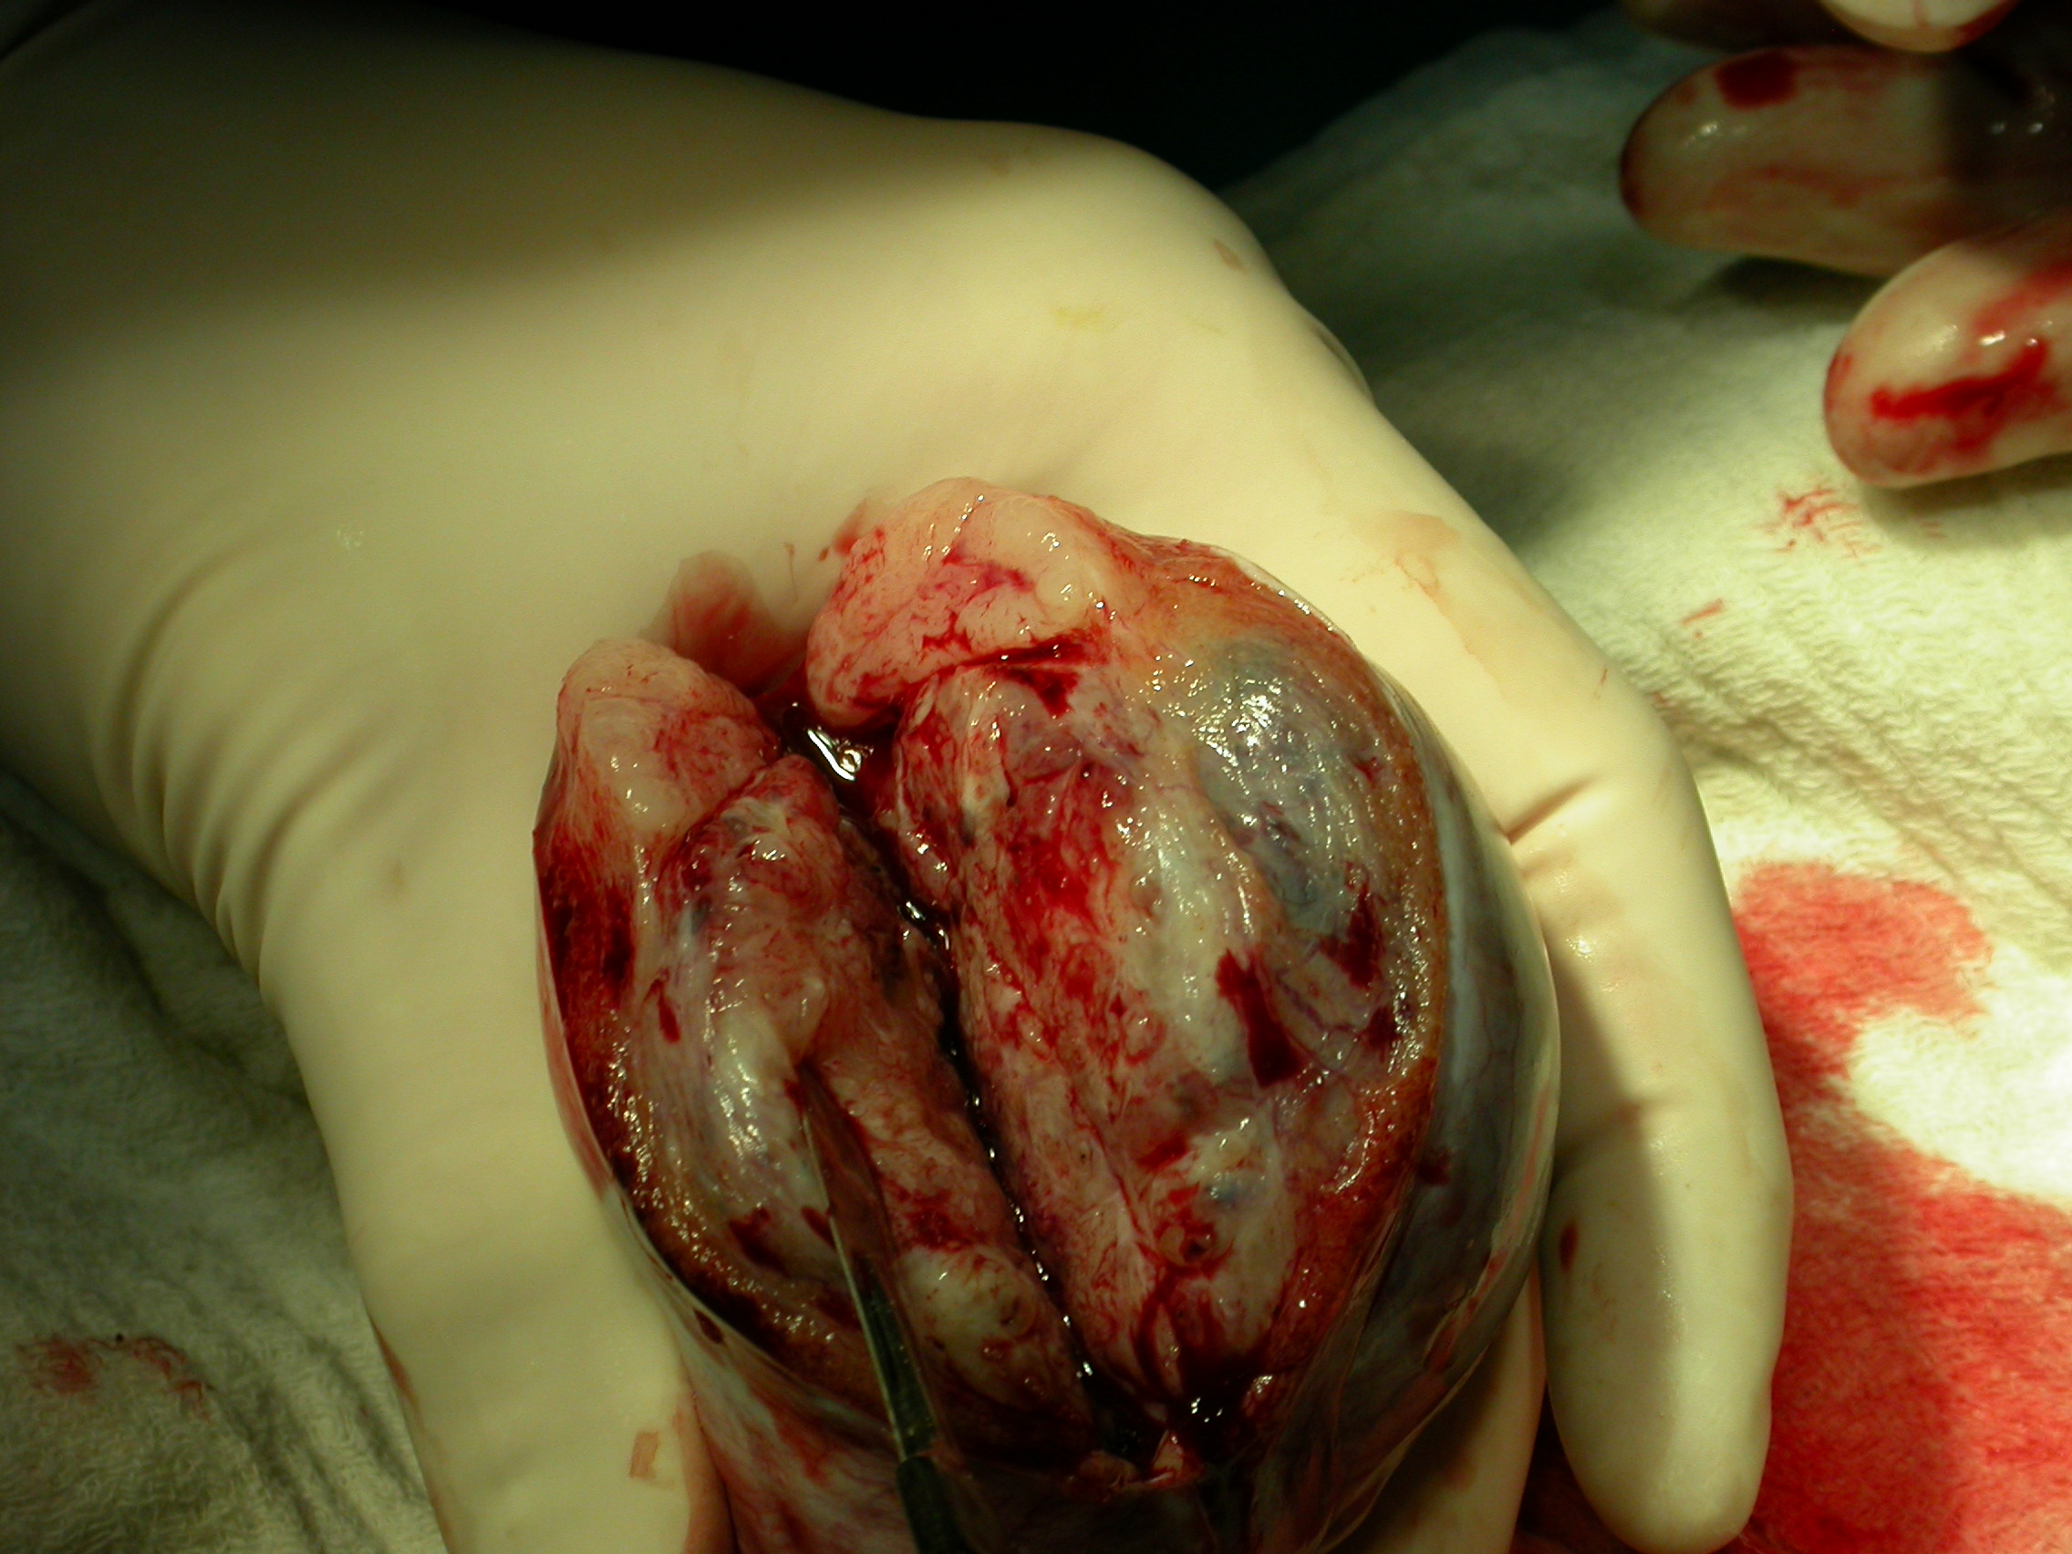

Fig. 1. A tumour of the testis. At the edge of the gonad, a normal
appearance of the testis parenchyma can be seen (arrow).

A bilateral orchiectomy followed. Pieces of tumour tissue were fixed in 10% buffered formalin, dehydrated, embedded in paraffin and processed for histological analysis. Areas of normal parenchyma were carefully dissected into several smaller pieces. 3 pieces were immediately immersed into 4% buffered glutaraldehyde and Bouin’s fluid. The tissue was embedded either in paraffin or Durcopan; paraffin and semi-thin sections have been performed. The rest of the parenchyma with the normal consistency was placed into the Sperm Prep medium (Medicult). Afterwards, they were plunged into Sperm Freezing medium (Medicult) and stored in liquid nitrogen for potential in vitro fertilization procedures. A total number of 6 tissue pieces were frozen.

Final diagnosis. The histological analysis revealed within the testes and spermatic cord a bilateral tumour – an embryonal carcinoma with metastases (stage II). The histology of the testis areas with normal appearance and consistency revealed a ”mixed atrophy” of seminiferous tubules. Seminiferous tubules in the close proximity of the tumour were transformed into the fibrous tissue; some seminiferous tubules were lined only with supporting Sertoli cells and occasional spermatogonia. However, the seminiferous tubules distant to the tumour contained all spermatogenic cells including sperm. It has been concluded that the frozen bioptic material was suitable for the combined TESE/ICSI procedure (testicular sperm extraction & intracytoplasmic injection into the oocyte).

Management and treatment. The tumour has been removed surgically by a bilateral orchiectomy. Since retroperitoneal lymph nodes were affected, a combination of chemotherapy and retroperitoneal lymph node dissection (RPLND) has been performed.
Infertility management. 2 pieces of the testicular tissue stored in liquid nitrogen were frozen-thawed. Freezing medium was discarded and tissue was immediately placed in a vial with IVF medium (Medicult) and collagenase type IA (Sigma). After an incubation in CO₂ incubator at 37ºC for 90 min., the biopsies were additionally microdissected by sterile needles. The vials were centrifuged for 10 min. (500-800 G). The supernatant with collagenase has been discarded and the rest of the vial content resuspended in a 0.5 ml of IVF medium (Medicult). Spermatozoa have been collected form the vial, incubated for 30 min. in an incubator and placed in PVP. A total number of 12 oocytes have been retrieved and were processed for ICSI. 3 embryos were transferred into the uterine cavity and 2 frozen for further embryo transfer attempts. No pregnancy has been achieved in the first attempt. The in vitro procedure has been repeated after 3 months. 2 embryos have been transferred and the pregnancy achieved. The woman is subjected to regular check-ups at dept. of gynaecology and obstetrics.

Lessons to be learned & conclusions. The case described above demonstrates that, despite azoospermia and the presence of the testicular tumour with metastases, modern reproductive techniques are capable of yielding spermatozoa and achieving pregnancy.

Literature

1.Chow V, Cheung AP. Male infertility J Reprod Med 2006:51:149-156
2.Kumar R i sur. Drug therapy for idiopathic male infertility: rationale versus evidence J Urol 2006:176:1307-1312
3.Cavallni G. Male idiopathic oligoasthenoteratozoospermia Asian J Androl 2006:8: 143-157
4.Turek PJ. Practical approaches to the diagnosis and management of male infertility. Nature 2005:2:226-238

