From Research to Teaching Human Kinesiological Biomechanics: A Zagreb Experience

VLADIMIR MEDVED
Faculty of Kinesiology
University of Zagreb
Horvaćanski zavoj 15, 10000 Zagreb
CROATIA
vmedved@kif.hr

Abstract: - University-level teaching relies significantly on research in the field. In the case of locomotion biomechanics, research methodology comes from biomedical engineering, including classical physics-, cybernetics- and systems analysis-components. More than two decades of experience of working in this field at the University of Zagreb, centered at the Faculty of Kinesiology (the former Faculty of Physical Education), has resulted in several new courses being developed and introduced. (We consider here primarily undergraduate teaching level.) Courses for future kinesiologists are focused on motor behaviour and physiology; for engineers on measurement techniques and robotics; and for medical doctors on clinical diagnostics aspects. Both the textbook and laboratory equipment setting were realized, serving as a prerequisite for respective courses offered, some given in English and some in Croatian. Multidisciplinary teaching staff coming from various university departments is provided. An up-to-date teaching performance of kinesiological biomechanics subject matter is attempted, being compatible with international education trends.

Key-Words: - biomechanics, locomotion, education, engineering, kinesiology, medicine

1 Introduction
Kinesiological biomechanics contributes to understanding the function of locomotor system in kinesiological tasks, to be applied to sportive and pathological locomotion alike. This interdisciplinary field uses principles of classical mechanics to study locomotor system function via inverse dynamic approach. In addition, neural control of movement is also considered [1, 2]. Basic modelling and measurement metholodogies, although standard, are undergoing continuous improvements in application due to technological advancement of - in the first place - computers and sensor technologies. Automated measurement methods are available today to capture locomotion including 3D kinematics, ground reaction, and telemetric multichannel surface electromyography [3]. Also, sophisticated biomechanical human body models may be implemented in software enabling subject-specific simulations of various interventions in the locomotor system [4].
Advancements in the field at the Faculty of Kinesiology, University of Zagreb, during the period lasting over two decades has brought some improvements in teaching which are reported here. “Biomechanics” was among basic methodological courses in the standard curriculum and was therefore regularly thought early in the study. Complexity of the matter required additional teaching efforts.
2 How to teach kinesiological biomechanics
It is well known that research methodology in biomechanics comes from exact sciences, witnessed in history of the field also by pairs, or even groups of researchers of various backgrounds acting together in developing the field. (Weber brothers, Braune and Fischer, The Berkeley Group may be taken as examples.) It would therefore be logical to teach this subject as a part of a broader biomedical engineering curriculum. At the University of Zagreb there is no such faculty i.e. department, while only the Croatian Medical and Biological Engineering Society (CroMBES) provides certain expertease in the field; its Biomechanics Division being particularly relevant in this matter. Since “Biomechanics” was the only obligatory undergraduate course presenting elementary knowledge in the field, our efforts were directed towards introducing the respective subject into curricula of several university departments.

- Courses for specific teaching curricula
  - Electrical engineering and computing
By accummulating research results and relying on a significant measurement component (A/D signal conversion, force and EMG signal processing) an idea arose to develop a course on human locomotion suited to electrical engineering curriculum. The course entitled: “Multisensor Systems and Locomotion” was aimed to
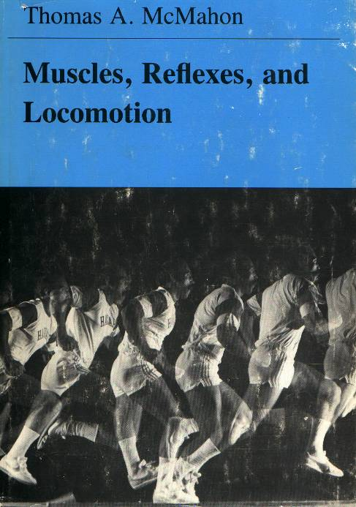

Figure 1. A systems theoretical approach to explain locomotor function: fundamental to kinesiological biomechanics [1].

treat the aspects of sensors as well as (loco)motor function in humans in analogy to robotics. Following are its units [5, 6]. The notion of robotics as an intelligent connection between perception and action. The analogy with biosystems. Vision sensors. Optoelectronic methods of scene measurement and acquisition. Photogrammetric tranformations and algorithms. Modelling of the environment. Measurement of forces, distributed pressures and tactile sensors. Other sensor modalities. Integration of sensor modalities. Kinematics, biomechanics, and modelling of movement in biosystems. Locomotion. Artificial muscle: realizability. Prostheses: cybernetic and motor aspects and their functionality. Movement simulation and virtual reality. Through class and laboratory work the course is aimed at explaining the methodology and instrumentation in human movement analysis.
While the initial aim was to provide balance between subjects of human biomechanics and of robotics, however, time has brought orientation practically towards human biomechanics. The course is given as an elective to electrical engineering students, directions industrial electronics, computing and, in the future, automation.

3.2 Medicine
Development of the field and publishing of a textbook [3] has brought us to the point to be able to equipe the laboratory. In this task we have had a support by the Faculty of Mechanical Engineering and Naval Architecture, professor Muftić in particular, and the Zagreb-based import firm Polimedika, while the ultimate funds provider was the Ministry of Science, Education and Sports of the Republic Croatia. The ELITE kinematic system (BTS, Milan, Italy), the “Kistler” force platform (Switzerland), and 8-channel telemetric surface EMG system also by BTS were installed in our laboratory facility, which forms a part of a larger sport diagnostic centre. With the help of our orthopaedic colleague professor Pećina a course “Measurement and Analysis of Human Locomotion” was conceptualized, developed and offered as an elective in the new Medical Studies in English curriculum at The School of Medicine [7]. Theoretical background for biomechanical analysis of human locomotion is provided at the beginning. Macroscopic body modelling is explained, and inverse dynamic approach, being a central methodological paradigm, is introduced. Experimental methods including 3D kinematics, ground reaction force kinetics and multichannel surface electromyography (EMG) are then explained, as well as basics of spiroergometry. Gait, a principal locomotor pattern is discussed. Basic clinically recognizable gait pathologies are identified. Other typical pathologies linked to the locomotor system function are identified; primarily those related to posture and eqilibrium disturbances [8]. Computerized locomotion laboratory setting serves for a number of clinical measurement applications and case studies. Experimental data are interpreted in the context of the underlying physiological system (mal)function. Expert knowledge of relevant medical specialist is relied upon, and biomechanical data are combined and integrated into the comprehensive diagnosis- and clinical decision-making picture. More objective differential diagnostics of various locomotor pathologies is seeked, being applicable in rehablitation follow-up, pre-surgery planning and post-surgery evaluation, prostheses of extremities' evaluation, etc. Sport-specific movement applications are discussed as well.
The course is aimed at introducing to the medical student modern clinical application methods of biomechanical locomotion analysis. An interdisciplinary tailored faculty team, trained in the fields such as biomedical and clinical engineering, several medical specialties, and kinesiology demonstrates inter-disciplinary nature of this rapidly developing field. By virtue of its position in the teaching curriculum the course is among the first to convey a certain “clinical flavour” to future physicians.

3.3 Kinesiology
Long year research in the realms of the projects: “Neuro-muscular Biomechanical Diagnostics of Sportive and Pathological Locomotion” and “Creating Centre of 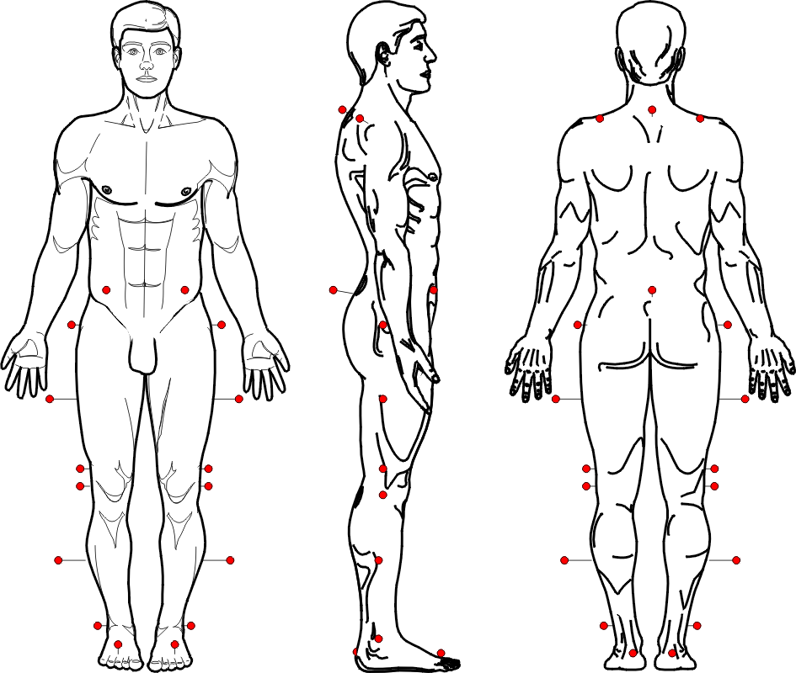 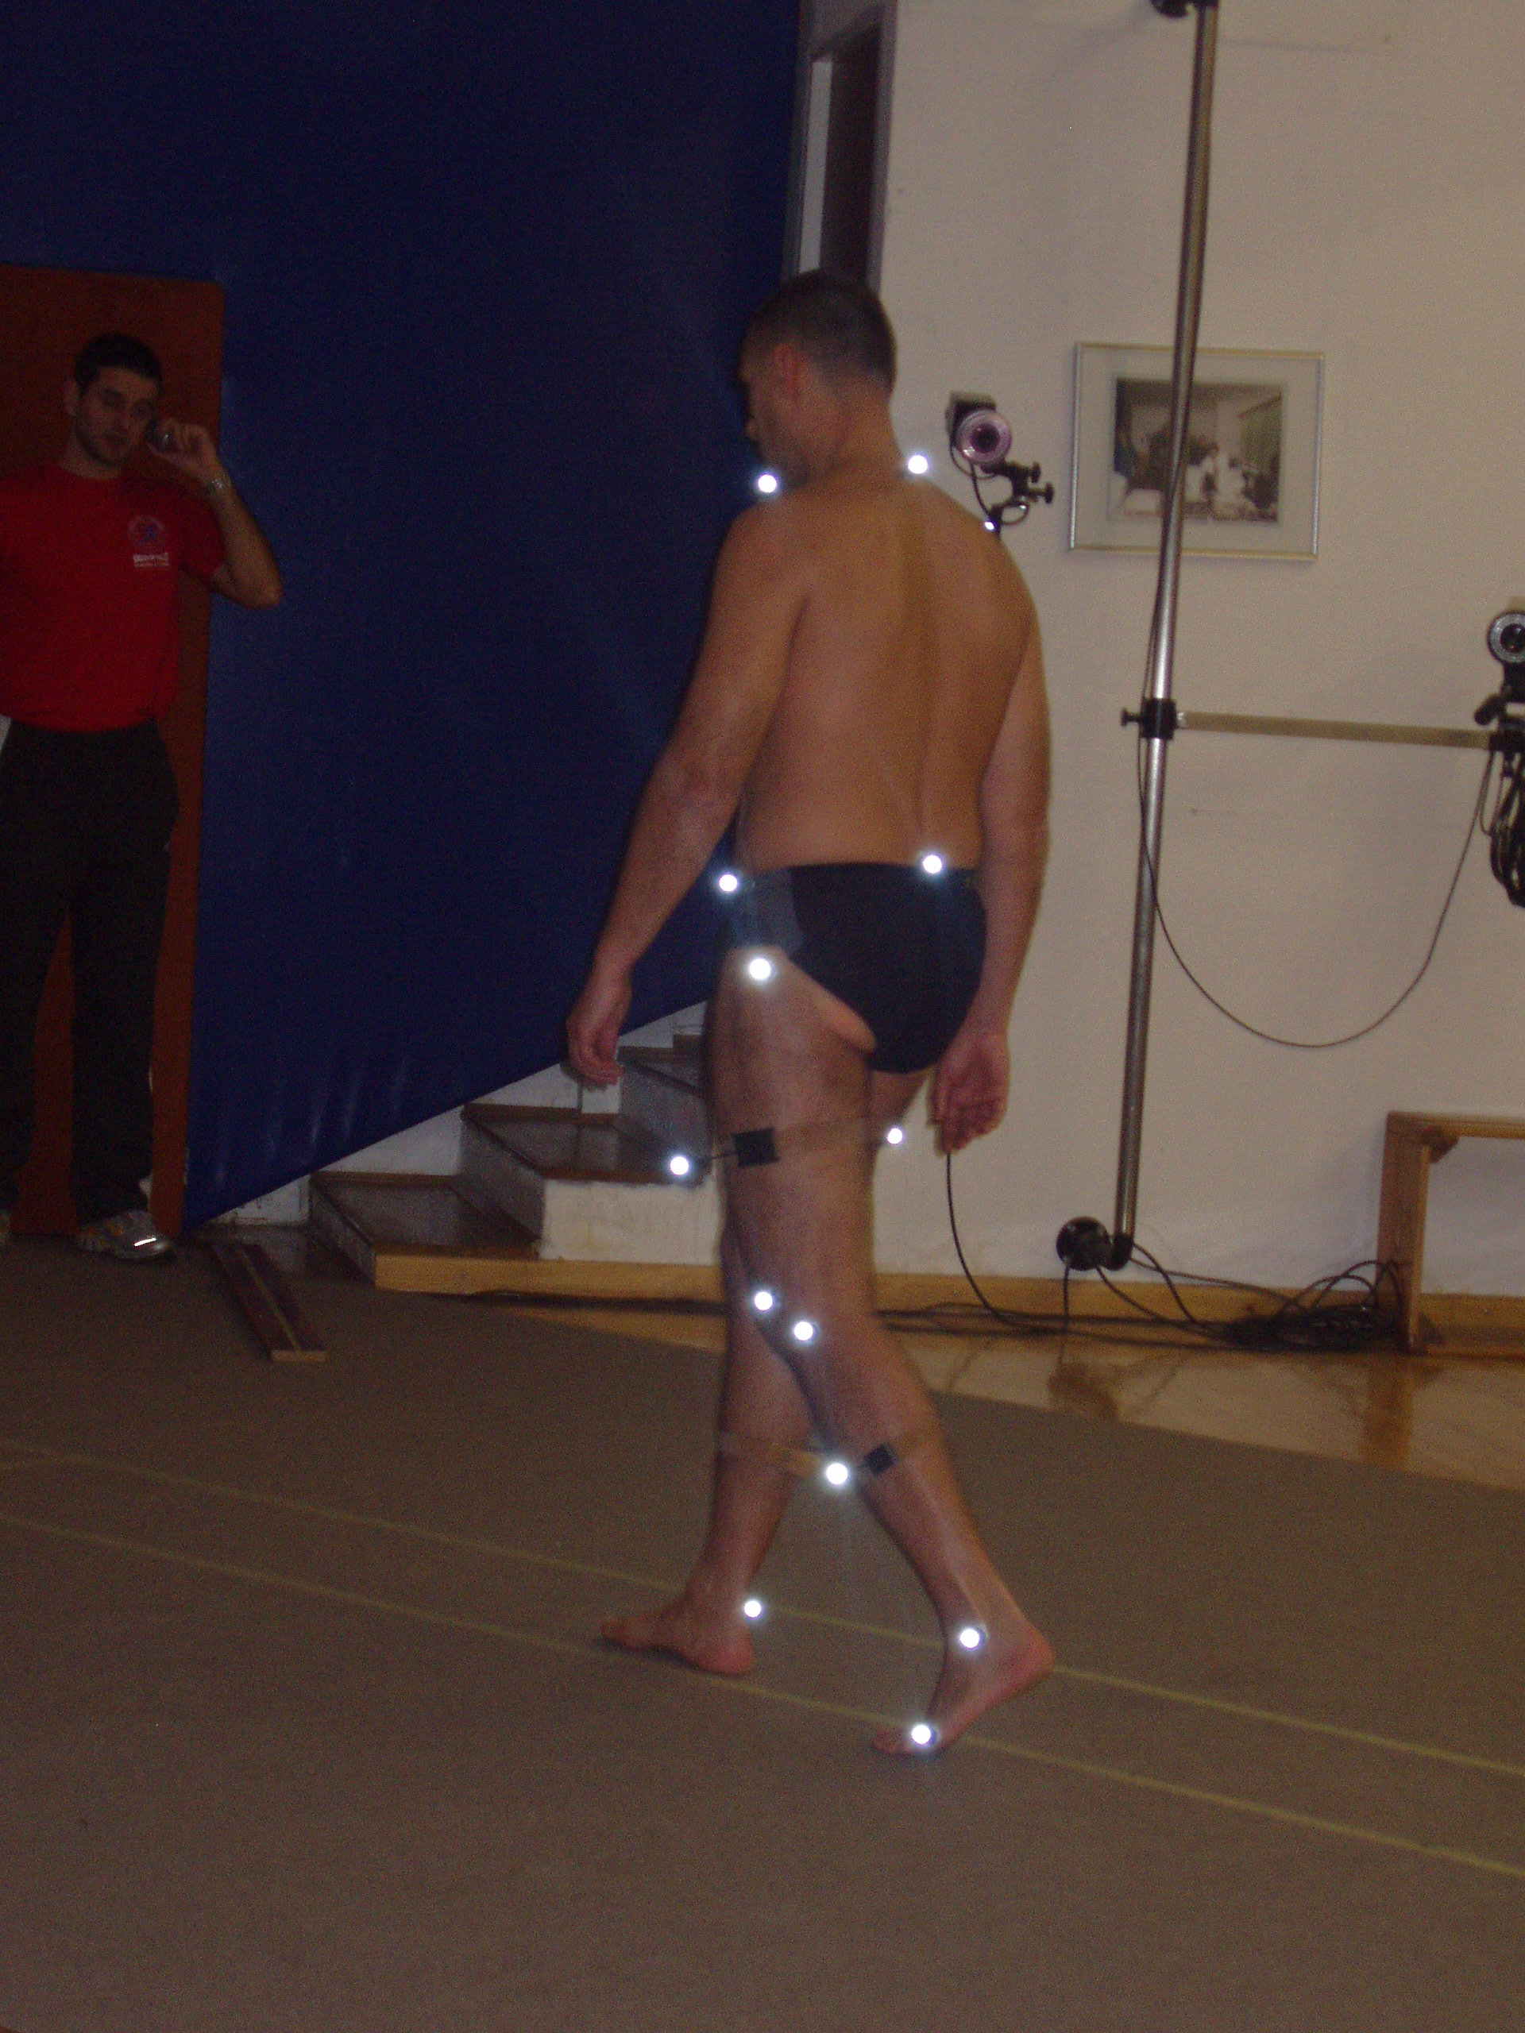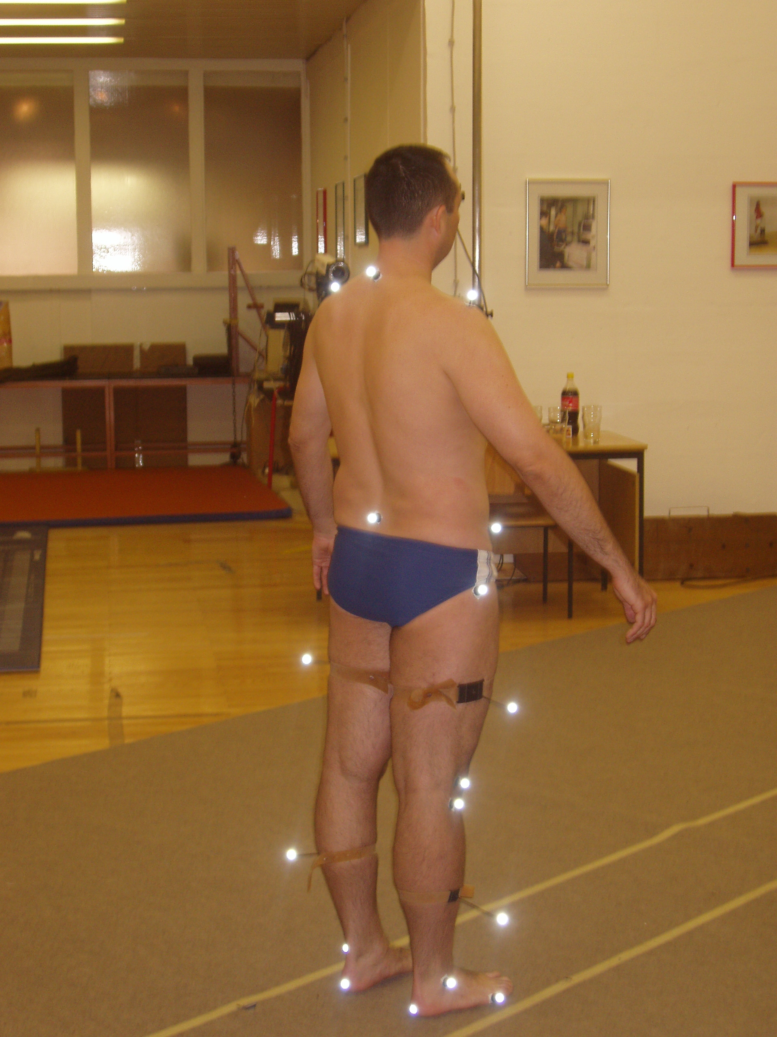

Figure 2. Measurements of human gait: a central experimental paradigm in kinesiological biomechanics [9].

Excellence for Locomotion Study” has accumulated a number of experimental findings as well as applied and verified many signal processing methods, both in time and in frequency domain. So the new elective subject for kinesiologists, following “Biomechanics”, and suited to the Bologna Declaration has been proposed: “Neuro-muscular Biomechanical Diagnostics”. It begins with the description of the movement measurement and analysis laboratory facility, indicating basic procedural steps in its use. The units are then as follows. Biomechanical diagnostics in kinesiology and medicine. Neuro-muscular function diagnostics. Skeletal muscle as an actuator in locomotor system. Biomechanical muscle models. Electrophysiological features of skeletal muscle function. Relationship of myoelectric, i.e. electromyographic (EMG) signal and mechanical muscle function. Surface EMG signal and its processing. EMG signal spectral analysis in static and dynamic contractions and muscle fatigue monitoring. Correlation between EMG, kinematic and kinetic variables. Practical applications of neuromuscular diagnostics in sports, kinesitherapy and several medical fields. Human gait: biomechanical, kinesiological and energy aspects [9]. Multichannel EMG signal processing including application of neural networks. Clinical testing of posture and equilibrium. Comparison of modelling and experiment in biomechanics [10]. Virtual reality application.
The course builds scientific fundaments for research into muscle biomechanics, along the lines of McMahon [1], offering the student the knowledge of an inter-disciplinary area of clinical diagnostics of neuromuscular function in kinesiology and medicine. We hope in the future to develop this course into modern vehicle for understanding the impact of physical exercise to human body in quantitative terms, being complementary to sports physiology and sports medicine approaches.

4 Conclusion
Feedback until now from the first two courses mentioned is positive and student interest remains stable. Each of these courses has been standardized in terms of teaching units and the teaching staff, being of diverse background: electrical and mechanical engineers, kinesiologists and medical specialists; orthopaedists, neurologists and physiatrists. As already mentioned, lacking a single biomedical engineering department (and, consequently, not offering a biomedical engineering degree) at the University of Zagreb, the courses described remain incorporated as electives into standard curricula of respective schools.
It is worth, finally, to mention a recent important addition to the library of - rather rare if not unique - textbooks in Croatian language treating the subject of biomechanics by Nikolić and his collaborators, which is to appear soon [11].

Acknowledgment: “The results presented are the product of the scientific project “Automated Motion Capture and Expert Evaluation in the Study of Locomotion”, realized with the support of the Ministry of Science, Education and Sports of the Republic of Croatia.”

References:
[1] McMahon, T.A., Muscles, Reflexes, and Locomotion. Princeton University Press, Princeton, NJ, 1984.
[2] Rose, J. and Gamble, J.G. (Eds.), Human Walking, Third Edition, Williams and Wilkins, Baltimore, 2006.
[3] Medved, V., Measurement of Human Locomotion, CRC Press Inc., Boca Raton, Fl, 2001.
[4] Delp, S.L., Arnold, A.S. and Piazza, S.J., Clinical applications of musculoskeletal models in orthopedics and rehabilitation, In: Biomechanics and Neural Control of Posture and Movement, (J. M. Winters and P.E. Crago, Eds.), Springer - Verlag, New York, 2000, 477-489.
[5] Medved, V., Locomotion systems study in biomedical engineering curriculum, World Congress on Medical Physics and Biomedical Engineering, Chicago, 2000.
[6] Medved, V., Teaching instrumentation and methodology in human motion analysis, 23th Annual International Conference of IEEE Engineering in Medicine & Biology Society. Istambul, 2001.
[7] Medved, V. and Pećina, M., Introducing human locomotion analysis into the medical curriculum at the University of Zagreb, Proceedings of the World Congress on Medical Physics and Biomedical Engineering (S. Cheong, Ed.), Sydney, Amlink digital services, 2003. 4309
[8] Pećina, M. and Bojanić, D., Overuse Injuries of the Musculoskeletal System, Second Edition; CRC Press Inc., Boca Raton, Fl, 2003.
[9] Heimer, Ž.,. Automated clinical measurement of biomechanics and kinesiology of gait, M. Sc. Thesis, Faculty of Electrical Engineering and Computing, University of Zagreb, Zagreb, 2005. (in Croatian)
[10] Medved, V., Experiment vs. modelling and simulation - a task for biomechanists. Workshop on Signals and Systems in Human Motion. SoftCOM 2004 (D. Begušić, H. Dujmić, V. Zanchi, Eds.), Split-Dubrovnik-Venice, 2004, 31-32.
[11] Nikolić, V. et al., Biomechanics: Principles and Elements, Second Edition, Naklada Ljevak, Zagreb, in print. (in Croatian)

