NEW WAYS IN MANUFACTURING ENGINEERING ´2008
19. – 21. June 2008, Prešov, Slovak Republic

Vplyv preťaženia na prevádzkovú kapacitu valcovej nádrže s torisferickými hlavami pre podzemné skladovanie ropy

Overloading effect on the carrying capacity of cylindrical tank with torispherical heads for the underground storage of petrol

Dražan KOZAK, Ivan SAMARDŽIĆ, Sergej HLOCH, Pejo KONJATIĆ

Abstract: Horizontálna valcová dvojplášťová nádrž s torisférickymi hlavami pre podzemné skladovanie nafty bola vyrobená v dielni s rozmermi nádoby 2,5m a s hrúbkou plášťa 6mm. Pred využitím bola nádrž testovaná s tlakom 2 bary podľa normy EN 12285-1. Počas testu sa tlak nekontrolovateľne zvýšil. Vplyv pretlaku bol analyzovaný s použitím metódy konečných prvkov. Výpočtom je dokázané, že plastický kolaps vnútornej hlavy vnútornej hlavy sa vyskytol v rozsahu medzi 5 – 6 bar.

Abstract: Horizontal cylindrical double skin steel tank with torispherical heads for the underground storage of petrol has been manufactured in the workshop (diameter of the vessel was 2,5 m and the shell thickness 6 mm). Before exploitation it has to be tested with pressure of 2 bars according EN 12285-1 norm. During the pressurization uncontrolled pressure increasing happens. Effects on this overloading have been analysed by using of finite element method. It is numerically proven that plastic collapse of internal head occurred in range between 5 and 6 bars.

Key words: cylindrical pressure vessel, torispherical head, pressure overload, finite element method.

INTRODUCTION

Pressure vessels are probably the most widespread “machines” within the different industrial sectors. In fact, there is no factory without pressure vessels, steam boilers, tanks, autoclaves, collectors, heat exchangers, pipes, etc. More specifically, pressure vessels represent fundamental components in sectors of enormous industrial importance, such as the nuclear, oil, petrochemical, and chemical sectors [1]. When constructing pressure vessels they have to comply with EN or ASME Code developed specially for pressure vessel design. In practice, pressure vessels designed in accordance with the ASME Code, Section VIII, Division 1, are designed by rules and do not require a detailed evaluation of all stresses. It is recognized that high localized and secondary bending stresses may exist but are allowed for by use of a higher safety factor and design rules for details [2]. However, many investigations were conducted regarding to various pressure vessel head design because classical torispherical and ellipsoidal heads disturb the membrane state of stress in a pressure vessel [3].

PROBLEM DESCRIPTION

This paper deals with pressure overloading effects during the fabrication of one pressure vessel. Observed pressure vessel was actually a double skin tank with torispherical heads used for underground storage of petrol with diameter of 2,5 m and shell thickens of 6 mm with geometry shown in Fig 1. Connection between torispherical head and cylinder of pressure vessel was accomplished by welding of these two elements. After production this pressure vessel had to be tested for safety. Described vessel was tested according to EN 12285-1 norm [4]. Usually the test can be hydrostatic or pneumatic. A hydrostatic test is generally preferred method while pneumatic test is used when hydrostatic test cannot be used. Many reasons can prevent usage of hydrostatic test on certain pressure vessels including its design or its intolerance to liquid or traces of liquid. Due to mentioned reasons observed vessel was subjected to pneumatic test with pressure of 2 bars as it is proposed in norm for pressure vessel testing.
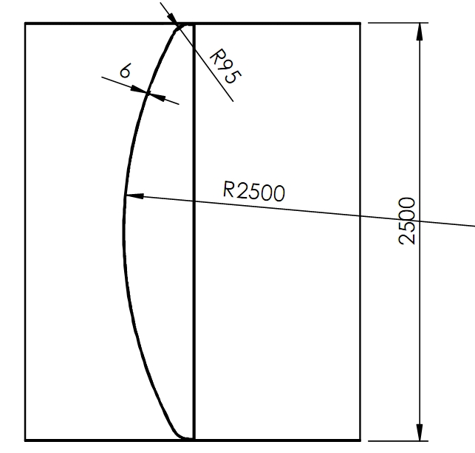
Fig. 1 Geometry of pressure vessel

While it was under testing an uncontrolled rising of pressure occurred leading to failure of subjected pressure vessel (Fig. 2).

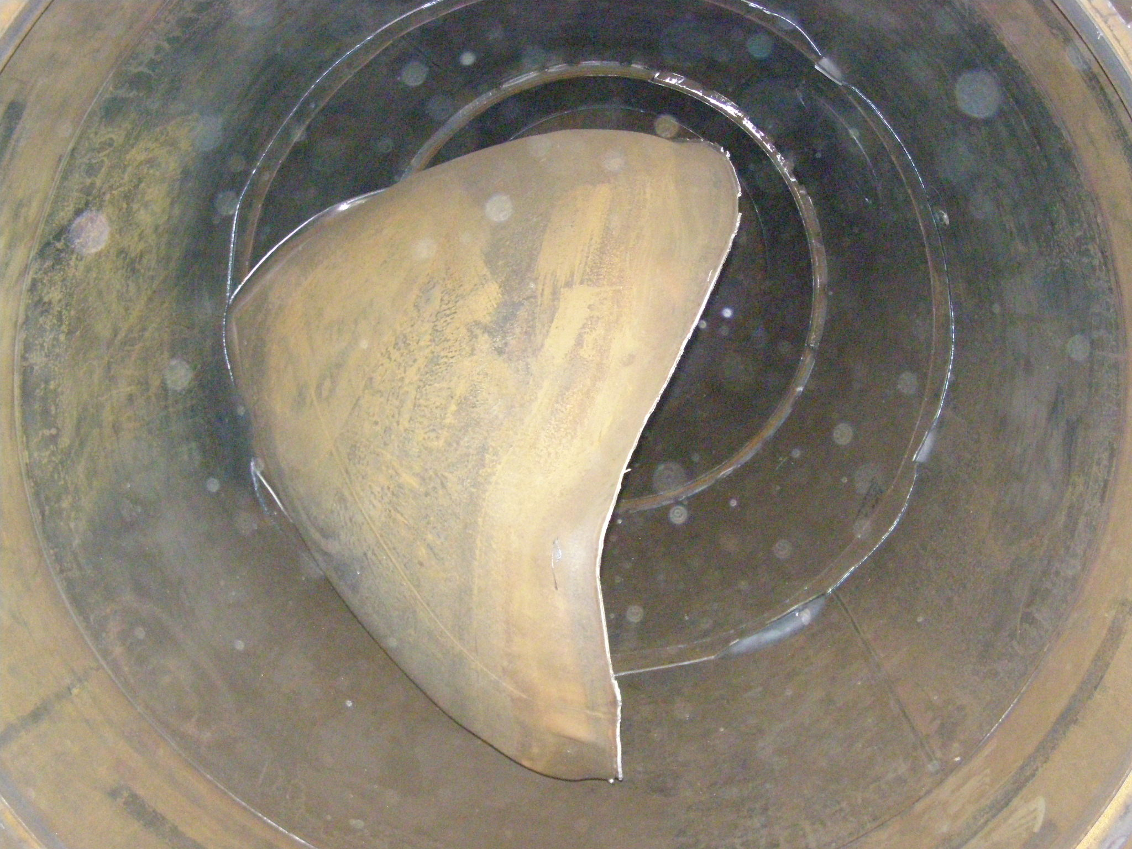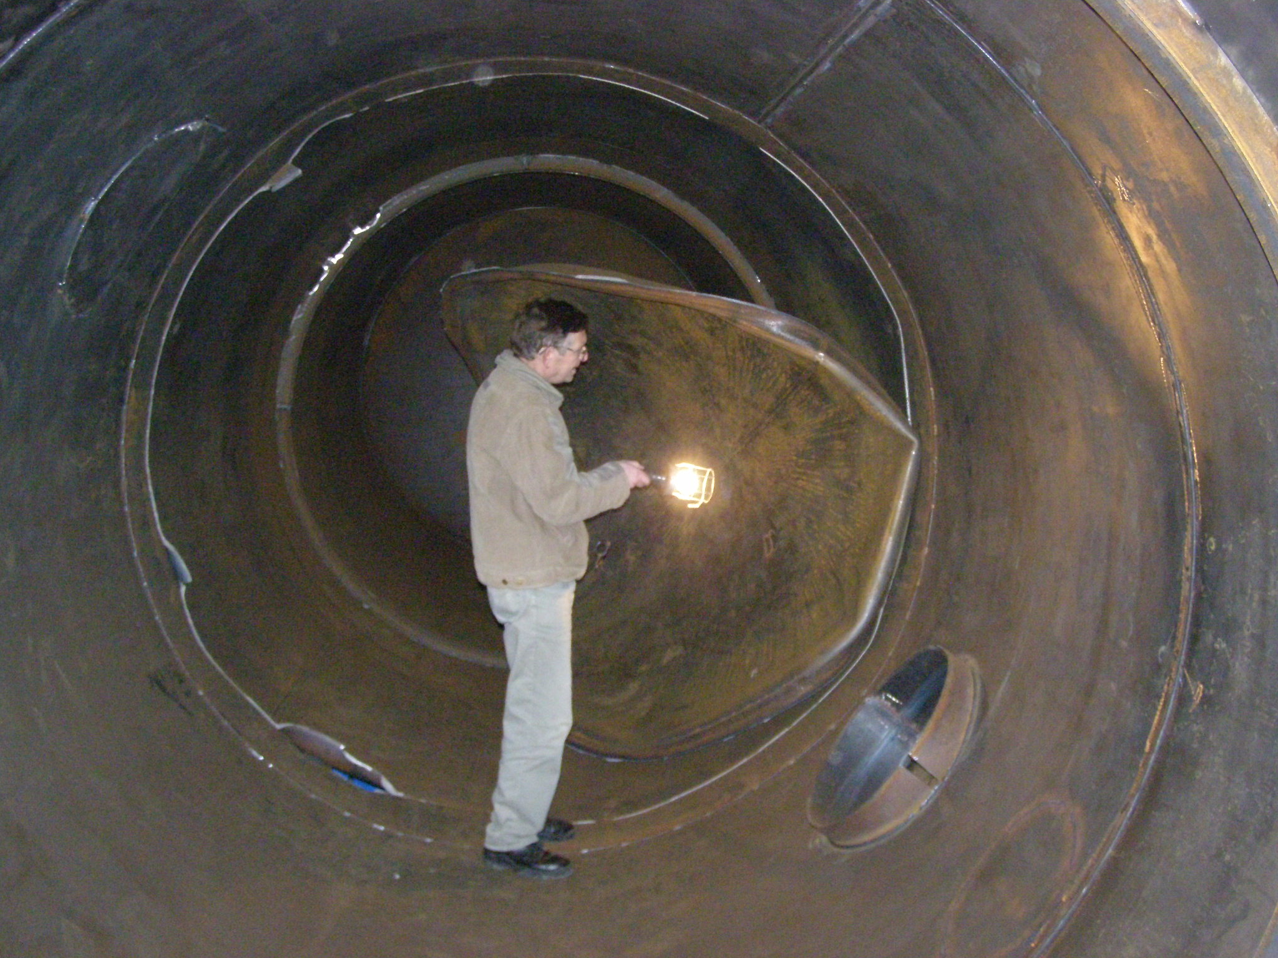
Fig. 2 Pressure vessel after failure caused by pressure overload

Required pressure vessel head thickness and the value of pressure overload have been estimated analytically and numerically by using of 3 D finite element analysis.

ASME EQUATIONS FOR PRESSURE VESSELS WITH TORISPHERICAL HEADS

ASME Code for pressure vessels gives equations for determining required thickness of different heads with various spherical and knuckle radii which are designed to the requirements of ASME Code Section VIII-1. For torispherical heads and pressure on concave side of head required thickness is:
(1)
where t is thickness of the head, P is pressure on concave side of the head, L is inside spherical radius, S is allowable stress of material, E is joint efficiency factor and M is shear intensity factor defined as:
(2)
where r is knuckle radius.

For large ratios R/t, the knuckle region of the head is prone to buckling under internal pressure [5]. Based on plastic analysis [6], the following expression is used for thickness:
(3)
where l is crown radius, D is diameter of the shell to which the head is attached.

ANALITICAL SOLUTIONS AND NUMERICAL ANALYSYS

According to expressions (1) and (2) pressure vessel head thickness of 6 mm will safely withstand pressure of 4.7 bar with joint efficiency factor E = 0,85 for single filleted weld between cylinder and head. If calculation based on plastic analysis according expression (3) is done, safe pressure is under 1.3 bars.
Beside analytical calculation a numerical analysis was performed in order to find exact amount of pressure needed to lead to plastic failure of pressurized vessel. Vessel is modelled using ANSYS software [7] for finite element analysis. Because failure of pressure vessel occurred in torispherical head only the head is modelled as well as cylinder in length of 1 meter on each side of head including weld between these two parts as shown on Fig 3.

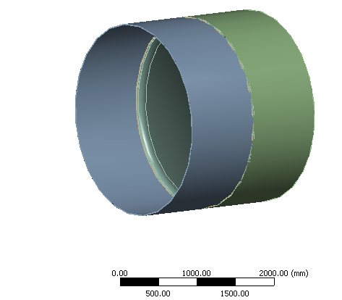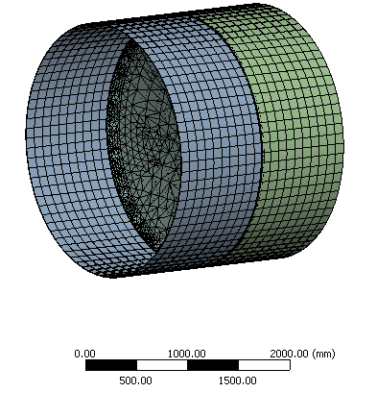
Fig. 3 3D model of pressure vessel and meshed finite element model

All elements are modelled with exact material properties including nonlinear material effects defined as multilinear isotropic hardening of material. These properties were obtained by standard tests for determination of tensile properties of materials. Yield strength of cylinder was 284 MPa, torispherical head 235 MPa and for weld it was 400 MPa. Contact between torispherical head and weld, as well as contact between weld and cylinder were set to bonded in order to simulate welded bond between these parts. The whole model had 188627 nodes and 83277 elements. Inner surfaces of torispherical head and cylinder were subjected to pressure in ranges from 2 bars (suggested by standard testing procedure) to 6 bars. As certain criterion for failure of structure, plastification of whole cross section of pressure vessel was used. Under pressure of 6 bars plastification firstly occurred on pressure vessel head shown on Fig. 4 where safety factor is presented.

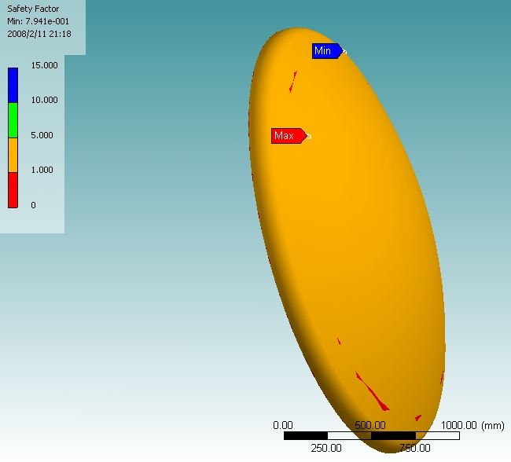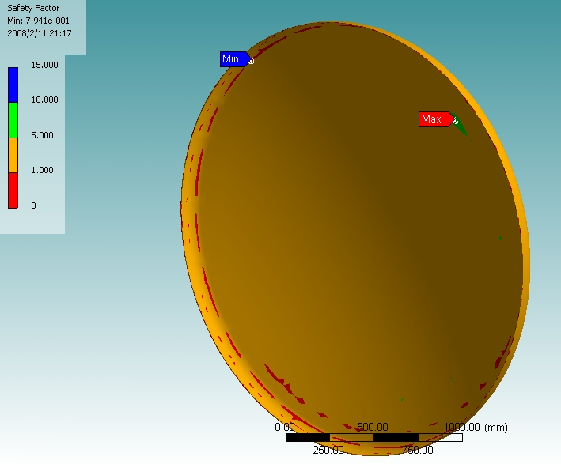
Fig. 4 Safety factor of torispherical head under pressure of 6 bars

Red colour indicates areas where yielding of material occurs through whole thickness, confirming that under such condition pressure vessel head will fail.

CONCLUSION

Overloading which occurred during pneumatic test pressure of the tank with torispherical ends has been analysed by analytical expressions according to ASME and by using of finite element analysis. It is found that the solution for allowable pressure given by ASME Code Section VIII-1 is very close to the numerical one, but a little bit conservative. Of course, it has to be on the safe side. The pressure which leads to plastic collapse of the tank is in the range between 5 and 6 bars for the vessel with diameter of 2500 mm and 6 mm in thickness. It is shown that the yielding of material through whole section will occur firstly in the region where the geometry transits from the torus to the sphere.

REFERENCES

[1] Annaratone D.: “Pressure Vessel Design”, Springer-Verlag Berlin Heidelberg 2007
[2] Moss D.: “Pressure Vessel Design Manual, The Third Edition”, Elsevier, USA 2004, pp. 1-14
[3] Magnucki K, Lewinski J.: “Fully stressed head of a pressure vessel”, Thin-Walled Structures Vol 38, Elsevier, USA 2000, pp. 167-178
[4] Workshop fabricated steel tanks - Part 1: Horizontal cylindrical single skin and double skin tanks for the underground storage of flammable and non-flammable water polluting liquids (EN 12285-1), 2003
[5] Chattopandhyay S.: “Pressure Vessels Design and Practice”, CRC Press, 2005, pp. 78-79
[6] American Society of Mechanical Engineers, Boiler and Pressure Vessel Code, ASME, New York.
[7] ANSYS Workbench version 10, 2006.

prof.dr.sc. Dražan Kozak, Mechanical Design Department, Mechanical Engineering Faculty in Slavonski Brod, Josip Juraj Strossmayer University of Osijek, Trg Ivane Brlić-Mažuranić 2, HR-35000 Slavonski Brod, Croatia, T: +385 (35) 493452, F: +385 (35) 446446, E: drazan.kozak@sfsb.hr
prof.dr.sc. Ivan Samardžić, Department of Technology, Mechanical Engineering Faculty in Slavonski Brod, Trg Ivane Brlić- Mažuranić 2, Josip Juraj Strossmayer University of Osijek, HR-35000 Slavonski Brod, Croatia, T: +385 (35) 493400, F: +385 (35) 446446, E: ivan.samardzic@sfsb.hr
Ing. Sergej Hloch, PhD., Dept. of Technology Systems Operation, Faculty of Manufacturing Technologies TU of Košice with the seat in Prešov, Štúrova 31, 080 01 Presov, Slovak Republic, T: + 421 (51) 77 23 504, E: hloch.sergej@fvt.sk
Pejo Konjatić BSc Mech. Eng., Mechanical Design Department, Mechanical Engineering Faculty in Slavonski Brod, Trg Ivane Brlić-Mažuranić 2, Josip Juraj Strossmayer University of Osijek, HR-35000 Slavonski Brod, Croatia, T: +385 (35) 493416, F: +385 (35) 446446, E: pejo.konjatic@sfsb.hr

