The 19th International DAAAM SYMPOSIUM
"Intelligent Manufacturing & Automation: Focus on Next Generation of Intelligent Systems and Solutions"
22-25th October 2008

INFLUENCE OF LASER POWER OUTPUT ON THE QUALITY OF COLOUR IMAGING

MAJNARIC, Igor; MODRIC, Damir & GOLUBOVIC, Kristijan

Abstract: This paper investigates commercial 4-beam laser diode array with 830 nm laser wavelength output which is used for creating DAD virtual image on OPC photoconductors, i.e. the future printing elements. It is possible to generate different sizes of screen elements on photoconductor, and consequently in printing process, with the controlled variation of output laser power (from 1 µW to 12 µW). The results have been processed colorimetrically and with the defining of color difference CIE LAB ΔE with characteristic solid tones and 50% screened area. Results obtained are interesting because of the fact that changes in prints are not fully proportional to laser power, differences also exist between different separations (especially in yellow colour), which is caused by the chemical composition of toner.
Key words: digital colour offset, CIE LAB ΔE, image analysis

1. Introduction

Commonly used imaging method in electrophotographic printing process is DAD (discharged area development) method where the photoconductor surface is exposed to prior defined electromagnetic wavelength (energy) which causes local photoelectric effect in CGL (Charge Generation Layer) layer. The result is a spatially localized electropositive potential on the photoconductor surface. This localization (electrostatic charges) corresponds to the latent image (charged light image) on the photoreceptor drum. Well defined light rays formed printing elements to be colored later in the developing process by electropositive toner which adheres selectively on the discharged areas of the surface, thereby making the latent image visible.(Kipphan, 1994)
Laser diode is common in the laser head construction and by varying the laser output strength it is possible to control the photoconductor potential difference, influencing the formation quality of the thinnest image elements (digital screen dot).(Landa, 1994)

2. THEORy

Productivity of electrophotographic machines is in direct correlation with operation principles of the exposure device (laser head). The construction of the exposure device is decisive for the quality of the color reproduction.
Main goal of our investigation was to analyze the influence of laser power on quality of color prints and behavior of half-tone image according to this modified conditions. We expected that laser power increase would generate the screen element enhancement. To accomplish this analysis we used the machine internal software to increase laser power. (Chatow, 2001)

Laser beam is focused at the center of the pixel (matrix super pixel 6 x 6 is used in formation the smallest screen element). It reduces the complexity of images from hundreds of thousands of pixels to only a few hundred superpixels. Bell shaped curves on figure 1 represent levels of charge on photoreceptor which is proportional to the distribution intensity of laser beam in TEM₀₀ mode. Dashed line is the threshold voltage which defines charge on developer drum. The ink is deposited on
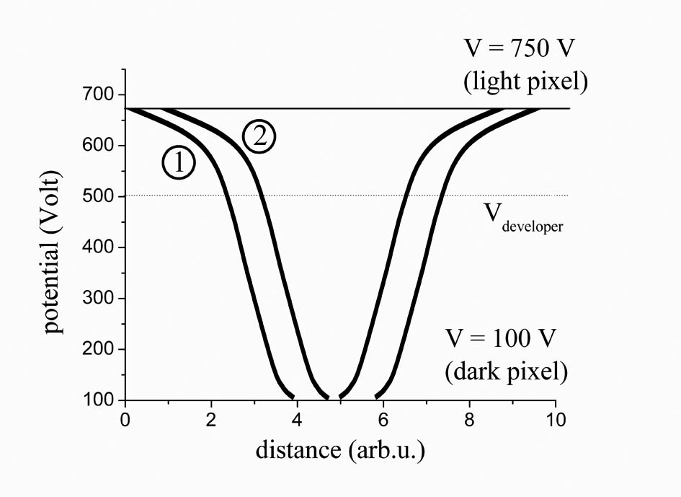
Fig. 1: Figure summarizes the influence of the applied voltage on developer drum and laser power on the image formation. Two horizontal lines on graph represent the level of the applied potentials on photo-imaging plate. Curve 1) corresponds to higher and 2) to lower laser power. Horizontal dashed line represents voltage on the developer drum. (Livne, 2003)

photoreceptor where the area below the developer line intersects with area above the laser curve. It is evident that rising of the laser power enhances the area around the center which results in larger halftone dot.
Laser power primarily affects the size of halftone dots and not their thickness which makes it very effective in controlling of the midtones output.(Goldman, 2004)

3. EXPERIMENT

In this work we analyzed the influence of the laser diode power change on multicolor reproduction. Experimental prints were made with previously calibrated electrophotographic machine HP Indigo TurboStream on the standard fine art paper. Variation of output laser power was applied while other relevant electrophotographic parameters retain constant by means of introducing the bypass control. For colorimetric measurements we applied spectrophotometers X-rite DTP 41 and ColorShop (determination of ΔE CIE Lab) software. Two calibration areas (solid tone and 50% screen value) were thoroughly analyzed for colorimetric purpose. The results are presented in two dimensional forms for the primaries (CMY) and for the secondary colors (RGB). For determination of laser strength influence on print quality it is important to measure the primary and the process colors on printed model with spectrometer. Each primary color is presented with two characteristic patches (solid tone and 50% screen patch). Their deviation from the calibration print, i.e. their color difference (ΔE CIE Lab) which is the result of the laser strength variation, is presented in figure 2.

It was compared with visual estimation which presents colors shift regarded to the calibration print. During our research we have controlled the possible optical system defocusing and the change of focus position of the writing head which could considerably influence the size and the shape of laser spots. The defocusing influences the negative appearance of banding; especially during the illumination of HDI (High Definition Images).(You, 2004)

4. RESULTS AND DISCUSSION

For determination of laser strength influence on print quality it is important to measure the primary and process colors with spectrometer on the printed model. Each primary color is presented with two characteristic patches (solid tone and 50% screen patch). It was compared with visual estimation which presents colors shift regarded to the calibration print: (the upper part of the graph (gray area) presents the darker hue compared to the calibration, while the lower part of the graph (white area) presents lighter hue). Variation of the laser strength generates the visible hue deviation when printed on the fine art paper, (average coloring of all the tones is ∆E_{MAX} - ∆E_{MIN} = 6.90). For all applied laser powers the solid tones, reproduced on fine art paper, reveal tone deviation (∆E_{MAX} - ∆E_{MIN} = 0.93) which could be observed by measuring with optical spectrometer. This is mostly evident on green and yellow prints (∆E_{100%} = 1,1).
The average deviation of the screened hue colors is mostly prominent on yellow print (∆E_{50%} = 20,2), while magenta print exhibits the value (∆E_{50%} = 7,0) and cyan print (∆E_{50%} = 6,3). This behavior influences the maximum color difference in green prints (∆E_{50%} = 19,9) and red prints (∆E_{50%} = 16,8) which is the result of color mixing of the process colors (CMY).
In respect to the calibration the smallest aberration appears with the strength application of the laser 9 (cyan and magenta) and laser 1 (yellow). Fine quality reproduction of the secondary color prints depends on laser powers.
Our results point that optimum choice should be laser 8 for violet blue, laser 2 for green and laser 1 for red. We designated laser powers values with numbers representing the applied laser powers (e.g. laser 6 means that laser operates in 6 μW regime). The voltage difference between the illuminated and non illuminated areas is approximately 600V. In this way the latent printing form is formed which can accept the optimal quantity of developer material (100% color coating on print corresponds to standard classical lithographic offset printing).
Concentration of the yellow pigment in liquid ElectroInk (special electrophotographic liquid toner for Digital Color Offset) is higher, compared to other ElectroInks (cyan, magenta and black). The increase of pigment particles portion in liquid toner requires the increase of electric conductivity of ElectroInk, which directly depends on the quality of the ink adherence on photoconductor. Excessive fraction of this substances results in thicker ink layers and enhanced dot gain, which is predominantly observable for higher tone values.
Fig. 2. CIE LAB ΔE color differences for cyan, magenta and yellow (right graph) and for red, green and violet blue (left graph). Part of the graph with ΔE>0 presents the darker hue compared to the calibration, while the lower part of the graph presents the lighter hue
5. CONCLUSION

The printed light and middle tones formed by varying the laser power in the above mentioned process suffer ten times greater tone change compared to the solid patches.

By comparing the calibrated images and the images obtained with laser power regulation (from 1 to 12 μW), it was noticeable that the process inks in solid patch had the minimal change (ΔE_{cyan}=0,8, ΔE_{magenta}= 0,9 ΔE_{yellow}=1,1). It is similar with the secondary inks in solid patch ΔE _{red}=0,9, ΔE_{green}=1,1, ΔE_{blue}=0,8). Nevertheless, it is evident that ΔE is not zero even at nominal laser power. Reason for this behavior lies in the fact that we compare test prints with calibrated print. Our investigation is a part of larger analysis of our printing system during which we needed some reference in the form of the calibrated print.

In the screen reproduction (50% screen value) the expected stronger influence of laser strength on the reproduction is noticeable. These results demonstrate the initial idea that the initiated laser power change affects alternation of screen value. Yet, this method must be applied selectively for every color (process or secondary). Change of the laser power influences the minimal deviation in coloring the solid tones (100% saturated inks), but it influences the obvious change of the printed screen value (increase of laser power generates dimensional enlargement of the screen elements mostly on yellow, red and green).

Additional attention must be paid to the yellow prints which are troublesome in the sense of reproduction due to the reasons mentioned above. For this reason the yellow separation demands monitored control of laser power which complicates the print quality maintenance. This leads to certain screen printing defects due to mechanical damage of photoconductor surface which can be solved with regular replacement of photoreceptor with the new one.

This effect can be compensated with increasing the laser power maintenance of the exact (desired) middle and low hues.

6. References

Chatow, Udi, (2001), The Fundamentals of Indigo’s Digital Offset Colour Printing Process and How it Rivals Mechanical Offset Printing, Proc. DPP 2001: Eye on the Future, p.p. 21-25., ISBN / ISSN: 0-89208-233-X, Antwerpen, Belgium, May 13, 2001., IS&T Antwerpen, Belgium
Goldmann, G. (2004) The World of Printers, Oce Printing Systems GmbH, ISBN 3-00-001081-5 Dusseldorf, p.141.
Kipphan, H. (2001) Handbook of Print Media, Springer - Verlag Berlin, ISBN 978-3-540-67326-2, Heidelberg, p. 90.
Landa, B. (1994), Digital Offset Color -Today and Tomorrow, Proc. SPIE, 2171: 2, ISBN: 9780819414663, San Jose, CA, USA, May 1994
Livne, H. Plotkin, M., High Speed Laser Scanning Unit Using 12-Beam Laser Diode Array and Image Tracking System (ITT) for High Quality Color Printing, IS&T's NIP19: International Conference on Digital Printing Technologies, pp. 472-475., ISBN / ISSN: 0-89208-247-X New Orleans, Louisiana, September 2003.
You, J. Kim. H. Han, S., (2004) Banding Reduction in Electrophotographic Printer”, Proc. IS&T NIP 20th International Conference on Digital Printing Technologies, pp. 470-473. ISBN / ISSN: 0-89208-253-4, Salt Lake City, Utah

