A GRAPHICAL INTERFACE FOR A TRANSPORT NETWORK DATABASE

Dario Mikić, Ivan Matasić, Zoran Skočir
University of Zagreb, Faculty of Electrical Engineering and Computing
Unska 3, HR-10000 Zagreb, Croatia
Tel: +385 1 6129 751, e-mail: dario.mikic@fer.hr
Tel: +385 1 6129 686, e-mail: ivan.matasic@fer.hr
Tel: +385 1 6129 831, e-mail: zoran.skocir@fer.hr

ABSTRACT: This paper describes a graphical tool for presentation of transport networks with SDH and PDH elements. The transport network information model was developed within a research program that deals with information models for transport network monitoring and management. Modelling of a transport network database has been carried out, and graphical presentation tools are the next logical step. The graphical tool includes support for interactive applications for presentation of objects stored in a transport network database.

KEYWORDS: transport network, database, graphical applications

INTRODUCTION

The transport network layer with manageable elements was introduced to achieve modularity and efficiency much higher than the one attainable in the transmission layer. Information System of the transport network has been designed so as to allow the user (network operator) take advantage of the transport layer features. Although the scope of the developed model is restricted to configuration monitoring and management issues, it can be replenished with descriptions of other transport network functions as well (security, performance etc.). Developed transport network information model is one of the results of the on-going research programs at the Department of Telecommunications, Faculty of Electrical Engineering and Computing, University of Zagreb, [6], [7], [8], [9]. It relies highly on Generic Network Information Model and descriptions of entities and attributes defined in the corresponding ITU-T and some other recommendations [1], [2], [3], [4].
Basic assumptions related to transport network object analysis and database modelling are shown in Chapter 1. Chapter 2 describes graphical application design and functionality. Conclusion from Chapter 3 is followed by a list of references.

- TRANSPORT NETWORK OBJECT ANALYSIS AND DATABASE MODELING

Generic Network Information Model is based on partitioning and layering. Network partitioning allows efficient management, while layering provides a high level of recursion. Each layer supports the transmission of information which has various characteristics (bit rate, etc.). Transport functions (or processes) are used in manageable transport of information throughout the network [6]. It should be emphasized that transport layer processes are just an abstract representation of the corresponding processes in the transmission layer.
The analysis of transport network processes was complemented with the identification and description of basic elements in the transport network. The intention was to align the presentation of transport network to the “nodes-and-branches” principle on every level of recursion. Description of network topology is also one of the main objectives of various decomposition steps. When top-down analysis was used, the following topological entities, accompanied with corresponding relationships were defined: Network, Transport Node, Equipment, Network Element, Connection and Reference Point (RP) [6], [8], [9].
The equipment used in telecommunications can be represented abstractly at the transport layer by the function it performs. The abstract representation of equipment is called a Network Element (NE). Every NE on the transport layer is represented as real equipment or a part of equipment on the physical layer. In other words, transport functions are performed in NEs and each NE represents a single transport function. The internal structure of NE is described by RPs and Connection(s). Each transport function is performed within a NE and represented at the lowest recursion level by connection between pairs of RPs. RPs are regarded as input and output points. In other words, connection is placed inside the NE, and can be represented by a line that connects input and output points within that particular NE.
Topologically, the network consists of Connections separated (or connected) by RPs. The detail static network configuration can be defined by describing RPs and Connections within NEs, and Connections between pairs of NEs. As all Connections cannot be defined in the non-flexible static network configuration phase (e.g. we cannot define cross-connections), RPs have been used as basic elements for defining the network offer. Flexible static configuration is realized by connections in cross-connect NEs and is described by trails. The Trail consists of all connections from source to sink points.
The final result of the analysis is the conceptual Entity-relationship model of the transport network database, which is implemented by RDBMS Oracle 8. The database is restricted to store information about configuration monitoring and management of transport networks. It includes definitions of network “offer” (static configuration) and network flexibility in cross-connection and other elements that are being used for implementing trails (flexible static configuration). The development of efficient applications for presentation of relevant information about transport network was the next logical step. The first results will be presented in the next Chapter.
- DATABASE APPLICATIONS IN ORACLE FORMS AND GRAPHICS

ORACLE developing tools includes ORACLE DESIGNER/2000 and ORACLE DEVELOPER/2000 package. This paper contains a description of applications developed in ORACLE FORMS 4.5 and ORACLE GRAPHICS 2.5, which are part of ORACLE DEVELOPER/2000 package [5]. ORACLE FORMS 4.5 is mainly used for development of data base manipulation application. It enables forms, menus and procedure creation, which can be integrated as a whole. ORACLE GRAPHICS 2.5 combines informational and presentational resources for creation of graphical interface, which can be dynamically connected with data sources (database). GRAPHICS includes variety of options in graphical presentation of data.
Application developed in ORACLE FORMS is called ‘Presentation of transport network elements’ (PETM). This application is developed for simplification of fetching and displaying database information about:
- Network elements,
- Connections,
- Reference points,
- Trails.

Presentation of data is realized through form display after it is filtered with defined query procedures. Development of PETM application was done through following steps:

- Design of form layout
- Menu (button) design
- PL/SQL trigger procedure building

Form layout is organized as a multirecord type. It is composed of twelve records for more useful presentation of data. The data interesting to the end-user is placed into blocks for easy retrieval. There are four main blocks:

- Network presentation block,
- Transport node presentation block,
- Equipment presentation block,
- Network element presentation block.

The important part of the application are the buttons. Pressing any button invokes some action. Buttons are divided into three menus, each with three buttons. The main menu offers a choice between network and equipment presentation. After pressing the appropriate button the application proceeds to submenu.
Submenus offer two choices of data fetching, via ID (identification) number or via specific label. Selection of any type of data fetching invokes LOV (List of Values) window where one record must be selected. This selection is used for data filtering in following query execution. The result of query is shown in specified block (Figure 1).
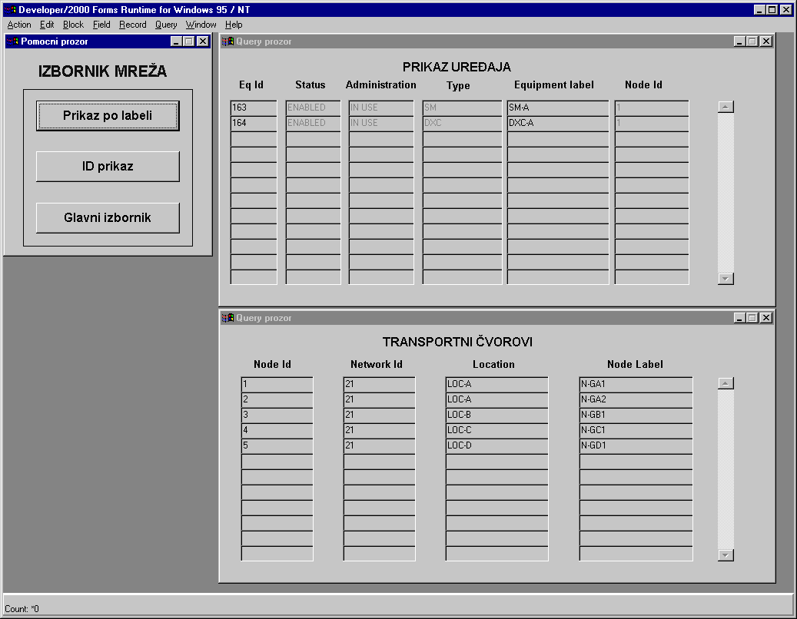
Figure 1 – PETM application window
The most important part of application (engine) are trigger procedures. They include management and control during application runtime and are divided into two main types: when-mouse-clicked and when-button-pressed triggers. Both types of triggers do the same work, but are differently invoked. When-button-pressed triggers are included into application so that end-user can access menus and buttons over keyboard. Every trigger procedure ensures proper transition to another step in application runtime.

An application developed in ORACLE GRAPHICS is called ‘Application for Graphical Presentation’ (AGP). It allows us a detailed view of status and inside configuration of cross-connect (XC) or optical cross-connect (OXC) network element (NE) using simple mouse click. Through information stored in the database we get the necessary parameters needed for graphical presentation:

- Size of equipment,
- Number of reference points,
- Connections scheme,
- Type of connection,
- Network element operative status.
Inside workspace we can show any data that end-user considers relevant to his needs.

The purpose of AGP application is to show a way of application development for presentation, creation and configuration of NEs and their attached object like connections, trails, etc. Every information can be used for creation of graphical objects directly or for description of object’s attributes. AGP’s graphical interface simplifies overview of entire system allowing easier network monitoring and management using only mouse click to invoke an action. In this way, every allowed user action is protected with database triggers and procedures, which insures database integrity and consistency.

When application is started, screen is divided into two main areas: area for NE ID input and area with NE ID catalogue. NE ID input area contains event-active numeric buttons, delete and enter button. NE ID catalogue contains list of ID’s along with NE type. Upon entering accurate ID number, AGP transits from ‘Enter NE ID’ mode to ‘Network element draw and view’ mode. Application fetches necessary data from database and begins drawing. Data needed to determine the size of NE are fetched first. They include information about number of NE reference points. This information determines the size of display. After this, application begins drawing of NE with reference points and connections inside, and appropriate background. NE information data are written on top screen, and connection type legend is shown. NE information data is written on top of cross-connect and contains NE, equipment and transport node identification numbers and NE operative status information.

Every reference point and connection is now event-active. User can click on them to get some additional information. That information includes following: reference point connectivity, end points of a selected connection, connection’s trail and pathway identification numbers. They are written in ‘connection information area’ as shown on Figure 2.
Future development would include:

- Expansion of defined functions, especially those who work with connections
- Improved information window – separate independent displays
- Integration with other ORACLE application – PETM
- User interface modification
- CONCLUSION
The graphical interface to a database gives a user-friendly tool for data retrieval. Applications presented in this paper are designed to demonstrate the efficiency of such a graphical interface. The ‘Transport network informational model’ is a conceptually understandable model, but without some (graphical) interface to the database it would be a significantly harder task for the end user to get the necessary data. It can be seen that in PETM application, where data is presented through forms that simplify database retrieval, data fetching is still difficult to perform. At this point, an AGP application is introduced. It provides another step toward simplified data retrieval and understanding. Its graphical interface and design are user-friendly, oriented toward mouse clicking. In AGP, button and trigger procedures that ensure database integrity and manipulation are implemented. Both applications are designed as functional modules. This enables that implemented functions can be expanded simply by adding new procedures (logical modules).
Figure 2 – AGP application window
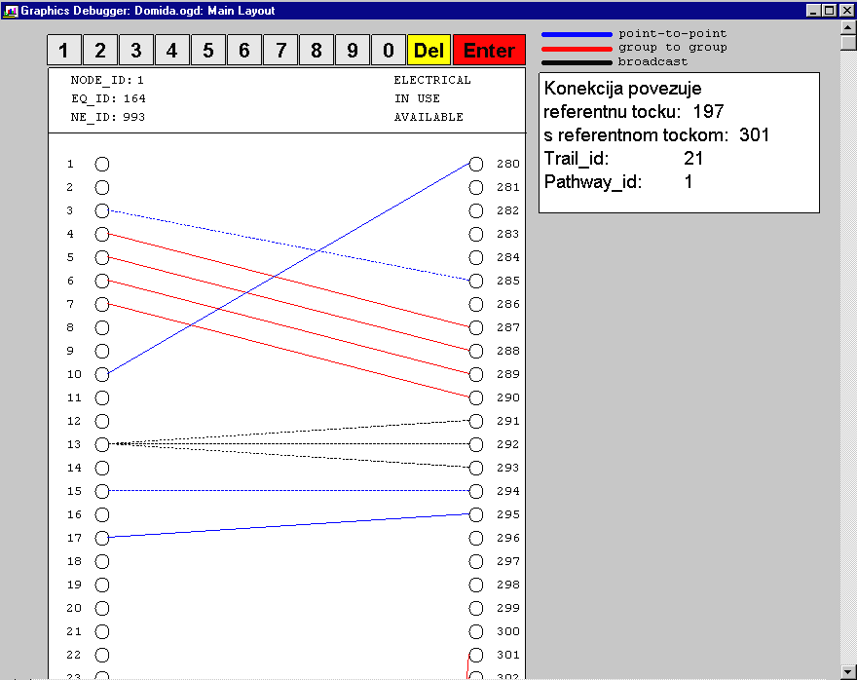

REFERENCES
[1] ***Recommendation G.803: Architecture of Transport Networks Based on the Synchronous Digital Hierarchy (SDH), ITU-T, 03/1993.
[2] ***Draft Recommendation M3010: Principles for a Telecommunications Management Network, CCITT, 1992.
[3] ***Revised Draft Recommendation M3100: Generic Network Information Model, ITU-T, 1994.
[4] ***Recommendation G.782: Types and General Characteristics of Synchronous Digital Hierarchy (SDH) Equipment, ITU-T, 1994.
[5] ***ORACLE FORMS Developers Guide, Release 4.5, on-line help, ORACLE Corp.
[6] I. Matasic, Z. Skocir, E. Sehovic: "An Approach to Information Modeling of Transport Networks with SDH and PDH Elements". Proceedings of International Conference on Telecommunications ICT '98, Porto Carras, Greece, 21-25 June, 1998, Vol. IV, p.p. 457- 461.
[7] Z. Skocir: "Further Investigation and Development of Information System for Telecommunication Network". ITA, 13, 1994, p.p. 329-336.
[8] Z. Skocir, E. Sehovic, I. Matasic, V. Kesegic: "Application for Information Design of Network Elements", Proceedings of International Telecommunications Symposium VITEL 98, Ljubljana - Slovenia, October 5-6, 1998, pp. E.33-E.37.
[9] V. Kesegic, I. Matasic, Z. Skocir, E. Sehovic: "On an Intelligent Designer for Transport Network Database", Proceedings of 5th International Conference on Telecommunications ConTEL 99, Zagreb, June 1999, p.p. 249-256.

