Intelligent algorithm for smoke extraction in autonomous forest fire detection

Ivan Grubišić, Darko Kolarić and Karolj Skala
Optoelectronics and Visualization Laboratory
Centre for Informatics and Computing
Ruđer Bošković Institute
Complete address: Bijenička cesta 54, Zagreb, 10000, Croatia
Phone: (01) 45-71-277 E-mail: grubisic@irb.hr

ABSTRACT - Forest fire, if not detected early enough, can cause great damage. In order to reduce it, it is vital to detect fire as soon as possible and act upon it. In its early stage, forest fire manifests itself primarily as smoke, as flames are too little to be seen. Therefore, to ensure forest fire detection in its earliest stages, smoke detection is utilized.
Autonomous forest fire detection based on smoke detection is currently one of the greatest challenges in image processing field. The main reason for it is that there are lots of smoke-resembling natural phenomena such as clouds, cloud shadows and dust. So the essence of the problem lies in separating these phenomena from real smoke.
In this article we propose a smoke detection algorithm that combines motion detection, edge detection, spectrum analyzing and moving shape analyzing algorithms, matched together to increase detection rate and to decrease false alarm rate.

I. INTRODUCTION

Forest fire or wildfire is uncontrolled fire that occurs in the wildland. Causes are numerous and can be divided in two groups:
- human influence (e.g. human carelessness, slash-and-burn farming, arson)
- natural causes (e.g. lightning, volcanic activity)
Wildfires start when an ignition source meets a combustible material (e.g. wood) subjected to sufficient heat with an adequate supply of oxygen. In the beginning the fire is small and easy to be put out but if there is a huge mount of combustible material such as in forests (especially in dry forests during summer time), it grows very fast. As the fire grows, the damage and expense to put it out are rising. So, to minimize damage it is important to detect and extinguish it as soon as possible. That’s why continuous forest surveillance is necessary. These activities have been traditionally carried out by experienced people in watchtowers. In some countries (with huge forest areas) surveying from an aircraft has also been done in critical seasons with high risks in wild forests. The main problems of these methods are expense and subjectivity of human surveillance. Thus, development of automatic fire detection system is of a high importance.
In the early stage of forest fire flames are too little to be seen, but even then smoke is usually big enough to be detected. So to ensure the fire is detected in early stage it is important to detect smoke.
There are already several smoke detection systems such as [[1], [[2] and [[3].
In this paper we present method for autonomous smoke extraction in forest fire detection based on images in visual spectrum from surveillance camera placed on the high position in forest.

II. SMOKE EXTRACTION ALGORITHM

Autonomous forest fire detection based on smoke extraction is currently one of the greatest challenges in image processing field. The main reason for it is that there are lots of smoke-resembling natural phenomena such as clouds, cloud shadows and dust. So the essence of the problem lies in separating these phenomena from real smoke.
Smoke detection algorithm in this article is based on several algorithms matched together to increase detection rate and to decrease false alarm rate. The algorithm combines motion detection, edge detection, spectrum analyzing and moving shape analyzing algorithms, as depicted in Fig. 1.
Prior to applying the algorithm, preprocessing is done on the image obtained from the camera. The image gets separated on regions, whose sizes and shapes are dependent on the landscape and distance from the camera [[4]. Such preprocessing aids the algorithm in reducing detection of the wind tossed trees and electronic noise.
After preprocessing image of the new frame comes to the motion detection algorithm, if there is no motion detected any further analyze is unnecessary.

Fig. 1. Smoke extraction algorithm flow diagram.
1. Motion detection algorithm

The motion detection algorithm is based on detecting changes on the images from frame to frame. Because of its characteristic as expanding, moving in the wind direction and upwards, smoke is a moving object and gets detected by this algorithm, but also clouds, moving cars, birds and any other moving or changing object get detected. Thus, it is necessary to do more to reduce these false alarms.
The basic idea in this algorithm is that if we subtract image of the same landscape captured in different time we can see what changes occurred during that time (Fig. 2).

Fig. 2. Basic motion detection (example).

The intervals between subtractions of frames need to be short enough to catch fast moving smoke from close distance and long enough to detect moving of the slow long distance smoke. That’s why it is necessary to do more then one subtraction. In our implementation, we have used three different subtractions: first one with short time period between frames (for detecting close smoke), the second one with medium time (for detecting smoke in middle distance) and the third one with long time period (for detecting far smoke). Motion gets detected if there exists any sector with subtracted value bigger than some predefined threshold and that motion is detected during some time in same sector or in one of the first neighbor sectors.

2. Edge detection algorithm

The edge detection algorithm is algorithm for extraction of moving edge of the smoke. It is based on the expanding and moving characteristics of the smoke (such as in motion detection algorithm).

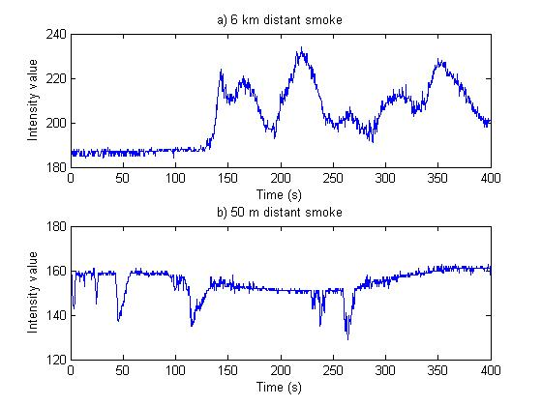

Fig. 3. Intensity value change of single pixel for a 6 km (a) and for a 50 m distance smoke (b).

On Fig. 3 it is shown how intensities of the pixels change when smoke occurs. There can be seen on the Fig. 3 (a) that there isn’t significant change in intensity during first 140 seconds because there is no smoke, but around 140th second intensity suddenly change and that is the time when smoke started. After that we can see how the intensity changes because of movement and change of the smoke, so for some time it is on the place of that pixel and in some other time it isn’t, and some parts of the smoke region have higher intensity than others.
To detect and extract moving edge of the smoke we need to determine the threshold. Intensity and change of intensity can be very different from sample to sample so the threshold can’t be constant. Also, as depicted on Fig. 3, there is a possibility that smoke makes positive or negative changes of intensity. That’s why we used averaging of intensity with upper and lower detection thresholds [[4]. To determine averaging we used median function with size of time window depending on the information from the motion detection algorithm. Empirically, the median gave better results than the mean, because it's less sensitive to outliers.
Fig. 4 and Fig. 5 show intensity averaging (red dashed line) with upper and lower detection thresholds (green dash - dot line) with time window size 100 s (Fig. 4) and 20 s (Fig. 5).
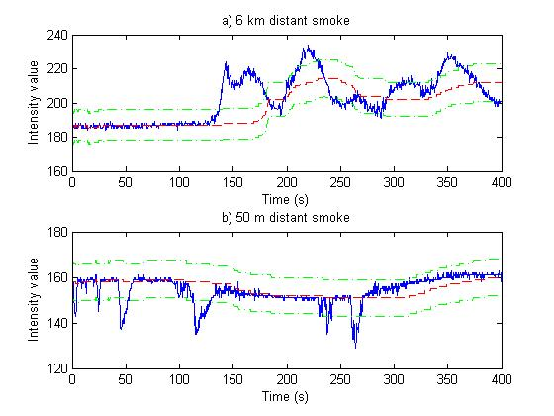

Fig. 4. Intensity value change, intensity averaging with upper and lower detection thresholds of single pixel for a 6 km (a) and for a 50 m distance smoke (b).
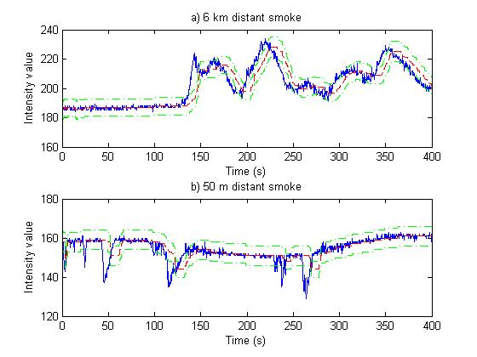

Fig. 5. Intensity value change, intensity averaging with upper and lower detection thresholds of single pixel for a 6 km (a) and for a 50 m distance smoke (b).
If we use a bigger time window for averaging, we have a simple version of background and foreground estimation able to detect new or changing object on the image. On the other side, if we use a smaller time window we can detect moving edges of the changing or moving object. Combining this two averaging detection method we can extract smoke plumes, but we can’t distinguish them from any other moving object.

3. Spectrum analyzing algorithm

The spectrum analyzing algorithm is an algorithm for reducing false smoke detection based on color characteristics of the smoke. Forest fire smoke is mostly white in the beginning and as the fire grows, smoke becomes darker but it’s always grayish, so the feature that can help distinguish smoke from other moving objects is grayness. Gray color is color where all three RGB components have same values (depending on values intensity changes). We can determine how close some color is to gray by calculating saturation. The lower saturation is the color is closer to gray. So in this algorithm we are analyzing saturation and change of saturation to determine if object is smoke-alike or not [[5].
However, a difference exists between the saturation of the pixel changes during the time when there is smoke on the grayish background (Fig. 6.) and when there is smoke on the non grayish background (e.g. red background, Fig. 7.).
We can see on the Fig. 6 that the mean saturation values of both smokes depicted are lower then 0.02 and those small and high-frequency changes are not correlated to the smoke, and usually have origin in electronic noise (this effect is reduced by preprocessing explained in beginning section of II chapter above Fig. 1). Smoke depicted in Fig. 7 has mean saturation value around 0.56 and its saturation changes are considerably bigger and slower then previously described examples. Comparing intensity (Fig. 7 (a)) and saturation (Fig. 7 (b)), one can see that correlation exists between saturation changes (downs) and smoke appearances.
In conclusion, we can say that if background saturation is low there won’t be visible changes in saturation if smoke occurs, but if background saturation is high enough there will be significant change.

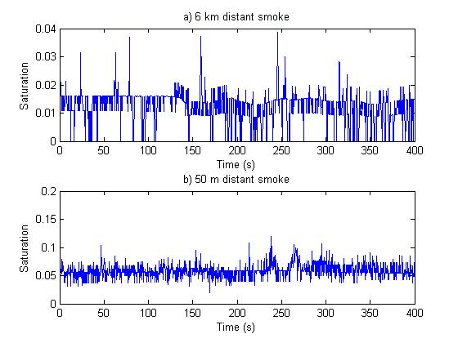
Fig. 6. Saturation change of single pixel for a 6 km (a) and for a 50 m distance smoke (b).

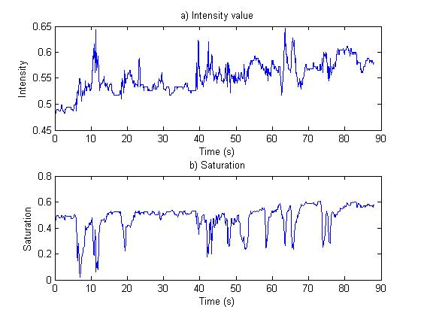
Fig. 7. Intensity value change (a) and saturation change (b) of single pixel for a 20 m distance smoke on the red background

4. Moving shape analyzing algorithm

To further reduce false detection of moving smoke-alike objects, we will analyze movement and the shape changing characteristics of smoke. In the beginning, the fire is small and limited to one specific area. That’s why smoke plum need to have beginning in the same area.
Fig. 8 shows an example of how a smoke plume changes with time. A starting point can be seen (position of fire), and from that point smoke occurs. Also, observing the same smoke plume at three different time moments will lead us to these facts:
- Starting point (fire) must be below horizon.
- Starting position of a smoke plume is always connected to the starting point (Fig. 8 (t0)).
- Next position of a same smoke plume is connected to the previous position of that plume.
- Changes of a smoke plume during time:
  - Expanding,
  - Moving in wind direction,
  - Moving upwards.
Moving shape analyzing algorithm is using these facts to determine if a detected smoke-alike object is really smoke or not.

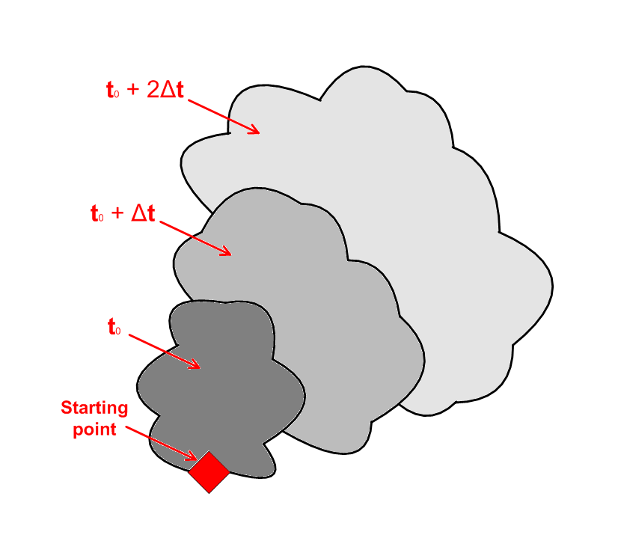

Fig. 8. Smoke plume changes in time.

III. CONCLUSION

Using this algorithm we managed to considerably increase detection rate and reduce false alarms of the smoke detection system. Reducing false alarms is traded off with maximal smoke detection time. With all our smoke video examples we manage to have 100 % smoke detection with 0 % false alarms with just 15 seconds maximal detection time. These results may sound incredible, but our example database isn’t big enough to say for sure whether this algorithm would work this good in any occasion. That’s why our priority is to enlarge our smoke video example base so we can perform further experiments and evaluate the algorithm better.

REFERENCES

[1] N. Fujiwara and K. Terada, Extraction of a smoke region using fractal coding, IEEE International Symposium on Communications and Information Technology, 2004, ISCIT 2004, Volume 2, 26-29 Oct. 2004, Page(s):659 – 662.
[2] B. U. Toreyin, Y. Dedeoglu, and A. E. Cetin, Wavelet based real-time smoke detection in video, 13th European Signal Processing Conference EUSIPCO 2005
[3] J. Vicente, and P. Guillemant, An image processing technique for automatically detecting forest fire, International Journal of Thermal Sciences 41, 2002, Page(s):1113 – 1120
[4] E. den Breejen, M. Breuers, F. Cremer, R. Kemp, M. Roos, K. Schutte, and J. S. de Vries, Autonomous forest fire detection, 14th Conference on Fire and Forest Meteorology, VOL. II, Page(s):2003 – 2012, (Luso, 16/20 November 1998)
[5] Turgay Çelik, Hüseyin Özkaramanlı, and Hasan Demirel, Fire and smoke detection without sensors: Image processing based approach, 15th European Signal Processing Conference EUSIPCO 2007, Eurasip, 2007, Page(s):1794 – 1798

