11th International DAAAM Symposium
“Intelligent Manufacturing & Automation: Man-Machine-Nature”
19-21 October 2000

CHECKING THE ACCURACY OF WORKING SYSTEMS

Ivancic, I., Mihoci, K.

Abstract: Deviations from a given relative motion between tool and workpiece are consequence of: failures generated in manufacturing phase or during assembly; elastic deformations caused by static, dynamic and/or thermal stresses; failures in control circuits.
Check can be done by means of test devices that can be quickly and easily set on a machine, and processing of the given information can be performed on personal computers. One such test was made by means of “Quick Check Ballbar System” equipment of the “Renishaw” company on the three-axis machining centre. Testing is very short, and information about current condition of the machine is sufficient for analysis.
Monitoring of working system condition, i.e. monitoring of changes in deviations could be done by laser interferometer. Besides, by applying elements of adaptive control, laser interferometer could be used for automatic (program) correction of geometrical deviations.

Key words: testing, monitoring, maintenance

1. Introduction

Deviations of the working system that are transferred to the workpiece result from the failures in manufacturing or installation of the working system components and due to elastic deformations that are unavoidable but need to be correctly understood. Working systems are designed to a permitted rigidity, and various elastic deformations of the system result from static, dynamic, and thermal stresses and /or their combination. These deviations of the working system can be determined by means of geometrical analyses, workpiece analyses, checking of position accuracy, study of dynamic and thermal phenomena.
Quick check of the current condition of a machine can reveal that the permitted deviations of positioning accuracy and repeatability might have been exceeded, or it can confirm the declared deviations. These checks should be fast and accurate so as not to cause too much machine downtime. Also, the obtained data have to be in compliance with the standards according to which comparisons can be made (ISO 230-1, 1996).
The new AC (Kief, 92/93) of control allow correction of machine manufacturing failures and electronic achievement of higher precision (in case of measuring co-ordinating machines and precision machining centres) or elimination of geometrical errors as result of wear due to operation in a single limited area.
The adaptive correction of failures requires other measurements as well, such as linearity, parallel guide ways, verticality, wrappness, etc., enabled today by laser measurement systems. A quick check of the condition was performed on the three-axis machining centre for the purpose of checking the permitted deviations of positioning accuracy and repeatability. Also, a check of positioning accuracy was carried out subsequently by means of a laser.

2. SYSTEMATISATION OF WORKING SYSTEMS DEVIATIONS

Numerically controlled working system axes, compared to movements in conventional machine tools are characterised also by new types of deviations. Synchronous movements of two or more axes increase the number of new types of deviations.
Deviations defined by the standard (ISO 9283) can be systematised in two groups: time-specific deviations and geometrical deviations.

TIME-SPECIFIC DEVIATIONS
Positioning and orientation deviations | Deviations in case of shift along one axis
Position stabilisation time  Overpassing of the position  Slide displacement of the position characteristics (within a defined period of time) | Axis speed variation  Axis speed accuracy  Axis speed repeatability
Table 1 – Division of time-specific deviations of numerically controlled axes

GEOMETRICAL DEVIATIONS
Position deviations | Deviations from movement along a defined path
Position accuracy  Position repeatability in one direction  Dispersion of multiple positioning from different directions  Gap (Distance) accuracy  Repeatability of distance accuracy | For geometrically easy-to-describe forms of required path: path precision, path repeatability.  Circle: path radius deviation, circle shape deviation.  Corner: gouging, rounding error, path stabilisation length.
Table 2 – Division of geometrical deviations of numerically controlled axes

2.1 Causes and possible deviations of numerical axes

Deviations of the actual path from the given path in two synchronous runs of numerically controlled axes (linear and circular interpolation) can be caused by dynamic characteristics of regulation circles or by mechanical influences.
All measuring systems cannot find all the failures. That is why the West has made a division into indirect (encoders, circular scales) and direct (linear measuring scale) measuring systems. However, the Japanese treat both more concretely as direct measuring systems, but they distinguish them as control with closed feedback and semi-closed feedback in case of encoders. Failures of numerically controlled axes result from:
- Elastic deformations of the ballscrew caused by the acceleration of the mobile tables. Table mass of 500 [kg] and acceleration of 4 [m/s² ] will cause elastic deformation of the thread spindle of 10-20 [μm]
- Friction forces of the slide paths depending on the type of the guide way amount to 1 – 2 [%] for the rolling ones and 2 – 6 [%] for the sliding ones, of the weight of the mobile table and cause elastic deformation of the thread spindle of 0.25 - 6 [μm]
- The way of positioning the thread spindle and the preload parameter of the nut in order to avoid backlash when changing the direction of the movement causes friction and warming up of the nut and the spindle and elastic deformation. Thread spindle 1 [m] long, fixed with two axially fix bearings of 700 [N/μm] rigidity during a 6-hour operation, between two points 150 [mm] apart with feed speed of 24 [m/min] will raise the max. temperature by 10 [K] in the middle of the spindle, resulting in elastic deformation of the thread spindle of 22 [μm], and if the other end is axially free, the deformation will amount even to 34 [μm] (Braasch, 2000).
- Special problem are low feed speeds which cause stick slip effect and higher friction. This is characteristic for the circular interpolation crossing from one quadrant to the other when one axis has always the maximum and the other the minimum feed speed. This phenomenon is easy to notice also on the workpiece surface or by a quick check Ballbar system.

3. CHECKING DEVIATION FROM IDEAL CIRCLE

The “Renishaw” compnay has developed a system for quick control of the contour-controlled CNC machines “Quick Check System – Ballbar”. The measuring “stick” – linear converter is fixed by means of two joints, at one end to the mobile tables (they perform circular interpolation) and at the other end into the main spindle (e.g. in a milling machine, machining centre, etc.). By changing the length of the stick i.e. the radius R² = x²+y²+z² can indicate several inaccuracies of the machine: errors of an axis, errors in the circular interpolator, error of the servo-amplifier when crossing from a quadrant into a circle quadrant, verticality errors of certain axes.
The result of one measurement on a three-axis working centre is presented in Figure 1 (Ivančić, Udiljak, Mihoci, 2000).

4. APPLICATION OF LASER INTERFEROMETER

The first and today still the most frequently used application of laser interferometer in working systems is the determining of the position accuracy of the linear numerical axis according to VDI/DGQ 3441. What parameters will be measured in the working system and what procedure is to be applied, this is defined by the annex to the contract, as foreseen by the VDI/AWF 2870 recommendation in its Annex A3. An example of a measured result is given in Figure 2. On the length of one meter of the numerical axis, measurements need to be performed at 13 randomly selected measuring points, arriving at each point five times (VDI), or seven times (JIS), from a different direction. The laser system of the “Renishaw” company which is used at the “Ericsson Nikola Tesla d.d.” company was constructed from several independent units, which means that depending on the available configuration, it can be used not only for measuring position accuracy of the working systems, but also for the following measurements: speed, angle, linearity, verticality, parallel characteristic, flatness and dynamic measurements.

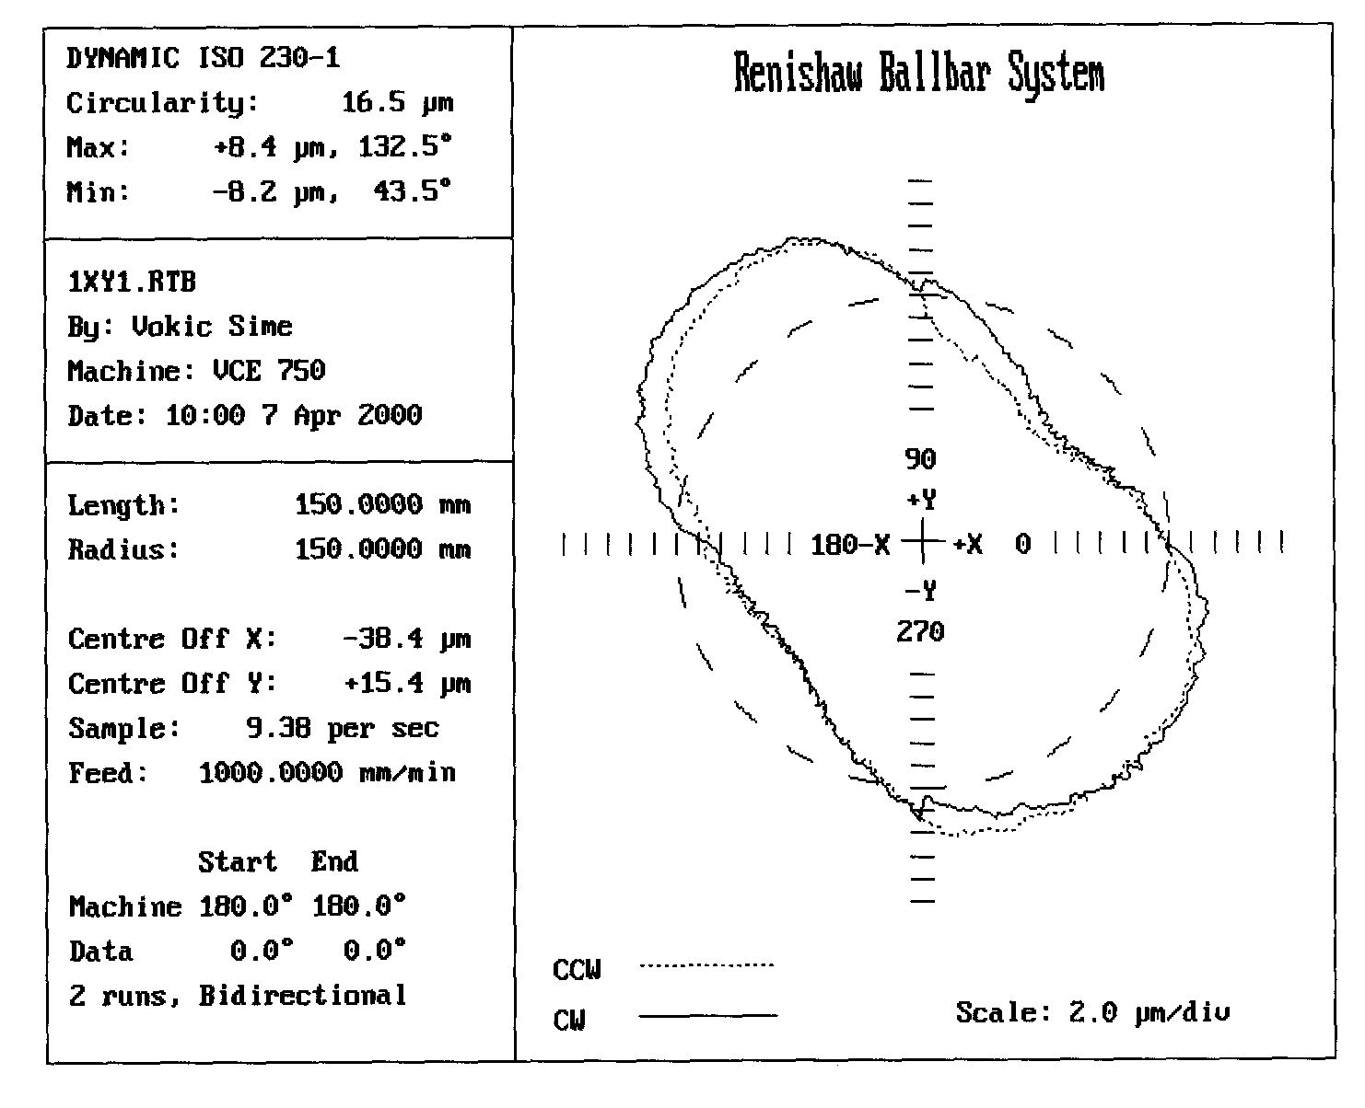
Figure 1: Dynamic circularity according to ISO 230-1 [μm] in the XY plane

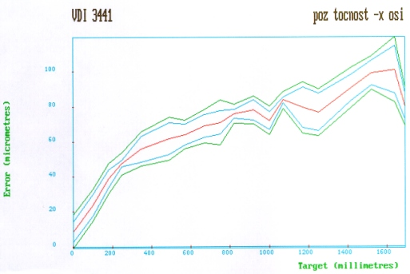
Figure 2: Results of measuring positioning accuracy according to VDI 3441

5. CONCLUSION

Automation and development of working systems has raised the significance of maintenance. By introducing a series of ISO 9000 standards, the function of maintenance within an enterprise is getting new tasks and it has an active role participating in insuring the process performance. Checking of accuracy of the working systems is only one segment in calibrating their measuring and regulation devices.
Those who provide services of repairing the working systems today, and especially in the future, will have to document the quality of the performed service, and this would be impossible without high-quality measuring equipment.

6. References

ISO 230-1(1996) & ISO 230-2 (1997); Test Code for Machine Tools; Part1: Geometric accuracy of machines operating under no-load or finishing conditions & Part2: Determination of accuracy of positioning numerically controlled axes.
H. B. Kief: “NC Handbuch 92/93”, NC-Handbuch-Verlag, Stockheim.
ISO 9283 Manipulating industrial robots - Performance, criteria and related test methods, International Organization for Standardization, CH-1211 Geneva 20, Switzerland, 1990.
J. Braasch: Accuracy of Feed Drives, Heidenhain INFO, 2000.
I. Ivančić, T. Udiljak, K. Mihoci: “Točnost i ponovljivost pozicioniranja obradnog centra”, 6. međunarodno savjetovanje – Održavanje 2000 – Opatija, 2000.
Authors: Ivan Ivančić, M.Sc., Manager at the company Ericsson Nikola Tesla d.d., Krapinska 45, 10000 Zagreb, Croatia,
Phone: 00385 1 365 41 21, Fax: 00385 1 365 40 39,
E-mail: etkini@etk.ericsson.se,
Home page: http://www.ini.hr/ivancic
Kristijan Mihoci, B.Eng., FSB-Zagreb,
E-mail: mihoci@sjever.fsb.hr

