7th International Conference
CADAM 2009

NEW MUTATION SCREEN ELEMENT „SOFT RHOMB“

Žiljak Vujić, J.; Stanić Loknar, N.; Rudolf, M.; Koren, T.; Žiljak, I.

Abstract: By using (the programme) „Mathematica“, a new screen element, whose analitical phrase were translated in the Postscript programming language for graphic reproductions, has been designed. The new screen element named „Soft rhomb“, which has properties to change shapes from vertical lines through rhombs to horizontal lines shape in constant screening angle, is represented. Its own algorithm, implementation of the PostScript presentation and examples of design are presented. The using of screen Soft rhomb has been tested in vector graphics, pixel graphics and in typography. Application of the new screen element has been conducted in multicolor reproduction. Designers solution, created in this way, could be used in space of stochastic and artistic screening. The proposals for applications in individualized graphics and in security printing are described.

Keywords: screen element, anti counterfeiting, security print

1 INTRODUCTION

Security graphic is based on original screening methods (*2). New screen Soft rhomb has the mutation changes shape when it makes covering, and that enables us to create individual design solutions. The proposed structure, for minor covering of 5% to 15% of the surface, takes the structure of thin horizontal lines in condition of zero value screen angle. With high covering from 20% to 75%, it assumes the circular shape, while at maximum covering from 80% to 95% it passes into the vertical line.

2 PRESENTATION OF NEW RASTER ELEMENT

Analitycal definition of SoftRomb screen element is:
Z= ( – )
Postscript language definition is:
/SoftRomb {exch 2 mul sin exch dup 3 1 roll add abs sqrt exch abs sqrt exch sub abs} def
Fig. 1. Three-dimensional and two-dimenzional form of expansion of coverage
The using of conventional screen shapes results in small changes in the position of screen elements within the screen cells (*1). With the screen, presented in this work, significant changes are in shape, depending on the coverage. The shape "kare" at 5% coverage, is gradually mutating into the "rounded kare" structure, but in the negative. In Figure 2, the percentage change covering is presented, while screening angle remains the same. This screen format is suitable for use in deep print with high liniature, and is ideal for multicolour printing. The various tests were performed for random distribution of line and angle in the multicolor reproduction (*3). Stochastic application provides unrepeatable internal color screen structure. Repetition is possible only with knowledge of the parameters in congruention method for CMYK separation.
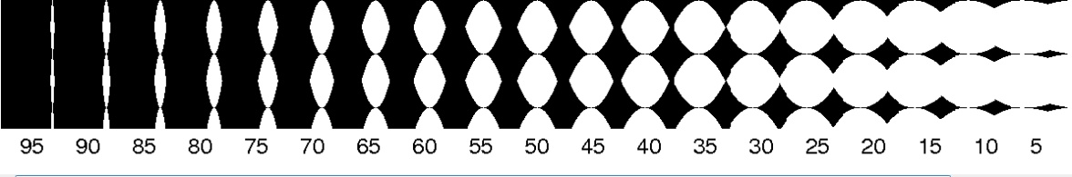

Fig. 2. SoftRomb shapes mutation in coverage from 5 to 95% at angle of 0° , 7 lpi

The feeling of replacement angle during progres of covering is achieved. This is a new feature, which will make improvement in multicolor reproduction and security print.

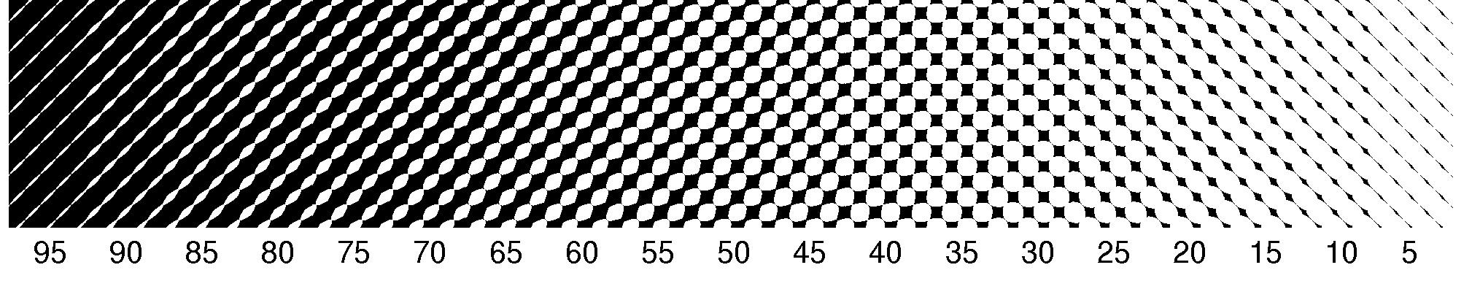

Fig. 3. Mutation in 45° at 25 lpi

3 MEASURING DOTGAIN FOR “SOFT RHOMB” IN DIGITAL PRINTING

In the press there is always a deviation in surface coverage in comparison to a digital bit map.
Dotgain is dependent on the screen elements range, for larger range means more diffusion of ink on paper. Table 1 shows the relationship between surface coverage by measuring bit map and the surface coverage of printed material. From these data is calculated dotgain in digital printing for the new raster.

Ink coverage | Percentage of coverage in bitmap | Percentage of coverage in digital print | Dotgain
5 % | 5,5779 | 5,6631 | 0,0852
10 % | 10,4802 | 10,7747 | 0,2945
15 % | 15,5116 | 15,7822 | 0,2706
20 % | 20,5114 | 20,6529 | 0,1415
25 % | 25,5993 | 25,9897 | 0,3904
30 % | 30,7204 | 31,0759 | 0,3555
35 % | 35,8987 | 36,3040 | 0,4053
40 % | 40,8490 | 41,2704 | 0,4214
45 % | 45,8333 | 46,4466 | 0,6133
50 % | 50,8911 | 51,3840 | 0,4929
55 % | 56,1100 | 56,6454 | 0,5354
60 % | 61,0639 | 61,6313 | 0,5674
65 % | 66,1317 | 66,8260 | 0,6943
70 % | 71,2222 | 71,7965 | 0,5743
75 % | 76,0845 | 76,7843 | 0,6998
80 % | 80,9233 | 81,9962 | 1,0729
85 % | 85,8443 | 86,7605 | 0,9162
90 % | 90,7411 | 91,8080 | 1,0669
95 % | 95,3444 | 96,3715 | 1,0271

Table 1.

Table 1. shows The results of measurements dotgain for digital printing. Samples that were taken for measurements were standardized to the dimensions 500x500 pixels at a resolution of 300 dpi
Screen is printed on a digital printer, scanned and then repeated the measurement of coverage to printed samples. Surface coverage for which the measured data was taken ranges from 5% coverage to 95%.
As expected, dotgain increases as the range of screen element grows ranging from 0.08 with coverage of at least 5%, to 1.07 in areas of major coverage. Although dotgain increases as increasing coverage area, however, is smaller than in conventional measurements of dot screen element.
4 APPLICATION OF SCREEN ELEMENT “SOFT RHOMB” IN DESIGN WITH TYPOGRAPHIC FORMS

The aforementioned examples show the implementation of new screen element shapes to the typography performed through a programming language PostScript.


a)
/lin 10 def
/kut 90 def
0.7 setgray
0 0 moveto 700 0 rlineto 0 700 rlineto -700 0 rlineto closepath fill
0.15 setgray gsave
10 10 moveto
/Helvetica findfont 700 scalefont setfont (D) show grestore
50 100 translate 80 0 moveto 90 rotate
0.85 setgray
/Helvetica findfont 100 scalefont setfont (design) show

a)



123234 srand
/m {2 31 exp 1 sub} def /rn {rand m div} def
/kut { rn 75 mul} def
/lin { rn 10 mul 15 add} def
50 600 translate lin kut {noviraster} bind setscreen gsave
sivo setgray
lin kut {noviraster} bind setscreen
font {pop pop /sivo sivo 0.05 add def
rn setgray
lin kut {noviraster} bind setscreen}
(grafika) kshow grestore

b)

b)

Fig. 4. "soft rhomb" applied to the typography with an appropriate program in the PostScript

The example above (a) shows the brighter text (15% coverage surface) printed on dark line (85% coverage), ie the text in the negative, with a background 30% coverage of the surface. In this example is perceived feature of a new screen that apparently changes the angle.
While the program set the angle of 90 ° for all surface coverings, in the light areas vertical lines are visible, which in the darkest areas exceeds to the horizontal line, while in middle value screen takes the appearance of rhomb.

At the lower example (b) the word "grafika" each letter is carried out with a different liniature and different screen angle. In the program the angle and liniature of screening are specified stochastically, ie by generating random values of numbers that can be controlled only by the initial "seed". Such graphics after prints impossible to reproduce without the knowledge of programmed graphics solutions. Seed determines all stochastic values that are unknown to everyone except the developer.

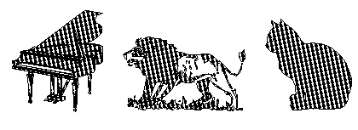
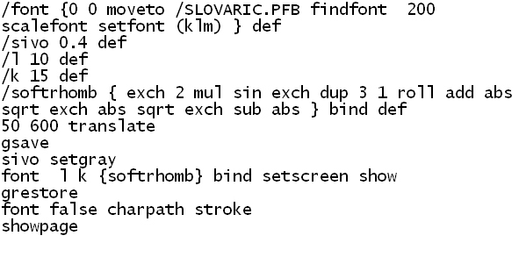
Fig. 5. Screen element "soft rhomb" applied on pictograms as font solution

In the above example screen element "soft rhomb" is applied to pictograms. Shown is a software solution in PostScript for this example. The font pictogram is used from our database. Gray tone is defined with a 60% black. Screen liniature is very small and amounts to 10 lpi, so screen elements could be clearly visible to the naked eye. In this example, is defined screen angle of 15 °.

5 APPLICATION OF SCREEN ELEMENT "SOFT RHOMB" IN THE DESIGN WITH VECTOR AND PIXEL GRAPHICS
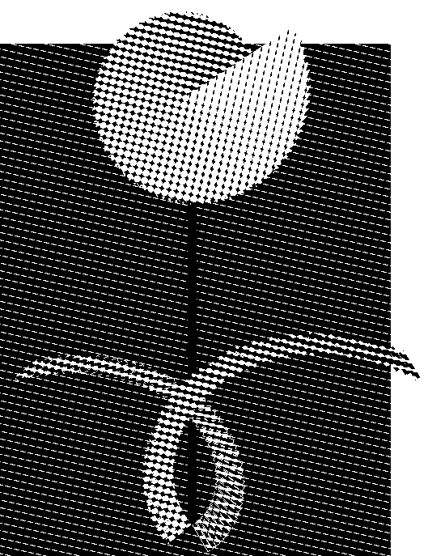

Flower

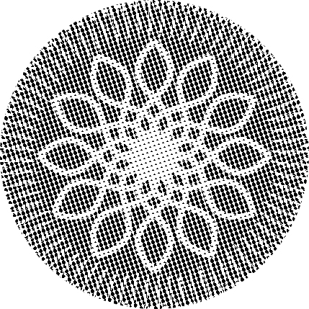

Roseta

Fig. 6. Screen element "soft rhomb" applied to vector graphics

Realized examples present the possibility of using the new screen shape "soft rhomb" on vector graphics. Examples are created by programming through PostScript programming language. In example of "flower" structure was put under the angle of 75 ° while the liniature was set to 10 lpi. Dynamic and interesting forms are obtained by different degrees of coverage in the flower. Roseta also uses a new screen "soft rhomb", which is placed under the angle of 15 ° and liniature of 15 lpi. Coverage with rosettes is in the range from 5% in the center and derived lines "leaves" to 75% in other parts of the graphics.

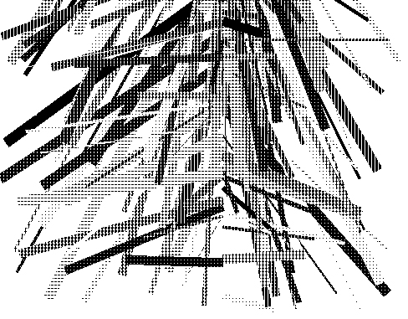

a)

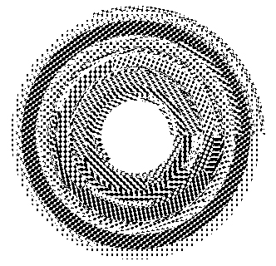
b)

Fig. 7. Screen element "soft rhomb" applied to stochastic vector graphics

These examples use stochastic generated values of coverage and screen angle, which are applied on shapes in vector graphics.
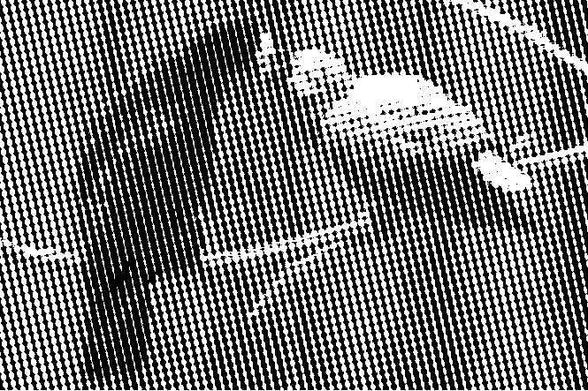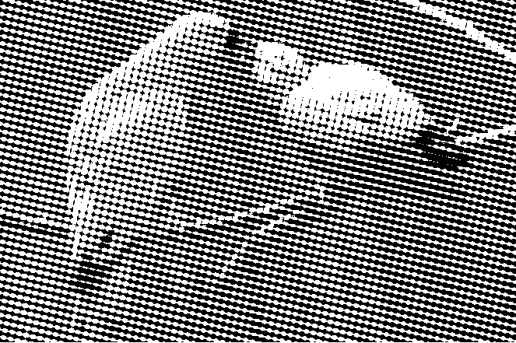

Cyan Magenta

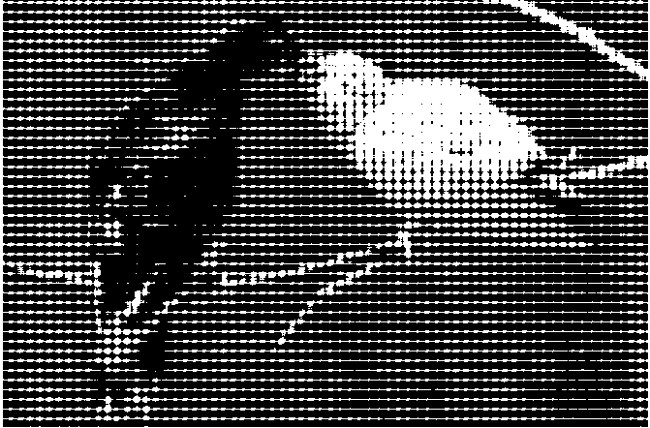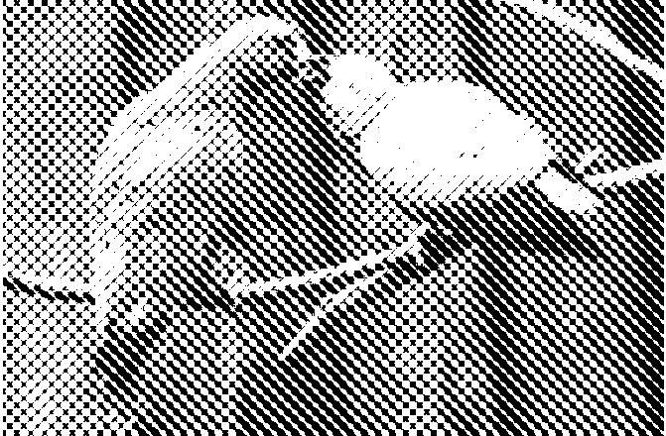

Yellow Black

Fig. 9. Screen element "soft rhomb" applied to the image by CMYK channels

Screen "soft rhomb" is applicable in the multi-color printing. Example in Fig. 9. shows the application of the new screen to the CMYK channels in photography, where the angles are set according to screening standards in conventional printing. With liniature of 10 lpi the moire effect and the effect on the overall impression of the image was observed. Although the angles are strictly defined by each channel, the impression of the image is just opposite. At different coverage areas, the appearance of screen angle is changed so that, seems like, in one channel appears more different angles. Apparent change of slope in different ink coverage achieves diversity of overlapping screen elements.
Fig. 10. and Fig. 11. show stochastic way of screening images in the final aligning of CMYK channels completely eliminates the moire effect. In example Fig. 10. screen angle is constant while liniature varies from 20 to 40 lpi. In order to get an even greater variety and avoid creation of uniform shapes when overlapping, in Fig. 11. it was added stochastic screen angle generation. Each screen element of the image is set with random value of liniature from 20 to 40 lpi and screening angle from 0° to 90°, so that when channels are overlapping there is a large number of different angles and lininature screen elements, which prevent the formation of moire effect.
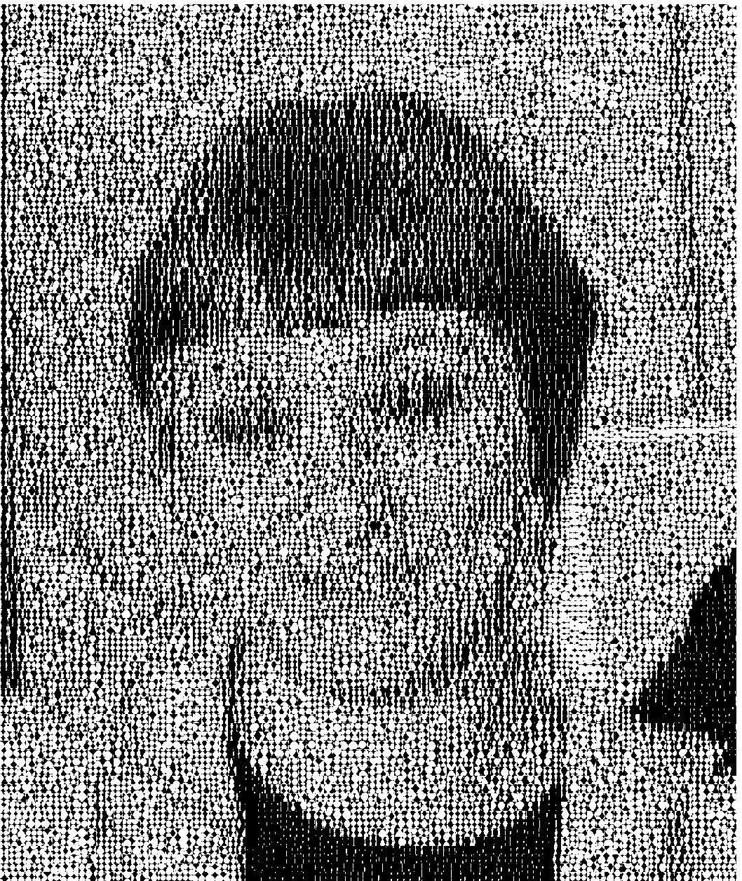

Fig. 10. Value of screen liniature between 20 and 40 lpi. with a constant angle of 0 °

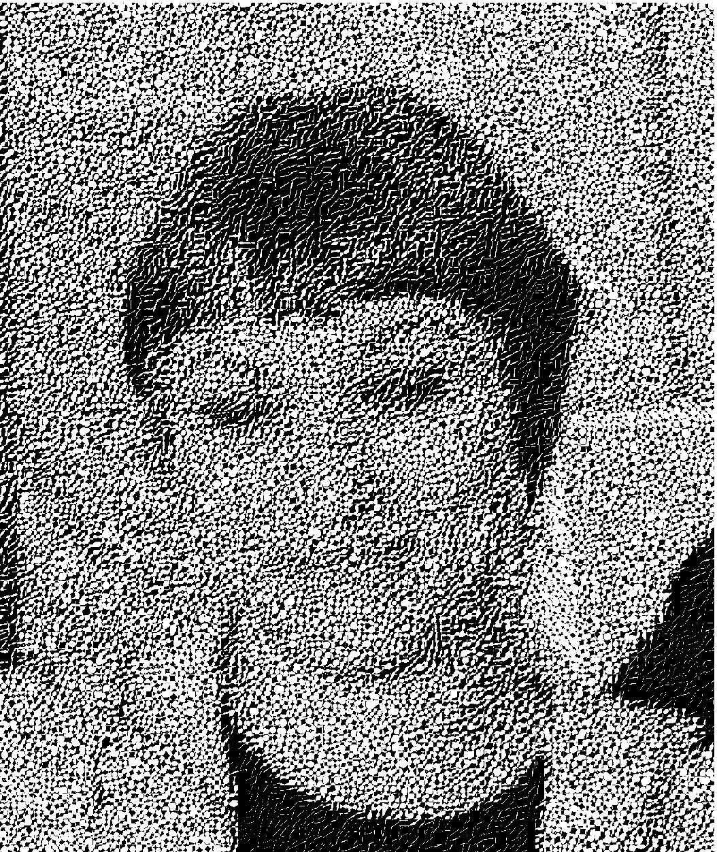

Fig. 11. Random value of angle in the range from 0° to 90° and screen stochastic liniature between 20 and 40 lpi°

Such a method of execution of images, not only that it removes unwanted moire effect, but it also allows complete individualisation of printed images. In that way it is provided unique print reproduction and disabled counterfeiting of the print. All graphics originated in this way can be used in securities printing, but also in creating the unique design solutions.

5 CONCLUSION

The specific feature of the new screen shape is based on the fact that along the same angle of screening, the mutating forms, which can significantly improve the verification of prints in color, are achieved. The application takes part in individual design, security reproduction of documents, and the jumbo poster solutions, which target the presentation according to the content of the original design.

References:
[1] Pap, K.; Žiljak, I. & Žiljak-Vujić, J. (2008). Design of Digital Screening, ISBN 978-953-7064-10-5, FotoSoft d.o.o.

[2] M. Rudolf, N. Stanić Loknar, M. Turčić, T. Koren, (2008) Raster elements in securities typography, International design conference - DESIGN 2008 Dubrovnik - Croatia , 2008. ISBN 978-953-96020-8-4
[3] Pap K.; Žiljak I.; Žiljak-Vujić J. & Stanić N. (2006) Stohastic angle layout in digital rastering with independent initiators of random number generators, CADAM 2006, ISBN 953-7142-19-1, Zigo Rijeka
[4] Pap, K; Žiljak, V. (2002) Digitalni udžbenik PostScript grafike, & POSTSCRIPT programiranje grafike, Zagreb : FS. ISBN: 953 - 199 - 000
[5] Žiljak-Vujić, J..; Pap, K. ; Žiljak, I. (2006) Modeling of screening elements in stochastic multi- color reproduction 33rd International Research Conference IARIGAI Leipzig 2006. Advances in Printing and Media Technology

