The 20th International DAAAM SYMPOSIUM

"Intelligent Manufacturing & Automation: Theory, Practice & Education"
25-28th November 2009

THE paradigm as a condition of quality of information system

POGARCIC, I[van]; ZILJAK VUJIC, J[ana] & RAJKOVIC, I[van]

Abstract: This research is about the general approach to projecting and development of information systems. Various aspects that caused the definition of certain models are being scrutinised. In the second part main causes for insisting on certain approaches with signs of certain weaknesses have been critically scrutinised. The emphasis has been put on facts that have caused the necessity for changes and developments in certain areas of these issues. The work is questioning the continuity of changes, in approach defining, in a recognisable form for the purpose of easier and faster implementation of the particular approach. Derived conclusions and suggestions are based exactly on the evaluation of significant applicable approaches in the development and implementation of information systems.
Key words: ICT, planning, information system, projecting, information system development, paradigms, approach, inheritance

1. Introduction

Every process that makes sense is defined in a unique way i.e. it has been determined by space and time in which it is happening and by activity carriers – participants and their correlation. Space and time frame the realisation, and realisation itself is a consequence of the activity derived from the participants’ correlation and their effect on resources at their disposal. Each one of those processes is necessarily supported by information that is crucial for its realisation.
Process is rarely self-sufficient and self-standing. Usually it is a part of a set of processes with which it commonly reaches a certain goal and realises a certain function of a business system. A set of all supporting information systems in a business system tandem correspondent information process makes affiliated information system.
Information system is often being equalised with the application solution that represents a support to both information and business system. Computers on which the application is being realised are a hardware support and together with the application – software – they make a part of information system. Initial idea of development and use of computers for the purpose of getting rid of boring, routine and mass jobs has turned into a necessary need for a computer in every human activity. Because of the specificity of an information system, the approach to projecting and implementation is specific as well. Various circumstances have been defining that approach and have also been changing it, historically speaking, over time.

2. FROM MONOLITHIC TO LAYERED APPLICATIONS

Sixty years of computer technology and applicative software development is a short time period in which many grand achievements have been saved. It will not be until 1962 that Thomas Kuhn will use a term paradigm in his theoretical dissertations about science, and therefore technology development. This is quite late since the first computer was constructed in 1946 and the initial form of paradigm already existed.
What is and what is the concept of paradigm in ICT and information system development at all and why is it important? In literature many different interpretations of this conception can be found. The most common definition is the one saying that paradigm is a frame of opinions and beliefs through which a certain phenomenon or reality is being interpreted. Definitions stated are of general character. More detailed definition of paradigm says that “A paradigm is a constellation of concepts, values, perceptions and practices shared by a community which forms a particular vision of reality that is the basis of the way a community organises itself."(Kuhn, 1962) In this definition, Kuhn stays on the general idea of a community, but later on he will insist on a difference between normal and revolutionary science.
Initial applicative solutions have been called the monolithic applications. They have been defined as a single-tier in which user interface, program and data are placed on the same platform. The basic feature of monolithic applications is autonomy and independence of other programs. The need for distribution in processing and physical dislocation of the user interface has led to changes in approach and in paradigm modification to two-tier architecture or, so called client/server architecture in which the user interface is being realised on a client, and data base is being saved on the server. Programs can be executed on any client or on server. Newer form of this architecture is a modification on a three-tier architecture whereat a middle-tier is being introduced for security and application performance (Fig. 1) (Erl, 2005).
Architecture paradigm has been founded on the necessity of structure parting or de-layering on an optimal but also a functional number of layers. It is still being insisted on firm connections between certain parts/layers. Multi-tier organisation will be a basis for new paradigms modifications.
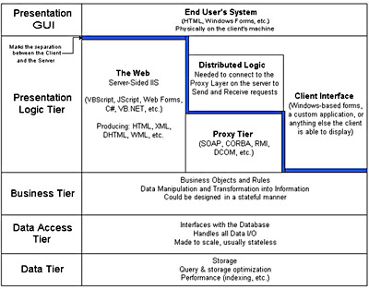
Fig. 1. n-tier model (source: http://www.riptidesoftware.com/assets/images/multi_tier_arch.jpg)

3. what are the modern approaches?

Reasons for modification towards object oriented paradigms are of pragmatic character. The user became more sophisticated in his demands, the number of demands have been significantly increased. On the other hand, technical possibilities – memory space, processing speed – stopped being restrictive factors. Organisation of graphical user interface, freed the users of frustrations related to interactive communication with the computer. The core of object-oriented paradigms (abstraction, encapsulation, inheritance and polymorphism) is summarised in the slogan “write it once and use it wherever you might need it”. Nowadays, many modern program languages support these paradigms. However, organisations through libraries of components that can easily be reused and, if necessary, further processed, have certain flaws.
Quality technical and program possibilities ensure the quality of business processes but they also allow the increase in their performance speed. The new paradigm modification has been prompted by the necessity for in time and adequate organisation of total business activity observed through the elementary form of relations between end-actors. A service-oriented architecture is a framework for integrating business processes and supporting IT infrastructure as secure, standardized components—services—that can be reused and combined to address changing business priorities.( (Bieberstein at all, 2008). A motion towards system architecture and actor visualisation in the relation that is being defined as a service has been noticeable. Virtualisation demands multi-layer de-layering and a looser connection between actors – loose coupling (Fig. 2). Loose coupling is the key SOA feature and it denotes loose connection and dependence between services by which speed and freedom in combining services that are being provided by a business system is enabled.

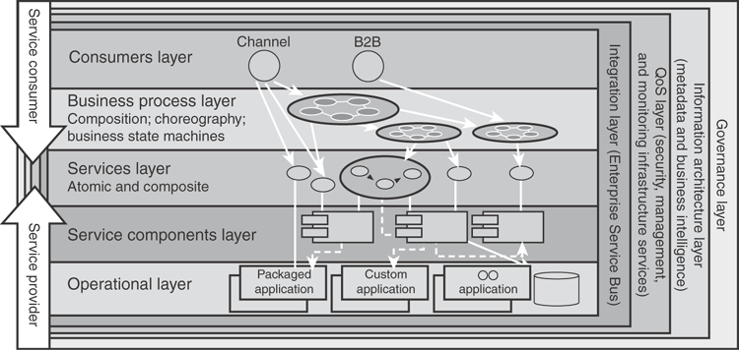
Fig. 2 Logical view of SOA Reference Architecture (Bieberstein at all, 2008)

4. Quo VADIS ICT?

SOA is a modification of object-oriented paradigms. Loose coupling is a combination of good features of inheritance paradigms and encapsulation in realisation of relations between services and system elements, while the elasticity in creation of variations and inclusion of a necessary number of elements is a modification of abstraction polymorphism paradigms implementation. The new thing about SOA paradigm is the insisting on constant connection with changes in business processes and necessity for in time and valid support in each new combination.
Paradigm in ICT can be understood and accepted in different ways. Regardless the structure and architecture, user should be in the centre of information system and all that is being done is constructed in order to satisfy his needs. ICT development will slightly move information system’s centre of gravity around the user’s position. Boundedness and motionlessness of monolithic surroundings through a relationship basis enabled the computer’s larger executive power and indirectly the one of the user as well. Multimedia enabled a way to define new forms of data and expressed the necessity for object approach. Internet and more powerful communications freed the user from being connected to a physical location. However, this freedom is only apparent since it demands networking of locations where the program is being performed together with the machine where the program is resident, i.e. software is not independent of location, at least not entirely. Grid computing is a try to solve that problem. Grid architecture is a form of distributed processing where “a big virtual computer” consists of loosely coupled computers networked on the cluster principle, for the purpose of more demanding processing and more complicated tasks. (Hirtenfelder, 2008) Although it is often being stated that grid architecture is intended towards more complicated and larger scientific calculations, that is not the sole reason for this kind of organisation. Adjustability to the user’s financial abilities has not been enabled with any of the stated paradigms. The attempted enabling of those abilities is being included in the so called cloud computing paradigm.(Miller, 2008) Thought out as an Internet market where the user uses a search engine and applicative solutions to enable realisation of the needed service by the self-service principle with an adequate price that he can afford.

5. CONCLUSION

Conformity of team members’ opinions is one of the problems in team solving of project tasks. The team hast o have formally or informally expressed consensus of problem concept and the way it will be solved. If the team is heterogenic, the differences are even bigger. Even though team work presumes supplementary of certain members’ actions, differences in the level of understanding the basic issues are a huge obstacle in the project’s realisation. The result of the achieved consensus is the paradigm. Paradigm is the acceptance of the way of thinking achieved by consensus, but it is not final, nor unalterable. Paradigm modification becomes clear in the way of changing opinions and demands, reason and trigger. (Kuhn, 1962) claims that it is a transformation, form of revolution, sort of metamorphosis. ICT development has partially denied this opinion, at least in pragmatic sense. End user is the centre of information system and the approach to applicative support development demands paradigms that he will understand and will be ready to accept. This is necessary further more since a well led project demands end user’s involvement in all significant phases of information system development. Therefore, monolithic application paradigm is modified to paradigms that are accepted to cloud computing but in a way to preserve the basic ideas and set goals. Enabling the service and keeping the independence considering space and time of user’s activity’s realisation, as well as financial ability will condition acceptance and further direct changes in paradigms.

6. References

Bieberstein, N. at all (2008), Executing SOA: A Practical Guide
for the Service-Oriented Architect, IBM Press, ISBN:
0132353741, Indianapolis
Erl, T. (2005). Service-Oriented Architecture: Concepts,
Technology, and Design, Prentice Hall, ISBN: 0131858580
Hirtenfelder, J. (2008) The Evolution of Grid Computing, VDM Verlag Dr. Mueller e.K., ISBN: 3836475650, Germany
Kuhn, T.S. (1962) The Structure of Scientific Revolutions. University of Chicago Press, ISBN: 0226458083, Chicago
Miller, M. (2008), Cloud Computing: Web-Based Applications That Change the Way You Work and Collaborate Online, Que, ISBN: 0789738031, Canada

DAAAM AUTHOR QUESTIONNAIRE

Use as many space /pages as you need!

Paper Data

Name and email address of corresponding author: pogarcic@veleri.hr
This paper will be presented (oral presentation / poster): oral
This paper will be NOT presented at Symposium please send the Proceedings to following address:
Please send PDF Off prints of Paper to following e-mail address: pogarcic@veleri.hr

Authors Data
Please fill this questionnaire for each of the authors (use as many space/pages as you need):

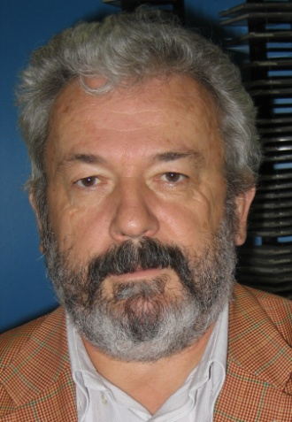
- First / Middle / Family Name: Ivan, Pogarčić
- Titles: MSc
- Position / Since: leader of education
- Institution: Polytechnic of Rijeka
- Place and Date of Birth : 1953-07-18
- Nationality / Citizenship: Croatian/Croatia
- Field of interests (key words): Database, development of information system, e-learning
- Hobbies: Skiing, music
- E-mail address: pogarcic@veleri.hr
- Site: www.veleri.hr/∼pogarcic
- Phone & Fax #: +385 98 456 065 & +385 51 673 529
- Postal address: Marinici Mucici 46 a, 51216 Viskovo
- I am interested in the following DAAAM activities to be active member of one of our international committees, and reviewer of papers and manuscripts

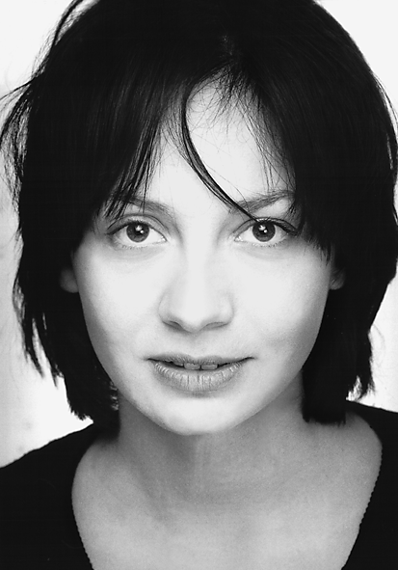

- First / Middle / Family Name: Jana,Ziljak Vujic
- Titles: PhD
- Position / Since: professor
- Institution: Polytechnic of Zagreb
- Place and Date of Birth: 1972-06-25
- Nationality / Citizenship: Croatian/Croatia
- Field of interests (key words):
- Hobbies: Sport pilot, Skiing,
- E-mail address: janazv@tvz.hr
- Site: http: www.ziljak.hr
- Phone & Fax #: ++3851 5603 999
- Postal address: Vrbik 8, 10000 Zagreb, Croatia
- I am interested in the following DAAAM activities to be active member of one of our international committees, and reviewer of papers and manuscripts

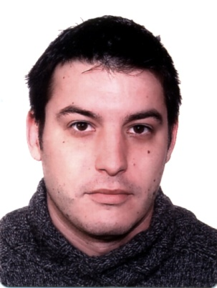
- First / Middle / Family Name: Ivan Rajkovic
- Titles: BSc Film and Television Editing; IT engineer
- Position / Since: asistent
- Institution: Polytechnic of Zagreb
- Place and Date of Birth : Zagreb, 1978-08-05
- Nationality / Citizenship: Croatian/Croatia
- Field of interests (key words): Tv, video, multimedia, internet TV
- Hobbies: swimming, reading, film
- E-mail address: ivan.rajkovic@ffprodukcija.com
- Site: www.ffprodukcija.com
- Phone & Fax #: 00 385 95 912 8775
- Postal address: Maksimirska 50a, Zagreb, Croatia
- I am interested in the following DAAAM activities to be active member of one of our international committees, and reviewer of papers and manuscripts

