Electromechanical Simulation Of A Linear Solenoid Actuator

Marko Topolnik, Željko Štih, and Zijad Haznadar
Faculty of Electrical Engineering and Computing
Unska 3, HR-10000 Zagreb, Croatia

Abstract: The results of numerical simulation of a linear solenoid actuator are presented. The simulation was done using the finite element method, by performing a coupled electromagnetic field and structural displacement field calculation. The results agree well with the measurements and give additional insight into the function of the actuator.

Introduction
Electromagnetic solenoid actuators form one of the largest classes of magneto-mechanical applications [1]. They are generally used to provide force and/or motion to position parts or close switches by transforming electrical input into linear motion of a moving armature. Reliability and dynamic response of an actuator is a crucial item in the function of an apparatus which utilizes conversion of electrical pulse into mechanical energy. Accurate simulation of these features plays an important role in their design. A typical example are modern current-limiting circuit breakers.
In this paper, numerical simulation of a cylindrical actuator in a current-limiting circuit breaker will be described. Accurate simulation has to take into account the coupling between electromagnetic forces and structural displacement. This requirement enforces a coupled solution of electromagnetic field and structural displacement field in the actuator. In order to simplify the mathematical model, time dependence of the current pulse that drives the actuator was prescribed, and geometry was defined as axially symmetric.

Mathematical model
The field solution was obtained using the finite element method [2]. The domain of interest is divided into a grid of finite elements, each element being defined by its grid points, called nodes. For every node, a set of differential equations is written, one for each degree of freedom (DOF). In this case (cylindrical axisymmetric system), there are two electromagnetic DOF’s (the θ-component of the magnetic vector potential $\vec{A}$, and the time-integrated scalar potential ψ), and two structural DOF’s (displacement in the r and z direction). Since the moving part is allowed to move only in the z direction, the r DOF is constrained to zero at all grid points and can be eliminated from the calculation.
All electromagnetic differential equations are condensed into one differential matrix equation. The same is done with the structural equations. The electromagnetic solution is then obtained in the form of the electromagnetic potential vector $\left\{u_{E}\right\}$. Every element of the vector represents the state at one grid point. The governing matrix equation is [3]:
$\left[M_{E}\right]\left\{\frac{∂^{2}u_{E}}{∂t^{2}}\right\}+\left[B_{E}\right]\left\{\frac{∂u_{E}}{∂t}\right\}+\left[K_{E}\right]\left\{u_{E}\right\}=\left\{F_{\text{ET}}\left(t\right)\right\}$ (1)
where $\left[M_{E}\right]$ is the permittance matrix, $\left[B_{E}\right]$ is the conductance matrix, and $\left[K_{E}\right]$ is the reluctance matrix. The right-hand term is the total electromagnetic excitation. It is a linear combination of two components: the usual electromagnetic excitation vector, and additional excitation produced by structural motion (eddy currents).
The structural equation has the same form, only different interpretation:
$\left[M_{\text{SS}}\right]\left\{\frac{∂^{2}u_{S}}{∂t^{2}}\right\}+\left[B_{\text{SS}}\right]\left\{\frac{∂u_{S}}{∂t}\right\}+\left[K_{\text{SS}}\right]\left\{u_{S}\right\}=\left\{F_{\text{ST}}\left(t\right)\right\}$ (2)
Here, $\left\{u_{S}\right\}$ is the structural displacement vector, $\left[M_{\text{SS}}\right]$ is the stiffness matrix, $\left[B_{\text{SS}}\right]$ is the damping matrix, and $\left[K_{\text{SS}}\right]$ is the mass matrix. The right-hand term is the total force vector, consisting of structural forces and additional electromagnetic forces obtained from the electromagnetic solution.
The coupling between these two equations is achieved through the right-hand terms. First the equation (1) is solved, then the equation (2). As the structural solution is being obtained, the electromagnetic matrices are recomputed to account for the structural motion.

Actuator parts and function
Figure 1 presents a drawing of the actuator and explains its main parts.
The armature is held in position by the permanent magnet. The purpose of the magnetic shunt above the magnet is to allow the magnet’s flux lines to bend towards the armature. When a voltage pulse is applied to the coil, it creates a magnetic flux that counteracts the flux of the magnet, and the spring ejects the armature. After that, the armature has to be manually reset to the lower position. When the armature is in the ejected position, the magnetic flux of the magnet flows through the gap between the shunt and the case. The size of the gap is such that the demagnetization of the magnet does not occur.
Figure 1: The actuator

Finite element model
The simulation was executed by the EMASTM analysis package, using coupled transient analysis with small motion. This is a time-stepped simulation. At each time step, an electromagnetic field solution is calculated, followed by a structural displacement field solution. Structural motion of conductive parts can produce motional eddy currents, which in turn produce magnetic fields. Also, electromagnetic fields produce structural forces. Because of that, structural and electromagnetic analyses have to be coupled at each time step.
The simulated actuator has parts of saturable magnetic material, which implies non-linear permeability. Also, the gap elements under the armature have nonlinear structural properties (stiffness), in order to constrain motion in the z-direction. Thus, both the electromagnetic and structural analyses have to be nonlinear.
Figure 2 presents the finite element mesh used in the simulation. Since the modeled actuator is a cylindrical, axially symmetrical object, only the right half of the cross-section has to be modeled. The analysis package is instructed to interpret the model as axisymmetric. The symmetry axis runs through the left edge of the model.
The mesh has been formed using triangular finite elements of the second order. This means that the nodes are placed at each vertex of the element, as well as at the midpoint of each edge.
There is a thin layer of elements in the gap between the armature and the rest of the model. These elements get deformed as the armature moves. If they get too distorted, the accuracy of the simulation results is compromised. This limits the amount of motion the model can accurately simulate. In this case, the allowed amount of armature displacement is sufficient to place it far enough from the shunt as to break the magnetic circuit. After that, only the spring force acts on the armature, so that further distortion of the elements does not affect the accuracy of simulated armature motion. The accuracy of flux distribution in the rest of the actuator is not substantially disturbed by this, either.
Magnetic boundary conditions have been applied to the outer edge of the model. They force the magnetic flux to be tangential to the model boundary, confining the flux within the model. Structural boundary conditions have been specified on every element. They constrain the motion of the armature and the surrounding gap to the z-direction, and prevent the motion of all other elements.

Figure 2: Finite element mesh
The coil was modeled by specifying uniform, time-dependent electrical current density over its cross-section. Time dependency was described with a piecewise linear function, shown in Figure 3. The spring was modeled as constant structural force applied to a single node on the armature.
Figure 3: Coil current vs. time

The results
The simulation run shows how the distribution of magnetic flux changes through the transient state of current raise, and how the armature accelerates when the ejection begins.
Figure 4, which shows data extracted form the results of the simulation, presents the latter.
Figure 4: Time graph of armature ejection
It can be seen that full acceleration is achieved while the displacement is still relatively small, about 0.5 mm. Beyond this point, the motion of the armature is not affected by the magnetic field anymore.
The shown electric field was recovered from a node within the coil. It is representative of the electric field in the entire coil. As the current rises, electric field opposes the dissolution of magnetic flux in the actuator. When the armature starts moving, the field increases because the remaining flux is abruptly removed due to the breaking of the magnetic circuit. After the magnetic flux is gone, electric field falls back. At that point, the armature is still moving up.
Figure 5 presents the distribution of magnetic flux at two key points: static state before current is applied, and the moment within the transient state at which the armature begins moving up. The magnetic force on the armature depends upon the amount of magnetic flux that runs through the armature. The dark area within the shunt is the area where the flux splits between the path through the armature and the path through the air gap between the shunt and the case. It can be seen how the applied current redirects the flux to the latter path.
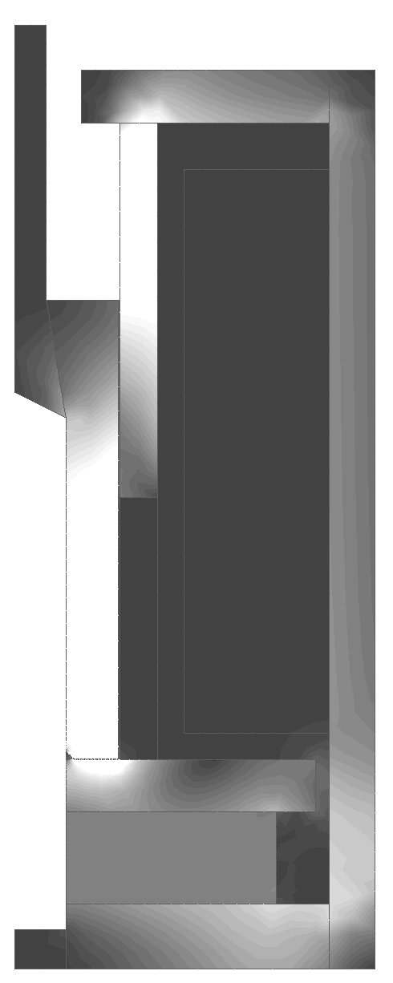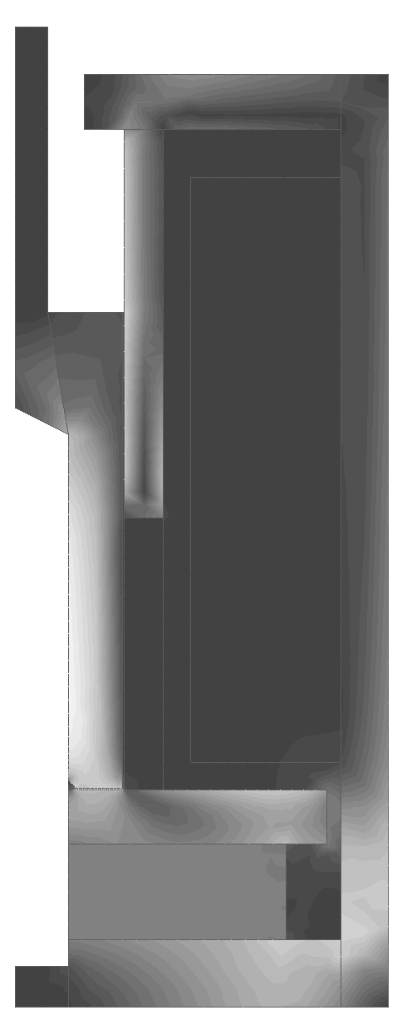
t <= 0 ms: static state t = 3.25 ms: begin of
ejection
Figure 5: Magnetic flux distribution
Figure 6 presents the distribution of electric field at the begin of ejection, and at the point when it reaches maximum value within the coil. The electrical field strength in the coil affects the shape of the current pulse. This simulation was executed with a prescribed current pulse shape. In reality, current drops when the ejection begins, and recovers again while the armature is still moving up. The real shape of the current pulse can be deduced from the time graph of the electric field.
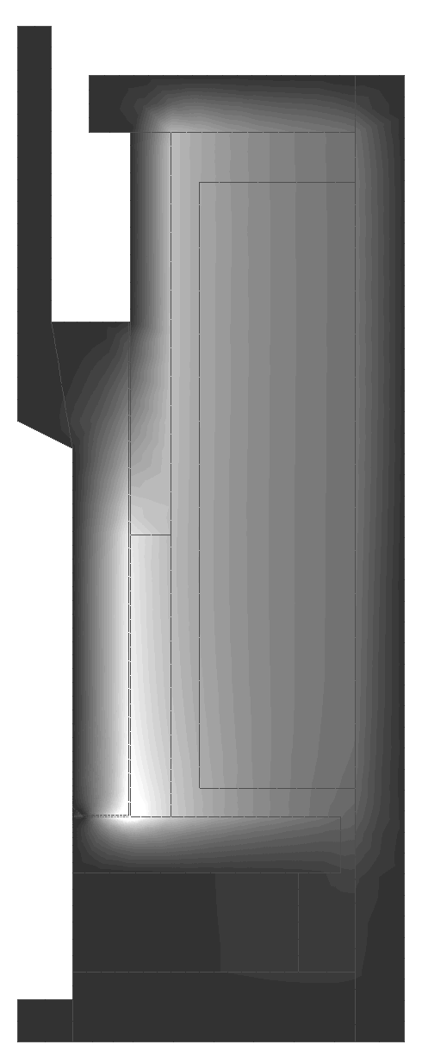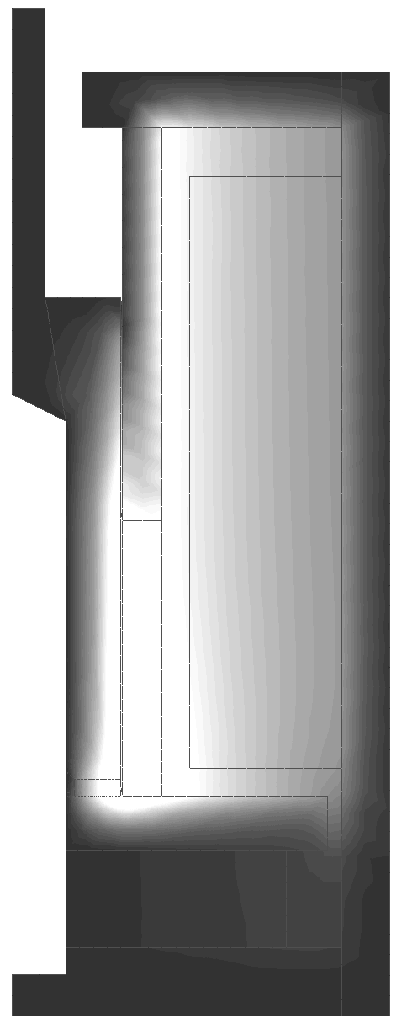

t = 3.25 ms: begin of t = 4.25 ms: maximum ejection electric field
Figure 6: Electric field distribution

Comparison with measurements
In the static state with no applied current, the force upon the armature was measured on the real actuator. This force can be calculated for the simulated model using the principle of Maxwell’s tensor. The calculated force matches very well with reality.
Dynamic characteristics of the actuator were measured by applying a quadratic voltage pulse to the coil and recording the shape of the current pulse. The results are shown in Figure 7. From this recording, the begin (I) and end (II) of ejection were deduced. The simulation was in accordance with the measured pulse shape, but it also showed that the ejection does not end at point II, as it was supposed. At that point, the armature has moved only by approximately 2 mm. The current begins recovering because at this point the magnetic circuit through the armature has been broken and further armature motion has no influence on the shape of the pulse.
Figure 7: Measured coil current

Conclusion
The paper presented the simulation of a linear solenoid actuator using a fully coupled transient electromagnetic and structural finite element analysis. The used materials have nonlinear properties, and they have been taken into account by the simulation.
The results of the simulation agree well with the measurements and give more insight into the function of the actuator, which will enable the proposal of a more optimal design of the actuator.

References
- F.C. Moon. Magneto Solid Mechanics, Willey & Sons, Inc, New York, 1984.
- Z. Haznadar, Ž. Štih. Electromagnetism 1 & 2, Školska knjiga, Zagreb 1997 (in Croatian).
- J.R. Brauer, J.J. Ruehl. 3D Coupled Electromagnetic and Structural Finite Element Analysis of Motional Eddy Current Problems. IEEE Transactions on Magnetics, Vol. 30, No. 5, pp. 3288-3291, September 1994.
- Ansoft Corp. EMAS Version 4, User’s Manual, July 1997.

