TEM-Cell with increased usable test area

Krešimir Malarić, Juraj Bartolić, Borivoj Modlic

University of Zagreb, Faculty of Electrical Engineering and Computing,

Dept. of Radiocommnunications and Microwave Engineering,

Unska 3, Zagreb, CROATIA,
Tel: +385 1 6129 789, 6129 663, 6129 672,
e-mail: kresimir.malaric@fer.hr, juraj.bartolic@fer.hr, borivoj.modlic@fer.hr

ABSTRACT

This work gives an insight into the TEM-cells, their use and application. It deals with problems regarding characteristic impedance, higher mode, dimensions and usable test area. A TEM-cell designed at FER is presented here with initial results. This TEM-cell has characteristic impedance of 75 Ω and increased usable test area. It can be utilized for GSM as well as EMC measurements at 900 MHz due to the uniform TEM field on this frequency.

I. INTRODUCTION

$Z0=\frac{\text{376},\text{73}}{4\left[w(b−t)+Cf\text{'/}ε\right]} (1)$Transverse electromagnetic (TEM) transmission line cells are devices used for establishing standard electromagnetic (EM) fields in a shielded environment. They are triplet transmission lines with the sides closed in to prevent radiation of RF energy into the environment and to provide electrical isolation. The cell consists of a section of rectangular coaxial transmission line tapered at each end to adapt to standard coaxial connectors (Fig.1). A uniform TEM-field is established inside a cell at any frequency of interest below that for which higher order mode begin to propagate. TEM-cells are used for emission test of small equipment, for calibration of RF probes and for biomedical experiments. The wave travelling through the cell has essentially a free-space impedance (377 Ω, thus providing a close
Fig. 1. TEM-cell

approximation to a far-field plane propagating in free-space. The cells are broadband having a linear phase and amplitude response from DC to the cell’s cutoff frequency.
This characteristic allows continuous-wave (CW) or swept-frequency, as well as impulsive and modulated signal testing to be performed. The cell has its limitations. The main is that the upper useful frequency is bound by its physical dimensions which, in turn, constrain the size of item that can be tested.

II. CHARACTERISTIC IMPEDANCE

The characteristic impedance of transmission line has been given by Crawford [1] in terms of the fixed dimensions of the line’s cross section (Fig. 2) as well as an unknown fringing capacitance per unit length C_{f} ’.

where ε = 8,852 • 10 ^{–12} F/m, assuming an air dielectric.
Fig. 2. Line’s cross section

$\frac{C f'}{ε}=\frac{2b}{π(b−t)}\text{ln} \left[1+\text{coth} \left(\frac{π}{2}\frac{a−w}{b−t}\right)\right]+\frac{t}{a−w}\text{.}\text{.}\text{.} (2)$For a center conductor with finite but small thickness,

The above equation is valid for (a-w)/2b<0.4.

Crawford cell (and most cells) are designed to have 52 ohms characteristic impedance. Fifty two ohms were chosen to allow for some impedance loading effect when inserting the EUT (equipment under test) inside the cell. The equations for zero thickness center conductor and with center conductor t/b>0.2 can be found in [4].

III. HIGHER ORDER MODES

A basic TEM-cell limitation is the appearance of resonance which tend to destroy the desired TEM-mode field distribution. There are numerical solutions for the normalized cutoff frequency of the initial higher order modes as a function of the inner conducting width. However, determining the resonant length of a cell is nontrivial since the tapered sections affect each higher order mode differently. Because TEM-cell is a high-Q cavity, the higher order resonance appear at sharply defined frequencies. Thus, there may exist windows between resonance where TEM-cell usage is still quite valid. To what extent these structures are usable when higher order mode resonance are present and whether or not they are usable at frequencies between such resonance depends very much on the particular application for which the cell is being used.
$l(\text{mn})=pλ{g(\text{mn})}/2 ; p=1,2,3 (5)$The cutoff frequency for TE₁₀, usually the first higher order mode, is given by

where c is the velocity of light.

$\frac{1}{λ^{\text{ 2}}}=\frac{1}{λg^{2}}+\frac{1}{λ_{c(\text{mn})}^{2}} (6)$The equation for the cutoff frequency for any higher mode is:

The TEM-mode propagates through the tapered ends of the cell without significant alteration. Each higher mode is always reflected at some point within the taper where it becomes too small to propagate the mode. The propagating energy in the higher-order mode undergoes multiple reflections, end to end, within the cell until it is dissipated. At certain frequencies, a resonance condition is satisfied, in which the cell’s effective length for the mode is “p” half guide wavelengths long (p=1,2,3,…). At the resonant frequencies, f_{R(mnp)}, a TE_{mnp} resonant field pattern exists. Using:
$l(\text{mn})=pλ{g(\text{mn})}/2 ; p=1,2,3 (5)$
$\frac{1}{λ^{\text{ 2}}}=\frac{1}{λg^{2}}+\frac{1}{λ_{c(\text{mn})}^{2}} (6)$and,

where λ_{c(mn)} represents the cutoff wavelength value, the following expression by which various resonant frequencies can be predicted is given,
$f_{R(\text{mnp})}^{2}=f_{c(\text{mn})}^{2}+{\left(\frac{\text{pc}}{2l_{(\text{mn})}}\right)}^{2} (7)$
where f_{c(mn)} = c/λ_{c(mn)}.

Extension of the useful frequency range of the cell can be done by absorber loading. This is achieved by lowering Q inside the cell, which depends on frequency. Absorber improves the uniformity of the field between the septum and top or bottom walls by increasing the vertical component of the electrical field at the edges of the septum.

IV. DESIGN OF 75 Ω TEM-CELL

Fig. 3. Diagram of TEM-cell

While designing the cell, taking into the account its future purpose, (biomedical exposures as well as RF probe calibration and EMC) dimensions of the cell had to be chosen in a way to have the largest possible test area for the frequency of app. 900 MHz, while maintaining standard characteristic impedance. All this could not have been achieved with 50Ω. Dimensions were chosen in a way that a<b, thus achieving more space in vertical dimension. This resulted in a characteristic impedance of 75 Ω. Although most network analyzers have 50Ω impedance, matching can be done with 50Ω/75Ω transformers. Fig. 3 shows the sketch of TEM cell designed at FER. The material is aluminum, except for septum which is made of copper (1.5 mm). The size of EUT can be from 3 cm to 5 cm at most, still having the uniformity of the field inside the cell.

V. MEASUREMENTS
Fig. 4. VSWR
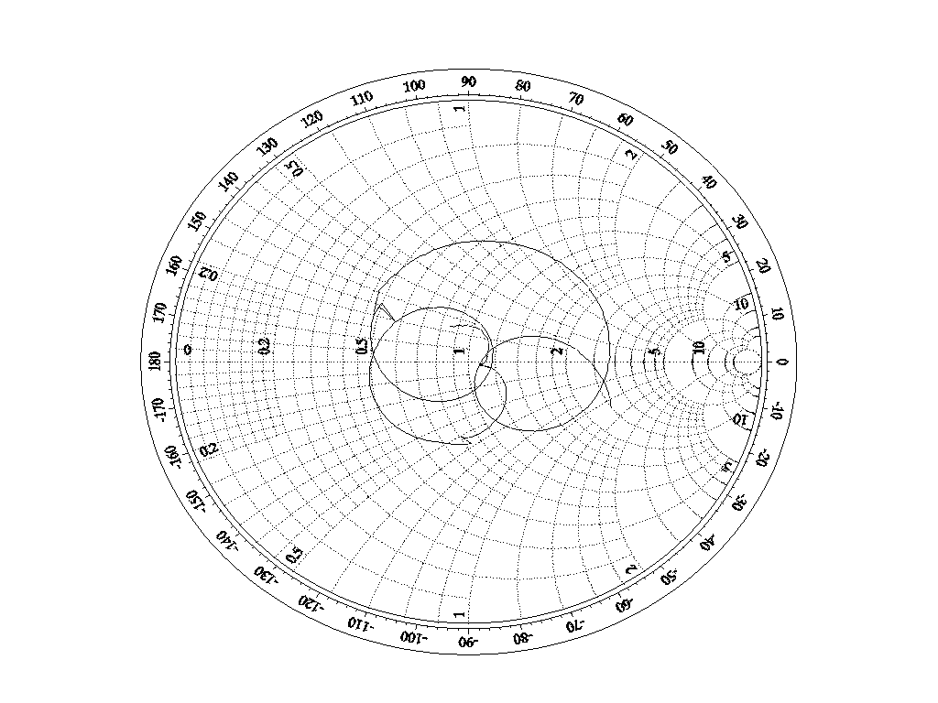Fig. 5. Insertion loss

Fig. 6. Smith diagram of TEM cell with transformers

$\begin{aligned}\left[J_{1} | \right]\left[J_{2} | \right]\left[ ⋅ | \right]\left[ ⋅ | \right] \\ \end{aligned}$Cell was tested at the laboratory of Department of Radiocommunications and Microwave Engineering. Using HP 8720B, network analyzer, VSWR (Fig. 4) and transmission characteristics (Fig. 5)as well as Smith diagram (Fig. 6.) were measured by 50Ω/75Ω transformer for matching. At the frequency of 935 MHz, VSWR was measured to be 1.07, attenuation 4.5 dB and the input impedance 80.8 – j0.92 Ω. It should be slightly over 75Ω for the insertion of EUT and impedance loading effect. To measure the field inside the cell, a field probe is necessary with all the appropriate equipment. This may be done in the future.

VI. FINITE ELEMENT METHOD (FEM)

Finite method is used to solve complex, nonlinear problems in magnetics and electrostatics. The first step in finite-element analysis is to divide the configuration into a small homogeneous elements.Finite-element model is shown in Fig. 7. The model contains information about the device geometry, material constants, excitations and boundary constraints. The elements are small where geometric details exist and much larger in other places. In each finite element, a linear variation of the field quantity is assumed. The corners of the elements are called nodes. The goal of the finite-element analysis is to determine the field quantities at the nodes.

Structure Geometry Finite-Element Model

Fig. 7. Finite-Element Modeling Example
Finite-element analysis techniques solve for the unknown field quantities by minimizing an energy functional. The energy functional is an expression describing all the energy associated with the configuration being analyzed. For 3-dimensional, time-harmonic problems this functional may be represented as,
$F=\int_{v}{\frac{ μ \left|H \right| ^{2}}{2}+\frac{ε \left|E \right| ^{2 }}{2}}−\frac{J⋅E}{2jω}\text{dv} (8)$The first two terms in the integrand represent the energy stored in the magnetic and electric fields and the third term is the energy dissipated (or supplied) by conduction currents.Expressing H in terms of E and setting the derivative of this functional with respect to E equal to zero, an equation of the form f(J,E) = 0 is obtained. A kth order approximation of the function f is then applied at each of the N nodes and boundary conditions are enforced, resulting in the systemof equations,
The values of J on the left-hand side of this equation are the source terms. They represent the known excitations. The elements of the Y-matrix are functions of the problem geometry and boundary constraints. Since each element only interacts with elements in its own neighborhood, the Y-matrix is sparse. The terms of the vector on the right side represent the unknown electric field at each node. These values are obtained by solving the system of equations. Other parameters, such as the magnetic field, induced currents, and power loss can be obtained from the electric field values. In order to have a unique solution, it is necessary to constrain the values of the field at all boundary nodes. The metal box of the model in Fig. 7 constrains the tangential electric field at all boundary nodes to be zero. The electrical and geometric properties of each element can be defined independently. Fig. 8, 9 and 10 are results of numerical modelling analysis.
Note: Higher values are warmer colors (brighter)

Fig. 8. Strength and vectors of E

Fig. 9. Strength and vectors of H

Fig. 10. Potential lines

VII. CONCLUSION

TEM-cell can be used for biological exposures and EMC measurements up to 1GHz. At 935 MHz, measurements can be done with biological materials (bacteria, for example) to observe effect of GSM, as well as EMC measurements (small IC or electronic devices). The ratio of a/b = 0.833 enables larger usable test area, while characteristic impedance is standard 75Ω instead of 50Ω used in most TEM-cells. Although higher order modes start to appear above 500 MHz, the cell can still be used at higher frequencies, because there are gaps with uniform TEM-field above the first cutoff frequency.

REFERENCES

[1] Myron L. Crawford : “Generation of Standard EM Fields Using TEM Transmission Cells”, IEEE Transactions on Electromagnetic Compatibility, Vol. EMC-16, No. 4, November 1974
[2] Myron L. Crawford, John L. Workman, and Curtis L. Thomas: “Expanding the bandwidth of TEM Cells for EMC”, IEEE Transactions on Electromagnetic Compatibility, Vol. EMC-206, No. 3, August 1978
[3] Norris S. Nahman, Motohisa Kanda, Ezra B. Larsen and Myron L. Crawford: “Methodology for Standard Electromagnetic Field Measurements”, IEEE Transactions on Instrumentation and Measurement, Vol. IM-34, No. 4, December 1986
[4] Claude M. Weil: “The Characteristic Impedance of Rectangular Transmission Lines with Thin Center Conductor and Air Dielectric”, IEEE Transactions on Microwave Theory and Techniques, Vol. MTT-26, No. 4, April 1978
[5] Claude M. Weil and Lucian Gruner: “High-Order Mode Cutoff in Rectangular Striplines”, IEEE Transactions on Microwave Theory and Techniques, Vol. MTT-32, No. 6, June 1984

[6] Perry F. Wilson and Mark T. Ma: Claude M. Weil and Lucian Gruner: “Simple Approximate Expressions for Higher Order Mode Cutoff and Resonant Frequencies in TEM Cells”, IEEE Transactions on Electromagnetic Compatibility, Vol. EMC-28, No. 3, August 1986
[7] Douglas A. Hill: “Bandwidth Limitations of TEM Cells due to Resonances”, Journal of Microwave Power, Vol. 18, pp 181- 195, June 1983
[8] Dr. Todd H. Hubing:: “Survey of Numerical Electromagnetic Modeling Techniques”, Report Number TR91-001.3, University of Missouri-Rolla, Electromagnetic Compatibility Laboratory, September 1, 1991

