SOME ASPECTS OF PROCESS

PLANNING IMPROVEMENT

P. Cosic and N. Volarevic
Department od Industrial Engineering
Faculty of Mechanical Engineering and Naval Architecture
University of Zagreb
Ivana Lucica 5, Croatia

ABSTRACT
The intention of this paper is to give some methodological approach in process planning. Within this intention it covers the issues of primary process selection, defining of the sequence of operations, etc. Matrix method for defining the sequence of operations will be very useful in development of IT application, but the development will be continued by AI methods. Selection of the primary process is useful in optimization process planning. The level of product quality, production time and production costs are results of developed procedures and their factors for sequence of operations, primary process selection, shape commplexity, variants of process plans, etc. The purpose is to analyse the influences of sequence of operations, primary process selection on process planning and how to apply them in decision making.

1. INTRODUCTION
Good interpretation of the part drawing includes mainly dimensions and tolerances, geometric tolerances, surface roughness, material type, blank size, number of parts in a batch, etc. The following factors would be the basis for decision support selection of the manufacturing process as the primary process selection, shape complexity, selection of machine tools and tools, sequencing the operation, variants of process planning and estimation of production times/costs [1]: a) quantity, b) complexity of form, c) nature of material, d) size of part, e) section thickness, f) dimensional and geometrical accuracy, g) surface roughness, etc [2].

2. PRIMARY PROCESS SELECTION
The following factors would be the basis for decision support selection of the manufacturing process as the primary process (for example, forming by deformation): a) quantity, b) complexity of form, c) nature of material, d) size of part, e) section thickness, f) dimensional accuracy, g) cost of raw material, h) possibility of defects and crap rate, etc.

2.1 Methods for Manufacturing process selection
Initially when product is in the concept stage great number of processes and materials are considered. As product starts to get its shape and more details number of processes and materials reduces. Applying these criterions results in optimal process selection and design that is adapted to process and material avoiding review of the part design in the advanced process planning stage.
All methods included in research have few things in common. They all give some general capability range for each process (tolerances, surface roughness, shape). Each method has its own shape classification but one thing is mutual, shapes are generally divided into round shapes, prismatic shapes and shapes that belong to neither of these two. Within this classification shapes are further divided into subclasses weather they contain features such as holes, change of section thickness. Economical batch is given by some of them [2,3] although some give this in a very wide range which is not very useful for making quality decisions. Material and process combinations are included into every method giving plain sight which combinations are out of question [4]. In order to gain final decision on process selection some authors [2,4] developed manufacturing cost estimation procedures.
Intention is to test some methods through case study and to compare the results. Figure 1. displays a part for which process selection will be carried out. Valve material is stainless steel (X45CrNi18-9; yield strength – 400MPa). The likely annual requirement is 50.000 units. Valve weight is 0,07kg. Other properties of the part can be found on the drawing (Figure 1.).

2.2 Selection strategies using Primas (Process Information Maps) [2]
Starting point is a data that provides information which processes are economically viable for certain combination of material and quantity. For stainless steel and batch quantity of 50.000 peaces combination a list of economically viable process is created. Process candidates are compared with product requirements and ones that don’t match them are excluded from list. Figure 2. is example of process information data for shell molding. After analysis process candidates eliminated from further consideration are:
- Centrifugal casting (shape doesn’t match - circular bore remains in the finished part),
Fig. 1. Air throttle valve example.
- Shell molding, ceramic mold casting, drawing, swaging, powder metallurgy,
- Electro-chemical machining, electro-beam machining, laser beam machining ),
- Chemical, machining (primary.weight reduction by producing shallow cavities)
- Remaining processes are: investment casting, forging, automatic machining, should be able to produce part (valve) according to requirement. It is obvious that further elimination need to be done in order to choose the optimal process. Relative component processing cost analysis for each candidate process can be done according to equation
. (1)
Where Vf is volume of finished component, WC is waste coefficient, Cmt is cost of material per unit volume, Cmp is relative cost associated with material-process suitability, CC is relative cost associated with component geometrical complexity, CS is relative cost associated with size and component cross section, Cft is relative cost associated with tolerance or surface finish, PC is basic processing cost.
Table 1. represents processing cost estimates of the part presented in Figure 1. which can help process planner select the optimal process and to minimize project and product costs. It is important to mention that relative cost associated with tolerance or surface finish coefficient (Cft) takes into account the need of additional machining since most primary
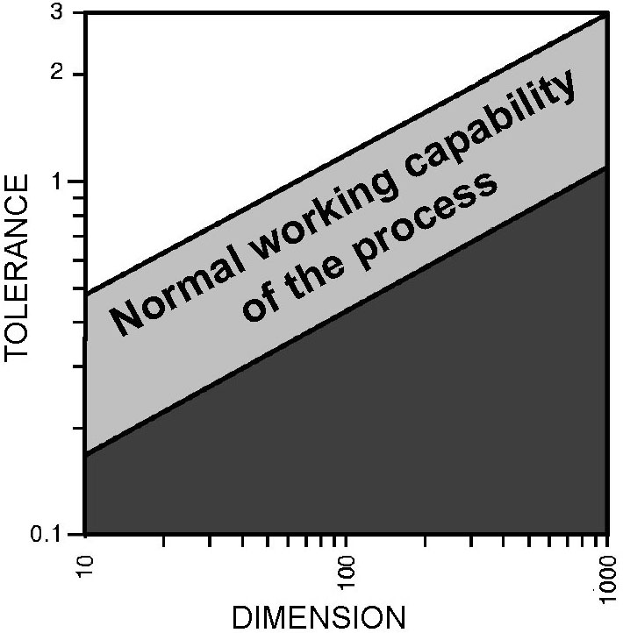
Fig. 2. Shell molding process information [2].

processes are not capable to achieve final tolerances and surface finishes. In this case forging turns out to be most suitable primary process due to material, design, batch quantity and other process limitations.

Table 1. Component processing costs
Primary process | Shape complexity | Volume [mm³] | C_{mt} | W_{c} | M_{c} | P_{c} | C_{c} | C_{mp} | Section [mm] | C_{s} | Tolerance [mm] | C_{t} | Surface finish, Ra [μm] | C_{f} | C_{ft} | P_{c} x R_{c} | Mi  (euro-cent)
Investment casting | A1 | 8760 | 0,00377 | 1,0 | 33,03 | 29,2 | 1 | 1 | 6,1 | 1 | 0,01 | 4,3 | 0,8 | 1,3 | 4,3 | 125,35 | 158,37
Forging | A1 | 8760 | 0,00377 | 1,1 | 36,33 | 1,9 | 1 | 2 | 6,1 | 1,3 | 0,01 | 4,2 | 0,8 | 2,4 | 4,2 | 20,75 | 57,08
Automatic machining | A1 | 8760 | 0,00377 | 1,6 | 52,84 | 2,9 | 1 | 4 | 6,1 | 1,0 | 0,01 | 3,5 | 0,8 | 1,3 | 3,5 | 40,60 | 93,44

This cost estimation could be inaccurate since at this level it is not possible to determine sequence of operations positioning and work-holding, queuing due to failures or facility occupation, number of machines. It was shown that variants of process planning can have significant influence on production time and therefore cost of production.

3. SEQUENCING THE OPERATION
Operations sequencing depends on many influences like [5]: nature of the material, general shape of the part, required level of accuracy, size of the raw material, number of parts in the batch, possible choice of machine tools, etc. One of the possible approaches is to classify different categories in the following way: a) dimensional precedence – dimensions with a datum as anteriority, b) geometric precedence – geometric tolerances with data references as anteriorities, c) datum precedence – case to the choice of a datum, d) technological precedence – case of a technological constraint, e) economic precedence – economic constraints that reduce production costs and wear or breakage of costly tools.
To achieve the nominated goal for definition of sequencing the operations is very complicated, multi-level, particular problem. Therefore, the expected difficulties in the process of solving this problem can be: pattern recognition, selection of datum, connection between machining surfaces and type of operations, machining tools, tools and positioning and work holding, etc. So, as the first step in process sequencing is selection of the simplified approach. It includes definition of: a) codes for machining surfaces, b) number of passes, c) type of fine (F) / rough (R) machining, d) definition the relevant anteriorities different types (dimensional, geometric, technological, economic).
As it is obviously, this approach expects the experienced process planner. One of the well-known methods of finding the order of precedence of the operations is based on the use of a matrix. Having defined all the anteriorities, it is now possible to find the right sequence of operations for machining. The consistency of the anteriorities depends heavily on the experience of the process planner. Solution is result of weighted category of anteriorities, minimal number of precedence operations and finishing of precedence operations. The chosen order of anteriorities implementation is result of higher priority associated to dimensional and geometrical features then economical aspects. The difficulty can come from the assessment of the anteriorities, which can result in contradictory conditions. In this case the process planners have to introduce additional criterion in order to solve this contradictions. At the same time process planer defines anteriorities needed to establish a matrix, he makes a table that contains possible machining processes, machines, fixture devices and tools for every feature. To solve contradictory situation the feature that precedes according to matrix is compared with the momentarily possible features in the matrix. “Values” in the table that belong to features are compared. The feature whose “values” from table are the most similar to “values” of preceding feature has advantage. The logic in this approach is that as much as possible number operations in a sequence should be done by same process on the same machine in the same fixture and using same tool.

MATHRIX METHOD – BOLT EXAMPLE
The first step is to analyze the part drawing and “divide” the part into features/surfaces(1-12). (Fig. 1). Features are made by different machining operations. According to geometric shape, tolerances, surface quality and other information a drawing contains we can select possible machines and tools by which a specific feature could be produced.
For the example in Figure 1 a selection was made and is presented below in Table 2. Taking into account geometry of the product the primary shape would be a bar Φ20. The problem that appears next is which feature should be machined first and more important in which order should features be done. Certainly there are restrictions regarding technology, geometric and dimensional tolerances, datum, economy (reduce production costs and wear or breakage of costly tools). Taking into account all this restrictions another table (Table 2) is
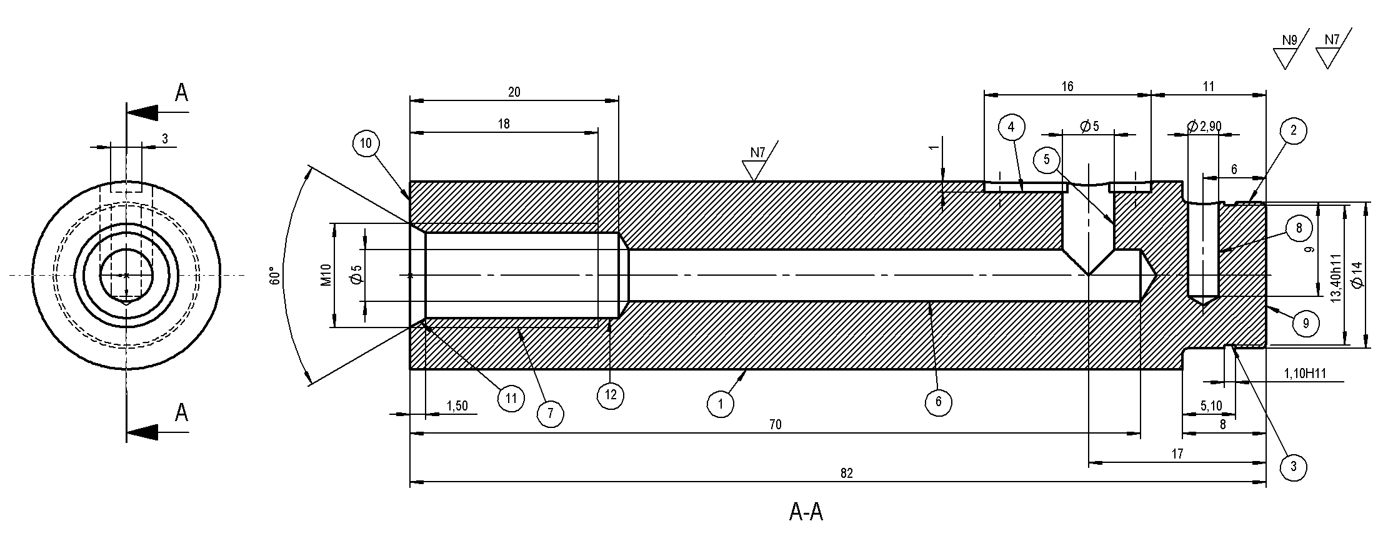
FIGURE 1. Bolt drawing
Quantity: 14 000 pcs., Material: St60-2; Quantity: 14 000 pcs., Material: St60-2

made in which it is clear which features must precede before other features. If Table 3 is presented in matrix (Table 4), advantages from this approach are now clear. It is easy to see that the first feature to be machined is 10R. When 10R is removed from table it sets free other features that were “blocked” by it. [3]. It would be interesting to look at the situation when two or more features are not preceded by any other feature that needs to be done before. This means that all of them can be done at the same time. But this is not possible because only one feature can be machined in time. One of them must go first and then the other. In this example this situation occurs in the third step.
This situation is shown in Table 4. The feature that was done before is 1R (Table 4a). In this step we have to decide which feature is going to be machined first 2R or 4R (Table 4b). To make this decision we need more data. Therefore another table was made, shown in Table 5. In Table 5. a few additional criteria were brought out. In order of significance they are: same machine (if we change the machine we change all other factors: process, fixture and tool), same process (if we change the process we change fixture type, tool and sometimes machine), same fixture (changing fixture needs more time than changing tool and it is recommended to do as much operations as possible in one fixture because it is more precise), same tool (the least significant factor in this list).
If we look at the Table 5. we can see that feature 1R that proceeded was done by turning process on lathe. Since feature 2R is also done by turning on lathe which means by the same machining process as feature 1R it has advantage before feature 4R. Feature 4R requires milling and therefore different tool and fixture.
TABLE 2. Table of anteriorities
TABLE 3. Matrix of anteriorities
Surface  (Feature) |  | Anteriorities
1R | Φ18k6 | 10R
2R | Φ14 | 1R,10R
3R | Φ13,40h11 | 2R
4R | Counter bore 2mm | 1R,10R
5R | Φ5 | 1R,4R,6R
6R | Φ5 dpth.70 | 10R,1R,3R,2R
7R | M10 dpth.18 | 6R,12R,10R,11R
8R | Φ2.90 dpth.9 | 2R
9R | 82 (right side) | 1R,2R,3R
10R | 82 (left side)
11R | 1.5x60° | 6R,10R,12R
12R | Φ8.4 dpth.20 | 6R,10R,1R
 | execute this operations
before this operations |  | 1R | 2R | 3R | 4R | 5R | 6R | 7R | 8R | 9R | 10R | 11R | 12R
before this operations | 1R |  |  |  |  |  |  |  |  |  | X |  |  | 1
before this operations | 2R | X |  |  |  |  |  |  |  |  | X |  |  | 2
before this operations | 3R |  | X |  |  |  |  |  |  |  |  |  |  | 1
before this operations | 4R | X |  |  |  |  |  |  |  |  |  |  |  | 1
before this operations | 5R | X |  |  | X |  | X |  |  |  |  |  |  | 3
before this operations | 6R | X | X | X |  |  |  |  |  |  | X |  |  | 4
before this operations | 7R |  |  |  |  |  | X |  |  |  | X | X | X | 4
before this operations | 8R |  | X |  |  |  |  |  |  |  |  |  |  | 1
before this operations | 9R | X | X | X |  |  |  |  |  |  |  |  |  | 3
before this operations | 10R |  |  |  |  |  |  |  |  |  |  |  |  | 0
before this operations | 11R |  |  |  |  |  | X |  |  |  | X |  | X | 3
before this operations | 12R | X |  |  |  |  | X |  |  |  | X |  |  | 3

4. CONCLUSION
The first process selection strategy is capable to give unique answer which process is optimal regarding its costs and capability, although elimination of processes in 2nd step could be a bit inaccurate regarding limited information about particular process. Second strategy of candidate process “screening” is more precise but it usually provides more than one process and further reduction is often not possible in the early stage due to lack of information. Experience and knowledge of process planer has lot of influence on decision which features precede other features. The shape of part is usually very complex so process planer can miss
or not see some relations. Knowledge and experience are limited. This example shows logical
approach that can be used to solve conflict situations in decision making regarding sequencing of operations.
TABLE 4. Matrixes of anteriorities for second step and third step
- b)
 | execute this operations
before this operations |  | 1R | 2R | 3R | 4R | 5R | 6R | 7R | 8R | 9R | 11R | 12R
before this operations | 1R
before this operations | 2R | X
before this operations | 3R |  | X
before this operations | 4R | X
before this operations | 5R | X |  |  | X |  | X
before this operations | 6R | X | X | X
before this operations | 7R |  |  |  |  |  | X |  |  |  | X | X
before this operations | 8R |  | X
before this operations | 9R | X | X | X
before this operations | 11R |  |  |  |  |  | X |  |  |  |  | X
before this operations | 12R | X |  |  |  |  | X
 | execute this operations
before this operations |  | 2R | 3R | 4R | 5R | 6R | 7R | 8R | 9R | 11R | 12R
before this operations | 2R
before this operations | 3R | X
before this operations | 4R
before this operations | 5R |  |  | X |  | X
before this operations | 6R | X | X
before this operations | 7R |  |  |  |  | X |  |  |  | X | X
before this operations | 8R | X
before this operations | 9R | X | X
before this operations | 11R |  |  |  |  | X |  |  |  |  | X
before this operations | 12R |  |  |  |  | X
TABLE 5. Additional criterions for solving conflict situations
Surface  (Feature) |  | Process | Machine | Fixture | Tool
1R | Φ18k6 | Turning | Lathe | 10 9 | 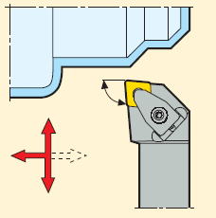
2R | Φ14 | Turning | Lathe | 10 9
3R | Φ13,40h11 | Turning | Lathe | 10 9 | 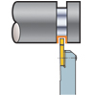
4R | Counter bore 2mm | Milling | Mill | 1 | 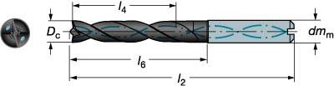
5R | Φ5 | Drilling | Drilling machine  Mill | 1 | 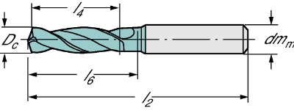
6R | Φ5 dpth.70 | Drilling | Drilling machine  Lathe | 1 | 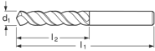
7R | M10 dpth.18 | Threading | Drilling machine  Mill | 1 | 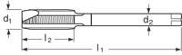
8R | Φ2.90 dpth.9 | Drilling | Drilling machine  Mill | 1 | 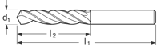
9R | 82 (right side) | Turning | Lathe | 1 10 | 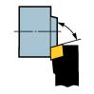
10R | 82 (left side) | Turning | Lathe | 1 9
11R | 1.5x60° | Countersinking | Mill  Drilling machine | 1 | 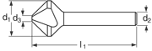
12R | Φ8.4 dpth.20 | Drilling | Drilling machine  Lathe | 1 | 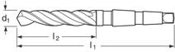

REFERENCES
- Kalpakjian S., Schmid S.: Manufacturing, Engineering & Technology, Prentice Hall, Upper Saddle River, NJ, 2006.,
- Swift, K.G., Booker, J.D. Process Selection, from Design to Manufacture, Butterwort-Heinemann, Linacre House, Jordan Hill, Oxford, 2003.,
- Halevi, G., Process of Operation Planning, Kluwer Academic Publishers, Dordrecht, 2003.
- Boothroyd G., Dewhurst P., Knight W.: Product Design for Manufacture and Assembly, CRC Press, 2nd edition, 2002.

