IMPACT OF INFORMATION AND COMMUNICATION TECHNOLOGIES TO THE LANGUAGE CHANGES AND THE CREATION OF NEW LANGUAGE FORM – “NETSPEAK”
Dina Vasic, Karmela Aleksic-Maslac, Jagoda Poropat Darrer
Zagreb School of Economics and Management, Croatia

Abstract
The pinnacle of technological progress is not measurable by any analysis preconditions. It is clearly evident that the present users of modern technology are well informatically literate that the only difference can be noted in the user’s age difference. Regarding the high level of information technology use in education, especially at the high education institutions such as the Zagreb School of Economics and Management (ZSEM), which has currently around 1,200 enrolled students, and the use of e-learning at a high level (a total of about 120 developed e-learning courses), we determined to test the impact of modern technology and development of online communication on current communication skills of students and possible deviation from the standard use of language. Rapid development of information and communication technology (ICT) and daily use of new forms of communication such as MSN, Skype, Facebook, a text message in different ways affect the change of language, and its adaptation to new methods of communication (narrowing or expanding the communication channel). In this paper we will analyze the research conducted on ZSEM among students of the 1st and 7th semester about the perception of language changes caused by modern technology development.

Introduction
New communication technology provides excellent coverage of education in all areas of the world. To standardize the communication within a nation has been arranged a formal type of communication. However, by the development of new technologies, the formal communication - particularly in education and relationships among students - gets an informal note. Because of the technological progress, and human alienation caused by technology development there are created a new kinds of communication through some new media. An increasing number of social networks across the Internet (Facebook, MySpace, Flickr, Twitter, ...) created some new forms of communication that are every day more and more accepted by users.
Today, the educational institutions, and students themselves have different views on social networks. They use them in order to get additional information about their students, colleagues,and some news regarding the study. Social networking has resulted in a lack of information security, privacy, and ultimately created some new ones, now nonexisting, linguistic forms.
Generating online content by users and making all kinds of social networks has led to making it a "new generation" (Web 2.0). Phenomena such as YouTube and MySpace is a hint in which direction is Internet about to move, or how it would have an impact on everyday life. Precisely because of that it is necessary to implement better control to the process of some new language forms creation that is taking the primacy of communication, even to the extent when users stop to distinguish the difference between formal and informal communication, especially when using these new unstandardized language forms. There are several types of new language forms, but certainly the most interesting use of the entire new language is popularly called "Netspeak“.

E-learning at ZSEM
Zagreb School of Economics and Management uses so called hybrid education – a combination of face-to-face education and the intensive usage of e-learning. The strategy of e-learning development was created during the School foundation in year 2002. [1] The faculty staff played an important role in the systematic introduction of e-learning system into the process of education. [2] The systematic introduction of e-learning system includes the following steps:
- In order to track the quality of the developed e-learning courses, e-learning group has developed 11 standards that can be divided into three groups: static, dynamic and administrator standards. [3,4]
- E-learning is obligatory for all lecturers and students. Each lecturer has obligation to make his/her course available in e-learning form, and in addition, he/she is due to improve it constantly. [5]
- At all courses the same Learning Management System (LMS) is used, and in this case it is WebCT. [6]
At the moment 1200 students are attending lectures at ZSEM, and more than 120 developed e-learning courses are at their disposal, including both undergraduate and graduate programmes.

Necessity to adapt the standard written language
Language is historicaly subject to changes. At the present time the principle of alteration postuled one hundred years ago by Ferdinand de Saussure, father of modern linguistics, is easily observed in new mass media such as those generated by computer science (chat, msn, forums, ect.) and the mobile phons (sms). Although this principle guarantees the continuity of languages, it is not taken into account when debating, when voices arise in favour and against the new codes of communication arise.[7]
Every communication process's task is to analyze the source, coder, transmitter, channel, reciver, decoder and recipient as shown in Figure 1. Understanding communication models and the messages flow is very important for effective communication. [8] From the practice is well known that there are many factors that complicate the smooth flow of messages. In the first place these are the words. Words are symbols that we use to express ideas. Choice of words, the manner of their use and assigning meaning to them often can lead to semantic problems, arising from the meaning of the words we use. The same word can have different meanings for different people. Thus, the symbols we use in order to transfer the meaning can be a big obstacle to successful communication. At the same time, the symbols can be very useful for the efficient way to transmit messages. We are witnessing the daily message "overcoding" that we are transmitting to any formal communication on an informal communication level.
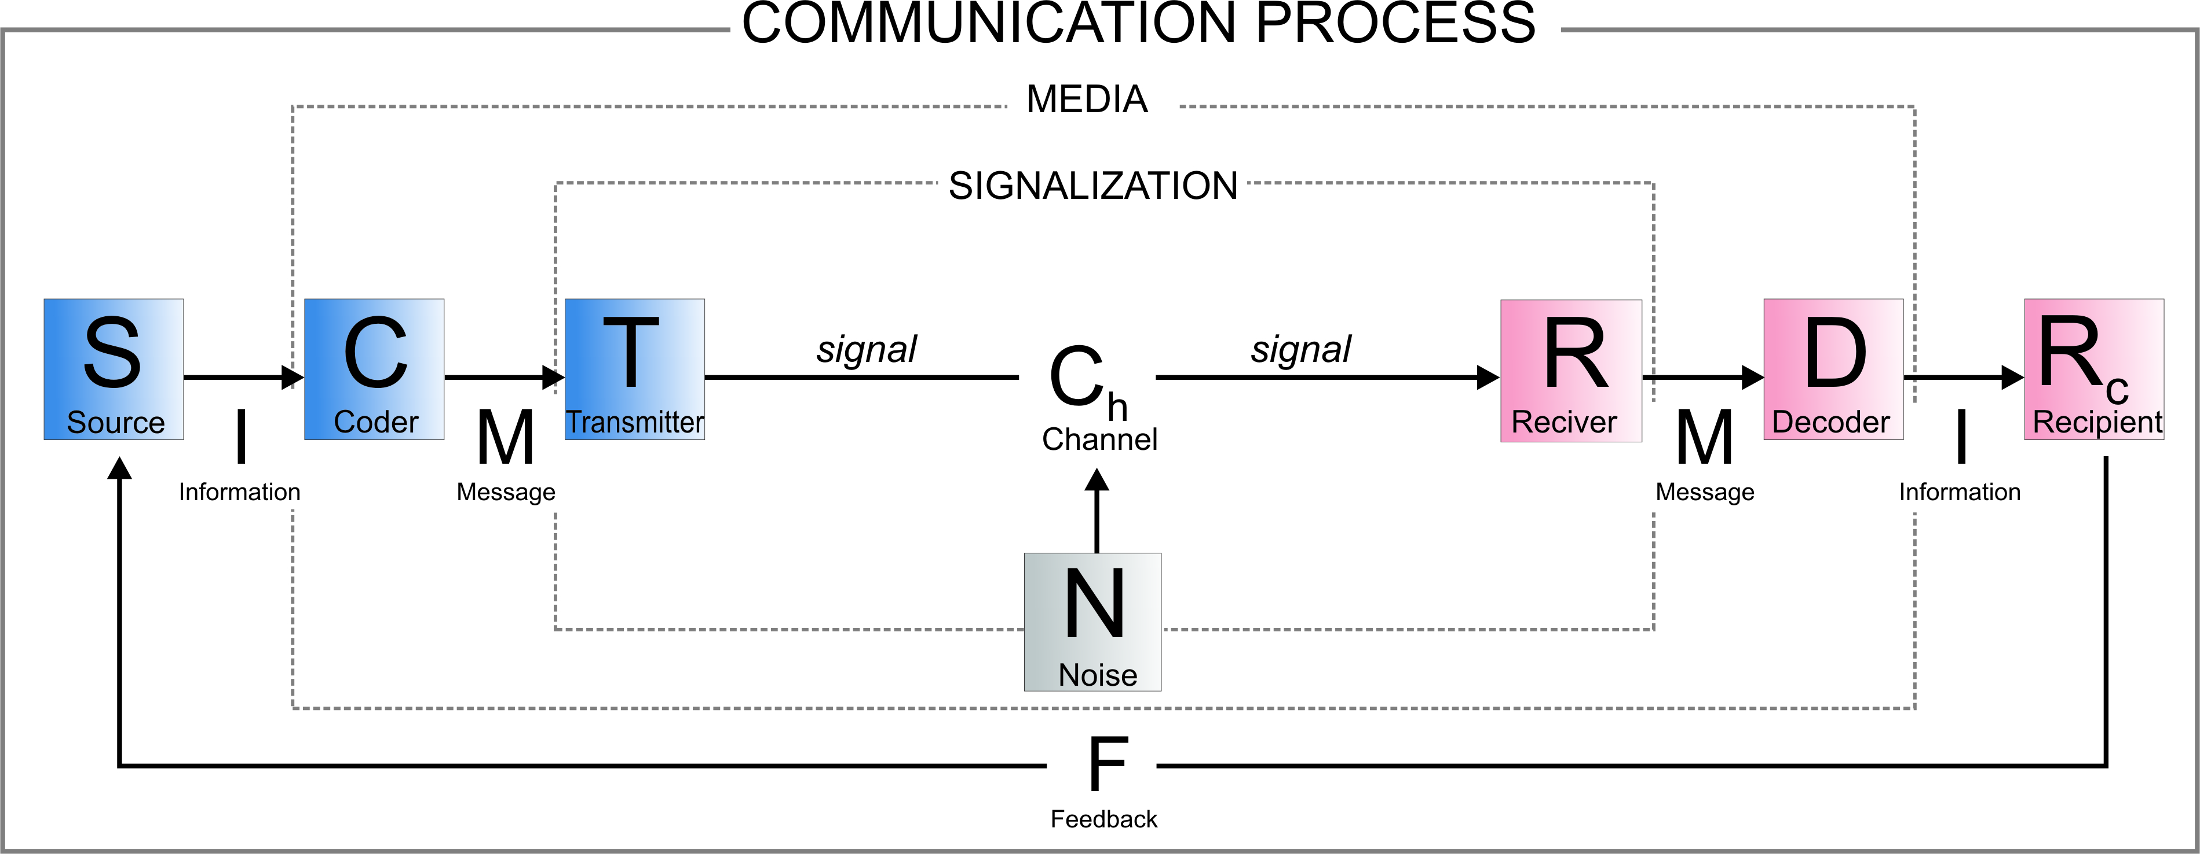
Figure 1 Communication process [9]
Undisputable is that a new language of electronic messages has been imposed and created , the only question is how it represents the move from the current standards and does it affect negatively to it. And it doesn't mean that in this way the language is becoming poor, it is just adapting itself to a new media. A new way to communicate. [10] Very keen to that idea are the scientists from the University of Kent. Their idea of enriching the language with new terms, acronyms and grammatical tenses is opposed to the hard-core old-school linguists who argue that the new language is actually impoverished version of the standard language.
„Instant messaging, or IM, is not just bad grammar or a bunch of mistakes,” says Dr. Pamela Takayoshi, Kent State University associate professor of English. “IM is a separate language form from formal English and has a common set of language features and standards.” [11]

Research
For this paper we proposed a research based on changes made by social web and technology transform among culture and behaviour of ZSEM students during 1st and 7th semester of study. In this paper we were particularly interested in how the students use the standard written language in communication (the formal and informal one) by means of new technology, also the attitude towards the use of diacritical marks that we believe are omitted and recorded by the standard rules of English language, the attitude towards the use of so-called emoticons (a word made by two words emotion and icons) - the universal symbol for a particular mood, all in order to shorten the time for communication and finally, the the use of abbreviations and acronyms.
In order to determine the perceptions of ZSEM students regarding the issue of language changes caused by the development of modern technology, in research we included first and fourth year students. Final sample of students who participated in the survey was N = 351 (N1.year = 247, N4.year = 104). The survey contained 14 questions that were related to the use of the standard written Croatian in the formal and informal communication, the use of diacritical marks in SMS messages and electronic mail, the use of acronyms and abbreviations in formal and informal communication, the use of emoticon in formal and informal communication and a range of open answers where they developed their own thoughts on the set topic. Online survey was set through LMS WebCT and students were given 7 days for its completion.

The use of the Standard Written Croatian in researched communication
Croatian language is a Slavic language spoken by Croats in their communities. Any society that homogenizes, achieves it due to internal communication. For the purposes of these communications forms, a common language (koine) is created, which occurs spontaneously, appropriate to the needs and communications, space and/or time. Optimizes according to the principle of minimum cost, the economy in the language, such as lingua franca. [12] The standard idiom has a function of understanding and creating the official, general and cultural activities in schools, universities, parliament, national television and radio, print, public signs, services and activities of clerks and political, entrepreneurial, scientific and professional public. It is one and unique to all members of diverse organic idiom to whom is possible and desirable. The standard idiom (previously referred to as the literary language) is more valuable than the organic (dialect) speech. [13]
Regarding the use of standard written Croatian in researched communication, we separated the formal and informal communication. As for taking into account use of the standard written Croatian in formal communication, there is no essential difference between 1st and 7th semester students who participated in the research. Students largely assessed to take into account the use of the standard written Croatian in formal communication and in larger proportions than 60% as shown in Figure 2. Data for both subject groups are equal. A small part of the students (9,6% and 11,7%) concernes; they really do not take into account use of the standard written Croatian in formal communication. Unlike the use of standard language in formal communication, by the informal communication most of the 1st and 7th semester do not take into account the proper use of the standard written Croatian.
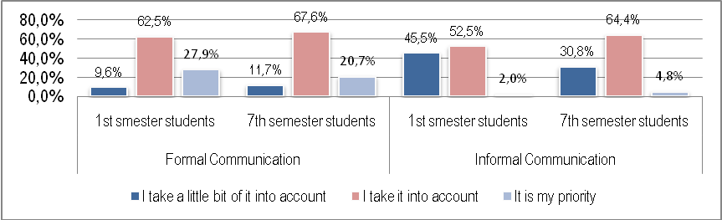
Figure 2 How much do you take into account the use of standard written Croatian in the formal and informal communication?

Use of diacritical marks in electronic correspondence
To check how many students actually use diacritical marks, one of the most common form in the Croatian language, we set the question about using those among the electronic mail and writing SMS text messages. SMS text messaging has become one of the most dominant means of communication in Croatia. The latest statistics show that in 2008 three mobile operators serviced 5,880,00 users of mobile phones (also including one person having two or more mobile phones) among Republic of Croatia, in relation to the 4,437,460 of inhabitants that Croatia has at the moment [14] With respect to their linguistic features SMS text messages have become a language variety in their own right , exhibiting specific regularities in different aspects of language use. [15]
In one text message fits exactly 160 characters in which spaces are included, but diacritical marks carry a greater value than one character. So the message with 225 characters, for example, will be charged as a two text messages because of the 160 characters per message limit. However, if the message contains five diacritical marks, it will be charged as four text messages which is more than double from the messages, which are for 'č, š, ž' used 'c, z, s'. This occurs because the SMS server in Croatia does not recognize 'our' letters, and mobile phones convert them when sending into a combination of characters that is automatically longer than one character. When such a message arrives at the server it decodes and is re-sent to the recipient with understandable diacritical marks. When sending e-mail, no such problems are found because of the latest mailing servers’ system updates that are supporting diacritical marks.
It is evident from the student responses that they take into account diacritical marks, but most of them understand using diacritical marks among electronic correspondence as a combination of two letters in order to avoid sending multi-message. The data show that 7th semester students increasingly understand the use of diacritical marks in text messages more irrelevant (43,3%), while the relative share of 1st semester students in electronic correspondence (52,4%) use diacritical marks on a daily basis. A large share of 7th semester students uses diacritical marks in writing e-mails (58,7%), just as much larger share of 1st semester students (65,3%) as shown in Figure 3. The difference is not large, but certainly could be explained by the increasing development of technology that supports Croatian diacritical marks, and developed in recent years when the younger generation of students (1st semester) had the opportunity to meet new technological developments. Language loses its power; is very much evident in the use of diacritical marks priority to students in 7th semester (20,2%) versus the use of diacritical marks from 1st semester students (11,4%). This part of the research shows that students with the development of technology are less burdened by the basic properties of languages and a flexible approach in terms of using diacritical marks.
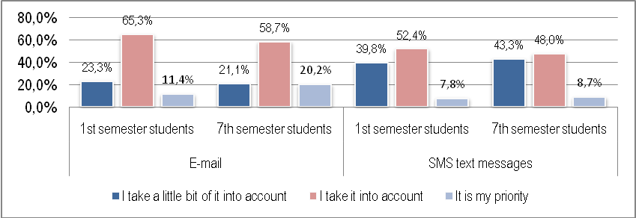
Figure 3 How much do you take into account the use of diacritical marks in the e-mail and SMS correspondence?

Use of acronyms and abbreviations in formal and informal communication
Acronyms are types of formed abbreviations composed of the initial letters of each letter of the expression in that is about to be shortened. Abbreviations are miscallaneous, there are regular and occasional. Permanent abbreviations are created by established principles, and occasional ones are created by writers. There are common abbreviations that are short parts of words or sets of words, and are read as if the words are spelled correctly. Other abbreviations are formed by merging the initial letter or letters of multi-member names and are usually read as written. [16]
Most of the 1st semester (97,1%) and 7th semester students (98%) are familiar with the difference between linguistic forms of acronyms and abbreviations. Likewise, students increasingly are using acronyms and abbreviations in informal communication, both the 1st semester (60,4%) and 7th semester students (72,1%) as shown in Figure 4. Regardgind generation gap, it is evident the reduction of use acronyms and abbreviations in formal communication with 70,6% 1st semester students to 63,5% 7th semester students. The most commonly used abbreviations and acronyms are among both groups the names of public institutions (eg ZSEM, HTV, NATO, OPEC, RH), abbreviations of language names (en, njem, hr), and acronyms like rotfl (Rolling of the floor laughing) LOL (laughing out loud), OMG (oh my god), btw (by the way), asap (as soon as possible), etc. (et cetera). This is just one part of the answer, but from the research is the most visible use of abbreviations and acronyms derived from the English language, and mostly used in chat channels.
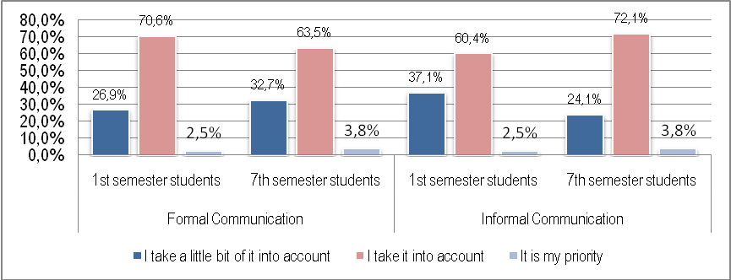
Figure 4 How much do you take into account the use of abbreviations and acronyms in formal and informal communication?

Use of “emoticons” in the formal and informal communication
Standard written language, like any language idiom, has two main functions: communication and symbolic one. These two functions has also its writing. Communication examines the role of language in communication benefit, and symbolic to be a sign of the community. This symbolic role is well known in our language through the use of emoticons, a new field of written communication. An “emoticon” is a textual expression representing the face of a writer's mood or facial expression. Emoticons are often used to alert a responder to the tenor or temper of a statement, and can change and improve interpretation of plain text.
By the use of emoticons in formal communication there is visible generation maturity, 7th semester students in even 81,3% consider that emoticons shall not be used, while only 27,7% of 1st semester students believe in the same fact as shown in Figure 5. The informal communication, students are using emoticons, regardless of generation maturity. To conclude this part of the research we can say that emoticons have become an additional communication form in a way that gives a dose of "humanity“ to electronic messages. Regardless of age, consumers use them, but it's definitely separated formal and informal communication, where it is clearly visible in the formal communication emoticons have no place.
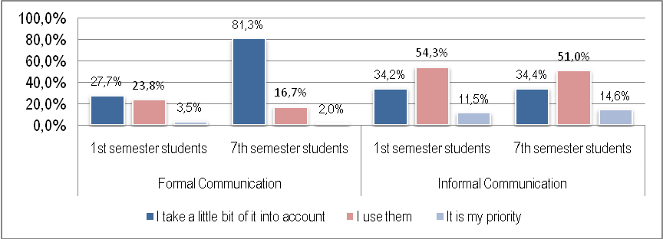
Figure 5 How much do you take into account the use of emoticons in formal and informal communication?

Conclusion
Literacy is part of a particular culture and tradition, but in the new, information-time, with new media it has received a completely new interpretation. Regular expressing the meaning by language is directed toward multi-media expression meaning that multiplied by meaning and context of images and text. Experts say that we will in twenty years with our present knowledge be illiterate - obviously we are aware of the fact that our knowledge is becoming obsolete and it must be amended by new one. [17]
In this time of universal technologization, digitalization and virtualization, literacy takes on new aspects, new style. In addition to the existing functional styles of the standard written Croatian, such as scientific, administrative and business, journalistic and conversational style seems to be dangerously approaching the introduction of new Internet style that may result from the latest, but goes beyond it by establishing their own new rules. Conversational style, as it is known, is the everyday style (mostly verbal) communication. In a written account appears in the records, letters and notes with its well known features: extempore, informality, ease and simplicity. More than other styles, it has conditioned with the specific way of thinking. Therefore, it is full with expressive and emotionally coloured expressions. Has its own forms, which are reflected in the phonetics and in the grammar and in the vocabulary. Since it is spontaneous, it is much less susceptible to the norms of standard language. Natural and spontaneous. [18]. And there the similarities with the conversational style stop and start the ramification , reshuffling rearranging and erosion by Internet-style grammar. The new style is telegraphic, such as the Internet is and coded rule applies to no rules.

References
- Coric, M., Aleksic-Maslac, K. (2009) „Knowledge Generation and e-Learning Potential of Universities in Developing Contries: A Theoretical Framework of Complexity od Education Delivery in Croatian Universities“, The 13th World Multi-Conference on Systemics, Cybernetics and Informatics (WMSCI), Jul 10-13, 2009,, Orlando, Florida, USA
- Njavro, D., Aleksic-Maslac, K. (2006). “The Role of Management in the Development of the E-Learning System”. GUIDE 2006 – Global Universities in Distance Education, Rome (Italy), Feb. 13-14, 2006.
- Aleksic-Maslac, K., Korican, M., Njavro, D.: "E-Learning Course Development – Quality Standards", International Conference on Education and Information Systems, Technologies and Applications (EISTA 2008), Orlando, USA, June 29th to July 2nd, 2008.
- Aleksic-Maslac, K., Njavro, D., Karalic, K. (2009) “Motivational Characteristics of E-Students” Distance and e-learning in transition: learning innovation, technology and social challenges, ISTE Ltd and John Wiley & Sons, Inc.
- Aleksic-Maslac, K., Njavro, D. (2006) ”Systematically Using WebCT at Zagreb School of Economics and Management”, Showcase, 5th Annual WebCT European User Conference, Edinburgh (Scotland), Feb 27 – Mar 01, 2006.
- http://www.blackboard.com
- Parilla, E. A. (2007). Alteraciones del lenguaje en el era digital. Comunicar, n° 30, v. XV, 2008, Revista Científica de Comunicación y Educación ; 131-136
- Krstić M., Pavlović T., 2003, "Akronyms – more and more the future language of management", Proceedings of the Scientific Conference on Industrial Management, 267-272., Kruševac (Serbia), June 10th to June 11th, 2003.
- Škarić, I. (1991). Fonetika Hrvatskog književnog jezika. In Babić, S., Brozović, D., Moguš, M., Škarić, I., Težak, S, Povijesni pregled, glasovi i oblici hrvatskog književnog jezika, 70. Zagreb: HAZU - Globus.
- http://www.vjesnik.hr/Pdf/2002%5C05%5C19%5C31A31.PDF, Retrieved on January 26, 2010.
- Kent State University (2008, May 2). Instant Messaging: A New Language? ScienceDaily. Retrieved January 20, 2010, from http://www.sciencedaily.com /releases/2008/05/080501154219.htm
- Martinet, A. (1982). Osnove opće lingvistike. Zagreb: GZH.
- Škarić, I. (2006). Hrvatski govorili! Zagreb: Školska knjiga.
- Central Bureau of Statistics of the Republic of Croatia http://www.dzs.hr/ , Retrieved on January 28, 2010.
- Žic Fuchs, M., Tuđman Vuković, N. (2008). Communication technologies and their influence on language: Reshuffling tenses in Croatian SMS text messaging, Jezikoslovlje 9.1-2: 109-122.
- Babić, S., Finka, B., Moguš, M., (1996). Hrvatski pravopis. Zagreb: Školska knjiga.
- Ribičić, G. (2008)., Diktat nove pismenosti mladih u suvremenim medijima, Croatian Librarian Conference, Metković September 24th to September 26th, 2008.
- Silić, J., Pranjković, I. (2007) Gramatika hrvatskog jezika. Zagreb: Školska knjiga

