Coining as a microforming process
Zdenka Keranª, Miljenko Mathª and Marko Skuncaª
^{c}University of Zagreb, Faculty of Mechanical Engineering and Naval Architecture
Ivana Lucica 5, HR-10000 Zagreb, Croatia
Abstract. Although elastic springback makes a great challenge in sheet metal forming, it is also a value that is considered in the area of coining. It is a parameter that can often make many difficulties when coin should obtain the etching of the die. That can happen because of small coin height in which leading part takes material composition, its grain size and microstructure. It classifies coining process to a group of microforming processes. Therefore, an experiment has been carried out whose task was to provide data about percentage of elastic springback in total deformation during coining process of Al 99.5%. This has been carried out for three different grain sizes of the same material. An experiment has also included microscopic observation of gravure filling for mentioned grain sizes and also for different tool forces. The final result is a correlation between grain size and elastic springback in coining process, and also a correlation between grain size and gravure filling for different tool forces.
Keywords: coining, elastic springback, microforming, grain sizes.
PACS: 89.20.Bb

Introduction
Coining is a deformation processing of metallic materials. It is usually closed die forging where only the surface topography of a blank is modified without significant bulk metal flow in a large scale. In this sence, coining is widely used for giving a functional and decorative surface geometry. The main characteristic of coining process is threedimensional traceabillity of surface microgeometry.
Apparently, the process of coining is very simple: it is nothing but geometrical matching of die and workpiece by plastic deformation. Even at atomic scale precision it seems possible to complete the process. However, the following factors hinder even micrometer scale precision: surface damage, insufficient filling, foreign substance, excess lubricant, deformation during unloading and large elastic springback.
Coining can be divided into two categories, i.e. (a) producing cavities and (b) producing projections. More problems and difficulties are found in category of producing projections. This is because cavities are produced by indentation of surface micro projections of tools, and therefore, the close contact between workpiece and tool can usually be attained.
This work is going to deal with the last mentioned problem: elastic springback of the material and also with forming force that is needed for correct filling.
Microforming approach to the problem is going to be used. This approach takes into consideration grain size influence on the process parameters.
The goal of performed experimental research is to solve some of the most common problems that occur in coining process:
- Insufficient filling of very small parts of the die.
- Significant changes of forming force and elastic springback for different grain sizes.
Hypothesis of performed research is that blank material, because of the size influence, acts according to microforming postulates. Furthermore, it is assumed that material is going to show significantly different behavior in open and closed die coining processes and will also demand significantly different forming force for different grain sizes.
It is expected to optimize grain size according to forming force and best die filling. Enlarged coin surface is given on Fig.1.
Figure 1. Photography of an experimental coin made by stereomicroscope.

MICROFORMING APPROACH TO THE GRAIN SIZE INFLUENCE
The surface grains are less restricted than volume grains. Dislocations moving through the grains during deformation pile up at grain boundaries but not at the free surface. This leads to less hardening and lower resistance against deformation of the surface grains. Additionally to the decrease of yield stress the scattering is rising, which can be explained by the decrease of the number of grains over the cross-section. The specific conditions of orientation and size of every single grain are now reflected in the forming result as it is no longer averaged by a huge number of grains. For example, the micro size tensile tests at room temperature have shown that the yield strength and the tensile strength decrease with scale decreasing, as well as with grain size increasing.
In a closed die, grains would not have free surfaces (they are going to be surrounded by the die) and influence of the part size will go off because there will be no free material flow. That is why there is no reduction of forming force. In those cases, even enlargement of forming force occurs, caused in the first place by larger friction coefficient.

EXPERIMENTAL RESEARCH AND THE ACIEVED RESULTS
Because we are dealing with a part with relatively small dimensions (1-2mm high, and 0.06mm - the smallest die parts), it is assumed that this forming technology completely turns into microforming technology. Working part is observed as a group of crystal grains with defined shape and dimensions.
Because of that, it is expected that blank material is going to follow microforming assumptions in a way that amounts of elastic springback are going to have the opposite values whether the coining process is performed in open or closed die. This way of material behavior would confirm the assumption that coining in complete belongs to the group of microforming processes, and should be treated like one of them. In such way many problems could be avoided.
An experiment should prove all these assumptions. Blanks made of Al 99.5, initial height 2mm, initial diameter 20mm are going to be deformed with different reduction coefficient in open and closed die. The results of annealing are three different grain sizes: 76µm, 47µm and 39µm. Measured values will be: forming force, total deformation, elastic springback and die filling.
The first step of the experiment
Blanks of a three different grain sizes have been coined in an open die. This means they have been pressured between two plane parallel parts of a tool. The regulated variable was forming force. It was changed from 50 kN to 400 kN in a step of 50 kN. The measured values were total deformation and elastic springback. Deformation speed was 0.1mm/s. Tool position was measured by linear variable differential transformer and tracked by a computer. Obtained results are presented on the following diagrams.

Figure 2. Diagram shows a relation between forming force and total displacement for blank forging in an open die.

Figure 3. Diagram shows a relation between elastic springback and forming force for blank forging in an open die.

Figure 4. Diagram shows a relation between elastic springback and total deformation for blank forging in an open die.
It is noticeable that there exists a significant difference between relevant variables for different grain sizes. Total displacement grows up along with the grain size. On the opposite, elastic springback rises as the grain size declines.
Using measured experimental values, flow curves have been calculated for each grain size. Flow stress can be calculated as it follows:

where k_{f} presents flow stress, F is a momentary forming force, and A is a momentary pressurized surface area.
True strain hides in the following expression:

Where φ is a true strain, h₀ is an initial blank high; Δh is a total tool displacement for the specific forming force. Calculated flow curves are presented on Fig. 5.

Figure 5. Diagram shows flow curves for different grain sizes.

Although there are some irregularities in the shape of the curves, the tendency of flow curve decreasing as the grain size grows up is obvious.
It is important to notice the reason of certain imperfections in curve shapes on presented diagrams. Each point that defines certain diagram is calculated from the experimental results. It presents an average of numerous measurements. Because of great dissipation of measured values, the calculated average cannot form a perfect shape of diagrams.
The second step of the experiment
The second step of the experiment leads to exploration of closed die coining of identical blanks as they were in the first step of the experiment. Because of die influence, the metal flow has been restricted and steered to die filling. Material behavior in such changed conditions has been examined. In this case ´material behavior´ means elastic springback after action of forming force. Greater elastic springback can cause insufficient die filling. Furthermore, the quality of coined surface after influence of different forming forces and for three different grain sizes is going to be considered.
Results of measurements are given on Fig. 6 and Fig. 7. Figure 6 shows the relation of forming force and total deformation for two sizes of total deformation - 800µm and 850µm. Measurements have been made on five samples (blanks) for each size of total deformation and also for each grain size. Figure 7 shows the relation between total deformation and elastic springback for two sizes of total deformation - 800µm and 850µm. It can be noticed that forming force rises with greater total deformation and also at coarse grain. Elastic springback also rises together with grain size.

Figure 6. Diagram shows relation of total deformation and forming forces for three different grain sizes in closed die coining.

Figure 7. Diagram shows relation of total deformation and elastic springback for three different grain sizes in closed die coining.

The influence of grain size on die filling has also been monitored during the second part of the experiment. Specimens of different grain sizes with total deformation of 800µm have been shoot microscope. Lower total deformation has been chosen because it demands lower forming force and lower forming force is always more acceptable in industrial conditions. Difference in die filling is very obvious. Specimens with grain size of 76µm have much worse die filling than those whose grain size is 39µm. the most obvious parts are marked at Fig. 8.

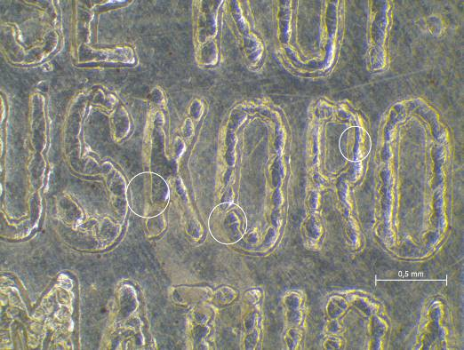(a) 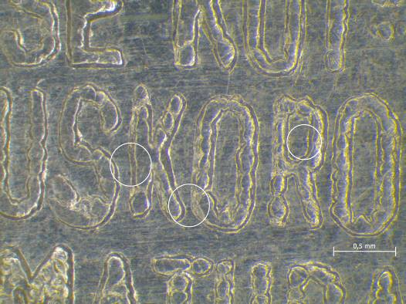(b)
Figure 8. Photos of coin surface, specimens with two grain sizes, (a) 76µm and (b) 39µm produced with the same total deformation.

CONCLUSION
Experimental results very clearly put the coining process into a microforming category. As it is presented, an open die coining designates that finer grains cause greater elastic springback and greater forming force. Also enlargement of the grain size causes decrease in flow stress. All these differences in process variables are significant and reach even 20% between specimens of two different grain sizes (39µm and 76µm). Such behavior is typical for microforming processes. On the contrary, when coining process is performed in the closed die, and material flow is restricted and steered to die filling, the process variables show the opposite behavior. Now, coarse grains demand greater forming force, and cause larger elastic springback. Also, coarse grains cause poor die filling. Such behavior is also typical for microforming processes. So, the conclusion of this research can be that coining process belongs to the group of microforming processes. To avoid some specific problems that occur during coining process, it must be treated as a microforming process. This means that grain size takes a leading part in controlling of process parameters. If coining process is preformed in a way that material flow is free, or mostly free, coarse grains are recommended. On the other hand, if material flow is restricted in a closed die, and exact die filling is important, finer grains should take a part.

References

1. W.D. Carden, L.M. Geng, D.K. Matlock, R.H. Wagoner, “Measurement of springback“, International Journal of Mechanical Sciences 44 (2002), 79-101.
2. K.P. Li, W.P Carden, R.H. Wagoner, “Simulation of springback“, International Journal of Mechanical Sciences 44 (2002), 103-122.
3. H. Justinger, G. Hirt, “Estimation of grain size and grain orientation influence in microforming processes by Taylor factor considerations“, Journal of Materials Processing Technology 209 (2009), 2111-2121.
4. F. Vollertsen, H. Schulze Niehoff, Z. Hu, “State of the art in micro forming“, International Journal of Machine Tools & Manufacture 46 (2006), 1172-1179.
5. U. Engel, R. Eckstein, “Microforming – from basic research to its realization“, Journal of Materials Processing Technology 125-126 (2002), 35-44.
6. H. Ike, M. Plančak, “Coining process as a means of controlling surface microgeometry“, Journal of Materials Processing Technology 80-81 (1998), 101-107.
7. H. Ike, “Surface deformation vs. bulk plastic deformation – a key for microscopic control of surfaces in metal forming“, Journal of Materials Processing Technology 138 (2003), 250-255.

