Prediction-and-Verification for Face Detection

Zdravko Lipošćak and Sven Lončarić
Faculty of Electrical Engineering and Computing, University of Zagreb
Unska 3, 10000 Zagreb, Croatia
E.mail: zdravko.liposcak@sk.tel.hr, sven.loncaric@fer.hr

Abstract

This paper presents a segmentation scheme for automatic detection of human face in color video sequence. The method relies on a three-step procedure. First, regions are detected which are likely to contain human skin in the color image. In the second step, differences in regions produced by motion in the video sequence are detected. In the final step, Karhunen-Loeve transformation is used to predict and verify the segmentation result. Experimental results are presented and discussed in the paper. Finally, conclusions are provided.

1. Introduction

In recent years, face recognition research has attracted much attention in both academia and industry. Segmentation of moving faces from video is very important area in image sequence analysis with direct applications to face recognition. Methods based on analysis of difference images, discontinuities in flow fields using clustering, line processes or Markov random field models are available [1], [2], [3]. For engineers interested in designing algorithms and systems for face detection and recognition, numerous studies in psychophysics and neurophysiological literature serve as useful guides [4], [5].
One of the essential goals of face detection and recognition is to develop new methods that can derive low dimensional feature representations with enhanced discriminatory power. Low dimensionality facilitates real time implementation, and enhanced discriminatory power yields high recognition accuracy [6].
In this paper, we detect the face of the subject within a source video sequence containing a face or head movements and complex backgrounds. The detection of the face is based on the segmentation approach originally presented for hand detection by Cui and Weng [7]. The major advantage of Cui and Weng scheme is that it can handle a large number of different deformable objects in various complex backgrounds. Lowering the subspace dimension is done using Karhunen-Loeve transformation. Use of the color and motion information for the extracted regions of interest speeds up the process of the segmentation.
An integrated system for the acquisition, normalization and recognition of moving faces in dynamic scenes using Gaussian color mixtures can be find in the [8].
In the training phase partial views of face are generated manually in such a way that they do not contain any background pixels. These partial views are used to train the system to learn mapping each face shape to the face mask. During the performance phase, the face position is predicted using face sample provided by color and motion information and the learned mapping. Each face position is further verified by the learnt information about a large set of learnt face appearances againts what is cut off by the predicted mask position.

2. Dimensionality reduction

Face detection procedure locates the face images and crops them to a pre-defined size. Feature extraction derives efficient (low-dimensional) features, while the classifier makes decisions about valid detection using the feature representations derived earlier.
Face detection in video sequence with unknown complex background requires a set of visual tasks to be performed in a fast and robust way. In this paper, detection process includes the computation and fusion of three different visual cues: color, motion and face appearance models.

2.1. Color and motion information

The pre-processing step isolates the color of skin in each image inside image sequence. The input color images should be in RGB format. If a pixel color ratios R/B, G/B and R/G fall into given ranges the pixel is marked as being skin in a binary skin map array where 1 corresponds to skin pixels in the original image and 0 corresponds to non-skin pixels. The skin filter is not perfect but removes pixels with significantly different color then skin color.
In the next step we estimate motion of the pixels that belong to the skin color for every two consecutive frames. Methods based on analysis of difference images are simple and fast. First, we convert color video sequence to greyscale video sequence. Given an image I and the neighbouring image I’ in the greyscale video sequence:

1. get the difference image D such that
$D\left[i,j\right]=\left\|I\left[i,j\right]−I'\left[i,j\right]\right\|$, (1)
2. threshold D,
3. find the centroid of regions containing
the largest connected component in D.

2.2. Karhunen-Loeve transformation

The Karhunen-Loeve (KL) transformation is a very efficient way to reduce a high dimensional space to a low-dimensional subspace that approximates the linear space in which the sample points lie [9]. The vectors produced by the Karhunen-Loeve projection are typically called the principal components.
The video sequence with k color images of m rows, n columns and c colors can be represented by N=kmnc –dimensional vector. Typically, N is very large.
Let X∈R^{N} be a random vector representing an image, where N is the dimensionality of the image space. The vector is formed by concatenating the rows or the columns of the image which may be normalized to have a unit norm and/or equalized histogram. The covariance matrix of X is defined as:

$C_{X}=E\left\{\left[X−E\left(X\right)\right]{\left[X−E\left(X\right)\right]}^{T}\right\}$ (2)

where E(⋅) is the expectation operator, T denotes the transpose operation, and C_{X} ∈ R^{NxN}. We can factorize the covariance matrix C_{X} into the following form:
$C_{X}={\text{ΦΛΦ}}^{t}$ (3)
with
$Φ=\left\{φ_{1},φ_{2},…φ_{N}\right\},Λ=\left\{λ_{1},λ_{2},…λ_{N}\right\}$ (4)
where Φ∈R^{NxN} is an orthonormal eigenvector matrix and Λ∈R^{NxN} a diagonal eigenvalue matrix with diagonal elements in decreasing order (λ₁ ≥ λ₂ ≥ ⋅⋅⋅ ≥λ_{N}). φ₁, φ₂, ... , φ_{N} and λ₁, λ₂, ... , λ_{N} are the eigenvectors and the eigenvalues of C_{X}, respectively. In the Karhunen-Loeve projection only a subset of principal components is used for the transformation matrix construction
P = {φ₁, φ₂, ... , φ_{m}}, m<N. (5)

The lower dimensional vector Y captures the most expressive features (MEF) of the original data X.
$Y=P^{t}X$ (6)

3. Segmentation method

In this paper we use attention images from multiple fixations on each training face image. Given a face attention image, a fixation image is determined by its fixation position (s, t) and a scale r.
Figure 1 shows the attention images of 18 fixations from one training sample. Table 1. lists these 18 combinations of scales r and positions (s, t) for an image with m rows and n columns. A fixation position brings to the centre of mask whole face and five face parts which can make significant movement inside of face; left and right eye, left and right eyebrow and mouth.
Given a training set L = {I₁, I₂, ... , I_{n}}, where I_{i} is a training face attention image, there is a corresponding set of masks M = {M₁, M₂, ... , M_{n}}. We first obtain a set of attention images from multiple fixations for each I_{i}. Let F_{i,j} be an attention image from j-th fixation of sample i in L. The attention images from the training set L_{F} are:

$L_{F}=\left\{F_{1,1},⋯,F_{1,m_{1}},F_{2,1,}⋯,F_{2,m_{2}},⋯⋯,F_{n,1},⋯,F_{n,m_{n}}\right\}$ (7)

where m_{i} is the number of the attention images generated from the training image I_{i}. Each attention image in L_{F} is projected to the MEF space computed from the set L_{F}. Each attention image from a fixation is associated with the segmentation face contour mask M_{i}, the scale r, and the position of the fixation (s, t). This set of information is used to move and scale the mask back to the original reference image.
During the segmentation stage, we first use the color and motion information to select visual attention. Then, we try different fixations on the input image. An attention image from a fixation of an input image is first projected to the MEF space, and then is used to query the training set L_{F}. The segmentation mask associated with the query result F_{i,j} is the prediction. Next, the predicted segmentation mask is applied to the input image to mask off background pixels. Finally, we verify the segmentation result to see if the image region retained by the mask corresponds to a face image that has been learned. If the answer is positive, we find the solution. This solution can further go through a refinement process.
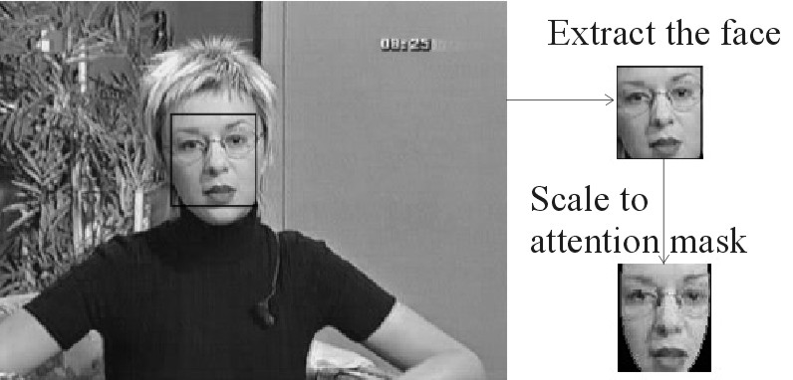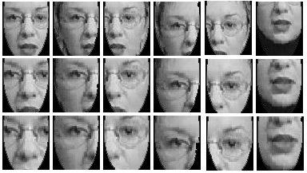

Fig.1. Attention images from 18 fixations of a training sample.

4. Experiments

As training and testing set we have used the color video sequence database which contains front views of the 50 people. Each video sequence, with head or face movements, is transformed to twenty RGB images. Pictures are with natural, complex background and size of these images is 240 x 320 pixels. The variation of face size in images was limited.
The size of attention mask used in the experiment is 68 x 59 pixels.
In the training phase we select 15 faces and generate the attention images from multiple fixations. The eye position is detected manually in the training images and eye distance d is calculated. Input image is then rotated until the eyes came in a horizontal line. Rotated image is scaled in such a way that eye distance has a constant value d = 32 and then face region is masked and cut out (see Fig.1.).
The selection of the fixations is mechanical. Fixations bring to the centre of mask five parts of face that can move and cause significant change in the face image: left and right eye, left and right eyebrow and mouth. With original face image, five face parts and three scales the total of 18 attention images were used for each training sample.

Table 1.
Scale  (r) | Position (s, t) (mask size 68 x 59)
Scale  (r) | P₁ | P₂ | P₃ | P₄ | P₅ | P₆
1 | (29,47) | (13,47) | (45,47) | (13,57) | (45,57) | (29,17)
1.25 | (29,47) | (9,47) | (49,47) | (9,60) | (49,60) | (29,9)
1.5 | (29,47) | (5,47) | (53,47) | (5,62) | (53,62) | (29,2)

Using KL transformation and first twenty eigenvectors we obtain transformation matrix P (Eg.5) and then calculate the coefficient for each of 270 attention images (Eg.6). One attention image is now represented by only 20 numbers (coefficients).
In the testing phase we applied the described segmentation scheme to the task of face segmentation from input video sequence. In the first step, the simple color filter is used to detect the image area with skin color. Because of filter simplicity the filter range are quite wide and used ratios are shown in the Table 2.

Table 2.
Ratio | Range
R/G | 1.045 < R/G < 1.365
R/B | 1.008 < R/B < 1.568
G/B | 0.992 < G/B < 1.242

In the next step, the motion information inside skin color region is used to find a motion attention window. Image I and a neighbouring image I’ in the sequence with biggest number of pixels in the difference image D (Eg.1) are used for motion attention window calculation. Attention window mask is placed in a position where the smallest rectangular window contains the largest connected component in D (the bounding box). Using KL transformation we calculated the coefficients of the masked part of image.
If we have two image descriptors x, and y, of dimension k, then we can take an Euclidean distance between them as a measure of the similarity of the images they represent. The smaller the distance, the more similar the images. A segmentation result was rejected if the system could not find a valid segmentation with Euclidean distance under threshold T. The segmentation was considered as a correct one if the correct mask size is selected and placed in the right position of the test image. For the distance threshold log(T)=6.94, we have achieved 94 percent correct segmentation rate.
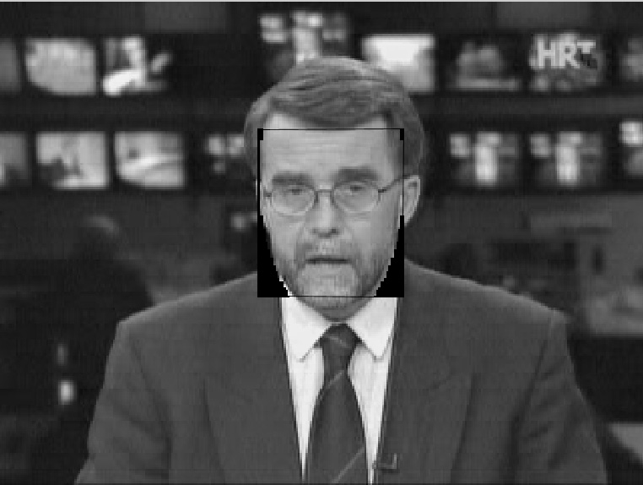

Fig.2. Results of segmentation.

The average computation cost for each video sequence was 2 minutes on a PC with 450 MHz Intel PIII processor and Matlab environment.

5. Conclusions

In some way, the proposed segmentation scheme follows the natural vision process. Motion and color first attract our vision system and in the next step we try to recognize the moving object.
The major advantage of this approach is that it can detect different faces in a various complex backgrounds. For testing on a large video database it is necessary to increase the number of KL coefficients. To fit the face shape exactly another algorithm can be used [10].

References

[1] W.N. Martin and J.K. Aggarwal, “Dynamic scene analysis: A survey”, Computer Vision, Graphics and Image Process, Vol. 7, 1978, pp. 356-374.
[2] J.K. Aggarwal and N. Nandhakumar, “On the computation of motion from sequences of images”, Proc. IEEE, Vol. 76, 1988, pp. 917-935.
[3] R. Chellappa, C.L. Wilson, and S. Sirohey, “Human and Machine Recognition of Faces: A Survey”, Proc. of the IEEE, Vol. 83(5), 1995, pp. 705-740.
[4] S. Zeki, “The Visual Image in Mind and Brain”, Scient. American, 1992. pp. 43-50.
[5] R. Baron, “Mechanisms of human facial recognition”, Int. J. Man-Machine Studies, Vol. 15, 1981, pp. 137-178.
[6] C. Liu, “Statistical and evolutionary approaches for face recognition”, Ph.D. Dissertation, Geo. Mason Uni, 1999.
[7] Y. Cui and J. Weng, ”A Learning-Based Prediction-and-Verification Segmentation Scheme for Hand Sign Image Sequance”, IEEE Trans. on Patt. Ana. and Mach. Intell., Vol 21, 1999. pp. 798-804.
[8] S. J. McKenna, S. Gong and Y. Raja, “Modelling Facial Color and Identity with Gaussian Mixtures”, Patt. Recog. Vol. 31(12), 1998, pp. 1883-1892.
[9] M. Turk and A. Pentland, “Eigenfaces for recognition”, Journal of Cognitive Neuroscience, Vol. 3(1), 1991. pp. 71-86.
[10] T. McInery and D. Terzopoulos, “Deformable models in medical image analysis: A survey”, Medical Image Analysis, Vol. 1, 1996, pp. 91-108.

