Unsupervised ICA neural networks applied to the reticle optical trackers

Ivica Kopriva∗ª, Member OSA, IEEE, Harold Szu^{b}, Fellow OSA, SPIE, IEEE

ªInstitute for Defense Studies, R&D, Bijenička 46, 10000 Zagreb, Croatia

^{b}ONR Code 313, 800 N Quincy Arlington, Virginia 22217-5660, USA

ABSTRACT
Reticle systems are considered to be the classical approach for estimating the position of a target in a considered field of view and are widely used in IR seekers. Due to the simplicity and low cost, since only a few detectors are used, reticle seekers are still in use and are subject of further research. However, the major disadvantage of reticle trackers has been proven to be sensitivity on the IR countermeasures such as flares and jammers. When redesigned adequately they produce output signals that are linear convolutive combinations of the reticle transmission functions that are considered as the source signals in the context of the Independent Component Analysis (ICA) theory. Each function corresponds with single optical source position. That enables ICA neural network to be applied on the optical tracker output signals giving on its outputs recovered reticle transmission functions. Position of each optical source is obtained by applying appropriate demodulation method on the recovered source signals. The three conditions necessary for the ICA theory to work (statistical independence and non-Gaussianity of the source signals and nonsingularity of the mixing matrix) are shown to be fulfilled in principle for any kind of the reticle geometry.

Key words: optical trackers; independent component analysis; unsupervised neural networks;

1.0 INTRODUCTION

Reticle systems are considered to be the classical approach for estimating the position of a target in a considered field of view and are widely used in IR seekers,¹⁻¹⁴. However, the application of the reticle tracking systems as guidance tools to aim at target emitting infrared radiation is important in many other fields such as astronomical observation and industrial machinery¹². Reticle IR seekers were used extensively in the early 1960s in systems such as Sidewinder missile. Some versions of a Stinger missile also employ certain kind of the IR reticle seeker⁴⁷. The Semi-Automatic-Command-to-Line-Of-Sight (SACLOS) Anti-Tank (AT) missile systems developed during 1970s, and still in use, such as TOW or MILAN employ also reticle based IR seeker. The advantage of the reticle seekers is simplicity and low cost because only a few detectors are used^{5,6}. Since the reticle modulates the incoming signal the simple circuitry used in demodulation process can generate a tracking error signal. Owing to a spatial filtering effect of the reticle, the IR reticle tracker may exclude unwanted background signals^{1,2}. However, the major drawback of the reticle trackers has been proven to be sensitivity on the IR countermeasures such as flares and jammers^{3,5,6}. There were a number of attempts to solve this problem,^{5,6,7,13,14} and references given therein. All these attempts were exclusively engaged with the air-to-air scenario. Basically they assume that jammers can be detected on the basis of the energy and spectral discrimination^{6,7}. It is also assumed that, when jamming is detected, detector signal is replaced with the predicted version based on its past values provided that target performs no maneuvering⁷. These assumptions are partially true for the anti-aircraft missile scenario but generally do not hold in the anti-tank missile engagement¹⁵. The underlying feature of discussed attempts was the introduction of the segmented focal plane arrays (FPA) behind the reticle, because it was understood that limitation of the reticle systems in many applications was very often due to use of the single detector element^{5,13}. Since the advantage of the reticle seekers is simplicity and low cost the segmented FPA must be comprised of a small number of detectors so as not to become as complex and expensive as an imaging system with a full strength FPA¹³. Such strategy enables space discrimination between the optical sources. The problem exists when the two sources are in space region acquired by the same detector element. Appropriate space resolution should be ensured requiring more detector elements. A new approach was proposed in^{16,17} was extended in¹⁸ and will be exposed in this paper. It is based on the ICA theory and an appropriate modification of the optical tracker design. Since ICA performs signal separation simultaneously in space and time it allows for a small number of targets to be discriminated by the same number of 1D detectors. It has been shown in^{16,17,18} how an optical system based on a nutating reticle can be modified to resolve the multisource limitation problem^{3,4,6} by the combined use of the ICA theory and an appropriate modification of the optical tracker design. Since reticle based optical systems are not widely known we present in Section 2 a description of the optical modulation theory while more details can be found in¹⁻¹⁴. Both, nutating and spinning reticle trackers that generate either frequency modulated (FM) or amplitude modulated (AM) error signals are covered. In Section 3 a rigorous statistical optics based derivation of the signal model of the modified optical tracker output signals is given^{19,20}. It is shown that in the case of either partially or totally coherent optical radiation the resulting signal model is nonlinear. When incoherence is assumed a linear model is obtained. Linear ICA is a very well understood subject and many algorithms are available to solve such problem²¹⁻³⁸. The most distinguished approaches are based on the entropy maximization principle^{21,22,23,30} and minimization of the fourth order cross-cumulants^{31,32}. In Ref. 18 a unification of the unsupervised entropy maximization ICA and the energy minimization PCA is given. The nonlinear ICA is a more difficult problem, and only a few papers have addressed this subject for some special types of nonlinearity^{21,39-43}. It is shown at the end of Section 3 how, by the proper design of the optical tracking system, it can be ensured that nonlinear signal model be transformed into linear one by simple linear band-pass filtering operation. In Section 4 a discussion of the ICA theory requirements is given for linear and nonlinear signal models. Fulfillment of the mixing matrix non-singularity condition as well as the statistical independence and non-Gaussianity assumptions imposed on the source signals is examined here. Example of adaptive infomax ICA algorithm is described in Section 5 while experimental and simulation results are presented in Section 6. Conclusions are given in Section 7.

2.0 OPTICAL MODULATION THEORY

The reticle system provides directional information for tracking and also suppresses unwanted background signals¹ by performing modulation of the incident light flux. According to the type of the reticle and the relative motion produced by the scan pattern, the encoding method of the reticle may be classified into AM, FM and pulse code modulation. In addition, according to how the relative motion between the reticle and the optical spot is obtained we may classify reticle systems into fixed or moving reticle. When reticle is fixed relative motion can be obtained by using rotating mirror which causes the light beam and hence the spot to either nutate or rotate in relation to the fixed reticle. In the opposite case spot forming optics is fixed while reticle performs either nutation or spinning. The general case of one moving reticle system is illustrated with Fig. 1. Moving reticle is placed in the focal plane of the collecting optics, while filed optics collects modulated light and focuses it on detector. The selective amplifier center frequency is usually the number of spoke pairs times the nutation or spinning frequency. The rising-sun reticle that is very often used in the nutating FM reticle trackers^{10,11,12,16,18} is shown on Fig. 2.

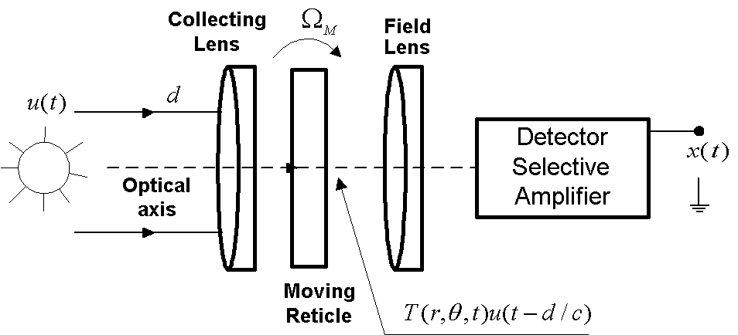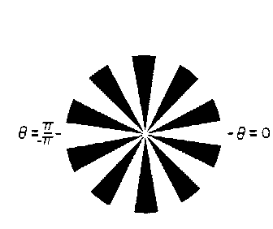

Figure 1. Moving reticle based optical tracker Figure 2. The rising-sun reticle

It can be noted from the previous discussion that relative motion between the spot and the reticle can be ensured either by nutation^{10,11,12,16,18} or rotation (spinning)^{7,8,9,14}. In any case detector output voltage is proportional to the light irradiance behind the reticle according to⁸⁻¹²:
$I(t) =I_{P} \int{\int{T(r,θ)δ\left[r−r_{0},θ−(Ωt−θ_{0})\right]} \text{rd}θ\text{dr}}$ (1)
where T(r,θ) is reticle transmission function and r and θ are spatial variables of the reticle transmission function ranging from 0 to R and -π to π, respectively. Also let the reticle nutation or spinning rate be Ω in rads⁻¹ and let r₀ and θ₀ be the spatial coordinates of a point source that is imaged onto the reticle. I_{P} in (1) is the peak irradiance of the point source through the reticle transmission function. Since the convolution of any function with delta function is the function located at the delta function coordinates the Eq. (1) becomes:

$I(t) = I_{P}T(r_{0},Ωt−θ_{0})$ (2)
Therefore, the temporal response of all the subsequent spatial reticle transmission functions is found replacing r with r₀ and θ with Ωt-θ₀. In optical trackers that generate FM signal by means of the rising-sun reticle, Fig. 2, and nutation the reticle spatial transmission function is shown to be of the form^{10-12,16,18}:

$T(r,θ,t)=I_{p}\text{cos}\left[mΩt−m(r/a)\text{sin}(θ)\right]$ (3)

where the reticle coordinate system with parameters related to the Eq. (3) is shown by Fig. 3. The optical spot performs circular motion around the center with coordinates (r₀,θ₀) relative to the center of the reticle. Necessary condition for Eq. (3) to hold is (r₀/a)² << 1. m in Eq. (3) is the number of spoke pairs of the reticle. Eq. (3) represents canonical form of the FM signal⁴³ where frequency deviation from the carrier frequency is directly proportional with the spot r₀ coordinate. So by using nutating rising-sun reticle, both directional information, distance and azimuth, are encoded in the reticle transmission function. Instead of using nutation the relative motion between the spot and the reticle can be obtained by simple rotation or spinning⁶⁻⁹.

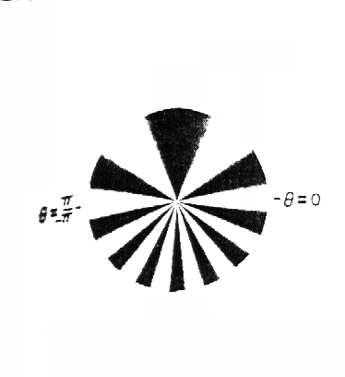
Figure 3. Nutating reticle coordinate system Figure 4. Angular cosine modulated reticle⁸.

That happens when according to Fig. 3 r₀=0 while a representing spot radial coordinate. It is obvious from Eq. (3) that reticle transmission function is reduced on pure cosine being invariant of the spot coordinates. It means that the rising-sun reticle cannot be used for encoding the optical spot position in the spinning case, nevertheless whether FM or AM modulation is used. A lot of other spokes geometry is proposed for such purpose^{8,9}. It has been shown in Ref. 8 that reticle transmission function of the spinning FM reticle can be written in general form as:

$T(r,θ) = \frac{1}{2} + \frac{1}{2}\text{cos}\left[m(r)\int{f(α)dα}\right]$ (4)

The ½ DC term in Eq. (4) allows an average reticle transmission of ½ rather than zero (i.e. no light passing the reticle). Spinning FM reticles can be completely described by these three parameters: frequency vs. angle f(θ), frequency vs. radius m(r) and phase or spoke function ρ(r). For a spinning FM reticle to give angular target location information, an angular variation in frequency must be imposed on the reticle transmission function. The most often case in literature shown for this variation of frequency vs. angle is shown in Fig. 4. The spatial transmission function of this reticle is:

$T(r,θ) = \frac{1}{2} + \frac{1}{2}\text{cos}\left[m(θ + α\text{cos}θ)\right]$ (5)

This reticle has other two parameters m(r)=1 and ρ(r)=0. In order to obtain radial target information the number of spokes
subtended onto a circular contour centered at the reticle origin must be changed for different radii. That is m(r) in Eq. (4)
must change vs. radius. A requirement for a useful tracking m(r) function is that mapping be single valued. The linear single
valued mapping is ensured with the reticle shown in Fig. 5. The spatial transmission function of the reticle is⁸:

$T(r,θ) = \frac{1}{2} + \frac{1}{2}\text{cos}\left[m\left(1 + \frac{r}{R}\right)θ\right]$ (6)
This reticle has other two parameters f(θ)=1 and ρ(r)=0. To use a spinning reticle for finding a target in both the radial and azimuth direction at least nonconstant f(θ) and m(r) parameters must be imposed on the reticle. Such reticle is shown in Fig. 6. The spatial transmission function of this reticle is:

$T(r,θ) = \frac{1}{2} + \frac{1}{2}\text{cos}\left\{m\frac{r}{R}\left[θ + 0\text{.}4\text{sin}(θ)\right]\right\}$ (7)

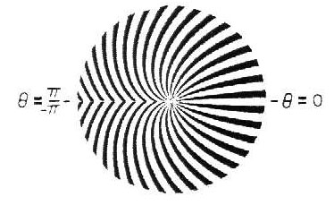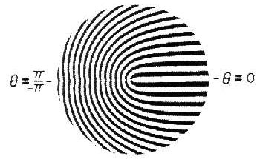
Figure 5. Frequency vs. radius reticle⁸. Figure 6. Frequency vs. radius and angle⁸.

All reticle transmission functions given until this point have been written with respect to some phase reference. This reference has been θ=0 line on the reticle. Reticle shown in Fig. 7 has linear dependence of phase vs. radius giving the spatial transmission function:
$T(r,θ) = \frac{1}{2} + \frac{1}{2}\text{cos}\left[m\left(θ + \frac{π}{\text{12}}\frac{r}{R}\right)\right]$ (8)

with m=10. Because an FM signal is known to be superior to an AM signal with regard to signal quality, that is, it suffers less noise interference⁴³ the FM reticles are generally of greater interest. Nevertheless, the AM reticles are used in IR missile seekers especially in surface-to-air and air-to-air environments. It has been shown in Ref. 9 that it is possible to describe spinning AM reticles using three amplitude parameters (similar to previously described FM parameters): amplitude vs. angle f(θ), amplitude vs. radius g(r), and phase ρ(r). The general AM equation is given by ⁹:

$S(θ) = \frac{1}{2} + V\left[1 + \text{mf}(θ)\right]\text{cos}(kθ)$ (9)
where S(θ) is the modulated signal, V is a constant, m is the modulation index, f(θ) is the low frequency modulation signal and k is the carrier frequency that corresponds with the number of spoke pairs. Like in the FM reticle case the ½ DC term in Eq. (9) allows an average reticle transmission of ½ rather than zero (i.e., no light passing the reticle). For an AM reticle to provide angular target location a variation in amplitude must be imposed on the reticle as the function of angle. One such amplitude vs. angle reticle is shown in Fig. 8. The reticle transmission function is given by:

$T(r,θ) = \frac{1}{2} + \frac{1}{4}\left[1 + \text{cos}(θ)\right]\text{cos}(\text{30}θ)$ (10)
where V=1/4, m=1, f(θ)=cos(θ) and k=30. The general form of the spinning AM reticle transmission function that encodes both radial and angle coordinates is given by:

$T(r,θ) = \frac{1}{2} + \text{Vg}(r)\left[1 + \text{mf}(θ)\right]\text{cos}(kθ)$ (11)
The reticle shown in Fig. 9 has linear dependence of amplitude vs. radius i.e.:

$T(r,θ) = \frac{1}{2} + \frac{1}{2}\frac{r}{R}\text{cos}(\text{30}θ)$ (12)
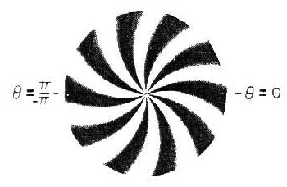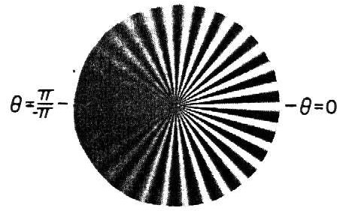
Figure 7. Frequency vs. phase reticle⁸. Figure 8. Amplitude vs. angle reticle⁹.

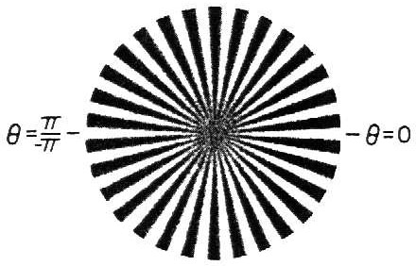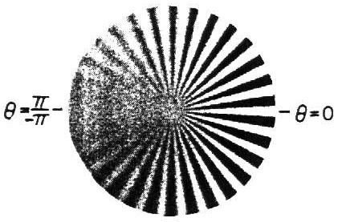
Figure 9. Amplitude vs. radius⁹. Figure 10. Amplitude vs. radius and angle⁹.

Reticle that encodes both target radial and angular position is shown in Fig. 10. The spatial transmission function is given by:
$T(r,θ) = \frac{1}{2} + \frac{1}{4}\frac{r}{R}\left(1 + \text{cos}θ\right)\text{cos}(\text{30}θ)$ (13)
The AM reticles presented so far have been written with respect to some phase reference. This was θ=0 line on the reticle. The general equation for the spatial transmission function of the spinning AM reticle having amplitude dependence on all three parameters is:
$T(r,θ) = \frac{1}{2} + \text{Vg}(r)\left[1 + \text{mf}(α)\right]\text{cos}(kα)_{α=θ + ρ(r)}$ (14)
Reticle in Fig. 11 has combination of all three parameters⁹:

$T(r,θ) = \frac{1}{2} + \frac{1}{4}\left[1 − \text{exp}\left(−2\frac{r}{R}\right)\right]\left\{1 + \frac{\left[θ + ρ(r)\right]}{π}\right\}\text{cos}\left[\text{30}\left(θ + ρ(r)\right)\right]$
$ρ(r) = \frac{π}{3}\text{exp}\left[−4{\left(\frac{r−\frac{R}{2}}{b}\right)}^{2}\right] b≈ R/5$ (15)
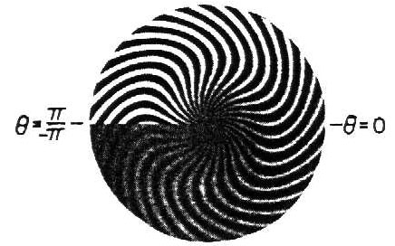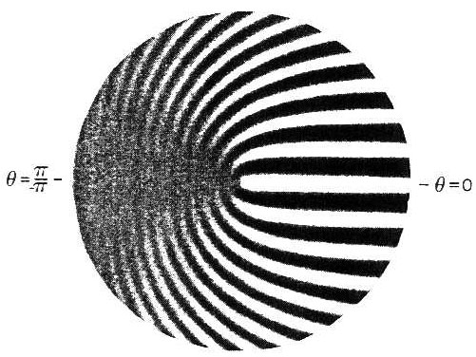
Figure 11. Amplitude vs. radius, angle and phase⁹. Figure 12. Amplitude vs. angle and frequency vs. radius⁹.

Finally reticle shown in Fig. 12 combines FM and AM parameters i.e. carrier frequency is proportional to radius r and is additionally amplitude modulated with amplitude vs. angle dependency. The spatial transmission function of such spinning reticle is:

$T(r,θ) = \frac{1}{2} + \frac{1}{4}\left(1 + \text{cos}θ\right)\text{cos}\left(\text{30}\frac{r}{R}θ\right)$ (16)

3.0 DERIVATION OF THE OPTICAL TRACKER SIGNALS MODEL

We start with the problem of detecting optical radiation at point D when optical fields are emitted from two sources at points P₁ and P₂ (see Fig. 13). The optical field at point D is given as the sum of the individual fields multiplied by reticle transmission functions:

$u_{D}(t) = K_{1}u_{1}(t)s_{1}(t) + K_{2}u_{2}(t−Δt)s_{2}(t)$ (17)

where$Δt$represents relative time delay between u₁ and u₂ due to the path length difference i.e. $Δt = (d_{2}−d_{1})/c$. In order to be consistent with the ICA theory notation the reticle transmission function T(r,θ, t) will be replaced by s(t) and called the source signal. Target coordinates r and θ will mostly be dropped in order to simplify notation. K₁ and K₂ are in general case complex constants representing path losses. We will assume here that they are real numbers.
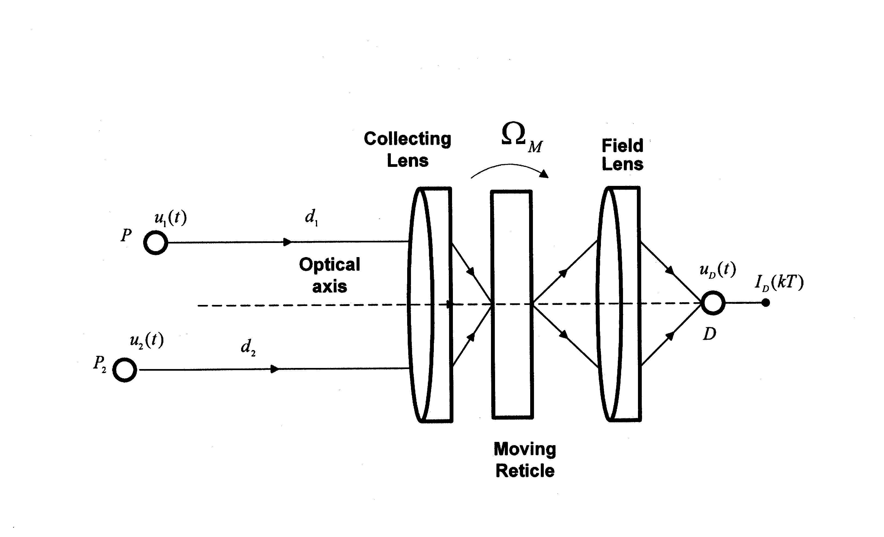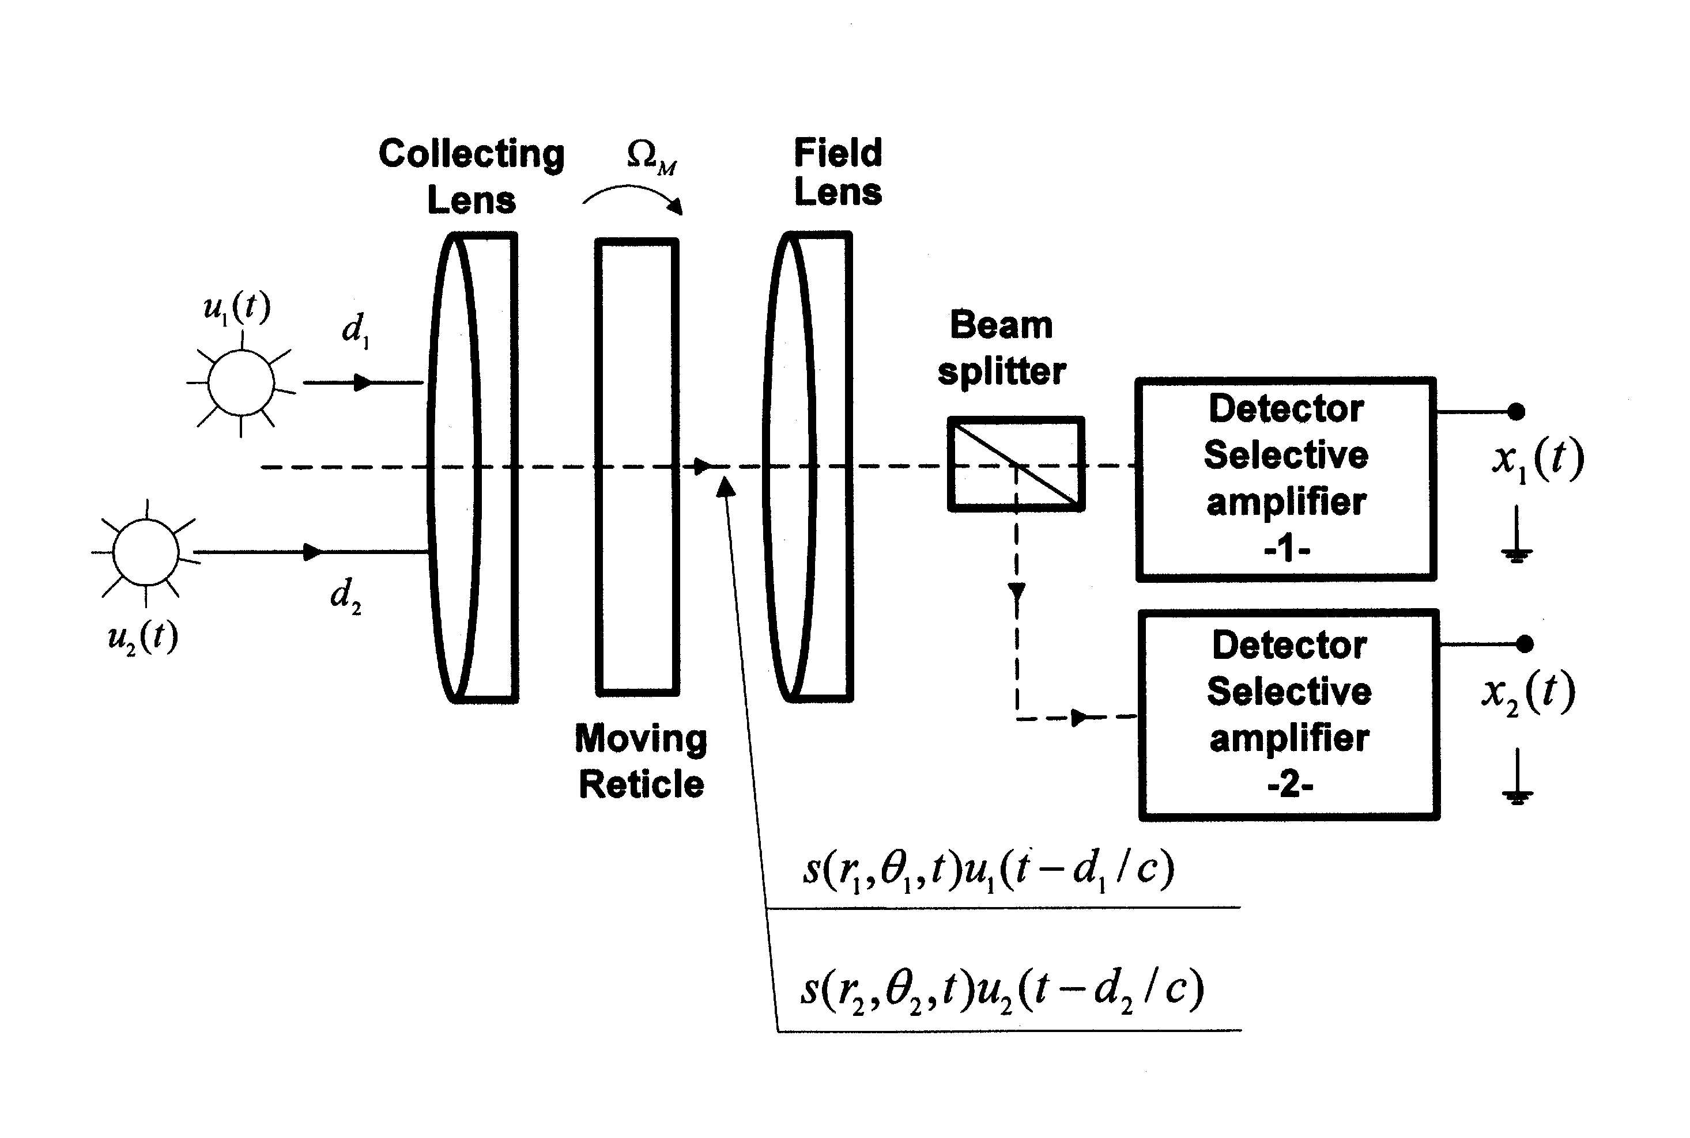
Figure 13: Optical radiation from two sources Figure 14: The modified optical tracker

Detector will sense intensity obtained as^{19,20}:

$I_{D}(\text{kT}) = \left\langle u_{D}^{}(t)u_{D}(t)\right\rangle$ (18)

where T represents detector averaging time and kT is new discretized time that allows treatment of nonstationarity. When (17) is applied to (18), I_{D} is obtained as:

$I_{D}=I_{1}s_{1} + I_{2}s_{2} + 2K_{1}K_{2}\sqrt{I_{1}I_{2}}\text{Re}\left\{γ_{\text{12}}(Δt)\right\}s_{1}s_{2}$ (19)

In the Eq. (19) the time index is dropped in order to simplify notation. $γ_{\text{12}}(Δt)$is the normalized mutual coherence function¹⁹:
$γ_{\text{12}}(Δt)=\frac{\left\langle u_{1}(t)u_{2}^{}(t−Δt)\right\rangle }{\sqrt{I_{1}I_{2}}}$ (20)
Eq. (19) is obtained based on the fact that transmission functions s₁ and s₂ are functions of the coordinates of the corresponding optical sources and are mutually independent. They are also independent relative to the optical fields u₁ and u₂. The complete derivation of the Eq. (19) is given in¹⁸. Intensities I₁ or I₂ in Eq. (19) correspond with the peak irradiance I_{P} in Eq. (1). The photocurrent is obtained when the intensity I_{D} is expressed in terms of spectral irradiance and when detector spectral responsivity is taken into consideration, giving:

$\begin{aligned} i(\text{kT}) =A\int{I_{1}(λ,\text{kT})R(λ)dλ}×s_{1}(\text{kT}) + A\int{I_{2}(λ,\text{kT})R(λ)dλ×s_{2}(\text{kT})} + 2K_{1}K_{2}\sqrt{\int{I_{1}(λ,\text{kT})R(λ)dλ}×\int{I_{2}(λ,\text{kT})R(λ)dλ}}×\text{Re}\left\{γ_{\text{12}}(Δt)\right\}×s_{1}(\text{kT})s_{2}(\text{kT})\end{aligned}$ (21)

where A is the detector sensing area and$λ$is wavelength. When in accordance with Fig.14 the beam splitter and two detectors are used, Eq. (21) can be used to obtain expressions for the corresponding photocurrents by simply inserting $τ(λ)$and$ρ(λ)$into integrals over$λ$ in (21). Here $τ(λ)$and $ρ(λ)$ are beam splitter transmission and reflection coefficients, respectively. Responsivity$R(λ)$should be replaced with $R_{1}(λ)$ when i₁ is computed and with$R_{2}(λ)$when i₂ is computed. The optical tracker output signals x₁ and x₂ are obtained as:

$x_{j}(t) = g_{j}(t) ∗i_{j}(t) j ∈ \left\{1,2\right\}$ (22)

where t stands for kT, g₁ and g₂ are impulse responses of the selective amplifiers, and * means temporal convolution. Based on (21) and (22) the following is obtained:

$x_{1}(t) = g_{\text{11}}(t)∗s_{1}(t) + g_{\text{12}}(t)∗s_{2}(t) + g_{\text{13}}(t)∗\left[s_{1}(t)s_{2}(t)\right]$
$x_{2}(t) = g_{\text{21}}(t)∗s_{1}(t) + g_{\text{22}}(t)∗s_{2}(t) + g_{\text{23}}(t)∗\left[s_{1}(t)s_{2}(t)\right]$, (23)

where impulse responses $g_{\text{ij}}, i,j ∈ \left\{1,2,3\right\}$ can be identified from (21), (22) and (23) as:
$g_{\text{11}}(t) = A_{1}g_{1}(t)B_{\text{11}}(λ,t),$$g_{\text{13}}(t) = A_{1}g_{1}(t)2K_{1}K_{2}\sqrt{B_{\text{11}}(λ,t)B_{\text{12}}(λ,t)}×\text{Re}\left\{γ_{\text{12}}(Δt)\right\}$
$g_{\text{12}}(t) = A_{1}g_{1}(t)B_{\text{12}}(λ,t) ,$ $g_{\text{21}}(t) = A_{2}g_{2}(t)B_{\text{21}}(λ,t),$
$g_{\text{22}}(t) = A_{2}g_{2}(t)B_{\text{22}}(λ,t) ,$ $g_{\text{23}}(t) = A_{2}g_{2}(t)2K_{1}K_{2}\sqrt{B_{\text{21}}(λ,t)B_{\text{22}}(λ,t)}×\text{Re}\left\{γ_{\text{12}}(Δt)\right\}$
$B_{\text{11}}(λ,t) = \int{τ(λ)I_{1}(λ,t)R_{1}}(λ)dλ$, $B_{\text{12}}(λ,t) = \int{τ(λ)I_{2}(λ,t)R_{1}}(λ)dλ$
$B_{\text{21}}(λ,t) = \int{ρ(λ)I_{1}(λ,t)R_{2}(λ)dλ}$, $B_{\text{22}}(λ,t) = \int{ρ(λ)I_{2}(λ,t)R_{2}(λ)dλ}$ (24)

Usually assumed linear model is obtained as a special case when optical fields are incoherent. If only the basic optical tracker construction is used (see Fig. 1) then Eq. (23) shows that optical tracker sees convolutive combination of the reticle transmission functions s₁ and s₂. It has been shown analytically in Ref. 3 that in such a case the optical tracker follows the centroid the coordinates of which are functions of the effective brightness of the two sources. The point is that optical tracker fails to determine the accurate coordinates of either of the two sources. That is known as IR jamming problem. In relation to already discussed approaches a new approach was proposed in¹⁶⁻¹⁸ and is extended here. It is based on the ICA theory and an appropriate modification of the optical tracker design and for the case of two sources is shown on Fig. 14. Generally, ICA enables source signals s₁ and s₂, Eq. (23), to be recovered on the basis of the observed signals x₁ and x₂ only. Since the nonlinear ICA algorithms are designed for the special types of the nonlinearity only, transformation of the non-linear convolutive model (23) into linear one would be of great importance. It has been shown in Ref. 18 that if the optical tracking system is designed such that:
$ω_{\text{min}} > \frac{ω_{\text{max}}}{2}$ (25)
where ω_{min} and ω_{max} are minimal and maximal corner frequencies of the optical tracker selective amplifiers, respectively, the nonlinear model (23) can be transformed into linear one by applying linear bandpass filtering operation on the measured signals x₁ and x₂ of the signal model (23). The new model is obtained:

${\hat{x}}_{1}(t) = {\hat{g}}_{\text{11}}(t)∗s_{1}(t) + {\hat{g}}_{\text{12}}(t)∗s_{2}(t)$
${\hat{x}}_{2}(t) = {\hat{g}}_{\text{21}}(t)∗s_{1}(t) + {\hat{g}}_{\text{22}}(t)∗s_{2}(t)$ (26)

where ${\hat{g}}_{\text{ij}}(t) = h_{{}_{\text{BP}}}(t)∗g_{\text{ij}}(t), i,j ∈ \left\{1,2\right\}$ and h_{BP} is impulse response of the linear bandpass filter with the corner frequencies ω_{min} and ω_{max}.

4.0 INTERPRETATION OF THE ICA THEORY REQUIREMENTS

Independent component analysis also known as blind source separation is a fundamental problem in signal processing. The problem is described for a number of source signals coming from different sources and a number of receivers²⁴. Each receiver (antenna, microphone, photodiode,…) receives a linear combination of these source signals. Neither the structure of the linear combination nor the source signals are known to the receivers. In this environment the identification of the linear combinations is called the blind identification problem and the decoupling of the linear combinations is called the blind source separation problem²⁴. In this paper we are considering the blind source separation problem. Two cases of linear mixture are possible: scalar and convolutive. Since, in our application measured signals are convolutive combination of the source signals (Eq. (23), (24) and (26)) the convolutive mixing case will be treated in this paper. Convolutive mixture is mathematically described by:
$x=G∗s$ (27)

where G is the matrix of impulse responses. To recover the source signals (spatial transmission functions of the reticle), see (26) and Fig. 15, the feedback separation network shown in Fig. 16 will be used. A feedback separation network is preferred over a feed-forward network in order to avoid the whitening effect³⁰.

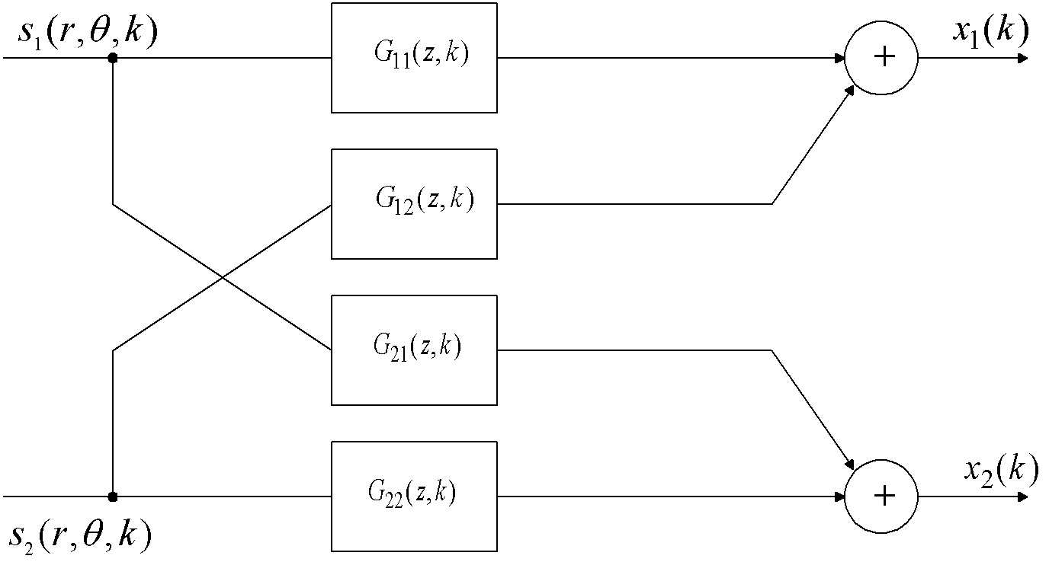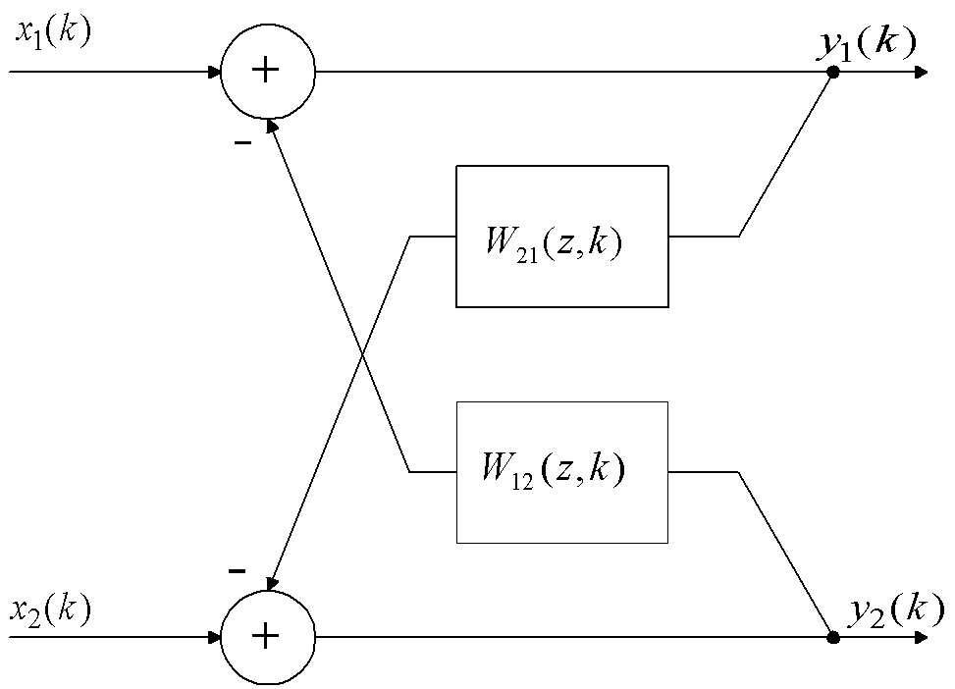
Figure 15. Convolutive signal model. Figure 16. Feedback separation network.

There are three fundamental assumptions on which all ICA algorithms are based: statistical independence of the source signals, the source signals are non-Gaussian and the non-singularity of the mixing matrix in the model of the observed signals. The question of whether these assumptions are fulfilled for the model of the modified optical tracker’s output signals (given by (23) or (26)) are examined briefly at this point. The statistical independence assumption of the source signals$s_{1}(r,θ,t)$ and $s_{2}(r,θ,t)$ is reasonable since they are generated by the two different (independent) optical sources. Figures 17 and 18 show power spectrums of the two FM source signals Eq. (3).

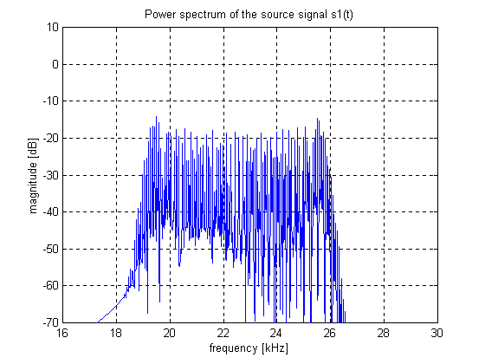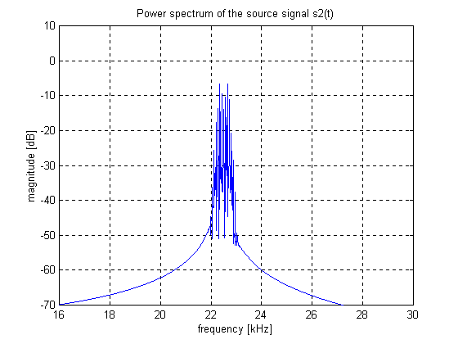
Figure 17. The source signal $s(r_{1}, θ_{1})$, Eq. (3). Figure 18. The source signal$s(r_{2}, θ_{2})$, Eq. (3).

The absolute extreme values of the auto-correlation C₂s₁, C₂s₂ and cross-correlation C₁₁s₁s₂ as well as of the fourth order cumulants C₄s₁, C₄s₂ and cross-cumulant C₂₂s₁s₂ are given in table 1. It can be seen that in both cases the cross-statistics are approximately 10 times smaller than auto-statistics.

Table 1. Second and fourth order (cross-)statistics
Statistics | C₂(s₁) | C₂(s₂) | C₁₁(s₁s₂) | C₄(s₁) | C₄(s₂) | C₂₂(s₁s₂)
Max. value | 0.5 | 0.5 | 0.068 | 0.375 | 0.369 | 0.034

The second assumption, that the source signals are non-Gaussian is also fulfilled for the following reasons. It has been shown in Eq. (3)-(16) that source signals are either FM or AM signals. These types of signals, as most communication signals, belong to the sub-Gaussian class of signals having negative kurtosis, where kurtosis of the signal x is defined as:
$κ(x) = \frac{C_{4}x}{C_{2}^{2}x}$ (28)

and C₄x is fourth order cumulant and C₂x is second order cumulant of the signal x. The kurtosis shows how far the signal is from the Gaussian distribution, which has kurtosis equal to zero. This is due to the fact that random processes with Gaussian distributions have all cumulants of order three or more equal to zero^{44,45,46}. Fig. 19 shows estimated p.d.f. of the source signal s₁ (Fig. 17). The shape of the p.d.f. characteristic for the sub-Gaussian processes (tend to the uniform distribution) can be observed. The estimated value of the kurtosis is κ(s₁)=-1.49. For all FM reticle spatial transmission functions Eq. (3)-(8) the estimation of the kurtosis gives the value of roughly –1.5. For AM and combined AM/FM reticles Eq. (9)-(16) the estimated kurtosis lies between –0.15 and –0.9, depending on the relative speed of motion between the target and the reticle. Only the transmission function (13) for higher relative speed gives positive value of kurtosis. Nevertheless, the non-Gaussianity assumption is fulfilled for all types of the reticle transmission functions i.e. all types of reticle geometry.

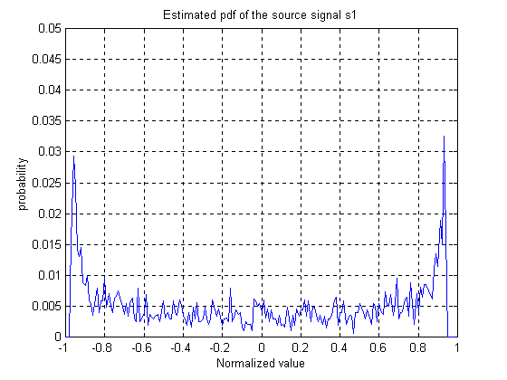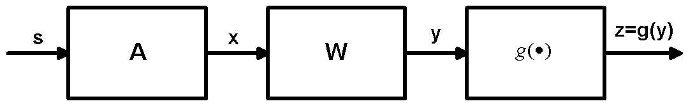
Figure 19. Estimated p.d.f. of the $s(r_{1}, θ_{1}, t)$. Figure 20. The instantaneous signal model

The third assumption is the non-singularity of the mixing matrix when the convolutive model (23) i.e. (26) is transformed into the frequency domain. It has been shown in Eq. (24)-(26) that under proper condition of the optical tracker design the nonlinear model (23), generated by the coherent optical sources, can be transformed into linear model (26) by simple linear bandpass filtering operation. Therefore, we shall examine the nonsingularity requirement on the linear model (26). The nonsingularity requirement means that measured signals${\hat{x}}_{1}$and ${\hat{x}}_{2}$must be linearly independent combinations of the source signals s₁ and s₂, which ensures a benefit from using two sensors. It is shown in¹⁶⁻¹⁸ that this assumption holds. The signal model (26) transformed into frequency domain yields:

$\begin{aligned}\left[{\hat{X}}_{1} | \right] \\ \end{aligned}$ (29)

where all quantities in the Eq. (29) are Discrete Fourier Transforms (DFTs) of the related time domain quantities in the signal model (26). The frequency variable$ω$is dropped in Eq. (29) in order to simplify notation. The nonsingularity condition is transformed into:
$G_{\text{11}}G_{\text{22}} − G_{\text{12}}G_{\text{21}} ≠ 0$ (30)

Inserting DFTs of the impulse responses (24) in (30) gives the following inequality:

$\begin{aligned}\int{τ(λ)R_{1}(λ)I_{1}(λ,t)dλ}×\int{R_{2}(λ)I_{2}(λ,t)}dλ − \int{τ(λ)R_{1}(λ)I_{1}(λ,t)dλ}×\int{τ(λ)R_{2}(λ)I_{2}(λ,t)}dλ ≠ \\ \int{τ(λ)R_{1}(λ)I_{2}(λ,t)dλ}× \int{R_{2}(λ)I_{1}(λ,t)dλ} − \int{τ(λ)R_{1}(λ)I_{2}(λ,t)dλ} ×\int{τ(λ)R_{2}(λ)I_{1}(λ,t)dλ}\end{aligned}$ (31)

Provided that $R_{1}(λ)≃R_{2}(λ)≃R(λ)$ the inequality (31) is transformed in¹⁶⁻¹⁸:

$\int{τ(λ)R(λ)I_{1}(λ,t)dλ}×\int{R(λ)I_{2}(λ,t)}dλ ≠ \int{τ(λ)R(λ)I_{2}(λ,t)dλ} ×\int{R(λ)I_{1}(λ,t)dλ}$ (32)

The inequality (32) is fulfilled when:

$τ(λ) ≠ \text{const}$ (33)

over the wavelength region of interest that is fulfilled for the real beam splitters^{16,51}.

5.0 THE ICA ALGORITHM

All ICA algorithms recover the source signals by minimizing or maximizing certain criteria that indirectly factorizes the joint probability density function of the recovered signals. Since the source signals are independent by assumptions, the discussed factorization actually reconstructs the source signals. A consequence of such a separation criteria is that the separated signals represent scaled and permuted version of the source signals^{24,25,26} i.e. in a case of the linear instantaneous model (Fig. 20):
$x = \text{As} x, s ∈ R^{n}; A∈R^{\text{nxn}}$ (34)
the source signals are recovered as:
$y = \text{Wx} y ∈ R^{n}; W ∈ R^{\text{nxn}}$ (35)
where the separation matrix W is found as:

$W = PΛ$ (36)
where Λ is diagonal and P is permutation matrix. Algorithms for the blind separation of sources can be derived from several different principles. A guiding principle for source separation is to optimize a function Φ(W) called a contrast function which is a function of distribution of y=Wx,^{32,33,38}. The infomax also known as Bell-Sejnowski algorithm²² is one of the most popular ICA algorithms. Referred to Fig. 20 the infomax principle to source separation consists in maximizing an output entropy z=g(y) whereas the infomax contrast function is:

$Φ_{I}(W) = H\left(g(\text{Wx})\right)$ (37)

where $H(∘)$ is the (Shannon) differential entropy Eq. (45). The natural or relative gradient based learning rule for the memoryless model (34)-(35) is given with^{33,34,38}:

$W(k+1) = W(k) − μ\left[I − ϕ(y)y^{T}\right]W(k)$ (38)

where from both the entropy maximization and maximum likelihood maximization approach the following requirement is imposed on the nonlinearity $ϕ(∘)$^{21,48-50}:
$ϕ(y)=−\frac{d}{\text{dy}}\text{log}p(y)$ (39)
and p(y) is the true p.d.f. of the source signals which in the blind source separation are usually unknown. However, it was shown in Ref. 49 that learning rule will still be superefficient provided that p(y) are even and ϕ(y) are odd. In many applications p(y) are even, see estimated p.d.f. of the source signal s(r_{1,}θ₁ ), Fig. 19. Then ϕ(y)=tanh(y) is an appropriate choice for a class of super-Gaussian signals, while ϕ(y)=y³ or ϕ(y)=y/σ² – (μ/σ²)tanh(yμ/σ²), are suitable for sub-Gaussian signals²¹. The infomax algorithm^{22,30} is applied here on the convolved signal model (26) and Fig.15 with the recurrent neural network Fig. 16. The input-output relations of the feedback network (Fig. 16) are given by:

$$y_{1}(k)\text{}=\text{}x_{1}(k)\text{}−\text{}\sum_{i=1}^{M}{w_{\text{12}}(i)y_{2}(k−i)}$$
$y_{2}(k)\text{}=\text{}x_{2}(k)\text{}−\text{}\sum_{i=1}^{M}{w_{\text{21}}(i)y_{1}(k−i)}$ (40)

For causality reasons w₁₂(0) and w₂₁(0) must be zero. It is assumed that the source signals$s_{1}(r,θ,k)$ and $s_{2}(r,θ,k)$are zero mean and statistically independent. It has been shown in^{16,22} that the maximization of the information transfer through the sigmoid function $z_{i}=g(y_{i})$ also reduces the redundancy between the outputs of the separation network y_{i} (Fig. 16). The mutual information between the sigmoid outputs can be obtained as²²:

$I(z,y)=H(z)−H(z/y)$ (41)

where H(z) is the entropy of the sigmoid outputs, while H(z/y) is the residual entropy in the output which did not come from the input. Since in the BSS scenario we have no noise (both signals and noise are treated equally) the entropy H(z/y) has its lowest possible value: it diverges to $\text{-¥}$,²². So the maximization of the mutual information I(z/y) is equivalent to the maximization of the joint entropy H(z) with respect to the separation filter coefficients:

$\underset{w_{\text{ij}}}{\text{max}}I(z,y)=\underset{w_{\text{ij}}}{\text{max}}H(z)$ (42)

To see why the maximization of H(z) separates signals y_{i} (i.e. factorizes joint probability density function f(y)) the mutual information (i.e. statistical independence between the components z_{i}) is expressed in a form of Kullback divergence³²:

$\text{MI}(z)=δ\left(f(z),\prod_{i=1}^{n}{f_{i}(z_{i})}\right)=\int_{−∞}^{∞}{f(z)\text{log}\frac{f(z)}{\prod_{i=1}^{n}{f_{i}(z_{i})}}}\text{dz}$ (43)

MI(z) vanishes if the components z_{i} are statistically independent and it is strictly positive otherwise³². Based on (43) the mutual information MI(z) can be defined in terms of joint and marginal entropy H(z) and H(z_{i}) respectively:

$\text{MI}(z)=−H(z)\text{}+\text{}\sum_{i=1}^{n}{H(z_{i})}$ (44)
where the entropy terms are defined by:
$H(z)=−E\left[\text{log}f(z)\right]=−\int_{−∞}^{∞}{f(z)\text{log}f(z)\text{dz}}$
$H(z_{i})=−E\left[\text{log}f(z_{i})\right]=−\int_{−∞}^{∞}{f(z)\text{log}f_{i}(z_{i})\text{dz}}$ (45)
It follows from (44) that:
$H(z)=\sum_{i=1}^{n}{H(z_{i})−\text{MI}(z)}$ (46)

It can be seen from (46) that the maximization of the joint entropy H(z) actually maximizes the marginal entropy H(z_{i}) and minimizes mutual information MI(z) which, due to (43), leads to the factorization of f(z). Since the z_{i}’s are related to y_{i}’s with some invertible transformation, as for example z_{i}=tanh(y_{i}), factorization of f(z) will have as a direct consequence the factorization of f(y). When z=g(Wx) has a unique inverse, the multivariate probability density function can be written as²²:

$f(z)=\frac{f(x)}{\left|J\right|}$ (47)
where $\left|J\right|$ is the absolute value of the Jacobian of the transformation. The Jacobian is defined as the determinant of the matrix of partial derivatives:
$J=\text{det}\begin{aligned}\left[\frac{∂z_{1}}{∂x_{1}}\text{}\text{.}\text{.}\text{.}\text{}\frac{∂z_{1}}{∂x_{n}} | \right]\left[\text{}\text{.}\text{}\text{.} | \right] \\ \end{aligned}$ (48)

Then using (45) and (47) the joint entropy can be written as:

$H(z)=−E\left[\text{ln}f(z)\right]=E\left[\text{ln}\left|J\right|\right]−E\left[\text{ln}f(x)\right]$ (49)

Now, the maximization of H(z) with respect to the coefficients of the separation filters w_{ij} is equivalent to the maximization of $\text{ln}\left|J\right|$ since in Eq. (49) $\text{ln}f(x)$ does not depend on w_{ij}. Hence,

$\underset{w_{\text{ij}}}{\text{max}}H(z)=\underset{w_{\text{ij}}}{\text{max}}\text{ln}\left|J\right|$ (50)

For the feedback separation network shown in Fig. 16. and described with the input-output relation (40) the absolute value of the Jacobian is obtained as:
$\left|J\right|=\left|\text{det}{\left[\frac{∂z_{i}}{∂x_{i}}\right]}_{\text{ij}}\right|=\left|\frac{∂z_{1}}{∂y_{1}}⋅\frac{∂z_{2}}{∂y_{2}}\right|$ (51)

The adjustments of the separation filter coefficients are then obtained as:

${Δw}_{\text{ij}}(k,m)=\frac{∂H(z)}{∂w_{\text{ij}}(k,m)}=\frac{∂\text{ln}\left|J\right|}{∂w_{\text{ij}}(k,m)}=\frac{∂}{∂w_{\text{ij}}(k,m)}\text{ln}\frac{∂z_{i}}{∂y_{i}}$
${Δw}_{\text{ij}}(k,m)={\left(\frac{∂z_{i}}{∂y_{i}}\right)}^{−1}\frac{∂}{∂w_{\text{ij}}(k,m)}\left(\frac{∂z_{i}}{∂y_{i}}\right)$ (52)

The entropy of the sigmoid output will be maximal provided that:

$z_{i} = g(y_{i}) ≃ \int{p_{y}(ν)dν}$ (53)
i.e.:
$\frac{∂z_{i}}{∂y_{i}} = \frac{∂g(y_{i})}{∂y_{i}} = p_{y}(y_{i})$ (54)

and (52) can be written as:
${Δw}_{\text{ij}}(k,m) = ϕ(y_{i})y_{j}(k−m)$ (55)

where ϕ(y_{i}) is in the form of Eq. (39), k is the discrete time index, and m is the coefficient index of the related separation filter. From this the separator learning rule is obtained as:

$\begin{aligned}w_{\text{ij}}(k+1,m)=w_{\text{ij}}(k,m) + {μΔw}_{\text{ij}}(k,m) \\ \text{}=w_{\text{ij}}(k,m) + \text{μϕ}(y_{i})y_{j}(k−m)\end{aligned}$ (56)

where$μ$in Eq. (56) is a small positive constant also called the adaptation gain. Then ϕ(y)=tanh(y) is an appropriate choice for super-Gaussian signals, while ϕ(y)=y³ or ϕ(y)=y/σ²–(μ/σ²)tanh(yμ/σ²), are suitable for sub-Gaussian signals²¹.

6.0 SIMULATION RESULTS

Measured signals x₁ and x₂ were generated according to the nonlinear signal model (23) on the basis of the two FM source signals s₁ and s₂ the power spectrums of which are shown on Fig. 17 and 18. The total coherence case, $γ_{\text{12}}(Δt)=1$, was assumed. Power spectrum of the measured signal x₁ is shown on Fig. 21. The nonlinear effect due to the nonlinear part in the signal model (23) can be observed. Power spectrum of the measured signal x₂ looks very similarly. When, in accordance with the exposed analysis Eq. (24)-(26), the linear bandpass filtering is applied on the measured signals x₁ and x₂, signals ${\hat{x}}_{1}$ and ${\hat{x}}_{2}$ are obtained, Eq. (26). Power spectrum of the signal ${\hat{x}}_{1}$ is shown on Fig. 22. It is obvious that nonlinear effect has been eliminated. Power spectrum of the signal ${\hat{x}}_{2}$ looks very similarly. When FM demodulator is applied on either signal ${\hat{x}}_{1}$ or signal ${\hat{x}}_{2}$, only the IR optical source that was placed near the center of the filed of view (FOV) can be discriminated. If, however, the entropy based ICA algorithm, Eq. (56), is applied on the signals ${\hat{x}}_{1}$ and ${\hat{x}}_{2}$ the influence of the IR source placed near the center of the FOV can be eliminated and both IR sources can be discriminated. Power spectrums of the signals y₁ and y₂, according to Eq. (40), are shown on fig. 23 and 24. It can be observed in signal y₁ that influence of the IR source placed near the center of the FOV is eliminated. Signal y₁ represents reconstructed version of the source signal s₁ while y₂ represents reconstructed version of the source signal s₂.

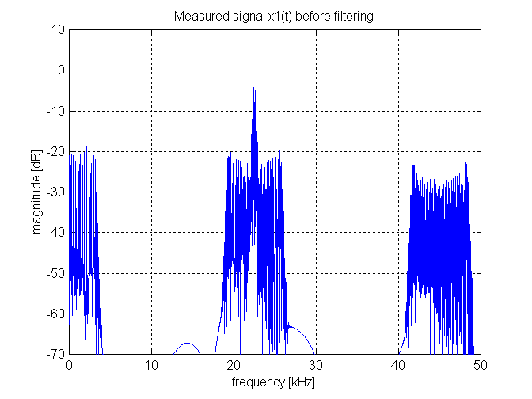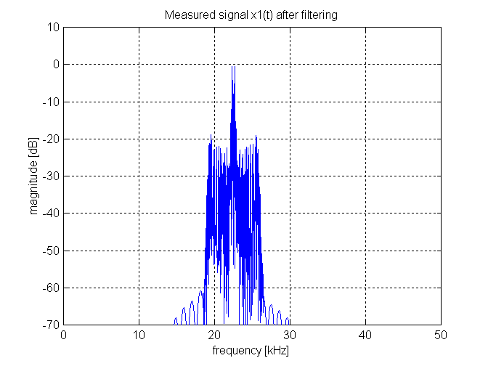
Figure 21. Power spectrum of x₁, Eq. (23). Figure 22. Power spectrum of ${\hat{x}}_{1}$, Eq. (26).

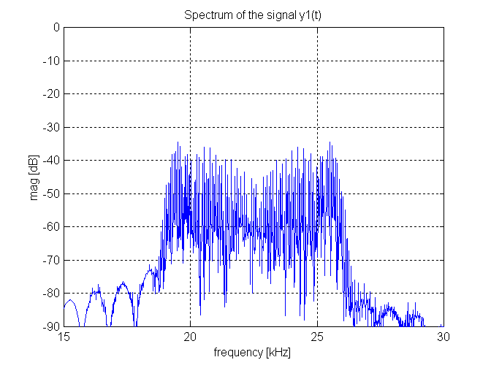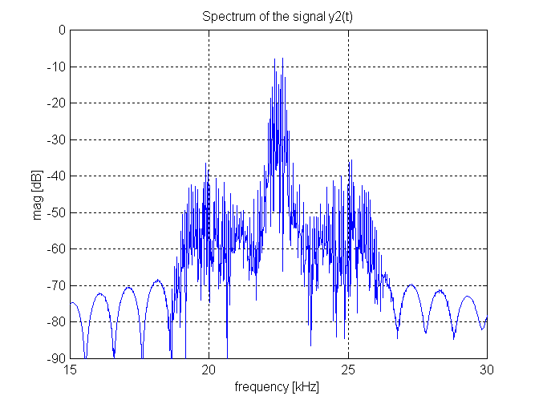
Figure 23. Power spectrum of y₁, Eq. (30). Figure 24. Power spectrum of y₂, Eq. (30).

7.0 CONCLUSION

ICA approach to resolve the multisource limitation of the reticle based optical trackers is exposed in the paper. When redesigned adequately optical trackers produce output signals that are linear convolutive combinations of the reticle transmission functions, considered to be the source signals in the context of the ICA theory. Each function corresponds with single optical source position. That enables ICA neural network to be applied on the optical tracker output signals giving on its outputs recovered reticle transmission functions. Position of each optical source is obtained by applying appropriate demodulation method on the recovered source signals. The three conditions necessary for the ICA theory to work (statistical independence and non-Gaussianity of the source signals and nonsingularity of the mixing matrix) are shown to be fulfilled in principle for any kind of the reticle geometry. A statistical optics based analysis is performed that yields a mathematical model of the output signals of a modified reticle based optical tracker. It has been shown that coherence between optical sources produces a nonlinear signal model that becomes linear when optical sources are incoherent. It has been shown additionally that by the proper optical tracker design the nonlinear model, generated by the coherent optical sources, can be converted into linear one by simple linear bandpass filtering operation. It has been also shown that the nonsingularity of the mixing matrix in the frequency domain can be ensured requiring the beam splitter transmission coefficient be non-constant over the wavelength region of interest. Thus the requirements necessary for the ICA theory to work are fulfilled for both coherent and incoherent optical sources. Consequently, the multisource limitation of the either nutating or spinning reticle based optical trackers can in principle be overcome for both coherent and incoherent optical sources.

REFERENCES

- R. D. Hudson, Jr., Infrared System Engineering, Chap. 6, 235-263, J. Wiley, New York, 1969.
- G. F. Aroyan, “The Technique of Spatial Filtering,” Proc. Inst. Radio Engrs. 47, pp. 1561-1568, 1959.
- A. F. Nicholson, “Error Signals and Discrimination in Optical Trackers that see Several Sources,” Proc. of the IEEE 53, pp. 56-71, 1965.
- T. B. Buttweiler, “Optimum Modulation Characteristics for Amplitude-Modulated and Frequency-Modulated Infrared Systems,” J. Opt. Soc. Am. 51, pp. 1011-1015, 1961.
- H. K. Hong, S. H. Han, and J. S. Choi, “Simulation of an improved reticle seeker using segmented focal plane array,” Opt. Eng. 36(3), pp. 883-888,1997.
- H. K. Hong, S. H. Han, and J. S. Choi, “Dynamic simulation of infrared reticle seekers and an efficient counter-countermeasure algorithm,” Opt. Eng. 36(8), pp. 2341-2345, 1997.
- H. K. Hong, S. H. Han, and J. S. Choi, “Simulation of the spinning concentric annular ring reticle seeker and an efficient counter-countermeasure,” Opt. Eng. 36(11), pp. 3206-3211, 1997.
- R. L. Driggers, C. E. Halford, G.D. Boreman, D. Lattman, and K. F. Wiliams, “Parameters of spinning FM reticles,” Applied Optics 30(7), pp. 887-895, 1991.
- R. L Driggers, C. E. Halford, and G. D. Boreman, “Parameters of spinning AM reticles,” Applied Optics 30(19), pp. 2675-2684, 1991.
- K. Suzuki, “Analysis of rising-sun reticle,” Opt. Eng. 18(3), pp. 350-351, 1979.
- Z. W. Chao, and J. L. Chu, “General analysis of frequency-modulated reticles,” Opt. Eng. 27(6), pp. 440-442, 1988.
- Z. W. Chao, and J. L Chu, “Parameter analysis of frequency-modulation reticle design,” Opt. Eng. 27(6), pp. 443-451, 1988.
- R. L. Driggers, C. E. Halford, and G. D. Boreman, “Marriage of frequency modulation reticles to focal plane arrays,” Opt. Eng. 30(10), 1516-1521(1991).
- S. J. Taylor, and R. G. Driggers, “Tracking with two frequency-modulated reticles,” Opt.Eng. 32(5), pp. 1101-1104, 1993.
- K. Ćosić, I. Kopriva, T. Kostić, M. Slamić, , and M. Volarević, “Design and implementation of a hardware-in-the-loop simulator for semi-automatic guided missile system,” Simulation Practice and Theory 7(2), pp. 107-123, 1999.
- I. Kopriva, and A. Peršin, “Discrimination of optical sources by use of adaptive blind source separation theory,” Applied Optics 38, 1115-1126, 1999.
- I. Kopriva, and A. Peršin, “Blind separation of optical tracker responses into independent components discriminates optical sources,” Proceedings of the First International Workshop on Signal Separation and Independent Component Analysis, J. F. Cardoso and Ph. Loubaton (ed.), pp. 31-36, University Joseph Fourier - Grenoble, Aussois, France, 11-15 January, 1999.
- H. H. Szu, and I. Kopriva, “Independent component analysis approach to resolve the multi-source limitation of the nutating rising-sun reticle based optical trackers,” submitted to Optics Communication.
- J. W. Goodman, Statistical Optics, Chap. 5, pp. 157-236, J. Wiley, New York, 1985.
- M. V. Klein, and T. E. Futrak, Optics, Chap. 8, pp. 507-582, J. Wiley, New York, 1986.
- T. W. Lee, Independent Component Analysis – Theory and Applications, Chap. 4, pp. 83-107, Chap. 6, pp. 123-137, Kluwer AP, Boston, 1998.
- A. J. Bell, and T. J. Sejnowski, “An information-maximization approach to blind separation and blind deconvolution,” Neural Computation 7, pp. 1129-1159, 1995.
- H. H. Szu, Progress in unsupervised learning and real world applications, Russian Academy of Nonlinear Sciences, 1999.
- X. R. Cao, and R. W. Liu, “General Approach to Blind Source Separation,” IEEE Trans. On Signal Processing 44, pp. 562-571, 1996.
- D. Yellin, and E. Weinstein, “Criteria for Multichannel Signal Separation,” IEEE Trans. On Signal Processing 42, pp. 2158-2168, 1994.
- D. Yellin, and E. Weinstein, “Multichannel Signal Separation: Methods and Analysis,” IEEE Trans. On Signal Processing 44, pp. 106-118, 1996.
- J. Wang, and H. Zhenya, “Blind Identification and Separation of Convolutively Mixed Independent Sources,” IEEE Trans. On Aerospace and Electronic Systems 33, pp. 997-1002, 1997.
- E. Weinstein, A. V. Oppenheim, M. Feder, and J. R. Buck, “Iterative and Sequential Algorithms for Multisensor Signal Enhancement,” IEEE Trans. On Signal Processing 42, pp. 846-859, 1994.
- S. V. Gerven, and D. V. Compernolle, “Signal Separation by Symmetric Adaptive Decorrelation: Stability, Convergence, and Uniqueness,” IEEE Trans. On Signal Processing 43, pp. 1602-1612, 1995.
- K. Torkkola, “Blind Separation of Convolved Sources Based on Information Maximization,” IEEE Workshop on Neural Networks for Signal Processing, Kyoto, Japan, 4-6, September 4-6. 1996.
- H. L Nguyen Thi, and C. Jutten, “Blind source separation for convolutive mixtures,” Signal Processing 45, pp. 209-229, 1995.
- P. Common, “Independent component analysis, A new concept?,” Signal Processing 36, pp. 287-314, 1994.
- J. F. Cardoso, and B. Laheld, “Equivariant adaptive source separation,” IEEE Trans. Signal Processing 44(12), pp. 3017-3030, 1996.
- A. Cihocki, R. Unbehauen, and E. Rummert, “Robust learning algorithm for blind separation of signals,” Electronic Letters 28(21), pp. 1986-1987, 1994.
- J. Herault, and C. Jutten,, “Space or time adaptive signal processing by neural network models”, Neural Networks for Computing. Proceedings of the AIP Conference, J.S. Denker (ed.), American Institute of Physics, New York, pp. 206-211, 1986.
- C. Jutten, and J. Herault, “Blind separation of sources, Part I: An adaptive algorithm based on neuromimetic architecture,” Signal Processing 24, pp. 1-10, 1991.
- P. J. Smaragdis, “Blind Separation of Convolved Mixtures in the Frequency Domain,” International Workshop on Independency and Artifical Neural Networks, Tenerife, Spain, February 9-10, 1998.
- S. Amari, “Natural gradient works efficiently in learning,” Neural Computation 10(2), pp. 251-276, 1998.
- L. Molgedy, and H. G. Schuster, “Separation of a Mixture of Independent Signals Using Time Delayed Correlations,” Physical Review Letters 72, pp. 3634-3637, 1994.
- H. Yang, S. Amari, and A. Cihocki, “Information-theoretic approach to blind separation of sources in non-linear mixture,” Signal Process. 64, pp. 291-300, 1998.
- T. W. Lee, and B. U. Koehler, “Blind Source Separation of Nonlinear Mixing Models,” IEEE International Workshop on Neural Networks for Signal Processing, Institute for Electrical and Electronic Engineers-New York, Florida, September, 1997.
- A. Taleb, C. Jutten, and S. Olympieff, “Source separation in post nonlinear mixtures: an entropy based algorithm,” International Conference Acoustics, Speech, Signal Processing, Institute for Electrical and Electronic Engineers-New York, Seattle, Washington, May, 1998.
- H. Taub, and D. L. Schilling, Principles of Communication Systems, Chap. 4, 142-182, McGraw-Hill, New York, 1987.
- D. R. Brillinger, Time Series Data Analysis and Theory, Chap. 2, pp. 16 – 44, McGraw-Hill, New York, 1981.
- J. M. Mendel, “Tutorial on Higher-Order Statistics (Spectra) in Signal Processing and System Theory: Theoretical Results and Some Applications,” Proc. of the IEEE 79, pp. 278-305, 1991.
- P. McCullagh, Tensor Methods in Statistics, Chap. 2, pp. 24-46, Chapman & Hall, London, 1987,1995.
- H. M. Oden, M. D. Curry, T. L. Thomas, and C. Combs, “Uses and Benefits for the Validated Stinger Hardware-In-the-Loop Simulations,” Proceedings of the Summer Computer Simulation Conference, Society for Computer Simulation International, San Diego, California, pp. 555-559, Chicago, Illinois, July, 1999.
- D. T. Pham, “Blind separation of mixtures of independent sources through a quasimaximum likelihood approach,” IEEE Trans. Signal Processing 45, pp. 1712-1725, 1997.
- S. Amari, “Superefficiency in Blind Source Separation,” IEEE Trans. Signal Processing 47, pp. 936-944, 1999.
- J. F. Cardoso, “Infomax and maximum likelihood for blind source separation,” IEEE Signal Processing Letters 4, pp. 112-114, 1997.
- I. Kopriva, “Localization of light sources by using blind signal separation theory,” PhD Thesis (in Croatian), Faculty of Electrical Engineering and Computing, University of Zagreb, 1998.

 Correspondence: Email: ivica.kopriva@public.srce.hr; telephone: +385 1 4603 825; Fax: +385 1 4603 820.

