Comparison of different measuring systems for printing plate’s coverage values evaluation

Tamara Tomašegović^{1*}, Tomislav Cigula¹, Sanja Mahović Poljaček¹, Miroslav Gojo¹

¹Faculty of Graphic Arts, Department for printing plates, Zagreb, Croatia

*Corresponding author: ttomaseg@grf.hr

Keywords: lithographic printing plate, quality control, image analysis

Abstract
Quality control is a significant aspect of every industrial production. In multistep industry, such as graphic arts industry, one should control every single step of production in order to ensure desired quality level of final product. Control of lithographic printing plate is made by observing printing areas, made of photoactive coating; or nonprinting areas, made of aluminium-oxide. In order to determine quality level of printing plate’s printing areas, control wedges with various elements are transferred from the film or computer to the printing plate and measured by the image analysis device (plate reader).
Aim of this paper is to determine influence of the different measuring systems on evaluation of printing areas by coverage values measurement. For this purpose printing plates made by varying developing process were prepared. Control wedge with coverage values from 10% to 100%, with ascent of 10% of coverage value per field, was transferred onto printing plate and measured with Gretag Macbeth IC Plate II plate reader and Wayne Rasband’s ImageJ program. Results of this research have shown suitability of image analysis program in evaluation of printing plate quality.

- Introduction
Graphic reproduction is a complex conjuction of interdependent operations. The printing plate making process is one significant segment of reproduction, where it’s product’s (printing plate’s) quality and stability during the printing highly influences the quality of final product. Having this fact in mind, systematic and standardized control of printing and nonprinting areas must be performed to enable detection and correction of processing errors [1].
Control of the printing areas is made by transferring control elements (control wedges) onto printing plate together with the image for reproduction. Control wedges usually contain various elements, among others coverage values fields, to monitor transfer of the coverage values from the original computer-generated file to the printing plate and in the end on the imprint [2].
Control of the plate’s printing areas is commonly performed by using portable plate readers that operate on the principle of determining the coverage area of printing elements by means of the CCD camera. Alternative method, which will be presented and evaluated in this paper, uses free image analysis software for characterization of printing areas.
Since previous research [3] showed that variation of developing time in the lithographic printing plate’s making process has a significant impact on the surface characteristics of nonprinting areas, the aim of this paper will be focused on the influence of the developing process on the printing areas of the printing plate and on the evaluation of the measuring methods.

- Materials and Methods
For this investigation, five samples of positive diazo printing plates were prepared by copying control wedge with fields from 10% - 100% coverage value and screen resolution of 100 lpcm. All samples were exposed in equal conditions. After the exposure, samples were immersed in commercial offset plate developer in various period; optimal and +/- 1/10 and 1/5 from optimal developing time for each sample (16, 18, 20, 22 and 24 s).
Measurements of coverage values were performed by Gretag Macbeth’s IC Plate II plate reader (Fig.1), and repeated five times for each field on the control wedge. IC Plate II is equipped with a high resolution camera, with measuring time of 3-4 seconds. Before measurements unit is automatically calibrated. It can work independently, displaying information on built-in display, or connect it to the computer and store results using accompanying software (Plate Quality Software). The unit enables measurement of coverage values, diameter of printing element, screen resolution and screen angle [4].
Furthermore, coverage value fields were captured with OlympusBX51 (Fig.2) in order to get images of each field necessary for coverage values measurement in free image analysis software (Wayne Rasband’s ImageJ). The images were recorded at magnification of 100× and saved in tiff format. ImageJ enables calculation of area and pixel value statistics of user-defined selections and intensity thresholded objects. It can create density histograms and line profile plots. Program supports standard image processing functions such as logical and arithmetical operations between images, contrast manipulation, convolution, Fourier analysis, etc. [5] The microscope images were transformed into bitmap image in ImageJ, where the coverage value was calculated.

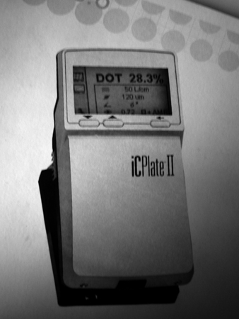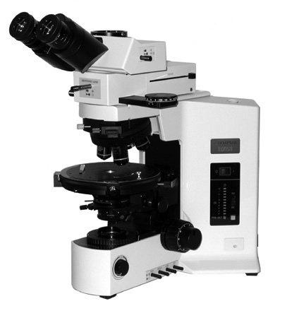
Fig.1. Gretag Macbeth’s IC Plate II Fig.2. OlympusBX51

- Results and Discussion
Figures 3 and 4 show results of the coverage values of bottom half of scale measured by using ImageJ and IC Plate II, respectively.

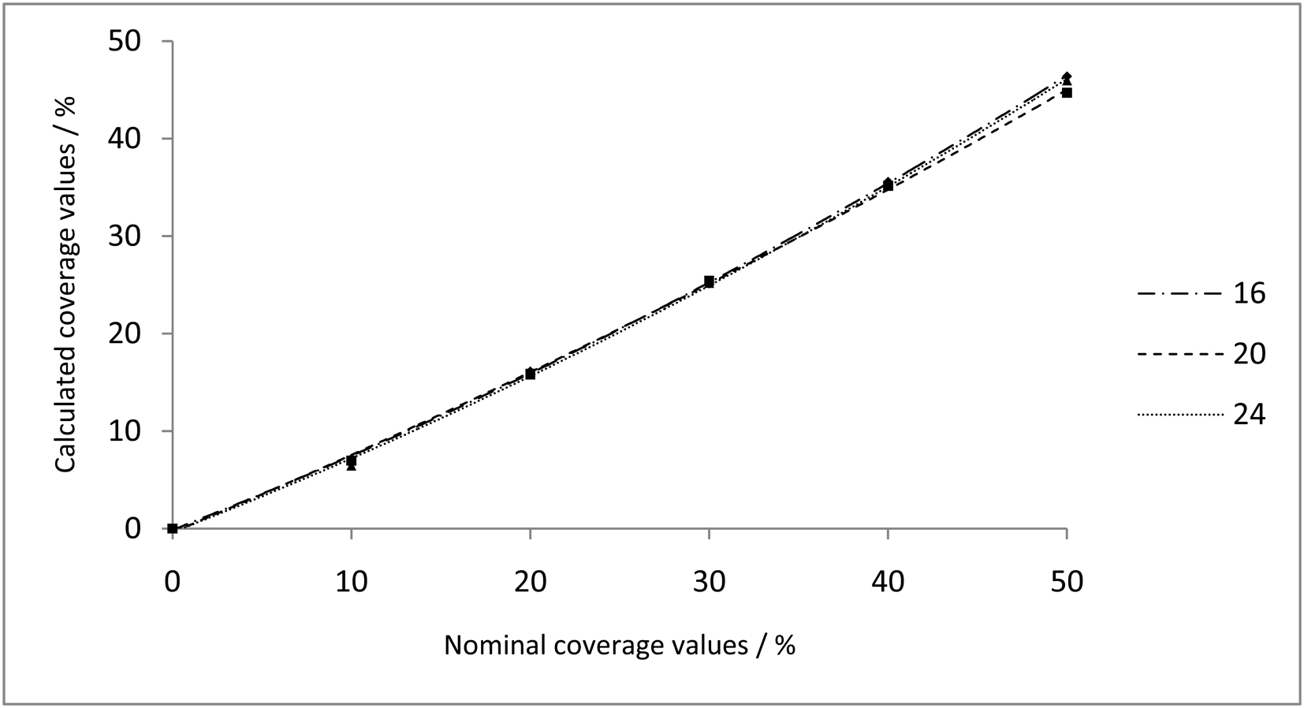
Fig.3. Coverage values on printing plate at 0% - 50% nominal values calculated by ImageJ

Observing figures 3 and 4 one can see that largest differences in coverage values for different developing time are measured at 40% - 50% of nominal coverage value. Measuring results obtained by IC Plate II show large difference between measured
samples in comparison to the results of the ImageJ measuring. Both methods show lowest coverage values on the sample made with longest developing time.
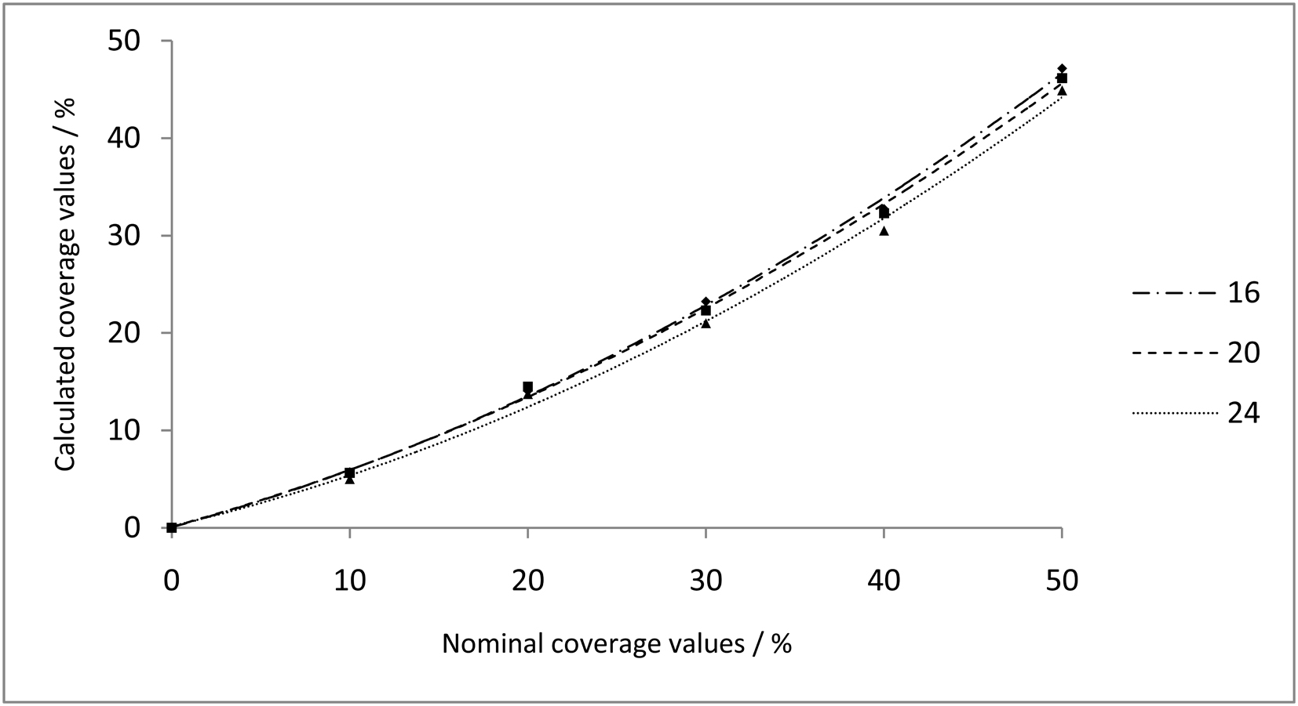
Fig.4. Coverage values on printing plate at 0% - 50% nominal values calculated by IC Plate II

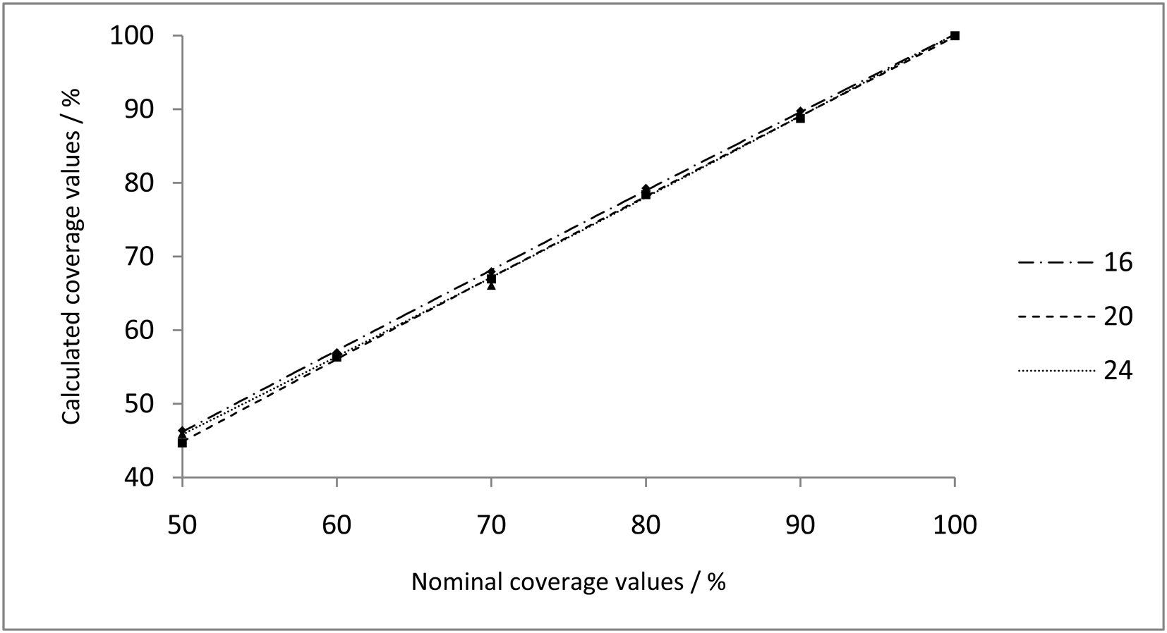
Fig.5. Coverage values on printing plate at 50% - 100% nominal values calculated by ImageJ

Figures 5 and 6 show measured vs. nominal coverage values obtained by two investigated measuring methods at nominal coverage values of 50% - 100%. Opposite to the values of the lower nominal coverage, higher coverage values (50% - 100%) show greater differences on samples by using ImageJ.
In addition, both methods show that differences in coverage values on investigated printing plate's samples are decreasing by increase of the nominal coverage value.
After calculating mean coverage value for each field measured both by IC Plate II and ImageJ, results were compared and correlation between coverage values calculated by ImageJ and IC Plate II was determined.
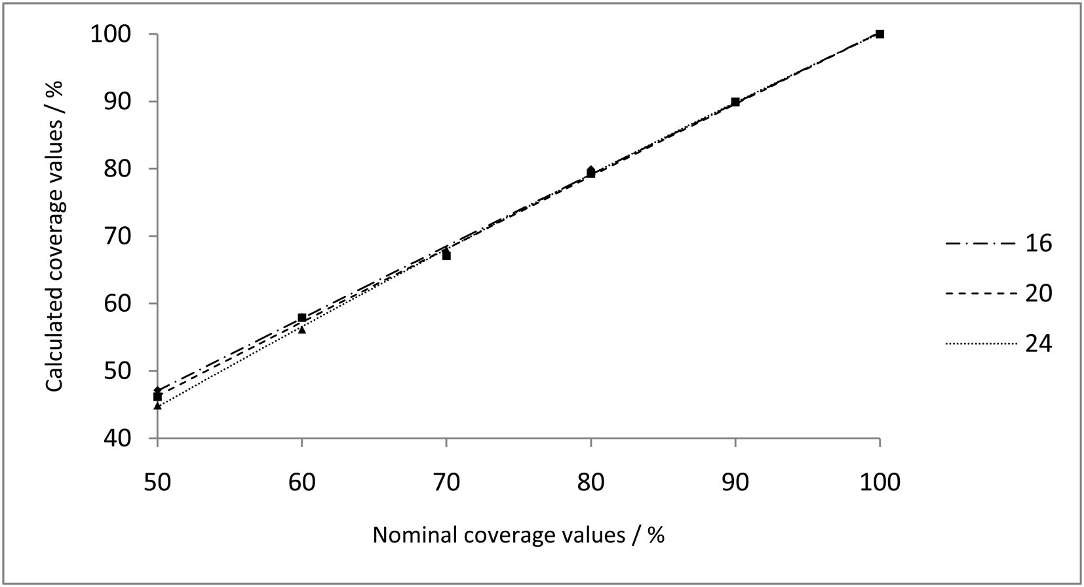
Fig.6. Coverage values on printing plate at 50% - 100% nominal values calculated by IC Plate II

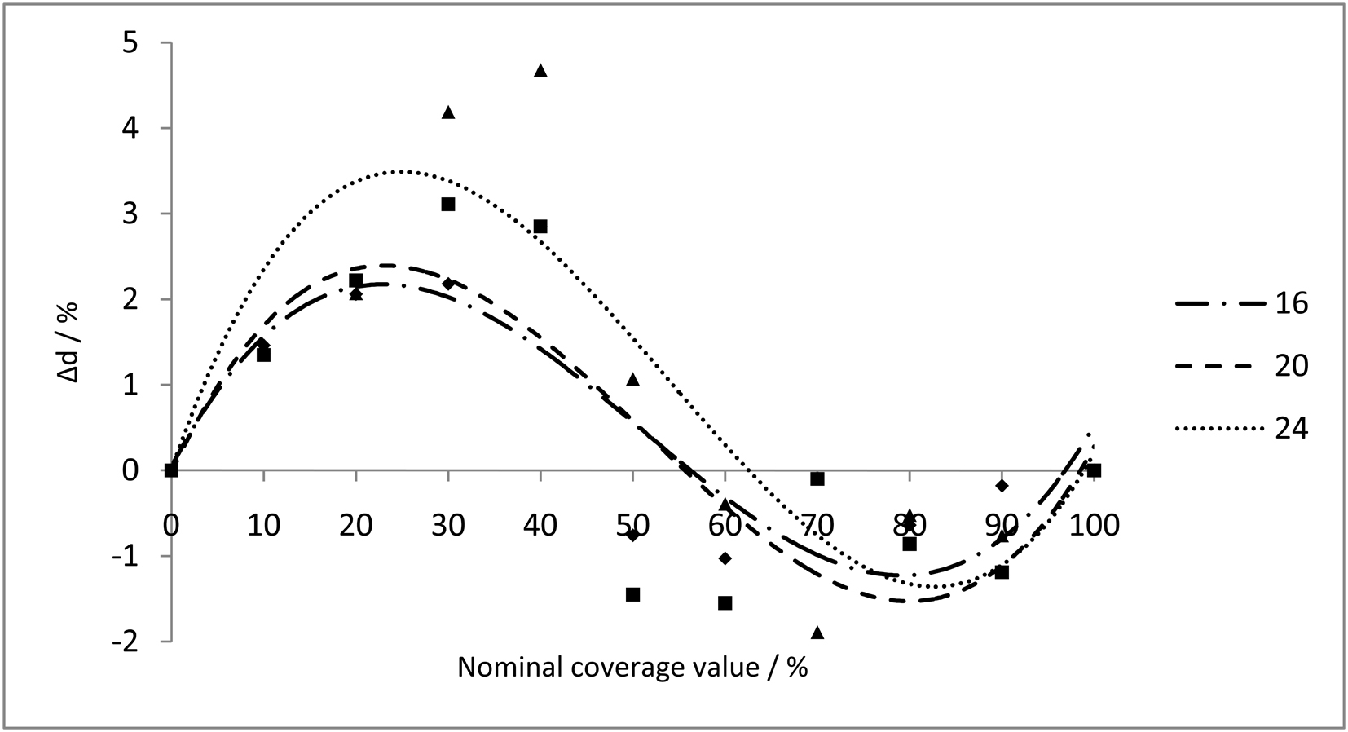
Fig.7. Comparison of coverage values calculated by ImageJ and IC Plate II

Figure 7 shows the difference of coverage values measurements performed by ImageJ and IC Plate II. Δd presents difference between coverage value calculated by ImageJ measured by IC Plate II (1).

Δd = coverage value_{ImageJ} – coverage value_{IC Plate II} (1)

One can see that Δd is positive for coverage values from 0% - 60%, meaning that ImageJ detects higher coverage values in this area. From 60% - 100% IC Plate II measures higher coverage values than ImageJ.
Printing plate sample with developing time of 24 s shows the highest difference in coverage values measurement, while sample developed 16 s shows the smallest difference. The reason of this behaviour could be caused by different algorithms for conversion of grayscale image to bitmap used by each device/software. Extended developing time affects the printing areas by causing dissolution of printing element’s edges and dissolving only part of the photoactive film which causes different gray tone values. On the other hand, ImageJ calculates higher values in general, but at higher coverage values (> 60%), it analyzes the image as a negative image. This means that further correction was made on the nonprinting areas resulting as decrease of calculated coverage values.

- Conclusion
In this paper the differences in measuring systems for determining coverage value of the diazo positive lithographic printing plate’s control wedge have been investigated and the influence of the developing process on printing areas was observed.
Results have showed that duration of developing process changes the printing plate’s coverage values. With extended developing time, developing solution starts to dissolve edges of printing elements, causing the decrease of the coverage value [6].
Investigation of two different measuring systems for image analysis (IC Plate II and ImageJ) showed the difference in coverage values calculation. IC Plate II is automated device for capturing the printing plate’s area, storing the information and automatically calculating coverage value, while ImageJ is software that analyzes imported image that needs to be captured by the microscope.
Based on the results and experience, one can say that ImageJ system is more complex method for coverage calculation, but it has greater control of the imported images and according to this obtaining the more accurate results.
In addition, portable camera and image analysis software could be powerful and economical tool for quality control of the printing plates, furthermore imprints, recycled papers and other similar products (materials) used in graphic arts reproduction.

5. References
[1] Neues J., Falge H.-J., Ugra/FOGRA Reproduction Test Chart 1999, Sonderdruck Nr. 6, Fogra, München, 2000.

[2] Kipphan H., Handbook of print media, Springer-Verlag, ISBN 978-3-540- 67326-2, Heidelberg, Germany, 2001.
[3] Baracic M., Cigula T., Tomasegovic T., Zitinski Elias P. Y., Gojo M., Influence of Plate Making Process and Developing Solutions on the Nonprinting Areas of Offset Printing Plates, Proceedings, 20th International DAAAM Symposium: "Intelligent Manufacturing & Automation: Theory, Practice & Education", (ed. B. Katalinic), ISBN 978-3-901509-70-4, Vienna, Austria, 2009.
[4] http://gretagmacbeth.software.informer.com/ (last request: 2011-09-14)
[5] http://www.uhnresearch.ca/facilities/wcif/PDF/ImageJ_Manual.pdf (last request: 2011- 09-15)
[6] Žitinski Elías P. Y., Tomašegović T., "Influence of the developing solution onto wetting of offset printing plate", Rector's Award, Univeristy of Zagreb, Zagreb, Croatia, 2009.

