Klara Bilić Meštrić

The Faculty of Teacher Education Osijek

Josip Juraj Strossmayer University of Osijek

Klara.bilic.mestric@gmail.com

HOW TO MOTIVATE JURAJ TO LEARN ENGLISH?

ACTION RESEARCH – TEACHING FIVE-YEAR-OLD FRATERNAL TWINS THE ENGLISH LANGUAGE

August, 2011.

# Introduction

This paper is a result of several weeks of work with my children, five-year-old twins. Though the title theme is more of pedagogical nature – how I can personally influence my son's motivation, it is also linguistic, as it gives an account of metalinguistic issues of concern (questions of motivation to learn a language and attitudes towards it).

# Theoretical framework

Given the wide scope of phenomena covered in this research – pedagogical (how can I personally improve one's learning), linguistic (foreign language acquisition), psychological (questions of motivation and individual differences) and sociological (learning a language as a form of group interaction, Halliday in Wells, 1999) – one can assume that there are numerous works that deal with this problematic. However, it is exactly for this reason that the choice of literature is somewhat narrower and it comes down to the key works in the fields concerning the theme.

## 2.1 On motivation

From the linguistic perspective, when tracking the development of one's own children is in question, one cannot but mention works by Marta Medved Krajnović (Medved Krajnović, 2010), who gives very detailed accounts of multilingual development of her own children. However, these works basically differ as the language development there refers to the second language acquisition, namely, language used on an everyday basis, either in school or in its natural surroundings. A second difference is in the approach itself – the research of Marta Medved Krajnović is not action research, while this one was (or at least attempted to be).

Not only is Marta Medved Krajnović's book important because of its theme, but because it also gives a concise theoretical overview of SLA and FLA, including issues of *motivation* and *individual differences* (Medved Krajnović, 2010.).

Far back in 1960 Robert C. Gardner wrote his PhD thesis on motivation in second language learning and indicated its importance in the process of language acquisition. As highlighted by Medved Krajnović (ibid, 2010.) his hypotheses are still accepted, with certain variations. In the book *Second Language Acquisition (An Introductory Course),* Gass and Selinker (2008) also stress the importance of motivation and see it as a dynamic construct: „it changes depending on the context and it changes over time“(ibid, 2008:429). Bearing this in mind, I find Marta Medved Krajnović's definition as the base for this research: „What is actually motivation? We can say that it is a set of motives, namely psychological states that drive and direct human behaviour and determine the intensity of that behaviour”. (Medved Krajnović, 2010:77)

Dörnyei (in Medved Krajnović, 2010.) breaks motivation down into five components:  
• An important goal or need  
• The desire to achieve this goal  
• Understanding / feeling that mastering the foreign  language is essential to the achieve a goal or satisfy the needs   
• Belief in the success / failure of the learning process  
• The importance of the possible outcomes

In spite of referring to up-to-date research, this categorisation, as well as the other one by Dörnyei concerning *the ideal self* and *ought-to self*, do not apply much to early language learning where a foreign language is primarily a part of some other goal – a game or book reading (listening). As Stengel puts it, new language presents a new way of playing for a child (Stengel in Mihaljević Djigunović, 1995) – so the goal of learning or the need for learning is overlapping with the goal of the game, while the learning process is still not made conscious. Research by Jelena Mihaljević Djigunović (ibid, 1995) states that this perception of learning a language as a form of game, decreases with age, so this is a typical characteristic of early learning.

Equally, it is difficult to approach the subject in regard to intrinsic factors (and to some extent extrinsic too) which determine motivation variations, which are also mentioned by Medved Krajnović: *motivational self-regulation* and *self-determination* are not traits easily attributed to five-year-olds. Namely, self-regulation refers to the ability of self-control – to keep the same level of motivation in various (unfavourable) circumstances. Earlier research has shown that pleasure is a key factor in earlier age, or as Mihaljević Djigunović puts it: „It is essential that younger learners of a foreign language perceive their learning as pleasurable“ (ibid, 1995).

As it will be shown soon, the five-year-olds are strongly determined by the circumstances in which activities take place and the issues of motivation have turned out to be central in their learning.

It is interesting though that some other factors mentioned by Medved Krajnović (Medved Krajnović, 2010), displayed a converse correlation in this research. Namely, Juraj was more willing to communicate with foreigners, he showed less language anxiety and a higher level of linguistic self-confidence, though he was the one who was not willing to learn English.

## 2.2. On language as a form of group interaction

Halliday’s „ *inter-organism* perspective, language as what goes on between people (language as interaction, or simply as behaviour” standing on the opposite side of spectrum to „Chomsky's *intra-organism* perspective (language as what goes on inside the head, language as knowledge) )“ (Halliday 1974:81 in Cattell 2000) is also one of the starting points for this research. Learning a language mostly takes place within a group (a mother and a child already make up a group), work by Michael Halliday and his viewpoint of a language as a form of social interaction through which we make meaning, I find essential for this research, since the group dynamics is of core importance for motivation of an individual in a community. It is noteworthy that Halliday also came to his findings by studying his son Nigel.

## 2.3 Studies on language development in twins

As this research is conducted with (and on) twins, it is important to address some major studies that deal with language development in twins. Jennifer Ganger from MIT gives a concise overview of research conducted on hundreds of twins which actually showed that twins are delayed in language development.

Though this research refers to first language acquisition, some of its findings can be connected with foreign language learning too. The first (biological) reason for this delay is somewhat mysterious – it has to do with the (low) birth weight. However, apparently it turned out that correlation between low birth weight and delay in language development concerns not only twins, but also singletons. (Akermannand Thomassen in Ganger 2011)

The second reason, environmental, is more applicable to this study: „ Several studies have now found that young twins receive less directed speech from their caretaker and participate in fewer situations where their attention is jointly engaged with the caretaker. Both of these situations are thought to be necessary (to some extent) for language learning“. (Ganger 2011). These findings highlight the importance of group dynamics, just like Halliday's .

Furthermore, studies that deal with second language acquisition indicate the importance of biological factors, and the lesser importance of the environment. Research conducted on 600 pairs of identical twins by Dale, Harlaar, Howorth and Plomin (2010) stresses the crucial role of hereditary factors. However this research was conducted on identical twins, who share the same genetic structure.

On the other hand, research on fraternal twins also displays the importance of biological factors. Tepeen states that Lenneberg' findings showed that 90% of identical twin pairs have a similar development of speech and language compared with 40% of fraternal pairs and he also highlights the fact that Lenneberg attributed the greater similarity between identical twins to their shared genetic inheritance. Furthermore, Tepeen concludes that subsequent work by other researchers confirms Lenneberg's findings (Tepeen, 2004:6).

He also quotes a similar study by Munsinger and Douglas who came to almost identical conclusions which all indicate a stronger position of hereditary factors than environmental, when language acquisition is concerned. These studies point to the need for different approaches in motivation stimulation when fraternal twins are concerned, giving us biological base of their individual differences.

# Methodology

Though these quantitative accounts inform the overall research, this is action research which is based on an individual approach and in which a researcher is at the same time a practitioner (the one who can, and is expected to, influence the results), and the informants are actually expected to be active participants.

The idea of educational action research developed at the beginning of the last century in the works of the American philosopher John Dewey, who recognised the inappropriateness of the application of natural sciences on humanistic ones and called for the new approach in humanistic sciences which would bridge the gap between theory and practice (Burns, 1999, Bognar, 2006).

The basic characteristics of this action research are those stated by Anne Burns (1999):

1. It is a contextual, small-scale and localised research – since it deals with my two children and it deals with issues of their motivation to learn a foreign language (one child in particular) – thus a very specific situation.
2. It is evaluative and reflective – it wishes to enhance motivation in a child who was unwilling to participate during research, and it also brought about a change in my own approach.
3. It is participatory as a few people take part in it – my critical friend prof. dr.sc. Branko Bognar, Blanka Treselj - an English teacher and a PhD student of linguistics and cognitive neuroscience, and also the father of the twins, my husband. The most important role is that of boys, who, with their comments and attitudes reshaped the stages of research.
4. And finally, changes in activities are based on the data collected and reflections of my critical friends.

# Research context

Research deals with my two sons, fraternal twins, five years and five months old – Juraj and Stjepan. At the beginning of the research they were five years old and two months. They had been sporadically exposed to the English language prior to the research. I read children books in English to them since they were babies to the same extent as I did with children books in Croatian. One of the first words that Juraj uttered was thunder (which did sound more like under), from Dr Seuss's *The Wonderful Book of Sounds*, which might have had to do with the affective value given to the word uttered onomatopoeically, making a loud noise. Before they turned two, they both liked to listen to the stories in English and did not show preference of one language over the other. As they turned two and started speaking with (meaningful) sentences this drastically changed and the boys insisted on the mother tongue. I would still read to them in English but now they were asking for translations (“cad fuvatki” - „now cvoaian“). My attempts to speak to them in English for longer periods would end with their crying and sentences such as „You are no(t) our mother“.

Regarding the mother tongue – it goes by the book, meaning that the language development is somewhat delayed. Though they are very fluent now, they do have problems with phonetic apparatus, a typical problem for twins of this age (Ganger, 2011) Stjepan cannot clearly articulate voices /l/ , /ts/ and / ʊ /, while Juraj has troubles pronouncing palatals / tʃ / and / ʃ / and the dentals /ts/ and / z̪ /.

Another curiosity which illustrates linguistic differences between the boys is that they speak different idiolects; Stjepan uses standard *što* dialect (štokavština) with a mixture of different standard and Zagreb dialects, while Juraj speaks *kaj* dialect (kajkavština) – a mixture of Zagreb and Zagroje dialects, their father's idiolect.

They have been constantly exposed to the English language through children books, occasional very short conversations in English (they tend to answer the questions with *Yes* and *No*, they use greetings *Bye*, *Hi* and *Hello*). Due to the popular culture influence they can say and understand expressions: *I am your son*, *I am your father*, *I am your mother* (through the *Star Wars*, especially Darth Wader’s character). The Dr Seuss collection of children books is ,as mentioned, a great source of their vocabulary (*cat, hat, box, fox, boat, goat, here, there, everywhere, tail, eggs,* constructions such as *Are you my mother, I don't like it*...), also through

some other classic children books they know how to name the animals, food and some natural phenomena (*The Runaway Bunny, The Hungry Caterpillar, Goodnight Moon, We are going on a bear hunt*...).

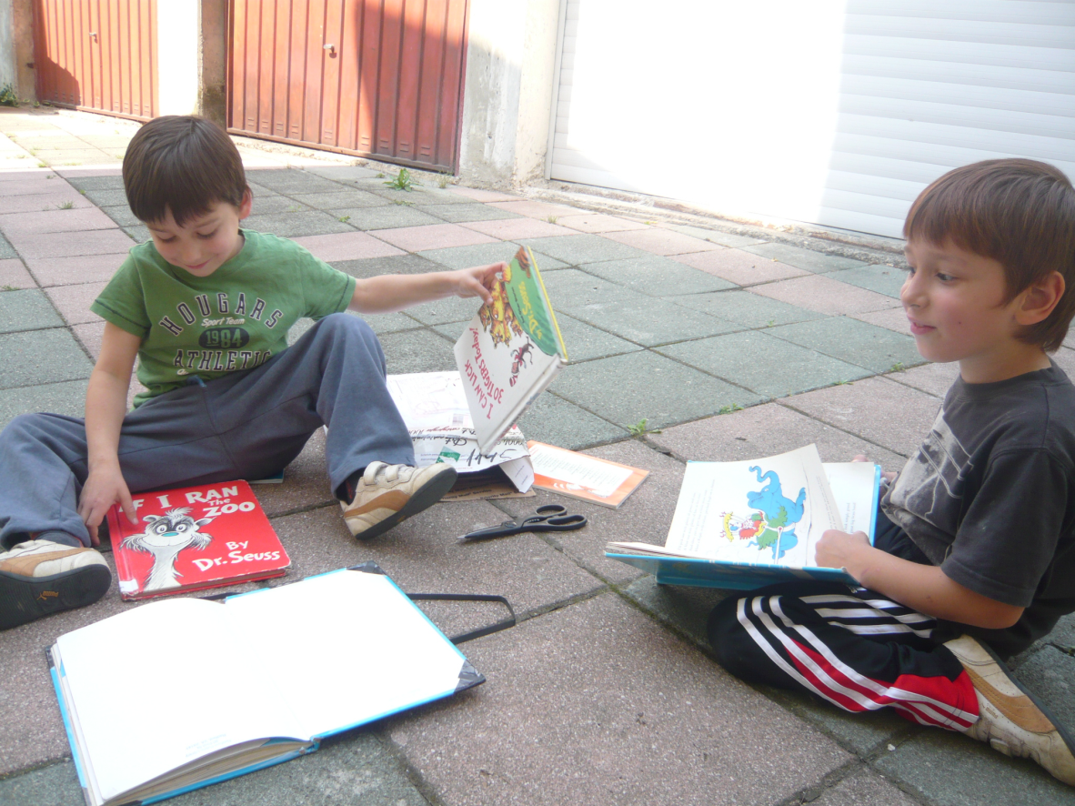

***Figure 1.*** *The boys with the Dr Seuss collection – the new package arrived and the survey is on.*

As far as individual differences are concerned, Stjepan, who has displayed greater eagerness for learning the foreign language, is more communicative and extroverted. He has no problems meeting new people and asking questions. He is very interested in numbers and relationships between people; his questions are mostly concerned with inter-personal relations (why somebody is with someone). Juraj is more introverted, he spends a lot of time drawing, he enjoys concrete tasks (digging in the garden, watering the plants) and he is more interested in natural phenomena (volcanoes, lava, rain, wind, seas). However, it is interesting to observe that Juraj's adaptation to peers is smooth, while Stjepan often ends up alone reading children books when in larger groups of peers.

Moreover, Stjepan is the one who possesses a higher need for achievement and perseverance –characteristics that by Naiman make a good language learner (Naiman et al, 1978). He is also more confident (positive task orientation) than Juraj and finds it important to keep a positive self-image (ego-involvement).

I am an English language teacher and I work at the Faculty of Teacher Education Osijek, the Slavonski Brod branch. I have loved the English language ever since I became aware of it. Before I started learning it I had my own made up language which sounded like English to me. I also lived in an English speaking area for two years as a teenager.

# Values

I have started this research from my own personal values in which knowledge of a foreign language has a high position. I see it as a way of broadening the communication, improving the chances to get to know both new people and new cultures, which would not be possible by knowing only a mother tongue.

As the research went by, my own pedagogical values were being changed due to the reflexive comments of my critical friends, and due to research findings. That is to say, at the beginning of the research, I promised the boys some rewards in order to motivate them, so I have employed a behaviouristic approach, having thus applied exactly the opposite of what is recommended if we want to stimulate intrinsic motivation (Watts Jr, Cashwell, & Schweiger, 2004). However, during the research I found out that this approach yielded only short-term results.

# Research plan

This research began as standard research through which I wanted to track linguistic development of my children in regard to the vocabulary. However, early at the beginning of research I noticed that the boys react differently to the foreign language learning. I kept in mind advice given by professor Višnja Pavičić Takač – „let yourself be driven by your own research curiosity“, and having taken into account that the boys share the same environment, are of the same age and same sex – their different reactions and different level of motivation turned out to be more intriguing and thus became the subject of the research. Understanding and accepting a different level of motivation and finding ways of enhancing Juraj's motivation became the primary goals of this research.

The action plan consisted of a set of activities in English, namely various games, story reading and conversations in English. Almost all of these activities were known to the boys from before, but now they became more frequent and more various. At one moment, the action plan was to sustain from action, which actually gave some positive results as soon shall be seen. Research criteria were set as Juraj's willingness to participate in the English language activities.

The data were collected in research journal, where I kept notes of the boys' behaviour, linguistic progress, attitudes towards learning and their valuable metalinguistic comments. I also recorded my critical friends' voices which influenced the research. I tried to video record the activities with the boys, but then their attention was completely distracted by the presence of a camera.

# The change process

Though the boys had been exposed to the English language through the above mentioned activities, as the research commenced I tried to formalise our activities. The activities were not merely in the function of play anymore as they now assumed a reflective dimension (keeping a journal, correspondence with critical friends). Furthermore, these activities were not now only in the form of occasional sporadic children books readings and short conversations but an active, planned endeavour which required my and their full involvement. I tried to keep the activities on an everyday basis, or at least every second day.

First of all we read books daily. They had to repeat words from a book I read to them - first they had to show the illustrations and then later complete the sentences, and where possible all phrases.

The new activity was a Bingo game specialised for early English learning. Cards had several general categories – *food, furniture, toys, animals, colours, shapes, means of transport, nature and weather, school* with an illustration on one side and the name on the other. The boys would take the card with six notions/images. At the beginning, they had a picture side up and I would draw the cards from the deck and say its name aloud – if the boys had it they had to say. In the beginning I showed the picture to them, to make sure they understood. Later on I would just read the word and they were expected to know whether they had this thing in their Bingo cards or not. We also played different variations of this game – guessing the words and categorising them.

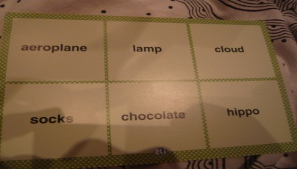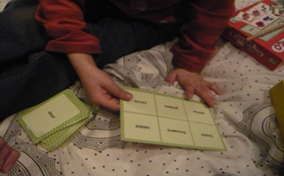

***Figure******2****. Bingo cards with which we played*

Stjepan was very willing to work; however, Juraj would easily give up and speak against learning a foreign language. At the same time, though the boys had been exposed to English to the same extent, Stjepan would give feedback faster, recognise the pictures when he heard the word. Juraj was not very focused in most of these activities and his attention had to be specially sought for.

Because this was how the research started, I asked for help from my critical friend – the boys' father, as a person who knows Juraj the most, besides me. The answer was not the answer an English teacher wants to hear: „Stjepan does it out of persistence and competition. Why would Juraj learn English, why would he be motivated? I don't know how to motivate people if they don't like something“. (Research journal, 23rd June, 2010)

This answer only made me think more – why one child liked the foreign language and the other did not. On the other hand, the choice of these activities was quite limited – it was mostly either Bingo games or books, so my critical friend prof.dr.sc. Branko Bognar suggested that „a modest variety of activities might be the problem, not learning the language itself“. „ (prof. dr. sc. Branko Bognar, personal correspondence, 28th June 2011).

We also learned songs from pupils books (*Building Blocks* and *Way to Go)* for early learning. Though the first song went smoothly with Juraj (*Up and down, turn around, up and down, hop-ho, up and down, stop-stop, stop*), when learning the second one (*Toys, toys for girls and boys, come and see play with me...*) – Juraj's comment was: „English is boring!“. I suggested they sing the song to their grandparents, a suggestion that Stjepan eagerly accepted while Juraj rejected the idea.

It is worth mentioning that at this early stage of research I tried to motivate them using rewards – giving them small presents I thought might make them happy. This approach worked with Stjepan. He would proudly show his rewards, while Juraj was not additionally motivated, and as it turned out it was needless even for Stjepan as he continued to participate in the activities later on when I stopped using rewards.

After several more tries (days with activities in English) Juraj did not want to participate at all, giving the following explanation: „I told you when I'll learn and speak English. When I come to England then I'll learn and speak it. I don't need it now.“ (Research diary, 1st July 2011). Not only did he know that he did not want to learn but he also knew why he did not want it – for a simple reason of not needing it.

At this moment I was still not aware that I should accept his determination and that insisting on further learning could actually only increase his resistance.

In order to enhance Juraj's motivation I decided to split the boys and work individually with each of them. I relied on research findings provided by Jennifer Ganger on the acquisition of mother tongue which implied that receiving less directed speech from one's caretaker causes delays in twins' language development (Ganger, 2011).

Halliday's perception of language development as a form of conversational interaction (Wells, 1999) also served as a base of these individual activities – if we acquire language through active involvement – Juraj's decreased activity could be the result of his brother's dominance.

Juraj was cooperative and very active in our first individual session. He answered my questions and seemed thoroughly involved. On the other hand we did not play Bingo, as it is not a one person game and also a game the function of which to learn the new vocabulary is rather prominent. We were reading a book by Dr Seuss – *Green Eggs and Ham*. Juraj did not ask for translation and he readily showed me the illustrations for – *green eggs, ham, box, fox, boat, goat, rain, train, sea..*. Afterwards he also answered my questions – „How would you say in English...?“

However, the following day, after my suggestion to play (my critical friend Blanka Treselj's suggestion was to avoid words *work* or *learn*) in English caused his old resistance: „Not English again, English is boring!“ (Research diary, 5 July, 2011)

After this remark I decided we needed a break. The more insistent I was, the more he seemed to resist learning. We now returned to our old activities, reading books in English sporadically at bed time – with translation of course.

...

After a ten day break I took the Bingo cards and without any introduction I asked them to play with me. Both of them accepted and this time both participated equally eager. At bed time I suggested a game with which we would check their memory. Both of them remembered the words we played with during the day and no one displayed any particular advantage over the other one. Juraj remembered some words better, and vice versa.

Our activities now had the same frequency as they did before the action research started, and that was obviously adequate for them, Juraj in particular. They were not something that was announced – „Now we will do English!“, but spontaneous activities incorporated in some other activities which were part of their everyday routine.

...

Another curiosity was that Juraj's role in language learning became more prominent when there really was a need for it. During the summer, the boys were hanging out with two girls from England (Olivia 8 years of age, and Phoebe aged 3). Besides playing with them on an everyday basis Juraj was the one who was more interested in communication with the girls. He also brought his English books to the older girl and asked her to read to him. Olivia read *Scrambled Eggs Super!,* by Dr Seuss, 64 pages of illustrations and text in one go to him and he was attentively listening. He would also often come to me and ask me how to say something in English, what he wanted to say to the girls. Interestingly, Stjepan, who was more willing to learn with me, kept more aside. This change in attitudes opens up space for further inquiry.

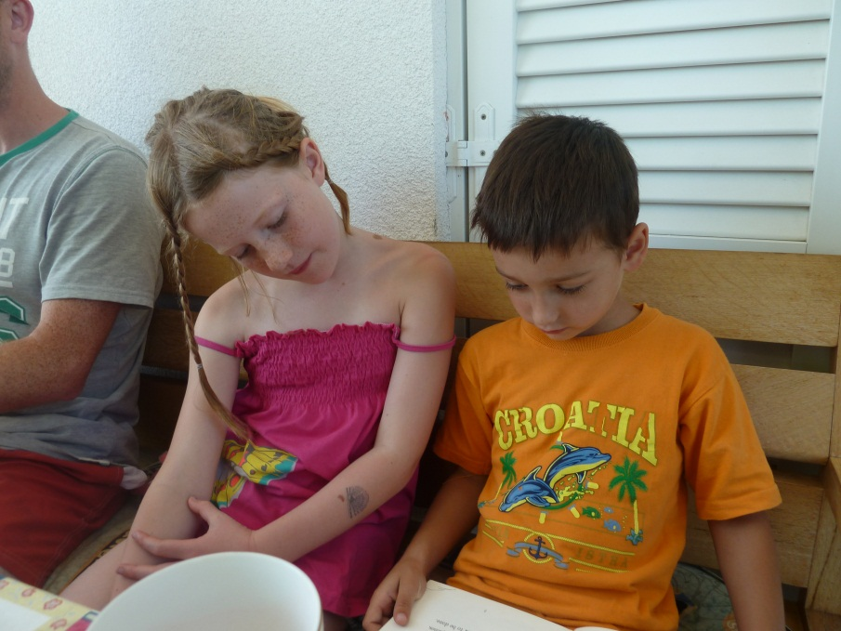

***Figure 3.*** *Olivia is reading Scrambled Eggs Super! by Dr Seuss to Juraj*

# Interpretation

At the beginning of research I was prone to think that Juraj's and Stjepan's different level of motivation was a result of their different genes. This is a conclusion I came to in the early stage of research:

„In spite of the same environment, the same age and the same sex, two boys display completely different attitudes towards the foreign language learning. Boys do not have the same gene structure (as they are fraternal twins), thus this different attitude might be the results of their different genes. The fact is that the boys' father and mother regard learning a foreign language differently – where mother perceives it as something self-purposeful, while father takes on a more pragmatic stance. However, it is hard to tell whether these are hereditary conditioned preferences or the result of their upbringing. (Note from research account dating 15 July 2011)

However, my critical friend dr. sc. Branko Bognar in his comment gave the following criticism:

„ One must take into account that small children can make decisions independently, which is not the result of hereditary factors, but attitudes which are autonomously caused.“ (Branko Bognar, personal correspondence, 22nd July 2011)

A commentary by my critical friend warned me of making prejudgments. Thus the focus shifted from the question – „Why the boys have different level of motivation?“ to one „How to motivate Juraj to learn English?“ and „How to improve my own approach towards these issues?“.

It turned out that the frequency of activities before the research was completely adequate and had positive influence on Juraj's motivation – never had he opposed the idea of learning English before the research, or at least not more than Stjepan. Furthermore, in the context where the language was really needed (playing with two girls from England) Juraj was more interested in English than Stjepan.

After this small-scale research, there are several conclusions I can reach:

Five-year-old twins, despite the same environment and sex, same upbringing, can have different attitudes towards a foreign language, and thus different levels of motivation.

1. Though the boys' motivation can be a result of different factors, from hereditary (as a vast amount of quantitative research suggests), through sociological (group dynamics – working alone with Juraj, working with Juraj and Stjepan together), and utterly individual (individual differences), in the end it turned out that a careful and attentive approach (which sometimes even means sustaining from action) can stimulate one's motivation. Though Juraj was resistant at the beginning, articulating this very clearly, in the end, by my acceptance of his refusal, and by accepting the frequency and intensity which met his needs, his attitude changed and he again participated in the activities.
2. Research has also shown that reward methods are not effective enough for motivation in very young learners, and that methods of obligation („we have to learn“) can be utterly contra productive. Or in other words – learning must be the result of intrinsic motivation, not extrinsic (Watts Jr, Cashwell, & Schweiger, 2004). A moderate amount of activities (as it was before the research) connected with their real interest (Yoshida in Szpotowicz, 2009.), as the examples of short conversations from *The Star Wars* or books by Dr Seuss, and the context which requires a real need for language turned out to be the best combination for Juraj's motivation.

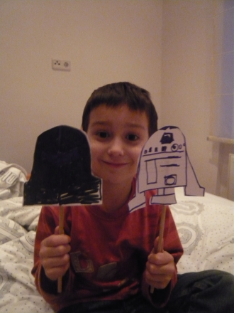

***Image 4.*** *Juraj with The Star Wars characters – Darth Wader i R2D2*

In the end, I can conclude that motivation truly is a dynamic construct dependent on time and context (Gass and Selinker, 2008), and as such open to change. In this short time Juraj's and Stjepan's motivation for learning a language turned out to be greatly influenced by the context, my personal efforts, and the conditions I could not control and as such it has only deepened my personal curiosity in which direction it might develop, regarding the forthcoming formal education and their individual differences, which are also questions for further research on this topic.

# Bibliography:

# Bognar, B. (2006). Akcijska istraživanja u školi. *Odgojne znanosti 8 (1)*, 209-227.

Burns, A. (1999). *Collaborative Action Research for English Language teachers.* Cambridge: Cambridge University Press.

Cattell, R. (2000). *Children's Language.* London: Cassell.

Dale, P. S., Harlaar, N., Haworth, C. M., & Plomin, R. (2010). Two by Two A Twin Study of Second-Language Acquisition. *Psychological Science*, 635-640.

Ganger, J. (2011). *Are twins delayed in language development.* Boston: http://twins.wjh.harvard.edu/delaylit.html#commentary.

Gardner, R. C. (1960). *Motivational variables in second-language acquisition.* http://publish.uwo.ca/~gardner/docs/phd.pdf.

Medved Krajnović, M. (2010). *Od jednojezičnosti do višejezičnosti - Uvod u istraživanja procesa ovladavanja inim jezikom.* Zagreb: LEYKAM INTERNATIONAL D.O.O.

Mihaljević Djigunović, J. (1995). Attitudes of Young Foreign Language Learners: A Follow-up Study. *Children and Foreign Language*, 16-33.

Naiman, N., Frohlich, M., Stern, H., & Todesco, A. (1978). *The Good Language Learner.* Toronto, Ontario: Ontario Institute for Studies in Education.

Norris-Holt, J. (2001). Motivation as a Contributing Factor in Second Language Acquisition. *The Internet TESL Journal, Vol. VII,* , http://iteslj.org/Articles/Norris-Motivation.html.

Selinker, S. M., & Glass, L. (2008). *Second Language Acquisition.* New York and London: Routledge.

Szpotowicz, M. (2009). Factors Influencing Young Learners' Vocabulary Acquisition. U M. Nikolov, *Early Learning of Modern Foreign Languages* (str. 195-211). Beistol, Buffalo, Toronto: Multilingual Matters.

Teepen, J. (n.d.). On the Relationship between Aptitude and Intelligence in. *Columbia University Working Papers in TESOL & Applied Linguistics, Vol. 4, Special Issue*.

Watts Jr, R. H., Cashwell, C. S., & Schweiger, W. (2004). Fostering Intrinsic Motivation in Children: A Humanistic Councelling Process. *Journal of HUMANISTIC COUNSELING, EDUCATION AND DEVELOPMENT, Vol 43*, 16-24.

Wells, G. (1999). *Dialogic Inquiry.* Cambridge: Cambridge University Press.