Model optimization of nanocrystalline Si:H thin film solar cells

V. Tudić*, Lj. Majdandžić*, J. Groš*
* Karlovac University of Applied Sciences/Department of Mechanical Engineering, Karlovac, Croatia
vladimir.tudic@vuka.hr

Abstract - Photovoltaic properties of nanocrystalline (nc-Si:H) heterojunction thin film solar cells with the single junction structure of TCO/p- nc-Si:H/i1- nc-Si:H/i2- a-Si:H/n- nc-Si:H/AZO was studied by a computer modeling software AMPS-1D in this paper. Due to spectral response of solar cells with the examined nc-Si thin films as active elements showed a narrower spectral distribution and a blue shift comparing to pure amorphous solar cells. The results were higher efficiency than amorphous cells due to higher optical gap (higher output voltage) and better fill factor (higher mobility).

I. INTRODUCTION

The electrical properties of amorphous-nano-crystalline thin films deposited by Plasma Enhanced Chemical Vapor Deposition (PECVD) were studied by a computer modeling software One-dimensional Analysis of Microelectronic and Photonic Structures (AMPS-1D) in this paper. The possibility of using hydrogenated amorphous-nano-crystalline silicon (nc-Si:H) thin film solar cells in the production of third generation photovoltaic [1] is most standing challenge. Nano-crystalline thin films are one of the most promising concepts in new thin film solar cells technology [2]. First benefit of nano-crystalline thin film layers are higher value of energy gap in correlation with the size distribution of individual crystal sizes and the crystalline to amorphous fraction [3]. The nano-crystals remain as individual in amorphous matrix (Fig.1) enabling quantum size effects related to small dimensions of crystals. Measurements of the optical properties showed that the spectral distribution of the absorption coefficient in a whole range of crystal to amorphous fractions remained close to pure amorphous silicon in the visible part of the spectrum and showed square dependence on the photon energy (Tauc gap) [4]. The average optical gap was larger for smaller nano-crystals and a higher crystal fraction just confirming the quantum size effects that correspond to quantum dots [5]. The second benefit for using nano-crystalline thin film layers in standard p-i-n solar cell structures is low degradation of electrical properties. Crystal grains either uniform across the sample or slightly larger when located closer to the surface some hove increases material stability to light iluminance degradation process.
A possible application of (nc-Si:H) film as active part in solar cells in a typical p-i-n solar cell structure was tested by computer simulator in respect to overall performance.
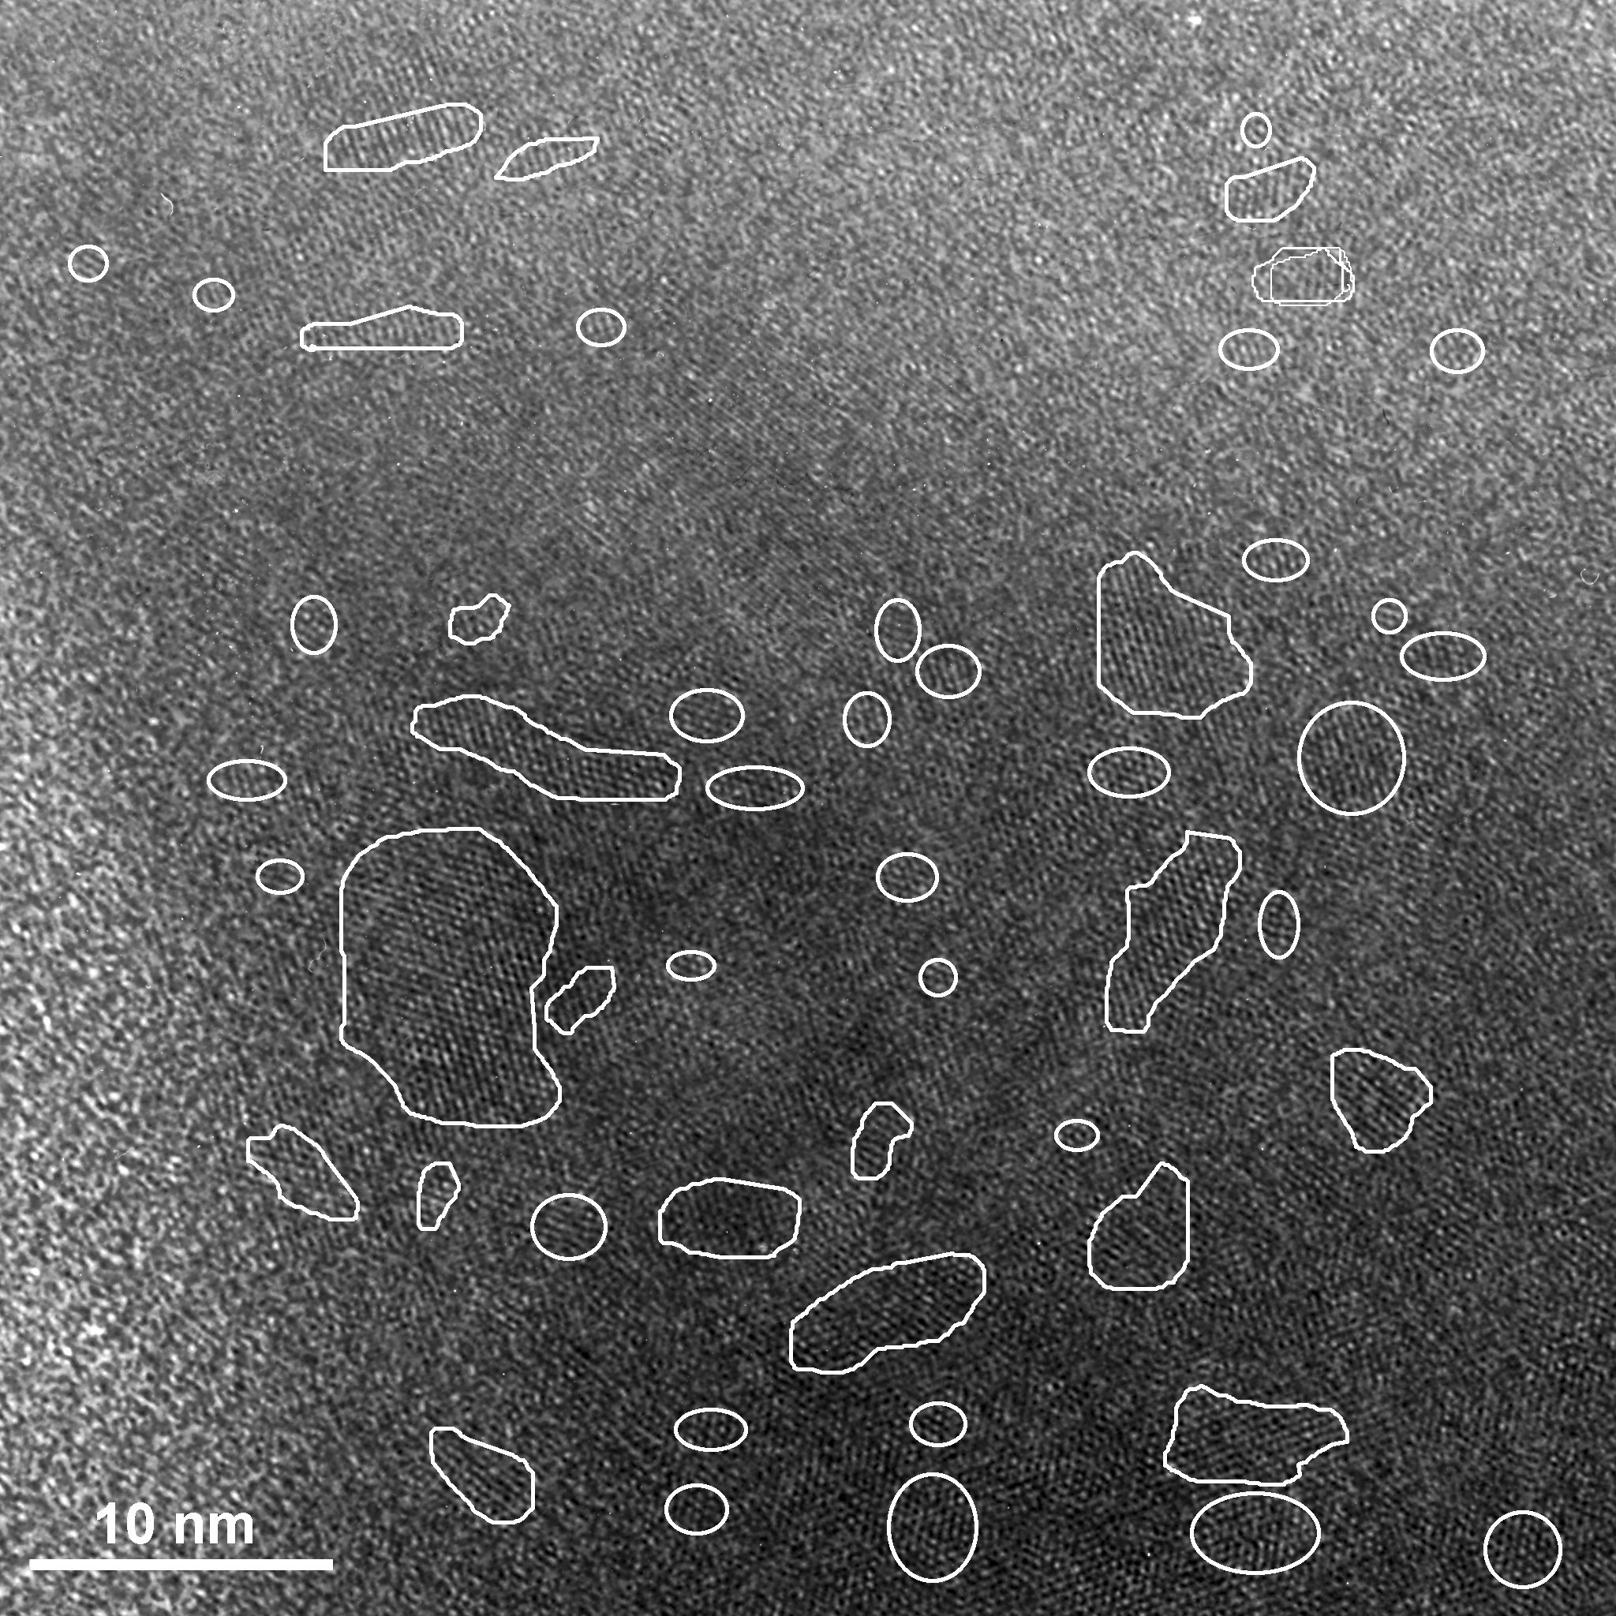
Figure 1. Typical HRTEM micrograph of amorphous-nano-crystalline silicon (nc-Si:H) thin film; 30 vol.% crystalline fraction, published in [4].

II. NANO-CRYSTALLINE LAYER
Nano-crystalline silicon (nc-Si) films consist of a matrix of amorphous silicon (a-Si) with embedded silicon crystals of nanometric dimensions [6, 7]. This material has improved properties with respect to pure amorphous Si and bulk crystalline Si (c-Si) owning quantum confinement effect [8]. When compared to amorphous silicon, nc-Si has better electrical transport characteristic [9], possibility to tailor the optical band gap [10, 11] and resistance to light-induced degradation [12]. The main advantage in comparison with crystalline silicon is its higher absorption, which allows efficient solar cells in thin film designed device. This material could be fraction of 'small crystals', expected to show effect of increase in optical gap due to quantum confinement predictable according to effective mass theory or quantum dots.
The optical properties of nc-Si thin films strongly depend on the production conditions and determination of the structural properties of the thin film.
The spectra of absorption coefficient, α(E), of typical nc-Si thin film calculated from transmittance by Fourier transform photocurrent spectroscopy (FTPS) and photo deflection spectroscopy (PDS) is shown in Figure 2.
Absorption coefficient data we used in our calculation and device simulation was published in literature [6, 13]. Amongst others, sample number two (K2) is chosen because of convenient value of its band gap energy (E_{g}=1.95eV) caused by lower crystalline fraction (vol. 30%).
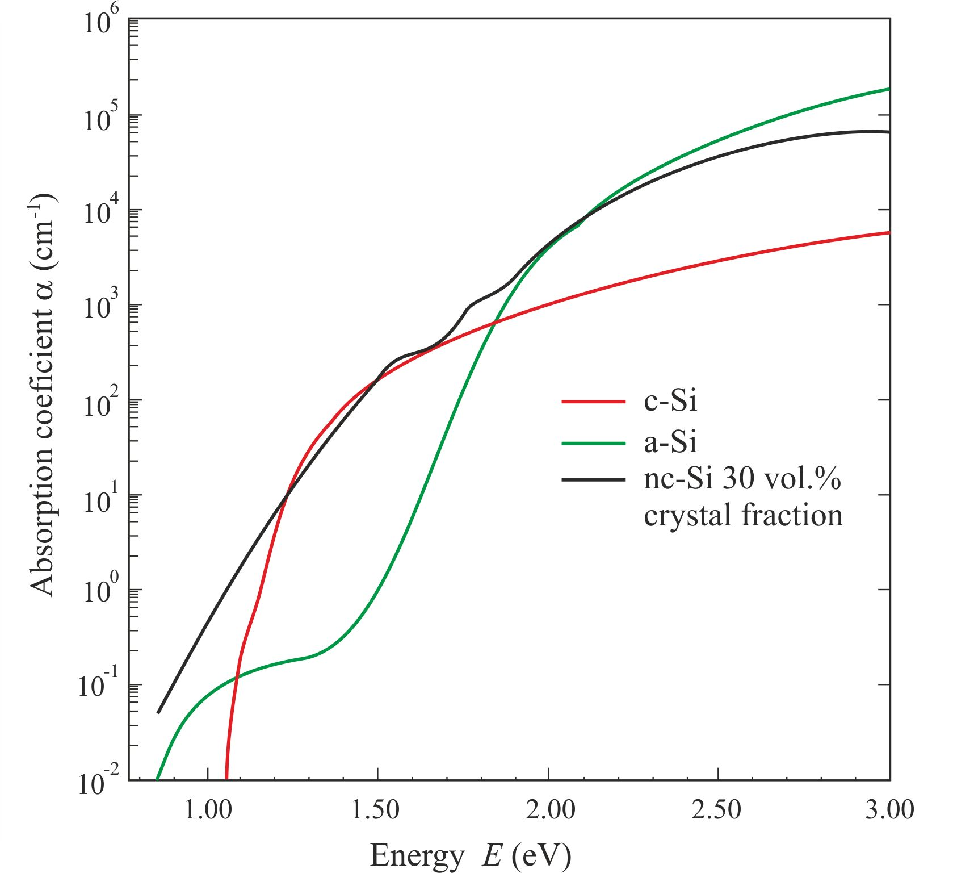
Figure 2. Distribution of absorption coefficient of nc-Si (black line), amorphous Si (green line) and mono-crystal Si (red line) calculated from FTPS and PDS.

III. SIMULATION MODEL

Computer modeling software AMPS-1D can simulate all modeled semiconductor and photovoltaic device structures. In the present version of AMPS-1D user can chose one of two different calculation models: Density of States (DOS approach) and Carrier Lifetime Model (CLM). DOS approach is more suited for silicon amorphous and nano-crystalline thin films layers due to large defect densities in midgap states [14, 15].
Model of photovoltaic device can be simulated throe optical and material parameters on device designed structure. Material and optical properties affect electrical parameters in tree differential equations in correlation: the Poisson's equation, electron continuity equation and hole continuity equation. Those tree equations are solved simultaneously under non-equilibrium steady-state conditions (i.e., under the effect of light, voltage bias or both) by using method of finite differences and Newton-Raphson technique. The used equations are:
Poisson's equation,
$\frac{ρ\left(x\right)}{ε}=\frac{∂Ψ\left(x\right)}{∂x}$ (1)
electron continuity equation,

$\frac{1}{q}\frac{∂J_{n}\left(x\right)}{∂x}=R\left(p\left(x\right),n\left(x\right)\right)−G_{\text{op}}\left(x\right)$ (2)
and hole continuity equation,

$\frac{1}{q}\frac{∂J_{p}\left(x\right)}{∂x}=G_{\text{op}}\left(x\right)−R\left(p\left(x\right),n\left(x\right)\right)$. (3)
All carriers in semiconductor layer can be described by net charge density value$ρ\left(x\right)$, expressed like

$ρ\left(x\right)=q\left[p\left(x\right)−n\left(x\right)+p_{T}\left(x\right)−n_{T}\left(x\right)+N_{A}−N_{D}\right]$ (4)

and the present electrostatic field E is defined as
$E=\frac{∂Ψ\left(x\right)}{∂x}$. (5)
In equation ε is the dielectric constant, E is electrostatic field, Ψ(x) represents the position of energy in the local vacuum level, x is position in the device, n and p the extended states density in conduction and valence band, respectively, p_{T} and n_{T} the trapped hole and electron population density, N_{A} acceptor doping density, N_{D} the donor doping density, if exists, the q the electron charge, R(x) the recombination rate, G_{op}(x) the optical generation rate of free electron-hole pair, J_{n} and J_{p} the electron and hole current density, respectively. The term R(x) is the net recombination rate resulting from band-to-band (BTB) direct recombination and Shockley-Read-Hall (SRH) indirect recombination traffic through gap states. The model used in AMPS for indirect recombination assumes that the traffic back and forth between the delocalized bands and the various types of delocalized gap states is controlled by SRH, capture and emission mechanisms. Since AMPS has the flexibility to analyze device structures which are under light bias (illumination) as well as voltage bias, the continuity equations include the term G_{op}(x) which is the optical generation rate as a function of x due to externally imposed illumination.
Generally, the three state variables completely define the state of a device: local vacuum energy level Ψ and the quazi-Fermi levels E_{Fp} and E_{Fn}. Once those tree dependent variables are calculated as a function of position in device, all other parameter can be determinate as its function. In thermodynamic equilibrium, the Fermi level is a constant as a function of position and hence the tree equations (1-3) essentially reduce to Poisson's equation. Therefore, local vacuum energy level Ψ is the only variable to solve in thermodynamic equilibrium.
Otherwise, in non-thermodynamic equilibrium steady-state, a system of three correlated non-linear second order differential equations in the tree unknowns (Ψ, E_{Fp}, E_{Fn}) is obtained. Further calculation need six boundary conditions, two for each dependent variable. The first two boundary conditions are modified versions of the ones used for solving Poisson's equation in thermodynamic equilibrium:
$Ψ\left(0\right)=0−χ\left(L\right)−ϕ_{\text{bL}}+χ\left(0\right)−V$ (6)
and
$Ψ\left(L\right)=0$ (7)
where L is the total length of the modeled device, χ(0), χ(L) are the electron affinities at x=0 and x=L, respectively and V is applied voltage. Zero value of local vacuum energy level Ψ is at boundary point x=L. The four other boundary conditions are obtained from imposing constraints on the currents at the boundaries at x=0 and x=L. These constraints force the mathematics to acknowledge the fact that the currents must cross at x=0 and x=L (contact position) by either thermionic emission or interface recombination. Mathematically expressed current values at boundaries:

$J_{n}(0)={\text{qS}}_{n0}\left[n\left(0\right)−n_{0}(0)\right]$ (8)
$J_{p}(0)={\text{qS}}_{p0}\left[p\left(0\right)−p_{0}(0)\right]$ (9)
$J_{n}(L)={\text{qS}}_{\text{nL}}\left[n\left(L\right)−n_{0}(L)\right]$ (10)
$J_{p}(0)={\text{qS}}_{\text{pL}}\left[p\left(L\right)−p_{0}(L)\right]$ (11)

where S_{n0}, S_{p0} are surface recombination velocities for electrons and holes respectively at the x=0 interface and the quantities are the corresponding velocities at the x=L interface. Strongly limited by thermionic emission largest value of recombination velocities cannot over cross 10⁷cms⁻¹. In equations (8-9) n(0) and p(0) are the electron and hole density at x=0, n(L) and p(L) are the same values at x=L. Analogy, n₀(0) and p₀(0), n₀(L) and p₀(L) are the electron and hole density at the thermodynamic equilibrium at boundaries x=0 and x=L, respectively. Now, when all conditions are defined, simultaneously calculation of Ψ, E_{Fp} and E_{Fn} can be obtained.
The model used in our simulation for gap states consist of two exponential tail states distributions and two Gaussian distributions of deep defects states (Fig.3).

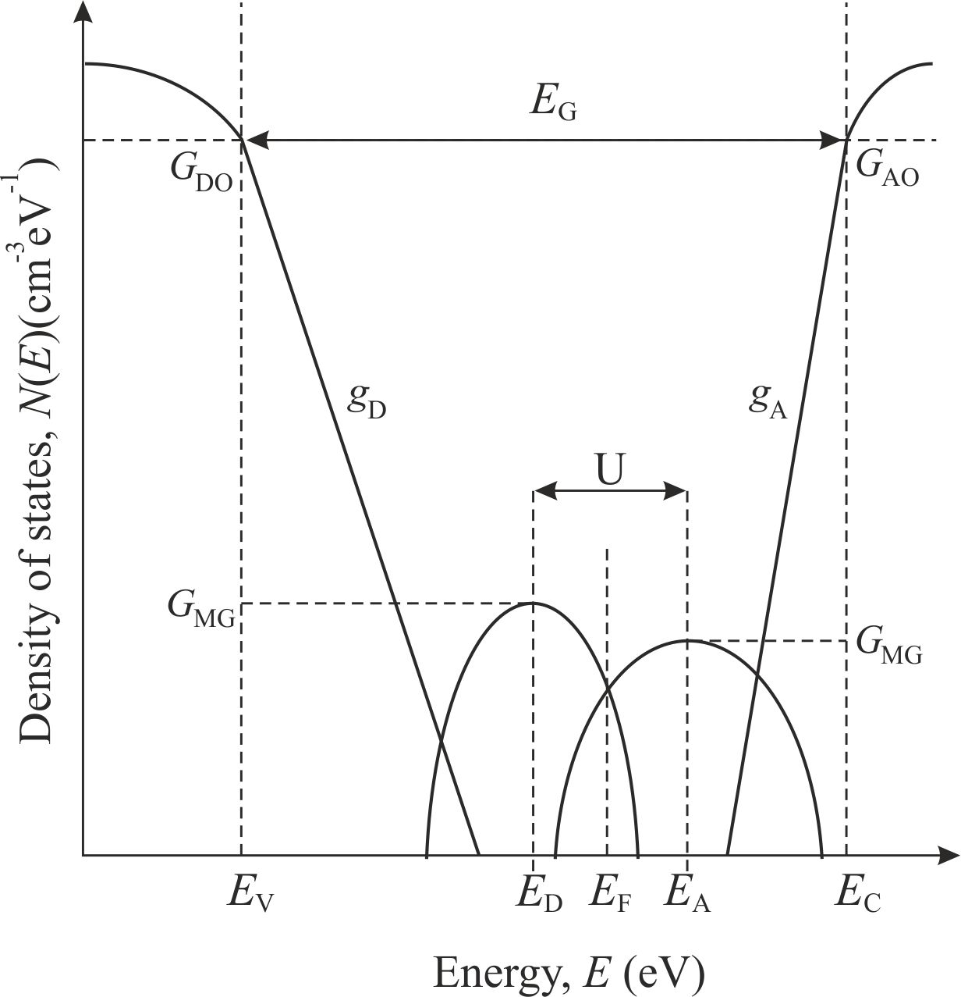
Figure 3. Density of stated distribution where G_{DO} / G_{AO} are exponential prefactors of the donor/acceptor-like tail states at the extended band edges, g_{D} / g_{A} are the donor-like / acceptor-like Urbach tail states, G_{MG} is constant density mid-gap value, E_{D} / E_{A} are Gaussian donor-like/acceptor-like characteristic energy density, U is correlation energy, E_{V} / E_{C} are valence / conduction band energy level, E_{F} is level of Fermi energy.
IV. SOLAR CELL STRUCTURE
In this paper we have simulated two types of single junction solar cells, the first type have the standard structure: p- a-SiC:H/i- a-Si:H/n- a-Si:H and the second type have the following structure: p- nc-Si:H/i1- nc-Si:H/i2- a-Si:H/n- nc-Si:H (Fig.4). Thickness of layers for the first structure is as follows: p- 8 nm/i- 350 nm/n- 15 nm and for second extended structure: p- 10 nm/i1- 50 nm/i2- 300 nm/n- 15 nm. Result comparison of output parameters in both modeled cases (absorber i- and absorbers i1-/i2-) has total thickness 350 nm.
We propose an implementation of chemically textured zinc-oxide ZnO:Al film or SnO₂ as a front TCO in our p-i-n solar cells, and in combination with Ag as a textured back reflector-enhancing dielectric layer for additional efficiency. Such modeled cells exhibit excellent optical and light-trapping properties demonstrated by high short-circuit current densities.
- Boundary conditions
The tree governing equations (1), (2) and (3) must hold every position in the device and the solution to those equations involves determining the state variables Ψ(x) E_{Fp}(x) and E_{Fn}(x). Non-linear and coupled equations cannot be solved analytically, numerical methods must be utilized. Boundary conditions must be imposed on the sets of equations. These are expressed in terms of conditions on the local vacuum level and the currents at the contacts. To be specific the solution to equations (1), (2) and (3) must satisfy the boundary conditions (6-11).

In computer modeling program AMPS Ψ(0) is PHIB0, Ψ(L) is PHIBL, S is recombination speed for holes and electrons depending on carrier position. Parameter RF is reflection coefficient at x=0, RB is reflection coefficient at x=L. In actual situation RF is parameter of lost photon flux transmitting throe glass substrate and TCO layer. Measurements of solar cells internal optical loses (in visible spectrum) showing wavelength (λ) or energy dependence [6, 11, 19]. Reflection coefficient RB depends of optical characteristics of back electrode which acts as an optical mirror and efficient light trapping. We propose a reflection-enhancing dielectric layer such as Al-doped zinc oxide (AZO) between the silicon and the metal. The properties of the front contact and back contact used as the model parameters are shown in Table I.

Table I. Boundary conditions in AMPS: PHIBO is Ψ(0) at x=0; PHIBL is Ψ(L) at x=L (total device length); SNO-SNL-SPO-SPL are surface recombination speeds at x=0 and x=L (N=electron, P=hole); RF is reflection coefficient at x=0; RB is reflection coefficient at x=L.

Front Contact | Back Contact
PHIBO = 1.730 eV | PHIBL = 0.120 eV
SNO = 1x10⁷ cm/s | SNL = 1x10⁷ cm/s
SPO = 1x10⁷ cm/s | SPL = 1x10⁷ cm/s
RF = 0.250 | RB = 0.600

- Solar cells parameters
The input parameters of modeled device layers that simulate output characteristics of actual solar cell are given in Table II. Published selected mobility parameters are taken from references [17, 18]. For calculation of solar cell output it was used the standard global illumination conditions, air-mass 1/cosΘ (AM1.5 spectrum), 1000 W/m² and 300 K temperature.

In nano-crystalline thin film layers transport mechanism strongly depends of carrier mobility μ (cm² V⁻¹s⁻¹). Electron μ_{n} and hole μ_{p} mobility have dependence to crystal lattice temperature also donor-like and acceptor-like doped concentrations, suggesting its maximal values in bulk material. Fraction of 'small crystals' in nano-crystalline material, expected to show effect of increase in optical gap due to quantum confinement predictable according to effective quantum dots and significant enhancing of mobility up to two order of magnitude. For example, electron mobility at temperature of 300K in bulk (intrinsic) crystalline silicon has mobility value 20-40 cm²V⁻¹s⁻¹. In nano-crystalline thin film electron mobility in bulk can reach up to 2000 cm²V⁻¹s⁻¹. According to doping level in silicon thin film mobility of carriers decreases rapidly [18].

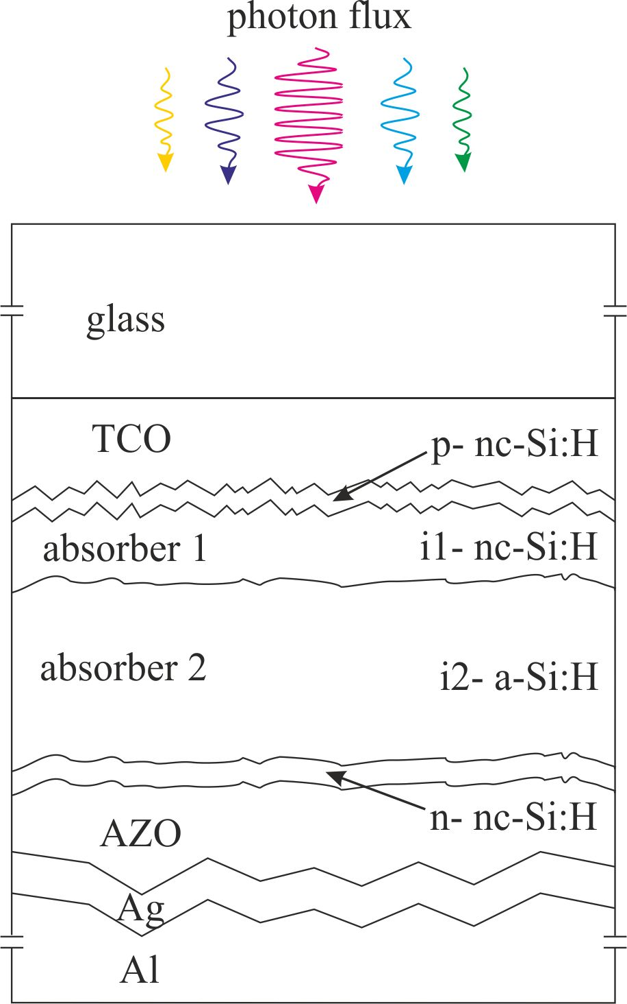

Figure 4. Extended model of solar cell with two absorbers: foton flux enters glass substrate (2-3 mm), Transparent Conductive Oxide (TCO) is solar cell front contact for collecting holes (0.3 μm), nano-crystalline p- window layer (8 nm), nano-crystalline top absorber i1- (50 nm), amorphous base absorber i2- (300 nm), nano-crystalline n- back layer (15 nm), Aluminum-doped Zinc Oxide (AZO) is reflection-enhancing dielectric layer (0.1 μm), Ag as a textured back reflector (0.5-2 μm), Aluminum back contact electrode (2-3 mm).
Table II. Material parameters written in AMPS used to simulate the output characteristic of the modeled single junction solar cell.

Layer Parameters | Solar cell layers
Layer Parameters | p- nc-Si:H | i1- nc-Si:H | i2- a:Si:H | n- nc-Si:H
M_{UN} (μ_{n}) (cm²/Vs) | 850 | 2000 | 20 | 850
M_{UP} (μ_{p}) (cm²/Vs) | 350 | 400 | 4 | 350
N_{A} (cm⁻³) | 1E+17 | 0 | 0 | 0
N_{D} (cm⁻³) | 0 | 0 | 0 | 1E+17
N_{C} (cm⁻³) | 2.5E+20 | 2.5E+20 | 2.5E+20 | 2.5E+20
N_{V} (cm⁻³) | 2.5E+20 | 2.5E+20 | 2.5E+20 | 2.5E+20
E_{g} (eV) | 2.00 | 1.95 | 1.80 | 1.95
CHI (χ) (eV) | 3.87 | 4.00 | 4.00 | 4.00
L (nm) | 8 | 50 | 500 | 15
E_{D} (eV) | 0.05 | 0.05 | 0.05 | 0.05
G_{DO} (cm⁻³eV⁻¹) | 1E+21 | 1E+21 | 1E+21 | 1E+21
Tσ/ND (cm²) | 1E-15 | 1E-15 | 1E-15 | 1E-15
Tσ/PD (cm²) | 1E-17 | 1E-17 | 1E-17 | 1E-17
E_{A} (eV) | 0.03 | 0.03 | 0.03 | 0.03
G_{AO} (cm⁻³eV⁻¹) | 1E+21 | 1E+21 | 1E+21 | 1E+21
Tσ/NA (cm²) | 1E-17 | 1E-17 | 1E-17 | 1E-17
Tσ/PA (cm²) | 1E-15 | 1E-15 | 1E-15 | 1E-15
N_{D, TOT} (cm⁻³) | 6.0E+17 | 1.0E+16 | 1.0E+16 | 8.0E+17
N_{DG} (cm⁻³) | 5.0E+17 | 5.0E+15 | 5.0E+15 | 5.0E+17
EDONG (eV) | 1.24 | 1.12 | 1.12 | 1.12
WDSDG (eV) | 0.15 | 0.15 | 0.15 | 0.15
Gσ/ND (cm²) | 1E-15 | 1E-16 | 1E-16 | 1E-15
Gσ/PD (cm²) | 1E-16 | 1E-17 | 1E-17 | 1E-16
N_{AG} (cm⁻³) | 1.0E+17 | 5.0E+15 | 5.0E+15 | 3.0E+17
EACPG (eV) | 1.14 | 1.02 | 1.02 | 1.02
WDSAG (eV) | 0.15 | 0.15 | 0.15 | 0.15
Gσ/NA (cm²) | 1E-16 | 1E-17 | 1E-17 | 1E-16
Gσ/PA (cm²) | 1E-15 | 1E-16 | 1E-16 | 1E-15

M_{UN} / M_{UP} (μ_{n} / μ_{p}): Electron / Hole Mobility, N_{A} / N_{D}: Donor / Acceptor doping concentration, N_{C} / N_{V}: Effective bands concentrations, E_{g}: Mobility band gap, CHI (χ): Electron affinity, L: Layer thickness, E_{D} / E_{A}: Characteristic energy of donor-like/acceptor-like tail states, G_{DO} / G_{AO}: Exponential prefactors of the donor-like/acceptor-like tail states, Tσ / ND: Neutral capture cross section density in donor-like tail, Tσ / PD: Charged capture cross section density in donor-like tail, Tσ / NA: Neutral capture cross section density in acceptor-like tail, Tσ / PA: Charged capture cross section density in acceptor-like tail, N_{D,TOT}: Dangling bond total concentrations in gap states, N_{DG} / N_{AG}: Dangling bond donor-like/acceptor-like concentrations, EDONG / EACPG: Energy of Gaussian donor / acceptor distribution, WDSDG / WDSAG: Standard deviation of energy of Gaussian donor / acceptor distribution, Gσ / ND: Neutral capture cross section density in donor-like gap states, Gσ / PD: Charged capture cross section density in donor-like gap states, Gσ / NA: Neutral capture cross section density in acceptor-like gap states, Gσ / PD: Charged capture cross section density in acceptor-like gap states.

V SIMULATION RESULTS AND DISCUSION
The performance of modeled solar cells was designed and analyzed in respect to the open circuit voltage (V_{oc}), short circuit current density (J_{sc}), fill factor (FF) and efficiency (η) by incorporating the layer parameters into AMPS- 1D. In this study we simulated two types of single junction solar cells, the first type has the standard structure: p-i-n with amorphous absorber of 350 nm thickness and for second extended structure: p-i1-i2-n with top nano-crystalline absorber of 50 nm thicknesses and base amorphous absorber of 300 nm. In second extended simulated device both top p- and bottom n- layers are also nano-crystalline thin film layers. The absorption profiles data of nano-crystalline layer (sample K1-K4) was taken from references [4] and [6]. We have studied the effect of varying the mobility band gap (E_{g}) in samples and its implication to output solar cell characteristic. In standard AM1.5 illumination for the single p-i-n structure simulation results are: J_{SC}=8.211 mA, η=6.86 %, FF=0.828 and V_{OC}=1.109 V. Second extended single junction structure pointed out better output parameters: J_{SC}=8.444 mA, η=7.16 %, FF=0.839 and V_{OC}=1.011 V. For both type of devices simulation promotes the same electric field to ensure good collection of photo-generated electron-hole pairs in absorber structure. In second simulation improvement in efficiency is supported by higher mobility and therefore better fill factor as shown in Table III.

Table III. Modeled illuminated I-V characteristic of two types of single junction solar cells: p-i-n and p-i1-i2-n structure.
Solar cell type | p-i-n | p-i1-i2-n
Output parameters | p-i-n | p-i1-i2-n
J_{SC} (mA/cm²) | 8.211 | 8.444
η (%) | 6.886 | 7.16
FF | 0.828 | 0.839
V_{OC} (V) | 1.009 | 1.011

First device structure only with amorphous layers has scattered crystal lattice order and therefore is not resistant to light induced degradation. Therefore, tree month after light exposure efficiency will be decreased by at least 20%. Light induced degradation of such solar cells has been simulated and results are shown in Table IV. Predictable calculations for solar cell with amorphous layers suggest efficiency of 5.5 % after degradation period.

Table IV. Light induced degradation simulation of solar cell with amorphous layers. Efficiency value after degradation period is lowered to the 80% of the initial value.

VI CONCLUSION
In this study we have simulated two types of single junction solar cells with nano-crystalline and amorphous absorbers using simulation computer program AMPS-1D. A series of simulations were carried out in order to calculate the efficiency of modeled solar cell by varying the properties each of layers in the range published in the literature. The obtained results show clearly that the nano-crystalline silicon thin film is a very interesting material to be used in single junction solar cells and tandem cells, respectively.
The substitutions of the amorphous p- window layer and n- layer in second type cell by a nano-crystalline silicon thin film layer leads to improvement of the output cells parameters: short circuit current incensement from 8.211 mA/cm² to 8.444 mA/cm² and efficiency enhancement from 6.886 % to 7.16 %. The additional improvement with i1- nano-crystalline top absorber is due to higher mobility of free carriers in all nano-crystalline layers, especially in additional absorber layer.
Nano-crystalline thin film solar cell model perform better cell efficiency and that is in good agreement with experimental results reported in the literature.

REFERENCES
[1] M. A. Green, Third Generation Photovoltaic: Solar Cells for 2020 and Beyond, Physical E14, 65-70 (2002).
[2] D. Gracin, S. Bernstorff, P. Dubček, A. Gajović i K. Juraić, Study of Amorphous Nanocrystalline Thin Silicon Films, Journal of Applied Crystallography, s373-s376 (2007).
[3] D. Gracin, J. Sancho-Parramon, K. Juraić, A. Gajović, M. Čeh, Analysis of Amorphous-nano-crystalline Multilayer Structures by optical, photo-deflection and photo-current spectroscopy, Micron 40, Elsevier, 56-60 (2009).
[4] D. Gracin, A. Gajović, K. Juraić, M. Čeh, Z. Remeš, A. Poruba, M. Vaneček, Spectral response of amorphous-nano-cristalline silicon thin films, Journal of Non-Crystalline Solids, 354 (2008) 2286-2290.
[5] N. M. Park, C. J. Choi, T. Y. Seong, S. J. Park, Quantum confinement in amorphous silicon quantum dots embedded in silicon nitride, Physical Review Letter, 86 (2001) 1355-1357.
[6] J. Sancho-Parramon, D. Gracin, M. Modreanu, A. Gajovic, Optical spectroscopy study of nc-Si-based p-i-n solar cells, Solar Energy Materials & Solar Cells 93 (2009) 1768-1772.
[7] D. Gracin, A. Gajović, K. Juraić, J. Sancho-Parramon, M. Čeh: Correlating Raman-spectroscopy and high-resolution transmission-electron-microscopy studies of amorphous/nanocrystalline multilayered silicon thin films; Thin Solid Films 517 (2009), 18; p. 5453-5458.
[8] A. M. Ali, Origin of photoluminescence in nanocrystalline Si:H films, Journal of Luminescence, 126 (2007) 614-622
[9] A. V. Shah, J. Meier, E.Vallat-Sauvain, N. Wyrsch. U. Kroll, C. Droz, U. Graf, Material and solar cell research in microcrystalline silicon, Solar Energy Materials & Solar Cells 78 (2003) 469-491.
[10] A. M. Ali, Optical properties of nanocrystalline silicon films deposited by plasma-enhanced chemical vapor deposition, Optical Materials 30 (2007) 238-243.
[11] M. R. Esmaeili-Rad, A. Sazonov, A. G. Kazanskii, A. A. Khomich, A. Nathan, Optical properties of nanocrystalline silicon deposited by PECVD, Journal of Material Sciences, Electron, 18 (2007) S405-S409.
[12] S. Hazra, S. Ray, Nanocrystalline silicon as intrinsic layer in thin film solar cells, Solid State Commun. 109 (1999) 125-128.
[13] D. Gracin, A. Gajović, K. Juraić, J. Sancho-Parramon, M. Čeh: Correlating Raman-spectroscopy and high-resolution transmission-electron-microscopy studies of amorphous/nanocrystalline multilayered silicon thin films; Thin Solid Films 517 (2009), 18; p. 5453-5458.
[14] A. Belfar, R. Mostefaoui, Simulation of n1-p2 Microcrystalline Silicon Tunnel Junction with AMPS-1D in a-SiC:H/μc-Si:H Tandem Solar Cell, Journal of Applied Science (2011) 10.3923.
[15] S. Tripati, R. O. Dusane, AMPS-1D simulation studies of electron transport in mc-SI:H thin films, Journal of Non-Crystalline Solids, 352 (2006) 1105-1108.
[16] E. Anastassakis, A. Pinczuk, E. Burstein, F. H. Pollak, M. Cardona, Effect of static uniaxial stress on the Raman spectrum of silicon, Solid State Commun, 8 (1970) 133-138.
[17] D. Stieler, V. D. Dalal, K. Muthukrishnan, M. Noack, E. Schares, Electron mobility in nanocrystalline devices, Journal of Applied Physics 100 (2006) doi.10.1063/1.2234545.
[18] B. Van Zeghbroeck, Mobility Carrier Transport, Principles of semiconductor devices, ECEE University of Colorado, 2011.
[19] R. H. Franken, R. L. Stolk, H. Li, C. H. M. Van der Werf, J. K. Rath, R. E. I. Schropp, Understanding light trapping by light scattering textured back electrodes in thin film n-i-p-type silicon solar cells, Journal of Applied Physics 102 (2007), 014503.
[20] D. Gracin, K. Juraić, I. Djerdj, A. Gajović, S. Bernstorff, V. Tudić, M. Čeh, Amorphous-nanocrystalline silicon thin films for single and tandem solar cells, Photovoltaic Technical Conference - Thin Film & Advanced Silicon Solutions 2012, UNPUBLISHED.
[21] V. Tudić, L. Majdandžić, AMPS-1D Simulation of the High Efficiency Hydrogenated Amorphous Single pin Solar Cells, Journal of Mechanical Engineering, Electronics and Electronic Technology, SV-JME 59 (2012), UNPUBLISHED

