Air tightness test of rooms
Joint research project of Pécs (HU) and Osijek (CR) Universities supported by EU IPA scheme

Dr. László Fülöp*, Dr. Željko Koški**, György Polics*
* University of Pécs / Faculty of Engineering and Information Technology, Pécs, Hungary
** Josip Juraj Strossmayer University of Osijek / Faculty of Civil Engineering, Osijek, Croatia
fulop@pmmik.pte.hu zkoski@gfos.hr gyorgy.polics@pmmik.pte.hu

Abstract - The article introduce a joint project of Pécs University and Osijek University. The aim of the project is to obtain information on the air tightness and on the natural air change rate of a set of buildings and houses in the Hungarian-Croatian border region. Another scientific aim is to find correlation between air change rates at +50 Pa and -50 Pa inside-outside pressure difference, 4 Pa pressure difference and air change measured with tracer gas concentration decay method. Tracer gases are SF₆ and CO₂.

Introduction
The first step to exploitation of Renewable Energy Sources is achieving the best possible energy performance of the system supplied. In case the overall energy consumption of the system supplied is high the renewable factor will be low, system size and price will be high and the payback period will be too long.
In case of buildings and houses the major component is heating that include transmission and ventilation losses. Transmission losses can be reduced by extended thermal insulation and low U-value windows such as triple glazing but ventilation cannot be reduced below a certain level.
Air tightness of rooms is a critical factor of buildings and houses. When reducing convective heat losses to a minimum by extended thermal insulation ventilation becomes the major factor of energy use. Any air change on the top of the necessary volume is a causeless loss. As consequence ventilation must be controlled strictly accommodate the need. Controlled ventilation is a critical factor of energy balance of buildings and houses especially that of low energy ones. To provide a proper controlled ventilation air tightness of the building is crucial.

Scientific target
The main scientific target is to gather information on the air tightness and air change rate of the buildings and houses of various construction types, use and age. The measured data will be used to estimate the energy and thermal comfort as well air quality consequence of the typical air change rates, ventilation volume and velocity within the rooms.
In a short term vital but missing data will be gathered that contributes developing design methods. Long term perspective is reconsidering the energy in building standards as well as requirements in rooms.

Target groups
Target group is the scientific community in the field of energy in buildings and comfort including air quality. Results of the research will probably contribute to standardisation and legislation. A set of recommendations will be prepared for decision makers, for the industry, for education, and for the general public
Another target group is the technical higher education by providing new vital information. Outputs are a scientific text book that can be applied in education too
Building industry is also a target group including design and construction by education and developments. Findings and results will be published for the use of the scientific community.

Background

Energy and comfort aspects
Air gaps cause uncontrolled ventilation that is insufficient when the temperature difference between inside and outside is small and the wind speed is low. As opposite, it is too much during cold and windy weather.
Insufficient air tightness has a secondary effect to energy demand via air quality and local thermal comfort problems. Too high air velocity in a room in cold weather results in local discomfort assuming that the draught effect only detectable at certain locations. As a result set temperature must be higher.

Air tightness and air change rate of the existing building stock
Ventilation is important factor regarding energy and comfort in the existing building stock. Despite the fact of the importance of ventilation and air tightness there is not enough information about the air tightness and air change rate of the existing building stock, not even that of the new buildings and houses. The aim of the project is to measure these factors in a carefully selected set of buildings in Croatia and in Hungary, Baranya region. Traditional buildings in the regions are similar by construction, but newer ones are more or less different.
One reason of the lack of information is that the measurements are circuitous and can be expensive too. Blower door test at 50 Pa pressure is a good, repeatable test, not too expensive, but the test method as a consequence of the high pressure modifies the measured value. The air change measured at 50 Pa is significantly different from the air change during normal conditions. In cold or very hot weather blower door test can be combined with thermography to spot the leakage points.
Tracer gas method is producing a realistic air change value, but expensive and the result as the air change itself is very much dependent upon the external conditions, first of all wind speed and temperature.
Combining the methods described above offers a good likelihood to obtain realistic values.

Methodological approach
Each of the rooms selected will be investigated by using a 50 Pa blower-door test and thermography to find and analyse the critical leakage points. Tracer gas test will be carried out during various meteorological circumstances, especially temperature and wind conditions. It is also targeted to find correlation between the results of 50 Pa blower-door tests and tracer gas tests.
Sensitive air velocity and temperature measurements will be used for comfort and air quality evaluation.

Tracer gas test

The basics of tracer gas test method
The use of tracers in many types of research and especially in fault-finding activities is very widespread. The basic idea for ventilation measurements using tracer gas: the air in a building is marked with something easily identifiable so that its movement can be traced.
The types of tracers used in ventilation measurements are usually colourless, odourless, inert gases, not normally present in the environment. Mixing properties that effect the relative density to air (specific gravity) is also important for air change rate measurements.
Perhaps the most frequently used simple qualitative technique is smoke visualisation but many other methods can be used. Even smells can be used as tracers!
Tracer-gas techniques are the only way of making many types of quantitative measurements of ventilation. These include infiltration and air exchange measurements, fume hood efficiencies, and spreading of pollutants. In other cases tracer-gas analysis methods are chosen in preference to other analysis methods because they are more convenient and more accurate. This is often the case when measuring airflow rates in ventilation ducts.
A very important aspect of tracer-gas measurements is that they can be made in occupied buildings. This is not only much more convenient but is also much more accurate since it takes into account the large effect occupancy can have on a building's air change rate – for example, the effect of opening and closing doors and windows. It is, after all, the air change rate of a building under normal working conditions that is important in most cases.
Since most of the gases (except Helium) are heavier than air a proper mixing fan should be applied. The difference in case of Helium is that the fan must be put under the ceiling.
The selected gases are the SF₆ and the CO₂. SF₆ is more expensive and much heavier than CO₂ but it is not present in the atmosphere that makes low concentration measurements possible. CO₂ gas is very common cheap gas, not too much heavier, easy to mix with the air but it is present in the atmosphere sometimes at quite high concentration in certain places. Only automatized unmanned test is possible in order to avoid incremental CO₂ penetration in the room.
- Suitable traces gases
 | Specifics
 | Name | Chemical symbol | Relative density
1 | Sulphur Hexafluoride | SF₆ | 5,11
2 | Helium | He | 0,14
3 | Tetrafluor-ethan (HFC) (Freon) 134a | C₂H₂F₄ | 3.86
4 | Dinitrogen-Oxide, Nitrous Oxide (Different from Nitrogen Dioxide (NO₂) | N₂O | 1.53
5 | Carbon dioxide | CO₂ | 1.521

Results from properly conducted tracer-gas measurements on a ventilation system can provide information about the amount of outdoor air brought into each room; the efficiency of heat recovery units; the amount of extract air which is re-circulated into the supply air ducts; the outdoor short-circuit from exhaust to outdoor air intake, and distribution of supply air in rooms. Much wasted energy and many “sick” buildings result from the fact that these parameters have not been taken into account at the planning stage of a building and are not measured as part of regular building maintenance checks.
The most common methods are:
- Concentration Decay
- Constant Injection
- Constant Concentration

The Concentration-decay Method
This is the most basic method of measuring air change rates and is used to obtain air exchange rates over short periods of time. A small quantity of tracer-gas is thoroughly mixed into the room air. The source of gas is then removed and the decay in the concentration of tracer-gas in the room is measured over a period of time.

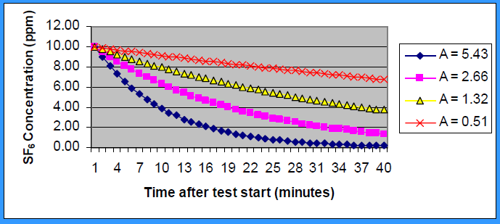
- Concentration decay at various air change rates. [1]
To ensure that the tracer-gas concentration is the same at all points in a room at any particular time, one or more mixing fan is run throughout the measurement period. Provided that no tracer-gas is supplied to the room during the measurement period and the airflow through the room is constant, the concentration of tracer will decay exponentially:
C(τ) = C_{start} exp(-Nτ). (1)
By plotting the natural logarithm of gas concentrations against time a straight line is obtained and the gradient of the line is the air change rate in the room:
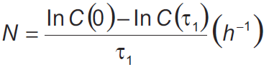 (2)
where C(0) = concentration at time = 0
C(τ₁) = concentration at time = τ₁
τ₁ = total measurement period
If an approximately straight line is not obtained, then the room air cannot be considered well mixed and the results are thus not valid.
The only equipment needed for this measurement method is a gas monitor, a bottle of tracer-gas, and a mixing fan. This makes the method the least expensive and easy to perform.

The Constant-emission Method
This method is used for long-term, continuous air change rate measurements in single zones (discussed below), or for measurement of the airflow through ventilation ducts
When using the constant-emission method, tracer-gas is emitted at a constant rate for the duration of the measurement period. Provided both the air change rate and the tracer-gas concentration in the zone are constant, the mass balance reduces to:
Air change rate:
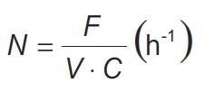 (3)
If either the air exchange rate or the tracer-gas emission vary during a measurement period, then the general mass balance has to be used to obtain the air change rate. As with the concentration-decay method, the tracer concentration should be the same throughout the zone at any instant of time. The mixing needed to achieve this is done with fairly large mixing fans.
A flow meter is needed to measure the flow of tracer-gas emitted into the room. Since tracer-gas is emitted continuously into the zone throughout the measurement period, special attention should be paid to the cost and amount of tracer-gas used. Using a monitor that allows you to measure inexpensive tracer-gases and/or allows very low concentrations to be detected and measured can help to keep this cost down.

The Constant-concentration Method
This method is used for continuous air change rate measurements in one or more zones. It is particularly useful for conducting analyses in occupied buildings.
When using the constant-concentration measurement method, the concentration of tracer gas in a zone is measured by a gas monitor. This information is then sent to a computer that controls the amount of tracer-gas “dosed” into the zone in order to keep its concentration constant. A small fan is normally used to help mix the tracer with the room air. Provided that the concentration of tracer-gas in the zone is constant over time, the mass balance reduces to:
Air change rate:
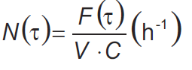 (4)
The air change rate is directly proportional to the tracer-gas emission rate required to keep the concentration constant.
This method offers two great advantages: not only can it be used to obtain an accurate long-term average air change rate in situations where the air change rate varies – for example, in occupied buildings; but it can also be used to document these variations in detail. As with the constant-emission method, tracer-gas costs may be an important consideration.
The constant-concentration method is also particularly well suited to the continuous determination of the infiltration of outside air into each individual room in a building. [2]

Limits of tracer gas tests
Traces gas tests are suitable to measure the real air change rate, but varies by temperature difference and wind speed greatly. As a result traces gas test cannot be applied for classification purposes since as many test result as many variations of parameters.

Blower-Door test

Basics of Blower-Door test
“Blower Door” is the popular name for a device that is capable of pressurizing or depressurizing a building and measuring the resultant air flow and pressure. The name comes from the fact that in the common utilization of the technology there is a fan (i.e.blower) mounted in a door; the generic term is “Fan Pressurization”. Blower-Door technology was first used in Sweden around 1977 as a window-mounted fan (as reported by Kronvall, 1980) and to test the tightness of building envelopes (Blomsterberg, 1977). That same technology was being pursued by Caffey (1979) in Texas (again as a window unit) and by Harrje, Blomsterberg and Persily (1979) at Princeton University (in the form of a Blower Door) to help find and fix the leaks.
During this period the diagnostic potentials of Blower Doors began to become apparent. Blower Doors helped Harrje, Dutt and Beya (1979) to uncover hidden bypasses that accounted for a much greater percentage of building leakage than did the presumed culprits of window, door, and electrical outlet leakage. The use of Blower Doors as part of retrofitting and weatherization became known as House Doctoring both by Harrje and Dutt (1981) and the east coast and Diamond et al. (1982) on the west coast. This in turn led Harrje (1981) to the creation of instrumented audits and Sonderegger et al. (1981) to computerized optimizations. [3]

Issues
Blower Doors are still used to find and fix the leaks, but more often the values generated by the measurements are used to estimate infiltration for both indoor air quality and energy consumption estimates. These estimates in turn are used for comparison to standards or to provide program or policy decisions. Each specific purpose has a different set of associated blower-door issues. [3]

The Testing Method
The BlowerDoor is installed in an external door of the building.
- Installation of the BlowerDoor in an external door of the building [4]
All other outside doors and windows are closed, all inside doors remain open. Any remaining openings in the building envelope are prepared so that they correspond to their later state and conditions of use during the heating period.
In seconds the BlowerDoor fan then creates an artificial pressure differential (depressurization or pressurization) between the building interior and the outside air. This pressure differential leads to a constant flow of air through the leakages in the building envelope. The air tightness test includes leakage detection at 50 Pascal negative pressure and determines the air flow at 50 Pascal V₅₀ from a series of measurements during depressurization or pressurization.
- The BlowerDoor draws air out of the building and fresh air constantly flows into the building via the leakages. [4]

Detecting Leakages
During the leakage test, the fan constantly sucks air out of the building. This creates depressurization which is adjusted at a pressure differential of 50 Pa. Through joints and other leakages outside air will constantly infiltrate the building. These air flows can be felt with hand, measured by use of an air velocity meter or visualized by fogging.
- Detecting leakages with a thermal anemometer [4]
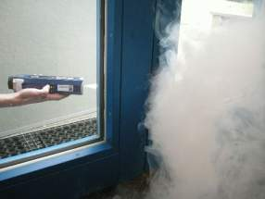
- Visualizing leakage paths with fog or smoke [4]
- Detecting leakages with a thermography camera. The cold air flowing in cools the surface and appears on the thermogram in darker colour [4]

Pressurizing versus depressurizing
Depending on window hinges if the windows open to inside or outside 50 Pa pressure makes gaps winder or narrower. As a result the measured air volume will be more or less than during normal circumstances. The difference between air volume during pressurizing and depressurizing is also important information about the airtightness of the building.

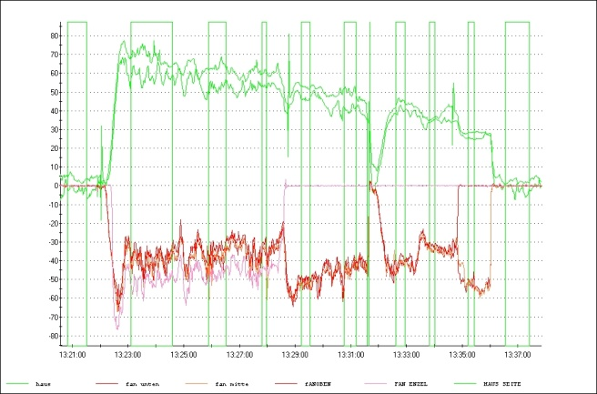
- Air leakage at pressurizing and depressurizing
However 50 Pa pressure difference between inside and outside is required to eliminate the effect of the temperature difference and that of small air movements. As a result V₅₀ is suitable for classification purposes. A repeated test should result is same numbers.

Blower-Door tests at 4 Pascal pressure dufference
To simulate average pressure difference 4 Pa Blower-Door test can be applied that is a more common, less expensive method compared to tracer gas. Similarly to tracer gas test the result is highly affected by wind speed and air temperature.

Comparison of the result of various test methods
One scientific aim of the project is to compare the result of the various test methods and to find correlation(s). In terms of air change rate the tracer gas test provide reference data. The question is how it can be replaced by a 5 Pa Blower-Door test. Regression analysis might result in a suitable equation. Measuring “real” air change rate would more convenient by 4 Pa Blower-Door tests in everyday practice.
Even more convenient if “real” air change rate could be calculated from 50 Pa Blower-Door test. There is a rule of thumb, which Sherman (1987) attributes to Kronvall and Persily that seemed to relate Blower-Door data to seasonal air change data in spite of its simplicity:
$\text{ACH}≈\frac{{\text{ACH}}_{\text{50}}}{\text{20}}$ (5)
That is the seasonal amount of natural air exchange could be related to air flow necessary to pressurize the building to 50 Pascals. [3]
This simple rule of thumb might varies by climatic zone and by construction type so a more refined equation will be needed.
EN 832 Standard provides a reasonably refined equation [5]:
${\overset{}{V}}_{\text{IN}}=\frac{V∗n_{\text{50}}∗e}{1+\frac{f}{e}∗{\left[\frac{{\overset{}{V}}_{\text{SUP}}−{\overset{}{V}}_{\text{EXN}}}{V∗n_{\text{50}}}\right]}^{2}}$ (6)
Where
V: Volume of the room [m³/h]
${\overset{}{V}}_{\text{IN}}$: spontaneous filtration [m³/h]
${\overset{}{V}}_{\text{SUP}}$: mechanical ventilation supply [m³/h]
${\overset{}{V}}_{\text{EXN}}$: mechanical ventilation extract [m³/h]
$n_{\text{50}}$: air change rate at 50 Pa [1/h]
„e” and „f” are leeward factors

The equation above and the factors are subject of validation for the local climate and typical buildings by type by construction and by use.

Conclusion
Within the framework of the project air change rate and air tightness of a set of buildings and houses will be measured to obtain information on a segment of the existing building stock on both side of the Hungarian-Croatian border.
Correlation will be searched between air change rate at 50 Pa pressure difference and the real air change rate within the given climatic zone.

Acknowledgment
Acknowledgement for EU Hungary-Croatia IPA (Instrument for Pre-Accession Assistance) Cross-border Co-operation Programme for funding the project including equipment procurements and manpower.

References
- Rex W. Moore, CIH, CSP Boelter & Yates, Inc. presented by Catherine E. Simmons, CIH Park Ridge, Illinois “Tracer gas test methods to diagnose ventilation-related indoor environmental quality problems,” Presentation. 19.06.2006
- Innova AirTech Instruments, Ventilation measurements and other tracer-gas applications, http://www.innova.dk.
- Max Sherman “The use of blower-door data” Energy Performance of Buildings Group, Energy and Environment Division, Lawrence Berkeley Laboratory, University of California, Berkeley, California, March 13, 1998
- Dipl.-Ing. Stefanie Rolfsmeier, “Air Tightness in Passive Houses”. BlowerDoor GmbH, Energie- und Umweltzentrum 1, D-31832 Springe
- EN-832 Standard

