FRACTURE ANALYSIS OF LIFTING HOOKS MADE OF CARBON STEELS

Ljerka Slokar, Tanja Matković, Prosper Matković

University of Zagreb Faculty of Metallurgy, Department for Physical Metallurgy, Aleja narodnih heroja 3, 44103 Sisak, Croatia

Abstract

Modern construction would not have been possible without steel as a primary material. It has to satisfy the requirements for acceptable application under different conditions. The goal of this investigation was to examine cause of fracture of lifting hooks made of two different plain steels (C45 and B 500B) via mechanical and microstructural properties. For that purpose mechanical tensile and hardness tests, Charpy impact test were carried out as well as light and scanning electron microscopy. Chemical composition was determined by optical emission spectrometer. Obtained results show that investigated steels have the lack of purity with respect to the inclusions, microporosity and high copper content. Therefore, lifting hooks made from investigated plain carbon steels have considerable potential for failure. Also, galvanizing as corrosion protection is not recommended because it might lead to the harmful effect on the mechanical properties of material.

Keywords: fracture, lifting hook, carbon steel, mechanical properties, microstructure

Sažetak

Moderne konstrukcije ne bi bile moguće bez čelika kao osnovnog materijala. On mora zadovoljiti određene zahtjeve da bi se mogao upotrebljavati u različitim uvjetima. Cilj ovog rada bio je ispitati uzrok loma kuka za podizanje tereta, izrađenih od dva različita ugljična čelika (C45 i B 500B) preko ispitivanja mehaničkih i mikrostrukturnih svojstava. U tu svrhu proveden je vlačni test, ispitane su tvrdoća i udarna radnja loma po Charpyju. Također su provedena svjetlosna i scanning elektronska mikroskopija. Kemijski sastav je određen optičkim emisijskim spektrometrom. Dobiveni rezultati pokazuju da su ispitivani čelici skloni povremenom pucanju zbog nedovoljne čistoće s obzirom na uključke, mikroporoznost i visoki sadržaj bakra. Također se ne preporučuje pocinčavanje kao zaštita od korozije, jer može dovesti do štetnog djelovanja na mehanička svojstva konstrukcije.

Ključne riječi: lom, kuke za podizanje tereta, ugljični čelik, mehanička svojstva, mikrostruktura

INTRODUCTION

Modern construction would not have been possible without steel as a primary material. Significant researches were undertaken to determine the necessary mechanical and chemical properties of steels that would satisfy the requirements for acceptable application under different conditions. Reinforced concrete buildings and bridges are likely to be subjected to dynamic load in the application, so they must meet the sufficient capacity and safety, which is achieved by sufficient yield strength, tensile strength, bending strength, toughness (Charpy impact energy) [1-3].
The purpose of this investigation was to examine cause of fracture of lifting hooks made of two different plain carbon steels (steel for concrete reinforcement) via mechanical and microstructural properties.

MATERIALS AND METHODS

In this work two types of steels, C45 and B 500B, were investigated. These steels are intended for lifting concrete blocks weighing 150 tons to build seaports. Each block is lifted with four hooks. Two of them were broken and analyzed in this paper with the aim of determining the reasons for failure.
Specimens were cut out by slow-speed saw so that heating was negligible. Cut samples for examination were designated with numbers as can be seen in a Figure 1.

(a) steel hook (b) part of galvanized steel hook
Figure 1. Two types of specimens

Mechanical tensile test was carried out on Zwick testing machine for samples 1/1 (hook 1/sample 1) and 2/4 (hook 2/ sample 4). For the same samples Charpy impact energy was examined. Samples 1/3, 1/5 and 2/5 were metallographically prepared by grinding and polishing for Vickers hardness testing, light and scanning electron microscopy (SEM). Microstructural observations were carried out on a light microscope Olympus GX51 and scanning electron microscope Tescan Vega TS 5136 MM. Chemical composition was determined for specimens 1/2 and 2/2 by ARL 3460 optical emission spectrometer. On samples 1/8, 1/9, 2/3, 2/7 direct visual fracture analysis was performed. Remaining samples were previously reviewed and served as a control samples.

RESULTS AND DISCUSSION

Visual observation of fracture
Fractures of investigated samples were extremely and deeply corroded (Figures 2a, 2b).
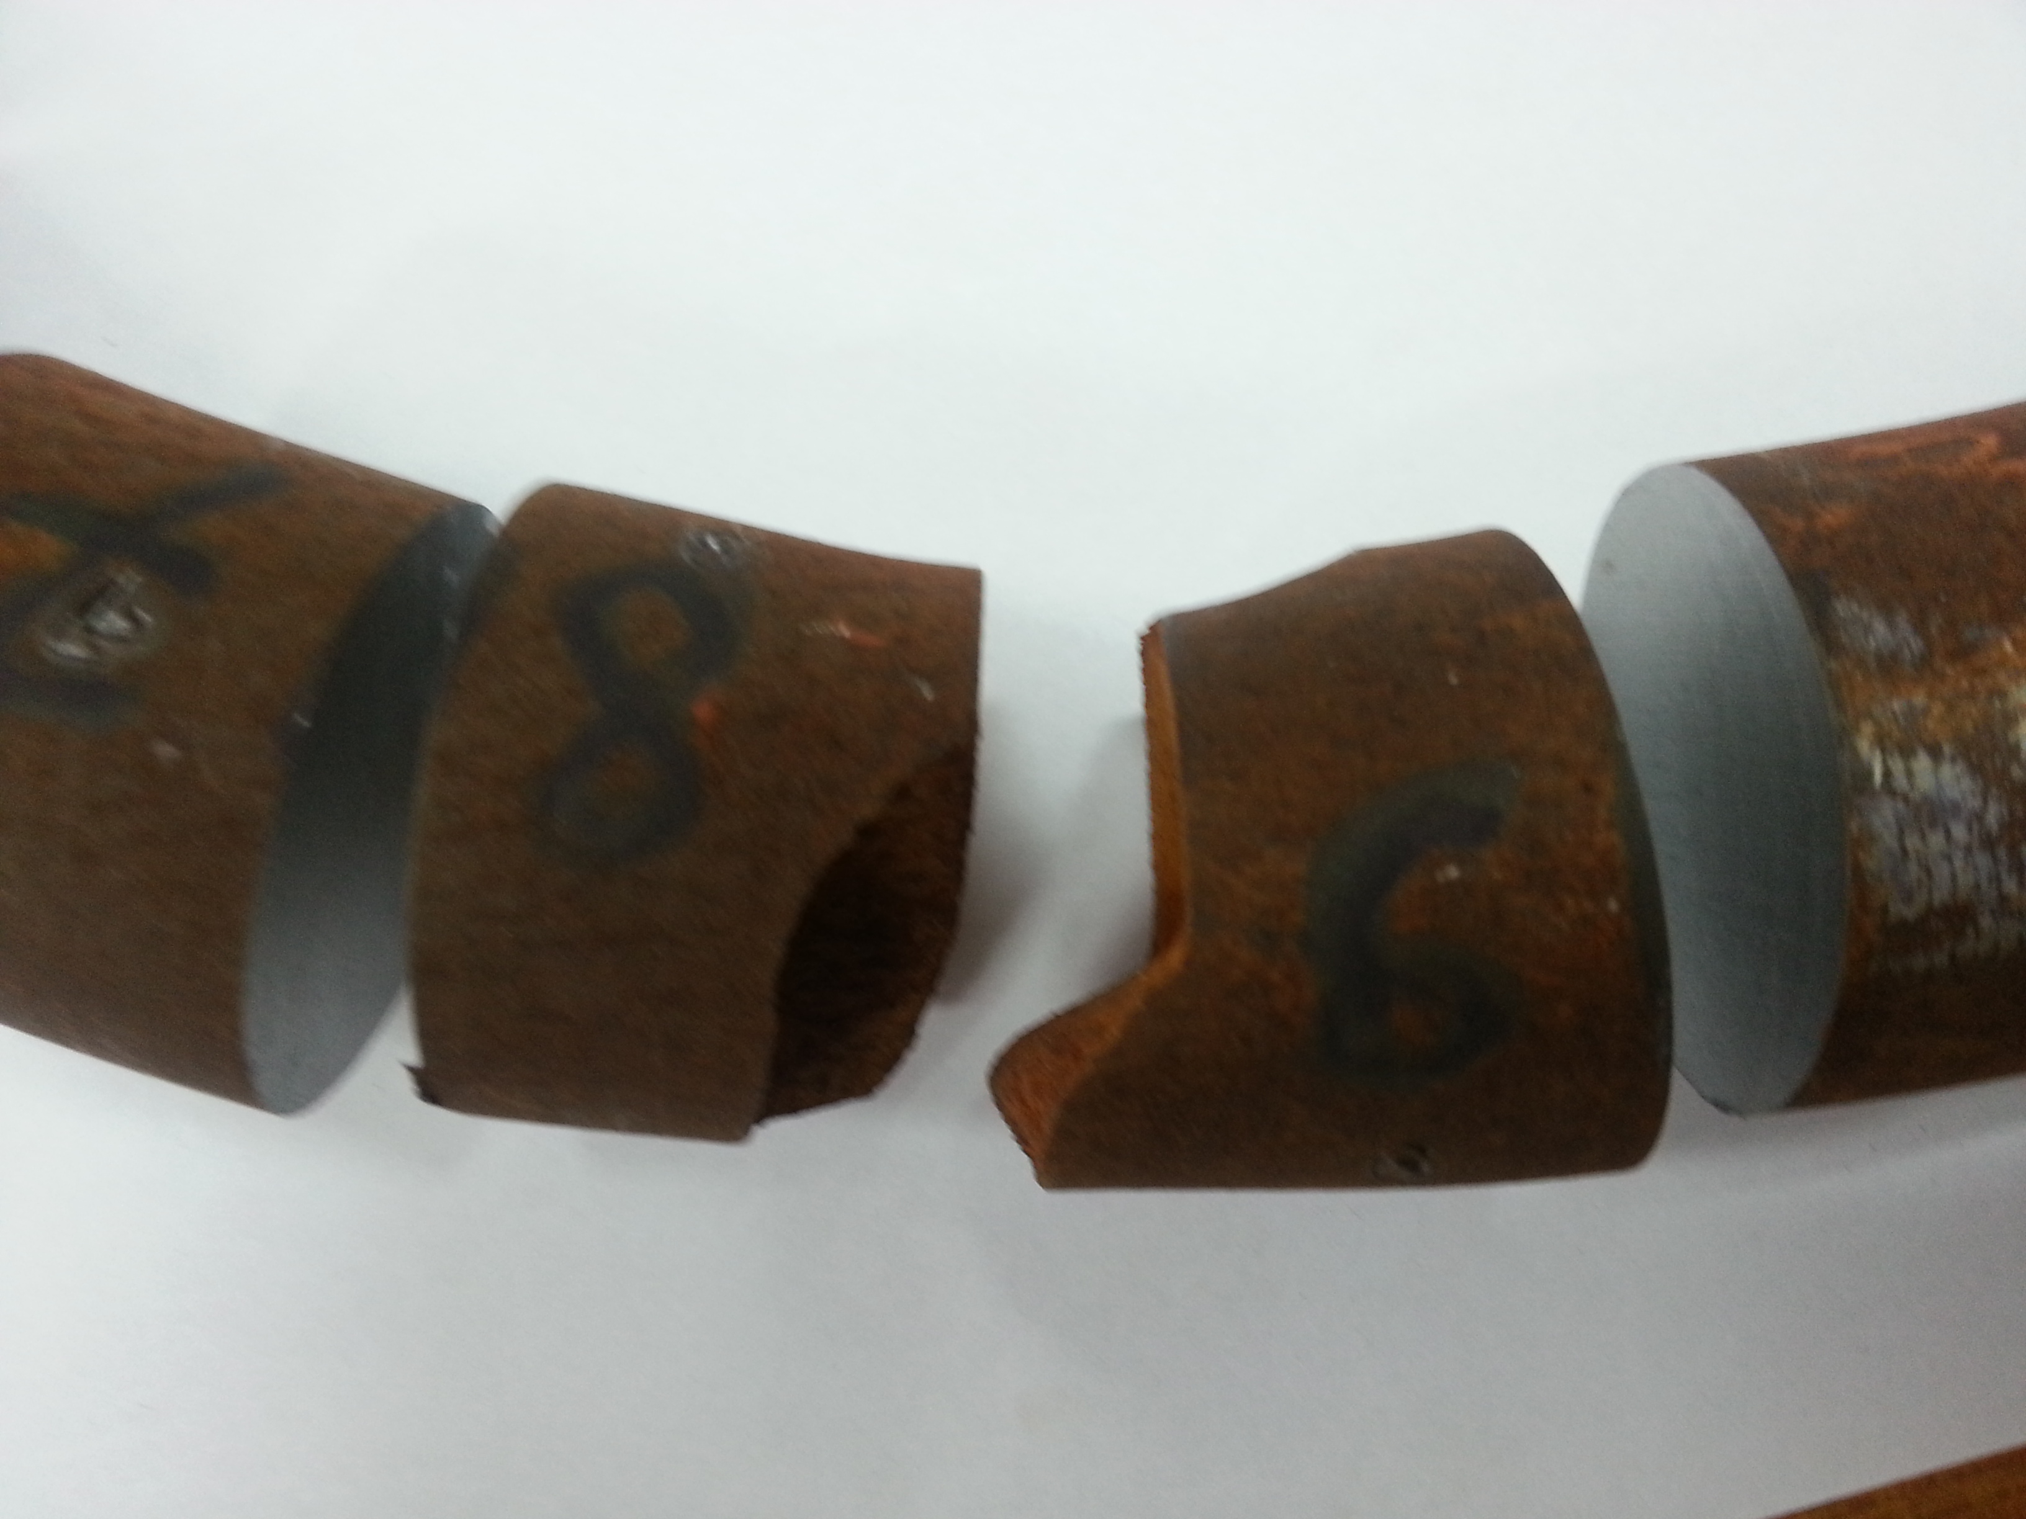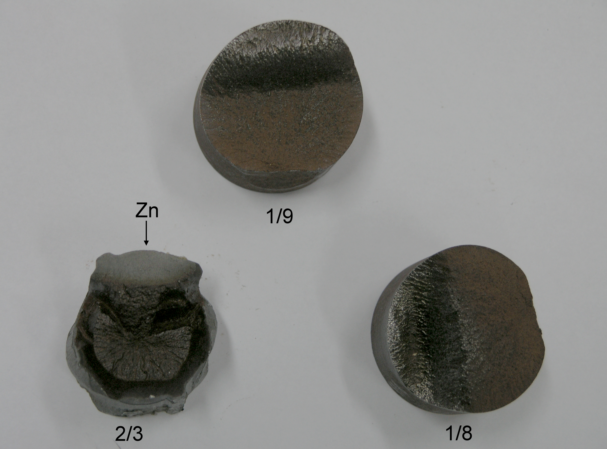
(a) steel hook (b) galvanized steel hook
Figure 2. Corroded samples
After partially successful cleaning it can be seen that zinc penetrated into macro-crack of previously bended steel rod in sample 2/3. These cracks were formed during the rod bending. Otherwise, samples show the main characteristics of ductile fracture.

Mechanical testing
Vickers hardness (HV2) for steel hook was measured on samples 1/3 and 1/5 to determine the influence of the cold deformation in bending rods to increase hardness. Hardness for galvanized rod was measure on sample 2/5.
Results of HV measurements (Table 1) show that bending has no substantial influence on hardness, but there is a difference in hardness measured on the edge and in the middle of section bars.

Table 1. Vickers hardness for investigated samples

Sample | Hardness, HV2
 | 1.measurement of the section edge | 2.measurement of the section middle | 3.measurement of the section edge | Average hardness, HV2
1/3 | 216 | 179 | 211 | 202
1/5 | 216 | 170 | 226 | 204
2/5 | 213 | 185 | 219 | 206

Naturally, hardness was slightly higher on the edge section of specimen due to influence of deformation when extruding rod, and its faster cooling in the production process.
Standard probes for tensile and Charpy impact test were made of samples 1/1 and 2/4. Figure 3 shows samples after tensile test.
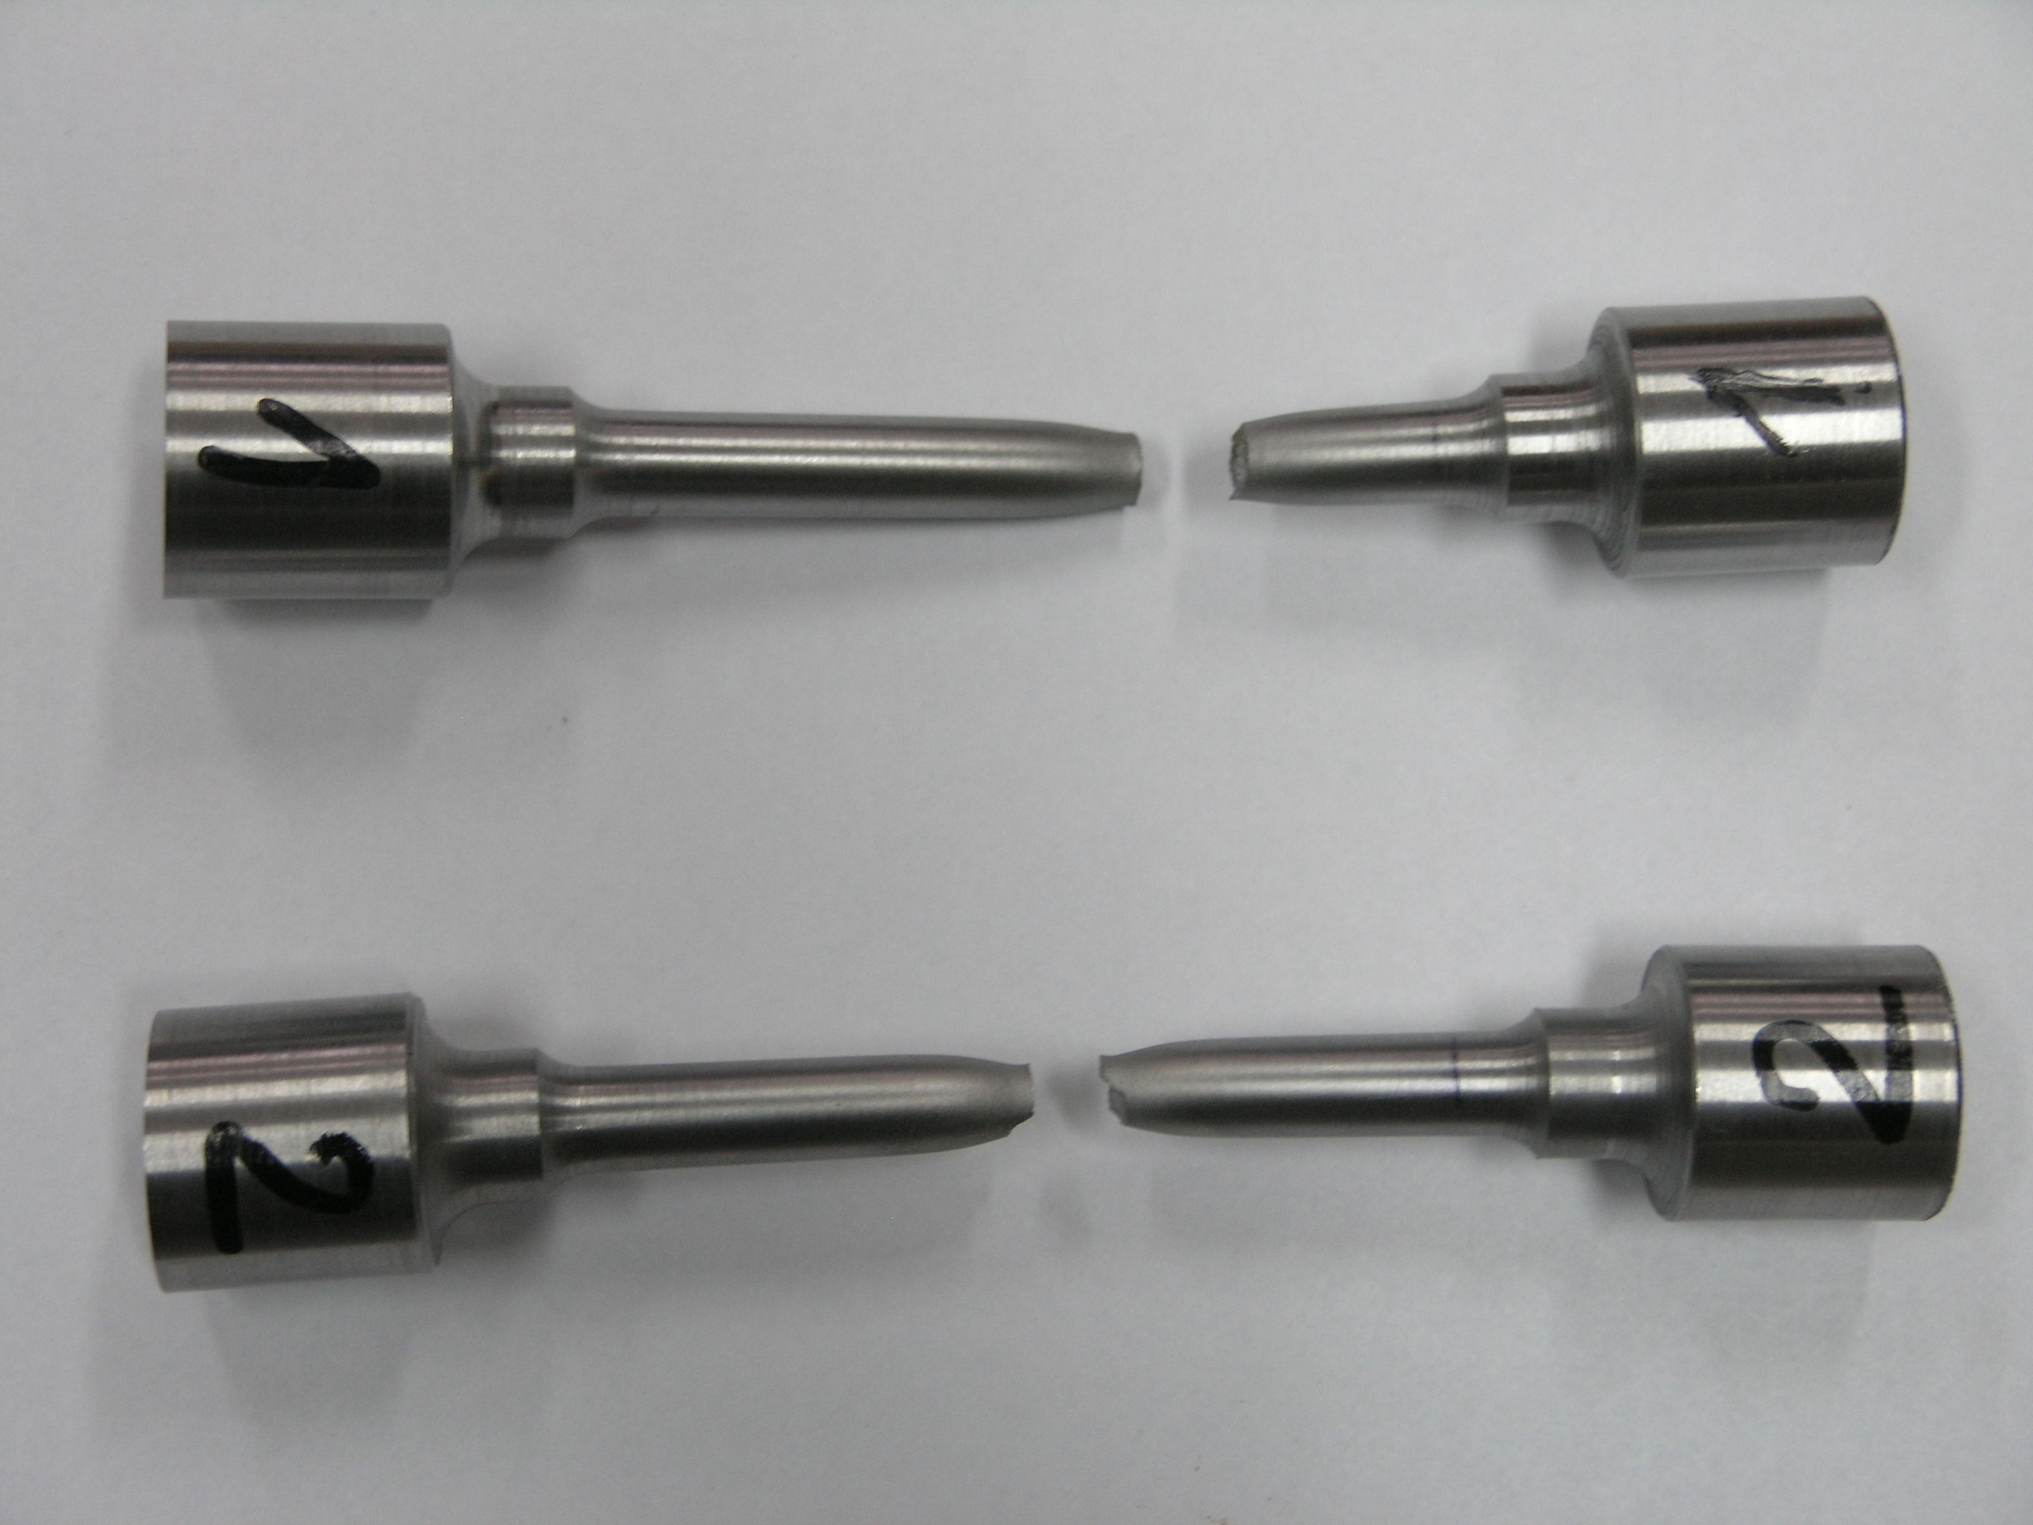
Figure 3. Samples 1/1 and 2/4 after tensile test

Table 2 shows that these two types of steel have yield and tensile strength which are within the limits provided with their standards. Yield strength for steel C45 according to standard [4] is minimum 275 N/mm² and 355 N/mm² for B 500B. Tensile strength for C45 is minimum 560 N/mm² and 590-735 N/mm² for B 500B. Since they have also sufficient amount of elongation and contraction can be concluded that these properties do not cause fracture of the hooks.

Table 2. Results of tensile test

Sample | Diameter  mm | Section,  mm² | Length,  mm | Yield strength, R_{e}  N/mm² | Tensile strength, R_{m}  N/mm² | Elongation  A,  % | Contraction,  Z,  %
1/1 | 100 | 78,54 | 50 | 474 | 560 | 24,8 | 51
2/4 | 100 | 78,54 | 50 | 435 | 596 | 30,2 | 60

From Table 3 it can be seen that the sample 1/1 has satisfactory impact toughness while sample 2/4 is significantly tougher. So, even these data cannot be taken as a reason for rods breaking.

Table 3. Results of Charpy impact energy

Sample | Thickness, mm | Width, mm | Section, mm² | Charpy impact energy, J
1/1 | 10,00 | 8,07 | 80,7 | 20
2/4 | 10,00 | 8,05 | 80,7 | 129

Examination of chemical composition
The results of chemical composition examination for samples 1/2 and 2/2 are shown in Table 4.
Table 4. Chemical composition of investigated samples

Element/  sample | C | Mn | P | S | Si | Cu | Mo | Al | Cr | Ni | Fe
1/2 | 0,412 | 0,630 | 0,016 | 0,018 | 0,237 | 0,244 | 0,013 | 0,031 | 0,032 | 0,090 | rest
2/2 | 0,182 | 0,937 | 0,019 | 0,044 | 0,253 | 0,424 | 0,033 | 0,001 | 0,088 | 0,122 | rest

Data given in this table for samples 1/2 and 2/2 show 0,244 % of copper content and 0,424 % respectively. That concentration could be harmful because copper is key element related to hot shortness caused by a loss of ductility during the hot processing. It can be seen that hot cracks begin to form at copper content above 0,2% where the crack depth is a function of copper content in steel [5]. The crack depth increases with increased copper content. That increases steel brittleness at cold deformation.

Microstructural observations
Samples 1/3 and 2/5 were metallographically prepared by grinding, polishing and finally etching in nital solution. Figures 4a-c shows the most important details in microstructure which implies on various anomalies in investigated types of steel.

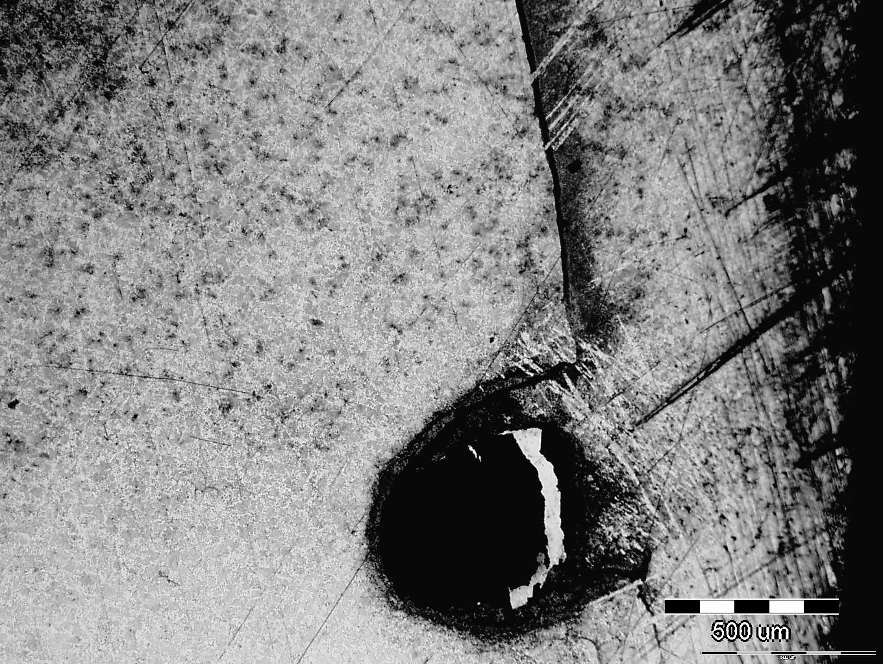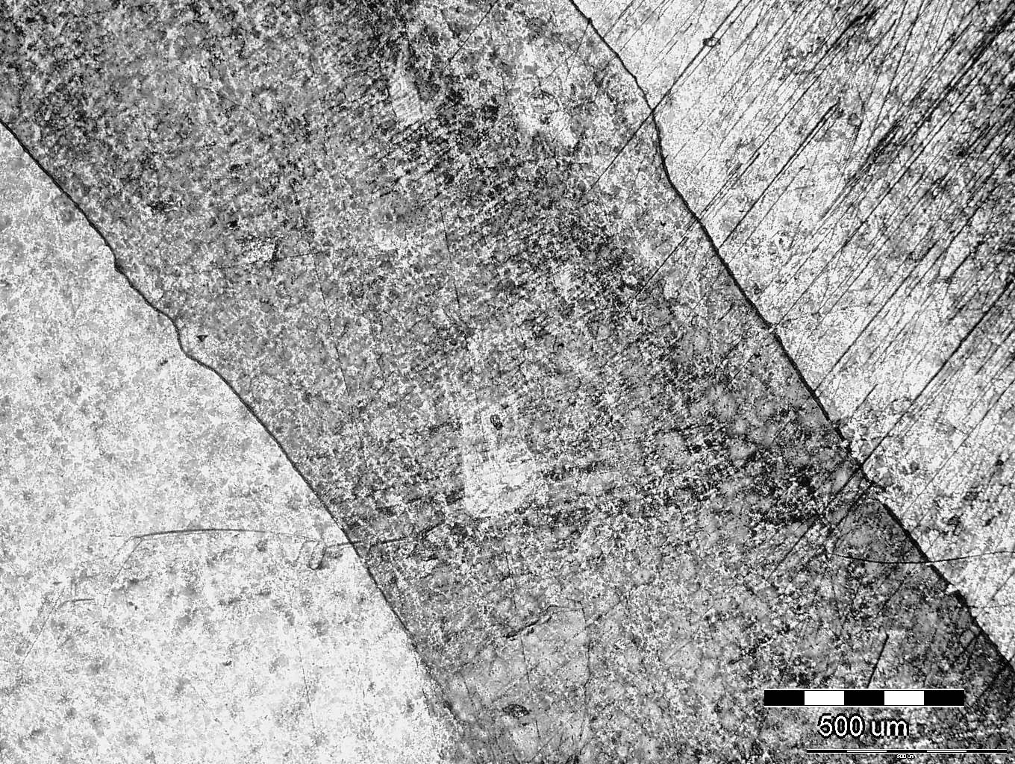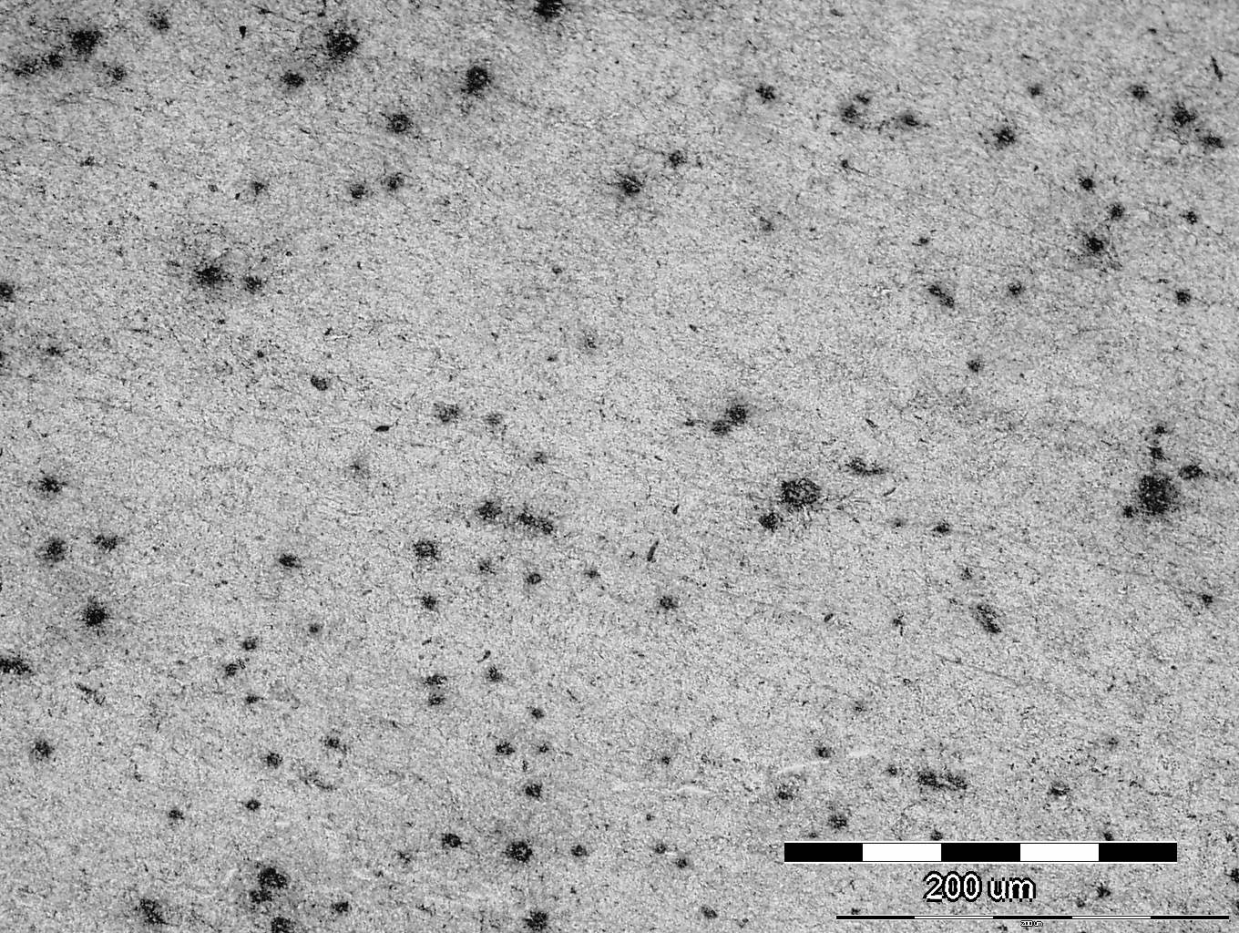
(a) sample 1/3 (b) sample 1/3 (c) sample 2/5
Figure 4. Light micrographs of anomalies in two types of steel

Fractured probe 1/1 after tensile test, samples 1/3 and 2/5 were examined by scanning electron microscope. On their micrographs (Figure 5) can be seen various defects in steel.
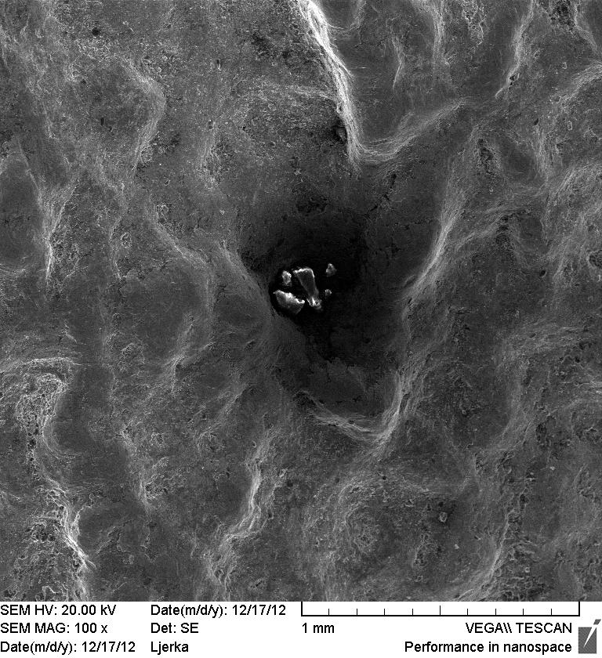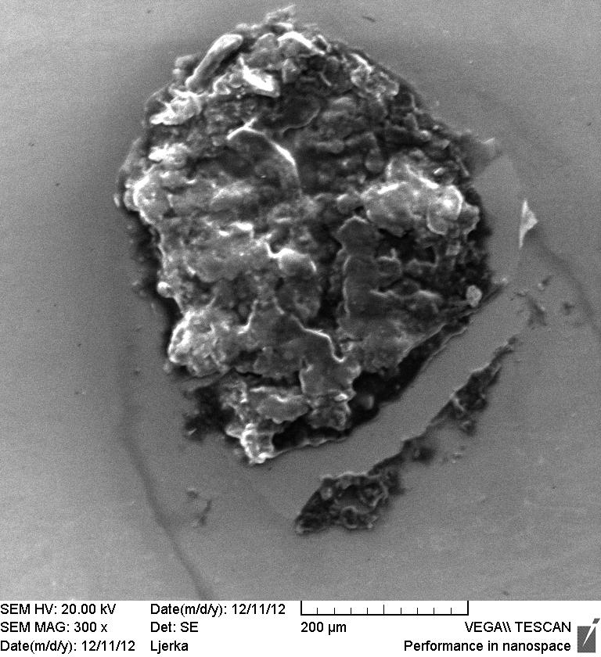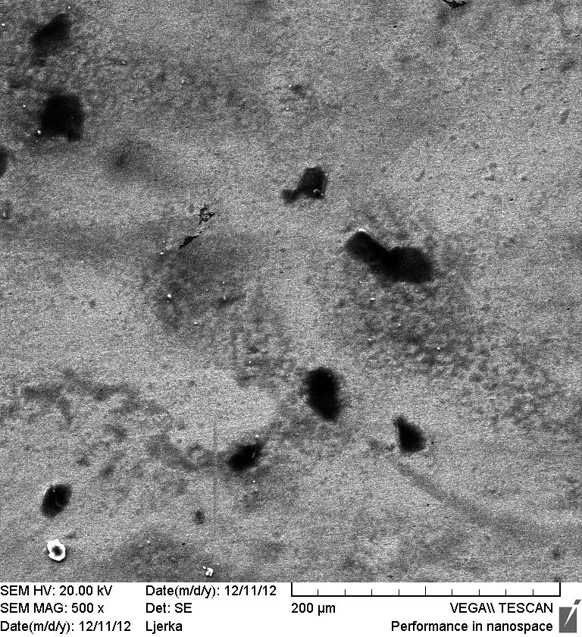
(a) fractured sample 2/1 (b) sample 1/3 (c) sample 2/5
Figure 5. SEM micrographs of investigated steels
Often, inclusions are initial spots for micro-cracks forming. They are under the influence of external stress quickly spread and lead to fracture [6].
Galvanized steel as well as former steel does not meet its purity due to the concentration of inclusions and micro porosity. It can be clearly seen in Figure 5a.

CONCLUSIONS

The results obtained in this investigation show that analyzed steels have the lack of purity with respect to the inclusions and micro porosity as well as high copper content. Because of that, lifting hooks made from investigated plain carbon steels have considerable potential for failure. When stronger (bending) strain is applied, the formation of cracks occurs in them. At high load when lifting concrete blocks they can progress rapidly and lead to fracture. For this reason, steels with better quality (purity) must be used. Also, galvanizing as corrosion protection is not recommended, because in some cases it might lead to the harmful effect on the mechanical properties of material.

REFERENCES

  - R. Bjorhovde, Development and use of high performance steel, Journal of Constructional Steel Research, 60 (2004) 393-400.
  - T. Filetin, F. Kovačiček, J. Indof, Svojstva i primjena materijala, Sveučilište u Zagrebu Fakultet strojarstva I brodogradnje, Zagreb, 2002.
  - J.A. Abdalla, R.A. Hawileh, F. Oudah, K. Abdelrahman, Energy-based prediction of low-cycle fatigue life of BS 460B and BS B500B steel bars, Materials and Design 30 (2009) 4405-4413.
  - http://www.concretecentre.com/codes__standards/eurocodes/eurocode_2/european_concrete_standards/standards_for_reinforcement.aspx
  - L. Savov, E. Volkova, D. Janke, Copper and Tin in Steel Scarp Recycling, RMZ – Materials and Geoenvironment, 50 (2003) 3, 627-640.
  - http://www.keytometals.com/page.aspx?ID=CheckArticle&site=kts&NM=198

