LABORATORY METHOD FOR KINESIOLOGICAL AND EMG DYNAMIC TESTING OF POSTURAL STATUS

V. Medved*, V. Filipović** and D. Katović*

* Faculty of Physical Education, University of Zagreb, Zagreb, Croatia
** School for Health Studies, Study for Physiotherapists, Zagreb, Croatia

vmedved@aris.ffk.hr

Abstract: Dynamic postural testing might be relevant both to healthy individuals and patients. Bad postures and scolioses in adolescence are the groups targeted here. We have introduced a simple test employing a custom designed balance platform, previously applied successfully to healthy student population. In the present study we develop a comprehensive measurement set-up, using this same platform, and including standard force platform and EMG apparatus, and kinesiological testing procedure - lasting in total cca. 60 min. and requiring three operators - to provide complex laboratory testing of postural status. Application of this procedure to three age-matched subject samples of: 38 scolioses, 31 bad postures, and 37 normals revealed that, in general, the degree of scoliosis correlates with an increased time of performance of kinesiological tests. Possible application of this procedure is in clinics, as an aid in medical diagnosis and during treatment.

Introduction

Dynamic postural testing bears importance in areas such as health status evaluation in normals and in pathologies. Regarding a specific class of pathologies: bad postures and scolioses, dynamic postural testing possibilities might be especially important. Namely, since to provide therapy to such patients is often not unequivocal [1], each new objective testing method may be a sought-for criterion in this process. Louis Nashner pioneered the area of dynamic postural testing ability by his Sc.D. thesis in 1970 at M.I.T. by constructing a research apparatus designed to permit studies of dynamic body sway. There have been many attempts since then to develop and standardise specific tests that would reflect appropriately the equilibrium and balance abilities, such as for instance those enabled using the well-known commercial EquiTest equipment, and the like. We have also worked along those lines by introducing a simple test employing a custom designed balance platform, and which - when applied to healthy student population - successfully discriminated between some testing conditions [2]. In the present study, we develop a comprehensive measurement set-up, using this same platform, and including force platform and EMG recorder, plus kinesiological testing, in the procedure to provide a complex evaluation of postural status, aimed at measuring patients with bad postures and scolioses. This paper describes our equipment set-up, testing procedure, and illustrates typical measurement results and some statistics. Our principal aim in this study is to evaluate whether idiopathic adolescent scoliosis results in disturbed balance and co-ordination functions, or, possibly, an organism is able to provide compensation in this respect [3,4].

Materials and Methods

The measurement set-up includes a balance platform, a bench, a strain gauge based force platform, and 4-channel surface EMG recorder. This equipment serves for biomechnical laboratory testing via two distinct paradigms: balancing and stepping at the bench from the force platform. During both paradigms surface EMG electrodes were positioned at following muscles: m. gluteus maximus sin. and dex., m. erector trunci sin. and dex. The balancing paradigm lasted for 15 seconds and included variations of tandem standing position and one-leg standing position, as well as eyes-open and eyes-shut conditions. Stepping paradigm included six full strides. Measurement signals were continuously acquired and stored into computer memory.
In addition, four classical kinesiological co-ordination tests were provided at another occasion. The tests were: side-step performance (MAGKUS), performance of the “eight” with forward trunk flexions (MAGOSS), aerial skill ability (MKTOZ), and floor skill ability (MAGONT) (detailed description in [5]). Quality of performance in all co-ordination tests is inversely proportional to time of performance.
Subject sample included 37 normals (controls), 38 diagnosed idiopathic adolescent scolioses and 31 diagnosed bad postures, all adolescents.
Measurement and testing procedure as a whole took about one hour per subject, occupying three operators.

Results

Figure 1 is an example of force platform stepping signals and two raw EMG signals (sin. and dex. erector trunci) generated by a female subject (age 10) diagnosed as idiopathic adolescent scoliosis, Th-dex, Cobb angle 28°, apex 8th thoracic vertebra (wears orthosis in normal life).
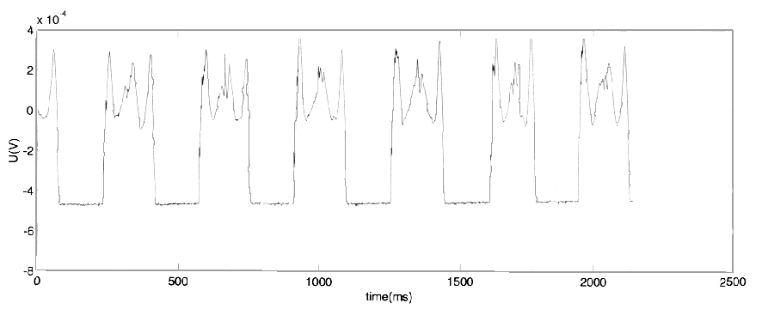
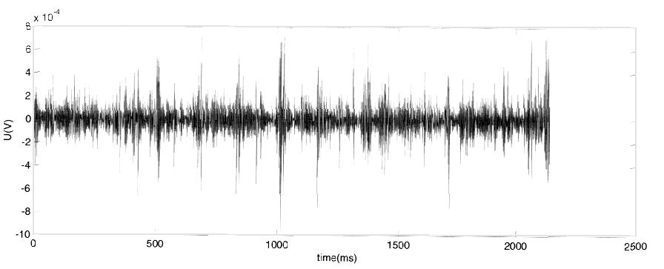
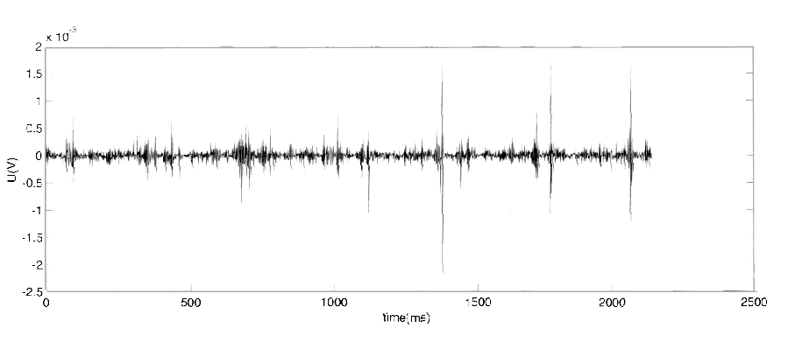
Figure 1

She was under classical orthopaedic and physical therapy.
Table 1 shows results of basic statistics of results of all co-ordination tests for three groups (G₁ - idiopathic adolescent scolioses, G₂ - bad postures, G₃ - normals).

 | mean G1 | SD1 | mean G2 | SD2 | mean G3 | SD3
MAGKUS | 14,75 | - | 11,71 | 1,47 | 13,31 | 3,15
MAGOSS | 36,42 | - | 33,94 | 3,83 | 21,73 | 4,06
MKTOZ | 7,22 | - | 5,9 | 0,92 | 5,59 | 1,16
MAGONT | 21,9 | - | 15,71 | 3,21 | 20,33 | 5,07

Table 1

Discussion

In the Figure 1, chosen as an example, one may notice a slight asymmetry in muscular function. Such finding may be the consequence of the disease.
Co-ordination test results reveal a trend where degree of illness accompanies longer performance time. The exception to this is in floor skill ability test (MAGONT). These findings deserve further attention.

Conclusion

While kinesiological co-ordination tests have, in general, shown results as expected, biomechanical laboratory measurement results were not analysed yet. The measurement paradigm itself has been standardised successfully, but only after thorough elaboration of measurement results, primarily by signal analysis, their individual interpretation in the context of clinical pictures, and also by their comparison with co-ordination test results, will it be possible to establish a true value to our procedure.

Acknowledgement

This study was supported by The Ministry of Science and Technology of the Republic of Croatia (Project No. 034-004).

REFERENCES

[1] T. Nagai, Y. Tsuchiya, A. Maruyama, M. Takemitsu and I. Nonaka, “Scoliosis associated with central core disease”, Brain and Development, vol. 16, pp. 150-152, 1994.
[2] V. Medved and S. Heimer, “A new balance measurement system: some analytical and empirical considerations”, Periodicum biologorum, vol. 95, pp. 101-104, 1993.
[3] V. S. Ruggieri, “Bodily perception in the organization of postural attitude and movement”, Perceptual and Motor Skills, vol. 82, pp. 307-312, 1996.
[4]G. Kidd, N. Lowes and I. Musa, Understanding neuromuscular plasticity - a basic for clinical rehabilitation. London: Hodder and Stoughton, 1992.
[5] S. Horga, On some relations between anxiety and co-ordination. Ph.D. Thesis. University of Zagreb. Faculty of Physical Education. 1976. (In Croatian).

