The influence of rolling speed on the fatigue life of rolls with grooves

ŽELJKO DOMAZET, FRANCISKO LUKŠA
University of Split; Faculty of Electrical Engineering, Mechanical Engineering and Naval Architecture;Ruđera Boškovića 32, 21000 SPLIT, Croatia

TATJANA STANIVUK
University of Split; Faculty of Maritime Studies; Zrinsko-Frankopanska 38, 21000 Split, Croatia

ABSTRACT: In the hot rolling process rolls with grooves are used for the production of various simple and complex profiles. Main factors influencing the fatigue life of these rolls result from the technological process of the rolling. Rolling speed is an important parameter of technological process which has great influence on overall production. In order to increase rolling production, an analysis of the rolling speed influence on the fatigue life of the rolls has been carried out. The fatigue life estimation is carried out according to the fatigue life stress concept based on the local stress. Stress spectra in critical areas are determined for three different roll speeds. The analysis shows that although increasing of the rolling speed causes decreasing of the fatigue life of the roll, the stresses caused by the rolling at the highest speed should not lead to roll fracture.

KEY WORDS: fatigue, fatigue life, shape rolling, rolls with grooves, rolling speed

INTRODUCTION

In hot rolling, the rolling speed is an important parameter of technological process and overall production depends of the rolling speed. Many producers want to increase the capacity of existing production line. One of the ways to increase the rolling mill production is to increase the rotation speed of existing rolling mill stands which can affect on roll fatigue life (Lukša, 2013). In order to increase the rolling production and to avoid possible fatigue failure of the rolls (Domazet, Lukša and Šušnjar, 2007), an analysis of the rolling speed influence on fatigue life of the rolls has been carried out on 3-high-roughing mill stand in “Steelworks Split”. Additional motivation for this study was the lack of adequate literature.
3-high-roughing mill stand was suitable for hot rolling of the billets with initial cross-section 100 mm square and 3 m initial length in 8 passes. The rolling mill production was 70 billets per hour. The mass of one billet was 230 kg. The rolling material was reinforcement steel mark BSt (Betonstahl) 400 S according to German standard DIN (Deutsches Institut für Normung) 488. The initial temperature of the rolled material in the first pass was 1200 C°. The roll speed was 120 rpm. The total length of the roll was 2300 mm, the roll barrel length was 1400 mm and the roll barrel diameter was 450 mm. The material used for the rolls was nodular graphite cast iron with the pearlitic base with hardness on the roll surface 380 HB. The roll machining due to wearing was estimated after 4000 rolling tons of steel.
Figure 1 shows the roll design and groove distribution (Designs and technological rules "Steelworks Split"). Pass shape rolling sequence (pass schedule) between rolls and corresponding grooves are numbered. The pass schedule and corresponding data are shown in Table 1.
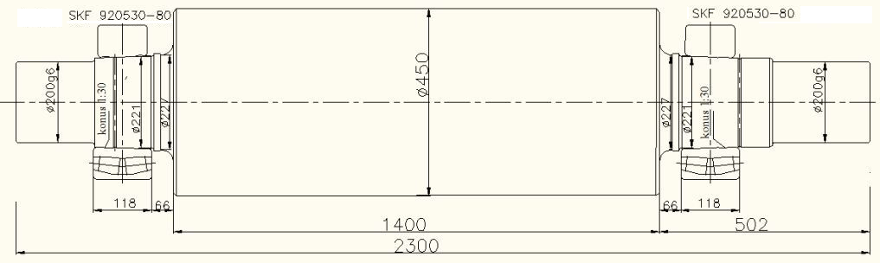
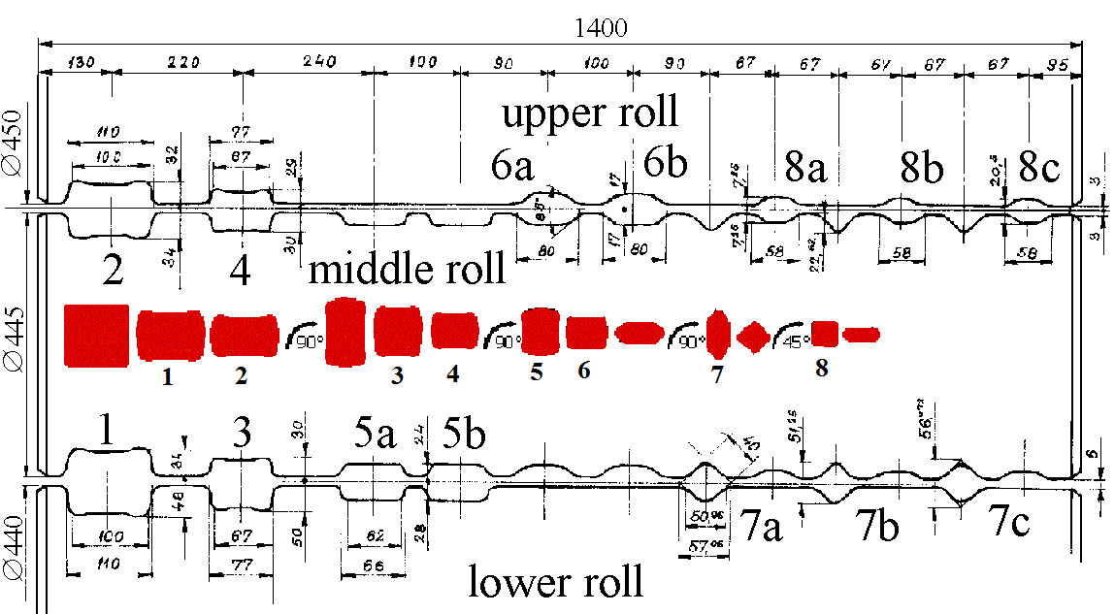

Figure 1. Roll design, groove distribution and rolling sequence

Table 1. Pass schedule

Pass |  | 1 | 2 | 3 | 4 | 5 | 6 | 7 | 8
Pass shape |  | box | box | box | box | box | oval | square | oval
Groove dimensions [mm] |  | 100x82 | 100x66 | 67x80 | 67x59 | 66x52 | 80x34 | 40 | 58x20
Cross-section [mm²] | 9850 | 8015 | 6474 | 5398 | 4032 | 3280 | 2286 | 1578 | 1075
Width [mm] | 100 | 104 | 108 | 71 | 76 | 65 | 82,5 | 53,5 | 60,5
Initial height [mm] |  | 100,0 | 82,0 | 108,0 | 80,0 | 76,0 | 52,0 | 82,5 | 40,0
Height after pass [mm] |  | 82,0 | 66,0 | 80,0 | 59,0 | 52,0 | 34,0 | 51,0 | 20,5
Average draught [mm] |  | 17,6 | 14,3 | 15,2 | 18,0 | 11,6 | 12,0 | 13,2 | 8,3
Absolute reduction [mm²] |  | 1835 | 1541 | 1076 | 1366 | 752 | 994 | 708 | 503
Elongation coefficient |  | 1,23 | 1,24 | 1,20 | 1,34 | 1,23 | 1,43 | 1,45 | 1,47
Working diameter [mm] |  | 372,5 | 393,5 | 372,5 | 398,5 | 396,5 | 419,5 | 397,25 | 433
Roll speed [rpm] |  | 120 | 120 | 120 | 120 | 120 | 120 | 120 | 120
Length of rolled stock [m] | 3 | 3,69 | 4,56 | 5,47 | 7,33 | 9,01 | 12,93 | 18,73 | 27,49
Projected length of arc of contact [mm] |  | 57,84 | 56,10 | 72,08 | 64,68 | 68,97 | 61,44 | 79,10 | 64,97
Projected area of contact [mm²] |  | 5900 | 5947 | 4938 | 4754 | 4276 | 4531 | 3461 | 3265
Rolling speed [ms⁻¹] |  | 2,33 | 2,62 | 2,42 | 2,77 | 2,55 | 2,78 | 2,7 | 2,89
Rolling time [s] |  | 1,58 | 1,74 | 2,26 | 2,65 | 3,53 | 4,65 | 6,92 | 9,52
Pause [s] |  | 3 | 3 | 3 | 3 | 3 | 3 | 3 | 3
Pull through angle – α[°] |  | 18,1 | 16,6 | 22,9 | 19,9 | 20,4 | 17 | 23,5 | 17,5
Deformation speed [s⁻¹] |  | 7,9 | 9,5 | 7,4 | 12 | 9,6 | 15,5 | 10,5 | 18,7

Rolling speed limit

Increasing of rolling speed is limited by the pull through angle. Pull through angles in the passes are determined in accordance with relation (Čaušević, 1983):

α = arcsin (2l_{d} / D), (1)

where l_{d} is projected length of arc of contact and D is diameter of the roll. Pull through angles in the passes are shown in Table 1. From the comparison of the pull through angles shown in table 1, it can be seen that the biggest pull through angle is 23,5° in the pass 7.
Experimentally obtained diagram of Z. and R. Wusatowski (Čaušević, 1979), shown on Figure 2 is used for the estimation of maximum rolling speed.

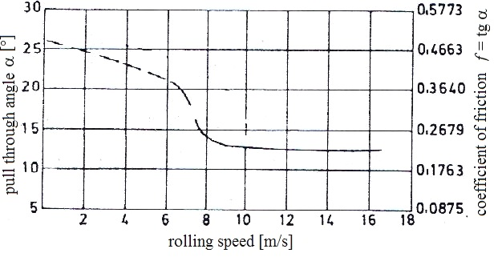
Figure 2. Pull through angle of low carbon steel with 0,18%C, Z. & R. Wusatowski

From the diagram on the Figure 2 is visible that maximum rolling speed for pull through angle of 23,5° is 4 ms⁻¹ what is 1,5 time more than rolling speed in 7. pass, see Table 1. According to that, maximum possible increasing of roll speed is from 120 rpm to 180 rpm. The increasing of roll speed from 120 rpm to 150 rpm and 180 rpm is analysed.

Resistance to deformation

The main parameter in describing the rolling force is resistance to deformation of rolling material. Resistance to deformation depends of the rolling temperature, deformation speed and deformation size. Figure 3 shows experimentally obtained diagram of A.A.Dinnik (Čaušević, 1979), deformation resistance of low carbon steel St3 for the draught of 30% and different deformation speed and rolling temperature. For draught different than 30%, value of resistance to deformation from this diagram should be multiplied by correction factor a (curve on top of the same diagram).
For rolling sequence in 8 passes on 3-high-roughing mill stand, deformation speed is in the range between 7,4 and 18,7 s⁻¹, see Table 1, and rolling temperature is in the range between 1200°C and 1100°C, Figure 3. Initial temperature in the first pass was 1200°C. Monitoring of the rolling temperature drop was carried out using digital pyrometer, see Table 2. Temperature in eighth pass was 1148°C.
Deformation speeds are determined in accordance with the relation (Čaušević, 1983):

(2)
Where v is rolling speed, h₀ is initial height and h₁ is height after pass, Δh_{sr} is average draught, R₁ and R₂ are radiuses of rolls.
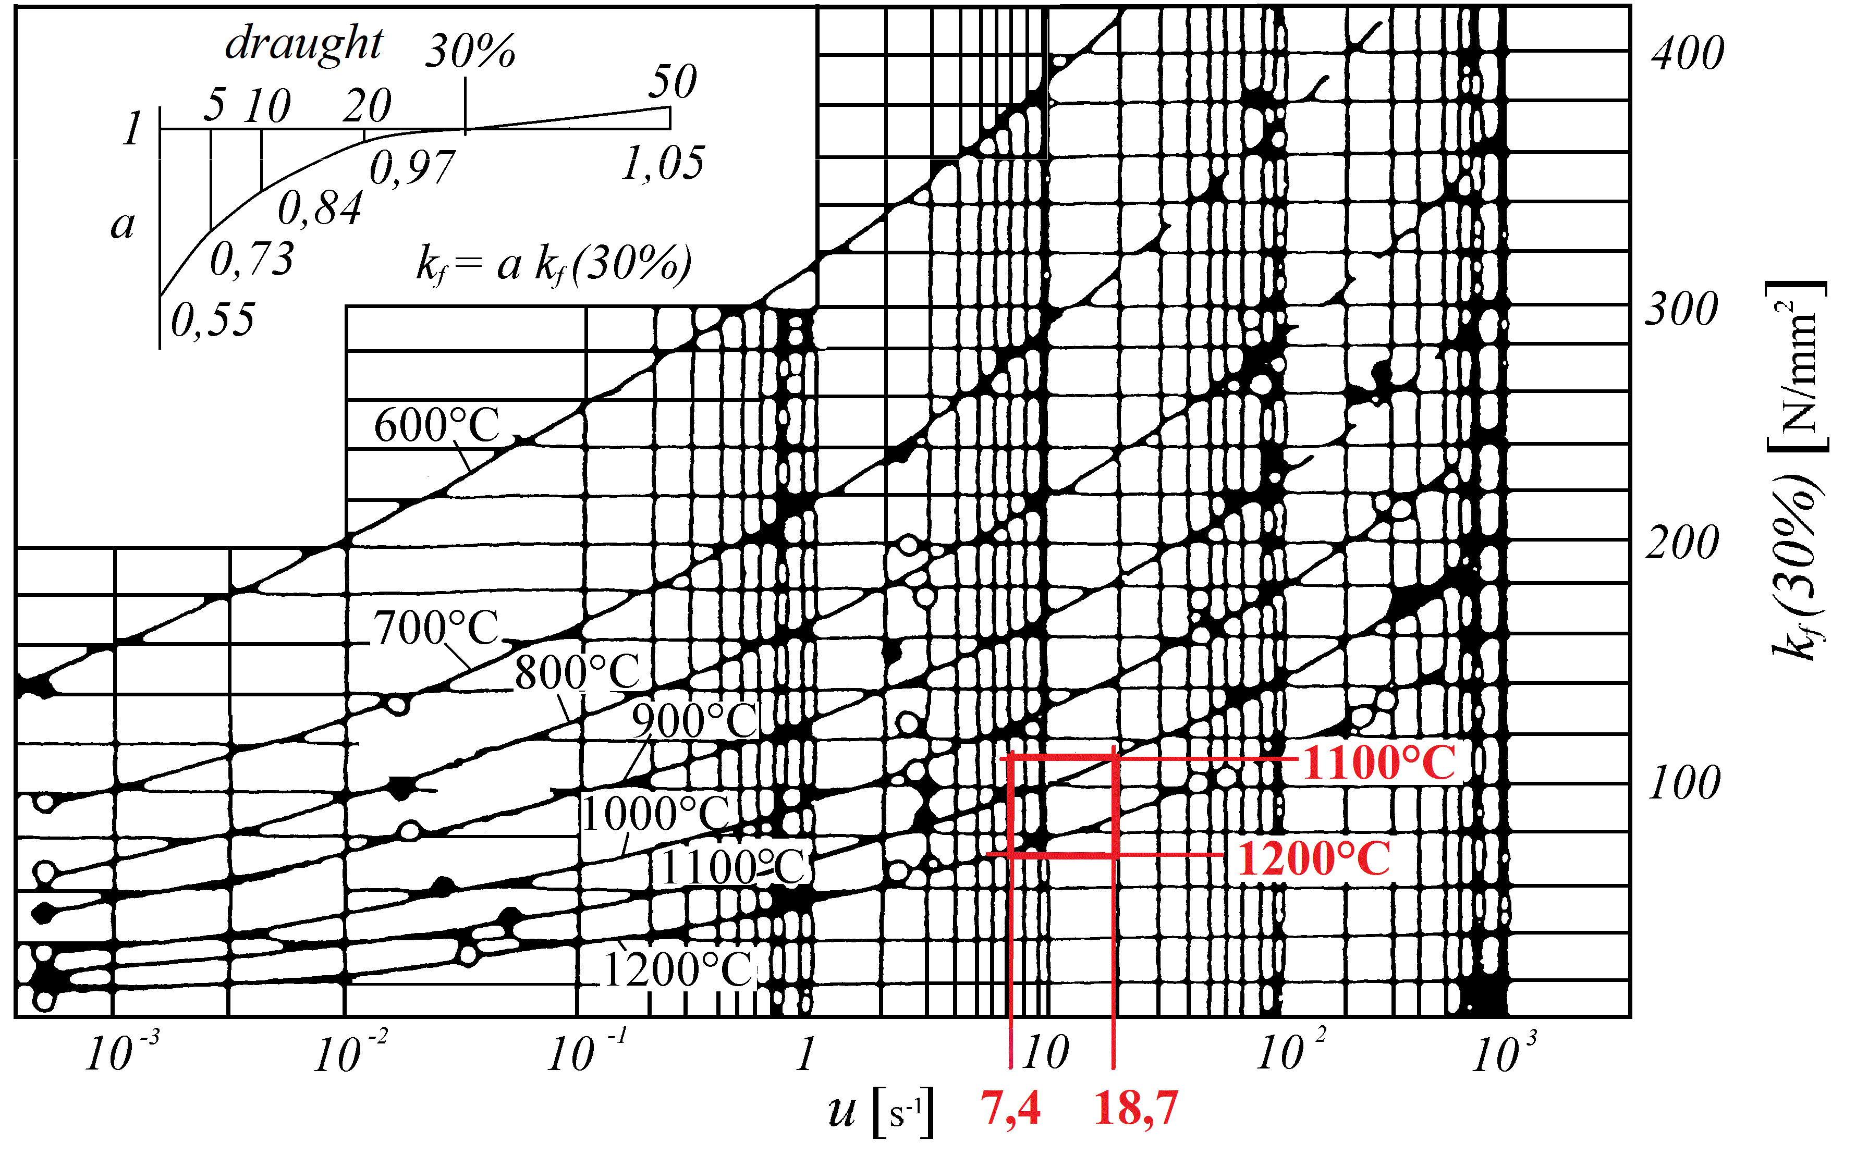
Figure 3. Resistance to deformation of low carbon steel St3, A.A.Dinnik

STRESS SPECTRUM DETERMINATION

Since there are numerous formulae for calculating the rolling force in hot rolling (Čaušević 1979), analytical calculation for this process was done according to methods of A.I.Tselikov, S.Ekelund, A.A.Korolev, A.Geleji, A.F.Golovin and V.A.Tiagunov, R.B.Sims and E.Siebel and the results were compared (Lukša, 2005). Comparison of the results shown large deviations, see Figure 6. Therefore the rolling forces were determined by experimental testing (Domazet, Lukša, 2005).
In accordance with results from analytical methods for determining the rolling force, four load cells, with three strain gauges on each, were designed for experimental determining of the rolling force, Figure 4.

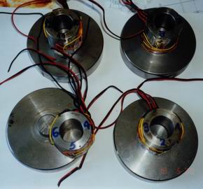

Figure 4. Load cells

The measuring devices were mounted on both sides of the stand, instead of two safety parts against the breakage of rolls, Figure 5. One pair of load cells was used to measure reaction forces due to rolling force between two rolls (lower and middle roll or middle and upper roll). Measurement of rolling forces was carried out during the 1 hour of rolling production.

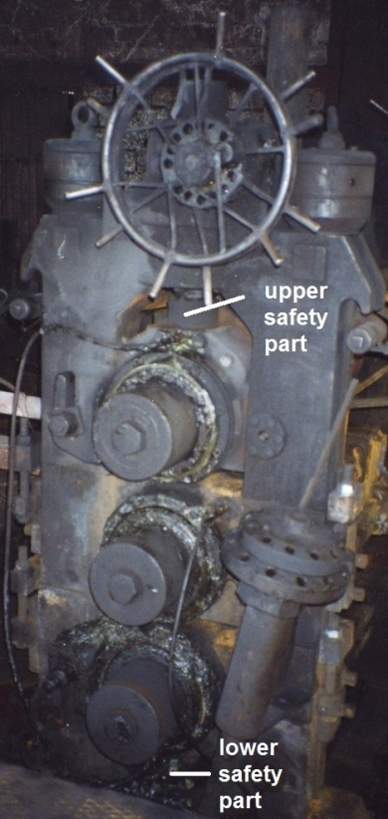 | 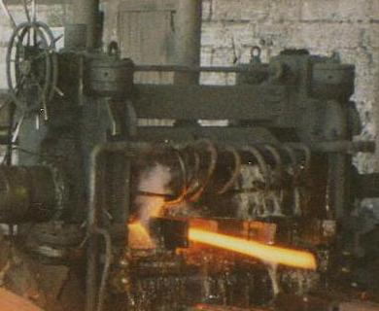  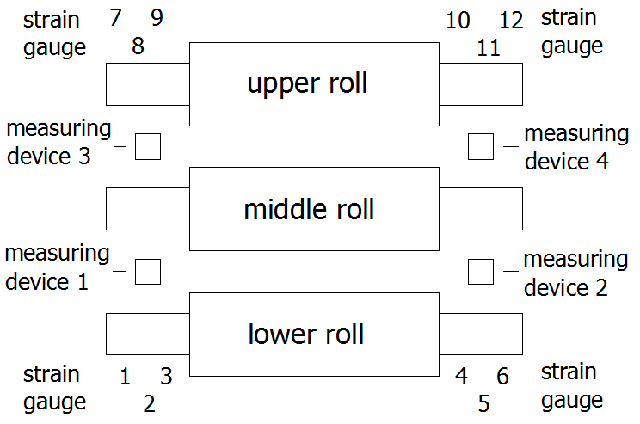
Figure 5. Positions of the load cells on 3-high-roughing mill stand

Experimentally determined rolling forces are shown in Table 2. Figure 6 shows the comparison of experimentally determined rolling forces and calculated results according to methods of A.I.Tselikov, S.Ekelund, A.A.Korolev, A.Geleji, A.F.Golovin and V.A.Tiagunov, R.B.Sims and E.Siebel for rolling in eight passes, see Table 1 and Figure 1.

Table 2. Experimentally determined rolling forces

Pass | 1 | 2 | 3 | 4 | 5 | 6 | 7 | 8
Rolling temperature [°C] | 1200 | 1198 | 1194 | 1188 | 1183 | 1176 | 1169 | 1159
Experimentally determined rolling forces [kN] | 356,1 | 494,6 | 356,1 | 524,2 | 346,2 | 544,0 | 286,8 | 445,1

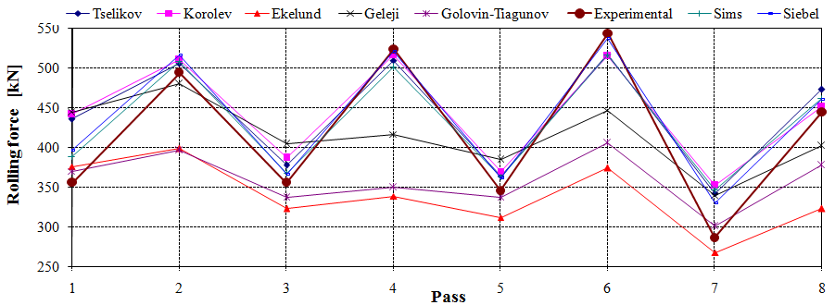

Figure 6. Analytically and experimentally determined rolling forces

It may be seen from the curves shown in Figure 6 that, for the same rolling conditions, there are large deviations in the calculated values ​​of force rolling by different authors. Values obtained for rolling forces calculated according to Tselikov, Korolev, Sims and Siebel have a good agreement with experimentally determined values in the first six passes and eighth pass and deviations in the seventh pass. The first six passes and eighth pass have clearly expressed the contact surface and shape is closer to rolling flat profile. In the seventh pass, due to square shape, pressure on the rolls varies considerably due to uneven deformation and additional frictional force on the sides of the caliber. Values obtained for rolling forces calculated according to Ekelund, Geleji and Golovin-Tjagunov methods are too low. Based upon these results, formulae of Tselikov, Korolev, Sims and Siebel will be used in following calculation.
Because of numerous parameters (the properties of the rolls and the rolling material; the form of the grooves; the friction between rolls and rolling material, …) experimental methods are more suitable and more accurate for determining the rolling force in the grooves.

The obtained experimental results of rolling forces are used for the numerical analysis of local stresses by the finite element method using ADINA software. The linear elastic model with 3D solid elements with eight nodes per element was used, Figure 7. Each node has 3 degrees of freedom, translation in X, Y and Z direction. Model is fixed on the both ends in the line and loaded with concentrated forces in the nodes. On the Figure 7 is shown concentrated force due to rolling force in pass 1.

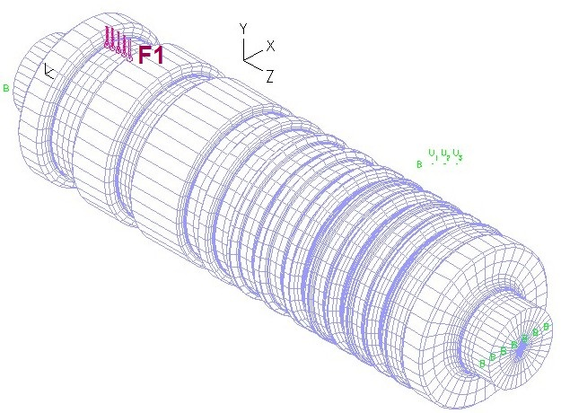

Figure 7. Linear elastic model with 3D solid elements

The complete numerical analysis included 30 cases of loading according to the rolling schedule. The FEM revealed that there are 3 critical areas of the roll: roll neck, pass groove 3-4 and pass groove 7a. Stress concentration factors at the critical areas have a good agreement with literature (Pilkey and Pilkey, 2008; Heibach, 1989).
Figure 8 shows the FEM model of the middle roll with stock positions in pass grooves 2 and 6 and corresponding stresses in direction Z. Critical areas of the roll are marked in figure.

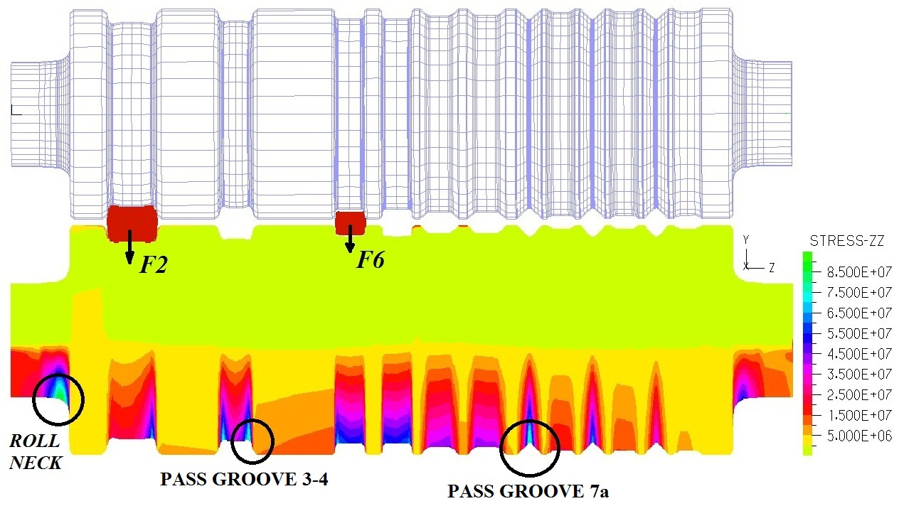

Figure 8. Numerical analysis

3-high-roughing mill stand rolling diagram according to time is constructed from the mill production and pass schedule, Figure 9.
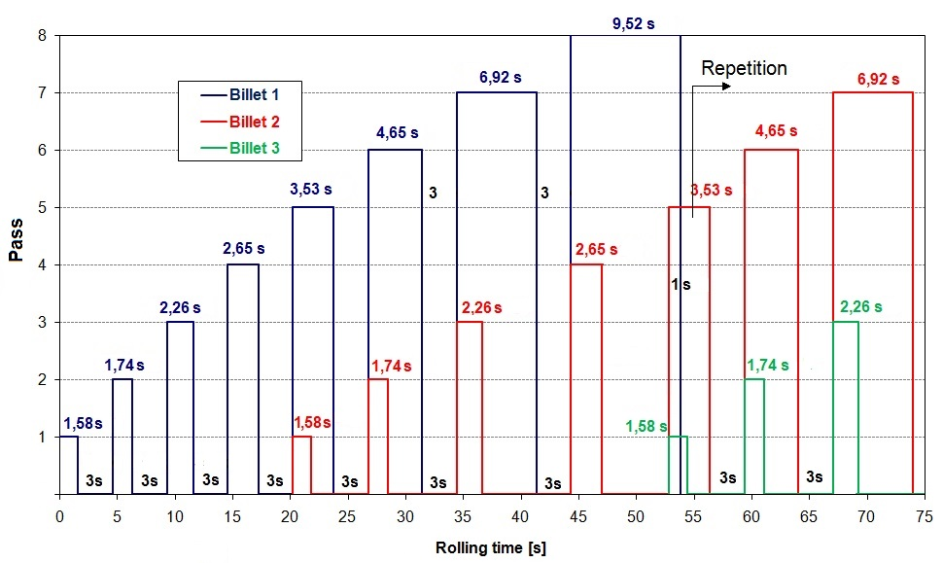

Figure 9. Rolling schedule according to time on 3-high-roughing mill stand

Rolling is starting with first billet in the pass 1 and rolling duration is 1,58 seconds, see Figure 9. After 3 seconds of idle time, rolling stock is coming in 2 pass and rolling duration is 1,74 seconds. Then follow pass 3 and pass 4 and after 20 seconds of first stock start, beginning rolling process of two billets together. Then rolling process on the 3-high-roughing mill stand continues according to rolling schedule.

Stress time history of the individual local stress and stress spectra are obtained from numerical analysis and rolling schedule according to time, Figure 13.

Fatigue strength of the roll material in the pass groove was missing and fatigue strength was determined by experimental testing.
From the new roll dimensions ∅500 x 1500 mm with same characteristic like rolls in service was taken out by turning one ring dimensions ∅440x∅320x170, Figure 10. The hardness measurements were done in four places.

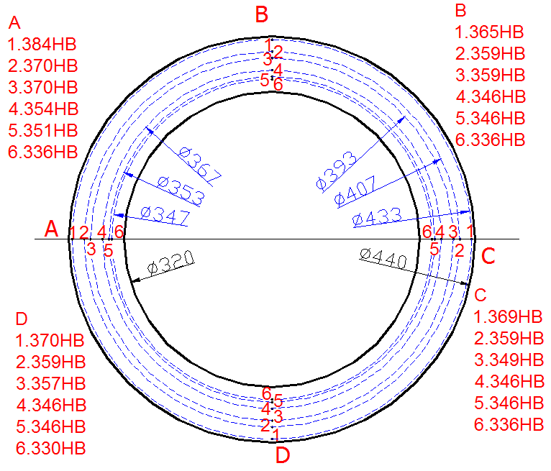

Figure 10. Ring was taken from the new roll in order to prepare specimens

Specimens, (as shown) in Figure 11, were taken from the ring by water cutting. Final testing shape of the specimen was made by grinding machine. During the grinding, specimens were cooled with lot of water to avoid that material lose the properties. Figure 12 shows metallographic structure of specimen.

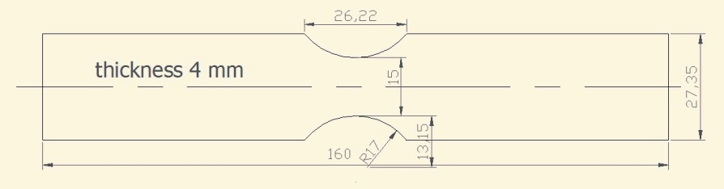  Figure 11. Shape and dimensions of the specimen | Figure 12. Metallographic structure of specimen (500x)

Dynamic test were carried out in Laboratory of fatigue strength at Department of Mechanical Construction, Faculty of Electrical Engineering, Mechanical Engineering and Naval Architecture, University of Split. Bending tests were performed on the plane bending mechanical testing machine.
Figure 13 shows experimentally obtained fatigue strength of the roll material under constant amplitude in the pass groove and stress spectra of three critical areas: on the roll neck, pass groove 3-4 and pass groove 7a for 4000 rolling tons.

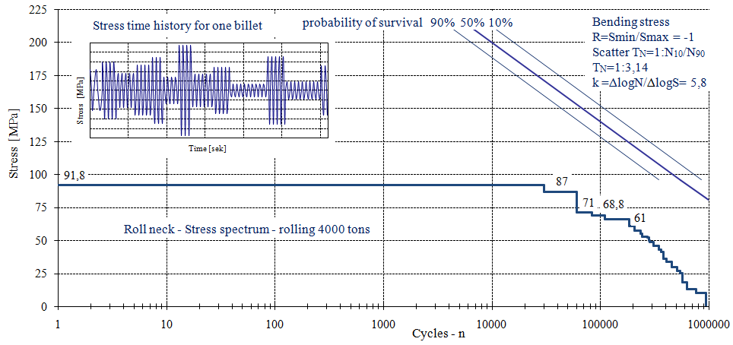
- Roll neck

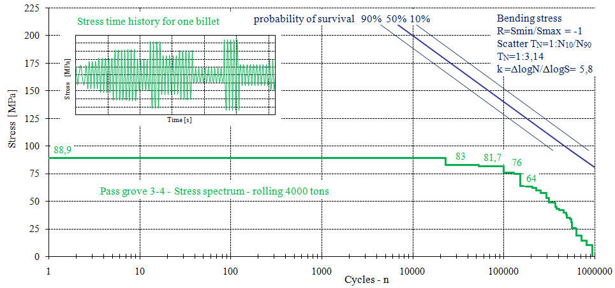
- Pass grove 3-4

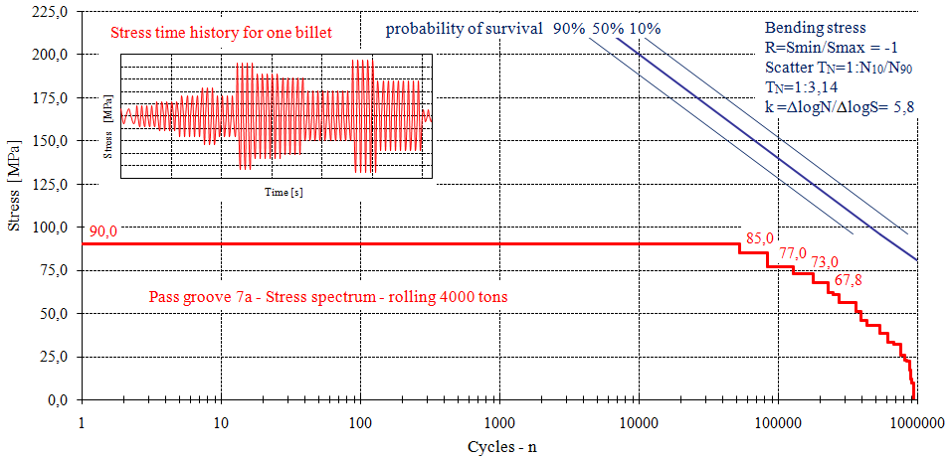
- Pass grove 7a

Figure 13. Stress spectra for critical areas

From the comparison of the presented spectra it can be seen that the most critical area of the roll is pass groove 7a.

INFLUENCE OF ROLLING SPEED ON THE ROLLING FORCE

Resistance to deformation for 3 different roll speeds in each pass is determined from diagram of A.A.Dinnik, Figure 3. The results are shown in Table 3. The influence of rolling speed on the resistance to deformation is shown in Figure 14.

Table 3. Resistance to deformation in the passes for different roll speeds

Roll speed | Pass No. | 1 | 2 | 3 | 4 | 5 | 6 | 7 | 8
120 rpm | Rolling speed [ms⁻¹] | 2,33 | 2,62 | 2,42 | 2,77 | 2,55 | 2,78 | 2,7 | 2,89
120 rpm | Deformation speed [s⁻¹] | 7,9 | 9,5 | 7,4 | 12,0 | 9,6 | 15,5 | 10,5 | 18,7
120 rpm | Resistance to deformation [N/mm²] | 66,3 | 75,5 | 64,5 | 83 | 73,6 | 89,8 | 86,8 | 98,1
150 rpm | Rolling speed [ms⁻¹] | 2,92 | 3,28 | 3,03 | 3,46 | 3,19 | 3,47 | 3,38 | 3,61
150 rpm | Deformation speed [s⁻¹] | 9,9 | 11,9 | 9,2 | 14,9 | 12,0 | 19,4 | 13,1 | 23,4
150 rpm | Resistance to deformation [N/mm²] | 68,6 | 78,1 | 66,7 | 85,8 | 76,1 | 92,9 | 88,9 | 101,6
180 rpm | Rolling speed [ms⁻¹] | 3,50 | 3,93 | 3,63 | 4,15 | 3,83 | 4,17 | 4,06 | 4,33
180 rpm | Deformation speed [s⁻¹] | 11,8 | 14,3 | 11,0 | 17,9 | 14,4 | 23,2 | 15,7 | 28,1
180 rpm | Resistance to deformation [N/mm²] | 70,5 | 80,2 | 68,6 | 88,2 | 78,3 | 95,5 | 92,4 | 104,4

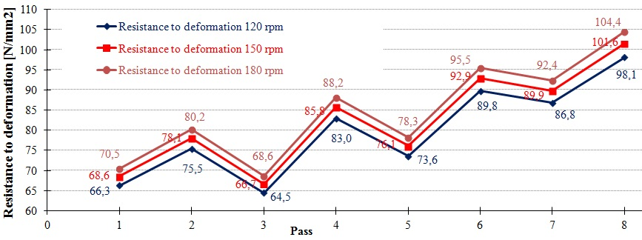

Figure 14. Influence of rolling speed on the resistance to deformation

Based upon the results of experimental determination of rolling forces, the methods of A.I.Tselikov, A.A.Korolev, R.B.Sims and E.Siebel were used to calculate rolling forces for 3 different roll speeds. Values of rolling forces for 3 different roll speeds obtained according to these four authors are shown in Table 4.

Table 4. Rolling forces calculation for 3 different roll speeds

Roll speed | Pass No. | 1 | 2 | 3 | 4 | 5 | 6 | 7 | 8
120 rpm | Rolling forces Tselikov F120 [kN] | 430,7 | 506,3 | 377,9 | 510,3 | 364,2 | 518,4 | 342,8 | 473,7
120 rpm | Rolling forces Koroljev F120 [kN] | 436,0 | 510,5 | 387,8 | 517,2 | 370,4 | 515,2 | 352,3 | 451,6
120 rpm | Rolling forces Sims F120 [kN] | 384,0 | 508,1 | 367,7 | 501,2 | 363,5 | 517,0 | 347,1 | 462,5
120 rpm | Rolling forces Siebel F120 [kN] | 391,2 | 516,2 | 366,1 | 521,7 | 361,9 | 538,1 | 330,6 | 460,5
150 rpm | Rolling forces Tselikov F150 [kN] | 445,4 | 523,6 | 390,9 | 527,9 | 376,8 | 536,3 | 354,7 | 490,3
150 rpm | Rolling forces Koroljev F150 [kN] | 450,9 | 528,0 | 401,1 | 535,0 | 383,2 | 533,1 | 364,6 | 467,4
150 rpm | Rolling forces Sims F150 [kN] | 397,2 | 525,5 | 380,3 | 518,5 | 376,1 | 534,9 | 359,2 | 478,7
150 rpm | Rolling forces Siebel F150 [kN] | 404,6 | 533,9 | 378,7 | 539,7 | 374,4 | 556,8 | 342,1 | 476,6
180 rpm | Rolling forces Tselikov F180 [kN] | 457,8 | 538,2 | 401,8 | 542,7 | 387,4 | 551,5 | 364,8 | 504,3
180 rpm | Rolling forces Korolev F180 [kN] | 463,5 | 542,8 | 412,3 | 550,1 | 394,0 | 548,1 | 374,9 | 480,8
180 rpm | Rolling forces Sims F180 [kN] | 408,2 | 540,1 | 391,0 | 533,0 | 386,6 | 550,0 | 369,4 | 492,3
180 rpm | Rolling forces Siebel F180 [kN] | 415,8 | 548,8 | 389,3 | 554,8 | 385,0 | 572,5 | 351,8 | 490,2
Rolling force increments due to roll speed increasing are shown in Table 5.

Table 5. Force increment

Pass No. | 1 | 2 | 3 | 4 | 5 | 6 | 7 | 8 | Average
Tselikov F150/F120 | 1,03 | 1,03 | 1,03 | 1,03 | 1,03 | 1,03 | 1,03 | 1,04 | 1,03
Koroljev F150/F120 | 1,03 | 1,03 | 1,03 | 1,03 | 1,03 | 1,03 | 1,03 | 1,04 | 1,03
Sims F150/F120 | 1,03 | 1,03 | 1,03 | 1,03 | 1,03 | 1,03 | 1,03 | 1,04 | 1,03
Siebel F150/F120 | 1,03 | 1,03 | 1,03 | 1,03 | 1,03 | 1,03 | 1,03 | 1,04 | 1,03
Tselikov F180/F120 | 1,06 | 1,06 | 1,06 | 1,06 | 1,06 | 1,06 | 1,06 | 1,06 | 1,06
Koroljev F180/F120 | 1,06 | 1,06 | 1,06 | 1,06 | 1,06 | 1,06 | 1,06 | 1,06 | 1,06
Sims F180/F120 | 1,06 | 1,06 | 1,06 | 1,06 | 1,06 | 1,06 | 1,06 | 1,06 | 1,06
Siebel F180/F120 | 1,06 | 1,06 | 1,06 | 1,06 | 1,06 | 1,06 | 1,06 | 1,06 | 1,06

Based on this data it is obvious that the rolling forces increment is about 3% for increasing roll speed from 120 rpm to 150 rpm and about 6% for increasing roll speed from 120 rpm to
180 rpm.

RESULTS AND DISCUSSION

The obtained experimental values of rolling forces with an increase of 3% and 6% are used for numerical analysis of local stresses by the finite element method. Stress spectra for the roll speeds 150 rpm and 180 rpm determined from numerical analysis and rolling schedule according to time are shown in Figure 15.

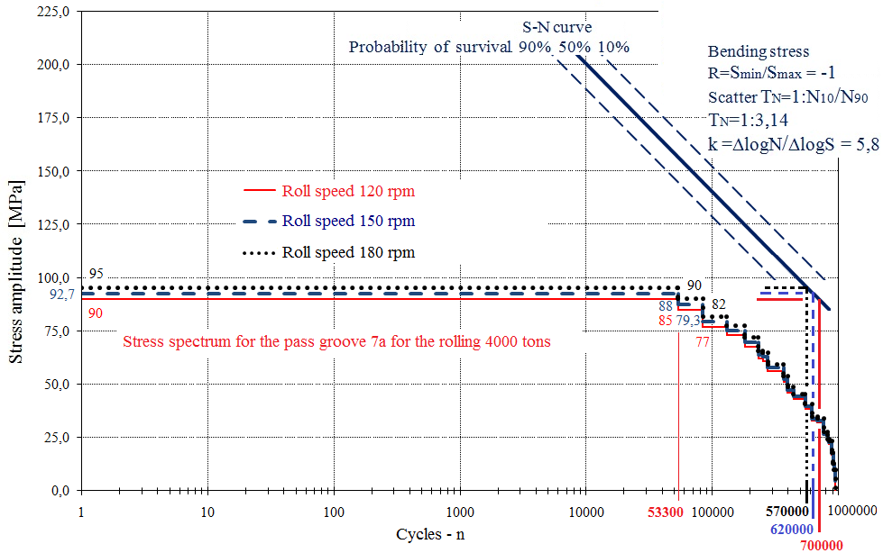

Figure 15. Influence of rolling speed on fatigue life

From Figure 15 it is evident:
- Increasing rolling speed from 120 rpm to 150 rpm causes increasing rolling force by 3% and reduces the fatigue life of the roll for about 11%.
- Increasing rolling speed from 120 rpm to 180 rpm causes increasing rolling force by 6% and reduces the fatigue life of the roll for about 19%.
- Although increasing rolling speed which causes decreasing of the fatigue life of the roll, the stresses caused by rolling with increasing speed for 50% should not lead to roll fracture for the rolling 4000 tons.

Conclusions

The analysis of rolling speed effects on calibrated rolls fatigue life shows that maximum increasing of rolling speed inside the technological limits will not affect the roll fatigue life and increasing of overall production by increasing the rolling speed should not lead to roll fracture.

REFERENCES

Lukša, F. (2013). Methodology of constructing optimal calibrated rolls with respect to fatigue strength, PhD Dissertation, University of Split, Faculty of Electrical Engineering, Mechanical Engineering and Naval Architecture, Split, Croatia
Domazet, Ž. and Lukša, F. (2005). Experimental determination of the rolling force on the rolls with grooves. Proceedings of the 22-nd Symposium "DANUBIA-ADRIA" on Experimental Methods in Solid Mechanics, Parma, Italy
Domazet, Ž., Lukša, F. and Šušnjar, M. (2007). Failure analysis of rolls with grooves, Engineering Failure Analysis, Volume 14, Issues 6, pages 1116-1174
Lukša, F. (2005). Investigation of the cause of the failures of the rolls with grooves. Master Thesis, University of Split, Faculty of Electrical Engineering, Mechanical Engineering and Naval Architecture, Split, Croatia
Čaušević, M. (1979). Teorija plastične prerade metala, Svjetlost, Sarajevo
Čaušević, M. (1983). Obrada metala valjanjem, Veselin Masleša, Sarajevo
Pilkey, W.D. and Pilkey, D.F. (2008). Stress concentration factors, 3rd edition, Hoboken, N.J.: John Wiley&Sons.
Heibach, E. (1989). Betriebfestigkeit, VDI Verlag Gmbh, Düseldorf
Designs and technological rules "Steelworks Split", Kaštel Sućurac, Croatia

