**AUTONOMOUS SURFACE PLATFORM FOR DIVER TRACKING AND NAVIGATION**

**Nikola Stilinović; Nikola Mišković;  
Đula Nađ; Antonio Vasilijević; Zoran Vukić**,  
*Laboratory for Underwater Systems and Technologies, Faculty of Electrical Engineering and Computing,  
University of Zagreb, Unska 3, 10000 Zagreb, Croatia*

*Tel: +385 / 1 6129 805*

*E-mail: {nikola.stilinovic; nikola.miskovic; dula.nad; antonio.vasilijevic; zoran.vukic}@fer.hr*

**ABSTRACT:**

This paper presents an autonomous surface platform with possibility of tracking and global localization of the diver. Such system increases diver safety during underwater activities. Broadcasting the GPS data to the diver makes navigating underwater easier. Furthermore, crew on base station (ship or coast station) can continuously keep track on divers work and his position which increases diver safety reacting promptly in case of emergency through communication with diver. Platform itself is designed in such way that is easy to transport it and lower it in the water by one person.

***Keywords:*** *autonomous vessel, GPS, USBL, diver safety***AUTONOMNA POVRŠINSKA PLATFORMA ZA PRAĆENJE I NAVIGACIJU RONIOCA**

**Nikola Stilinović; Nikola Mišković;  
Đula Nađ; Antonio Vasilijević; Zoran Vukić**,  
*Laboratorij za podvodne sustave i tehnologije,  
Fakultet elektrotehnike i računarstva,  
Sveučilište u Zagrebu, Unska 3, 10000 Zagreb, Hrvatska*

*Tel: +385 / 1 6129 805*

*E-mail: {nikola.stilinovic; nikola.miskovic; dula.nad; antonio.vasilijevic; zoran.vukic}@fer.hr*

**SAŽETAK:**

Ovaj rad prikazuje autonomnu površinsku platformu s mogućnošću praćenja i globalne lokalizacije ronioca. Takav sustav povećava sigurnost tijekom podvodnih aktivnosti. Prijenosom GPS podataka prema roniocu znatno se olakšava snalaženje u podvodnom svijetu. Nadalje, osoblje na baznoj stanici (brodu ili obalnoj stanici) može kontinuirano pratiti rad ronioca, njegovu poziciju i dodatno povećati sigurnost ronioca kroz pravovremenu reakciju u slučaju opasnosti kroz komunikaciju s roniocem. Sama platforma je dizajnirana tako da je omogućen lagani transport i polaganje platforme u vodu od strane jedne osobe.

***Ključne riječi:*** *autonomno plovilo, GPS, USBL, sigurnost ronioca*

# INTRODUCTION

Demand for small marine platform in marine robotics is very high, and its construction takes big part in whole project of creating an autonomous vessel. This one-man-portable platform is designed to be used on sea and lake for numerous guidance applications, e.g. dynamic positioning, path following, virtual target algorithm, etc. Platform's main task is diver tracking offering him global position underwater and communication with the ground station. The platform is designed and developed at the Laboratory for Underwater Systems and Technologies (LABUST) by a group of students on master program. It’s made from polyester resin and some technical characteristics are shown in **Table 1**. The platform is actuated by four SeaBotix® thrusters positioned in such a way that they form an x-shaped configuration as shown schematically in **Figure 1b)** what allows the design of complex guidance and control algorithms, especially dynamic positioning algorithm. The platform is equipped with single board computer, USBL, GPS, IMU and WiFi which allow autonomous work with other vessels or divers and manual control by operator from the ground station. As LABUST already developed two platforms for testing in the pool in laboratory conditions [2], the main motivation for building this type of a platform was to construct the platform which could be tested in real and harsh environment in which marine vehicles operate, characterized with unpredictable disturbances (waves, winds and currents) and to assist divers in underwater navigation and communication with the ground station. Further on, the developed platform will be used in cooperative guidance of unmanned underwater or surface vehicles. This application would allow more precise underwater localization and online mission replanning. This research is divided into four steps:

* Step 1 includes the design and construction of the small overactuated marine platform and acquisition of navigation devices;
* Step 2 includes integration of navigation devices, communication with ground station and software testing [3];
* Step 3 includes the design and implementation of algorithms for dynamic positioning, path following, virtual target, etc. [4]:
* Step 4 includes USBL integration, construction of underwater case for tablet and development of Android application.

|  |  |
| --- | --- |
|  |  |
| a) | b) |

Figure 1 a) Virtual model of the platform for dynamic positioning and b) x-shape actuator configuration

Step 1 was successfully ended in July 2011. and platform was ready for testing in pool conditions . Step 2 and 3 ended in July 2012. This paper presents the final step in research activities. It also presents how connection is established between platform, ground station and other vessels or divers. The results presented show that proposed navigation and communication devices can be used on a real system in real-time environment.

**Table 1 CHARACTERISTICS OF THE PLATFORM**

|  |  |
| --- | --- |
| Height [m] | **0.45** |
| Width [m] | **0.707** |
| Length [m] | **0.707** |
| Weight [kg] | **≈ 25** |

The paper is organized as follows. Section II describes general information about all devices used in platform. Section III describes underwater system for navigation and communication. Section IV gives short overview of Android application used in underwater tablet. Section V presents preliminary results. The paper is concluded with Section VI.

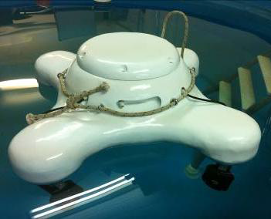

Figure 2 Autonomous platform for dynamic positioning

# DEVICES USED IN PLATFORM

Platform is powered with 21Ah 18.5V battery which powers all electrical devices. Single board computer with ROS [1] is in charge of performing control and guidance tasks. Apart form the batteries and CPU, the platform is equipped with:

* 9 DOF IMU for heading, roll, pitch and yaw measurements;
* a GPS for determining the platform position, and indirectly the diver position in the horizontal plane;
* Ultra Short Baseline (USBL) used to determine the position of the diver relative to the platform. The USBL is used simultaneously for localization and two-way data transmission via an acoustic link
* a wireless modem used to transmit data from the platform to the surface station, thus making the platform a router from the diver to the surface station where the diving supervisor is stationed.

# UNDERWATER SYSTEM FOR NAVIGATION AND COMMUNICATION

PlaDyPos underwater communication system consists of :

* USBL Transducer (MicronNav, Tritech);
* Modem Head (Micron Data Modem, Tritech);
* Battery (MetalSub, 12 V, 4 Ah);
* RS232-Bluetooth module (LM048, LM Technologies);
* Tablet (Samsung Galaxy Note 10.1).

USBL Transducer is connected to embedded computer which exchanges messages with the modem. Modem Head and Bluetooth module are powered with 12V battery. Modem Head communicates with Bluetooth module via RS232 which then wirelessly communicates with the tablet, i.e. with an Android application. The underwater part of the system is simply powered on by connecting the battery pack.



Figure 3 Underwater Communication System

# ANDROID APPLICATION

Android application is divided in three tabs:

* Map tab
* Communication tab
* Ascent tab

## Map tab

Map tab is divided in two fragments as shown in . Bigger fragment on the left side is Google Maps which shows position of the diver and can also show markers from .kml file connected with lines which form a path. Map also features three concentric circles indicating 5, 15 and 30 meters radius around the diver. User can manually add markers and rearrange them in different order through the smaller fragment on the right side of the screen. There are various buttons with following assignments:

* Alert - red button in tab bar sends alert message to platform, i.e. to ground station; this button is available on every tab due to its emergency features;
* Draw path - draws path among the markers added on map;
* Clear all - clears all markers and all paths;
* Add Mode - when in add mode, user can add markers with short click on map and also delete them with short click on existing marker on map; added markers are shown on the bottom of the screen;
* Ascent - Ascent tab is opened by selecting this button;
* Show position - when diver position is outside of map shown on the screen, clicking on this button positions the map on the diver’s position.;
* Zoom ± - zooms the map;
* Up, Down - order of the markers added can be changed by selecting the desired marker from array on the bottom of the screen and pressing the Up or Down button.

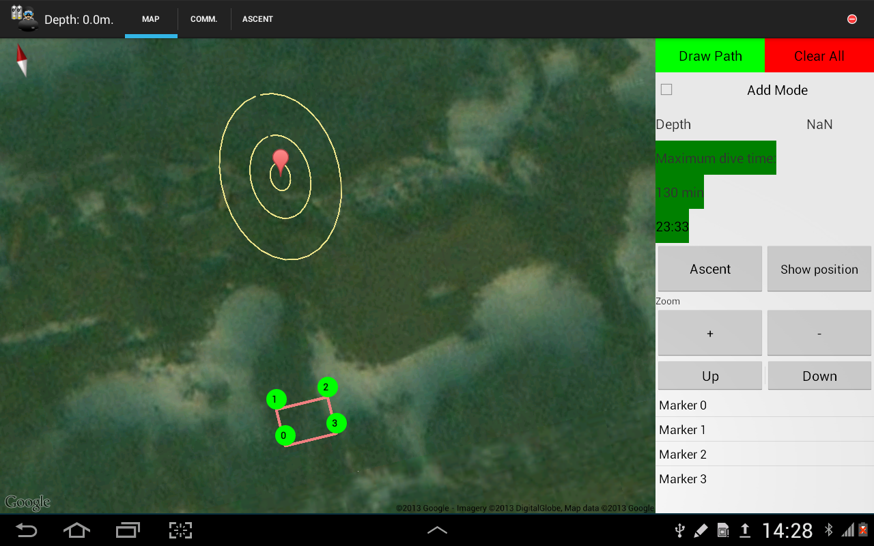

Figure 4 Diver Assistant application, Map tab

On the right side of the screen there is also an information about current dive time and estimated maximum dive time which is calculated using the depth and time spent under water. Current depth is displayed in the upper left corner on the tab bar. Depth can be acquired through the USBL or via optional depth sensor.

## Communication tab

Communication between diver and ground station is conducted in two ways. User can type custom message or send predefined message. On the right of the tab bar there is red alert button and next to it there are two buttons for starting the Bluetooth connections: first one opens the communication with modem, i.e. USBL system and the latter opens the communication with optional depth sensor. User can write a custom message by clicking on the line on bottom left part of the screen which inflates the virtual keyboard. After clicking the send button on virtual keyboard, message is saved to queue and ready to send via Bluetooth and USBL to the ground station when ground station requests it. Sent messages appear in upper left part of the screen and received messages from ground station are shown in bottom left part of the screen (Figure 5). Predefined messages can be sent by clicking on the list of predefined messages in center left part of the screen. Messages are saved in queue as were clicked with exception of Alert message which is always set on top of the queue.

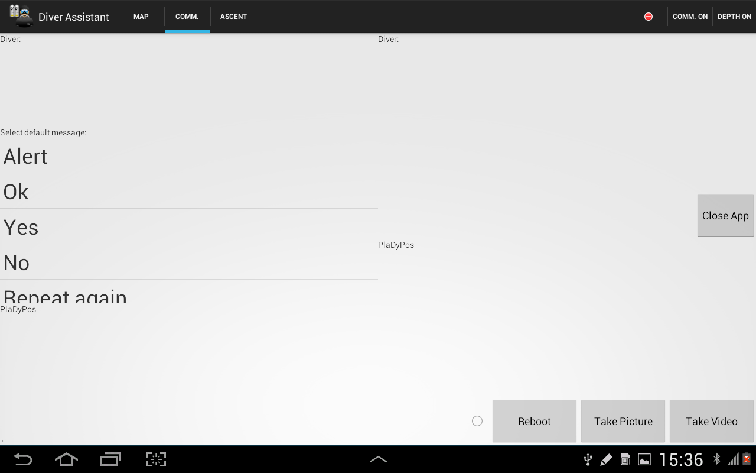

Figure 5 Diver Assistant application, Communication tab

Buttons on this tab are:

* Close App - back button is disabled because it shares position with hide keyboard button so there is risk of closing the application accidentally and therefore Close App button is added to securely close application;
* Take Picture - takes pictures from front or back camera;
* Take Video - takes video from front or back camera;
* Reboot - reboots the modem if communication with ground station stops.

## Ascent tab

Instead of separate diving computer, this tab shows critical information about decompression stops which are crucial for diver safety (Figure 6). Considering divers depth, application calculates time available for diver to be on current depth which is shown on Map tab. On the left side of the screen is the table with decompression stops depth and time needed to stay on that depth for safe ascent.

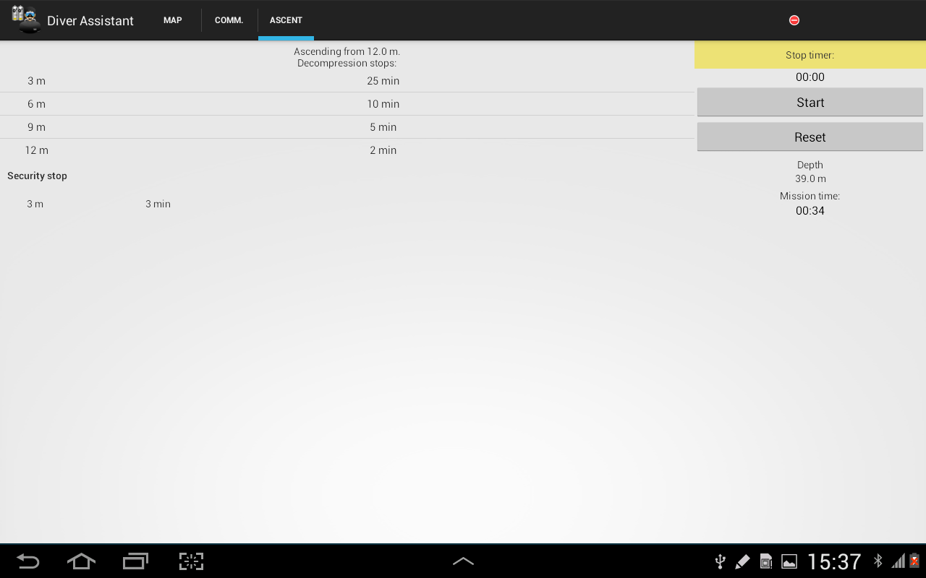

Figure 6 Diver Assistant application, Ascent tab

On the right side of the screen is stopwatch for measuring time of particular decompression stop. There is also an information about current depth and overall dive time.

# RESULTS

The results from testing at sea are visible in Figure 7. Bearing in mind that navigation works at frequency of 0.25 [Hz] and that sometimes USBL gives no data or calculates wrong data due to reflection and multipath effects of acoustic waves.

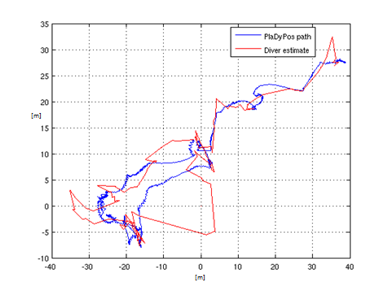

Figure 7 Platform path and diver estimate

# CONCLUSION

The work presented in this paper has demonstrated that the concept of using an autonomous surface platform for diver tracking is feasible. Based on USBL measurements aided with GPS, diver position, speed and orientation can be estimated with sufficient precision.

**ACKNOWLEDGEMENTS**

This work is supported by the Business Innovation Agency of the Republic of Croatia (BICRO) through the Proof of Concept programme. The authors are with the University of Zagreb, Faculty of Electrical Engineering and Computing, LABUST - Laboratory for Underwater Systems and Technologies, Unska 3, Zagreb, Croatia nikola.stilinovic at fer.hr

**REFERENCES**

[1] http://www.ros.org.

[2] N. Miskovic, Z. Triska, D. Nad and Z. Vukic. Guidance of Small – Scale Overactuated Marine Platform – Experimental Results. Proceedings of the 34rd International convention on information and communication technology, electronics ad mircroelectronics MIPRO 2011, CTS, 2011.

[3] N. Stilinovic. Integration of the Navigation Module in the Laboratory Platform for Dynamic Positioning, B.Sc. thesis, 2010.

[4] Z. Triska, N. Miskovic, D. Nad and Z. Vukic. Virtual Target Algorithm in Cooperative Control of Marine Vessels, Proceedings of the 35rd International convention on information and communication technology, electronics ad mircroelectronics MIPRO 2012, CTS, 2012.