ESTIMATION OF FATIGUE STRENGTH AT OPERATIONAL LOAD
D. JELASKA, S. PODRUG
Faculty of Electrical Engineering, Mechanical Engineering and Naval Architecture,
University of Split, R. Boškovića b.b., 21000 Split, Croatia
ABSTRACT
The simple way for estimation of fatigue strength at operational load on the basis of test results at constant amplitude stress is presented in this paper. It is necessary only to multiply the magnitude of constant amplitude endurance limit of a symmetrical cycle by three correcting factors, taking into account the shape of the spectrum, its asymmetry factor, static pre-stress, stress concentration and fatigue life. Each of these factors is derived and expressed in the form of analytical function. The explicit formula for fast estimation of fatigue life of the parts subjected to the acting of stress spectrum is obtained too.

KEYWORDS
Stress spectrum, stress amplitude, asymmetry factor, fatigue life, static pre-stress.

INTRODUCTION
The safest way to obtain the correct value of the fatigue limit of machine parts and structural components subjected to operational load is their testing at operational conditions. Such tests are time-consuming and expensive, and not always feasible in design stage, especially for the large size components of steel constructions, particularly offshore constructions, pressure vessels, stirrers, etc. In such cases, which occuring frequently, the only way of predicting the fatigue limit and consequently the fatigue life, is their analytical estimation by help of the results of constant amplitude testing. This methodology, based primarily on Palmgren- Miner cumulative damage linear hypothesis, is described in detail in a number of papers. However, it ignore many important physical and chemical changes which take place during fatigue life, e.g. change of fracture location with change of load intensity caused by stress redistribution, build-up and decay of residual stresses at critical area and change of load transfer characteristic of, e.g., bolted or riveted joints. For this reason the original Palmgren-Miner rule had to be improved. A significant improvement was made by introducing the relative Miner rule whose basic idea was to apply the damage sum previously experienced and different from unity. It implies testing with similar components under similar stress-time histories. Therefore, the need arose for fast estimation of fatigue strength without additional testing, i.e. only on the basis of the constant amplitude testing. It includes the problem of fatigue of steady pre-stressed parts which has not been studied at the level enabling the reliable estimation of the fatigue limit or fatigue life.

PROPOSITION FOR FATIGUE STRENGTH ESTIMATION AT OPERATIONAL LOAD
The highest amplitude of the boundary stress spectrum having r asymmetry number, N fatigue life, and k_{e} equivalence factor might be estimated, similarly to [1], by means of constant fatigue strength amplitude of the same part at r=-1 stress cycle asymmetry number and infinite life:
$R_{a}$ (N,k_{e},r)=K_{N}⋅K_{S}⋅K_{r}⋅$R_{\text{Da}}$ (1)
where fatigue life factor K_{N} , stress spectrum shape factor K_{S} and stress spectrum asymmetry factor K_{r} are defined as follows:
K_{N}=$\frac{R_{a}(r=−1;k_{e}=1;N)}{R_{\text{Da}}}$ (2)
K_{S} =$\frac{R_{a}(r=−1;N=N_{\text{gr}}→∞;k_{e})}{R_{\text{Da}}}$ (3)
K_{r}= $\frac{R_{a}(N=N_{\text{gr}}→∞;k_{e}=1;r)}{R_{\text{Da}}}$ (4)

Derivation of Fatigue Life Factor

It is evident from Eq.2 that fatigue life factor depends upon fatigue life only, i.e.
$K_{N}^{'}$=f_{N}(N). (5)
After definition and in accordance with S-N curve equation, it is easy to obtain
f_{N}(N)=(N_{gr}/N)^{-b'} (6)
Whereas for finite fatigue life the elastic-plastic strain region is reached, this factor has to be corrected with K_{C} ,factor taking into account the change of fatigue stress concentration factor in that region. This factor is defined as a ratio of fatigue strength concentration factors in elastic region to elastic-plastic region:
K_{C}=$\frac{K_{σ,\text{el}}}{K_{σ}}$ (7)
Involving in this equation the expression for K_{σ} presented in [2], it was obtained
K_{C}=$\frac{(N/{N_{\text{gr}}})^{b'−b}}{k_{C}}$, (8)
where b/b’ ratio and calculation factor k_{C} were completely determined by means of only the K_{σ,el} stress concentration factor, which is usually an available information. Finally, fatigue life factor might be expressed as
K_{N}=K_{C}$K_{N}^{'}$=$\frac{(N/{N_{\text{gr}}})^{2b'−b}}{k_{C}}$ (9)

Derivation of stress spectrum shape factor

Whereas S-N curves for both C.A. and V.A. spectrum have the same fatigue strength exponent, it is clear (Fig.1) that
logR_{a}-logR_{Da}=logσ_{max}-logσ_{e} (10)
where from, in accordance with definition after Eq.3, it follows
K_{S}=$\frac{R_{a}}{R_{\text{Da}}}=\frac{σ_{\text{max}}}{σ_{e}}=\frac{1}{k_{e}}$ . (11)
Fig.1 Determining the stress spectrum shape factor
Equivalent C.A. stress of V.A. stress spectrum depends on spectrum shape, and consequently the spectrum shape factor depends on spectrum shape only.
If operational conditions of load result with stress history, which can be described as stationary quasi-gaussian and ergodic random process, in which stress amplitude always exceeds a certain level p (called spectrum density factor and equals share of minimum spectrum amplitude), K_{S} factor might be obtained after [3] :
K_{S}=3^{a(1-p)} , (12)
where a is a material constant found to equal a=1,14 for welding joints.

Derivation of Stress Spectrum AsymmetryFactor

The fatigue limit line in schematized Smith’s diagram for infinite life of part subjected to acting of C.A. stress spectrum (Fig.2) can be expressed as
$R_{D}=R_{\text{Da}}+k_{σ}σ_{m}$. (13)
The fatigue limit is defined (Fig.2a) as an intersection of this line and r=const line
$σ_{\text{max}}=\frac{2}{1+r}σ_{m}$ (14)
after which the maximum stresses of stress cycle change. It is obtained:
$R_{D}=\frac{2}{2−k(1+r)}R_{\text{Da}}$ (15)
and
$R_{a}=R_{D}−σ_{m}$=$\frac{1−r}{2−k_{σ}(1+r)}R_{\text{Da}}$ . (16)
Stress spectrum asymmetry factor is now:
K_{r}=$\frac{R_{a}}{R_{\text{Da}}}$=$\frac{1−r}{2−k_{σ}(1+r)}$. (17)
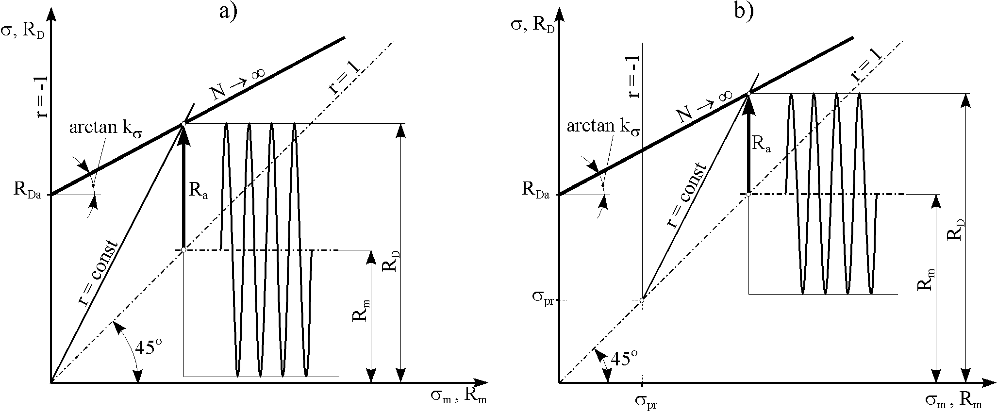
Fig.2 Determining the fatigue limit for infinite life of parts subjected to C.A. stress spectrum having r asymmetry number: (a) for not pre-stressed parts; (b) for previously pre-stressed parts
For the pre-stressed parts, it was explained in [4] that the origin of Smith’s diagram (Fig.2b) is moved to point ($σ_{\text{pr}},σ_{\text{pr}}$), consequently the equation of r=const line was obtained:
$σ_{\text{max}}=σ_{\text{pr}}+\frac{2}{1+r}(σ_{m}−σ_{\text{pr}})$. (18)
The fatigue limit is presented now as an intersection of this straight line and the fatigue limit line. In the similar way as before, it was obtained:
$R_{D}=\frac{2}{2−k_{σ}(1+r)}R_{\text{Da}}+\frac{1−r}{2−k_{σ}(1+r)}k_{σ}σ_{\text{pr}}$ (19)
$R_{a}=\frac{1−r}{2−k_{σ}(1+r)}\left[R_{\text{Da}}−(1−k_{σ})σ_{\text{pr}}\right]$ (20)
It is easy now to obtain a relation for determining the stress spectrum asymmetry factor for pre-stressed parts:
$K_{r}=\frac{1−r}{2−k_{σ}(1+r)}\left[1−(1−k_{σ}){σ_{\text{pr}}}/{R_{\text{Da}}}\right]$. (21)
By involving in Eq.1 the greatest amplitude of working stress spectrum instead R_{a}, it is easy to derive the simple formula for fast estimation the fatigue life of a part:
N=N_{gr}${\left(\frac{k_{c}σ_{a}}{R_{\text{Da}}K_{S}K_{r}}\right)}^{\frac{1}{2b'−b}}$ . (22)
CONCLUDING REMARKS
The simple way to estimate the fatigue strength and fatigue life of the parts and structural elements subjected to operational conditions of load by means of the results of C.A. testing, has been presented, and the unique formula for the fast estimation of fatigue strength amplitude is proposed. This estimation is good in so far as parameters existing in the derived relations are reliable. It is therefore necessary to make an effort in order to obtain the correct values of these parameters. This particularly refers to determining the stress spectrum, which represents the response of the part to load spectrum and might be significantly different from load spectrum, especially in case of vibrations. The necessary attention has to be paid to the influence of possible elevated temperatures, which could be taken into account e.g. by introducing the additional temperature factor in the fatigue strength amplitude formula. This might be dealth with in a future paper.

REFERENCES
- Paetzold, H., Petershagen, H.(1984): Untersuchungen zur Betriebsfestigkeit geschweisster Schiffbaukonstruktionen, Shiff und Hafen 11, p.71-74.
2. Jelaska, D.(1998) : Estimation of Fatigue Stress Concentration in the Zone of Elastic-plastic Strain, Proc.Int.Symp. Fatigue Design 1998, Espoo.
3. Jelaska, D.(1997) : Estimation of Fatigue Life under Random Loading, Proc.14 th Symp. "Danubia-Adria" on Exper. methods in solid mech., Poreč 1997., p.212-214.
4. Jelaska, D.(1994): Estimation of Fatigue Limit at Operational Load (in Croatian), Strojarstvo 36(3,4),p.127- 130.

NOMENCLATURE
b-fatigue strength exponent (slope of smooth specimen S-N curve)
b'-slope of notched specimen S-N curve
C.A.- constant amplitude
K_{N}-fatigue life factor
K_{r}-stress spectrum asymmetry factor
K_{S}-stress spectrum shape factor
$K_{s}$-fatigue stress concentration factor in the region of elastic-plastic strain
$K_{s,\text{el}}$-fatigue stress concentration factor in the region of elastic strain
$K_{s,q}$-stress concentration factor at the boundary of quasi-static fracture region
k_{C}- calculation factor
k_{e}- stress spectrum equivalence factor, =${σ_{e}}/{σ_{\text{max}}}$
$k_{s}$-slope of N→$¥$ isoline in schematized Smith's diagram, =2(1-R_{Da}/R_{D0})≈2(1-R₋₁/R₀)=0,7…1,0
N-fatigue life (number of endurable cycles)
p-spectrum density factor; =${s_{a\text{,min}}}/{s_{a\text{,max}}}$
R-strength (generally), MPa
r-stress cycle asymmetry number
V.A.- variable amplitude
α_{I}- frequency of occurance of i-th stress block $σ_{i}$
$s$-stress (generally), MPa
$σ_{e}$- equivalent stress, =${\left(\sum{α_{i}σ_{i^{{−1}/b'}}}\right)}^{−b'}$
$s_{\text{pr}}$-static pre-stress, MPa.
Subscripts
a- amplitude
D - C.A. spectrum acting on part or notched specimen
el- elastic region
gr- boundary between finite and infinite life region
m-mean
max-maximum
min-minimum
q- boundary of quasi-static fracture region
-1- r=-1 stress cycle
0- r=0 stress cycle

