Staša Borović

Department of Hydrogeology and Engineering Geology, Croatian Geological Survey
Zagreb, Croatia

stasa.borovic@hgi-cgs.hr

Keywords: Daruvar geothermal aquifer, hydrogeology, hydrochemistry, Croatia

Integrated Hydrogeological – Hydrochemical – Geothermal Model of Daruvar Geothermal Aquifer

The town of Daruvar lays in the westernmost part of the Croatian region of Slavonija, at the foothills of Papuk Mt. to the east, and Ilova River valley to the west (Fig. 1). Daruvar geothermal springs are situated near the centre of the town, in the valley of Toplica River. The waters from Daruvar geothermal aquifer are used for health and recreational tourism in the Termal complex and for recreation in Thermal water park Aquae Balissae. The most important natural springs are Ivanovo, Antunovo and Marijino vrelo, with temperatures ranging from 40 to 48 °C. Continuous pumping of geothermal water made thorough research of the aquifer necessary.
The data from 1948 onwards have been gathered from the archives and will be re-analyzed. These data include: i) hydrochemical analyses; ii) descriptions of now liquidated boreholes and related pumping tests; iii) electric and seismic profiling. In addition, data about water temperatures, levels and electrolitic conductivity have been acquired by a monitoring network since November 2012. The monitored data will be compared to the pumping regime of the users and the hydro-meteorological data collected for Daruvar area.
Monthly in situ measurements and sampling were also done and chemical analyses of waters regularly conducted. Stabile and radioactive isotope concentrations were measured. The aquifer in-depth temperature has been calculated via multiple geothermometers and the results are currently being evaluated.

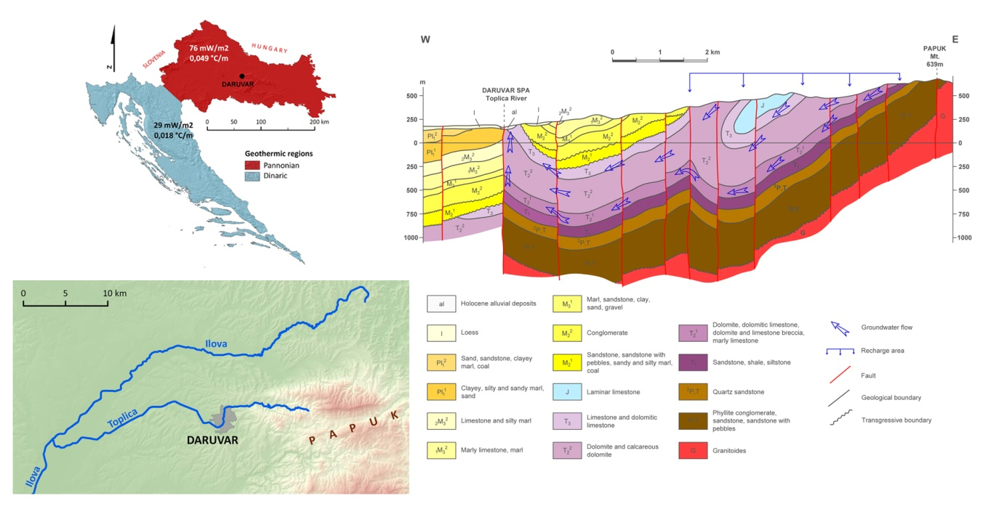
Fig. 1 Daruvar area geographical position and geological cross-section modified from Crnko et al., 1998

The rocks that crop out in the mountainous hinterland east of Daruvar were sampled and their thermal conductivities have been measured.
Some preliminary conclusions can be established by the gathered data. The geothermal waters are of meteoric origin according to the stabile isotopes. In Fig. 2 it is visible that δ²H and δ¹⁸O deviate only slightly from local meteoric water line. Tritium activity below the limit of detection in thermal waters shows their residence time is longer than 60 years, i.e. present day infiltration has no practical influence on the aquifer. The ¹⁴C dating points to the recharge around 11 – 15 ka BP, but the problem is that water equilibrated with Triassic carbonates so radiocarbon dating is not to be taken too strictly [Mook, 2000]. The recharge area of geothermal aquifer is located eastward from Daruvar, where fractured Triassic and Jurassic carbonates are widely present at the surface and favour the infiltration of the parental meteoric waters. The carbonates are underlain by impermeable Triassic and Permian clastic rocks which block further infiltration and enable lateral flow westward, in the direction of layer dip as well as potential drop (Fig. 1).
The geothermal aquifer comprises fractured middle and upper Triassic limestones and dolomites, underlying the Pliocene and Quaternary alluvial deposits. The domination of Ca²⁺, Mg²⁺ and HCO₃⁻ ions clearly points to water origin from dolomite aquifer [Hem, 1985]. The upwelling of water in the centre of Daruvar is enabled by N-S trending subvertical fault in Toplica River valley because it brought the aquifer in contact with impermeable Miocene deposits. High correlation in water chemistry (Fig. 2) and pumping tests show that all springs and boreholes are fed by the same aquifer.

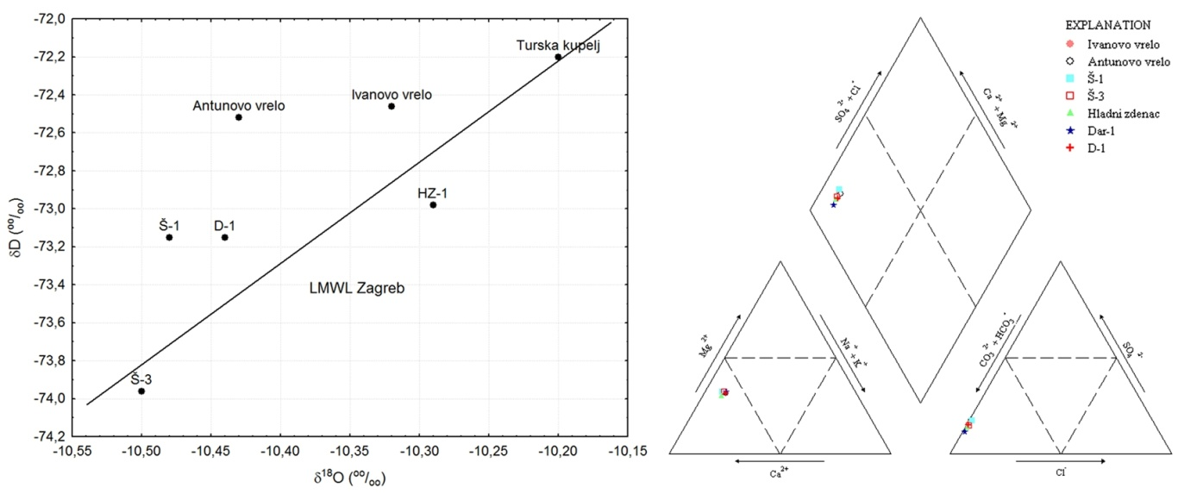
Fig. 2 Stabile isotope and major ion composition of waters from Daruvar localities

The obtained data will be used as hydrogeological, geothermal and geological input parameters for USGS HYDROTHERM with the aim of performing numerical simulations of Daruvar geothermal system.
The final product of the thesis will be the integrated model of Daruvar geothermal aquifer which will be used as a guideline in order to conserve water quantities and temperatures for future utilization. Also, carbonate geothermal aquifers in similar geological settings are present at various localities in Croatia so the methodology applied for Daruvar aquifer will be used in further research of Croatian geothermal aquifers.

Acknowledgements: The help that my advisor, Tamara Marković, PhD, provided is greatly appreciated, along with the help of previous researchers of Daruvar locality in CGS, especially Eng. Vinko Mraz and Ozren Larva, PhD. I am very grateful to Daruvarske toplice employee Mr. Slavko Pokorny for his help in fieldwork logistics and acquisition of pumping data.

References
Crnko, J. and Jamičić, D. (2008): Daruvar Spa in Geothermal and mineral waters of Croatia (ed. Šimunić, A.), 45-53, Croatian Geological Survey, Zagreb. (in Croatian)
Hem, J. D. (1985): Study and Interpretation of the Chemical Characteristics of Natural Water, USGS.
Mook, W. G., ed. (2000): Environmental Isotopes in the Hydrological Cycle - Principles and Applications, UNESCO/IAEA, Groningen.

