Design of Optimal Data Link Layer Topology for IP/WDM Networks
Marije Ljolje, Robert Inkret and Branko Mikac
FER, University of Zagreb, Croatia
marije@tel.fer.hr
inkret@tel.fer.hr
branko.mikac@fer.hr

Abstract
The paper deals with the design of data link layer topology in a multiple-layer IP/WDM transport networks. Data link layer portion of a network is composed of routers and data links that connect IP routers. Such data links between routers are realized through the service provided by WDM transport network. An approach presented in the paper focuses on the optimal design of a data link layer topology, which does not have to follow physical, i.e. WDM network topology. Design procedure is applied to the network example and the results are compared with reference data link layer topologies.

Introduction
All-optical wavelength division multiplexed (WDM) networks are considered to be potential candidates for the next generation of wide-area backbone networks. A WDM all-optical network can use the large bandwidth available in optical fiber, to realize many channels, each at different optical wavelength and each operating at a moderate bit rate (up to 10 Gbit/s). By utilizing WDM technology, we have a low-cost solution to meet traffic demands. The question is how to implement WDM technology to transport IP traffic in order to achieve low cost of the network structure. There are many scenarios to map IP on WDM (such as IP over ATM over SDH on WDM, IP over Simple Data Link-SDL on WDM, IP over Dynamic Packet Transport-DPT on WDM [2]), but the paper focuses on two techniques: IP over POS/SDH on WDM and IP over GbE on WDM (POS – Packet Over SONET, GbE - Gigabit Ethernet - Figure 1).
Figure 1. Transport network layer
Planning of multiple-layer IP/WDM networks and finding optimal solution is a complex problem. An integrated approach is not suited for the multiple-layer design because it requires very complex optimization algorithms. Therefore, in the paper, the design of the multiple-layer transport network is assumed to be divided into sub-problems, where each sub-problem is optimal design of one layer. Starting from the highest layer, optimization of each layer should give the results and input parameters for successive layer optimization. The paper presents the first step of the described design approach, i. e. the paper focuses on finding optimal topology of data link layer for IP/WDM networks using genetic algorithm.
The cost of the discussed network is the cost of the required number of interface cards and routers. The first part of the document contains description of a problem and assumptions taken into account. The overview of generic layer 2 protection and restoration (P&R) capabilities taken from [1] is given in part two. Short description of algorithm used to obtain optimal layer 2 topology, results and comments are given in the third part.

The Problem Space
The paper focuses on connectivity of IP backbone routers, i.e. layer 2 topology. Thus, we do not take into account cost of WDM equipment, assumed to be equal for any possible data link layer topology (layer 2 topology). Such simplification can be justified by two independent assumptions. In the first one, the process described here can be viewed as a single step in the multiple-layer transport network design, in which each layer, starting from the top, is designed independently, and where the resulting optimal topology is taken as an input to the optimal layer design of the successive layers. In the second assumption, it can be imagined as well, that there is enough of allocated capacity (in terms of wavelength channels) in the physical, i.e. WDM layer.
In addition, it is not necessary that topology of the layer 2 follows physical topology. For example, if one link in layer 2 does not exist in the physical layer, then layer 1 acts as a server to layer 2, and will, through configuration and routing of wavelength channels, provide connectivity to the client layer network.
In [1], three scenarios for layer 2 topology are presented:
- 1-to-1 mapping between Layer 1 and Layer 2 topology - L1 (Figure 2). In the scenario, layer 2 topology follows physical topology. This scenario in [1] has been proposed for low traffic load.
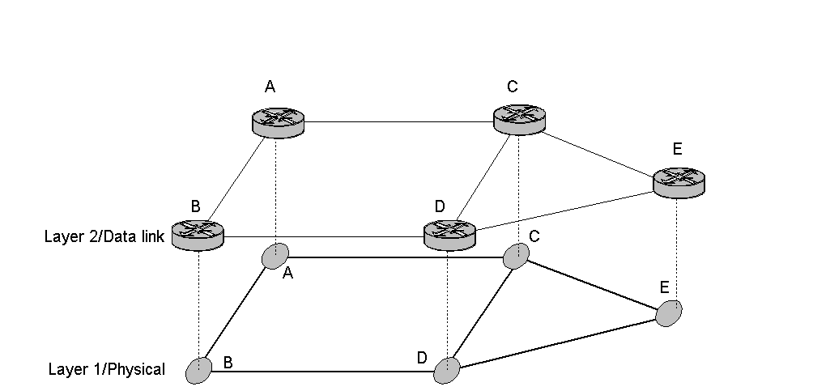
Figure 2. - Router interconnection - physical neighbors
- Full mesh Layer 2 topology - FM (Figure 3). In this extreme case each router in the backbone network is connected directly to all other routers, and minimum number of required interfaces equals to the sum of all nodes degrees. This scenario was found in [1] to be the best solution for high traffic load.
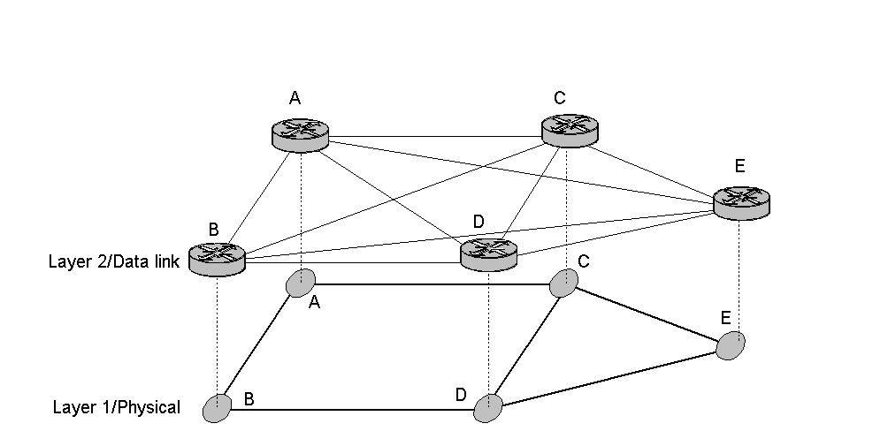
Figure 3. Router interconnection- full meshed at layer2
- Optimal topology that could give the best trade off between the number of interfaces and their cost. In the paper the focus is on finding optimal topology.
For large networks, finding optimal solution is a NP-hard problem. Hence, genetic algorithm (GA) is used to obtain optimal layer 2 topology. One logical layer 2 topology is presented by one chromosome in GA. The length of the chromosome equals to maximum number of logical links between IP access points (IAPs) (N*(N-1)/2 where N is the number of IAPs). Fitness function in this case is the cost of the network in terms of required number of interfaces and routers.
Physical topology is given, i.e. the length and placements of optical fibers are known. Traffic matrix between layer 2 nodes is also known. Traffic demands in layer 2 are routed to the shortest paths in layer 1 (length of the links in layer 2 is established by calculating the shortest path between corresponding nodes in physical topology). We assumed that the number of fibers on links is unlimited.
We assume that each router can carry up to 8 interface cards, and that the router price is 30k. In addition, prices of the assumed interface cards are given in Table 1. The capacities shown in Table 1 are the effective capacities available to layer 2.
Table 1. Capacity and cost of used interfaces
As mentioned in the introductory part, we consider only two scenarios for mapping of IP on WDM: IP/POS/WDM and IP/GbE/WDM. To our point of view, the application of chosen scenarios is most probable in the near future.
Interface cards | Capacity (Gbit/s) | Cost
OC-12c/STM-4 | 0.500 | 25 k
OC-48c/STM-16 | 2.245 | 95 k
OC-192c/STM-64 | 9.500 | 300 k
GbE | 0.902 | 10 k
10 GbE | 9.020 | 29 k
GbE is a preferable technique in being very simple and reasonably priced. Also, it is compatible with most widely used MAC frame format (MAC-Medium Access Control, IEEE 802.3/Ethernet), so making the conversions, which are usually very expensive in terms of conversion time and speed, are not necessary. Disadvantages of GbE are in relatively low efficiency and management functionality. On the other hand, low efficiency can be easily compensated by the relatively low prices (compared to the alternatives) of GbE interfaces and equipment.
Regarding P&R capabilities, in addition to standardized ones, such as link aggregation (trunking) and blocked bridges, some manufactures are introducing new P&R techniques for GbE. One of them is 3Com’s MPLA (Multi Point Link Aggregation) [1]. For transport of IP datagrams over WDM, full-duplex mode is assumed. Layer stack for IP/GbE/WDM [8] scenario is given in Figure 4.
Figure 4. Layer stack for IP/GbE/WDM
IP/POS/WDM [8] is a more expensive solution, but it is compatible with SDH/SONET. It has good and mature network management functionality. Its advantages are the possibility to use intermediate SDH network and it’s P&R capabilities that are mature and certified in practice. Layer stack for IP/POS/WDM scenario is given in Figure 4.
Figure 5. Layer stack for IP/POS/WDM

Generic Layer 2 P&R Capabilities
In order to simplify design of network, some generic P&R scenarios obtained from the first two layers are introduced:
- Dual link,
- Dual link with dual router configuration, and
- SDH/SONET network at the Layer 2.
In dual link scenario, router interfaces are doubled and placed onto two independent physical paths in layer 1 (two paths are two shortest independent paths in layer 1). Traffic between these interfaces can be divided (dual link shared), but in case of failure, load on the remaining interface increases, causing the increase of packet loss probability (Figure 6). In this paper we assumed that in case of the shared type protection, traffic load is equally divided between the working and backup interface (50%-50%).
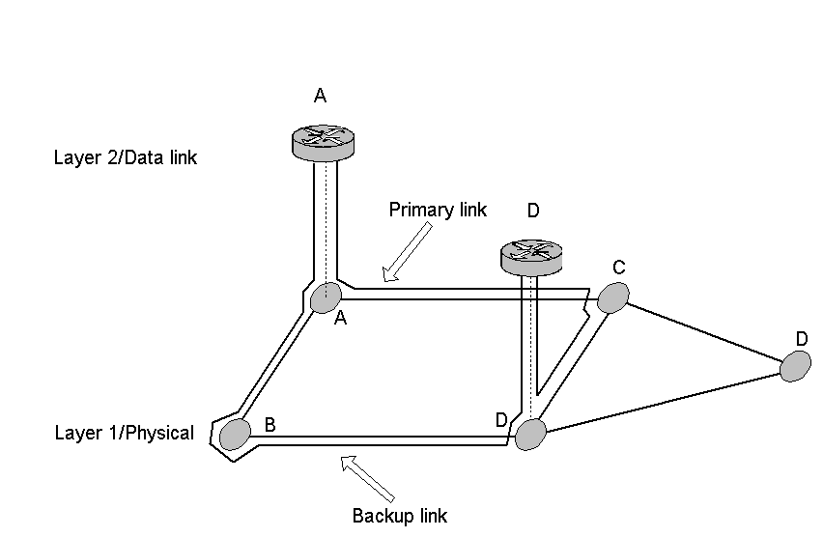

Figure 6. Dual link P&R scenario
Dual link scenario can be combined with the dual router configuration (Figure 7). In this case, instead of having all router interfaces on a single router, they are placed on two independent routers. Examples of such these technologies, just to name some of them, are: Dual Router Automatic Protection Switching by Juniper Networks, IETF’s Virtual Router Redundancy Protocol (VRRP, RFC2338), Cisco’s Hot Standby Router Protocol (HSRP, RFC2281), and Digital Equipment Corporation’s protocol IP Standby Protocol (IPSTB).
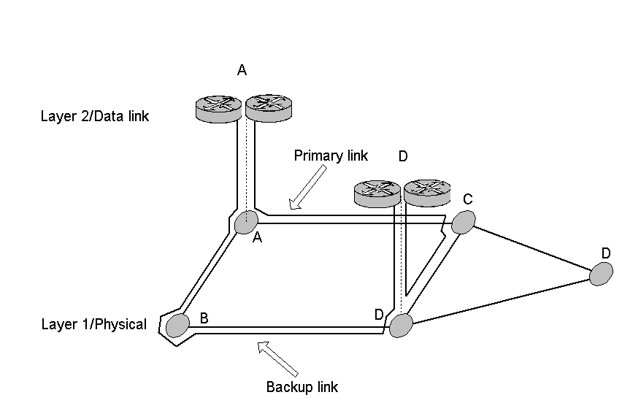
Figure 7. Dual link P&R scenario with dual router configuration.
These scenarios can be used with both POS and GbE interfaces.

Results and Comments
The described algorithm has been applied on a network sample (Figure 8) taken form case study developed within European project COST 239 [11]. The network is composed of 11 nodes and 25 links. We assume that the traffic matrix is given in terms of required 1 Gbit/s channels between layer 2 nodes (Table 2).
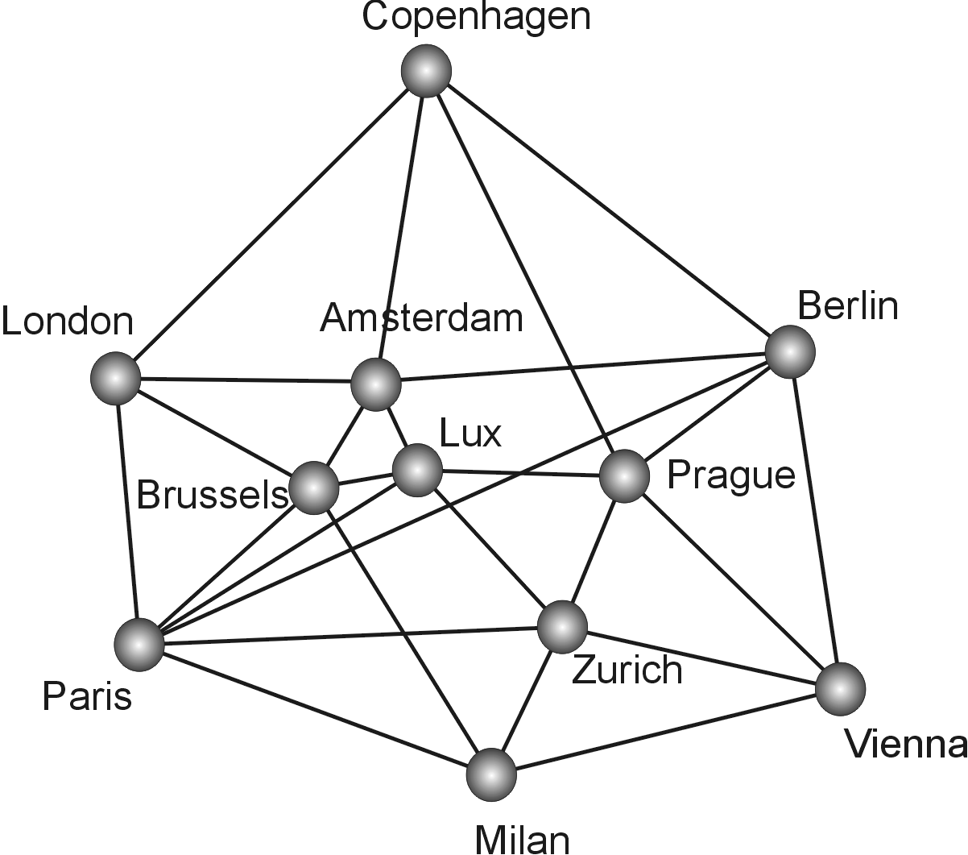
Figure 8. Network-COST239 - Case Study
The results with the applied algorithm are given separately for the presented scenarios: IP/POS/WDM and IP/GbE/WDM.
Table 2. Matrix of traffic demands between European cities
Table 3 shows the required number of interfaces and routers for different types of protection. Figure 9 shows optimal layer 2 topology for IP/GbE/WDM scenario, where there is no protection in the network (load=1).
Gbit/s | Par | Mil | Zur | Pra | Vie | Ber | Ams | Lux | Bru | Lon | Cop
Par | 0 | 2 | 2 | 1 | 1 | 4 | 2 | 1 | 2 | 3 | 1
Mil | 2 | 0 | 2 | 1 | 1 | 3 | 1 | 1 | 1 | 1 | 1
Zur | 2 | 2 | 0 | 1 | 1 | 3 | 1 | 1 | 1 | 1 | 1
Pra | 1 | 1 | 1 | 0 | 1 | 1 | 1 | 1 | 1 | 1 | 1
Vie | 1 | 1 | 1 | 1 | 0 | 3 | 1 | 1 | 1 | 1 | 1
Ber | 4 | 3 | 3 | 1 | 3 | 0 | 2 | 1 | 2 | 2 | 1
Ams | 2 | 1 | 1 | 1 | 1 | 2 | 0 | 1 | 1 | 2 | 1
Lux | 1 | 1 | 1 | 1 | 1 | 1 | 1 | 0 | 1 | 1 | 1
Bru | 2 | 1 | 1 | 1 | 1 | 2 | 1 | 1 | 0 | 1 | 1
Lon | 3 | 1 | 1 | 1 | 1 | 2 | 2 | 1 | 1 | 0 | 1
Cop | 1 | 1 | 1 | 1 | 1 | 1 | 1 | 1 | 1 | 1 | 0
Table 3. Required number of interfaces and routers for IP/GbE/WDM scenario
Figure 9 shows that optimal topology for IP/GbE/WDM without protection consists of 17 layer 2 links out of 55 possible. Topologies with dual link and dual link dual router type of protection are more expensive, but their performance is better in terms of potential packet loss. Figure 10 shows cost relationship between the scenarios described in chapter 2 (NP-No Protection, DL–Dual Link, DLS –Dual Link Shared, DLDR- Dual Link Dual Router, DLSDR- Dual Link Shared Dual Router). The sum of primary lightpath lengths shows that topologies with shared type of protection (DLS and DLSDR) consist of less layer 2 links than other types of protection.
Traffic load=1 | No protection | Dual link | Dual link shared | Dual link dual router | Dual link shared dual router
Nrouters | 11 | 13 | 11 | 22 | 22
1 GbE | 16 | 2 | 0 | 22 | 0
10 GbE | 33 | 76 | 46 | 68 | 48
Cost | 1 464 | 2 688 | 1 710 | 2 898 | 2 100
Sum of primary  lightpaths  (km) | 16 164 | 15 624 | 12 780 | 14 095 | 11 298
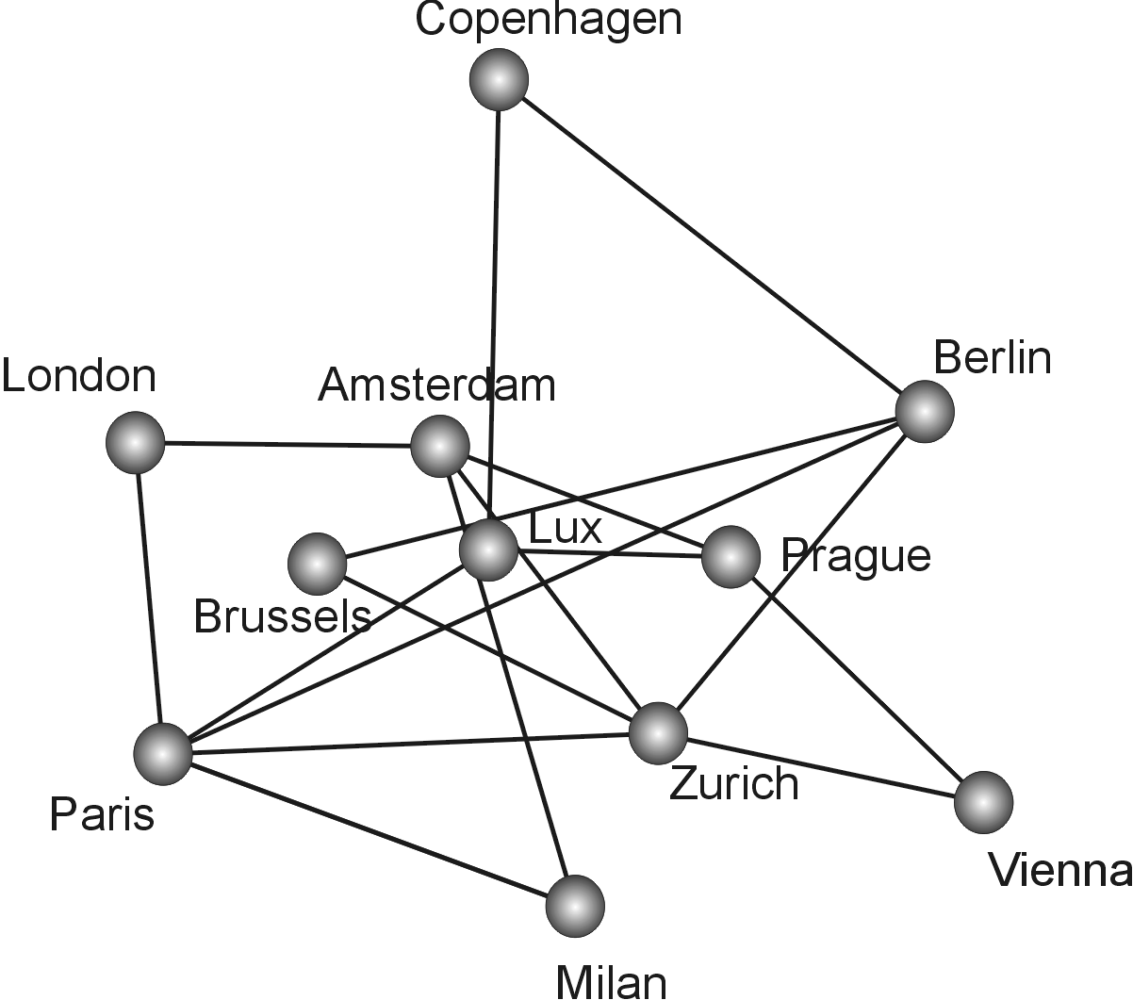
Figure 9. Optimal layer 2 topology for IP/GbE/WDM scenario without protection (load=1)
Figure 10 shows that optimal topology gives substantial reduction in price compared to other two proposed scenarios.
Figure 10. Cost relationship between proposed scenarios mentioned in chapter 2 (IP/GbE/WDM, load=1)
For IP/POS/WDM scenario (Table 4) connectivity is higher than that in IP/GbE/WDM (37 layer 2 links out of 55 possible). Figure 11 shows that the cost of optimal topology is approximately equal to the cost of fully meshed topology.
Figure 11. Cost relationship between proposed scenarios mentioned in chapter 2 (IP/POS/WDM, load=1)
Table 4. Required number of interfaces and routers for IP/POS/WDM scenario
Traffic load=1 | No protection | Dual link | Dual link shared | Dual link dual router | Dual link shared dual router
Nrouters | 18 | 28 | 37 | 38 | 42
OC-12c/STM4 | 62 | 104 | 238 | 148 | 230
OC-48c/STM16 | 25 | 80 | 28 | 80 | 32
OC192c/STM64 | 16 | 24 | 0 | 20 | 0
Cost | 9 265 | 18 240 | 9 720 | 18 440 | 10 050
Sum of primary lightpaths (km) | 30 660 | 30 634 | 42 856 | 33 684 | 40 882
Same conclusions can be drawn from Table 4 about IP/POS/WDM method concerning the structure and cost of optimal topologies for different types of protection.
Comparison of the costs of optimal layer 2 topologies for IP/GbE/WDM and IP/POS/WDM methods are shown in Figure 12. In terms of the cost and with respect to the prices of GbE router interfaces, IP/GbE/WDM technique is better.
Figure 12. Comparison of costs of optimal topologies for IP/GbE/WDM and IP/POS/WDM
When traffic load increases, optimal topologies become more connected, with the tendency to the fully connected network (Figure 13).
Figure 13. Number of logical links in layer 2 for different traffic loads for IP/GbE/WDM and IP/POS/WDM optimal topologies
Figures 14 and 15 show that with the growing traffic load, the cost of optimal topology increases almost linearly. .
Figure 14. Costs of optimal topologies for different traffic loads (IP/GbE/WDM)
Figure 15. Costs of optimal topologies for different traffic loads (IP/POS/WDM)

Conclusion
The results presented in the paper give global picture of how optimal layer 2 topology should look like.
Optimal layer 2 topologies for IP/GbE/WDM technique are more cost-effective than IP/POS/WDM, simply due to relatively affordable GbE/10GbE router interfaces. For lower traffic loads, optimal layer 2 topologies for IP/GbE/WDM (irrelevant of the type of protection) are weakly connected and almost tree-like. With the growing traffic load, optimal topologies for all types of protection tend to be better connected, until fully meshed.
Compared to IP/GbE/WDM, optimal layer 2 topologies for IP/POS/WDM technique for low traffic loads are more connected (dual link shared and dual link shared dual router type of protection give less connected topologies). In addition, IP/POS/WDM layer 2 topologies became fully meshed at lower traffic loads because of the relationship between capacity and cost of the used POS interfaces.
The costs of optimal topologies with dual link and dual link dual router type of protections are almost equal. When we apply shared type of protection (shared dual link and shared dual link dual router) we get twice cheaper solution.
Generally, optimal topologies for low traffic loads are tree-like. With the increased load they become better connected, until fully meshed.
Acknowledgements
The work presented in the paper has been made within the framework of the European COST 266 action "Advanced Infrastructure for Photonic Networks”. Part of the work has been funded by the European COST 266 action.
References
- R.Inkret, “Protection and Restoration Strategies for IP over WDM Networks”, Short Term Mission Report, COST 266 “Advanced Infrastructure for Photonic Networks”, France Telecom R&D, Lannion, France, 2000.
- EURESCOM Project P918, “Integration of IP over Optical Transport Networks: Networking and Management”, Deliverable 1, “IP over WDM, Transport and Routing”, October 1999.
- EURESCOM Project P709, “Planning of Optical Network”, Deliverable 3, Volume 3 of 9, March 2000.
- Jaeger, H.A., A. Mittermaier, “Packets over Circuits – The Impact of Ultra High Capacity Channels”, Workshop Photonic Networks in the Internet Era, September 6-8, 1998, Zurich, Switzerland.
- Project P615, “Evolution towards an Optical Network Layer”, Deliverable 1, Understanding Optical network Architectures, Volume 1 of 2: Main Report, August 1998.
- P. Batchelor, et al., Ultra-high capacity optical transmission networks Final Report of Action COST 239, Faculty of electrical engineering and computing, Zagreb, 1999.

