LEG ABDUCTION KINEMATIC CHARACTERISTICS OF HANDBALL GOALKEEPER

N. Rogulj1, V. Papić2, V. Srhoj1, V. Zanchi2

1Faculty of natural sciences, mathematics and education University of Split
2Faculty of Electrical Engineering, Mechanical Engineering and Naval Architercture

Because of the goalkeeper's specific function of performing in the extreme minimum-time situations, the quality of the defensive movement technique is top priority. The movements have to be performed with the maximum velocity, precision and rationality. Kinematic parameters analysis brings a new quality in the evaluation of the defensive movements, determination of the errors in the movements and their efficient correction within the goalkeeper's technical preparation.

In this paper, the analysis of leg abduction kinematic parametes which is one of the basic defensive movements in the handball is given. The leg abduction is used for the saves of the close range, medium high shots (Figure 1). On-site video recording was carried out using the 3D movement acquisition system developed in the Laboratory for the Biomechanics, FESB, Split. 3D coordinates for three referent points were calculated (hip, knee and ankle) along with the velocity of the distal parts of the leg as well as average velocity of the whole movement. The presenter was high-quality first league goalkeeper, who, according to the experts opinion, has excellent defensive movements technique and dominant motoric potential.
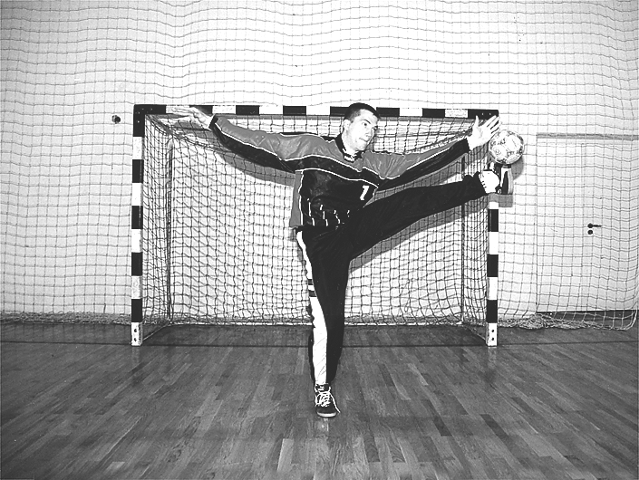Figure 1

HIP |  |  |  |  | KNEE |  |  |  |  |  | ANKLE |  |  |  |  |  | v  (m/s)
X | Y |  | Z |  | X |  | Y |  | Z |  | X |  | Y |  | Z
1310 | 1240 |  | 962 |  | 1246 |  | 1265 |  | 519 |  | 1284 |  | 1138 |  | 137 |  | 0,00
1309 | 1239 |  | 974 |  | 1160 |  | 1235 |  | 515 |  | 1308 |  | 1133 |  | 126 |  | 0,69
1313 | 1223 |  | 1021 |  | 1141 |  | 1341 |  | 594 |  | 1281 |  | 1134 |  | 197 |  | 1,90
1303 | 1230 |  | 1093 |  | 1153 |  | 1451 |  | 662 |  | 1285 |  | 1213 |  | 301 |  | 3,24
1351 | 1267 |  | 1142 |  | 1101 |  | 1437 |  | 791 |  | 1185 |  | 1161 |  | 449 |  | 4,66
1297 | 1267 |  | 1214 |  | 1030 |  | 1457 |  | 947 |  | 1136 |  | 1219 |  | 609 |  | 4,43
1272 | 1249 |  | 1309 |  | 1031 |  | 1572 |  | 1155 |  | 1082 |  | 1314 |  | 747 |  | 4,40
1269 |  | 1223 |  | 1345 |  | 1045 |  | 1531 |  | 1368 |  | 946 |  | 1368 |  | 954 |  | 6,32
1287 | 1184 |  | 1355 |  | 1050 |  | 1362 |  | 1508 |  | 820 |  | 1504 |  | 1201 |  | 7,74
1274 | 1161 |  | 1355 |  | 1011 |  | 1209 |  | 1554 |  | 715 |  | 1607 |  | 1507 |  | 8,48
1269 | 1152 |  | 1330 |  | 996 |  | 1229 |  | 1506 |  | 732 |  | 1507 |  | 1747 |  | 6,51
1266 | 1170 |  | 1271 |  | 1023 |  | 1296 |  | 1507 |  | 789 |  | 1329 |  | 1780 |  | 4,73
1275 | 1208 |  | 1236 |  | 1051 |  | 1251 |  | 1554 |  | 718 |  | 1308 |  | 1770 |  | 1,86
1279 | 1237 |  | 1177 |  | 1032 |  | 1197 |  | 1529 |  | 684 |  | 1299 |  | 1648 |  | 3,17
Average speed |  |  |  |  |  |  |  |  |  |  |  |  |  |  |  |  | 4,47

The result of the kinematic analysis (Table and Figure 2) showed that the speed of the movements rises progressively and achieves maximum in the ninth segment, and later decreases due to influence of the upper leg adductors and the resistance of the connective tissue in the joints. Maximal velocity at this point corresponds to the angle of 125o between engaged and supporting leg, and it is consequence of lover leg acceleration due to activation of the front side lower leg muscles up to the full extension. As the result, the goalkeeper is superior in the final phase of this movement which suggests the attacker to avoid this shooting zone.
Deviation of the ankle position from the ideal goalkeeper frontal plane is evident, and it is maximal for the highest speed segment. By partial deviation from the frontal plane upper leg abductors that dominantly participate in this movement are exonerated. Also, activation of the front side lower leg muscles that are acting as the sinergysts in this phase, and in the final phase as the agonists - extensors of the lower leg, is improved. Deviation from the frontal plane during any goalkeeper's defensive movement including the leg abduction isn't desirable because it unnecessarily lengthens defensive move trajectory and enlarges defending area as well which means that the Figure 2.
movement becomes non-optimal due to the longer trajectory.

Rogulj, N., V. Srhoj 2nd International Scientific Conference Kinesiology for the 21st century, Dubrovnik, 464-466, 1999.
Zanchi, V., V. Papić, A. Despalatović. 22nd International Conference Information Technology Interfaces ITI 2000, Pula, 287-292, 2000.

