BRUCELLA MELITENSIS IN SMALL RUMINANTS IN THE REPUBLIC OF CROATIA

Zeljko Cvetnic¹; Silvio Spicic¹; Tomislav Kiš ²; Maja Zdelar-Tuk¹; Sanja Duvnjak¹; Irena Reil¹; Boris Habrun¹; Miroslav Benic¹; Gordan Kompes¹
Scientific paper
Summary
In the period from 2009 to 2013, comprehensive melitococcosis testing was conducted in the Republic of Croatia. During the testing, the Rose Bengal test was applied to 344 019 blood samples of sheep and goats, and positive reactions were confirmed in 1143 (0.3%) of samples. The complement fixation test (confirmatory test) was conducted on 43 428 samples, with positive reactions confirmed in 768 (1.8%) of samples. The organs and tissues of 336 sheep and goats were inspected bacteriologically, and Brucella sp. was isolated in 15 (4.5%) of samples. Bacteriological and molecular techniques (Bru up/Bru-low and Bruce-Ladder) in isolates proved the presence of Brucella melitensis biovar 3.

Key words: Brucella melitensis, ruminants, serological and bacteriological tests, Republic of Croatia
INTRODUCTION
Melitococcosis or brucellosis is a chronic infectious disease of sheep and goats caused by the species Brucella (B.) melitensis. It is one of the most widespread zoonoses worldwide. This paper gives an overview of the distribution of Brucella (B.) melitensis in the Republic of Croatia in the period from 2009 to 2013. Bacteriological and molecular techniques were used to prove and confirm the species Brucella sp.
MATERIAL AND METHODS
In the investigated period from 2009 to 2013, a total of 344 019 blood samples of sheep and goats were tested serologically using the Rose Bengal test (RBT) for brucellosis (B. melitensis) at the Croatian Veterinary Institute. In addition, 43 428 samples were tested using the complement fixation test (CFT). The blood samples of sheep and goats were collected from the territories of 20 counties and the City of Zagreb. For bacteriological testing were taken lymph nodes, liver, spleen and reproductive organs (uterus and testes) from 336 sheep and goats. Isolates were identified by classical bacteriological and molecular analysis according to OIE Manual 2009.
RESULTS AND DISCUSSION
During the survey period from 2009 to 2013, the RBT screening test was applied to 344 019 blood samples, with positive reactions confirmed in 1143 (0.3%) of blood samples of sheep and goat. The CFT method was used to test 43 428 samples, with positive reactions confirmed in 768 (1.8%) of
blood samples. Organ and tissues samples of 336 sheep and goats were examined bacteriologically, and brucellosis was isolated in 15 (4.5%) of samples. All 15 isolates obtained from sheep, goats and
one bovine sample were proven to belong to the genus Brucella sp., the Bruce-Ladder test, a multiplex PCR assay with eight primers, was used to confirm that all 15 isolates belonged to the species B. melitensis.
Every country has their own legislation on the control of the disease, trade in livestock, marking, etc, and all of these regulations are more or less based on the legislation of the European Union. However, the strategy to eradicate the disease differs between countries, based largely on the situation with brucellosis in the country, the opportunities and other socio-political and financial circumstances that are important for the implementation of comprehensive measures to control and eradicate brucellosis. There are constant threats, including the fact that it is always possible the disease will emerge in a country resulting from a reduction in supervision due to an underestimation of the incidence of the disease. Terminations of programs to vaccinate sheep and goats result in flare ups of the disease, as do weak border controls and imports of infected animals into disease-free countries. Ultimately, wild ruminants also represent sources of brucellosis. For example, France has officially been a brucellosis-free country in ruminants since 2005, however, brucellosis caused by the species B. melitensis was proven in alpine ibex (Capra ibex) in the French alps. Subsequent research and molecular testing proved that the strain in humans and goats and domesticated ruminants was identical to that in the ibex.
CONCLUSIONS
Based on this survey, it can be concluded that Croatia has a favourable situation with regard to the infection of humans with B. melitensis, although there is the ongoing threat of the entry of infections from the territory of BiH into Croatia, which has been proven in this study. The appropriate strategies have proven to be efficient, and constant supervision and control of the disease is mandatory even in disease-free regions, and also in the Republic of Croatia.

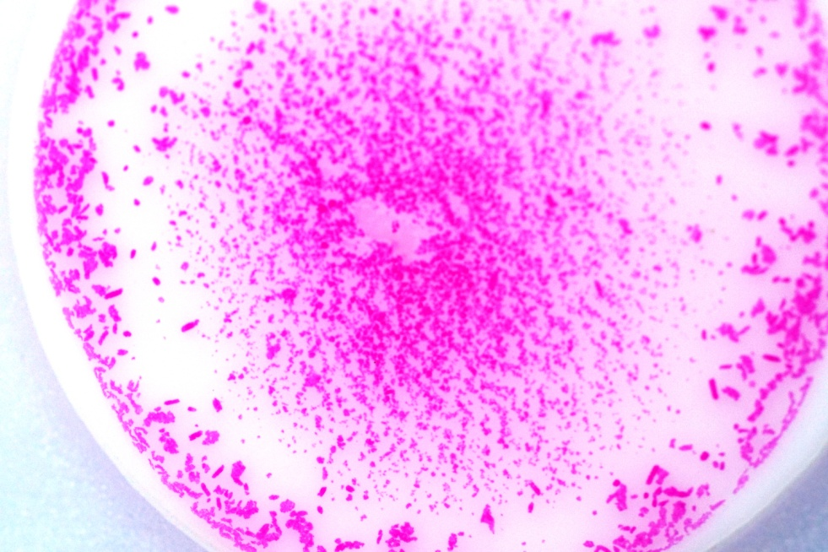
Picture 1. Rose Bengal test showing positive sample
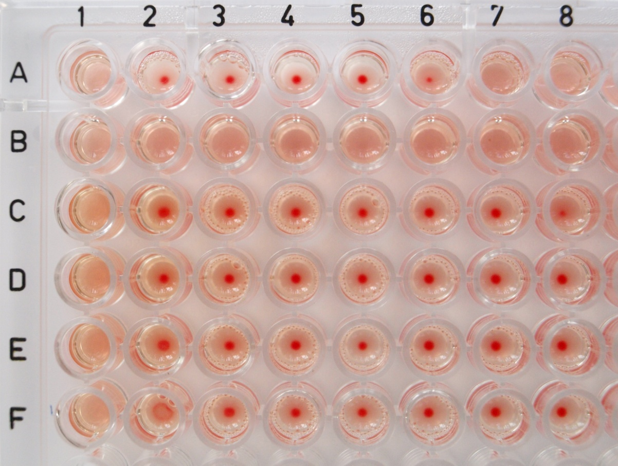
Picture 2. Complement fixation test (Line A – positive control; Line B – negative control,
Line C – F – positive samples)

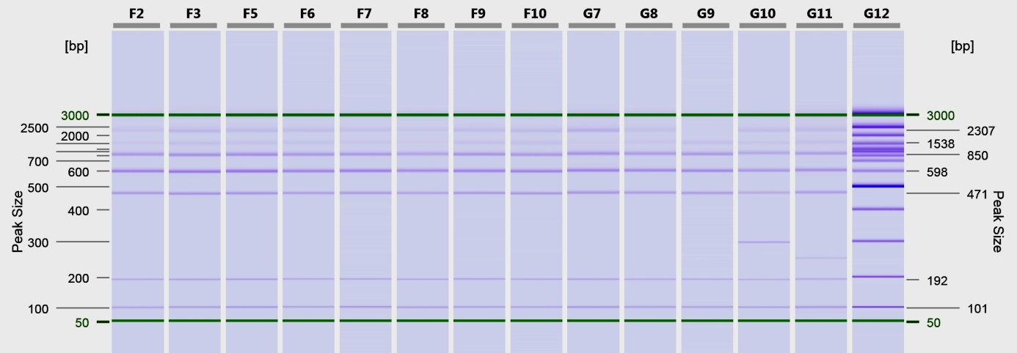
Picture 3. Bruce – Ladder F2 – F10 – positive samples; G7 – Brucella abortus PK (positive control); G8 – Brucella melitensis PK; G9 – Brucella ovis PK; G10 – Brucella suis PK; G11 – Brucella melitensis Rev1

