Exploring the effect of temperature on a mechanochemical reaction by in situ synchrotron powder X-ray diffraction
Krunoslav Užarević*,ª Vjekoslav Štrukil,ª Cristina Mottillo,^{b} Patrick A. Julien,^{b} Andreas Puškarić,ª Tomislav Friščić*,^{b} Ivan Halasz*ª
ª Ruđer Bošković Institute, Bijenička cesta 54, HR-10000, Zagreb, Croatia;
^{b} Department of Chemistry and FRQNT Centre for Green Chemistry and Catalysis, McGill University, Montreal, H3A 0B8 Canada

ABSTRACT: We describe the first in situ and real-time study of a mechanochemical reaction by variable-temperature synchrotron powder X-ray diffraction. Using the dry milling synthesis of a coordination polymer as a model system, we reveal a change in reaction mechanism if temperature is increased and a strong dependence of the reaction rate on temperature, with a ca. 6-fold increase of the rate of reactant depletion for a 45 °C rise in temperature. These experiments provide also the first direct evidence how a formally dry milling reaction is facilitated by water released from a hydrated reactant.

INTRODUCTION
Mechanochemical reactions,¹⁻⁴ conducted by milling, grinding or shearing⁵⁻⁶ are rapidly emerging as an attractive, clean, energy- and materials-efficient^{7,8} alternative to conventional solution-based synthesis of a wide range of materials, from supramolecular and organic soft materials,⁹⁻¹³ to inorganic,¹⁴⁻²⁰ organic,²¹⁻²⁷ organometallic²⁸⁻³⁴ and coordination compounds.³⁵⁻⁴¹ Besides providing a solvent-free reaction environment permitting chemical reactivity independent of reactant or product solubility,⁴² mechanochemistry also provides notable emergent synthetic advantages, including excellent control over product stoichiometry and access to materials and chemical transformations that are difficult to achieve by conventional synthetic methods.⁴³⁻⁴⁵
Growing interest in milling mechanosynthesis has highlighted a lack of knowledge of underlying mechanisms and reaction kinetics. Whereas the effect of temperature on chemical reactivity has been thoroughly investigated for a wide range of solution, gas and solid-state reactions,⁴⁶ there is little information on temperature dependence of milling reactions.^{47,48} It is, however, known that conducting a mechanochemical reaction at an elevated temperature, e.g. by pre-heating the milling equipment, can have a strong effect on the composition and structure of the resulting product.⁴⁹ Nevertheless, studies of temperature and thermal effects in ball milling reactions are rare,⁵⁰⁻⁵³ and most have focused on highly exothermic mechanochemical self-propagating reactions.⁵⁴⁻⁶⁰
One reason why the effect of temperature on kinetics of mechanochemical milling reactions has remained largely unexplored lies in the inability to follow mechanochemical reactions at a given temperature directly, without the need to interrupt milling and extract samples for analysis. Very recently, we have developed a technique for direct, real-time and in situ monitoring of mechanochemical reactions using synchrotron X-ray powder diffraction. This technique uses highly penetrating high-energy X-rays (λ ≈ 0.14 Å, E ≈ 86 keV) to obtain powder X-ray diffraction (PXRD) data from a sample while it is mounted on an operating mill, allowing qualitative⁶¹ and quantitative⁶² assessment of the reaction progress.^{45,63-65}
We now present the first variable-temperature in situ X-ray diffraction study of a mechanochemical reaction, using as a model system the assembly of coordination polymers of cadmium chloride with the ditopic ligand cyanoguanidine (cnge).⁶⁶ Reactions were performed using a thermally-insulated vessel equipped with thermal sensors that also permitted in situ diffraction studies. The results of this proof-of-principle study, which creates an entirely new opportunity to study the course and heat exchange in ball milling mechanochemistry, reveal a surprisingly strong effect of temperature on the reaction course and kinetics.

Scheme 1. Mechanochemical reactions between CdCl2 and cyanoguanidine (cnge)
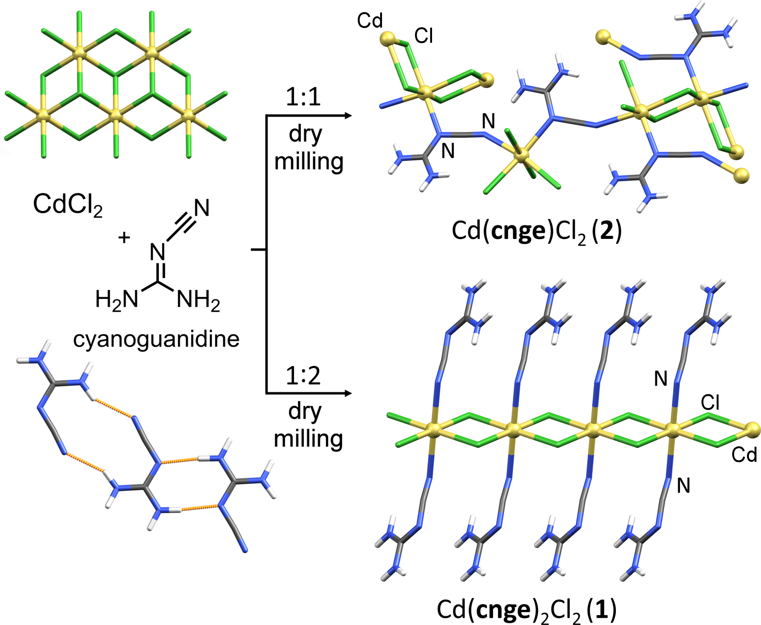

Mechanochemical milling reaction of CdCl₂ and cnge was previously studied ex situ by PXRD⁶⁶ and in situ by Raman spectroscopy,⁶³ making it a suitable model system. It was previously established that milling of the two components in either 1:1 or 1:2 respective stoichiometric ratio can give rise to two distinct coordination polymers, the one-dimensional (1-D) Cd(cnge)₂Cl₂ (1) and three-dimensional (3-D) Cd(cnge)Cl₂ (2, Scheme 1).

RESULTS AND DISCUSSION
The herein described reactions were conducted by neat grinding, i.e. without any auxiliary liquid additives. Reaction progress was monitored in situ at the high-energy X-ray beamline ID15B of the European Synchrotron Radiation Facility (ESRF), as described previously.⁶¹ To enable quantification of the reaction mixtures by Rietveld analysis, crystalline silicon was added as an internal scattering standard.⁶² For experiments at elevated temperatures, carefully weighed reactants placed each in one half of the vessel, and pre-heated in an oven together with the milling media. After being heated to a desired temperature, the reaction vessel was closed and placed in a thermally insulating and non-diffracting casing before being mounted on an in-house modified Retsch MM200 mill. Data was collected with a typical time resolution of 9 seconds.
The experimental hutch of the ID15B beamline was air-conditioned to 20.5 °C. Control over reaction temperature is challenging as it requires precise balance of heat generated by mechanical friction of milling media, and heat loss to the cooler environment of the experimental hutch. Without the latter, frictional heating would cause continuous temperature increase inside the milling vessel. A sophisticated methodology for controlling the reaction vessel temperature, e.g. by using an external flow cooling jacket, was not practical as it would severly limit the ability for in situ collection of X-ray diffraction data.
Reaction vessels were manufactured from polymethylmetacrylate (PMMA),⁶¹ itself a good thermal insulator (≈ 0.17 W m^{–1} K^{–1}), and additionally closed within a thermally insulating casing (Scheme S1). Temperature of the milled reaction mixture was measured by a rapid-response K-type thermocouple embedded in the milling vessel wall, close to the internal surface. Good thermal contact between the thermocouple and the vessel wall was ensured by thermally conducting paste. Temperature readings from the thermocouple were automatically written to a file concomitantly with recording of X-ray diffraction images. Reaction mixtures in all experiments were initially aimed to contain cnge and CdCl₂ in a 2:1 stoichiometric ratio, targeting the formation of 1. However, subsequent data analysis revealed that initially anhydrous CdCl₂ had partially transformed into the corresponding monohydrate CdCl₂·H₂O during transport and storage. Although unexpected, this deviation from the initial experiment design enabled the in situ observation of remarkably different reactivity of anhydrous CdCl₂ and its monohydrate.
Nominally room temperature (RT) milling experiments were conducted using two types of milling media. In one case, two stainless steel balls of 7 mm diameter were used (1.34 g each, sample/media weight ratio of 0.15), and in another a single stainless steel ball of 9 mm diameter (2.9 g, sample/media weight ratio of 0.14). Simultaneous temperature and PXRD measurements revealed a different increase in reaction temperature with time, as well as different reaction rates for the two experimental set-ups (Figure 1). Upon milling with two 7 mm balls (Figure 1a), the temperature of the reaction mixture rose from 23 °C to 26 °C over 30 minutes milling. During the first 20 min milling the reaction mixture underwent amorphization, evidenced by the gradual loss of intensity of reactant diffraction lines. At ca. 20 min, diffraction lines consistent with those expected from the known structure of 1 appear (CCDC code MAKXON).
Upon milling with a single 9 mm ball, (Figure 1b), the bulk temperature of the reaction mixture rose from 24 °C to 32 °C within 10 minutes. Quantitative Rietveld analysis confirmed that the mechanochemical reaction in both cases proceeds via amorphization, first of anhydrous CdCl₂, then of CdCl₂·H₂O, and finally of cnge (Figures S1, S2).⁶⁷ Based on Rietveld analysis, the first diffraction signals of 1 appear after ca. 50 % of the reaction mixture becomes amorphous. Previous in situ study by Raman spectroscopy revealed a similar reaction mechanism, where 1 was formed directly from reactants.⁶³ Partial melting and formation of a eutectic phase is unlikely since the reaction mixture remains in form of a free-flowing powder during milling. Comparison of quantitative reaction profiles reveals that the reaction using a 9 mm ball proceeded ca. 3 times faster. The faster formation of 1 when using a heavier milling ball reveals that the reaction rate is not related to the sample-to-media weight ratio. Such conclusion is consistent with the previous ex situ study of this reaction.⁶⁶

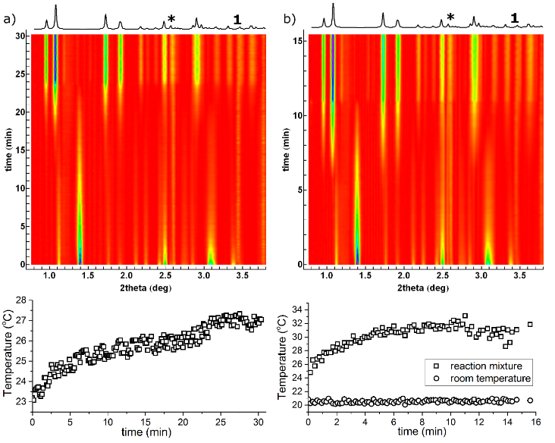
Figure 1. Time-resolved powder X-ray diffractograms (top) and associated temperature profiles (bottom) for the mechanochemical reaction at room temperature using: (a) two stainless steel balls of 7 mm diameter and (b) one stainless steel ball of 9 mm diameter. The simulated PXRD pattern for the expected coordination polymer product 1 (CCDC code MAKXON) is shown on top of each time-resolved diffractogram, and the position of the (111) X-ray reflection of the internal diffraction standard crystalline silicon is marked with ‘*’.

Room temperature in situ monitoring experiments, however, could not distinguish whether the reaction acceleration was more due to increased ball impact, or due to a larger temperature increase when using a heavier ball. In order to resolve this question, we conducted in situ investigation of the reaction involving two 7 mm stainless steel balls at different temperatures. Whereas bulk sample temperature could not be held constant due to imbalance between internal frictional heating and heat loss to the surroundings, the experimental set-up allowed reactivity studies at the nominal temperatures of 50 °C, 65 °C, and 70 °C.
The in situ collected PXRD data reveals a change in reaction mechanism at elevated temperatures. Disappearance of crystalline CdCl₂ and cnge was now immediately accompanied by the rapid formation of intermediate 2 as well as, more slowly, of 1 (Figure 2). Appearance of 2 was recognized by diffraction lines in the time-resolved diffractogram matching those calculated from the known crystal structure (CCDC code CDCACD01). For all reactions at elevated temperatures, the weight fraction of the amorphous phase remained below 10%, as determined by Rietveld analysis. Upon complete disappearance of crystalline CdCl₂ the reaction mixture underwent a sharp transformation involving the disappearance of 2 and rapid increase in content of 1. All reactions at elevated temperature exhibited this sequence of transformations. Differences in the amorphous phase content between RT and high-temperature mechanochemical reactions can be tentatively explained by higher mobility of amorphous phase at elevated temperatures, facilitating its crystallization into the final product 1 via the intermediate 2. Reaction at 50 °C corroborates these results, with reaction rates in between those at room temperature and 65 °C (Figure S3).
Detailed analysis of the reaction profiles is made challenging by reaction complexity, involving four or five crystalline phases for room temperature and elevated temperature reactions respectively. Specifically, reaction times at different temperatures are not strictly comparable due to the described change in mechanism. However, Rietveld analysis reveals that weight fractions of crystalline CdCl₂ and of crystalline 1 and 2 follow a linear pattern and the corresponding reaction rates are thus constant. These common features allow a quantitative comparison of reactivity at different temperatures by describing the change of the weight content (w) of crystalline CdCl₂, 1 or 2 with time (t) using a linear expression w = w₀ + b×t, with w₀ being the initial weight fraction of the crystalline phase and b the rate of its diminishing for CdCl₂ or formation for 1 and 2. (Figures S6-S9, Tables S1-S3).
Comparing the rate constant b across different experiments (Table 1) reveals that the rate of disappearance of crystalline CdCl₂ increases over 6-fold with temperature increase from RT to ca. 70 °C, which is consistent with the RT reaction achieving a constant composition after ca. 25 minutes, and the reaction at 70 °C reaching completion in 4 minutes (Figures 2c, d). The rate b for the linear segment of 1 and 2 formation also increases with temperature. The formation of 1 and 2 is, however, not suitable for comparing chemical reactivity at different temperatures, as the formation of new crystalline phases is dictated not only by a chemical reaction, but also by rates of crystal nucleation and growth.
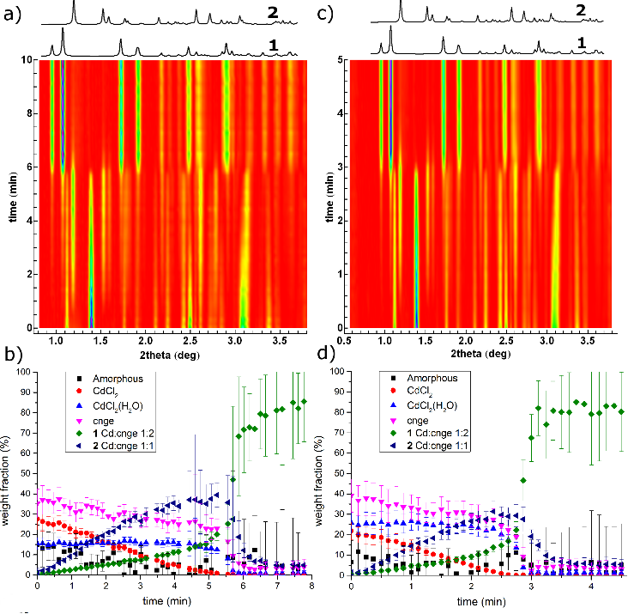
Figure 2. Time-resolved powder X-ray diffractograms for the mechanochemical reaction conducted at (left) 65 °C and (right) at 70 °C. Composition of reaction mixtures ceases to change after 8 minutes for the reaction at 65 °C and after 4 minutes for the reaction at 70 °C. Calculated diffraction patterns for products 1 (CCDC code MAKXON) and 2 (CCDC code CDCACD01) are shown above each diffractogram. (b) Time-dependent change in weight fractions of all participating crystalline and amorphous phases, established by Rietveld refinement of in situ collected PXRD data. Reliability of the Rietveld refinement is reduced with increasing amount of 1, due to the overlap of the (111) reflection of silicon standard with the group of reflections of 1 at around 2.6° in 2θ.
Table 1. Linear depletion (CdCl₂) and growth (1, 2) constants for mechanochemical milling reactions at different temperatures.ª
 | CdCl₂ |  | 1 | 2
Temperature (ºC) | b (%/min) | w₀ (%) | b (%/min) |  | b (%/min)
RT | -1.5 ± 0.1 | 31.6 ± 0.7 | - |  | -
RT^{b} | -3.0 ± 0.1 | 30.6 ± 0.4 | - |  | -
50 | -4.8 ± 0.1 | 17.1 ± 0.3 | 1.3 ± 0.1 |  | 8.3 ± 0.2
65 | -6.0 ± 0.1 | 28.1 ± 0.5 | 2.6 ± 0.1 |  | 9.5 ± 0.2
70 | -9.2 ± 0.1 | 23.2 ± 0.2 | 4.1 ±0.1 |  | 13.4 ± 0.4
a) unless noted otherwise, milling was performed using two stainless steel balls of 7 mm diameter (weight 1.3 grams); b) milling was performed using one stainless steel ball of 9 mm diameter (weight 2.9 grams).

The apparently higher reactivity of anhydrous crystalline CdCl₂ in a mixture with the crystalline hydrate CdCl₂⋅H₂O is surprising (Figures 2b, d, S1-S5). In all experiments at elevated temperatures where no or little amorphization takes place,⁶⁷ the content of CdCl₂·H₂O remains constant or changes only slightly until all crystalline CdCl₂ is depleted, after which the hydrate rapidly disappears. Such behaviour is unusual when one considers that the apparently more reactive hydrate lays dormant, while the less reactive anhydrous CdCl₂ is being slowly consumed. Also, several earlier reports on mechanochemical cocrystallization established that hydrates react faster than their anhydrous counterparts.⁶⁸⁻⁷² This, seemingly exceptional, behaviour can be explained by a mechanism in which CdCl₂⋅H₂O, rather than CdCl₂, reacts with cnge, releasing water that immediately reacts with anhydrous CdCl₂ to regenerate the CdCl₂⋅H₂O phase (Scheme 2). The net outcome of such a mechanism is the depletion of anhydrous crystalline CdCl₂ and cnge accompanied by the formation of the coordination polymer product.

Scheme 2. Interconversion of CdCl2 and CdCl2⋅H2O in milling synthesis of coordination polymers with cnge.
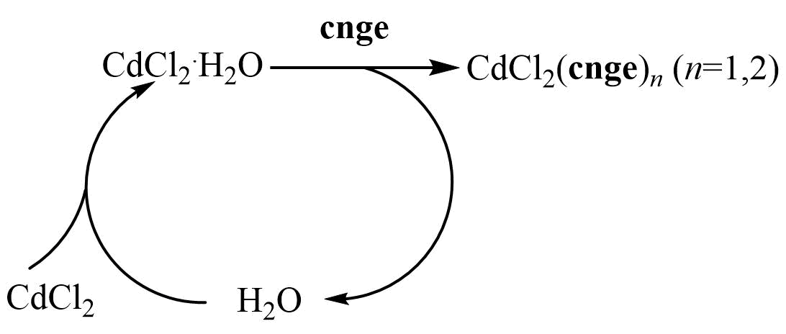

To verify the reactivity of anhydrous CdCl₂ towards water, we obtained a fresh batch of anhydrous CdCl₂. Preliminary PXRD analysis of this material revealed it was already completely converted into CdCl₂·H₂O, attesting to the high reactivity of CdCl₂ towards water. Next, we prepared crystalline CdCl₂ by dehydration of CdCl₂·H₂O at 180 °C. The material was highly hygroscopic, reacting with air moisture within minutes to yield CdCl₂·H₂O. Milling of freshly prepared anhydrous CdCl₂ with cnge for 30 minutes at room temperature did not lead to product formation, whereas CdCl₂·H₂O readily reacted to form 1 by milling for 30 minutes at room temperature. These observations fully confirm the proposed mechanism in which the mechanochemical reaction proceeds via depletion of CdCl₂·H₂O, which is immediately replenished by the reaction of released water with remaining anhydrous CdCl₂. This mechanism also explains rapid product formation upon complete disappearance of anhydrous CdCl₂. Namely, the reaction before the disappearance of CdCl₂ is a neat grinding process, where water released in the reaction of CdCl₂·H₂O is immediately bound again. However, once anhydrous CdCl₂ has been completely consumed, reaction of CdCl₂·H₂O results in a net release of water, transforming the reaction into a rapid liquid-assisted grinding process.⁷³⁻⁷⁵
While it was previously proposed⁷⁶ by the Boldyreva group that the formally neat mechanochemical reactions of solvated reactants are effectively liquid-assisted processes facilitated by the liquid released during the advancing reaction, the herein provided in situ and real time measurements are the first direct experimental confirmation of such a reaction mechanism.

CONCLUSION
This study established the possibility to conduct in situ monitoring of mechanochemical milling reactions at different temperatures. Despite difficulty in maintaining a constant temperature throughout each experiment, this first variable-temperature real-time observation reveals remarkable thermal sensitivity of a mechanochemical reaction of coordination polymer synthesis. For the model synthesis of the coordination polymer Cd(cnge)₂Cl₂, a modest 45 °C increase in bulk temperature resulted in a 6-fold decrease in reaction time, a commensurate increase in reactant consumption rate, as well as a change in reaction mechanism. Such high sensitivity of reaction kinetics to a relatively mild temperature increase offers fundamentally important insight into mechanisms of mechanochemical reactions. Reactions by milling are sometimes described by the "hot-spot" and "magma-plasma" models,^{77,78} which attribute reactivity to reactant activation by highly localized, short-lived extreme increases in temperature resulting from the impact of grinding media. Using inorganic salt metathesis in a planetary mill as a model system, such hot-spots have been evaluated to be ca. 1 µm² in size, reaching temperatures of up to 1000 °C, over ca. 10 ns. If such short-lived rises in temperature were the dominant factor in mechanosynthesis of Cd(cnge)₂Cl₂, varying the bulk reaction mixture temperature by ≈45 °C should not have a substantial effect on reaction rates. Demonstrated thermal sensitivity of reaction kinetics⁴⁷ indicates that the hot-spot model of mechanochemical reactivity, which has been developed in the contexts of inorganic materials, alloying and mineral processing, may not be adequate for the mechanochemistry of softer materials, such as coordination polymers or cocrystals. This conclusion is consistent with the recent investigation of Diels-Alder reactions of organic solids by the Mack group, who established that temperatures of hot spots during milling of an organic material are likely to be below 100 °C.⁷⁹ Herein presented results open an unprecedented, simple route for in situ and real-time explorations of mechanochemical reactivity at different temperatures. We are currently improving the instrumentation for more accurate temperature monitoring and control.

ASSOCIATED CONTENT
Supporting Information
Quantitative Rietveld plots, kinetic modeling and thermal analysis data. This material is available free of charge via the Internet at http://pubs.acs.org.
AUTHOR INFORMATION
Corresponding Authors
* Krunoslav Užarević, Ruđer Bošković Institute, Bijenička cesta 54, HR-10000, Zagreb, Croatia. E-mail: krunoslav.uzarevic@irb.hr;
*Tomislav Friščić, Department of Chemistry and FRQNT Centre for Green Chemistry and Catalysis, 801 Sherbrooke St. W. H3A 0B8 Montreal, Canada. E-mail: tomislav.friscic@mcgill.ca;
*Ivan Halasz, Ruđer Bošković Institute, Bijenička cesta 54, HR-10000, Zagreb, Croatia. E-mail: ivan.halasz@irb.hr;
Funding Sources
NSERC Discovery Grant, the FRQNT Nouveaux Chercheurs program; Tak-Hing (Bill) and Christina Chan Scholarship in Green Chemistry; the FRQNT Pre-doctoral Scholarship; and Marie Curie FP7-PEOPLE-2011-COFUND program NEWFELPRO under Grant Agreement No. 62.
ACKNOWLEDGMENT
We are grateful to Mr. Vitomir Stanišić and Mr. Siniša Pecik (Ruđer Bošković Institute) for manufacturing the PMMA reaction vessels and Mr. Tomislav Mrla (Ruđer Bošković Institute) and Mr. Thomas Buslaps (ESRF, ID15) for assistance with the temperature measurement setup. Help of Dr Simon A. J. Kimber (ESRF, ID15 beamline) in performing the experiments and insightful discussions with Dr. Nikola Bregović (University of Zagreb) are gratefully acknowledged. We acknowledge the financial support of the NSERC Discovery Grant, the FRQNT Nouveaux Chercheurs program, Ruđer Bošković Institute, Center of Excellence for Advanced Materials and Sensors (Croatia) and McGill University. C. M. acknowledges the Tak-Hing (Bill) and Christina Chan Scholarship in Green Chemistry and the FRQNT Pre-doctoral Scholarship. The work of K. U. is supported under the European Commission and the Croatian Ministry of Science, Education and Sports from the Marie Curie FP7-PEOPLE-2011-COFUND program NEWFELPRO under Grant Agreement No. 62.
REFERENCES
- James, S. L.; Adams, C. J.; Bolm, C.; Braga, D.; Collier, P.; Frišćić, T.; Grepioni, F.; Harris, K. D. M.; Hyett, G.; Jones, W.; Krebs, A.; Mack, J.; Maini, L.; Orpen, A. G.; Parkin, I. P.; Shearouse, W. C.; Steed, J. W.; Waddell, D. C. Chem. Soc. Rev. 2012, 41, 413.
- Boldyreva, E. Chem. Soc. Rev. 2013, 42, 7719.
- Baig, R. B. N.; Varma, R. S. Chem. Soc. Rev. 2012, 41, 1559.
- Hasa, D.; Schneider Rauber, G.; Voinovich, D.; Jones, W. Angew. Chem. Ind. Ed. 2015, 54, 7371.
- Michalchuk, A. A.; Tumanov, I. A.; Drebuschak, V. A.; Boldyreva, E. V. Faraday Discuss. 2014, 170, 311.
- Crawford, D.; Casaban, J.; Haydon, R.; Giri, N; McNally, T.; James, S. L. Chem. Sci. 2015, 6, 1645.
- Yuan, W.; Lazuen-Garay, A.; Pichon, A.; Clowes, R.; Wood, C. D.; Cooper A. I.; James, S. L. CrystEngComm 2010, 12, 4063.
- Stolle, A.; Ranu B., Eds., Ball Milling Towards Green Synthesis: Applications, Projects, Challenges, RSC Green Chemistry No. 31, The Royal Society of Chemistry, 2014.
- Stolle, A.; Szuppa, T.; Leonhardt, S. E. S.; Ondruschka, B. Chem. Soc. Rev. 2011, 40, 2317.
- Rothenberg, G.; Downie, A. P.; Raston, C. L.; Scott, J. L. J. Am. Chem. Soc. 2001, 123, 8701.
- Hernández, J. G.; Juaristi, E. Chem. Commun. 2012, 48, 5396.
- Balema, V. P.; Wiench, J. W.; Pruski, M.; Pecharsky, V. K. J. Am. Chem. Soc. 2002, 124, 6244.
- Braga, D.; Maini, L.; Grepioni, F. Chem. Soc. Rev. 2013, 42, 7638.
- Baláž, P.; Achimovičová, M.; Baláž, M.; Billik, P.; Cherkezova-Zheleva, Z.; Criado, J. M.; Delogu, F.; Dutková, E.; Gaffet, E.; Gotor, F. J.; Kumar, R.; Mitov, I.; Rojac, T.; Senna, M.; Streletskii, A.; Wieczorek-Ciurowa, K. Chem. Soc. Rev. 2013, 42, 7571.
- Šepelák, V.; Bégin-Colin, S.; Le Caër, G. Dalton Trans. 2012, 41, 11927.
- Gupta, S.; Kobayashi, T.; Hlova,I. Z.; Goldston, J. F.; Pruski, M.; Pecharsky, V. K. Green Chem. 2014, 16, 4378.
- Ralphs, K.; Hardacre, C.; James S. L. Chem. Soc. Rev. 2013, 42, 7701.
- Suryanarayana, C. Prog. Mater. Sci. 2001, 46, 1.
- Šepelák, V.; Becker, S. M.; Bergmann, I.; Indris, S.; Scheuermann, M.; Feldhoff, A.; Kübel, C.; Bruns, M.; Stürzl, N.; Ulrich, A. S.; Ghafari, M.; Hahn, H.; Grey, C. P.; Becker, K. D.; Heitjans, P. J. Mat. Chem. 2012, 22, 3117.
- Šepelák, V.; Düvel, A.; Wilkening, M.; Becker, K.-D.; Heitjans, P. Chem. Soc. Rev. 2013, 42, 7521.
- Kaupp, G. Top. Curr. Chem, 2005, 254, 95.
- Bruckmann, A.; Krebs, A.; Bolm, C. Green Chem. 2008, 10, 1131.
- Wang, G.-W. Chem. Soc. Rev. 2013, 42, 7668.
- Stolle, A.; Szuppa, T.; Leonhardt, S. E.S.; Ondruschka, B. Chem. Soc. Rev. 2011, 40, 2317.
- Stolle, A.; Ondruschka, B. Pure Appl. Chem. 2011, 83, 1343.
- Do, J.-L.; Mottillo, C.; Tan, D.; Štrukil, V.; Friščić, T. J. Am. Chem. Soc. 2015, 137, 2476.
- Zhu, S.-E.; Li, F.; Wang, G.-W. Chem. Soc. Rev. 2013, 42, 7535.
- Rightmire, N. R.; Hanusa, T. P.; Rheingold, A. L. Organometallics 2014, 33, 5952.
- Rightmire, N. R.; Hanusa, T. P. Dalton Trans. 2016, 45, 2352.
- Juribašić, M.; Užarević, K.; Gracin, D.; Ćurić, M. Chem. Commun. 2014, 50, 10287.
- Hermann, G. N.; Becker, P.; Bolm, C. Angew. Chem. Int. Ed. 2015, 54, 7414.
- Hernández, J. G.; Bolm, C. Chem. Commun. 2015, 51, 12582.
- Juribašić, M.; Halasz, I.; Babić, D.; Cinčić, D.; Plavec, J.; Ćurić, M., Organometallics 2014, 33, 1227.
- Hernandez, J. G.; Butler, I. S.; Friščić, T. Chem. Sci. 2014, 5, 3576.
- Adams, C. J.; Haddow, M. F.; Lusi, M.; Orpen A. G. Proc. Natl. Acad. Sci. 2010, 107, 16033.
- Balema, V. P.; Wiench, J. W.; Pruski, M.; Pecharsky, V. K. Chem. Commun. 2002, 1606.
- Ma, X.; Lim, G. K.; Harris, K. D. M.; Apperley, D. C.; Horton, P. N.; Hursthouse, M. B.; James, S. L. Cryst. Growth Des. 2012, 12, 5869.
- Lazuen Garay, A.; Pichon, A.; James, S. L. Chem. Soc. Rev. 2007, 36, 846.
- Braga, D.; Curzi, M.; Johansson, A.; Polito, M.; Rubini, K.; Grepioni, F. Angew. Chem. Int. Ed. 2006, 45, 142.
- Maini, L.; Braga, D.; Mazzeo, P. P. Dalton Trans. 2012, 41, 531.
- Masoomi, M. Y.; Morsali, A.; Junk, P. C. CrystEngComm 2015, 17, 686.
- Užarević, K.; Halasz, I.; Đilović, I.; Bregović, N.; Rubčić, M.; Matković-Čalogović, D.; Tomišić, V. Angew. Chem. Int. Ed. 2013, 52, 5504.
- Katsenis, A. D.; Puškarić, A.; Štrukil, V.; Mottillo, C.; Julien, P. A.; Užarević, K.; Pham, M.-H.; Do, T.-O.; Kimber, S. A. J.; Lazić, P.; Magdysyuk, O.; Dinnebier, R. E.; Halasz, I.; Friščić, T. Nat. Commun. 2015, 6:6662.
- Trask, A. V; van de Streek, J; Motherwell, W. D. S; Jones, W. Cryst. Growth Des. 2005, 5, 2233.
- Štrukil, V.; Gracin, D.; Magdysyuk, O. V.; Dinnebier, R. E.; Friščić, T. Angew. Chem. Int. Ed. 2015, 54, 8440.
- Atkins, P. W.; de Paula, J., Atkins’ Physical Chemistry, 7th Edition, Oxford University Press, 2002.
- Takacs, L; McHenry, J. S. J. Mater. Sci. 2006, 41, 5246.
- Schmidt, R.; Burmeister, C. F.; Baláž, M.; Kwade, A.; Stolle, A. Org. Proc. Res. Dev. 2015, 19, 427.
- Andre, V.; Hardeman, A.; Halasz, I.; Stein, R. S.; Jackson, G. J.; Reid, D. G.; Duer, M. J.; Curfs, C.; Duarte, M. T; Friščić, T. Angew. Chem. Int. Ed. 2011, 50, 7858.
- Belosta von Colbe, J. M.; Bogdanović, B.; Felderhoff, M.; Pommerin, A.; Schüth, F. J. Alloys Comp. 2004, 370, 104.
- Doppiu, S.; Schultz L.; Gutfleisch, O. J. Alloys Comp. 2007, 427, 204.
- Belosta von Colbe, J. M.; Felderhoff, M.; Bogdanović, B.; Schüth, F.; Weidenthaler, C. Chem. Commun. 2005, 4732.
- Zhang, J.; Cuevas, F.; Zaïdi, W.; Bonnet, J.-P.; Aymard, L.; Bobet, J.-L.; Latroche, M. J. Phys. Chem. C 2011, 115, 4971.
- Takacs, L. Prog. Mater. Sci. 2002, 47, 355.
- Tschakarov, Chr. G.; Gospodinov, G. G.; Bontschev Z. J. Solid State Chem. 1985, 41, 244.
- Lohse, B. H.; Calka, A.; Wexler, D. J. Appl. Phys. 2005, 97, 114912.
- Takacs, L. Faraday Discuss. 2014, 170, 251.
- Chakurov, Chr.; Rusanov, V.; Koichev, J. J. Solid State Chem. 1987, 71, 522.
- Chakurov, Chr.; Rusanov, V. J. Solid State Chem. 1989, 79, 181.
- Atzmon, M. Phys. Rev. Lett. 1990, 64, 487.
- Friščić, T.; Halasz, I.; Beldon P. J.; Belenguer, A. M.; Adams. F.; Kimber, S. A. J.; Honkimäki, V.; Dinnebier, R. E. Nature Chem. 2013, 5, 66.
- Halasz, I.; Friščić, T.; Kimber, S. A. J.; Užarević, K.; Puškarić, A.; Mottillo, C.; Julien, P.; Štrukil, V.; Honkimäki, V.; Dinnebier, R. E. Faraday Discuss. 2014, 170, 203.
- Gracin, D.; Štrukil, V.; Friščić, T.; Halasz, I.; Užarević, K. Angew. Chem. Int. Ed. 2014, 53, 6193.
- Tireli, M.; Juribašić-Kulcsár, M.; Cindro, N.; Gracin, D.; Biliškov, N.; Borovina, M.; Ćurić, M.; Halasz, I.; Užarević, K. Chem. Commun. 2015, 51, 8058.
- Batzdorf, L.; Fischer, F.; Wilke, M.; Wenzel, K.-J.; Emmerling, F. Angew. Chem. Int. Ed. 2015, 54, 1799.
- Štrukil, V.; Fábián, L.; Reid, D. G.; Duer, M. J.; Jackson, G. J.; Eckert-Maksić, M.; Friščić, T. Chem. Commun. 2010, 46, 9191.
- Rietveld refinement plots for quantitative analysis are given in Supporting Information pp. 16-220. Quantitative analysis of in situ diffraction data at elevated temperatures shows that the amount of amorphous phase is persistently below 10 % by weight. Nevertheless, to verify that the reactions are not actually mediated by an eutectic phase, we performed differential scanning calorimetry (DSC) experiments on a sample of the reaction mixture after 5 min milling. The physical appearance of the sample and the DSC thermogram confirm the absence of melting at temperatures of herein presented in situ experiments (Figure S11). The PXRD pattern collected immediately after the DSC experiment revealed complete conversion to 1 (Figure S12).
- Tumanov, I. A.; Achkasov, A. F.; Boldyreva, E. V.; Boldyrev, V. V. CrystEngComm 2011, 13, 2213.
- Jayasankar, A.; Somwangthanaroj, A.; Shao, Z. J.; Rodríguez-Hornedo, N. Pharm. Res. 2006, 23, 2381.
- Karki, S.; Friščić, T.; Jones, W.; Motherwell, W. D. S. Mol. Pharm. 2007, 4,347.
- Chieng, N.; Hubert, M.; Saville, D.; Rades, T.; Aaltonen, J. Cryst. Growth Des. 2009, 9, 2377.
- Pichon, A. L; James, S. L. CrystEngComm 2008, 10, 1839.
- Friščić, T.; Jones, W. Cryst. Growth Des. 2009, 9, 1621.
- Bowmaker, G. A. Chem. Commun. 2013, 49, 334.
- Converse transformation, of a LAG into a neat grinding process due to absorption of the catalytic liquid into the product phase was previously described, see: Strobridge, F. C.; Judaš, N.; Friščić, T. CrystEngComm 2010, 12, 2409.
- Losev, E. A.; Boldyreva, E. V. CrystEngComm, 2014, 16, 3857.
- Urukaev, F. Kh.; Boldyrev, V. V. Powder Technol. 2000, 107, 93.
- Urukaev, F. Kh.; Boldyrev, V. V. Powder Technol. 2000, 107, 197.
- McKissic, K. S.; Caruso, J. T.; Blair, R. G.; Mack, J. Green Chem. 2014, 16, 1628.

For Table of Contents Use Only

Exploring the effect of temperature on a mechanochemical reaction by in situ synchrotron powder X-ray diffraction
Krunoslav Užarević, Vjekoslav Štrukil, Cristina Mottillo, Patrick A. Julien, Andreas Puškarić,
Tomislav Friščić, Ivan Halasz

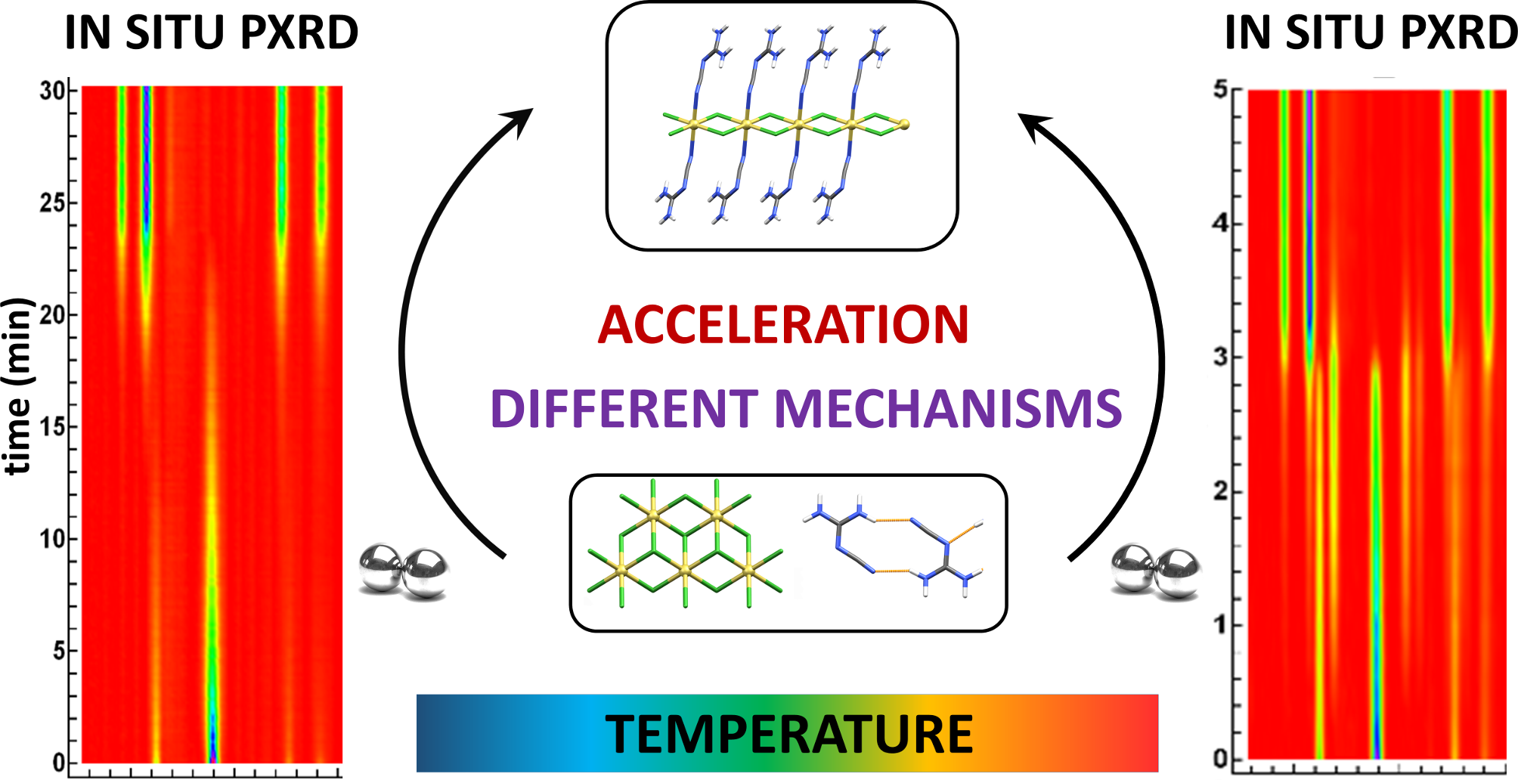
The first in situ and variable-temperature and real-time study of a milling reaction reveals a surprisingly strong dependence of reaction mechanisms and rate on temperature. We provide also the first direct evidence of how a formally dry milling reaction is facilitated by water released from a hydrated reactant.

