Decision support for machine tools selection in
process planning and equipment investment
Trstenjak Maja¹ Cosic, Predrag²,
^{1, 2}Department for Industrial Engineering
University of Zagreb
Zagreb, 10 000, Croatia
Abstract
The paper considers two cases of machine tools selection: machine tools selection as part of equipment investment and machine tools selection in defining technological process planning. The paper presents the issue of decision making using the Analytic Hierarchy Process (AHP) method. The application of the AHP method in solving multiple criteria decision making is illustrated through a practical example using the Expert Choice (EC) software. Selection of criteria, their significance and level of hierarchy are very important. In the considered case a machine tool is being selected from the range of machines existing in a smaller-sized production plant on the basis of a representative product. Some of the most commonly used criteria when choosing a machine tool include the following: production quantity, machining type, geometrical features of the machine, complexity of the workpiece, productivity etc. In case of machine tool selection as part of equipment investment a set of additional criteria related to the economic field need to be considered. These criteria are related to the price of machine tool, guarantee period, etc. We will elaborate some scenarios for both considered cases as part of decision support. The finally obtained results for both cases will be analysed and compared.
1. Introduction
Production planning process [1] in general is a constant fight between costs, product quality and product delivery time [2], [3]. In present situation, for most of the companies it is essential to listen to the voice of customer and offer an appropriate product or service with an optimum of the three mentioned facts [4]. It is required to be as flexible as possible and at the same time decide what will the best for the production process with minimum overall costs in order to ensure higher income [5], [6].
The very same situation is present when it comes to machine tools selection [7]. There are many influential factors, both technical and economical, with an addition of ergonomic and ecological factors. They are most frequently chosen through the brainstorming process of the experienced engineers and staff of a company and then valued and measured by the same [8], [9].
One of the methods that provide an adequate decision making process is the AHP method [10], [11], [12] which can be used in such situations, supported by simple and most common software for it, i.e. Expert Choice [13].
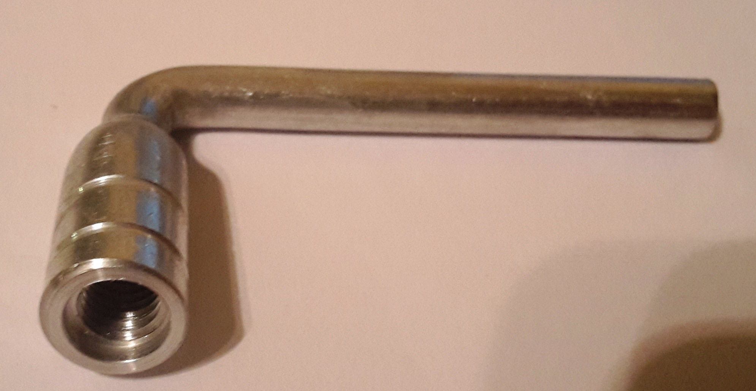
Figure 1: Representative of products for manufacturing

In the following paper, this process will be studied on an example of products made in a smaller-sized Croatian company Metal Product Ltd. and their machines [14]. The products concerned are aluminium parts, average dimensions to 100 mm, processed on machine tools, requiring milling, drilling, threading and turning [15].
2. Machine tools selection criteria
Machine tools selection must be based on various criteria. [16] The more detailed the criteria are, the better final decision will be. Although the machine tools selection criteria in case of equipment investment and in case of technological process planning are very similar, still there are a few significant differences.
In both cases, criteria based on technical features of machines must be involved. The level of details on the technical features of machines mostly depends on the manufacturers and on the information given in promotional materials. They are different by different manufacturers; however, generally it is possible to find out all information needed through meetings with their local representatives.
The criteria given in Figure 2 are based on ideas generated by experts [17] in a brainstorming process and will be considered in the AHP model. It might be also useful for companies to include their workers in the brainstorming process so that they may also contribute with their knowledge of the manufacturing process and machines themselves [18].

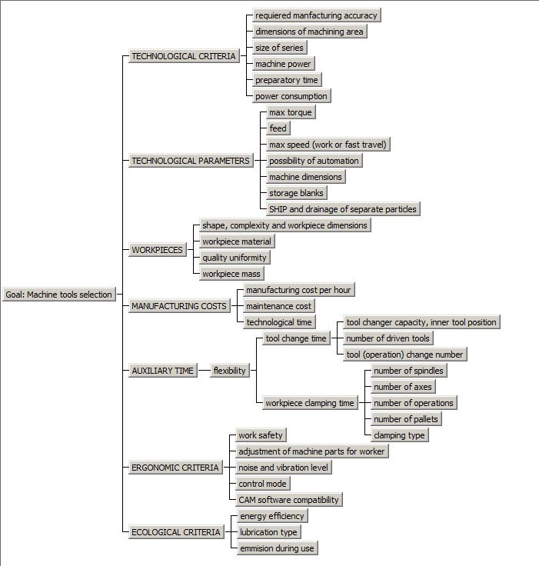
Figure 2: Machine tools selection as process planning criteria

When it comes to the technological process planning, the machines mentioned as alternatives have been already in use, so their features either have or have not been changed over time. That information is known by the staff in the maintenance department or by machine operators. Therefore, they must be included in the brainstorming process. Also, some criteria can now be transformed from quantitative to qualitative ones by using exploitation results, if these have been recorded during use. This can refer, for example, to preparatory time, quality uniformity, manufacturing cost per hour, technological time, or noise and vibration level.
On the other hand, while using AHP method as part of machine tools selection in equipment investment, the criteria also have to be based on ideas generated in the brainstorming process by the company’s experts in engineering and economy. The important feature nowadays are also ergonomic criteria which provide greater work safety and staff well-being by making the work easier and more user-friendly [19]. In addition, ecological criteria are very important because they are related to local regulations which must be followed.
In first AHP case the accent will be on technological criteria and auxiliary time criteria, while in the other case the focus will be on manufacturing costs and financial criteria.
When it comes to technological process planning, the machines mentioned as alternatives have been already in use, so their features either have or have not been changed over time. That information is known by employees in the maintenance department or by machine operators. Therefore, they have to be included in the brainstorming process. Also, some criteria can now be transformed from quantitative to qualitative ones by using exploitation results, if these have been measured during use. This can be applied, for example to preparatory time, quality uniformity, manufacturing cost per hour, technological time, or noise and vibration level.
3. Available machines (alternatives)
There will be three available machines considered as alternatives. These are real machines, used in Metal Product Ltd. Their characteristics are given in Table 1.

Table 1: Machine (alternatives) specification
No. | Machine Type: |  | Super VF3 | VCE 500 | DMC 65V
1 | Basic info | Manufacturer | HAAS | MICRON | DECKEL MAHO
 |  | Machine Type | Vertical machining centre | Vertical machining centre | Vertical machining centre
 |  | Machine Dimensions (height x width x length) [mm3] | 2750x3900x2700 | 2600x3000x2600 | 3420x3250x2420
 |  | Axes Number | 3+1 | 3 | 3
2 | Spindle | Max Spindle Power [kW] | 22.4 | 15 | 25
 |  | Max Torque [turn/min] | 12000 | 7000 | 12000
3 | Tool Head | Tool Capacity | 24 | 20 | 30
4 | Additional Functions |  | A-axis, dividing head | - | Pallet changer (2x) (5 s)
 |  |  | Wash through spindle |  | Wash through spindle
 |  |  | Fast tool change (2.4 s)
5 | Work space | Table length [mm] | 1219 | 600 | 850
 |  | Table width [mm] | 457 | 450 | 540
 |  | T-slot [mm] | 16 (5x) | 16 (5x) | 14 (5)
 |  | Max Weight on Table [kg] | 800 | 600 | 250
6 | Travels and Feed | X-axis [mm] | 1016 | 660 | 850
 |  | Y-axis [mm] | 508 | 350 | 500
 |  | Z-axis [mm] | 635 | 520 | 400
 |  | Work Travel [mm/min] | 21 | 16 | 20
 |  | Fast travel [m/min] | 35 | 22 | 30
7 | Accuracy | Position Precision (X-axis; Z-axis) [m] | 0,005 | 0.005 | 0.005
8 | Working Hour Price, Eur/h |  | 18.29 | 15.95 | 13.66

Other criteria will be qualified as qualitative because of the lack of precise information. They will be implemented in the AHP model with pairwise calculation [10], [11], [12] and rated regarding machine power, size, or work space, depending on the criterion.
Order of listing is based on known facts about the machines, particularly their power, torque, and dimensions. Machine dimensions are a good representative when it comes to ecological criteria and amortization criteria. The bigger the machine, the more complicated its disposal. Also, the market price of used machinery is based on its mass. So in this case, smaller, lighter and less powerful machines are better. Of course, this should not be the reason for selecting an inadequate machine, but should be certainly taken into consideration within the range of possibilities.
On the other hand, when the products to be manufactured are geometrically difficult or big in size and mass, some other options should be considered. This means that in such a case bigger, more powerful and more expensive machines would be better, because it will be possible to produce such products in easier and faster way. When smaller amounts of such products are to be produced, then the increase of overall costs can be expected. However, when larger quantities are requested, the product price decreases, as a result of overall cost decrease, since better machines have higher productivity.

Such kind of order had to be made because of the influential, but still qualitative criteria with no precise numerical data available. This mostly refers to auxiliary time criteria, which include workpiece manipulation. Decrement of auxiliary time is very influential on the overall process and will be considered by the AHP method. It has significant effect on productivity and, in the end, on total cost of products [20]. A shorter auxiliary time is in correlation with a shorter production cycle time, which leads to faster product delivery and lower product market price, which, in turn, increases the competitiveness of the company. [21]

Auxiliary time can be reduced by using turning pallets, extra spindle or even automatic workpiece manipulation by robots. It is hard to collect accurate quantitative data, however, the initial research data can be obtained from the local companies based on their experience. In general, these criteria and their change can be measured by work study processes, with simple time measurement of the mentioned actions [21]. There is also a space for economical study of profitability of implementing this as extra equipment on already owned machinery.
4. AHP model results
The mentioned criteria with alternatives were implemented in the AHP model in Expert Choice software and evaluated in the previously explained way. The results are given in dynamic sensitivity graph given in Figure 3.

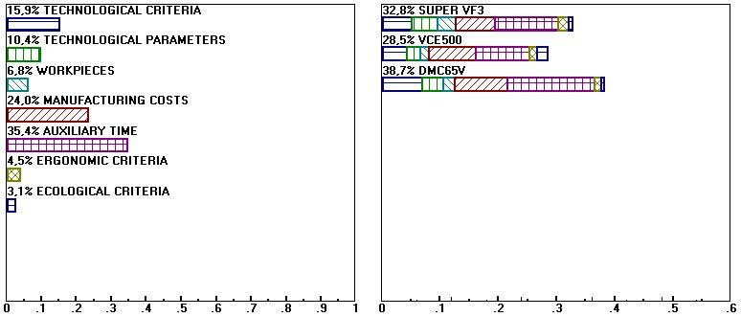
Figure 3: AHP method results

It is visible from Figure 2 that the machine DMC65V is the right choice. The high peak of VCE 500 with respect to the ecological criteria is due to its size and qualitative criteria mentioned. The obtained result was somehow expected because DMC65V has the best characteristics in the category of auxiliary time criteria and has also the lowest manufacturing costs per hour. These two criteria are most influential.
The consistency factors of the goal are less than 0,1 which makes this model adequate for future consideration and evaluation (Figure 4).

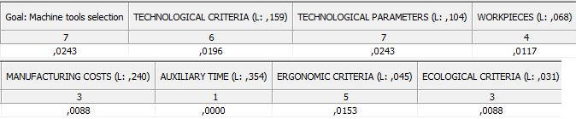
Figure 4: AHP model consistency factors

Let’s observe what will happen if suddenly the manufacturing price (per hour) on DMC65V changes from EUR 13.66 to 21 EUR. Thus, it would be the machine with the highest price (Figure 5).

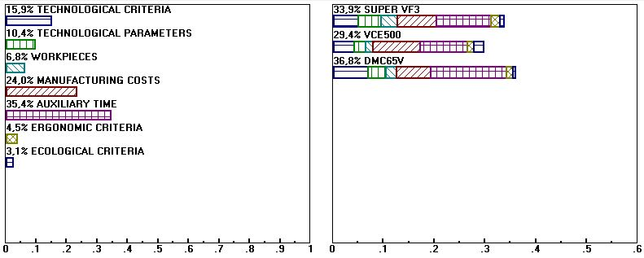
Figure 5: Sensitivity graph with DMC65V working hour price of EUR 21

The sensitivity graph shows that DMC65V is still the best choice, irrespective of the working hour price increase (Figure 5). Now let's observe what will happen if the working hour price on Super VF3 is reduced to EUR 14 (Figure 6).

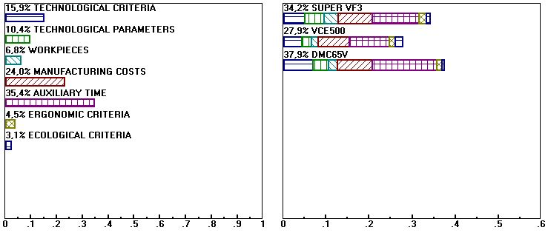
Figure 6: Sensitivity graph with Super VF3 working hour price reduced to EUR14

The DMC65V still remains the first choice. It is mainly because of its better technical characteristics needed for the process combined with the lowest price. This is very interesting, because Super VF1 has better characteristics at certain points (4th axis, bigger work piece mass and max. speed). This leads to the conclusion that the AHP method warns the users to focus just on the characteristics needed and made as most important for the process. Subjectively, some machines like Super VF3 might seem better, even with a lower working hour price, but still mathematically they are not better just because of the extraction of the characteristics that are most important for the process.
Now let us see how the change in auxiliary time will affect the final goal.
If we add an extra spindle to the machine with the best characteristics, and assume that the working hour price increases for 2 EUR, the results are the following:

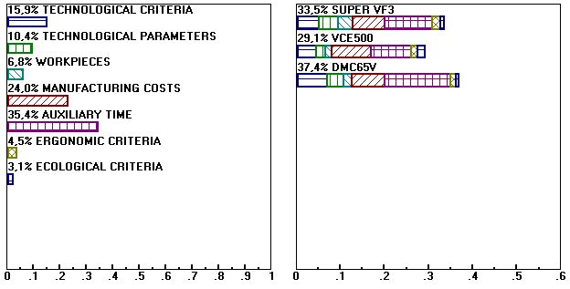
Figure 7: Sensitivity graph with increased working hour price and with extra spindle for VCE 500

Again, DMC65V is the first choice. It must be noted that despite the working hour price increase, this machine is still cheaper than other two, now with even better characteristics.
The most common problem in developing countries is coping with new ecological regulations, which is the cause of failure of smaller-sized companies because of the cost of implementation of these regulations. If the value of ecological criteria is increased, the results are the following.
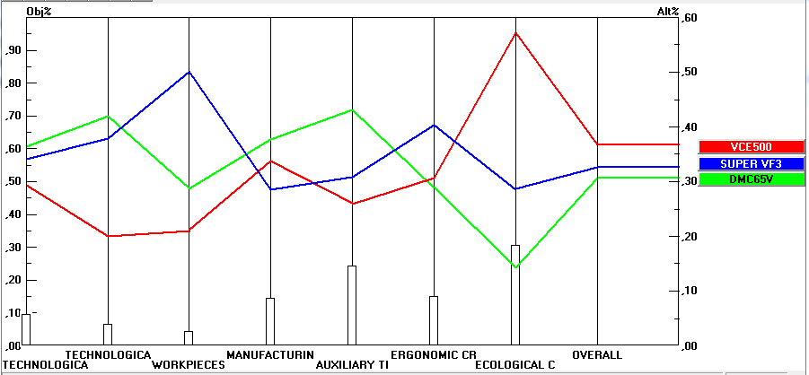
Figure 8: Sensitivity graph with increased ecological criteria

As shown in Figure 8, now the machine VCE 500 is the best, because it has better ecological features than other two machines. It must be noticed that the auxiliary time and manufacturing cost criteria are still pretty influential.
5. Selection of machine tools as part of equipment investment–new machine tools
Let us consider the situation when the decision to be made concerns selection of new machine tools. The assumption is that the very same machines are new and their market price does not vary much, because of that the pairwise calculation of it has been made.
When it comes to new machine tools selection, the most important factor is the amount of products scheduled to be produced. The bigger the amount, the smaller is the final price of the product, but also the use of better machines is more acceptable. Also, smaller and less powerful machines probably could not handle the big series of products, or this would result in extra maintenance costs. Product amount should be the first thing to consider while choosing the machine. In this case it is obvious that DMC65V is the best machine for such things, but usually the best and most powerful machines are the most expensive ones.
Also, financial criteria are very important here, however, when big series of products are concerned, these criteria are ranked on the second place according to the importance. Machine performances are now more important because a better machine reduces both the auxiliary and technological times, which in the end decreases overall costs and increases product quality and delivery time [22].

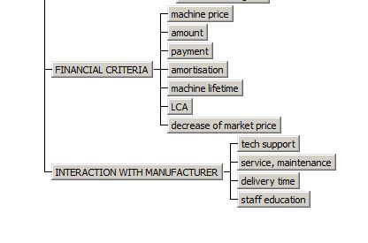
Figure 9: New machine tools selection – two additional criteria

To the previously listed criteria two new groups of criteria have been added – financial criteria and interaction with the machine manufacturer. Financial criteria are very influential and include machine market price, amount of machines that should be bought, payment method, machine lifetime, LCA [23] and amortization. In this case it is considered that payment method and amount of machines for each of the alternatives is the same. In real-life situations this varies and influences the final result, but in theory all of the possibilities are the same, because of the offers their sellers give. Another new group of criteria is the interaction with the manufacturer, which includes technical support, education, service and maintenance and machine delivery time. These criteria are important in new machine selection because they increase the product quality and decreases the company's maintenance costs because adequate technical support is provided. It is also assumed that for each of the three machines there is a local sales representative that provides maintenance services and education for the staff. The results have again shown that DMC65V is the first choice, while Super VF3 is the second ranked machine (Figure 10).

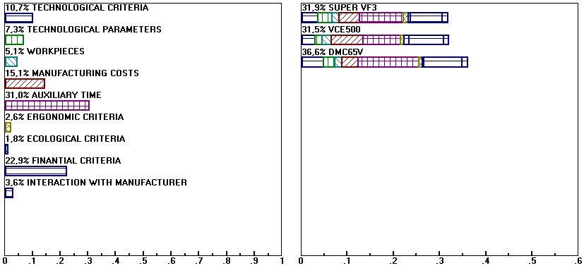
Figure 10: New machine tools selection results

Let's see what will happen if we improve VCE500 (which is assumed to have the lowest market price) with the 4th axis and workholder, which shortens the auxiliary time and decreases overall costs. Also, it has effect on maintenance costs and series size. Now VCE500 can handle bigger series. The results are shown in Figure 10.

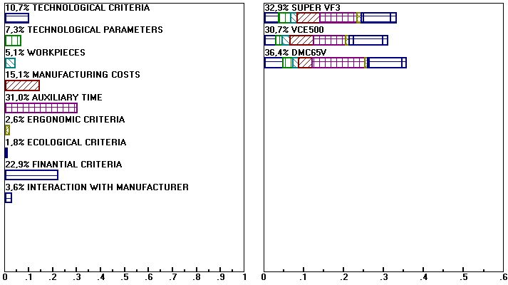

Figure 11: New machine tools selection results with improved VCE500

The results show how DMC65V is still the best choice overall, but VCE 500 is now the second best choice. Let’s observe what happens if we improve SUPER VF3 with the 5th axis workholder.
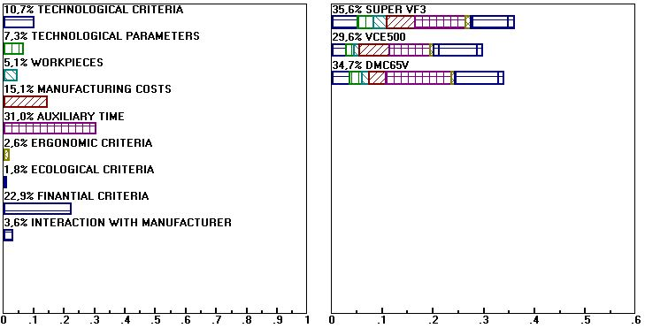
Figure 12: New machine tools selection results with improved Super VF3

It can be seen from the results in Figure 11 that Super VF3 is the first choice, but still, it is very close to DMC65V. The reason for that are great technological performances this machine now has. The 5th axis has reduced auxiliary time. Also, this machine has a possibility to machine more complex workpieces and is more flexible, which is very important.
6. Discussion on implementation of AHP method in real manufacturing
AHP method is a great help when it comes to a difficult decision making process. But the question is can this method be useable in real manufacturing and in everyday production planning situations. At this point, in the cases like the considered ones, it is never or extremely rarely used. The thing is that there are already many production planning software products that are easy to use and manufacturers rely on their use. Most of productions planning situations are not very complicated and the used software is taken for granted. The situation on the market is constantly changing and clients are requesting specialised products, which demands flexible production [4], [5]. The delivery times are shortening so the process must be close to perfection if the company wants to work with profit and be a competitive on the market [22].
That is why we can observe the cases where there are many different products requested for production in various amounts or company has many machines available [16]. Also, if the delivery times are really short, time should be utilized in the best possible way. The production costs are also important factor in this case. In situations like this, the AHP method should definitely be considered as an option for decision making. It provides a possibility to make a complex decision in a short period of time, so that the production could be planned in an appropriate way and the machines could operate at as high productivity as possible.
7. Conclusion
Machine tools selection is a very difficult task. In the first phase of the study only the detail expertise was made regarding machine tools selection criteria. The conclusion can be made that there is a difference between the criteria for new machine tools selection as an investment project and for machine tools selection as part of the process planning. An investment project includes also very important financial criteria, which should be considered carefully and sometimes are the most important factor in decision making process. Also, the interaction with manufacturers is important because they can provide technical support, maintenance and education in a short period of time. In both cases the most important, and in the AHP method the most influential, are technical criteria and the ones that have effect on the auxiliary time. Also, the amount of products that should be produced is the first thing to be considered, so that every other criterion can be based and evaluated in relation to that one. The next thing to be considered is the technical specification of the machine provided by the manufacturer. In future phase of work some disadvantages of AHP process should be considered. One of the biggest disadvantages of method is presence of human factor, subjectivity of human. Its influence should be measurable in some way and solution to minimize (ideally eliminate) this from the overall process would make this method more accurate and useable. Other way of future work would be devoted to decision making with many alternatives using this method or comparing it with possibilities of other decision support systems, which one is more adequate in cases like mentioned.
References
[1] Stadtler, H.: Supply Chain Management and Advanced Planning. Springer, 2008.
[2] So, K.; Song, J.: Price, delivery time guarantees and capacity selection. European Journal Of Operational Research. Vol. 11, No. 1, 1998., 29.-49.
[3] Laudon, K.; Laudon, J.: Essentials of Management Information Systems. Paerson Education, 2013.
[4] Pine, J.: Mass Customization: The New Frontier in Business Competition. Hardvard Business Review Press, 1992.
[5] Browne, J.; Rathmill, K.; Sethi, S.; Stecke, K.: Classification of flexible manufacturing systems. FMS Magazine, April 1984., 114.-117.
[6] Shah, R.; Ward, P.: Lean manufacturing: context, practice bundles and performance. Journal of Operations Management, Vol. 21, No. 2, 2003., 129-149
[7] Boothroyd, G.: Fundamentals of Metal Machining and Machine Tools., Marcer Dekker Inc., 1989.
[8] Clark, C.: Brainstorming: The Dynamic New Way to Create Successful Ideas; Tasa Rabula Interactive Publishing Co., 2006.
[9] Vašková, R.: Teamwork and high performance work organisation. European Foundation for the Improvement of Living and Working Conditions, Dublin, 2007.
[10] T. L. Saaty: "Decision making with the analytic hierarchy process", Int. J. Services Sciences, Vol. 1, No. 1, 2008.
[11] G. Coyle: “The Analytic Hierarchy Process (AHP)”, Pearson Education Limited, 2004.
[12] D. Kahneman, Thinking, Fast and Slow, Farrar, Straus and Giroux, New York, 2011.
[13] Expert Choice Tutorial. http://tea.ntue.edu.tw/~cyang/handout/advTesting/handout13_ExpertChoice.pdf (15.2.2015.)
[14] Metal Product. www.metal-product.hr (10.1.2015.)
[15] Metal Product Catalogues. http://www.metal-product.hr/proizvodi.html (10.1.2015.)
[16] E. Cimren, E. Budak, B. Catay: “Development of a Machine Tool Selection System Using Analytic Hierarchy Process”, The International Journal of Advanced Manufacturing Technology, Vol.35, No.3-4, 2007, 363-376 (SCI)
[17] Ziegler, R.; Diehl, M.; Zijlstra, G.: Idea Production in Nominal and Virtual Groups: Does Computer-Mediated Communication Improve Group Brainstorming?, Group Processes Intergroup Relations April 2000 vol. 3 no. 2 141-158
[18] Mullins, L.: Essentials of Organizational Behavior, Financial Times/Prentice Hall, 2011.
[19] Salvendy, E.: Handbook of Human Factors and Ergonomics. Wiley, 2012.
[20] Halevi, G.; Well, R.: Principles of Process Planning: A Logical Approach. Chapman & Hall, 1995.
[21] Aft, Lawrence: Work Measurement and Methods Improvement. John Wiley & Sons Inc., 2000.
[22] Fotsch, R.: Machine tool justification policies: Their effect on productivity and profitability. Journal of Manufacturing Systems, Vol. 3, No. 2, 1984., 169-195
[23] Klöpffer, W.: Life cycle assessment. Environmental Science and Pollution Research, Vol. 4, No. 4, 1997, 223-228

Corresponding author: Tel.: (385) 1-61 68 340; Fax: (385) 1 6157 123; E-mail: mt185947@fsb.hr

