The influence of Cd²⁺ cations on the α-Fe₂O₃ nanorings formation

Goran Dražićª, Tanja Jurkin^{b}, Marijan Gotić^{c}

ª National Institute of Chemistry, Hajdrihova 19, SI-1001 Ljubljana, Slovenia
^{b} Ruđer Bošković Institute, Division of Materials Chemistry, Laboratory for Radiation Chemistry and Dosimetry, Bijenička 54, Zagreb, Croatia
^{c} Center of Excellence for Advanced Materials and Sensing Devices, Ruđer Bošković Institute, Bijenička c. 54, Zagreb, Croatia

There is a long tradition in the synthesis of iron oxide particles with tailored chemical composition, shape and size. In order to modify the shape of iron oxide particles a lot of different surfactants, organic molecules, cations and anions have been used. In particular, phosphate anions have often been used to this end. It has been shown that the concentration of phosphate ions has a significant impact on the axial ratio of hematite particles. However, in spite of a long tradition of the synthetic iron oxide chemistry a convenient and reproducible one-pot procedure for a large-scale synthesis of iron oxide nanotubes and nanorings has been recently developed by Jia et al.[1]. These authors have shown that phosphate anions can induce the preferential dissolution of the hematite spindle precursor to form single-crystalline iron oxide nanotubes. The same authors [2] introduced sulphate anions into the system in order to achieve a better control of its morphology and this double anion mediation resulted in the synthesis of iron oxide nanorings. Contrary to the approach of introducing additional anions for better control of hematite nanotube/nanoring morphology, Gotić et al. [3] have exploited the benefits of introducing the divalent metal cations M²⁺ (M = Mn, Cu, Zn, Ni) into the system. With an increased M²⁺ addition the aspect ratio of hematite nanotubes gradually decreases and as a result hematite nanorings are formed. However, the role of the divalent metal cations in the formation of hematite nanorings is not fully understood. In this work, the influence of Cd²⁺ on the hematite (α-Fe₂O₃) nanotube morphology was studied in order to better understand the role divalent metal cations in the formation of nanorings morphology.
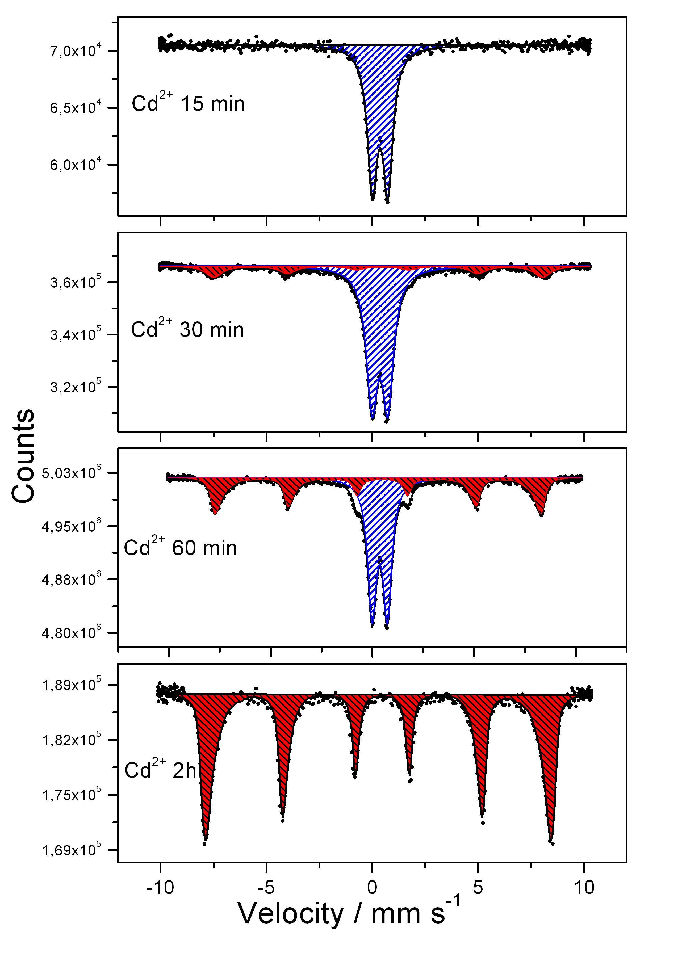
Fig. 1 The evolution of Mössbauer spectra after autoclaving the Cd²⁺ modified samples at 231 ºC.

Keywords: hematite, nanorings, akaganeite

References
[1] Jia et al., Angew. Chem. Int. Ed. 44 (2005) 4328.
[2] Jia et al., J. Am. Chem. Soc. 130 (2008) 16968.
[3] Gotić et al., J. Mol. Struct. 993 (2011) 167.

