20th Congress of the European
Anthropological Association

European Anthropology in a Changing World:
From Culture to Global Biology

Zagreb, Croatia
24th – 28th August 2016

ABSTRACT BOOK

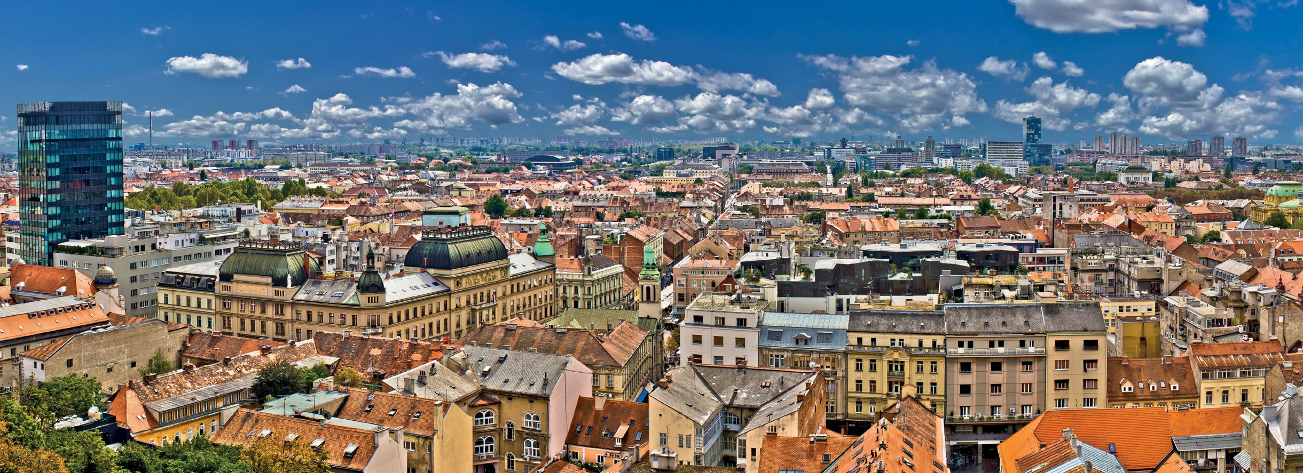
Institute for Anthropological Research, Zagreb, Croatia

Croatian
Anthropological Society
European Anthropological Association
morphological feature is more stable than the other similar variations and has a high genetic component. This feature including root numbers shows differences according to the population size and its spreading time. It is observed at the rate of 2.77% in Karagunduz Mound, 1.05% in Dilkaya Mound and 2.22% in Van Castle population, and all of them are from Middle Age archaeological sites in Eastern Anatolia, with the migration wave from Asia to west during Middle Ages. These features were not observed in Dilkaya Early Iron Age populations.

PALEOPATHOLOGICAL DATA FOR BURIED INDIVIDUALS REVEALED DURING RESCUE ARCHAEOLOGICAL EXCAVATIONS ON SITE NO. 2 OF SOFIA NORTH SPEED TANGENT, DISTRICT OF BENKOVSKI, SECTOR "NECROPOLIS"

Galabova Vasileva Borislava1, Atanassova-Timeva Donchova Nadezhda2

1Laboratory of Human Bioarchaeology, Sofia, Bulgaria
2Bulgarian Academy of Sciences, Institute of Experimental Morphology, Pathology and
Anthropology with Museum, Department of Anthropology and Anatomy, Sofia, Bulgaria galabovab@gmail.com

Rescue archaeological investigations were carried out during the construction of the new road in town of Sofia in 2015 under the direction of Prof. Ventzislav Dintchev, PhD and Assoc. Prof. Anelia Bozhkova, PhD at National Archaeological Institute with Museum - Bulgarian Academy of Sciences. The site (No. 2) is located in quarter of Benkovski in the northern outskirts of Sofia. In the Eastern sector were identified fifty three pits from the Iron Age and the Middle Ages, 12 semi-sunken medieval dwellings, and 6 accumulations of clay wall plastering and pottery fragments. In the Northern sector a Late Antique necropolis was investigated. The necropolis is dated in 5 century AD according to the occasional grave goods. The bone remains of
72 individuals were identified in 71 graves. The practice of burying was inhumation. All buried individual were placed in supine position with different placement of the upper limbs. Jaw bones and dentition have been preserved partly or entirely at 62 skeletons. What is noteworthy here is the high percentage of established dental and maxillofacial pathology registered in 26 skeletons (41.94%). Some traces of healing dental practice on the mandible (trephination) was identified in a juvenile individual from grave 38. The healing effect is observed in the area on dental root cyst around lower right first molar. No inflammation was found on the lower jaw, but signs of healing process are observed in this area. On that basis we could suppose that the juvenile had experienced this kind of treatment, and most likely the place was treated by antiseptic herbs. This find is unique at this stage of anthropological and archaeological studies in Bulgaria.

THE MEDIEVAL BURIALS IN CONTRACTED AND SEMI-CONTRACTED POSITIONS ON THE ARCHAEOLOGICAL SITE OUR LADY OF THE MOUNTAIN (LOBOR, CROATIA)

Hincak Zdravka1,7, Filipec Krešimir1, Merkaš Siniša2,7, Seiwerth Sven3, Potočki Kristina4, Špoljarić Igor2,7, Đapić Tomislav5, Rožić Sara2, Sukser Viktorija2, Popović Maja6, Mršić Gordan2,7, Mihelić Damir6

1Department of Archaeology, Faculty of Humanities and Social Sciences, University of Zagreb, Croatia
2Forensic Science Centre „Ivan Vučetić“, Zagreb, Croatia
3Institute of Pathology, School of Medicine, University of Zagreb, Croatia
4Clinical Department for Diagnostic and Interventional Radiology, Clinical Hospital Centre
Zagreb, Croatia
5School of Medicine, University of Zagreb, Croatia
6Faculty of Veterinary Medicine, University of Zagreb, Croatia
7Forensic Science Office, University of Zagreb, Croatia

15

zhincak@ffzg.hr

During the archaeological research in Lobor in 2011, three different time phases of the cemetery burials were defined at the east, outer part of the shrine of Our Lady of the Mountain. The third, youngest and most intriguing burial phase includes individual burials, the graves of five persons which were dug over an earlier stage. The bodies were placed in contracted or semi-contracted position of the arms and legs into the burial pits, with orientation east-west. Similar rituals have not been previously recorded at that site. Datation of this homogenous group is the second half of the 11th century. The anthropological analysis has been performed for each skeleton: determination of sex, age at death, body height and description of musculo- skeletal stress markers. Pathological changes visible in bones were both radiologically and histologically analysed. Skeletal and dental material from each grave was sampled for ancient DNA analysis, which was made to gain information of the possible kinship. DNA based kinship analysis within family group, chromosome DNA (STR DNA), was extracted using the standard forensic DNA extraction kit, 24plex qs.

INTO THE FLAME: THE CREMATED BONES OF EARLY ROMAN PERIOD AT GRADINJE SITE (SLOVENIA)

Hincak Zdravka1,6, Novšak Matjaž2, Špoljarić Igor3,6, Bačić Ivana3,6, Mršić Gordan3,6, Mikulka Ana1,6, Polak Tanja4, Mihelić Damir5,6

1Faculty of Humanities and Social Sciences, University of Zagreb, Croatia
2"Arhej d.o.o.“, Archaeological Research, Sevnica, Slovenia
3Forensic Science Centre „Ivan Vučetić“, Zagreb, Croatia
4Zagreb Zoo, Zagreb, Croatia
5Faculty of Veterinary Medicine, University of Zagreb, Croatia
6 Forensic Science Office, University of Zagreb, Croatia

zhincak@ffzg.hr

Analysis and interpretation of human cremated remains in the archaeological record still presents a real challenge to the bioarchaeologists. The standard osteological procedures for unburned skeletal remains often fail to identify those fragments transformed by fire. By examining thermal destruction patterns visible on bone and tooth remains, it is possible to interpret how the cremation happened. Analysis which includes diagenesis and nature of the cremated bones gives an opportunity of problem observation on different levels. The aim of this study is to present possibilities in the identification of human cremated remains using both macromorphological and histological methods. The histological methods applied were helpful in determining age at death. With application of the light microscopic analysis and the scanning electron microscopy (Scanning Electron Microscopy/Energy Dispersive Spectroscopy method SEM/EDX) morphological 2D and 3D characterization of the samples were obtained. This study is a reconstruction and an interpretation of the human cremated remains from six cremation urns of the Early Roman period from Gradinje in Slovenia.

16

