20th Congress of the European
Anthropological Association

European Anthropology in a Changing World:
From Culture to Global Biology

Zagreb, Croatia
24th – 28th August 2016

ABSTRACT BOOK

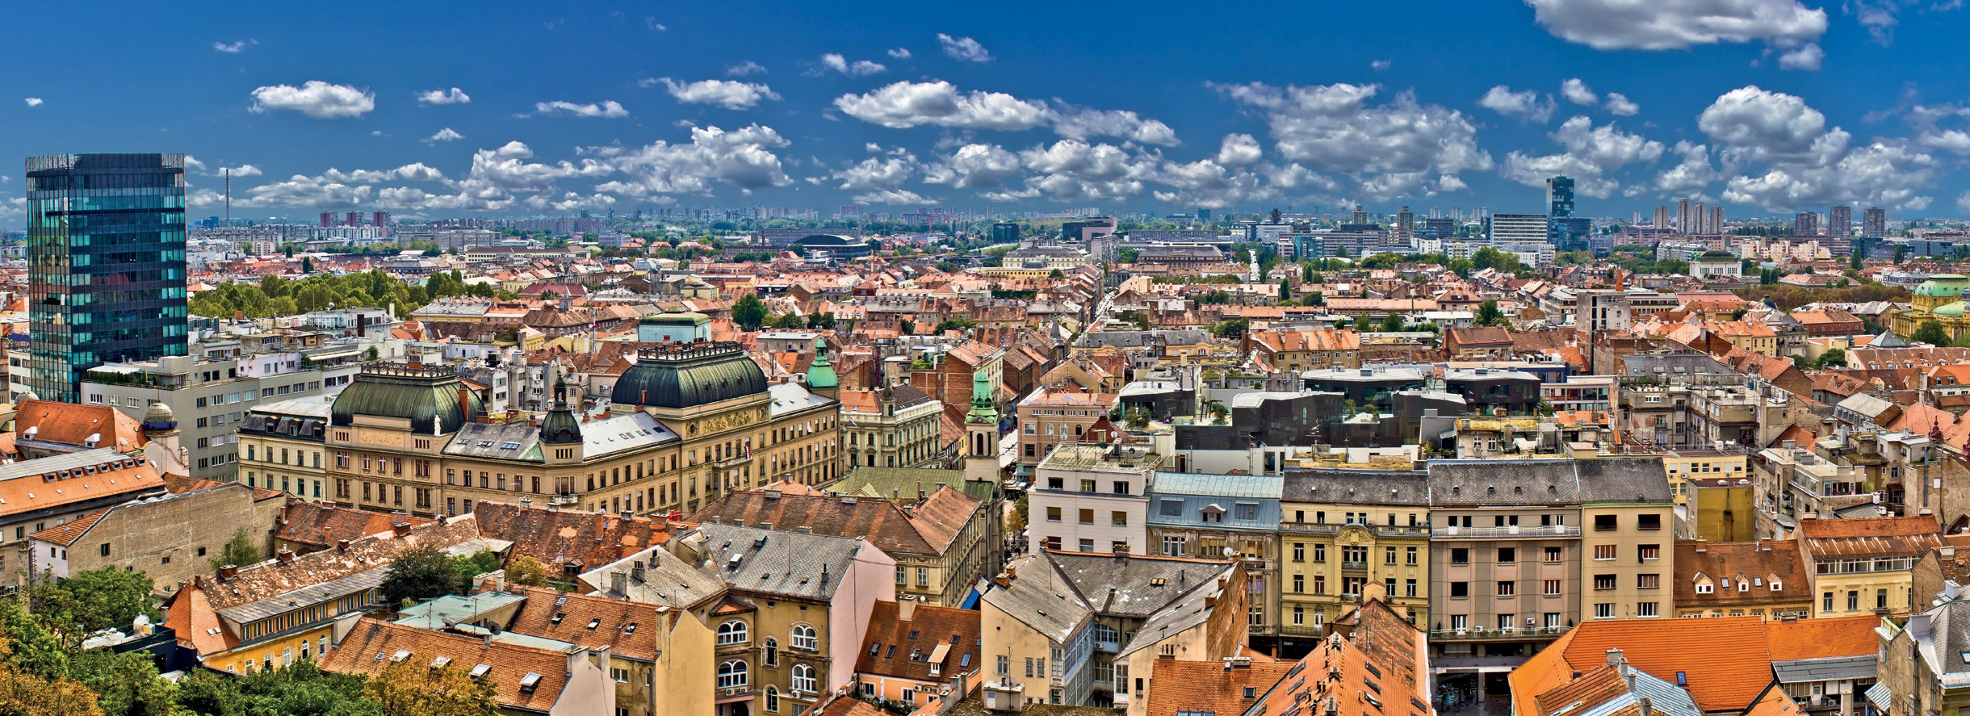
Institute for Anthropological Research, Zagreb, Croatia

Croatian
Anthropological Society
European Anthropological Association
for both sexes suggests that this group of people on which the study was carried cannot be categorized as stationary paleopopulation. This group is characterized by a small number of women, a large percentage of children and high infant mortality. This profile may belong to a type of population with special (military or defense) functions. The analysis of child mortality data in the studied group from Viminacium shows evidence that the conditions of existence of said children were extremely uncomfortable. Even more so, very high infant mortality rate leads to a decrease in the proportion of the young population, which changes the shape of the pyramid of life, and would probably result in a reduction of the population. The disproportion of sex-ratio can only be explained by a breach of the stationary population, a constant influx of the male population, which is likely related to military activities. More than visualizing a two-fold excess of the number of men over the number of women, it eloquently speaks of the social orientation of the society. It is logical to assume that the study group is a militarized society. A relatively small number of women and high infant mortality in this assumption seem logical, since the conditions for a military camp life cannot be considered suitable for women, and especially infants. These assumptions are proposed in the nature of hypotheses, but only in this fashion can the particular groups of the population that have been identified be logically explained. Further investigation on the territory of Viminacium can refine the hypothesis put forward.

PULL, PUSH, JUMP AND RUN: MUSCULOSKELETAL STRESS MARKERS IN THE PART OF LATE MEDIEVAL POPULATION FROM LOBOR (CROATIA)

Mikulka Ana1,3 , Filipec Krešimir1,3, Mihelić Damir2,3, Hincak Zdravka1,3

1Faculty of Humanities and Social Sciences, University of Zagreb, Croatia
2Faculty of Veterinary Medicine, University of Zagreb, Croatia
3Forensic Science Office, University of Zagreb, Croatia
mikulka.ana@gmail.com

The main goal of this research is to detect a biological status of individuals and the part of population, by analysing physical activities on the human skeletal remains from the Late Medieval period. The research included musculoskeletal stress markers on one hundred skeletons of male and female individuals, all with well preserved appendicular skeletal elements. Reconstruction of daily activity patterns, lifestyle and possible diseases in broader sense were analysed through musculoskeletal stress markers on the anatomical elements of upper and lower extremities and teeth. Described changes on the skeleton occur in the interaction of the musculoskeletal system, muscles and connective tissue. These are called entheseal changes or stress markers. The difficulties involved determining correct identification markers and degrees of expression. Therefore four scales were used: the Coimbra method, Mariotti´s method, Robb´s method and Hawkey and Merbs´ method. The data, specific modification of osseous or dental tissue obtained for each individual, offered a wide range of habitual behaviors and in some way, cultural practice of a population. After this extensive anthropological analysis, we hope that we will be able to bring bio cultural conclusions for part of this population.

21

