20th Congress of the European
Anthropological Association

European Anthropology in a Changing World:
From Culture to Global Biology

Zagreb, Croatia
24th – 28th August 2016

ABSTRACT BOOK

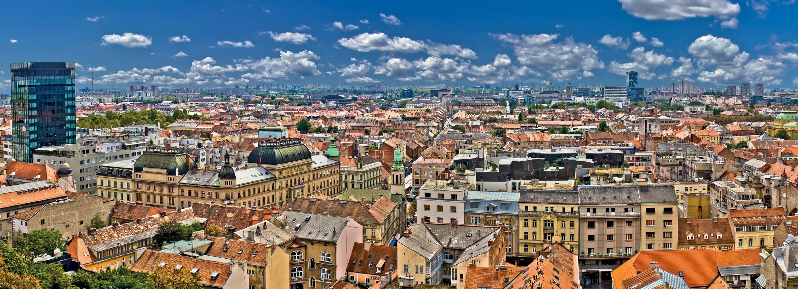
Institute for Anthropological Research, Zagreb, Croatia

Croatian
Anthropological Society
European Anthropological Association

zhincak@ffzg.hr

During the archaeological research in Lobor in 2011, three different time phases of the cemetery burials were defined at the east, outer part of the shrine of Our Lady of the Mountain. The third, youngest and most intriguing burial phase includes individual burials, the graves of five persons which were dug over an earlier stage. The bodies were placed in contracted or semi-contracted position of the arms and legs into the burial pits, with orientation east-west. Similar rituals have not been previously recorded at that site. Datation of this homogenous group is the second half of the 11th century. The anthropological analysis has been performed for each skeleton: determination of sex, age at death, body height and description of musculo- skeletal stress markers. Pathological changes visible in bones were both radiologically and histologically analysed. Skeletal and dental material from each grave was sampled for ancient DNA analysis, which was made to gain information of the possible kinship. DNA based kinship analysis within family group, chromosome DNA (STR DNA), was extracted using the standard forensic DNA extraction kit, 24plex qs.

INTO THE FLAME: THE CREMATED BONES OF EARLY ROMAN PERIOD AT GRADINJE SITE (SLOVENIA)

Hincak Zdravka1,6, Novšak Matjaž2, Špoljarić Igor3,6, Bačić Ivana3,6, Mršić Gordan3,6, Mikulka Ana1,6, Polak Tanja4, Mihelić Damir5,6

1Faculty of Humanities and Social Sciences, University of Zagreb, Croatia
2"Arhej d.o.o.“, Archaeological Research, Sevnica, Slovenia
3Forensic Science Centre „Ivan Vučetić“, Zagreb, Croatia
4Zagreb Zoo, Zagreb, Croatia
5Faculty of Veterinary Medicine, University of Zagreb, Croatia
6 Forensic Science Office, University of Zagreb, Croatia

zhincak@ffzg.hr

Analysis and interpretation of human cremated remains in the archaeological record still presents a real challenge to the bioarchaeologists. The standard osteological procedures for unburned skeletal remains often fail to identify those fragments transformed by fire. By examining thermal destruction patterns visible on bone and tooth remains, it is possible to interpret how the cremation happened. Analysis which includes diagenesis and nature of the cremated bones gives an opportunity of problem observation on different levels. The aim of this study is to present possibilities in the identification of human cremated remains using both macromorphological and histological methods. The histological methods applied were helpful in determining age at death. With application of the light microscopic analysis and the scanning electron microscopy (Scanning Electron Microscopy/Energy Dispersive Spectroscopy method SEM/EDX) morphological 2D and 3D characterization of the samples were obtained. This study is a reconstruction and an interpretation of the human cremated remains from six cremation urns of the Early Roman period from Gradinje in Slovenia.

16

