Ljerka Sedlan Kőnig, PhD
Josip Juraj Strossmayer University in Osijek, Croatia
Faculty of Economics in Osijek
Gajev trg 7, Osijek
Phone: +385 31 22 44 94
e-mail: sedlan@efos.hr
Tihana Koprivnjak, MA
Josip Juraj Strossmayer University in Osijek, Croatia
Faculty of Economics in Osijek
Gajev trg 7, Osijek
Phone: +385 31 22 44 94
e-mail: tihana@efos.hr

Petra Mezulić Juric, MA
Josip Juraj Strossmayer University in Osijek, Croatia
Faculty of Economics in Osijek
Gajev trg 7, Osijek
Phone: +385 31 22 44 94
e-mail: pmezulic@efos.hr

EMPLOYERS’ VIEWS ON STUDENTS’ EMPLOYABILITY IN EASTERN CROATIA

POGLED POSLODAVACA NA ZAPOŠLJIVOST STUDENATA U ISTOČNOJ HRVATSKOJ

ABSTRACT
Given the economic context and the situation of great competition for graduate jobs in Croatia, students are particularly interested in securing a degree that will enhance their employment prospects. The tensions between employers and academia remain because of faculty staff’s concerns that engaging with the employability agenda will lead to a diminution of academic standards and objectives (Gunn et.al. 2010). It is vital that universities produce graduates that economy needs, with the skills that employers value. Therefore, HE should take into account the employment needs of their students, including the generic skills and abilities needed in the workplace and reflect this in the strategy, curriculum and course design. With the objective to investigate the employers’ views on what skills and attitudes are important for employment, in April 2015 a total of 134 questionnaires from employers from Croatia were collected. In these surveys employers value problem solving skills, learning skills, willingness to learn, as well as enthusiasm and intelligence as the most important for employability. The findings indicate that skills and attitudes which employers expect graduates to bring to the workplace, such as intelligence, enthusiasm and motivation, application of knowledge, problem solving and learning skills are weakly developed during HE. This study highlights the growing need that HEIs put more emphasis upon promoting employability of students through skills development based upon employers’ priorities, upon structured approach to work placements, internships and work based learning opportunities, as well as meaningful partnerships with the employers. Strategic planning, as well as monitoring the effects of teaching at HEI in increasing the employability of students, is critical.
Key words: employability, graduates, employers, skills and attitudes, HEI

SAŽETAK
Uzimajući u obzir gospodarski kontekst u Hrvatskoj te postojanje velike konkurencije pri zapošljavanju, ne čudi što su studenti posebno zainteresirani za posjedovanje diplome koja će povećati njihovu zapošljivost. Zbog straha da će veći angažman oko pitanja zapošljivosti studenata dovesti do smanjenja akademskih standarda i ciljeva (Gunn et.al. 2010), još uvijek postoji neslaganje između poslodavaca i akademske zajednice. Ključno je da studenti nakon završetka visokog obrazovanja imaju znanja kakva gospodarstvo treba te vještine koje poslodavci cijene. Sveučilišta stoga trebaju uzeti u obzir generičke vještine i sposobnosti koje njihovi studenti trebaju da bi si osigurali veću zapošljivost te ih ugraditi u svoje strategije, programe i kolegije. S ciljem da se istraži mišljenje poslodavaca o vještinama i stavovima koji su važni za zapošljivost, u travnju 2015. prikupljeno je 206 upitnika od 72 nastavnika sa Sveučilišta Josipa Jurja Strossmayera u Osijeku i 134 poslodavca iz Hrvatske. U istraživanju je uočeno da poslodavci najviše cijene sposobnost rješavanja problema, vještine učenja, spremnost na daljnje učenje, kao i entuzijazam i opću inteligenciju. Rezultati istraživanja pokazuju da se vještine koje poslodavci očekuju od diplomanata prilikom zapošljavanja, kao što su inteligencija, entuzijazam, motivacija, primjena znanja, sposobnost rješavanja problema i vještine učenja, slabo razvijaju tijekom visokog obrazovanja. Također, istraživanje je istaknulo rastuću potrebu stavljanja većeg naglaska na: zapošljivost studenata kroz razvoj vještina, strukturirani pristup zapošljavanju, studentske prakse i učenje kroz rad, kao i na efektivno partnerstvo s poslodavcima. Pritom je strateško planiranje i praćenje efekata podučavanja na visoko obrazovnim institucijama u povećanju zapošljivosti studenata od iznimne važnosti.
Ključne riječi: zapošljivost, studenti, poslodavci, vještine i stavovi, visoko obrazovne institucije

- Introduction
One of the most often discussed topics concerning today’s labor market, in which requirements and priorities are constantly changing, are employability skills. The shift from an industrial economy to an information society has placed an emphasis on integrity, communication and flexibility. Technical expertise, which used to be sufficient for employment, is not enough to keep people employed nowadays. According to an extensive employers’ survey carried out in the UK, more than 70% of employers anticipate that employees will soon need to acquire new skills, due to rapid changes in the economy (Winterbotham et al., 2014).
With the ever-present challenge of global economic competition, the connection between higher education and employability is becoming more and more important, and is often a subject of discussion in the academic community. Due to rising unemployment among young graduates, universities are under more intense pressure from employers, government and other stakeholders to educate graduates with more than just skills in specific areas of specialization (Mason et al., 2006). It is widely agreed that the role of HE is to support students and graduates in developing the necessary qualities, behaviors, skills and knowledge for the contemporary workplace. Furthermore, contemporary HEI need to work together with the industry to ensure that the subject knowledge and skills that are acquired by students during HE and those needed in the workplace are complementary.
Eurostat data for March 2016 show that unemployment rate, seasonally adjusted, for EU28 was 8,8%, while, for the same period, the unemployment rate in Croatia was 14,9% and it puts Croatia among countries with the highest observed unemployment rates (alongside Greece and Spain). Youth unemployment rates are usually much higher than overall unemployment rates. According to Eurostat data, in March 2016, the lowest youth unemployment rates were observed in Germany (6.9 %), and the highest in Greece (51.9 % in January 2016). In the first quarter 2016 in Croatia the youth unemployment rate was 39.0%.
Although a considerable amount of literature addresses employability skills, much of the information is theoretical in nature, and offers policy recommendations and prescriptive advice which has not been tested in an entrepreneurially young country such as Croatia. This paper provides understanding of the employers’ perception of graduates’ employability skills and the role of higher education in promoting employability skills, focusing on graduates in Eastern Croatia.
The main objective of this paper is to determine what skills, knowledge and characteristics the employers in Croatia expect from their new employees, so that educators at HEI can promote these skills in their curriculum, and thus improve the employability of graduates. The research objective was also to measure to what degree HE contributes to the development of these skills and attributes, as well as to ascertain whether perceptions vary by location and size of enterprise.
In the first part, the authors review key literature on employability and propose the research question. Next, research method is presented, including sample description and research instrument, which was designed through modification of the existing research. Research results and the discussion from both theoretical and practical standpoint follow. Finally, recommendations for increasing employability of graduates are made.
- Literature review
The topic of employability has been very popular by researchers in many countries, and it has often been commented that current educational systems are ineffective in equipping graduates with relevant employability skills. Graduates in the 21st century are required to be adaptive and flexible, show they can easily learn and unlearn, and are able to make changes required by the environment. To succeed, new graduates need to manage rapid change, uncertainty and complexity in the environment, therefore employability skills, apart from subject specific knowledge and technical skills, should include transferable and entrepreneurial skills.
2.1. Concept of employability
Yorke and Knight (2006) define the concept of employability as a set of achievements, skills, understandings and personal attributes that make graduates more likely to gain employment, do well and secure occupations, which benefit themselves, the workforce, the community and the economy. Employability skills are distributed horizontally across all industries and vertically across all jobs (Robinson, 2000).
  - Employability skills
Much research has been done on the importance of employability skills in the workplace. Research reports that employability is enhanced by students who demonstrate entrepreneurial qualities, innovative approach, creativity, collaboration and risk taking. Klaus (2010) found that 75% of long term job success depends on people skills, while only 25% is determined by technical expertise. Another study indicated that hard skills, which include job skills and refer to specific, teachable abilities that may be required in a given context, contribute to only 15% of one’s success, whereas remaining 85% is due to soft skills (Watts and Watts, 2008, as cited in John, 2009). While Mason et al. (2003) assert that the concept of employability includes development of communication, numeracy, information technology and learning how to learn, more recent studies propose a number of inter-related competences. Little (2010) indicates that employers want graduates who can adapt to the workplace culture and use their abilities and skills to evolve the organization. According to Harvey et al. (2002) most employers are looking for graduates who are proactive, can use higher level skills including critical thinking and multi layered communication to facilitate innovative teamwork. Rothwell and Arnold (2007) proposed that employability, apart from students’ academic performance, ambition and confidence in skills and abilities, also includes student’s awareness of opportunities in the labor market, as well a labor market’s demand for people in the particular field. Confederation of British Industry (cited in Lowden et al., 2011) place an emphasis on graduates possessing a positive attitude as a key factor underpinning their employability and Archer and Davison (2008) illustrate that HEIs need to equip graduates with applied practical skills which make them more “work-ready”.
In conclusion, while there are variations in definitions of employability, there is a general agreement on what skills, characteristics and attributes constitute employability: employers expect graduates to have technical and discipline competences, but also require graduates to demonstrate a wide range of valuable skills and attributes.
  - Employers perceptions of employability and skills of recent graduates
A range of empirical evidence exists indicating that employers are more inclined to hiring graduates that possess both non-generic and technical skills. In the EC Eurobarometer report from 2010, covering 31 European countries on employers’ perception of graduate employability, recruiters highlighted the importance of team working, sector-specific skills, communication skills, computer literacy, being able to adapt to new situations, first class ability in reading and writing and analytical and problem solving skills. Graduate employers were less likely to highlight the importance of foreign language skills. A large majority of employers in that survey were at least rather satisfied with the level of skills and capabilities of their recent hires. The skills that employers in Catalunya Employers Survay (2014) considered to be the most important were responsibility at work, ability to acquire new knowledge and team working. The least important were negotiation skills and leadership. Previous studies point out that employers consider young graduates to have a good academic education and theoretical skills, but that they clearly lack practical skills and work experience. Graduates are also often unwilling to make sacrifices or be flexible and adapt reluctantly to the needs and requirements of the organization (Moreno, 2013, cited in AQU Catalunya Employers Survay, 2014).
In Croatia, a popular job search websites MojPosao.net in collaboration with EduCentar did a survey on 300 employees, 50 employers and 35 educational institutions and revealed that the majority of employers (63%) believe that their employees need good communication and public speaking skills. Employees, on the other hand, are not particularly interested in developing these skills. Only 40% stated that this is of interest to them. As additional informal education presents a critical factor in hiring candidates for as much as 71% of employers, the survey concludes that formal education is not enough to secure employment.
2.4. Higher education efforts in addressing employers’ needs
Cranmer (2006) and others maintain that employability issues should be at the very core of contemporary HE. Recently, in some EU countries there has been a shift concerning taking employability seriously (Harvey et al., 2002). Although more pressure is put on HEIs in Croatia to play a more active role in addressing employability of graduates, key stakeholders in HE do not appear to recognize this priority. On several occasions, both formally and informally, employers have stated that it is vital that HEI produce graduates that the economy needs, with the skills that employers value. With the increased policy efforts to embed employability into HE practice, it can be expected that HEIs introduce more systematic learning and teaching methods, course content to address employability in the curricula.
One of the major problems facing employability agenda in Croatia is the discrepancy between what academia and employers view the role of HE is. This opinion is not exclusive to Croatia. Researchers in other countries (Lees, 2002) highlight the fundamental differences in understanding of employability between employers and educators, which slows down the process of promoting graduate employability at HEI. It has been established (Gunn et.al. 2010) that the tensions between employers and academia remain primarily because of faculty staff’s concerns that engaging with the employability agenda will lead to a diminution of academic standards and objectives.
Knight and Yorke (2006) suggest that in addition to subject knowledge, course content should address specific and generic skills, self-efficacy and critical and reflective thinking. Some concerns have been raised with regard to how the development of such skills can be embedded into university practice, considering other priorities. It is concluded that employability can be developed through the integration of employability skills courses into mainstream curriculum, as well as though appropriate methods of learning, teaching, assessment, and work placements.
In order to evaluate to what degree the above findings are true for the Croatian context, two research questions have been considered:
- What skills, knowledge and attributes do employers in Croatia expect graduates to demonstrate apart from academic performance?
- What can HEI do to promote these skills, knowledge and attributes?

- Method
The main objective of the empirical research was to determine what skills, knowledge and characteristics the employers in Croatia expect from their new employees, so that educators at HEI can promote these skills in their curriculum, and thus improve the employability of graduates. The research objective was also to measure to what degree HE contributes to the development of these skills and attributes, as well as to ascertain whether perceptions vary by location and size of enterprise.

Two surveys conducted previously in Europe were used as reference for the design of this survey: the European Commission’s Eurobarometar 2010 titled “Employers’ perception of graduate employability” and the UK Commission’s Employer Skills Survey 2013: UK results (Winterbotham et al., 2014).

The questionnaire employed open and closed questions, as well as seven-point Likert scales as answers. Questionnaire was piloted prior to distribution, and the survey instrument was validated by an independent panel to ensure that all the questions were understandable to the respondents. The sample includes 134 surveys collected from Croatian employers. The survey was conducted online. Total of 1,647 questionnaires was sent to employers, with a response rate of 8.14%.

Although the sample is not representative of all enterprises employing graduates in Croatia, it does cover a wide range of branches of economic activity and different sizes (by number of employees) of enterprises. It, therefore, provides useful information that can be used for taking action to improve graduate employability in Croatia.

Graph 1 shows the distribution of enterprises according to location. In the sample, 51% of enterprises are from Eastern Croatia, which is of interest because of this paper’s focus on Eastern Croatia. Another 43% are from the Zagreb region, where the economic activity is the most intense in Croatia and where graduates are most likely to be employed. According to size, the sample includes micro (34%), small (36%), medium (13%) and large (17%) enterprises (see Graph 2).

Graph 1 Distribution of enterprises according to location
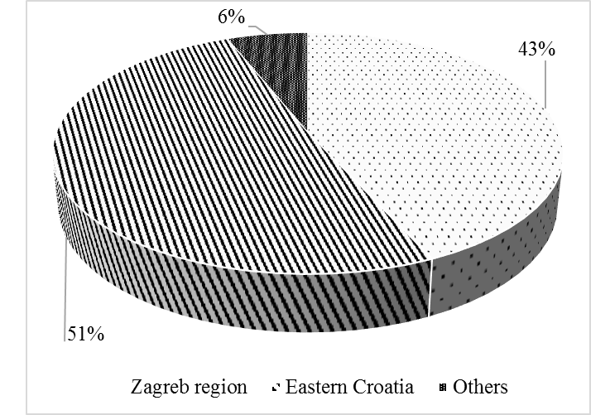
Source: Authors
Graph 2 Distribution of enterprises according to size
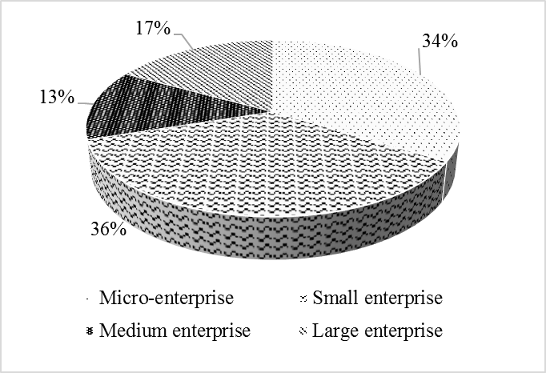
Source: Authors

- Results and discussion
Given that the majority of sampled companies were from two differently developed parts of Croatia, Eastern Croatia and Zagreb region, differences in opinions of employers in those two regions were compared. Although no significant differences between these two regions in rating the importance of employability skills were observed, there was a difference in rating HE contribution to development of employability skills. In general, employers from Eastern Croatia seem to be more satisfied with the degree to which HE contributes to development of employability skills, than employers from Zagreb region (see Graph 3.)
Graph 3 Comparison between Eastern Croatia and Zagreb Region concerning employers’ opinion on contribution of HE to the development of employability skills
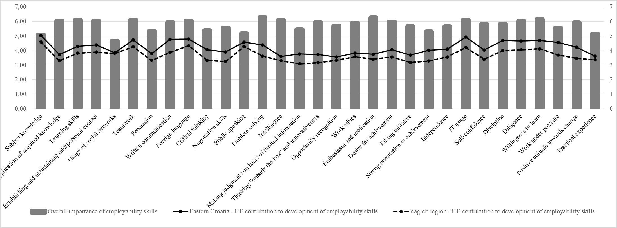Source: Authors
As it can be seen in Graph 4, employers in the survey believed that all listed skills are important for graduate employability, but the skills that employers considered the most important for graduate employability were problem solving skills (6.28 out of 7), enthusiasm and motivation (6.27), willingness to learn (6.14) and learning skills (6.12). The least important, from the employers’ point of view, were grade point average GPA (4.05), usage of social networks (4.67) and subject knowledge (5.1).
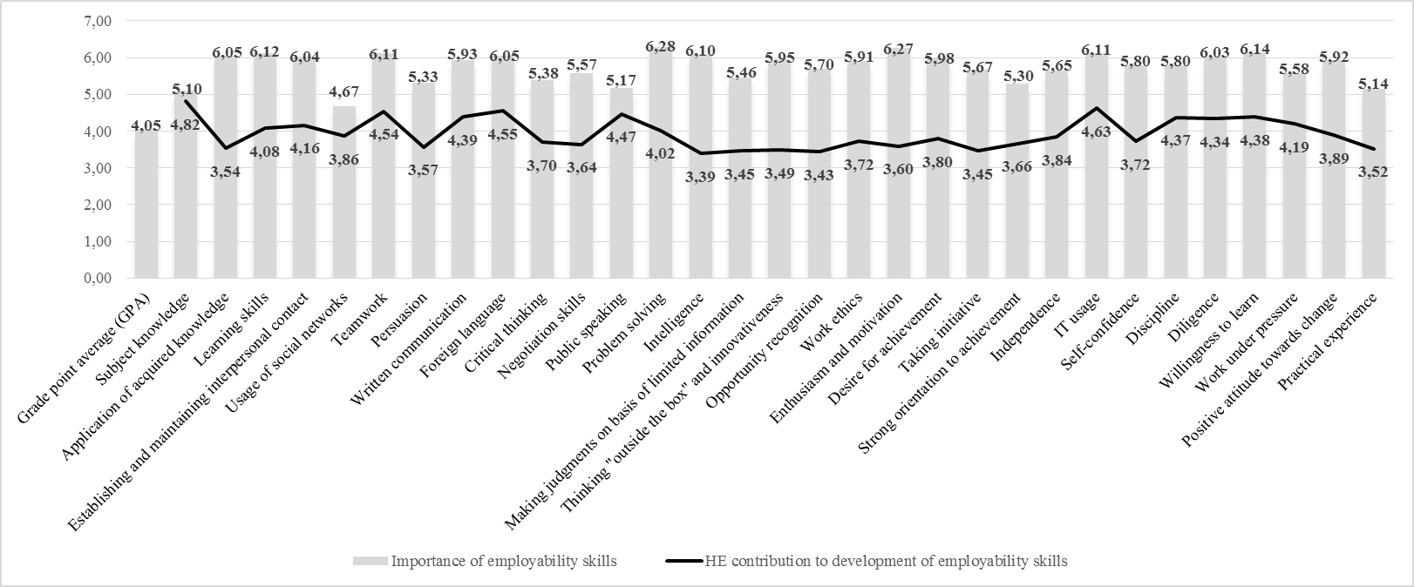
Graph 4 Employers' views concerning the importance of employability skills and the contribution of HE to the development of employability skills

Source: Authors

Significantly, employers gave higher importance to willingness to learn and learning skills than to student’s grade point average, which is in keeping with Winterbotham et al. (2014). This is in line with the previous findings that subject specific knowledge and technical skills are not enough to keep people employed. In conclusion, this research has shown that employers in this sample appreciate transferable skills and certain personal attributes highly, and give less importance to subject knowledge.
Considerable differences have been observed concerning the importance of employability skills and the contribution of HE to development of these skills. This corresponds with the findings in previous literature (Davies, 2000; Lindsay, 2002). In general, means for importance of employability skills were significantly higher than the means for HE contribution to their development. Also, in general, employers rated the contribution of HE to development of employability skills rather low. This finding is worrying because at the same time, the role of HE in increasing students employability was rated highly (values 6 and 7) by 64% of the employers. Employers in the survey thought that HE contributes most to acquisition of subject knowledge (4.82) IT usage (4.63) and team work (4.54). On the other hand, employers voiced their concern that HE contributes little to entrepreneurial skills such as thinking "outside the box" and innovativeness (3.49), making judgments on basis of limited information (3.45), taking initiative (3.45), opportunity recognition (3.43) and the least to increasing intelligence (3.39). These results are particularly disturbing because literature (Audibert and Jones, 2002) asserts that entrepreneurial attributes have become critical for hiring and promoting employees, and entrepreneurial, innovative, creative and adaptable employees are widely considered valuable for any organization. Moreover, entrepreneurship is recognized as one of the key competences for life-long learning (EU Parliament, 2006).
Interesting, although not surprising, is that the HE contribution to application of knowledge and practical experience was also rated rater low (3.54 and 3.52 respectively). Besides, 93% of employers consider that there is not enough attention given to the application of acquired knowledge during higher education. Additionally, 92% of employers thought that graduates lack soft skills, such as active listening, viewing different perspectives, flexibility, planning etc. This is in line with previous research (Rosenberg et al., 2012) which demonstrated that soft skills are the most deficient skills received in HE. Furthermore, 98% of employers stated that they would rather employ graduates with lower GPA, than those with a high GPA, if they have good communication skills, show a need for achievement, general intelligence, discipline and ethics.
In addition, a comparison between the mean values for employers' views concerning the importance of employability skills and the contribution of HEI to the development of employability skills was made. As it can be seen in Graph 5, the widest gaps between importance of certain skill and HE contribution to those skills were found in the following variables: intelligence, enthusiasm and motivation, application of acquired knowledge, thinking outside the box and innovativeness, opportunity recognition and problem solving. The gap was the smallest for subject knowledge, regardless of the enterprise size.
This is not surprising as in the media and elsewhere employers repeatedly voice their concern about the quality of graduates that exit HE. In their courses, teachers should, therefore, focus not only on the acquisition of subject knowledge, but to the application of acquired knowledge and put efforts into developing students’ intelligence and innovativeness, into raising enthusiasm and motivation and helping students demonstrate thinking outside the box, opportunity recognition and problem solving skills.
This is not surprising as in the media and elsewhere employers repeatedly voice their concern about the quality of graduates that exit HE. In their courses, teachers should, therefore, focus not only on the acquisition of subject knowledge, but to the application of acquired knowledge and put efforts into developing students’ intelligence and innovativeness, into raising enthusiasm and motivation and helping students demonstrate thinking outside the box, opportunity recognition and problem solving skills.
In conclusion, the results indicate that employers in Croatia are looking for well-developed young people with a number of attributes as their future employees. As employers’ opinion makes the difference, both teachers and students have to be aware of what employers expect, and work hard to meet these requirements.
Next, the impact of enterprise size on responses by employers will be discussed. In general, a wide gap between skills importance and HE contribution to development of these skills has been detected. This signals that HE does not educate graduates according to the employers’ needs, i.e. during their education graduates do not develop the skills that employers expect them to bring to the workplace. Although there is certain agreement in opinion among respondents in the survey, the study revealed differences in perspectives depending on enterprise size. The results in Graph 5 show that both micro and small enterprises consider enthusiasm and motivation, and problem solving as the most important skills for employment. But micro enterprises also value intelligence, learning skills and need for achievement as beneficial. It can also be seen that small enterprises appreciate willingness to learn, teamwork and IT usage.
Regardless of the enterprise size, the smallest distinction between the importance of employability skills and HE contribution to development of skills was observed in acquisition of subject knowledge. Apart from that other points were interesting. For example, employers from micro and small enterprises expect graduates to demonstrate problem solving skills, enthusiasm and motivation, intelligence, willingness to learn and desire for achievement, but HEIs support in these is not strong enough.
Graph 5 Micro and small enterprise ratings for importance of employability skills and HE contribution to their development
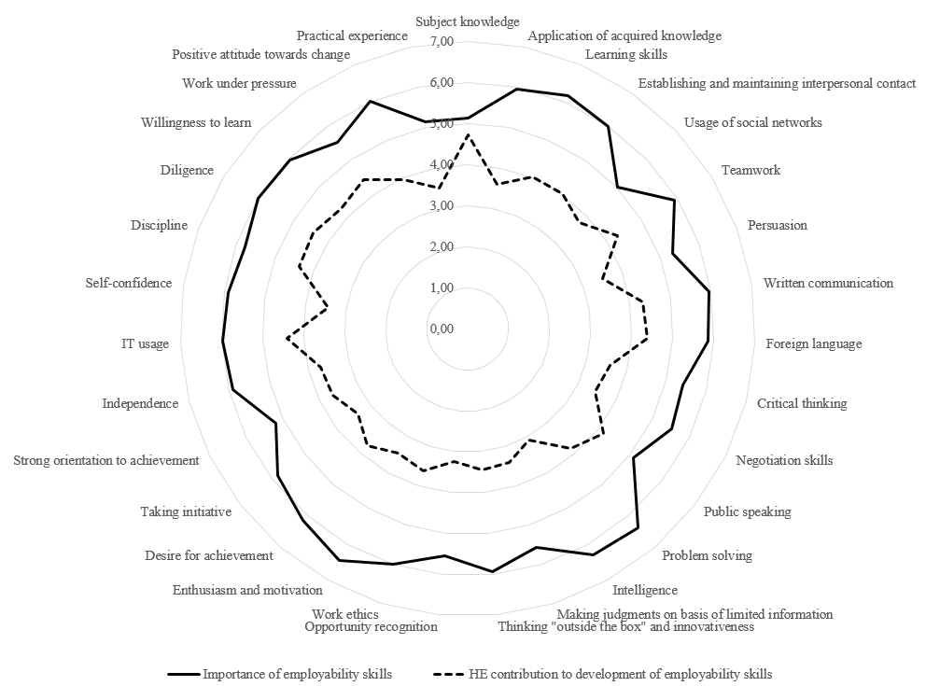
Source: Authors

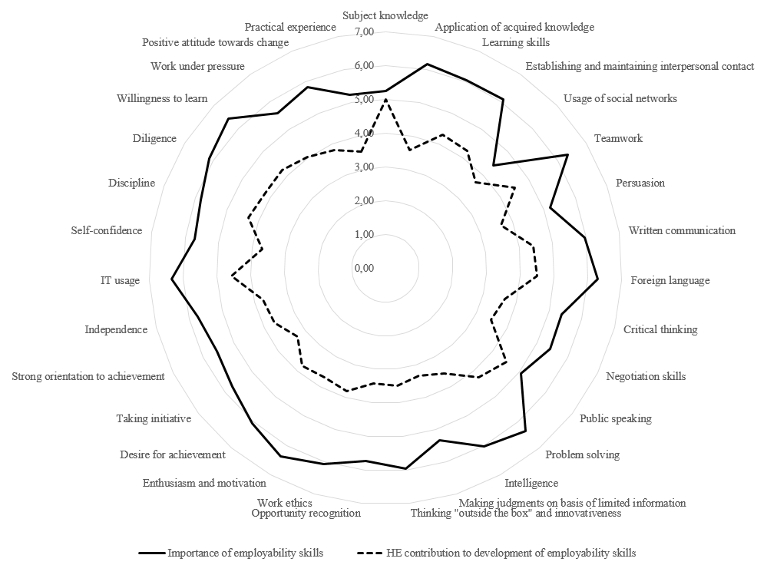
Source: Authors
Similarly, medium and large enterprises include teamwork and problem solving among valuable employability skills, and medium enterprises add application of acquired knowledge and diligence as important for employment (see Graph 6). Large enterprises, on the other hand, show the highest appreciation for intelligence, learning and problem solving skills, thinking outside of the box and innovativeness, as well as IT usage. Employers from medium and large enterprises consider application of acquired knowledge, problem solving and learning skills, thinking "outside the box" and innovativeness and intelligence, but are, in particular, unsatisfied with how much students develop these during HE.
Graph 6 Medium and large enterprises perspective of importance and HE contribution to development of employability skills
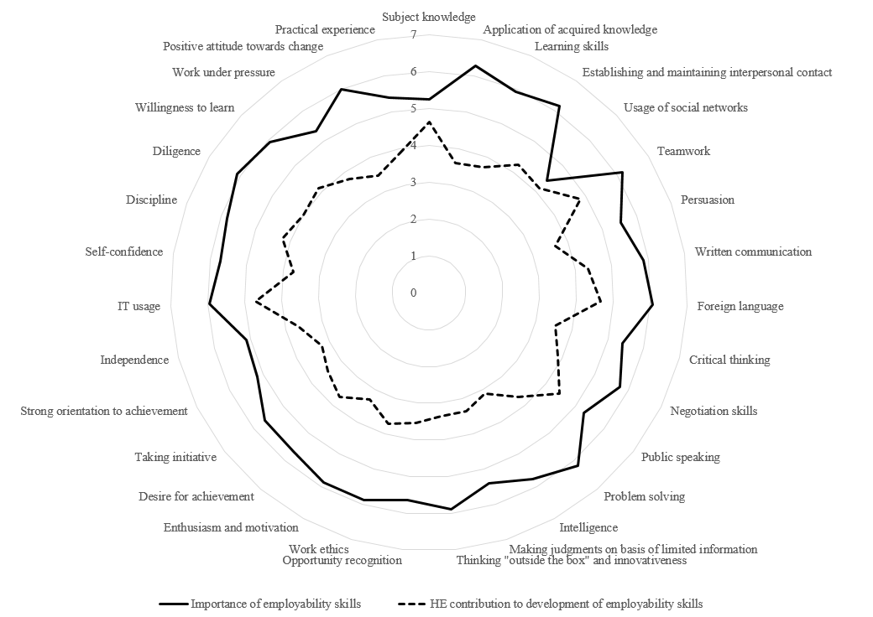
Source: Authors

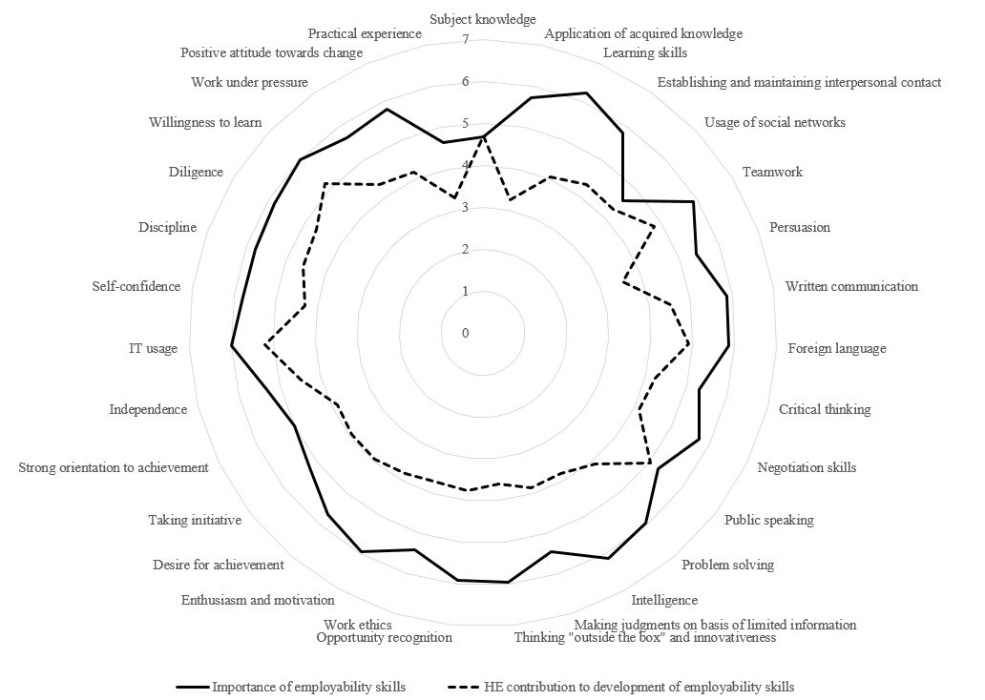
Source: Authors
Based on Graphs 5 and 6 it can be concluded that for the most part, large enterprises are less critical concerning the contribution of HE than micro and small enterprises. It also seems that micro and small enterprises identified more accurately what skills they expect from graduates.
In conclusion, for all four enterprise sizes the smallest gap between importance and HE contribution was observed for acquisition of subject knowledge, while the widest gap was connected with entrepreneurial skills. Employers perceive HE contribution most significant to acquisition of subject knowledge, teamwork, foreign language, IT usage and public speaking.
In the survey, the employers were additionally asked to rate the possibilities for improvement of students’ employability skills. The results are presented in Table 1.
Table 1 Importance of HE activities for improving graduate employability
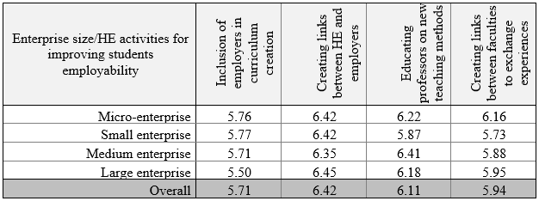
Source: Authors
Among the activities that HEI could undertake to improve graduates’ employability employers consider creating links between HE and employers the most valuable. Interestingly, they do not seem to believe that employers taking part in curriculum design would contribute much to improving the employability skills of graduates. The second most beneficial activity, as perceived by employers, was educating teachers on the contemporary teaching methods. Especially employers from medium sized enterprises consider this useful for creating employable graduates.
- Conclusion
This paper has considered the issue of students’ employability from the perspective of employers. The findings of this study could assist graduates in Croatia in understanding what employers require with regard to employability skills. The results of this study compliment previous research which established that for performance in an employment environment, application of knowledge, non-technical skills and certain personal attributes are more important than subject knowledge. Although the findings of this research correspond roughly with the findings from other countries, many significant differences have been observed. The employers in this survey seem to share the opinion that students in general leave faculty with good knowledge of the field studied, but employers do not consider subject knowledge critical for good performance in the employment environment. In their opinion, other dimensions such as learning skills and willingness to learn, as well as problem solving skills, enthusiasm and motivation, are much more important for employment. The findings illustrate that in the changing and challenging environment, students are expected to demonstrate greater employability skills that will help organizations to innovate and succeed. Consequently, the research clearly indicates the need for personal development among graduates for the 21st century workplace. A conclusion can also be made that respondents in this study perceive the importance of employability skills, but do not believe that teaching at HEI contributes sufficiently to the development of employability skills in students. The employers seem to agree that the role of higher education institutions (HEI) is not only to produce graduates with specific areas of specialization, but more importantly, to develop graduate employability skills that match the demands required by the employers. Employers in this survey believe that graduates in Croatia have gained adequate subject knowledge, but they seem to agree that more could be done to develop students’ wider employability skills and attributes, including valuable transferable and entrepreneurial skills. HEI need to educate people with knowledge and skills, need to facilitate practical application of theoretical knowledge and the acquisition of skills specific to the world of work along with training in areas specific to a particular sector. The employers share the opinion that cooperation between faculties and industry is the crucial factor for increasing students’ employability.
These results have obvious implications for improving the curriculum, planning courses and managing graduates careers. Therefore, some very clear recommendations for action can be made, including placing employability at the center of HEI’s strategic planning, widening access to work placements and promoting real partnerships between employers and HEIs, as well as considering funding mechanisms which should be used to encourage greater investment in students’ employability skills. Only in this way will HE ensure that graduates possess the required set of knowledge, skills, achievements and attributes that will secure employment, benefit themselves and the whole community. It seem that employers expect HEI to develop learning opportunities based on input from a wider variety of sources than in the past. This includes innovative pedagogy, developing novel teaching content, as well as reflection and experiential learning processes, outcomes and assessment to develop a range of employability skills. As other literature on employability, our research also shows that employers expect HEI to build stronger community relationships and partnerships with local employers. We suggest that work experience is used to enhance employability, and it could be arranged as part of regular courses, carried out on a voluntary basis or gained through part-time work. The importance of work placements, internships and work-based learning as effective approaches to promoting the employability of graduates cannot be stressed enough. Such practices are particularly welcome as they additionally promote better understanding and productive collaboration and partnerships between HEI and local employers. Although a few examples of good practice are present at some faculties of the university, it is suggested that these measures be systematic, included into strategic planning (rather than project-led) and embedded into learning and teaching practice because only that way they would insure a more sustainable impact on employability.
If university courses meet the needs of employers, the demand for such programs will increase. Similarly, by teaching the skills that students are interested in learning, HEI would enhance their students’ employment prospects.
Finally, the limitations of the study should be acknowledged. Although the size of the sample was rather small, the authors trust that the findings will have applicability beyond Eastern Croatia. Hence, further research that will include a much wider sample is needed.

REFERENCES
Agencia per a la Qualitat del Sistema Universitari de Catalunya (2015): Employers' perceptions of the employability and skills of recent graduations in Catalonia, Main findings of the AQU Catalunya Employers Survey 2014
Archer, W. and Davison, J. (2008): Graduate employability: What do employers think and want?, The Council for Industry and Higher Education (CIHE), London
Audibert, G., Jones, M. (2002): The Softer Side, Advisor Today, 97(2), pp. 72.
Cranmer, S. (2006): Enhancing graduate employability: best intensions and mixed outcomes, Studies in Higher Education, Vol. 31, No. 2, pp. 169-184
Davies, L. (2000): Why kick the 'L' out of 'Learning'? The development of students' employability skills through part-time working, Education & Training, No 42. pp. 436-444.
Eurostat unemployment statistics http://ec.europa.eu/eurostat/statistics-explained/index.php/Unemployment_statistics#Main_tables (accessed April 2016)
Gunn, V., Bell, S. and Kafmann, K. (2010): Thinking strategically about employability and graduate attributes: Universities and enhancing learning for beyond university, in: Enhancement themes, QAA, http://www.enhancementthemes.ac.uk/documents/G21C/Employability_230210.pdf (accessed February 2016)
Harvey, L., Locke, W. and Morey, A. (2002): Enhancing Employability Recognising Diversity, Universities UK, London
Moj posao: Neformalna edukacija sve bolja podloga za posao, http://www.moj-posao.net/Press-centar/Details/73337/Neformalna-edukacija-sve-bolja-podloga-za-posao/31/ (accessed March 28, 2016)
John, J. (2009): Study on the nature of impact of soft skills training programme on the soft skills development of management students, Pacific Business Review, pp. 19-27
Klaus, P. (2010): Communication breakdown, California Job Journal, No. 28, pp. 1-9
Knight, P. T. and Yorke, M. (2002): Employability through the curriculum, Tertiary Education and Management, Vol. 8, No. 4, pp. 261-276
Lees, D. (2002): Graduate Employability – Literature Review, LTSN Generic centre, University of Exeter, http://www.palatine.ac.uk/files/emp/1233.pdf (accessed February, 2016)
Lindsay, C. (2002): Long-term unemployment and the employability gap: priorities for renewing Britain's new deal, Journal of European Industrial Training, Vol. 26, No. 6., pp. 411-419.
Little, B. (2001): Reading between the lines of graduate employment, Quality in Higher Education, Vol. 7, No. 2, pp. 121-129
Mason, G. W., Williams, G. and Crammer, S. (2006): Employability skills initiatives in higher education: what effects do they have on graduate labour outcomes?, National Institute of Economiy and Social Research, London, http://www.hefce.ac.uk/pubs/rdreports/2003/rd13_03/default.asp (acessed February 2016)
Md Saad, M. S., Robani, A. Jano, Z. andA b. Majid, I. (2013): Employers' perception on engineering, information and communication technology (ICT) students' employability skills, Global J. of Engng. Educ, Vol. 15, No. 1, pp. 42-47
Recommendation of the European Parliament and of the Council of 18 December 2006 on key competences for lifelong learning OJ L 394, 30.12.2006, p. 10–18 Available at: http://eur-lex.europa.eu/legal-content/EN/TXT/?uri=celex:32006H0962 (accessed: March 2016)
Robinson, J. P. (2000): What are employability skills?, Alabama Cooperative Extension System, Vol. 1, No. 3, pp. 1-3
Rothwell, A. and Arnold, J. (2007): Self-perceived employability: development and validation of a scale, Personnel Review, Vol. 36, No. 1, pp. 23-41
Rosenberg, S., Heimler, R., Morote, E. S. (2012): Basic employability skills: a triangular design approach, Education and Training, 54(1), pp. 7-20.
The Gallup Organization (2010): Employers perception of graduate employability, Analytical report
Watts M and Watts RK (2008), Developing soft skills in students retrieved January 2009, http://l08.cgpublisher.com/proposals/64/index_html
Winterbotham M., Vivian D., Shury J., Davies B., Kik, G (2014) The UK Commission’s Employer Skills Survey 2013: UK Results, Evidence Report 81 Rotherham UKCES 2014 https://www.gov.uk/government/uploads/system/uploads/attachment_data/file/327492/evidence-report-81-ukces-employer-skills-survey-13-full-report-final.pdf (accessed March 2016)
Yorke, M. and Knight, P. (2006): Embedding Employability into the Curriculum, Learning and Employability Series One, York: Higher Education Academy, York
Zehr, M. A. (1998): New office economy putting greater demands on schools, Education week, Vol. 17, No. 23, p. 7

